[Simple way to create truly Dynamic Breadcrumbs in Oracle Apex](http://thedaya.blogspot.com/2015/08/simple-way-to-create-truly-dynamic.html)

So, when wanting to create a Dynamic Breadcrumb for an application I was working on, Google didn't really give me an adequate solution - Their solutions work, but were not really effective for pages that can be called from many different "Parents".

I spent a little time and came up with a simple solution that once implemented, should remove the need to ever worry about parenting breadcrumb regions, or even adding breadcrumbs to newly created pages.

Method behind this is simply:

* As opposed to using the standard "static" breadcrumb, use an apex collection to manage the tree of pages visited.

* Write robust procedures to manage the inserting of data into this collection (which includes figuring out when to clear the collection, for instance, when the Home page is visited), and functions to retrieve a html marked string that translates into hyperlinks, which can be displayed in the page title - in effect, becoming your breadcrumb :)

Lets start with the database procedures needed.

one package, 2 public procedures.

**Spec**

create or replace PACKAGE "BREADCRUMB_PKG" IS

function get_breadcrumb(p_collection_name varchar2, p_app_id number, p_session_id number) return varchar2;

procedure add_entry(p_collection_name varchar2,p_app_id number, p_page_id number, p_reset_breadcrumb varchar2 default 'N');

END breadcrumb_pkg;

/

**Body**

create or replace PACKAGE BODY "BREADCRUMB_PKG"

AS

FUNCTION get_breadcrumb(p_collection_name VARCHAR2,p_app_id number, p_session_id number ) RETURN VARCHAR2 IS

--return html breadcrumb

w_link varchar2(2000);

w_link2 varchar2(2000);

CURSOR c1 IS

select seq_id,c001, c002

 from apex_collections

 WHERE collection_name = p_collection_name

 order by seq_id asc;

begin

FOR r1 IN c1 loop --loop through entries in collection, produce html

w_link2:=w_link ||r1.c002||'';

w_link := w_link || '<a href="f?p='||p_app_id||':'||r1.c001||':'|| p_session_id||'::NO:::" class="t-Breadcrumb-label">'||r1.c002||' > </a>';

end loop;

return w_link2;

END get_breadcrumb;

 procedure add_member (p_collection_name varchar2, p_app_id number, p_page_id number) is

 --get page title and add to collection

 w_page_name varchar2(40);

 begin

 select page_title

   into w_page_name

   FROM APEX_APPLICATION_PAGES

  where page_id = p_page_id and APPLICATION_ID = p_app_id and page_mode = 'Normal';   
--note, coded to specifically exclude modals. you may remove if necessary

APEX_COLLECTION.ADD_MEMBER(

        p_collection_name => p_collection_name,

        p_c001            => p_page_id,

        p_c002            => w_page_name);

  exception

    WHEN no_data_found THEN

            NULL;

end add_member;

procedure add_entry (p_collection_name varchar2,p_app_id number, p_page_id number,  p_reset_breadcrumb varchar2 default 'N') is

-- add page entry to breadcrumb

cursor c1 (p_curr_seq_id number)is

select seq_id

 from apex_collections

 where collection_name = p_collection_name

 and seq_id > p_curr_seq_id;

begin

IF( (NOT APEX_COLLECTION.COLLECTION_EXISTS (p_collection_name))OR p_reset_breadcrumb = 'Y') THEN

if (apex_collection.collection_exists(p_collection_name)) then

     APEX_COLLECTION.TRUNCATE_COLLECTION (p_collection_name);

else

    APEX_COLLECTION.CREATE_COLLECTION(p_collection_name);

end if;

add_member(p_collection_name, p_app_id , p_page_id );

else

declare

  w_curr_seq_id number;

    begin

--first check if page exists in collection

  select seq_id

    into w_curr_seq_id

    from apex_collections

    where collection_name = p_collection_name

     and c001 = p_page_id;

for r1 in c1 (w_curr_seq_id) loop --if it does , delete entries that follow (caters for navigating back to a page)

    APEX_COLLECTION.DELETE_MEMBER(

        p_collection_name => p_collection_name,

        p_seq => r1.seq_id);

end loop;

exception

WHEN no_data_found THEN --if entry does not exist, insert

 add_member(p_collection_name,p_app_id,p_page_id );

end;

END IF;

end add_entry;

END breadcrumb_pkg;

/

Next, we need to utilize this from the apex front end.

First, create a hidden item on page 0 called P0_BREADCRUMB.

•         * Set source to PL/SQL expression, and put this as the source.

breadcrumb_pkg.get_breadcrumb('BREADCRUMB',:APP_ID,:A_SESSION_ID);

We also need an APPLICATION ITEM  - A_RESET_BREADCRUMB. This can help us control when to completely reset the breadcrumb, for instance, if an item from the navigation menu in clicked, it makes sense to clear our “tree”.

Now lets create a region to show the breadcrumb.

      1)    On page 0, create  a region of type PL/SQL Dynamic contact, and set region position to Breadcrumb Bar.

      2)    Now, add the code below to the PL/SQL block area .

begin

htp.print('<BR> &nbsp;&nbsp;  '||:P0_BREADCRUMB||'<BR>');

end;

We now need a way to populate the collection, so that when breadcrumb_pkg.get_breadcrumb is called, it can loop through it and return an html breadcrumb.

We do this by creating an APPLICATION PROCESS,on load (before header).

Add the following code to that.

declare

begin

breadcrumb_pkg.add_entry('BREADCRUMB',:APP_ID,:APP_PAGE_ID,:A_RESET_BREADCRUMB);

if(:A_RESET_BREADCRUMB = 'Y') then

:A_RESET_BREADCRUMB:='N';

end if;

end;

And……that’s it, you now have a completely dynamic breadcrumb ☺

When wanting to reset the breadcrumb (for items on the navigation menu for instance), simply set the application item A_RESET_BREADCRUMB to ‘Y’ as part of the parameters.

Pop a comment if you have any difficulties using this. Cheers

Posted 14th August 2015 by Unknown

# [Barry's Oracle Development Blog](http://barrybrierley.blogspot.com/)

I hate reading manuals. I find most of my answers on forum posts and blogs. But there's a lot of incorrect and outdated information out there. This is what worked for me.

## Wednesday, 14 October 2015

### Dynamically changing a breadcrumb name

#### Problem

You want your breadcrumb to have a dynamic name.

[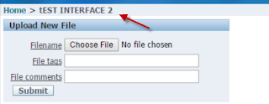](http://4.bp.blogspot.com/-mLhHl3zejcY/Vh4Tp6NusqI/AAAAAAAAB-s/t32wngoN12Q/s1600/14-10-2015%2B09-34-09.png)

#### Solution

Create a Shared Component > Application Item .

[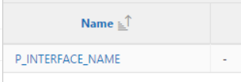](http://4.bp.blogspot.com/-BRyTDdOBtkM/Vh4USEC9unI/AAAAAAAAB-0/kwStbjxelCk/s1600/14-10-2015%2B09-36-53.png)

 Edit your Breadcrumb entry for the Page that is Create / Edit.  
 Change the Short Name to &(Application_item).  
NOTE: The fullstop at the end of it.

[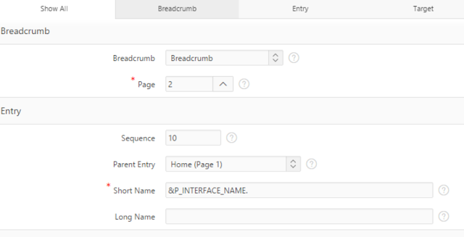](http://4.bp.blogspot.com/-4Q4vljCla1g/Vh4Uw4DzJmI/AAAAAAAAB-8/UL8L8Jx-UNs/s1600/14-10-2015%2B09-38-17.png)

 Create a process to populate the variable. In my it was a before header process on the page.

[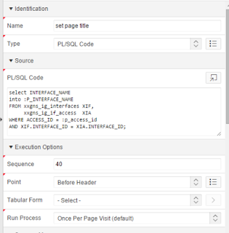](http://2.bp.blogspot.com/-RacGqiLkRhg/Vh4Vpb42FqI/AAAAAAAAB_E/29YEU7wi1UM/s1600/Capture.PNG)

