Pragya (pragyacareer.com)
Razorpay Activation — Merchant Website Details & Payment Flow
Prepared for the submitting team · Vision Circuit Labs LLP · July 2026

1. URLs for the application
Field | Value
Merchant Website URL | https://pragyacareer.com
Review / working URL | https://pragyacareer.com/razorpay-review
URLs to whitelist | https://pragyacareer.com, https://www.pragyacareer.com, https://pragyacareer.com/razorpay-review
Return URL / Referrer domain | https://pragyacareer.com

Regarding the earlier observation ("URL not working / Pay Now and policies not visible"): the originally submitted URL was the homepage, which did not surface a Pay Now option directly. The dedicated review URL above now presents Pay Now options, pricing, and all mandatory policies on one public page, and the homepage footer also carries a Pay Now link. All URLs are live over HTTPS with a valid certificate.

2. Business summary
Field | Value
Business | Online career assessment and counselling guidance for students and job seekers
Products | Career Assessment Test — Rs. 8,000 (launch offer Rs. 2,499); Employability Test — Rs. 5,000 (launch offer Rs. 999). One-time payments, inclusive of taxes.
Delivery | Digital only — assessment access and downloadable PDF report after payment verification. No physical shipping.
Disclaimer | Advisory guidance only; no job, admission, salary, scholarship, or outcome guarantees.

3. Customer payment flow
- Customer opens the pricing page, the review page, or any Pay Now link.
- Pay Now opens the public order summary (product, amount, delivery terms, policy links) — no login needed to view.
- Customer signs in or registers (Student / Job Seeker) to complete the purchase.
- Customer clicks Pay — Razorpay Checkout opens (UPI, cards, net banking, wallets).
- On success, payment is verified server-side and the assessment unlocks automatically.
- Customer completes the assessment online and downloads the PDF report from the dashboard.

4. Razorpay integration (technical)
- Integration type: Razorpay Standard Web Checkout (checkout.js) with server-side order creation via the Orders API.
- Payment verification: HMAC-SHA256 signature verification on the server for every payment.
- Webhook endpoint implemented for payment.captured with webhook-secret signature validation.
- Amounts: 2,49,900 paise (Career Assessment Test) and 99,900 paise (Employability Test), INR.
- Integration is fully built and deployed; it activates as soon as live API keys are issued for the account.

5. Reviewer demo access
For inspecting the logged-in flow (order summary through dashboard):
Login email | demo@pragyacareer.com
Password | Shared separately by Vision Circuit Labs
Role | Student (pre-paid, dashboard and assessment visible)

A fresh registration at https://pragyacareer.com/register can be used to see the unpaid order summary and Pay flow.

6. Merchant contact
- Support: support@pragyacareer.com · +91 95621 47770
- Technical contact for this application: Vision Circuit Labs LLP (developer/maintainer of pragyacareer.com)

7. Page evidence (live screenshots, 5 July 2026)

1. Razorpay Review Page
URL: https://pragyacareer.com/razorpay-review
Single page with Pay Now options, launch offer pricing, customer workflow, and all mandatory policy links.
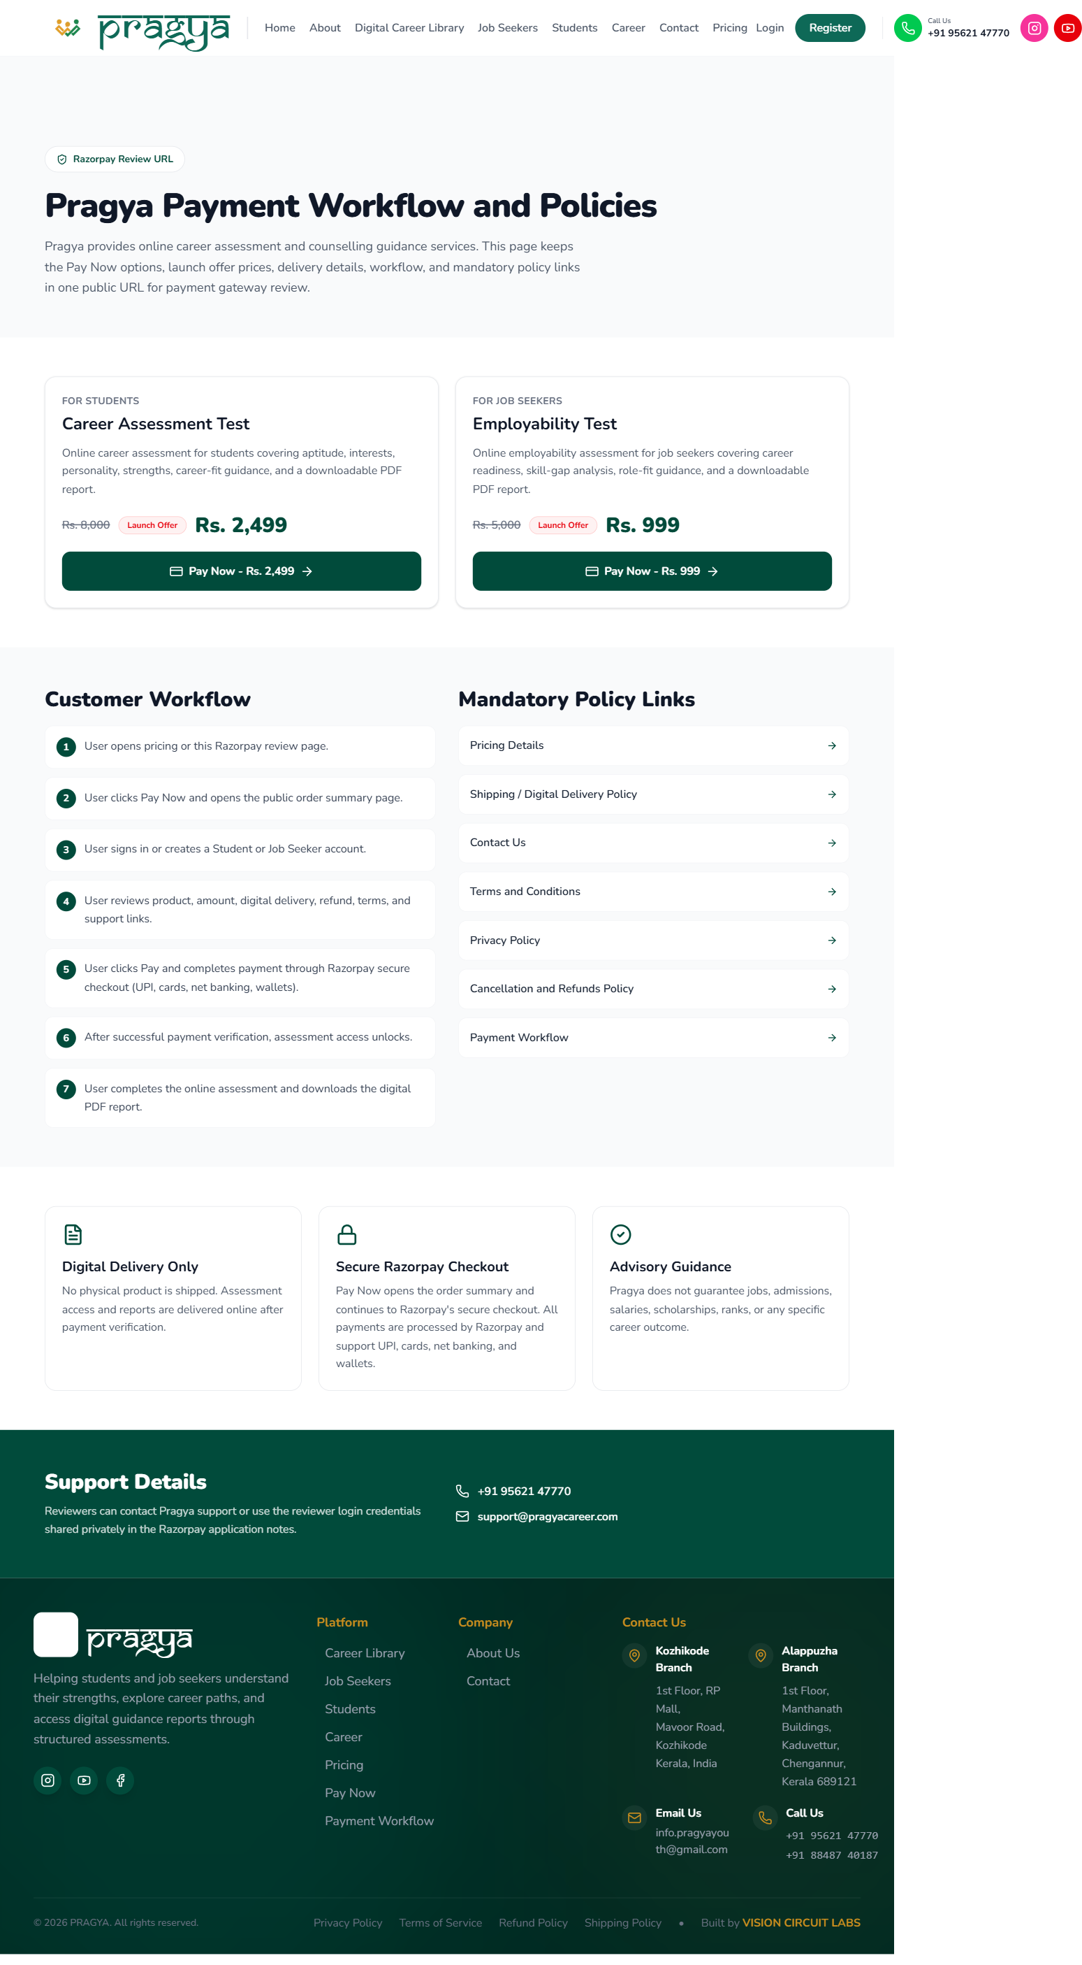

2. Public Order Summary — Career Assessment Test (Rs. 2,499)
URL: https://pragyacareer.com/payment?plan=student
Opens from Pay Now. Publicly accessible — no login required to view the order summary.
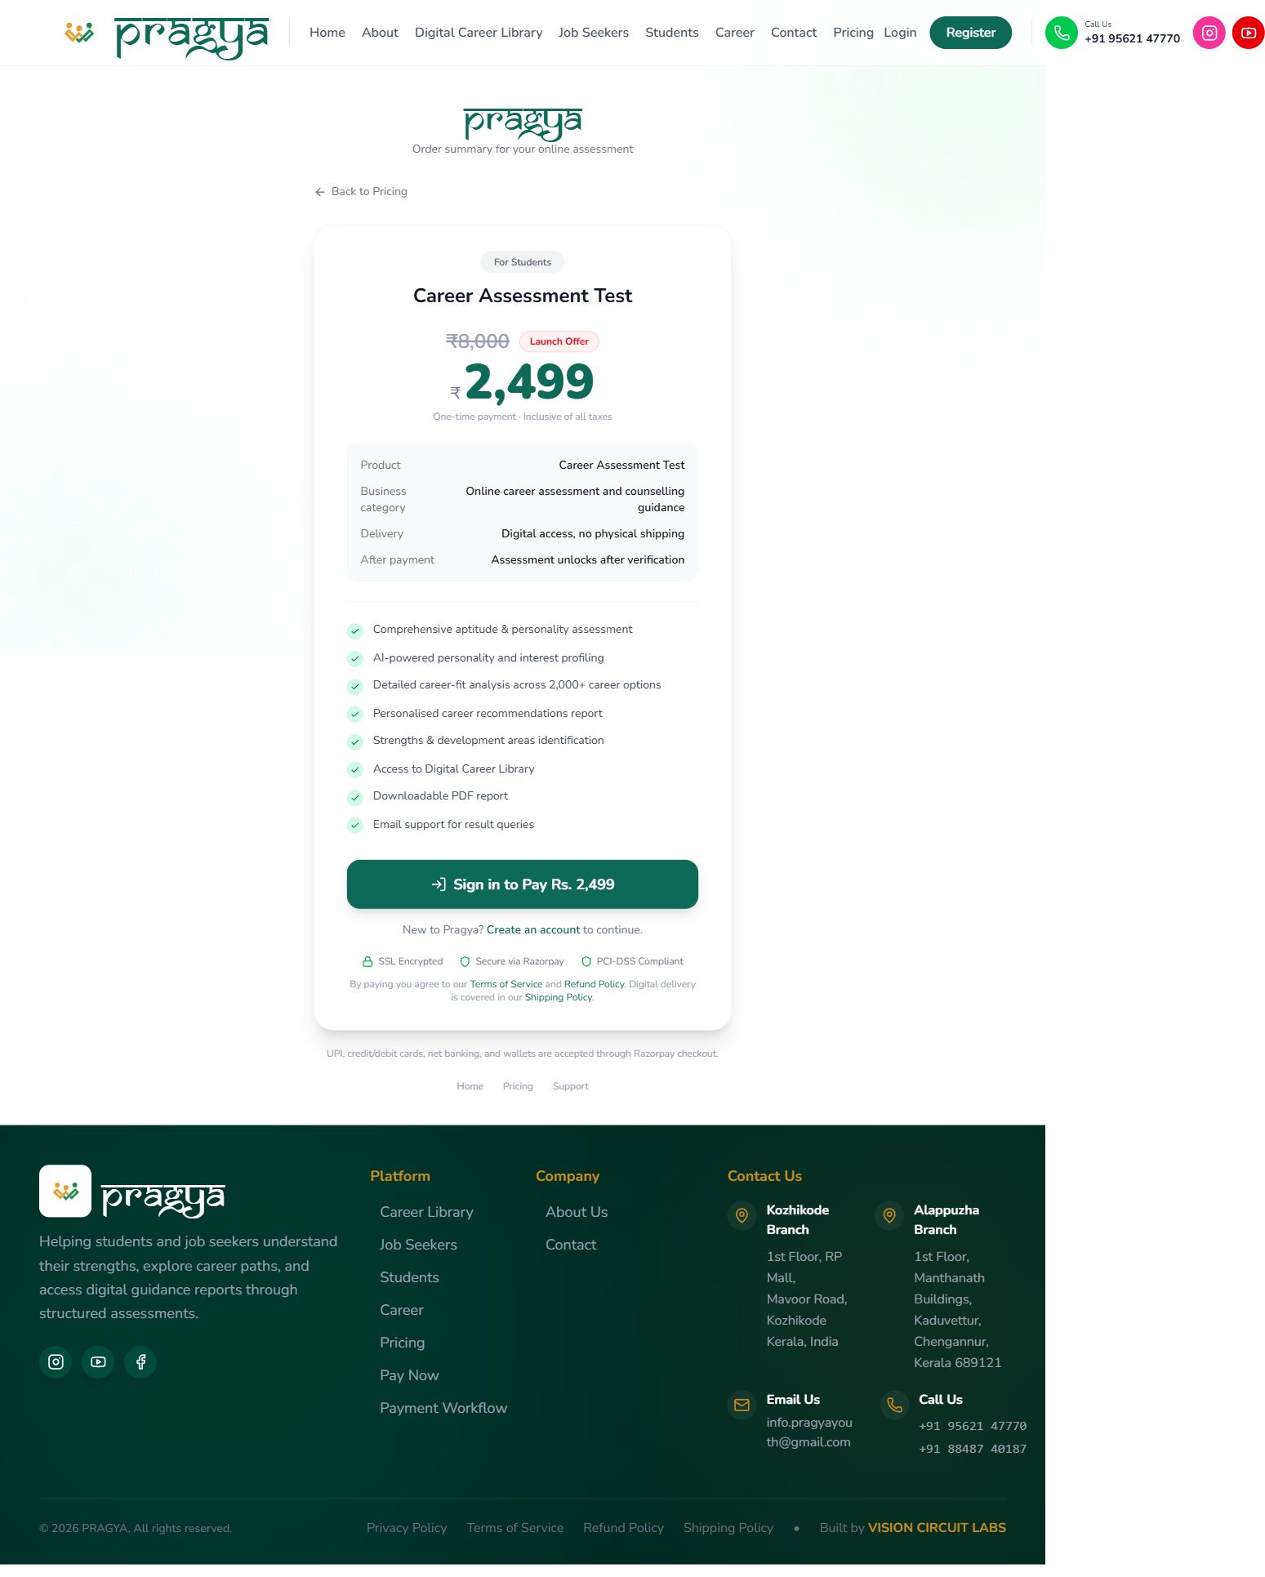

3. Public Order Summary — Employability Test (Rs. 999)
URL: https://pragyacareer.com/payment?plan=job_seeker
Same public order page for the job seeker product.
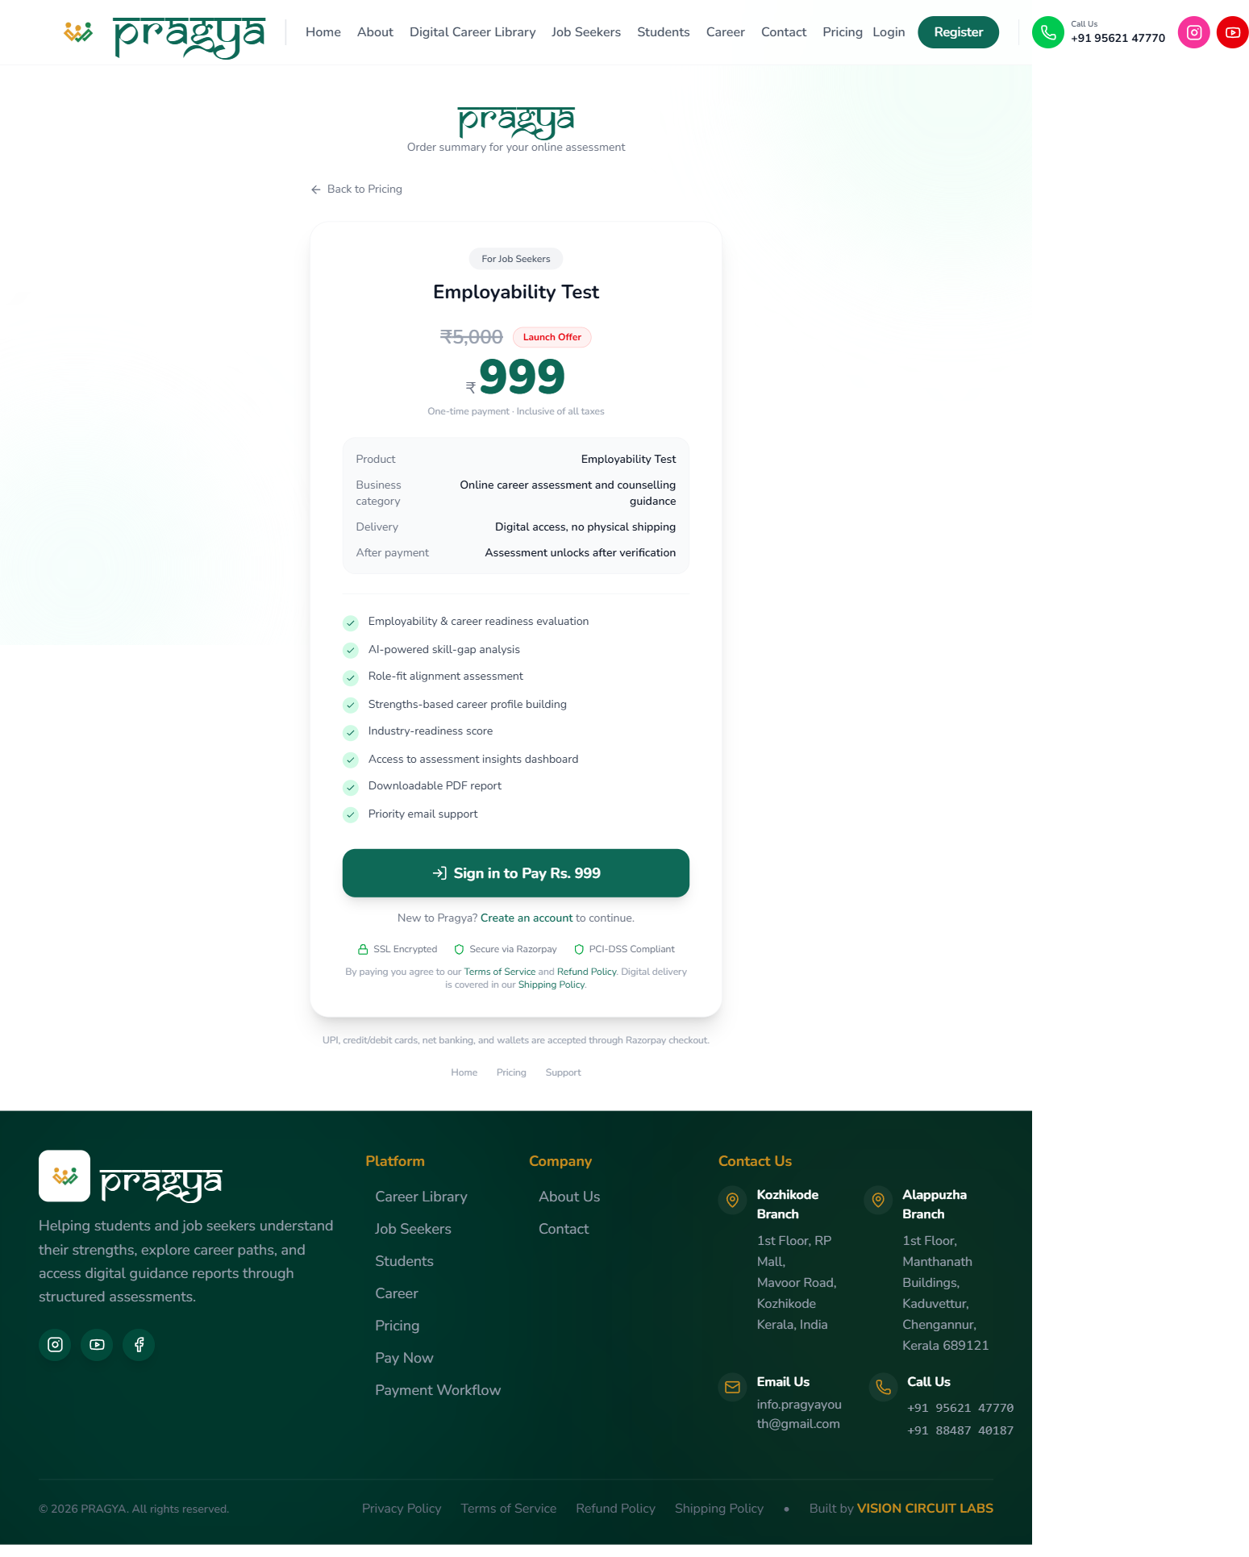

4. Homepage
URL: https://pragyacareer.com
Footer on every page carries Pay Now and all mandatory policy links.
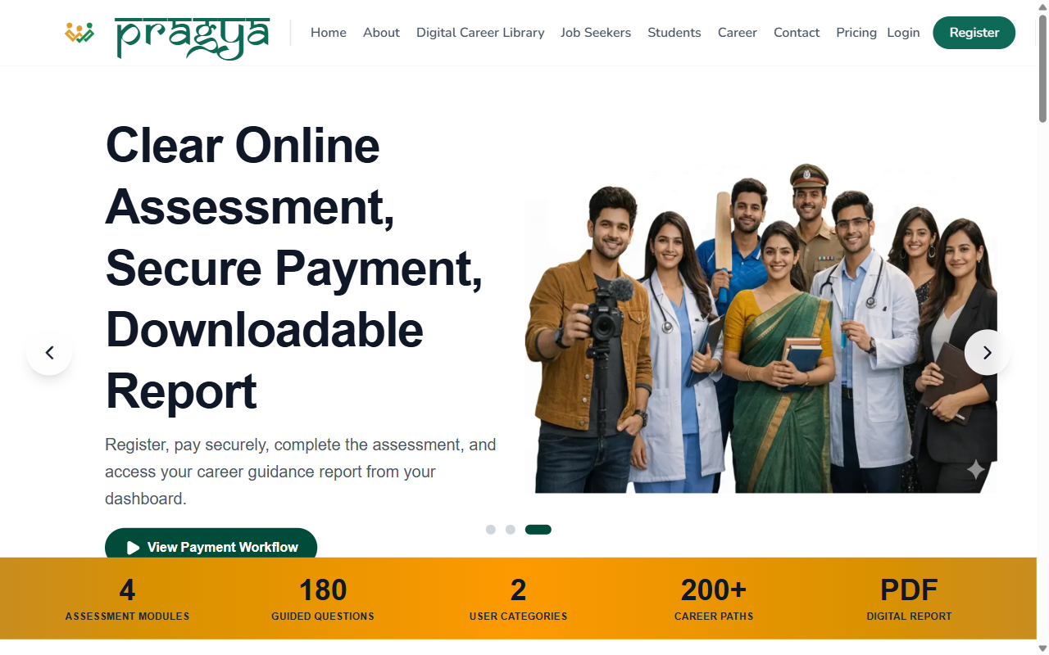

5. Pricing
URL: https://pragyacareer.com/pricing
Regular and launch offer pricing for both products.
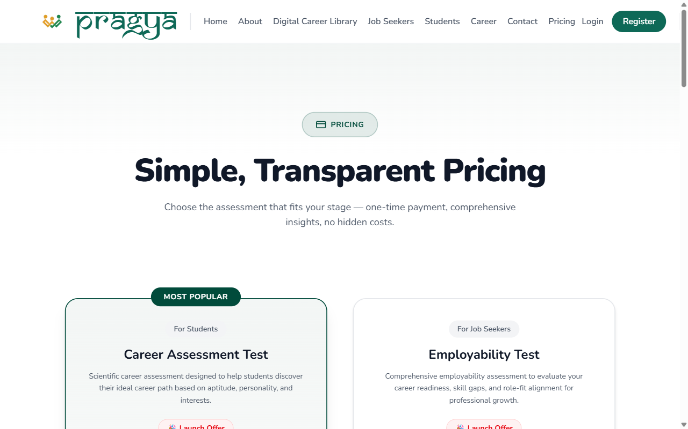

6. Payment Workflow
URL: https://pragyacareer.com/payment-workflow
Customer-facing explanation of the payment-to-delivery flow.
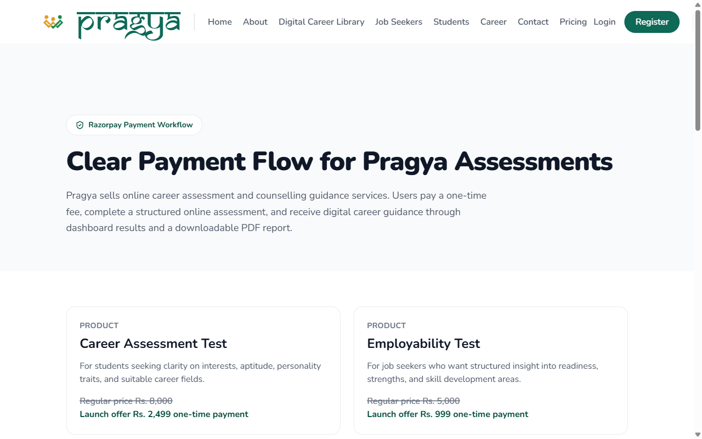

7. Shipping / Digital Delivery Policy
URL: https://pragyacareer.com/shipping-policy
Digital delivery only; no physical shipping.
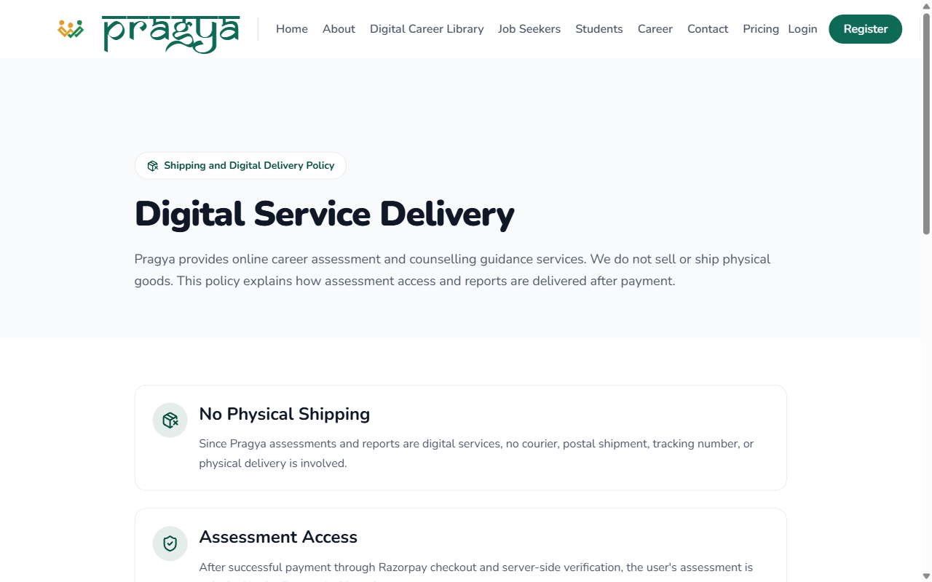

8. Cancellation & Refund Policy
URL: https://pragyacareer.com/refund-policy
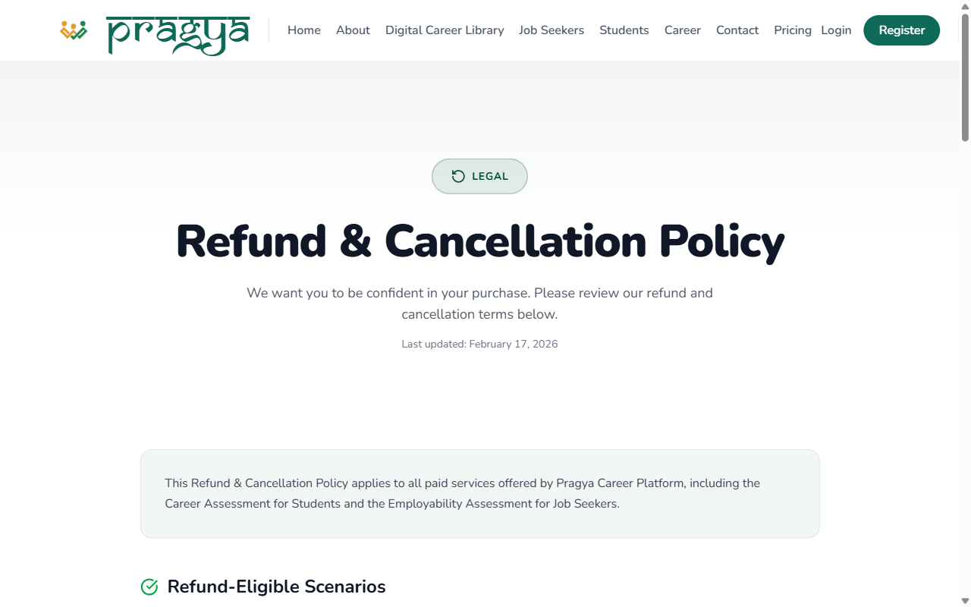

9. Terms & Conditions
URL: https://pragyacareer.com/terms
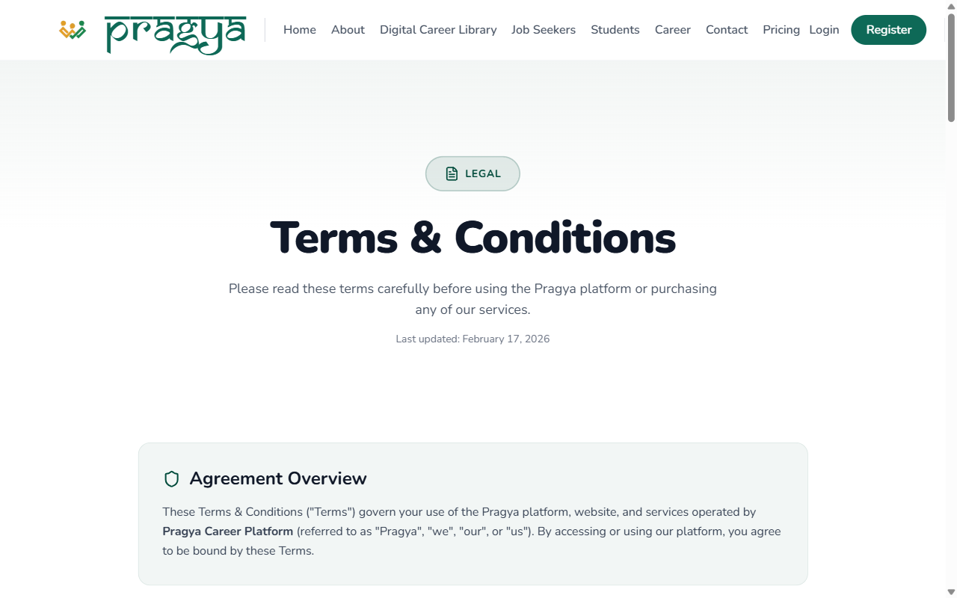

10. Privacy Policy
URL: https://pragyacareer.com/privacy-policy
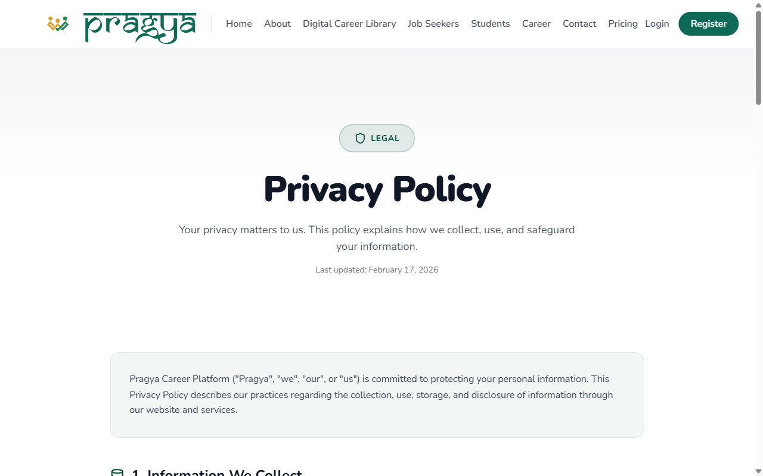

11. Contact Us
URL: https://pragyacareer.com/contact
Phone, email, and office addresses (Kozhikode and Chengannur, Kerala).
