Pragya — Razorpay Submission Guide
Everything you need to resubmit the Razorpay application
July 2026 · pragyacareer.com

What happened, in one minute
Razorpay rejected the earlier application because the URL we gave them (the homepage) did not show a Pay Now option or the mandatory policy pages clearly.
That is now fixed. We built a dedicated review page that shows everything Razorpay asks for in one place, and the payment pages are open for anyone to see — no login needed. All of it is live right now.

Step 1 — Copy these values into the Razorpay form
Field | What to enter
Website URL | https://pragyacareer.com
Review / working URL | https://pragyacareer.com/razorpay-review
URLs to whitelist | https://pragyacareer.com, https://www.pragyacareer.com, https://pragyacareer.com/razorpay-review
Return URL / Referrer domain | https://pragyacareer.com

Step 2 — Paste this note in the comments / description box
Pragya is an online career assessment and counselling guidance service for students and job seekers. The review URL https://pragyacareer.com/razorpay-review shows the Pay Now options, pricing, and all mandatory policies — Terms and Conditions, Privacy Policy, Cancellation/Refund Policy, Shipping/Digital Delivery Policy, and Contact details. The payment order summary pages are public and need no login: https://pragyacareer.com/payment?plan=student and https://pragyacareer.com/payment?plan=job_seeker. Delivery is digital only — no physical shipping. Reviewer demo login: demo@pragyacareer.com (Student role; password: _____ ).
Before submitting: fill in the demo account password where the blank ( _____ ) is. It is sent to you separately and is intentionally not printed in this document.

Step 3 — Where to do this
- Log in at dashboard.razorpay.com with the Pragya merchant account.
- Open Account & Settings, then Activation Details. Look for the section marked "Needs clarification" — usually on the Business Details / Website field.
- Enter the values from Step 1, paste the note from Step 2 in the comment box, and submit for re-review.
If the form has no comment box, simply reply to the email in which Razorpay sent the rejection, with the same note and URLs. Both routes reach the same review team.

Why it will pass their checklist
Razorpay asked for three things. Here is where each one now lives:
Razorpay asked for | Where it is now
A working URL | https://pragyacareer.com/razorpay-review — live, public, loads over HTTPS with a valid certificate
Visible Pay Now option | Two Pay Now buttons with prices on the review page; each opens a public order page. The homepage footer also has a Pay Now link.
All mandatory policies | Terms, Privacy, Refund/Cancellation, Shipping/Digital Delivery, Pricing, Payment Workflow and Contact — linked on the review page and in the footer of every page.

What the reviewer will see — page by page
Screenshots below were taken from the live website on 5 July 2026. You can open every URL yourself to confirm.

1. Razorpay Review Page (the URL to submit)
URL: https://pragyacareer.com/razorpay-review
One page with everything Razorpay asked for: Pay Now buttons with prices, the customer workflow, and links to every mandatory policy.
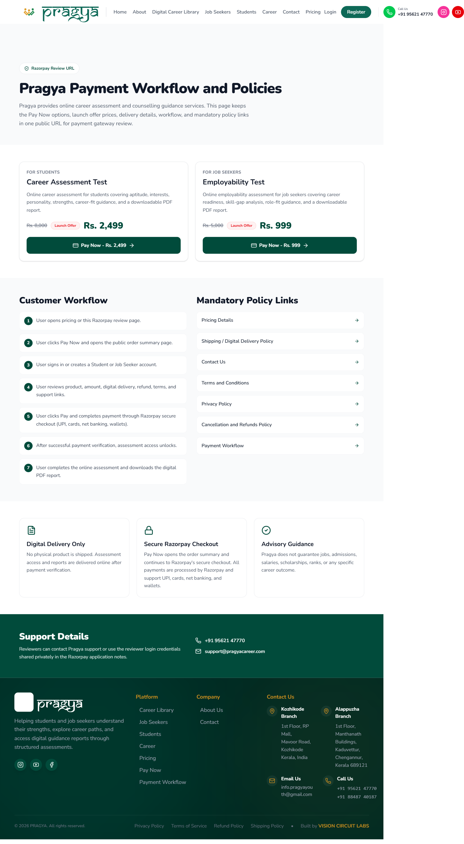

2. Payment Order Summary — Career Assessment Test
URL: https://pragyacareer.com/payment?plan=student
What opens when Pay Now is clicked for students. Full order details, Rs. 2,499 launch offer, policies linked below the button. No login needed to view.
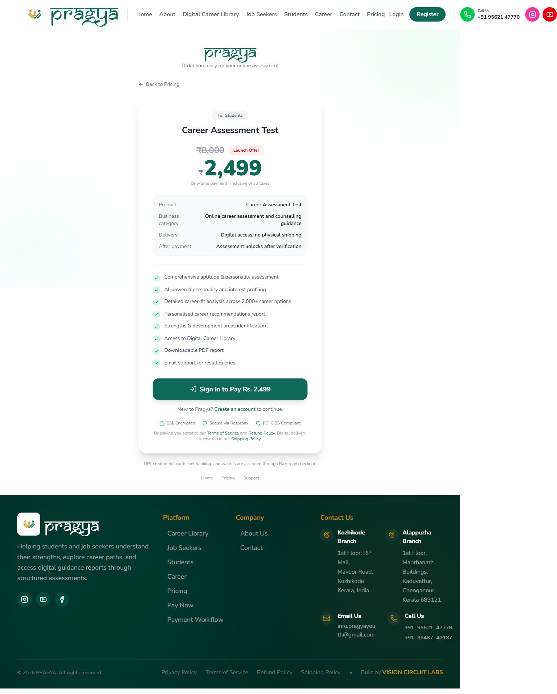

3. Payment Order Summary — Employability Test
URL: https://pragyacareer.com/payment?plan=job_seeker
The same public order page for job seekers, showing the Rs. 999 launch offer.
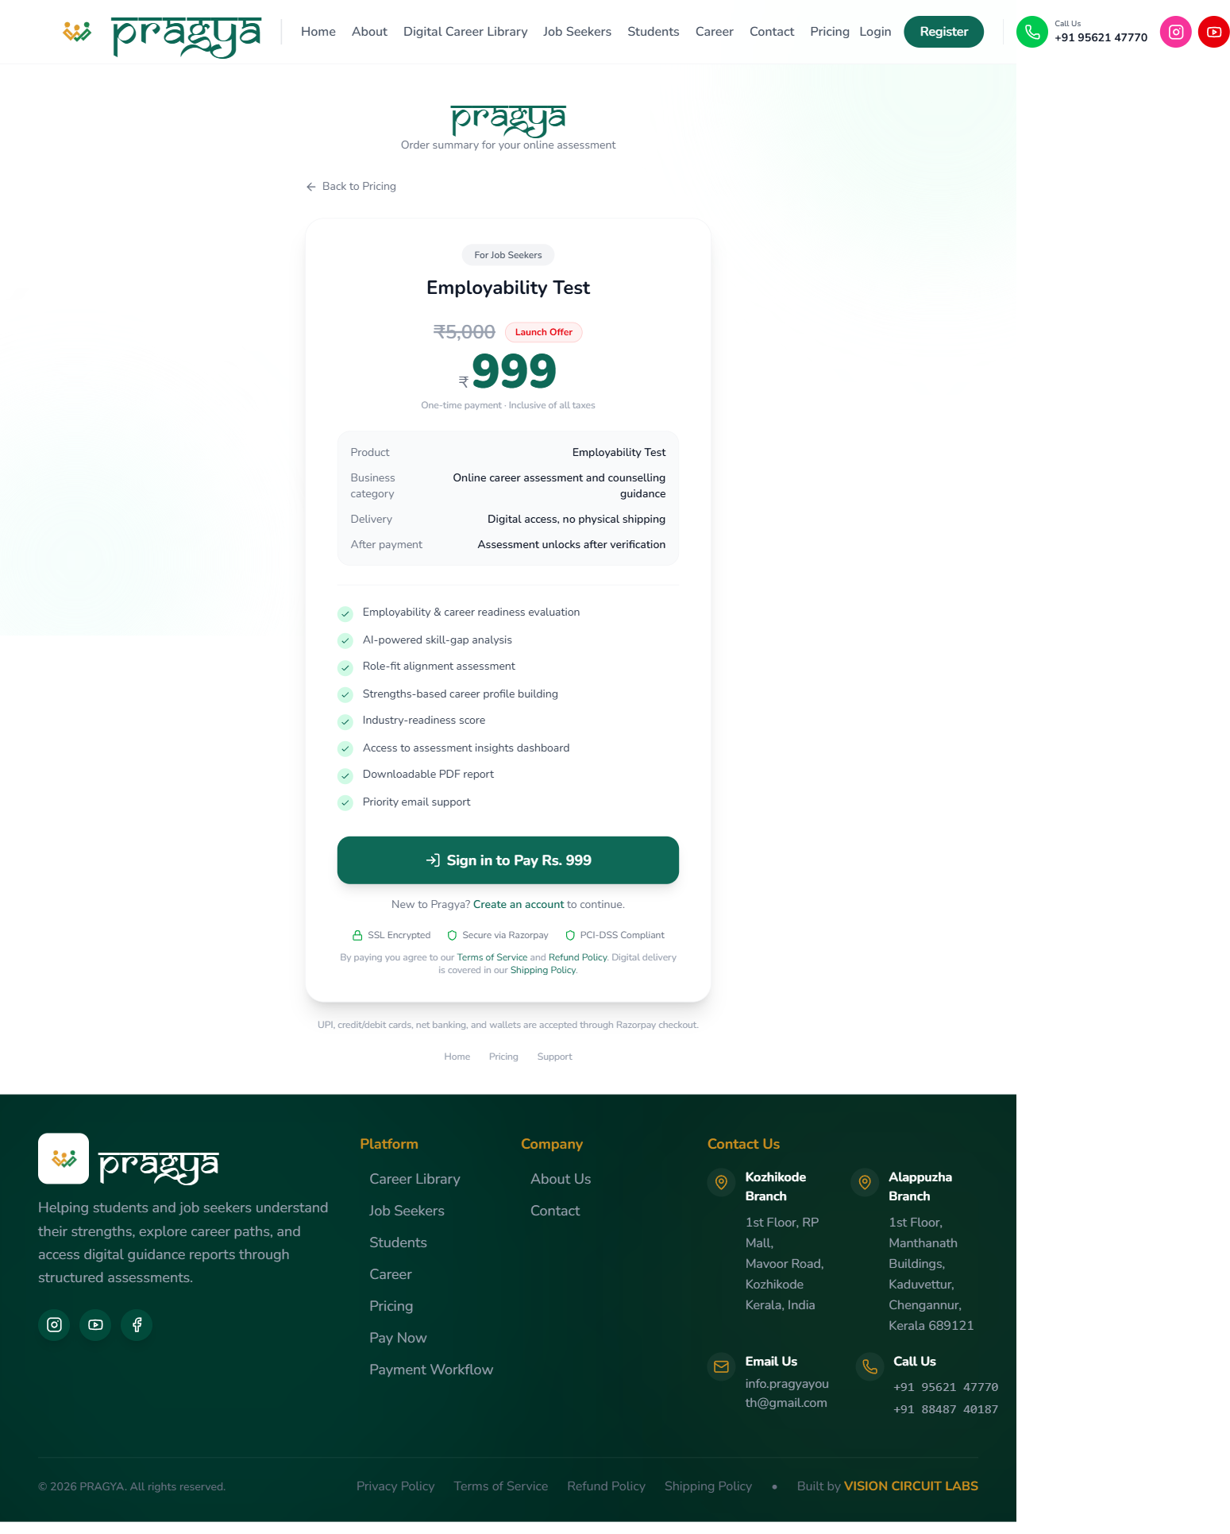

4. Homepage
URL: https://pragyacareer.com
The main website. The footer on every page carries a Pay Now link and all policy links.
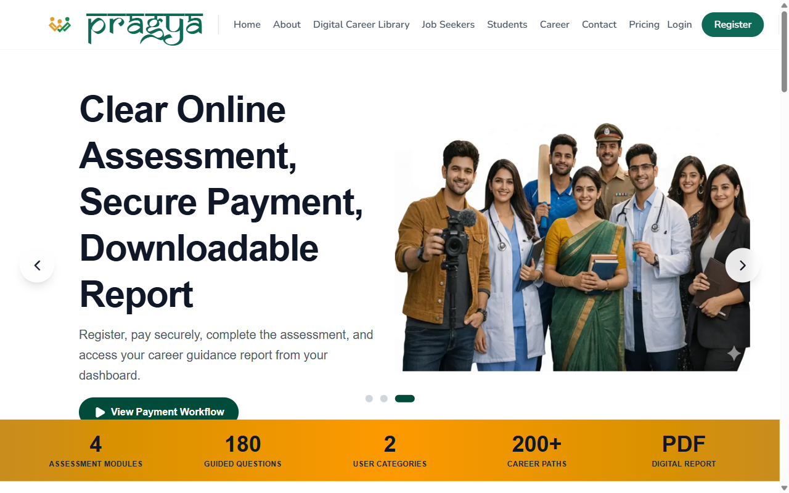

5. Pricing
URL: https://pragyacareer.com/pricing
Both products with regular and launch offer prices.
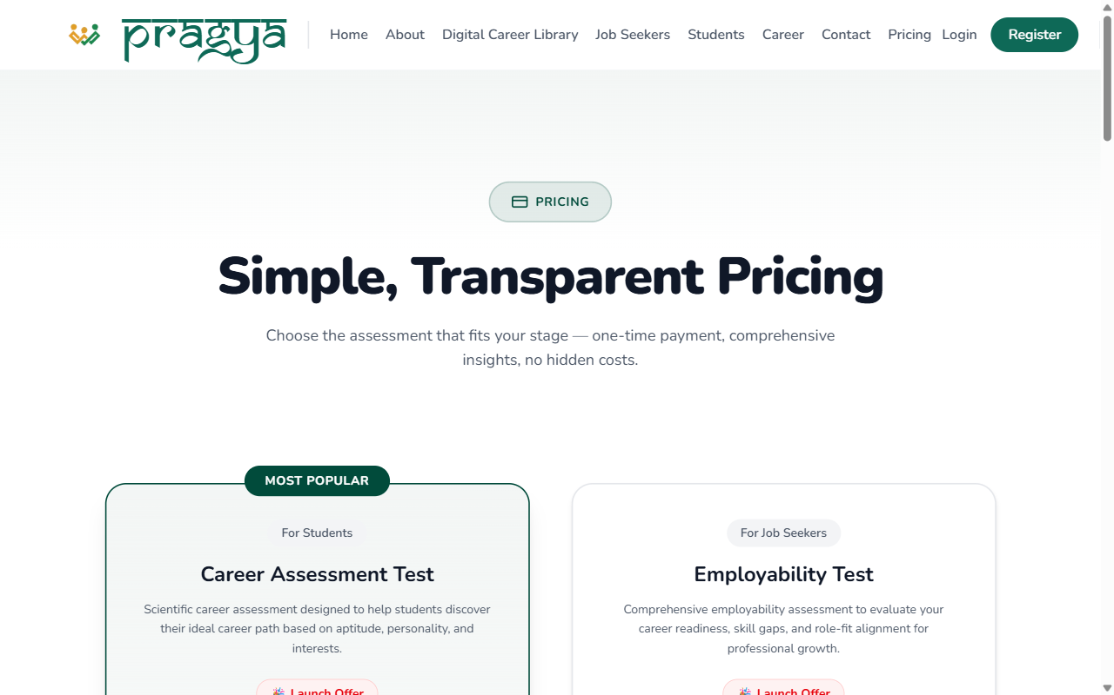

6. Payment Workflow
URL: https://pragyacareer.com/payment-workflow
Explains the steps from payment to receiving the assessment report.
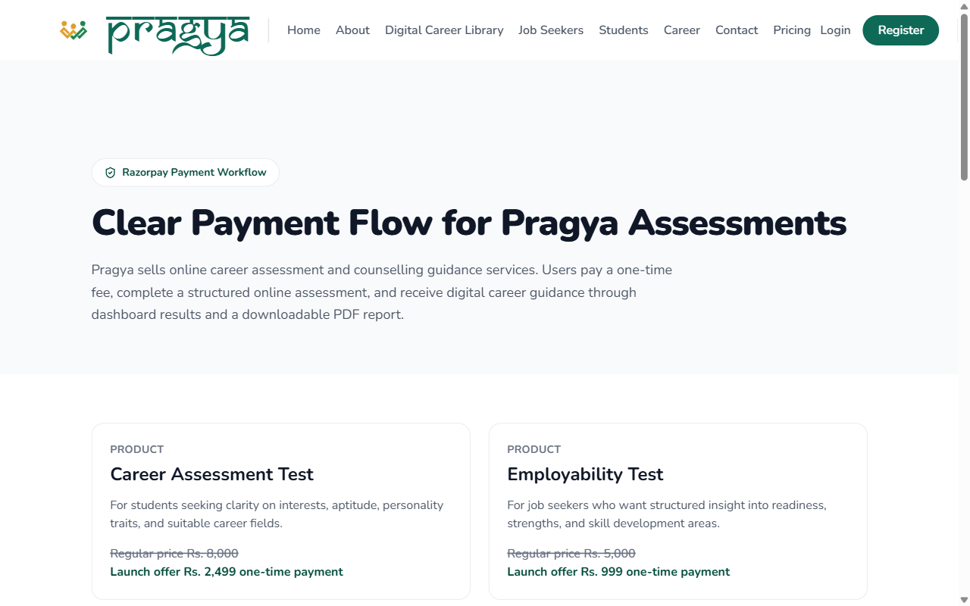

7. Shipping / Digital Delivery Policy
URL: https://pragyacareer.com/shipping-policy
States that delivery is digital only — no physical shipping.
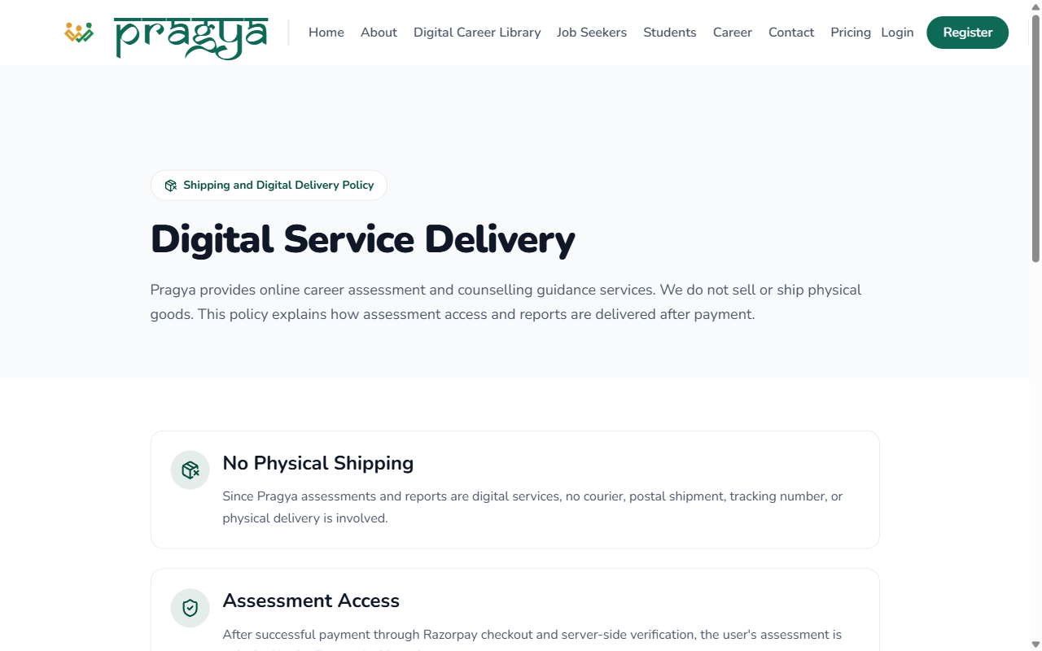

8. Cancellation & Refund Policy
URL: https://pragyacareer.com/refund-policy
The refund and cancellation rules.
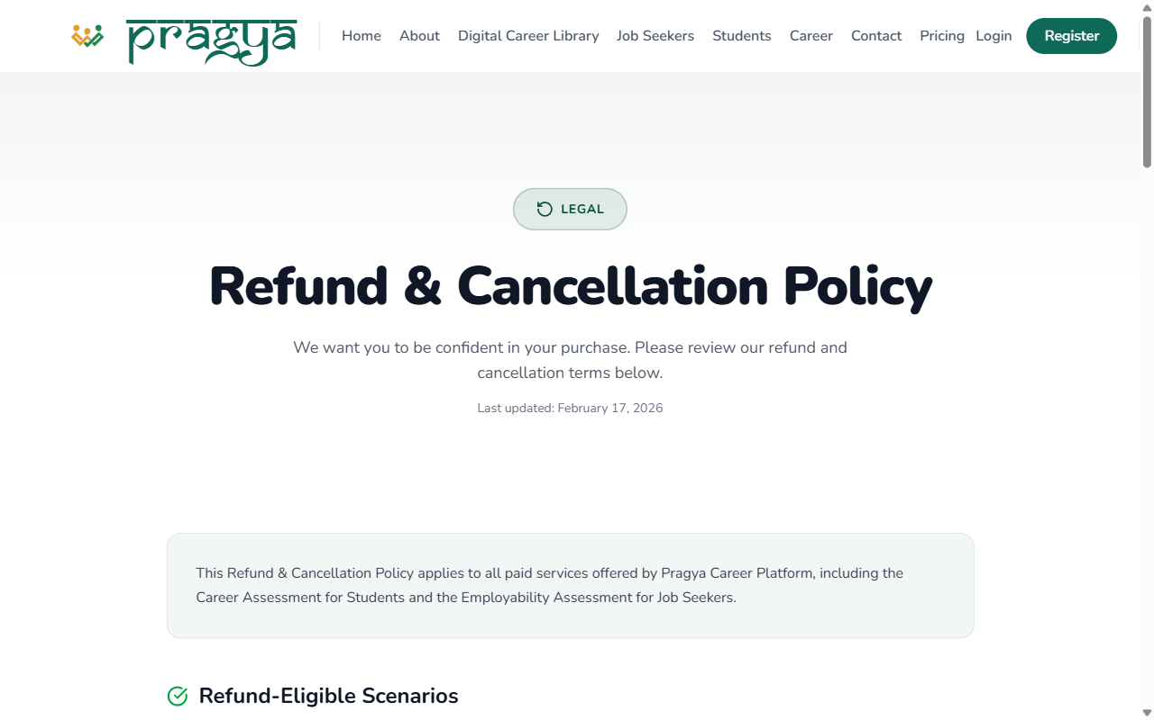

9. Terms & Conditions
URL: https://pragyacareer.com/terms
The terms of service.
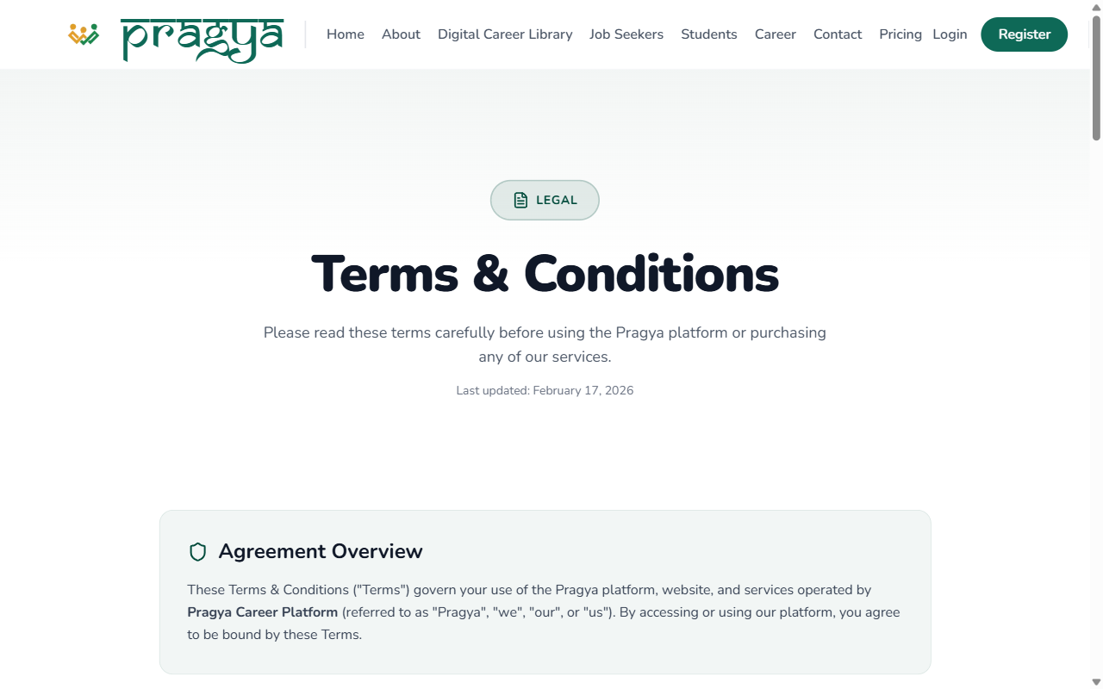

10. Privacy Policy
URL: https://pragyacareer.com/privacy-policy
How user data is handled.
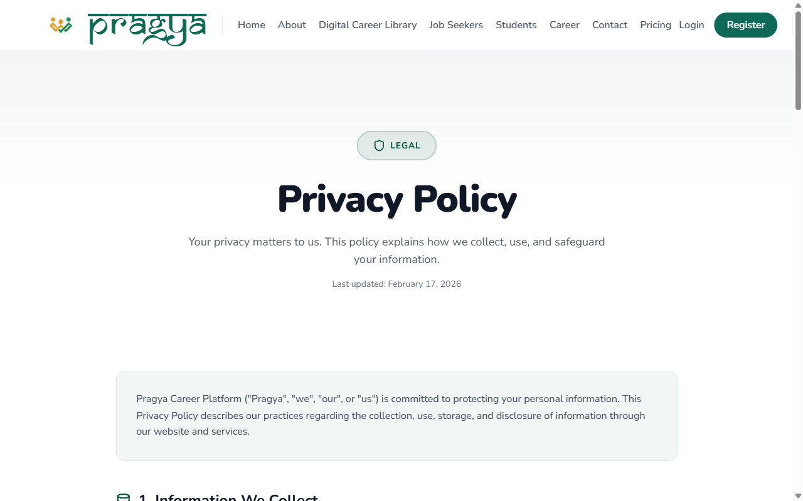

11. Contact Us
URL: https://pragyacareer.com/contact
Phone, email, and both office addresses (Kozhikode and Chengannur, Kerala).
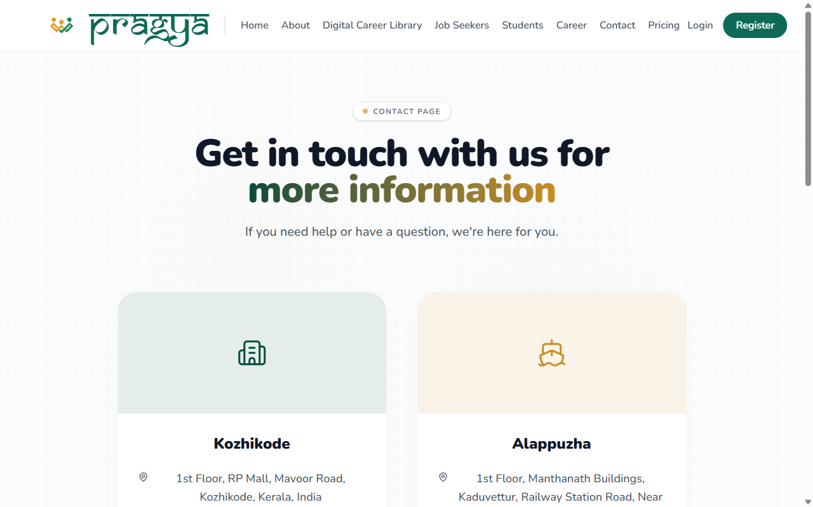

After Razorpay approves
- Razorpay will issue live API keys for the account.
- We add the keys to the server the same day — the Pay buttons then open the real Razorpay checkout (UPI, cards, net banking, wallets).
- We run one end-to-end test payment before announcing anything.

