DBMS PRACTICALS

Q1:Retrieve names of students enrolled in any society.

MariaDB [ss_94059]> SELECT DISTINCT S.STUDENTNAME FROM STUDENT
-> AS S JOIN ENROLLMENT AS E ON S.ROLLNO = E.ROLLNO;
+--------------+
| STUDENTNAME |
+--------------+
| AMAN GUPTA |
| NEHA SHARMA |
| ROHIT VERMA |
| ANJALI SINGH |
| SURESH KUMAR |
| POOJA MEHTA |
+--------------+
6 rows in set (0.01 sec)

Q2:Retrieve all society names.

MariaDB [ss_94059]> SELECT SOCNAME FROM SOCIETY;
+----------+
| SOCNAME |
+----------+
| DEBATING |
| DANCING |
| NSS |
| MUSIC |
| DRAMA |
+----------+
5 rows in set (0.00 sec)

Q3. Retrieve students name starting with letter ‘A’.

MariaDB [ss_94059]> SELECT STUDENTNAME FROM STUDENT WHERE STUDENTNAME LIKE 'A%';
+--------------+
| STUDENTNAME |
+--------------+
| AMAN GUPTA |
| ANJALI SINGH |
+--------------+
2 rows in set (0.00 sec)

Q4.Retrieve student’details studying in courses ‘computer science’ or ‘chemistry’.

MariaDB [ss_94059]> SELECT * FROM STUDENT WHERE COURSE = 'COMPUTER S' OR COURSE ='CHEMISTRY';
+--------+--------------+------------+------------+
| ROLLNO | STUDENTNAME | COURSE | DOB |
+--------+--------------+------------+------------+
| A10001 | AMAN GUPTA | COMPUTER S | 2002-06-12 |
| C10003 | ROHIT VERMA | CHEMISTRY | 2002-11-15 |
| D10004 | ANJALI SINGH | COMPUTER S | 2000-01-10 |
| F10006 | POOJA MEHTA | CHEMISTRY | 2001-03-30 |
+--------+--------------+------------+------------+
4 rows in set (0.00 sec)

Q5. Retrueve students’ names whose roll no either starts with ‘x’ or ‘z’ and ends with ‘9’.

MariaDB [ss_94059]> SELECT STUDENTNAME FROM STUDENT WHERE (ROLLNO LIKE 'X%9' OR ROLLNO LIKE 'Z%9');
+-------------+
| STUDENTNAME |
+-------------+
| SWATI VERMA |
+-------------+
1 row in set (0.00 sec)

Q6. Find society details with more than N totalseats where N is to be input by user

MariaDB [ss_94059]> SELECT * FROM SOCIETY WHERE TOTALSEATS >20;
+-------+---------+-------------+------------+
| SOCID | SOCNAME | MENTORNAME | TOTALSEATS |
+-------+---------+-------------+------------+
| S2 | DANCING | NEHA MEHTA | 25 |
| S3 | NSS | AMIT SHARMA | 30 |
+-------+---------+-------------+------------+
2 rows in set (0.00 sec)

Q7.Update society table for mentor name of a specific society.

MariaDB [ss_94059]> UPDATE SOCIETY
-> SET MENTORNAME ='ARYAN MAAN'
-> WHERE SOCNAME ='DRAMA';
Query OK, 1 row affected (0.04 sec)
Rows matched: 1 Changed: 1 Warnings: 0

MariaDB [ss_94059]> SELECT * FROM SOCIETY;
+-------+----------+-------------+------------+
| SOCID | SOCNAME | MENTORNAME | TOTALSEATS |
+-------+----------+-------------+------------+
| S1 | DEBATING | RAVI GUPTA | 20 |
| S2 | DANCING | NEHA MEHTA | 25 |
| S3 | NSS | AMIT SHARMA | 30 |
| S4 | MUSIC | POOJA GUPTA | 15 |
| S5 | DRAMA | ARYAN MAAN | 10 |
+-------+----------+-------------+------------+
5 rows in set (0.01 sec)

Q8. Find society names in which more than five students have enrolled.

MariaDB [ss_94059]> SELECT S.SOCNAME FROM SOCIETY AS S JOIN ENROLLMENT AS E ON S.SOCID =E.SID GROUP BY S.SOCID ,S.SOCNAME HAVING COUNT(E.ROLLNO)>5;
+---------+
| SOCNAME |
+---------+
| NSS |
+---------+
1 row in set (0.00 sec)

Q9. Find the name of youngest student enrolld in society ‘NSS’.
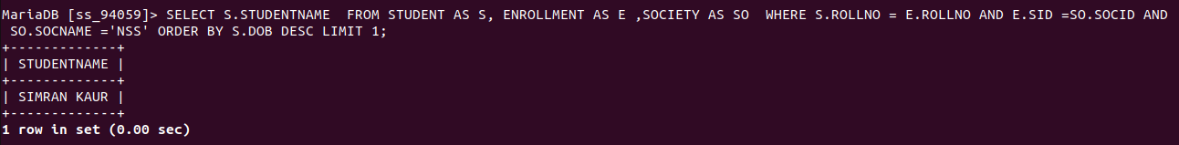
Q10.Find the name of most poopular society (on the basis of enrolled students.

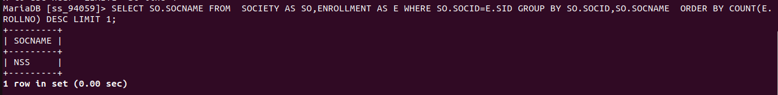
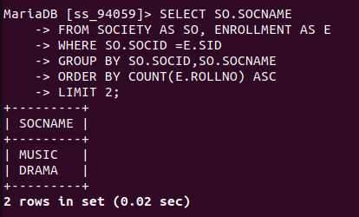

11. Find the name of two least popular societies (on the basis of enrolled students)

12. Find the student names who are not enrolled in any society
13. Find the student names enrolled in at least two societies.

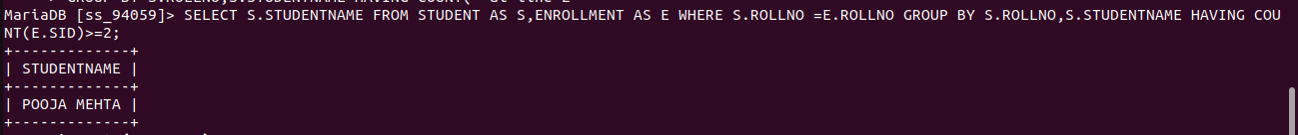
14. Find society names in which maximum students are enrolled.
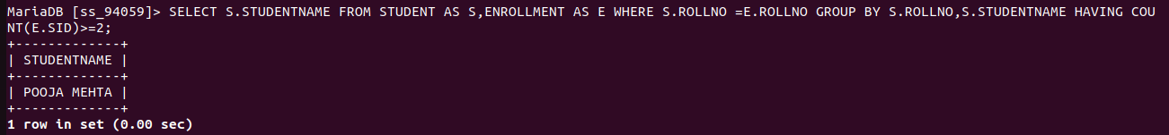
15. Find names of all students who have enrolled in any society and society names in which at
least one student has enrolled.
