16. Find names of students who are enrolled in any of the three societies ‘Debating’, ‘Dancing’
and ‘Sashakt’
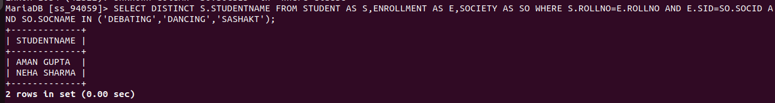
17. Find society names such that its mentor has a name with ‘Gupta’ in it.


18. Find the society names in which the number of enrolled students is only 10% of its
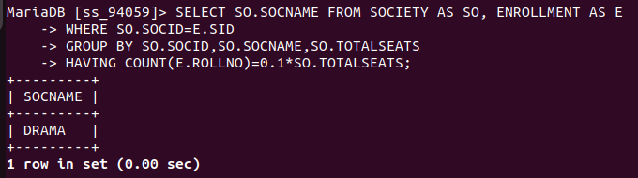
capacity.

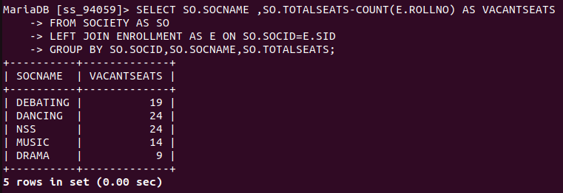
19. Display the vacant seats for each society.

20. Increment Total Seats of each society by 10%
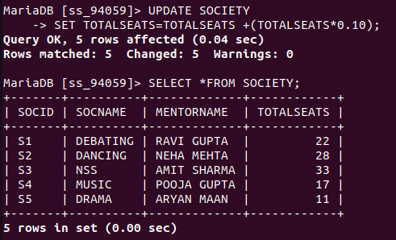
21. Add the enrollment fees paid (‘yes’/’No’) field in the ENROLLMENT TABLE

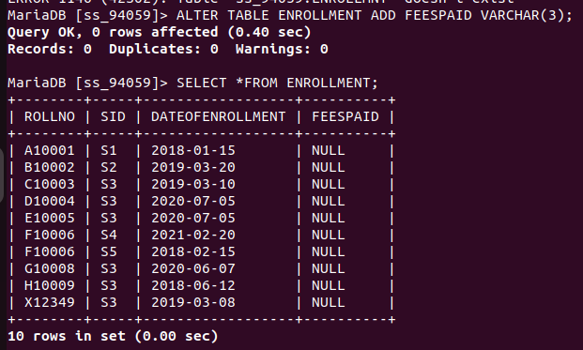

22. Update date of enrollment of society id ‘s1’ to ‘2018-01-15’, ‘s2’ to current date and ‘s3’ TO’2018--1-02’

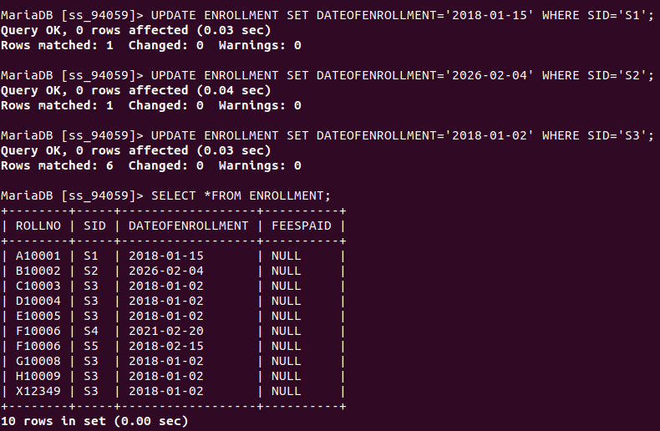

23.Create a view to keep track of society names with the total number of students enrolled in
it.

24. Find student names enrolled in all the societies
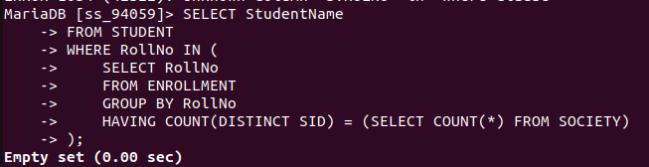

25.Count the number of societies with more than 5 students enrolled in it
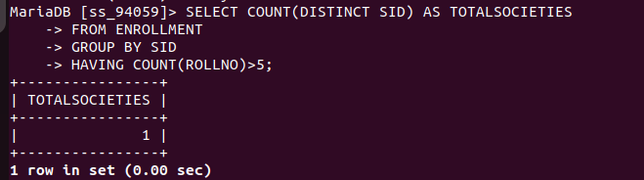

26.Add column Mobile number in student table with default value ‘9999999999’

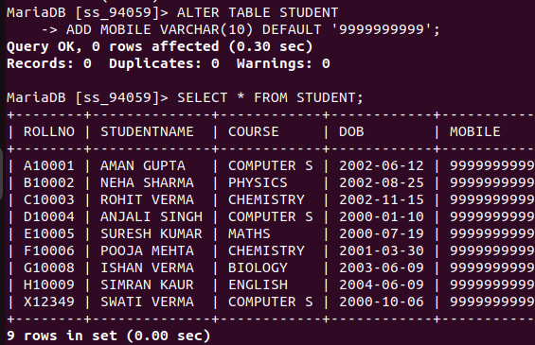
27.Find the total number of students whose age is > 20 years.

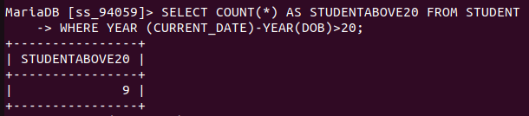

28.Find names of students who are born in 2001 and are enrolled in at least one society.
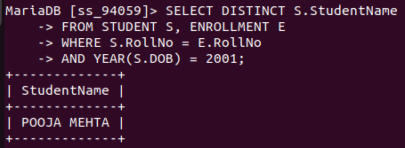

29.Count all societies whose name starts with ‘S’ and ends with ‘t’ and at least 5 students are
enrolled in the society.
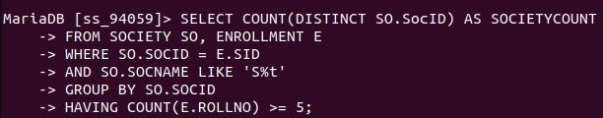
30.Display the following information:
Society name Mentor name Total Capacity Total Enrolled Unfilled Seats

