MViewer
Video, Audio, Remote
Conference System

Software Requirements Specification
Version 1.4
04/20/2013

Darie Mihai
Software Engineer
DSWT 1B

Revision History
Date | Version | Author | Comments
05/06/2012 | 1.0 | Darie Mihai | System Software Specifications 1st phase
04/15/2013 | 1.1 | Darie Mihai | References, Interface Requirements, Features description, Activity & Components diagrams
04/16/2013 | 1.2 | Darie Mihai | Data Flow Diagram
04/17/2013 | 1.3 | Darie Mihai | Sequence Diagram
04/20/2013 | 1.4 | Darie Mihai | UML Use Case Diagram, Executive Overview, Application Context, Product Perspective, Security, Performance, Inverse Requirements, Design Constraints

Document Approval
The following Software Requirements Specification has been accepted and approved by the following:
eSignature | Printed Name | Title | Date
mihai_darie2@yahoo.com | Darie Mihai | Software Engineer | 02/20/2012

Table of Contents

Revision History…………………………………………………………………………………..2
Document Approval………………………………………………………………………………2
1. Introduction
1.1 Purpose
1.2 Scope
1.3 Definitions, acronyms and abbreviations
1.4 References
1.5 Overview
2. General Description
2.1 Product Perspective
2.2 Product Functions
2.3 User Characteristics
2.4 General Constraints
2.5 Assumptions and Dependencies
2.6 Context
2.6.1 External Hardware
2.6.2 External Roles
2.6.3 External Software
3. Specific Requirements
3.1 External Interface Requirements
3.1.1 User Interface
3.1.2 Hardware Interfaces
3.1.3 Software Interfaces
3.1.4 Communications Interfaces
3.2 Functional Requirements
3.2.1 Functional Requirement or Feature #1
3.2.2 Functional Requirement or Feature #2
3.3 Use Cases
3.4 Classes / Objects
3.4.1 Class / Object #1
3.4.2 Class/ Object #2
3.4 Non-Functional Requirements
3.4.1 Performance
3.4.2 Reliability
3.4.3 Availability
3.4.4 Security
3.4.5 Maintainability
3.4.6 Portability
3.6 Inverse Requirements
3.7 Design Constraints
3.8 Logical Database Requirements
3.9 Other Requirements
4. Analysis Models
4.1 Sequence Diagrams
4.2 Data Flow Diagrams (DFD)
5. Change Management Process
A. Appendices
A.1 Appendix 1
A.2 Appendix 2

Table of Figures
TODO

1. Introduction

1.1 Purpose
The Software Requirements Specifications document is meant to assure the project management stakeholder(s) that the development team (in this case, me) really understood the business requirements properly. It provides a complete description of all features of the MViewer application.
The SRS is written in a way that it splits the software product into small components. The developer will understand what functionality needs to be developed and in what order.
Specified formalities in this document:
- Functional requirements
- Data requirements
- Quality requirements
- Constraints
The intended audience of the SRS is the Project Manager which will review the document and give his approval.

1.2 Business Scope/Goal
In the actual life a lot of people want/need to access a friend’s or work colleague’s computer in order to see his actions such as a presentations or to take control of his computer so that he can be the presenter and provide ad-hoc support or administer the OS. Considering this, we can say that the purposes of a remote control system are to gain control from distance of an activity, process or machine. Of course, a remote control system can be used for hacking/spying, but we don’t encourage this type of usage.
MViewer has to be a simple, fast and secure application for computer remote control and teamwork that can be used to provide ad-hoc support to friends, administer their computers and share your desktop for online presentations or collaboration.
Speaking of conferences and remote support, you cannot mention the utility of a video & audio conference when you trying to teach someone or provide him the support when he’s having trouble with some specific application.
Thus, the secondary feature of the MViewer has to be the video & audio conference which can help the teacher in providing remote support for the students. The MViewer audio & video conference feature must be easy to use and in the same time it must provide the basic functionality of such conference.

1.3 Glossary: Definitions, acronyms and abbreviations
SRS - Software Requirements Specifications
OS - Operating System
UI - User Interface
API - Application Programming Interface
DFD - Data Flow Diagram
DB - Database
TBC

1.4 References
Desktop remote
http://blog.bobcravens.com/2009/05/multiple-remote-desktop-viewer-c-wcf/

Voice conference
http://www.codeproject.com/Articles/19485/A-Voice-Conference-Application-in-C

Cryptography
http://www.codeproject.com/Articles/14151/Encrypt-and-Decrypt-Data-with-C

XML Data access
http://www.codeproject.com/KB/database/XMLData/XMLData_src.zip

Passing parameters to SVC c-tor
http://msdn.microsoft.com/en-us/library/aa702697(v=vs.100).aspx

WCF message level mutual security
http://msdn.microsoft.com/en-us/library/ms733102(v=vs.100).aspx

Validating x509 chain
http://msdn.microsoft.com/en-us/library/system.security.cryptography.x509certificates.x509chain.build.aspx

Custom certificate validation
http://msdn.microsoft.com/en-us/library/ms733806(v=vs.100).aspx

Image scaling
http://stackoverflow.com/questions/249587/high-quality-image-scaling-c-sharp

Windows API Code Pack
http://archive.msdn.microsoft.com/WindowsAPICodePack

Using video capture
http://msdn.microsoft.com/en-us/library/dd757677(v=vs.85).aspx

Webcam functionality using C#
http://www.c-sharpcorner.com/uploadfile/yougerthen/integrate-the-web-webcam-functionality-using-C-Sharp-net-and-com-part-viii/

Windows forms interaction
http://www.codeproject.com/Articles/2083/The-key-to-multi-threaded-Windows-Forms-UI-interac

Strategy pattern for switch-case refactoring
http://go4answers.webhost4life.com/Example/switch-dictionary-improving-way-code-113606.aspx

Binary formatter
http://msdn.microsoft.com/en-us/library/system.runtime.serialization.formatters.binary.binaryformatter(v=vs.100).aspx

Windows 7 firewall instructions
http://msdn.microsoft.com/en-us/library/ms751530.aspx

Using progress bar
http://msdn.microsoft.com/en-us/library/system.windows.forms.progressbar.aspx

Logger library
http://logging.apache.org/log4net/index.html

Generating class diagram from code
http://msdn.microsoft.com/en-us/library/vstudio/ff657806.aspx

Components diagram
http://msdn.microsoft.com/en-us/library/vstudio/dd409390.aspx

Class diagram add-in for VS2012
http://blog.ondrejsv.com/post/Modeling-Power-Toys-for-Visual-Studio-2012.aspx

Calculating remote mouse coordinate
http://stackoverflow.com/questions/11152608/how-to-calculate-mouse-coordinate-based-on-resolution-c-sharp

Input simulator C#
http://inputsimulator.codeplex.com/releases/view/37570
http://danv74.wordpress.com/2013/02/15/simulating-mouse-events-from-c/
http://www.codeproject.com/Articles/32556/Auto-Clicker-C
http://stackoverflow.com/questions/8561755/attempting-to-simulate-mouse-click-drag
http://alala666888.wordpress.com/2010/09/17/simulate-mouse-event-using-sendinput-and-setcursorpos/

Mouse and keyboard hooks in C#
http://www.codeproject.com/Articles/7294/Processing-Global-Mouse-and-Keyboard-Hooks-in-C
http://www.rqna.net/qna/kxyhvz-error-when-using-setwindowshookex-in-windows-xp-but-not-in-windows-7.html

Wrong password x509
http://understandavinash.blogspot.ro/2009/03/keysetnotfoundoracessdenied.html

Keyboard scan codes
http://www.gamespp.com/directx/directInputKeyboardScanCodes.html

Microphone process flow
http://www.c-sharpcorner.com/uploadfile/iersoy/how-to-use-microphone-in-xna/

Form localize at runtime
http://www.dotnetcurry.com/ShowArticle.aspx?ID=174

Use Case diagram tutorial
http://www.youtube.com/watch?v=OkC7HKtiZC0

AES encryption C#
http://www.overset.com/2008/04/17/simple-aes-rijndael-c-encrypt--decrypt-functions/

1.5 Overview
The MViewer system will be a desktop-based application that will bring together private individuals and help them to communicate remotely and exchange files up to 10 MB. It will take advantage of the Internet and World Wide Web to keep people connected and provide full stack of remote features such as video/audio/remote conferences.
The presenter objectives for the MViewer are to:
- hold remote presentations by sharing his desktop
- provide remote control to viewer and execute remote commands
- hold video/audio conferences by sending captures of his webcam and microphone
- watch and listen to the video/audio captures received from his companion
- provide requested files to conference partners through the file transfer feature
The viewer objectives for the MViewer are to:
- watch remote presentations and send remote commands if necessary
- watch and listen to video/audio captures
- send his video and eventually audio captures to the presenter
- provide requested files to the presenter through the file transfer feature

2. General Description
2.1 Product Perspective
This section aims to describe both the existing and the proposed systems, with respect to why the proposed system is needed.

2.1.1 Existing System
The existing systems for video/audio/remote conference (i.e. Skype, TeamViewer) aren’t providing full set of features in their applications.
Skype is servicing the video & audio conference feature but it doesn’t allow multiple video conferences, only in the Premium version of the application. Other than that, Skype doesn’t have the remote control feature yet implemented for the screen sharing module.
Meanwhile TeamViewer has both video/audio and remote conference features and it is free to use, no paid versions, but it doesn’t support contact list definition. Basically you can do a conference which can involve only 2 persons and cannot save contact details.
Other than the above drawbacks regarding their features, both Skype and TeamViewer can be started on the same machine only in single instance.
Skype is requiring account creation which isn’t a mandatory constraint for such systems. If you want to have two different contact lists you have to create separate accounts and so on.

2.1.2 Proposed System
The MViewer system will support contact list definition, will not require any account creation and will support service binding configuration to enable the start of multiple instances of the application.
And obviously, the MViewer will support all three types of conferences: video, audio and remote.
The MViewer will also provide file transfer feature for supporting the exchange of documents.

2.2 Product Functions
The main services provided by the system for the end users will be the desktop sharing and the remote controlling. Using these main features, the user must be able to see the other’s desktop and to have the possibility of taking control of his machine.
The secondary services that the system will offer for the end users will be the voice conference and the video conference.
The above features will be used only for non-commercial scopes, in teaching environments such as Faculty. The end-users might be the teachers and/or the students.

2.3 User Characteristics
The MViewer should/can be used by regular users such as private persons in a LAN network similar to the TuIasi network used by the students in the University Campus but it can be also used in other public networks, of course, only in demonstrative scopes or non-commercial support.
The end user must have minimal knowledge in configuring the MViewer according to the specifications of the User Guide so that the MViewer can be successfully used.

2.4 General Constraints
2.4.1 Hardware limitations
The machine(s) used by the developer(s) for designing the system must have a minimum of 2GB RAM and 2Ghz processor so the system can perform lots of send/receive operations which involve the transfer of serialized screen/video/audio captures in a very short time span.
Also, the machines must have a webcam and a microphone attached so the system’s video and voice conference features can be implemented and tested.
A good Internet connection is also required for the system to perform fast data transfers and remote command execution.

2.4.2 Interface to other applications
At a first instance, such as the Beta version, the MViewer doesn’t have/need to provide any interface for external applications as it’s not going to communicate with 3rd party systems.

2.4.3 Safety and security considerations
The system must respect at least one security policy studied at Distributed Systems Security and implement its specifications.
The traffic must run over SSL, mutual authentication using client and server certificates. There will be self-signed certificates that will help the developer in testing the secured data transfers.

2.4.4 High-level language requirements
The system must be implemented by using C# programming language, the development environment being Visual Studio 2010.
Windows Forms technology must be used in designing and implementing the User Interface.
WCF technology must provide the system back-end logic, based on SOAP/XML services.
The audio, video and remote modules will take advantage of the Windows API through the .NET Framework 4.0.

2.4.5 Criticality of the application
The most critical feature/module of the MViewer is the desktop sharing and remote control part which is mandatory for the system and it must be functional in any circumstances.

2.5 Assumptions and Dependencies
The single factor that can affect the requirements stated in the SRS is the allotted time for the development of the MViewer so the SRS document might change (by removing the video conference requirement).

2.6 Context
2.6.1 External Hardware
The MViewer interacts, either directly or indirectly, with the following significant external hardware:
User Hardware:
- Workstations, which are the personal computers used by the teachers and students to perform their tasks
Networks:
- Internet, which is the global network used for communication among Faculty employees, students and the MViewer
- Local Area Network, which is the TuIasi campus internal local area network used for communication among students and the MViwer

2.6.2 External Roles
The MViewer interacts, either directly or indirectly, with the following significant user roles:
- Presenters, who are any Faculty teachers who are performing presentations using the MViewer
- Viewers, who are any Faculty students who wish to learn by using the remote technologies serviced by the MViewer
2.6.3 External Software
The MViewer interacts, either directly or indirectly, with the following significant user software:
- OS, which is the software that is installed and it is running on the user personal computer that is hosting the MViewer and allows it to expose its services.

3. Specific Requirements
3.1 External Interface Requirements
3.1.1 User Interface
The UI must contain the following controls:
- picture box where the partner remote desktop will be displayed in a dedicated remote conference form (multiple such forms will be opened for multiple remote conferences);
- picture box where the partner video captures will be displayed in a dedicated video conference form (multiple such forms will be opened for multiple video conferences);
- all of the video, audio and remote conference form must display the partner friendly name;
- audio conference forms will display the call status (multiple such forms will be opened for multiple audio conferences) and they will be automatically opened by the MViewer when a specific conference action has been taken;
- labels where the local ID and friendly name will be displayed in the main application form;
- buttons that will start/stop or pause/resume the voice, video and remote conference; they will be included into a dedicated form known as Control Panel;
- list box where the contacts and their status will be displayed;
- application close button that will reside on the main application form;
- application configuration form that will be used in setting up the local IP address, video/audio/remote transfer frequency, accessible from the main application form;
- contact creation dedicated form, accessible from the main application form;
- file transfer progress form that will be automatically opened by the MViewer when the specific feature is in use;

3.1.2 Hardware or software interfaces
No external interface (API) should be provided by the system because it will communicate only with other MViewer instances through WCF client-server technology.
The internal software interface will be exposed through WCF SOAP/XML web service which will provide specific methods that will support video/audio/remote data transfers.
The below operation types must be supported by the WCF service API:
- video capture transfer
- audio capture transfer
- desktop capture transfer
- remote command transfer
- file transfer

3.2 Functional Requirements
3.2.1 Functional Requirement of Feature #1: Remote Conference
At first instance, a conference request is being sent by the initiator to his partner.
The receiver will either accept or deny the conference.
The remote conference initiator must be able share his desktop with the partner and in the same time the partner must be able to control the remote desktop via mouse & keyboard commands. The controlled desktop must be able to execute each of the received remote commands from the conference partner.
Either the initiator or the other part can stop or pause/resume the remote conference.
While stopped or paused, both parts will stop their actions: desktop images transfer & remote commands.

3.2.2 Functional Requirement of Feature #2: Video & Audio Conference
At first instance, a conference request is being sent by the initiator to his partner.
The receiver will either accept or deny the conference.
The video & audio conference initiator will start sending his webcam and microphone captures to the partner.
The partner’s MViewer application will automatically start it’s capturing modules (video & audio) once received any webcam and microphone captures from the other side.
Either of the conference parts can stop or pause/resume the video and/or audio conference.
While the conference is passing through a stopped or paused status, the audio & video flow must coordinate to the conference state and stop/pause. When resumed, the flow must restart.
3.2.3 Functional Requirement of Feature #3: File transfer
The MViewer end-users can share files of at most 10 MB length.
The file transfer feature isn’t depending on other features (audio/video/remote).
A file transfer can be initiated by any end-user by sending a file transfer (with transfer details such as file name and size) to the other guy. The receiver can either accept or deny the file transfer.
The file transfer feature must support file overriding and must warn the user of existing file before saving it.

3.3 Use Case Diagram
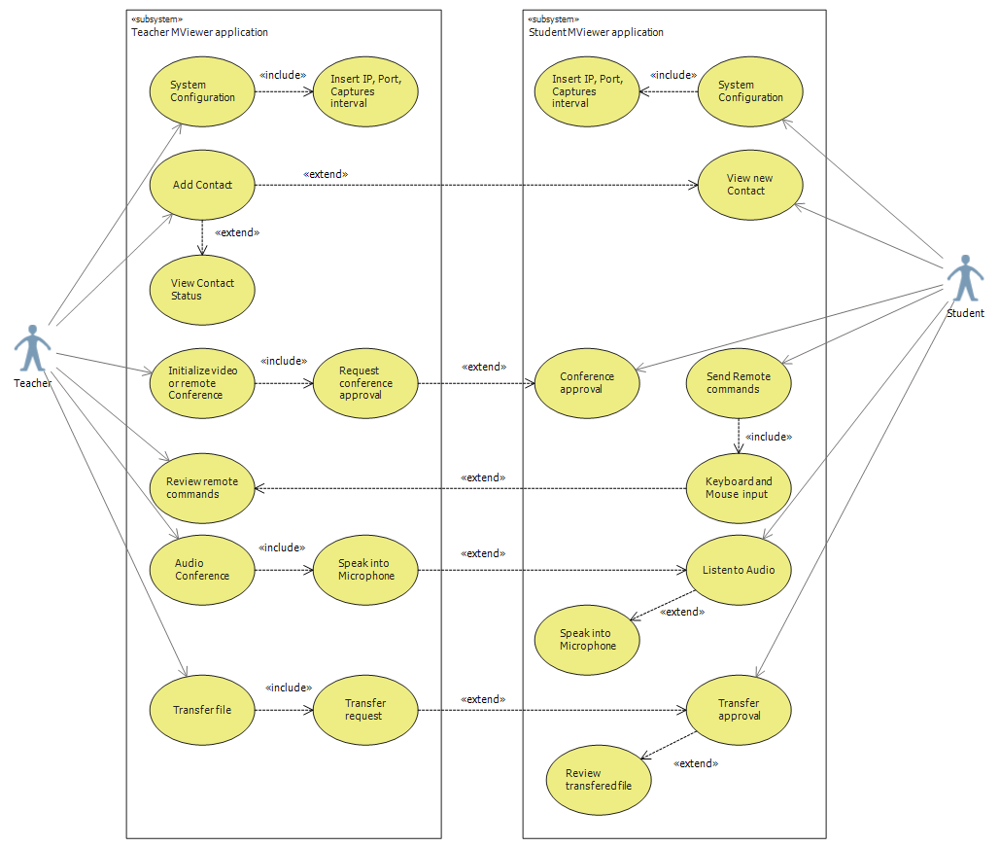
Description
The users are configuring their MViewer application by specifying their IP address, listening port and video/audio/remote captures intervals. Only after that they can add new persons to their contact list and initialize video/audio and remote conferences with their contacts. They can also send files to a contact.
Trigger
MViewer receives configuration details, contact details and conference initialization requests.
The users are entering configuration info, new contacts info and conference initialization commands by using the MViewer UI.
Actors
1. Teacher
2. Student(s)
Preconditions
1. System configuration
2. Contact list creation
3. Video/Audio/Remote secured conference
4. Secured File transfer initialization
Goals (Successful Conclusion)
1. System initialization and start-up
2. Secured video/audio/remote conference
3. Secured file transfers
Failed Conclusion
1. Invalid system configuration (invalid IP, busy port, high capture intervals)
2. Blocked conference connections (firewall or network issues)
3. Database file deletion
4. Application overwhelm
5. Destructive remote commands
Extensions (Alternatives)
1. Perform System restart if encountering video/audio/conference issues
2. Resend file if initial transfer has failed

3.4 Non-Functional Requirements
3.4.1 Performance
The MViewer must be able to provide video/audio/remote captures in a timely fashion in respect to the captures interval configured by the end user.
The file transfer will be as fast as the end user’s Internet connection is.
There must not be any noticeable de-synchronization between the video captures and the audio captures. Also, there must not be any noticeable de-synchronization between the screen captures, remote commands and the updates done to the remote screen.
The contact list must be refreshed in a timely fashion when necessary.

3.4.2 Reliability
TODO

3.4.3 Availability
TODO

3.4.4 Security
As already specified, the communication between two instances of the MViewer will be secured via SSL Certificates for both the server and the client.
Microsoft tools will be used for generating a server self-signed certificate without a password. Based on the server certificate, the client certificate will be generated using specific tools.
The server certificate will be bound to the server module and will be validated at the client’s end by implementing a custom server certificate validator.
Things to validate for a server certificate:
- first of all, the existence; if no server certificate was provided the connection must be rejected
- X509 Chain validation
- certificate issuer name against the allowed issuer name
- expiration date
The client certificate will be bound to the proxy client and will be validated at the server’s end by implementing a custom client certificate validator.
Things to validate for a client certificate:
- first of all, the existence; if no client certificate was provided the connection must be rejected
- provided certificate instance against the local client certificate instance
- X509 Chain validation
- certificate issuer name against the allowed issuer name
- expiration date

3.4.5 Maintainability
No maintenance should be done because the system will never be put on production. It will have a beta version that can be tested by teachers and students.

3.4.6 Portability
The targeted operating systems are Windows XP and Windows 7 both 32/64 bit versions.

3.6 Inverse Requirements
The system should prevent audio streaming from being stopped while the video streaming is on (the end user must use the pause feature for the audio).
The system must support file transfer of at most 10 MB as this feature isn’t the main goal of the application.
The system must prevent the User Identity editing. It will be auto-generated property.

3.7 Design Constraints
The video/audio/remote streaming will be done only for the active video/audio/remote room which will be the form that is activated at a specific point in time.
Other conferences may not receive video/audio/remote captures or commands until they become the active conference room at the partner’s MViewer instance.
The MViewer must have a modern design in which the main form will include the contacts list beside the end-user friendly name and identity that can be shared to the other partners before starting video/audio/remote conferences.
The video/audio/remote conferences must be showed up in separate forms and can be controller from a separate form known as control panel which will stay on front of all other application forms.
The form resizing will be allowed only for the remote and video conferences. Audio conference doesn’t need to have a resizable form.
The system configuration form must be accessible from the main application form and must stay over it as long as it is opened. The same behavior must be applied to the contact addition form.
The file exchange feature must provide the user with the file transfer progress in a separate form containing a progress bar.
After deleting a contact from his list, the system in cause must send a removal request to the removed partner when he comes online (in case he was offline when the removal took place).

3.8 Logical Database Requirements
The system will keep a database that will store the end-user contacts.
Each contact details will include:
- contact number (primary key - local contact identifier): type of integer
- contact identity (network identifier - generated by the MViewer based on IP:Port pair): type of string
- friendly name (provided by the end-user when adding a new contact): type of string

3.9 Other Requirements
TODO

4. Analysis Models
4.1 Sequence Diagrams
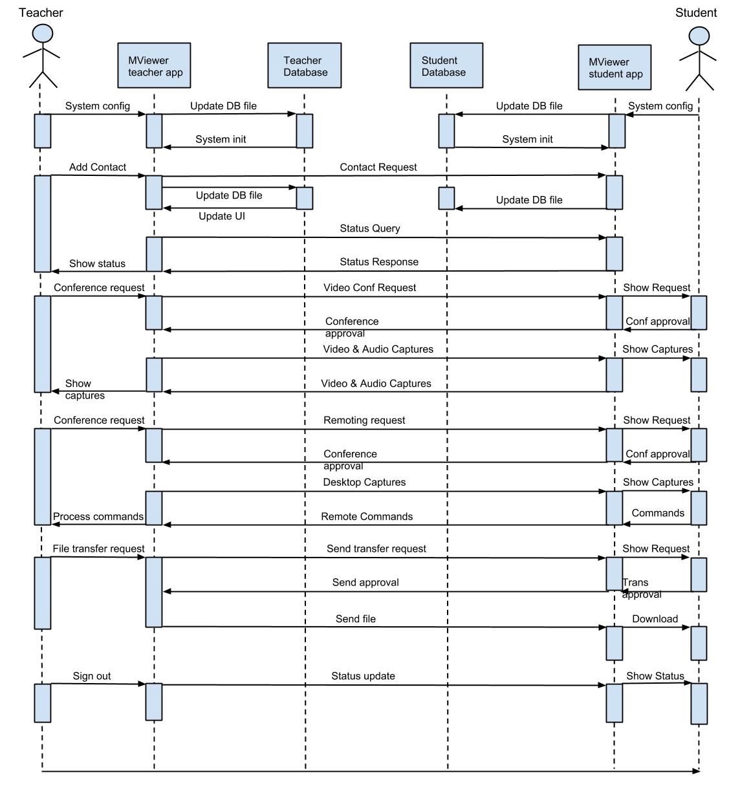

4.2 Data Flow Diagrams (DFD)
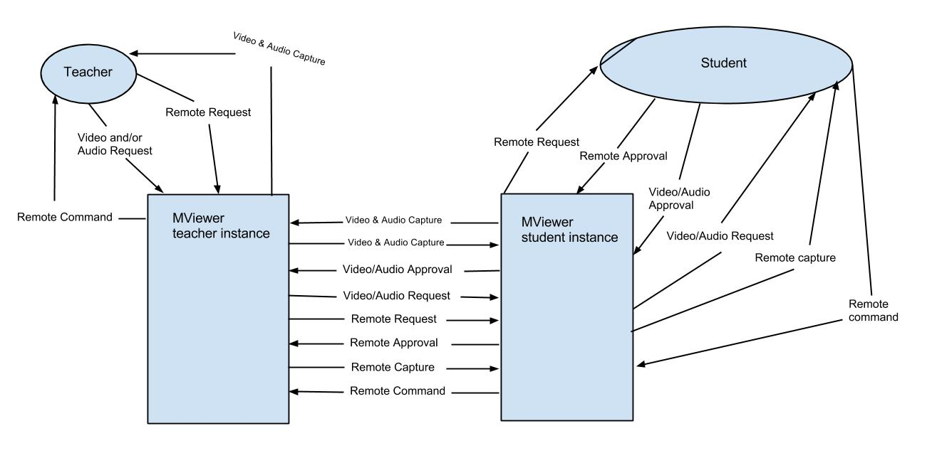

4.3 Activity Diagram
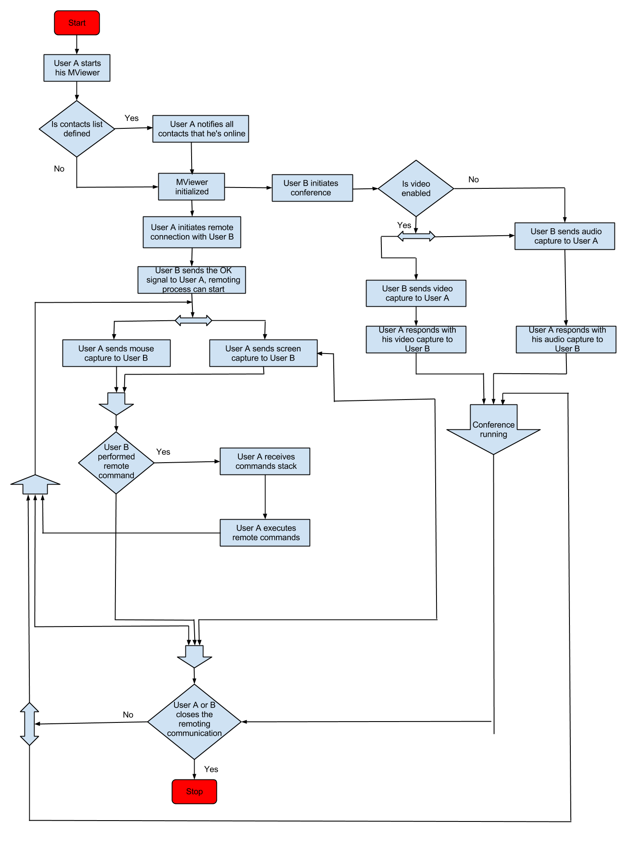
4.4 Components Diagram
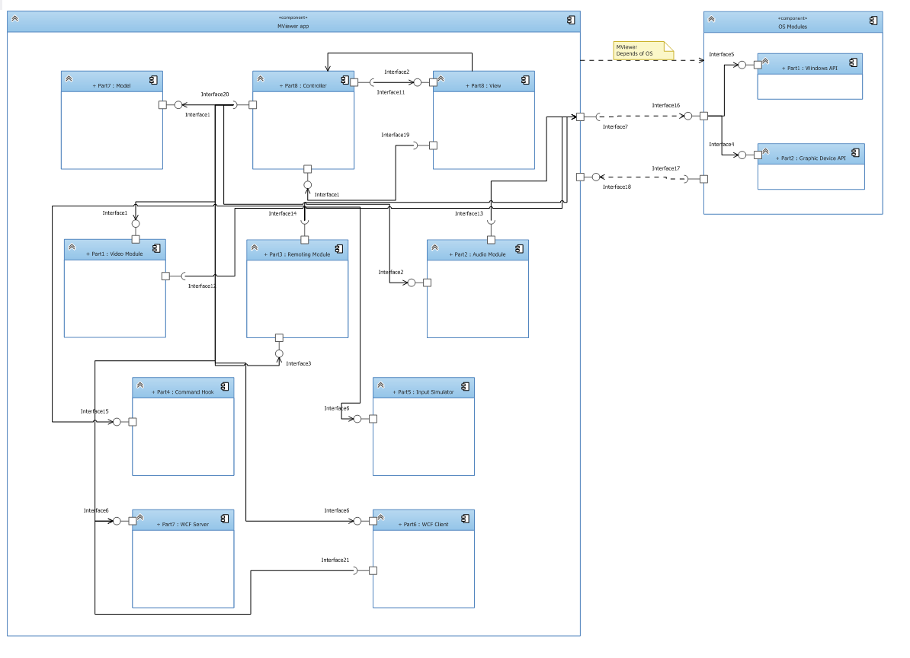
5. Change Management Process

A. Appendices
A.1 Appendix 1

A.2 Appendix 2

