VISION++

***Software Design Specification***

**Real-time Surveillance Detection and Monitoring System**

Vision Plus Plus

|  |  |
| --- | --- |
| **Author** | Vision Plus Plus |
| **Lasted Update Developer** |  |
| **Customer** | N/A |
| **Phase** | 1 |
| **Version** | 1.0 |
| **Status** | Draft |
| **Date of Creation** | 2021-10-18 |
| **Last Updated** | 2021-10-18 |

**Document Type**

|  |  |
| --- | --- |
| **Project Name :** | Real-time Surveillance Detection and Monitoring System |
| **Document Name :** | Software Design Specification |
| **Screen Name:** | Video Camera Dashboard |
| **Ref No :** |  |

**Revision History**

|  |  |  |
| --- | --- | --- |
| **Date** | **Version** | **Description** |
| 2021-10-18 | 1.0 | Create Document |
|  |  |  |
|  |  |  |
|  |  |  |
|  |  |  |
|  |  |  |

1. **Description**

|  |  |  |  |  |  |
| --- | --- | --- | --- | --- | --- |
| **Program ID :** | DASH001 | **Name :** | Video Camera Dashboard | **System ID. :** | RSDMS |
| **Description :** | To display, add, update and delete the video camera stream | | | | |
| **Association (Actor) :** | System Admin, General User | | | | |
| **Database Tables** | * Group * Camera Stream * Server * Feature * Camera * CameraFeature * CameraFeatureBoundary * ObjectCounting | | | | |

1. **Functional Design**

## Database Schema

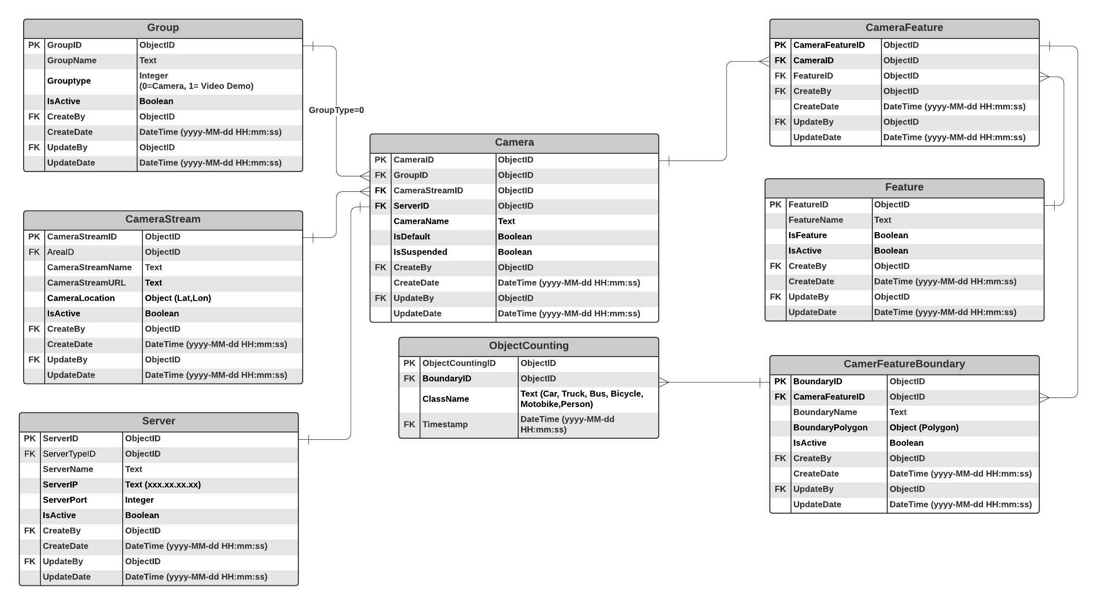

## Functional Detail

### Display Function: when user clicks on the menu “Camera Dashboard”, the system will display a search function screen.

**User Interface**

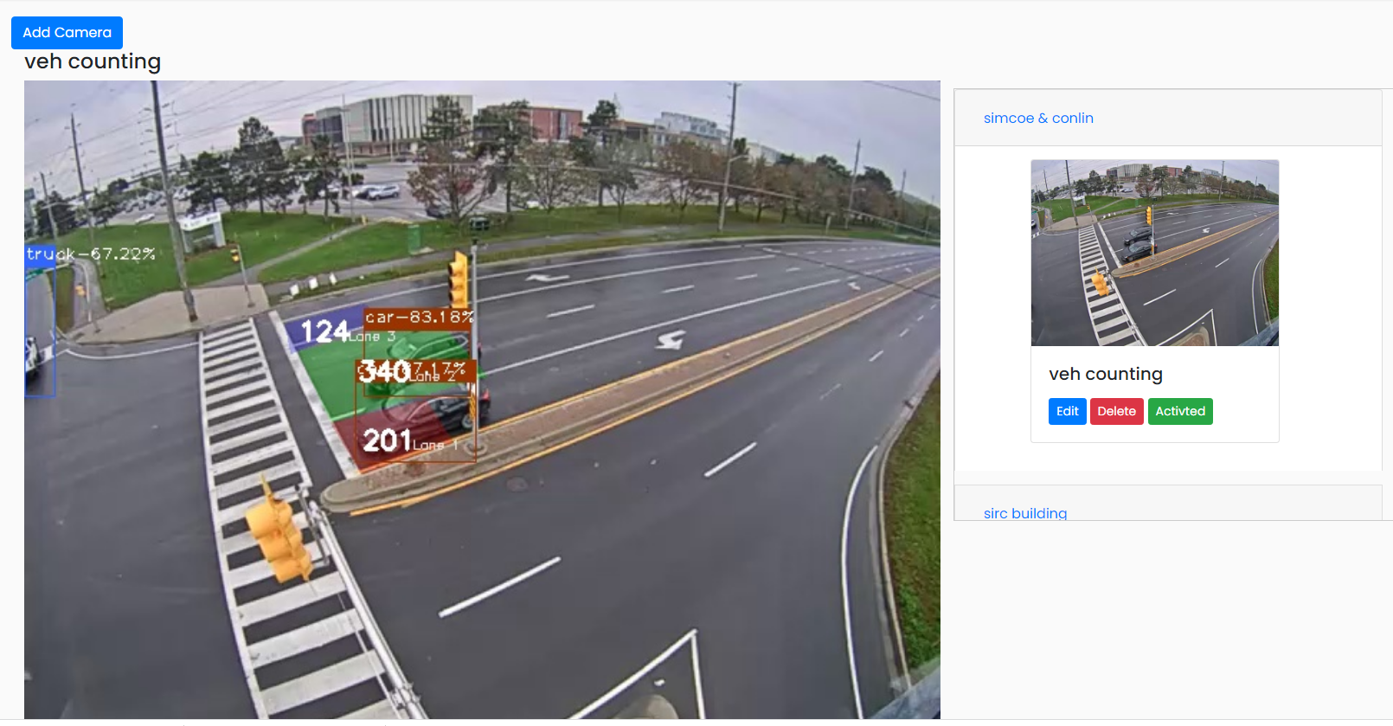

**Data Control**

|  |
| --- |
|  |

| **No.** | **Data Item** | **Data Type** | **Control Type** | **Mandatory** | **Value Range** | **Note** |
| --- | --- | --- | --- | --- | --- | --- |
| **Section:** Video Camera Dashboard [Display] | | | | | | |
|  | Main Display | Image | Image | - |  | Constrain   * + Select the data from table [Camera] where [Camera.IsDefault =0] to display on the main frame |
|  | Group Panel | Image | Panel | - |  | Constrain   * + Display all groups from table [Group] where [Group.IsActive=0] |
|  | Sub Display | Image | Image | - |  | Constrain   * + Select the image from table [Camera] where [Camera.GroupID=Group.GroupID] to display the camera that belong to each group   Click Event   * + Update [Camera.IsDefault =0] where [Camera.CameraID] = user clicks   + Update [Camera.IsDefault =1] where [Camera.CameraID] != user clicks |
|  | Edit | Button | Button |  |  | Click Event   * + Open the updating dialog |
|  | Delete | Button | Button |  |  | Click Event   * + Open the confirmation deleting dialog |
|  | Suspend | Button | Button |  |  | Constrain   * + [Camera.IsSuspended =0]   - Set enable image = False  - Stop the video steam  - Display bottom text = “Active”  - Set button color = gray   * + [Camera.IsSuspended =1]   - Set enable image = True  - Resume the video steam  - Display bottom text = “Suspend”  - Set button color = green  Click Event   * + Open the suspension dialog |

### Add Function: When users click from the searching screen, the system will popup the adding screen below.

**User Interface**

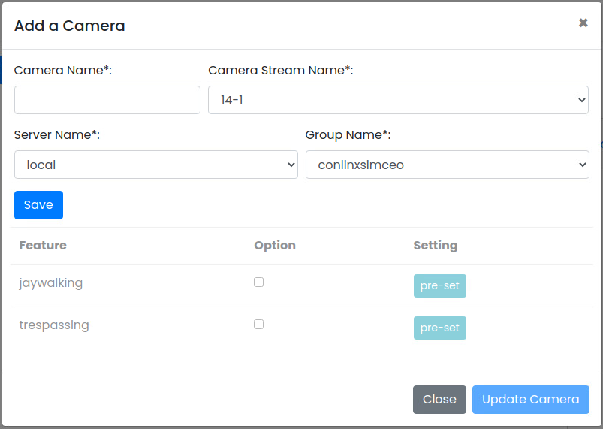

**Data control**

| **No.** | **Data Item** | **Data Type** | **Control Type** | **Mandatory** | **Value Range** | **Note** |
| --- | --- | --- | --- | --- | --- | --- |
| **Section:** Video Camera Dashboard [Add] | | | | | | |
|  | Camera Name | Text | Input | Yes | 100 | - |
|  | Camera Stream Name | Text | Drop-down Box | Yes | - | Constrain   * + Select the data from table [CameraStream] where [CameraStream. IsActivate =0]   + Display Text [CameraStream.CameraStreamName]   + Value [CameraStream.CameraStreamID] |
|  | Server Name | Text | Drop-down Box | Yes | - | Constrain   * + Select the data from table [Server] where [Server. IsActivate =0] and [Server.IsUsed=1]   + Display Text [Server.ServerName]   + Value [Server.ServerID] |
|  | Group Name | Text | Drop-down Box | Yes | - | Constrain   * + Select the data from table [Group] where [Group. IsActivate =0]   + Display Text [Group.GroupName]   + Value [Group. GroupID] |
|  | Save | Button | Button |  |  | Constrain   * + Check null value for the mandatory fields   + Check duplicate data [Camera.CameraName]   + Connect to the server where [Server.ServerID]   - if status = “Fail” then display the message “Cannot Connect to the Server xx.xxx.xx.xx port xxxx”  Add Process:   * + Add the data to table [Camera]   + [Camera.IsDefault] = 1   + [Camera.IsSuspended] = 1   + [Camera.CreateBy] = ObjectID of user   + [Camera.CreateDate] = Current DateTime (yyyy-MM-dd HH:mm:ss)   Post-process:   * + Enable Feature Panel |
| **Section:** Video Camera Dashboard [Add-Feature] | | | | | | |
|  | Feature Name | Text |  |  |  | Constrain   * + Select the data from table [Feature] where [Feature.IsFeature =1] and [Feature.IsActivate =0] |
|  | Option | Boolean | Checkbox |  |  | - |
|  | Setting | Button | Button |  |  | Click Event   * + Open the pre-set Screen |
|  | Update Camera | Button | Button |  |  | Constrain  -  Update Process:   * + Add the data to table [CameraFeature]   + [CameraFeature.CameraID] = [Camera.CameraID]   + [Feature.FeatureID] = Feature_Selected   + [CameraFeature.CreateBy] = ObjectID of user   + [CameraFeature.CreateDate] = Current DateTime (yyyy-MM-dd HH:mm:ss) |

### Vehicle Counting Pre-set Function: When user clicks at the search result screen, the system will popup the editing screen below.

**User Interface**

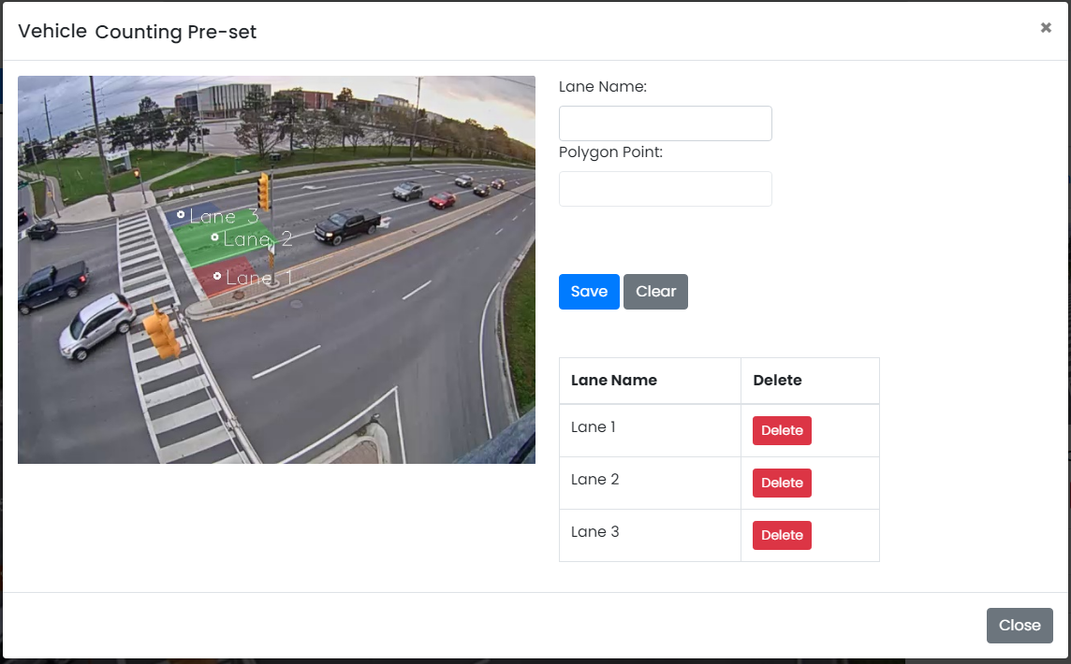

**Data control**

| **No.** | **Data Item** | **Data Type** | **Control Type** | **Mandatory** | **Value Range** | **Note** |
| --- | --- | --- | --- | --- | --- | --- |
| **Section:** Pre-set Maintenance [Add-Vehicle Counting] | | | | | | |
|  | Lane Name | Text | Input | Yes | 100 |  |
|  | Polygon Point | Text | Input | Yes | 100 | Enable=False |
|  | Save | Button | Button |  |  | Click Event   * + Close the Adding Screen |
|  | Clear | Button | Button |  |  | Click Event   * + Clear Lane Name   + Clear Polygon Points |
| **Section:** Contact Maintenance [Add – Result] | | | | | | |
|  | Lane Name | Text |  |  |  | Constrain   * + Select the data from table [ContactFeature] where [ContactFeature.ContactID] = [Contact.ContactID] |
|  | Lane Type | Text |  |  |  | Constrain   * + Select the checkbox if [ContactFeature.SendEmail] = True |
|  | Delete | Button | Button |  |  |  |

### Pedestrian Counting Pre-set Function: When user clicks at the search result screen, the system will popup the editing screen below.

**User Interface**

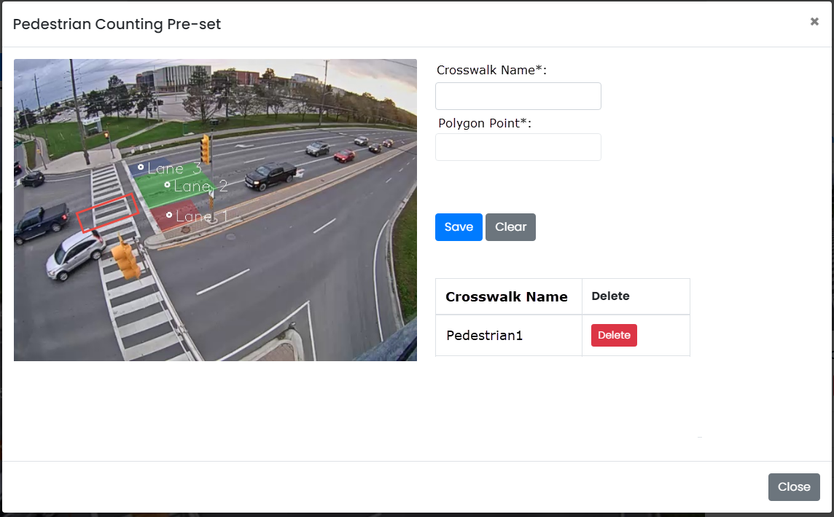

**Data control**

| **No.** | **Data Item** | **Data Type** | **Control Type** | **Mandatory** | **Value Range** | **Note** |
| --- | --- | --- | --- | --- | --- | --- |
| **Section:** Pre-set Maintenance [Add- Pedestrian Counting] | | | | | | |
|  | Crosswalk Name | Text | Input | Yes | 100 |  |
|  | Polygon Point | Text | Input | Yes | 100 | Enable=False |
|  | Save | Button | Button |  |  | Click Event   * + Close the Adding Screen |
|  | Clear | Button | Button |  |  | Click Event   * + Clear Crosswalk Name   + Clear Polygon Point |
| **Section:** Contact Maintenance [Add – Result] | | | | | | |
|  | Crosswalk Name | Text |  |  |  | Constrain   * + Select the data from table [CameraFeatureBoundary] where [CameraFeatureBoundary.CameraFeatureID] = [CameraFeature. CameraFeatureID] |
|  | Delete | Button | Button |  |  |  |

### Jaywalking Pre-set Function: When user clicks at the search result screen, the system will popup the editing screen below.

**User Interface**

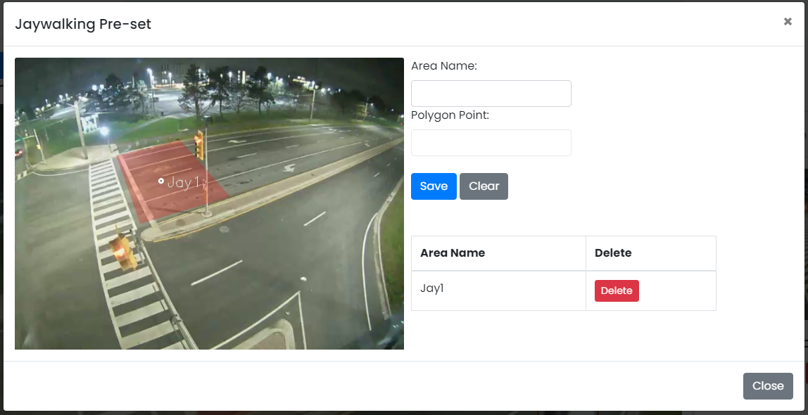

**Data control**

| **No.** | **Data Item** | **Data Type** | **Control Type** | **Mandatory** | **Value Range** | **Note** |
| --- | --- | --- | --- | --- | --- | --- |
| **Section:** Pre-set Maintenance [Add-Jaywalking Counting] | | | | | | |
|  | Area Name | Text | Input | Yes | 100 |  |
|  | Polygon Point | Text | Input | Yes | 100 | Enable=False |
|  | Save | Button | Button |  |  | Click Event   * + Close the Adding Screen |
|  | Clear | Button | Button |  |  | Click Event   * + Clear Area Name   + Clear Polygon Points |
| **Section:** Contact Maintenance [Add – Result] | | | | | | |
|  | Lane Name | Text |  |  |  | Constrain   * + Select the data from table [CameraFeatureBoundary] where [CameraFeatureBoundary.CameraFeatureID] = [CameraFeature.CameraFeatureID] |
|  | Delete | Button | Button |  |  |  |

### Trespassing Pre-set Function: When user clicks at the search result screen, the system will popup the editing screen below.

**User Interface**

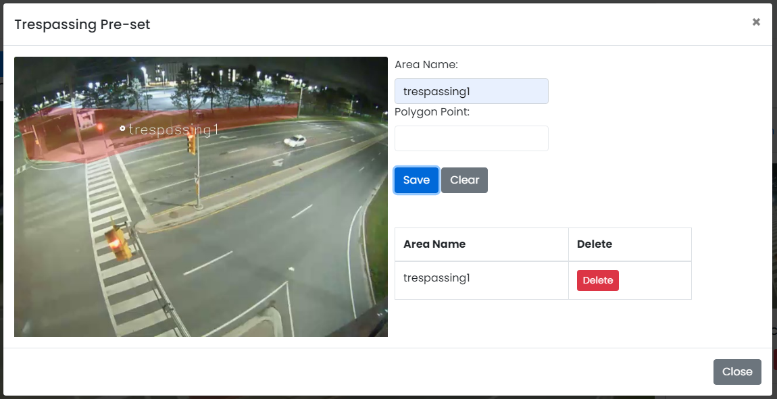

**Data control**

| **No.** | **Data Item** | **Data Type** | **Control Type** | **Mandatory** | **Value Range** | **Note** |
| --- | --- | --- | --- | --- | --- | --- |
| **Section:** Pre-set Maintenance [Add-Trespassing Counting] | | | | | | |
|  | Area Name | Text | Input | Yes | 100 |  |
|  | Polygon Point | Text | Input | Yes | 100 | Enable=False |
|  | Save | Button | Button |  |  | Click Event   * + Close the Adding Screen |
|  | Clear | Button | Button |  |  | Click Event   * + Clear Area Name   + Clear Polygon Points |
| **Section:** Contact Maintenance [Add – Result] | | | | | | |
|  | Lane Name | Text |  |  |  | Constrain   * + Select the data from table [CameraFeatureBoundary] where [CameraFeatureBoundary.CameraFeatureID] = [CameraFeature. CameraFeatureID] |
|  | Delete | Button | Button |  |  |  |

### Edit Function: When user clicks at the search result screen, the system will popup the a confirmation dialog box below.

**User Interface**

## 

**Data control**

| **No.** | **Data Item** | **Data Type** | **Control Type** | **Mandatory** | **Value Range** | **Note** |
| --- | --- | --- | --- | --- | --- | --- |
| **Section:** Camera Stream Maintenance [Delete] | | | | | | |
|  | Close | Button | Button |  |  | Click Event   * Close the screen |
|  | Delete Feature | Button | Button |  |  | Constrain   * Check data in table [Camera] [Camera.CameraStreamID] = [CameraStream.CameraStreamID] * Found: display message on the confirmation dialog box and not delete data * Not found: delete process   Delete Process:   * + Delete the from table [Camera] where [Camera.CameraStreamID] = [Feature. CameraStreamID]   + Delete the from table [VideoDemoFeature] where [VideoDemoFeature.FeatureID] = [Feature.FeatureID]   + Delete the from table [ContactFeature] where [ContactFeature.FeatureID] = [Feature.FeatureID]   + Delete data from table [Feature] where [Feature.FeatureID]   Post-process:   * Close the popup and refresh the screen |