VISION++

***Software Design Specification***

**Real-time Surveillance Detection and Monitoring System**

Vision Plus Plus

|  |  |
| --- | --- |
| **Author** | Vision Plus Plus |
| **Customer** | N/A |
| **Phase** | 1 |
| **Version** | 1.0 |
| **Status** | Draft |
| **Date of Creation** | 2021-10-18 |
| **Last Updated** | 2021-10-18 |

**Document Type**

|  |  |
| --- | --- |
| **Project Name :** | Real-time Surveillance Detection and Monitoring System |
| **Document Name :** | Software Design Specification |
| **Screen Name:** | Video Demo Dashboard |
| **Ref No :** |  |

**Revision History**

|  |  |  |
| --- | --- | --- |
| **Date** | **Version** | **Description** |
| 2021-10-18 | 1.0 | Create Document |
|  |  |  |
|  |  |  |
|  |  |  |
|  |  |  |
|  |  |  |

1. **Description**

|  |  |  |  |  |  |
| --- | --- | --- | --- | --- | --- |
| **Program ID :** | DASH002 | **Name :** | Video Demo Dashboard | **System ID. :** | RSDMS |
| **Description :** | To add, update, delete and display a demo video dashboard and features | | | | |
| **Association (Actor) :** | System Admin, General User | | | | |
| **Database Tables** | * Group * VideoDemoFile * Feature * VideoDemoFeature * VideoDemoFeatureBoundary * VideoDemo | | | | |

1. **Functional Design**

## Database Schema

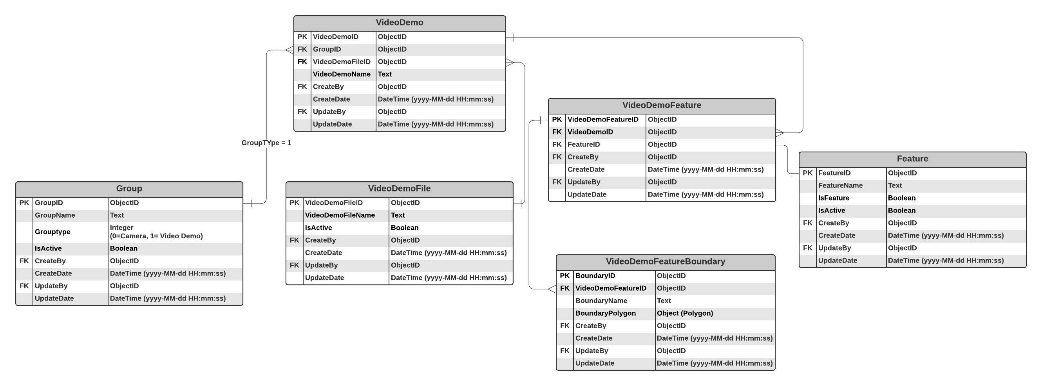

## Functional Detail

### Display Function: when user clicks on the menu “Demo Video Dashboard”, the system will display a search function screen.

**User Interface**

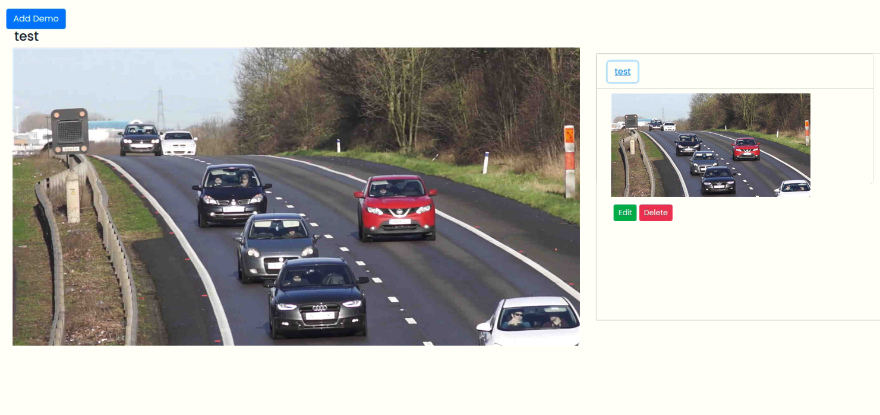

**Data Control**

|  |
| --- |
|  |

| **No.** | **Data Item** | **Data Type** | **Control Type** | **Mandatory** | **Value Range** | **Note** |
| --- | --- | --- | --- | --- | --- | --- |
| **Section:** Video Demo Dashboard [Display] | | | | | | |
|  | Main Display | Image | Image | - |  | Constrain   * + Select the data from table [VideoDemo] where [VideoDemo.IsDefault =0] to display on the main frame |
|  | Group Panel | Image | Panel | - |  | Constrain   * + Display all groups from table [VideoDemo] where [VideoDemo.IsActive=0] |
|  | Sub Display | Image | Image | - |  | Constrain   * + Select the image from table [VideoDemo] where [VideoCamera.GroupID=Group.GroupID] to display the camera that belongs to each group   Click Event   * + Update [VideoCamera.IsDefault =0] where [VideoCamera.CameraID] = user clicks   + Update [VideoCamera.IsDefault =1] where [VideoCamera.CameraID] != user clicks |
|  | Edit | Button | Button |  |  | Click Event   * + Open the updating dialog |
|  | Delete | Button | Button |  |  | Click Event   * + Open the confirmation deleting dialog |

### Add Function: When users click from the searching screen, the system will popup the adding screen below.

**User Interface**

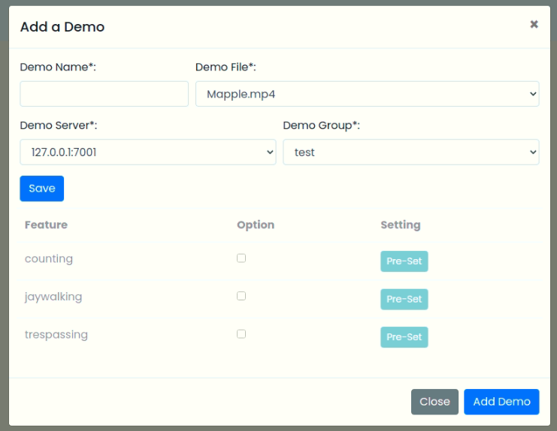

**Data control**

| **No.** | **Data Item** | **Data Type** | **Control Type** | **Mandatory** | **Value Range** | **Note** |
| --- | --- | --- | --- | --- | --- | --- |
| **Section:** Video Demo Dashboard [Add] | | | | | | |
|  | Demo Name | Text | Input | Yes | 100 | - |
|  | Demo File | Text | Drop-down Box | Yes | - | Constrain   * + Select the data from table [VideoDemoFile] where [VideoDemoFile.IsActivate =0]   + Display Text [VideoDemoFile. VideoDemoFileName]   + Value [VideoDemoFile. VideoDemoFileID] |
|  | Server Name | Text | Drop-down Box | Yes | - | Constrain   * + Select the data from table [Server] where [Server.IsActivate =0] and [Server. IsUsed=1] and Server. ServerTyp=’Video Demo’]   + Display Text [Server.ServerName]   + Value [Server.ServerID] |
|  | Group Name | Text | Drop-down Box | Yes | - | Constrain   * + Select the data from table [Group] where [Group. IsActivate =0]   + Display Text [Group.GroupName]   + Value [Group. GroupID] |
|  | Save | Button | Button |  |  | Constrain   * + Check null value for the mandatory fields   + Check duplicate data [VideoDemo. VideoDemoName]   + Connect to the server where [Server.ServerID]   - if staus = “Fail” then display the message “Cannot Connect to the Server xx.xxx.xx.xx port xxxx”  Add Process:   * + Add the data to table [Camera]   + [VideoDemo.IsDefault] = 1   + [VideoDemo.CreateBy] = ObjectID of user   + [VideoDemo.CreateDate] = Current DateTime (yyyy-MM-dd HH:mm:ss)   Post-process:   * + Enable Feature Panel |
| **Section:** Video Demo Dashboard [Add-Feature] | | | | | | |
|  | Feature Name | Text |  |  |  | Constrain   * + Select the data from table [Feature] where [Feature.IsFeature =1] and [Feature.IsActivate =0] |
|  | Option | Boolean | Checkbox |  |  | - |
|  | Setting | Button | Button |  |  | Click Event   * + Open the pre-set Screen |
|  | Update Camera | Button | Button |  |  | Constrain  -  Update Process:   * + Add the data to table [VideoDemoFeature]   + [VideoDemoFeature.VideoDemoID] = [VideoDemo.VideoDemoID]   + [Feature.FeatureID] = Feature_Selected   + [VideoDemoFeature.CreateBy] = ObjectID of user   + [VideoDemoFeature.CreateDate] = Current DateTime (yyyy-MM-dd HH:mm:ss) |

### Vehicle Counting Pre-set Function: When a user clicks at the search result screen, the system will popup the editing screen below.

**User Interface**

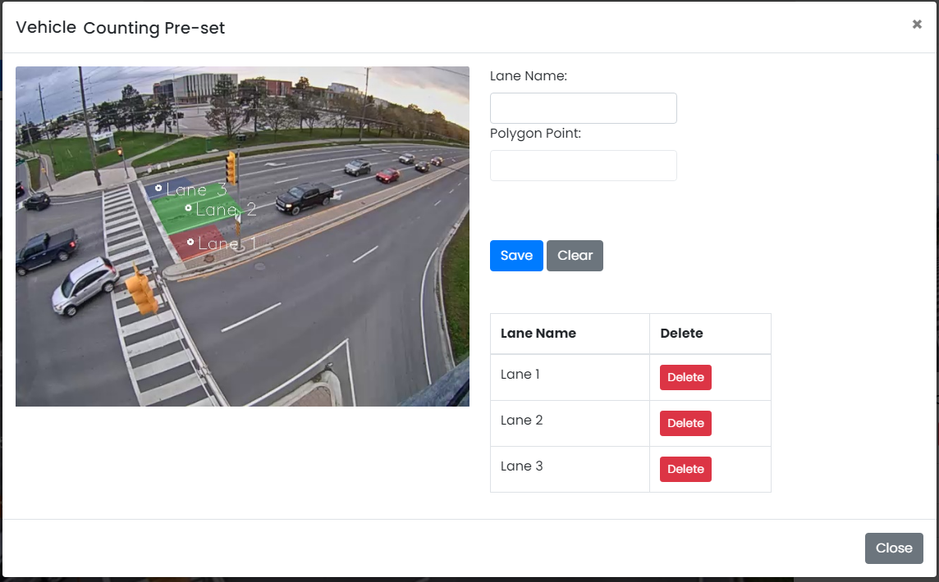

**Data control**

| **No.** | **Data Item** | **Data Type** | **Control Type** | **Mandatory** | **Value Range** | **Note** |
| --- | --- | --- | --- | --- | --- | --- |
| **Section:** Pre-set Maintenance [Add-Vehicle and Pedestrian Counting] | | | | | | |
|  | Lane Name | Text | Input | Yes | 100 |  |
|  | Polygon Point | Text | Input | Yes | 100 | Enable=False |
|  | Save | Button | Button |  |  | Click Event   * + Close the Adding Screen |
|  | Clear | Button | Button |  |  | Click Event   * + Clear Lane Name   + Clear Polygon Points |
| **Section:** Pre-set [Add – Result] | | | | | | |
|  | Lane Name | Text |  |  |  | Constrain   * + Select the data from table [VideoDemoFeatureBoundary] where [VideoDemoFeatureBoundary.FeatureID] = [Feature.FeatureID] |
|  | Delete | Button | Button |  |  |  |
|  | Delete | Button | Button |  |  | Click Event   * + Close the screen |

### Pedestrian Counting Pre-set Function: When a user clicks at the search result screen, the system will popup the editing screen below.

**User Interface**

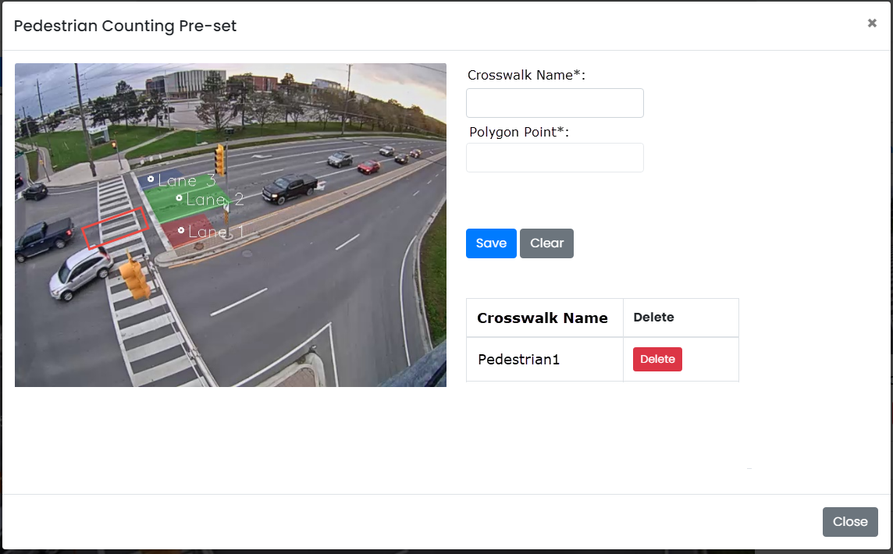

**Data control**

| **No.** | **Data Item** | **Data Type** | **Control Type** | **Mandatory** | **Value Range** | **Note** |
| --- | --- | --- | --- | --- | --- | --- |
| **Section:** Pre-set Maintenance [Add-Vehicle and Pedestrian Counting] | | | | | | |
|  | Crosswalk Name | Text | Input | Yes | 100 |  |
|  | Polygon Point | Text | Input | Yes | 100 | Enable=False |
|  | Save | Button | Button |  |  | Click Event   * + Close the Adding Screen |
|  | Clear | Button | Button |  |  | Click Event   * + Clear Crosswalk Name   + Clear Polygon Point |
| **Section:** Pre-set Maintenance [Add – Result] | | | | | | |
|  | Crosswalk Name | Text |  |  |  | Constrain   * + Select the data from table [VideoDemoFeatureBoundary] where [VideoFeatureBoundary.VideoDemoFeatureID] = [VideoDemoFeature. VideoDemoFeatureID] |
|  | Delete | Button | Button |  |  |  |

### Jaywalking Pre-set Function: When a user clicks at the search result screen, the system will popup the editing screen below.

**User Interface**

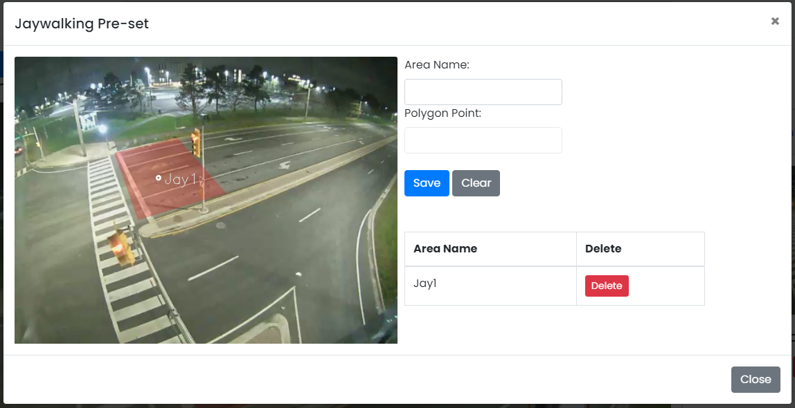

**Data control**

| **No.** | **Data Item** | **Data Type** | **Control Type** | **Mandatory** | **Value Range** | **Note** |
| --- | --- | --- | --- | --- | --- | --- |
| **Section:** Pre-set Maintenance [Add-Vehicle and Pedestrian Counting] | | | | | | |
|  | Area Name | Text | Input | Yes | 100 |  |
|  | Polygon Point | Text | Input | Yes | 100 | Enable=False |
|  | Save | Button | Button |  |  | Click Event   * + Close the Adding Screen |
|  | Clear | Button | Button |  |  | Click Event   * + Clear Area Name   + Clear Polygon Points |
| **Section:** Contact Maintenance [Add – Result] | | | | | | |
|  | Lane Name | Text |  |  |  | Constrain   * + Select the data from table [VideoDemoFeatureBoundary] where [VideoDemoFeatureBoundary. VideoDemoFeatureID] = [VideoDemoFeature. VideoDemoFeatureID] |
|  | Delete | Button | Button |  |  |  |

### Trespassing Pre-set Function: When a user clicks at the search result screen, the system will popup the editing screen below.

**User Interface**

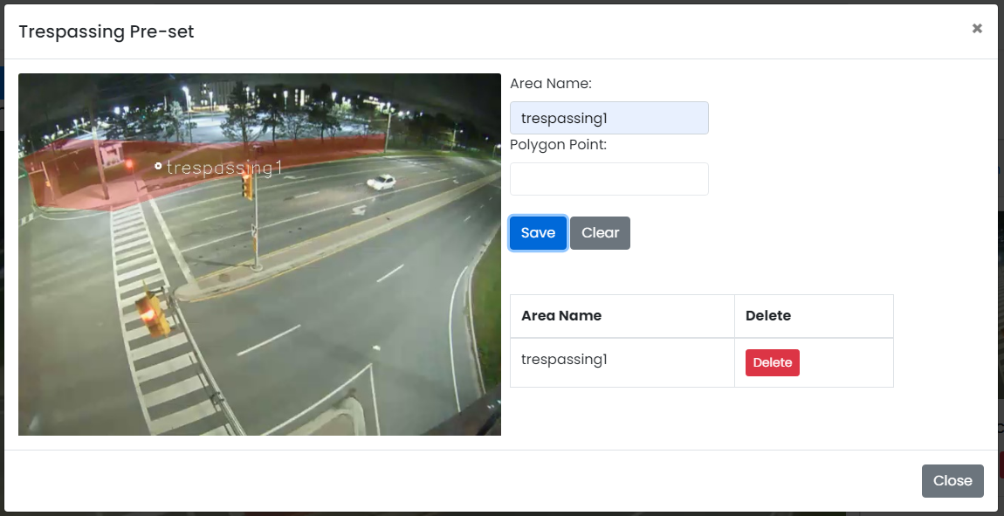

**Data control**

| **No.** | **Data Item** | **Data Type** | **Control Type** | **Mandatory** | **Value Range** | **Note** |
| --- | --- | --- | --- | --- | --- | --- |
| **Section:** Pre-set Maintenance [Add-Trespassing] | | | | | | |
|  | Area Name | Text | Input | Yes | 100 |  |
|  | Polygon Point | Text | Input | Yes | 100 | Enable=False |
|  | Save | Button | Button |  |  | Click Event   * + Close the Adding Screen |
|  | Clear | Button | Button |  |  | Click Event   * + Clear Area Name   + Clear Polygon Points |
| **Section:** Contact Maintenance [Add – Result] | | | | | | |
|  | Lane Name | Text |  |  |  | Constrain   * + Select the data from table [VideoDemoFeatureBoundary] where [VideoDemoFeatureBoundary. VideoDemoFeatureID] = [VideoDemoFeature. VideoDemoFeatureID] |
|  | Delete | Button | Button |  |  |  |

### Edit Function: When a user clicks at the search result screen, the system will popup a confirmation dialog box below.

**User Interface**

## 

**Data control**

| **No.** | **Data Item** | **Data Type** | **Control Type** | **Mandatory** | **Value Range** | **Note** |
| --- | --- | --- | --- | --- | --- | --- |
| **Section:** Camera Stream Maintenance [Delete] | | | | | | |
|  | Close | Button | Button |  |  | Click Event   * Close the screen |
|  | Delete Feature | Button | Button |  |  | Constrain   * Check data in table [VideoDemo] [VideoDemo. VideoDemoStreamID] = [VideoDemoStream. VideoDemoStreamID] * Found: display a message on the confirmation dialog box and not delete data * Not found: delete process   Delete Process:   * + Delete the from table [VideoDemo] where [VideoDemo. VideoDemoStreamID] = [Feature. VideoDemoStreamID]   + Delete the from table [VideoDemoFeature] where [VideoDemoFeature.FeatureID] = [Feature.FeatureID]   Post-process:   * Close the popup and refresh the screen |