VISION++

***Software Design Specification***

**Real-time Surveillance Detection and Monitoring System**

Vision Plus Plus

|  |  |
| --- | --- |
| **Author** | Vision Plus Plus |
| **Customer** | N/A |
| **Phase** | 1 |
| **Version** | 1.0 |
| **Status** | Draft |
| **Date of Creation** | 2021-10-18 |
| **Last Updated** | 2021-10-18 |

**Document Type**

|  |  |
| --- | --- |
| **Project Name :** | Real-time Surveillance Detection and Monitoring System |
| **Document Name :** | Software Design Specification |
| **Screen Name:** | Group Maintenance |
| **Ref No :** |  |

**Revision History**

|  |  |  |
| --- | --- | --- |
| **Date** | **Version** | **Description** |
| 2021-10-18 | 1.0 | Create Document |
|  |  |  |
|  |  |  |
|  |  |  |
|  |  |  |
|  |  |  |

1. **Description**

|  |  |  |  |  |  |
| --- | --- | --- | --- | --- | --- |
| **Program ID :** | MAS001 | **Name :** | Group Maintenance | **System ID. :** | RSDMS |
| **Description :** | To search, add, update and delete a group for the video live stream dashboard and video demo dashboard | | | | |
| **Association (Actor) :** | System Admin | | | | |

1. **Functional Design**

## Database Schema

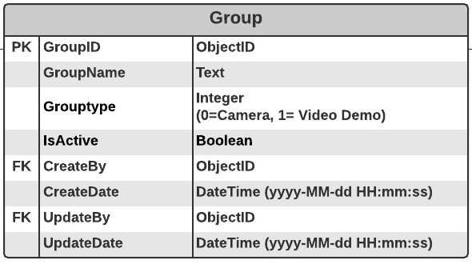

## Functional Detail

### Search Function: when a user clicks on the menu “Group Maintenance”, the system will display a search function screen.

**User Interface**

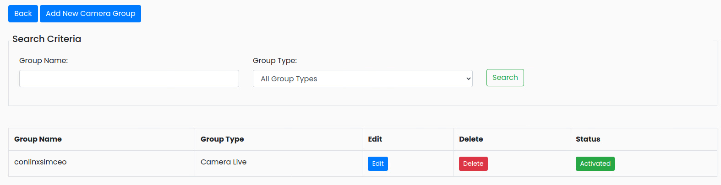

|  |
| --- |
| **Data control** |

| **No.** | **Data Item** | **Data Type** | **Control Type** | **Mandatory** | **Value Range** | **Note** |
| --- | --- | --- | --- | --- | --- | --- |
| **Section:** Group Maintenance [Search – Criteria] | | | | | | |
|  | Group Name | Text | Input | - | 100 | - |
|  | Group Type | Text | Drop-down Box | - |  | Item List  - All Groups  - Camera Live  - Demo Video  Default Value   * All Groups |
|  | Seach | Button | Button |  |  | Event Click   * Retrieve the data from the database [Group] based on the searching criteria |
| **Section:** Group Maintenance [Search – Result] | | | | | | |
|  | Group Name | Text | Input | - | 100 | [Group.GroupName] |
|  | Group Type | Integer | Radio Box | - | 0-1 | Display   * Camera Live [Group.GroupType=0] * Demo Video [Group.GroupType=1] |
|  | Edit | Button | Button |  |  | Event Click   * Popup the Editing Screen |
|  | Delete | Button | Button |  |  | Event Click   * Popup the Deleting screen |
|  | Status | Button | Button |  | 0-1 | Display   * Inactivate [Group.isActive =0] * Activate [Group.isActive =1] |

### Add Function: When a user clicks from the searching screen, the system will popup the adding screen below.

**User Interface**

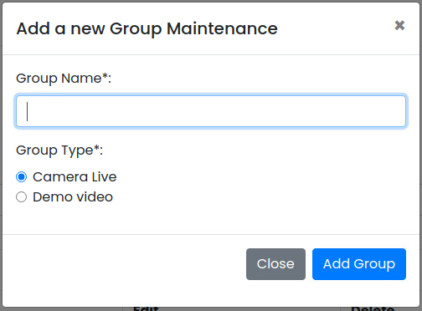

**Data control**

| **No.** | **Data Item** | **Data Type** | **Control Type** | **Mandatory** | **Value Range** | **Note** |
| --- | --- | --- | --- | --- | --- | --- |
| **Section:** Group Maintenance [Add] | | | | | | |
|  | Group Name | Text | Input | Yes | 100 | [Group.GroupName] |
|  | Group Type | Text | Radio Button | Yes |  | Item Lists:   * + Camera Live [Group.GroupType=0]   + Demo Video [Group.GroupType=1]   Default Value   * + Camera Live |
|  | Close | Button | Button |  |  | Event Click   * + Close the Adding Screen |
|  | Add Group | Button | Button |  |  | Constrain   * + Check null value for the mandatory fields   + Check duplicate value [Group.GroupName] and [Group.GroupType]   Add Process:   * + Add the data to table [Group]   + [Group.IsActive] = True   + [Group.CreateBy] = ObjectID of user   + [Group.CreateDate] = Current DateTime (yyyy-MM-dd HH:mm:ss) |

### Edit Function: When a user clicks at the search result screen, the system will popup the editing screen below.

**User Interface**

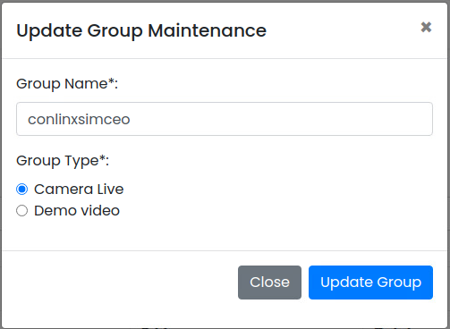

**Data control**

| **No.** | **Data Item** | **Data Type** | **Control Type** | **Mandatory** | **Value Range** | **Note** |
| --- | --- | --- | --- | --- | --- | --- |
| **Section:** Group Maintenance [Update] | | | | | | |
|  | Group Name | Text | Input | Yes | 100 | [Group.GroupName] |
|  | Group Type | Text | Radio Button | Yes |  | Item Lists:   * + Camera Live [Group.GroupType=0]   + Demo Video [Group.GroupType=1]   Deault Value   * + [Group.GroupType] |
|  | Close | Button | Button |  |  | Event Click   * + Close the Updating Screen |
|  | Update Group | Button | Button |  |  | Constrain   * + Check null value for the mandatory fields   + Check Duplicate [Group.GroupName] and [Group.GroupType]   Update Process:   * + Update the data to table [Group] where *[Group.GroupID]*   + [Group.UpdateBy] = ObjectID of user   + [Group.UpdateDate] = Current DateTime (yyyy-MM-dd HH:mm:ss) |

### Edit Function: When a user clicks at the search result screen, the system will popup a confirmation dialog box below.

**User Interface**

## 

**Data control**

| **No.** | **Data Item** | **Data Type** | **Control Type** | **Mandatory** | **Value Range** | **Note** |
| --- | --- | --- | --- | --- | --- | --- |
| **Section:** Group Maintenance [Delete] | | | | | | |
|  | Close | Button | Button |  |  | Event Click   * + Close the screen |
|  | Delete Group | Button | Button |  |  | Constrain:  -  Delete Process:   * + Delete the from table [Camera] where [Camera. GroupID] = [Group.GroupID]   + Delete the from table [VideoDemo] where [Camera. GroupID] = [Group.GroupID]   + Delete data from table [Group] where [Group.GroupID]   Post-processed:  Close the popup and refresh the screen |

### Activate/Inactivate Function: When a user clicks at the search result screen, the system will popup the confirmation dialog box below.

**User Interface**

## 

**Data control**

| **No.** | **Data Item** | **Data Type** | **Control Type** | **Mandatory** | **Value Range** | **Note** |
| --- | --- | --- | --- | --- | --- | --- |
| **Section:** Group Maintenance [Activate] | | | | | | |
|  | Close | Button | Button |  |  | Event Click   * + Close the screen |
|  | Inactivate | Button | Button |  |  | Constrain  -  Inactivate Process:   * + [Group.IsActivate]=False   Post-process:  Close the popup and refresh the screen |
|  | Activate | Button | Button |  |  | Constrain:  -  Inactivate Process:   * + [Group.IsActivate]=True   Post-process:  Close the popup and refresh the screen |