VISION++

***Software Design Specification***

**Real-time Surveillance Detection and Monitoring System**

Vision Plus Plus

|  |  |
| --- | --- |
| **Author** | Vision Plus Plus |
| **Customer** | N/A |
| **Phase** | 1 |
| **Version** | 1.0 |
| **Status** | Draft |
| **Date of Creation** | 2021-10-18 |
| **Last Updated** | 2021-10-18 |

**Document Type**

|  |  |
| --- | --- |
| **Project Name :** | Real-time Surveillance Detection and Monitoring System |
| **Document Name :** | Software Design Specification |
| **Screen Name:** | Feature Information |
| **Ref No :** |  |

**Revision History**

|  |  |  |
| --- | --- | --- |
| **Date** | **Version** | **Description** |
| 2021-10-18 | 1.0 | Create Document |
|  |  |  |
|  |  |  |
|  |  |  |
|  |  |  |
|  |  |  |

1. **Description**

|  |  |  |  |  |  |
| --- | --- | --- | --- | --- | --- |
| **Program ID :** | MAS002 | **Name :** | Feature Information | **System ID. :** | RSDMS |
| **Description :** | To search, add, update and delete a feature for the camera live stream dashboard, video demo dashboard, and contract feature screen | | | | |
| **Association (Actor) :** | System Admin | | | | |

1. **Functional Design**

## Database Schema

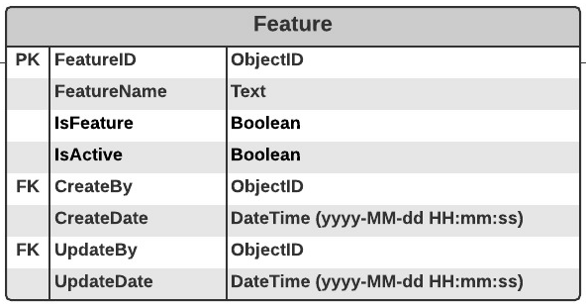

## Functional Detail

### Search Function: when a user clicks on the menu “Feature Maintenance”, the system will display a search function screen.

**User Interface**

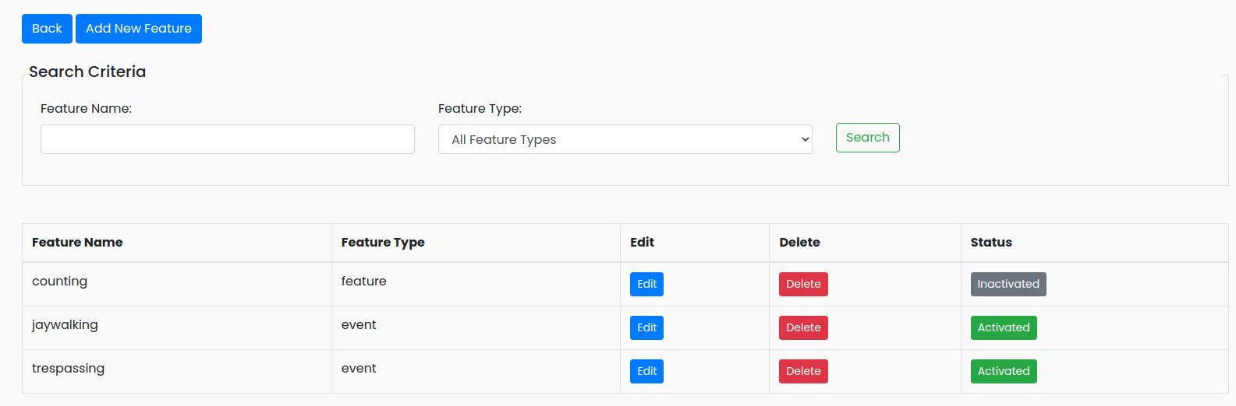

|  |
| --- |
| **Data control** |

| **No.** | **Data Item** | **Data Type** | **Control Type** | **Mandatory** | **Value Range** | **Note** |
| --- | --- | --- | --- | --- | --- | --- |
| **Section:** Feature Maintenance [Search – Criteria] | | | | | | |
|  | Feature Name | Text | Input | - | 100 | - |
|  | Feature Type | Text | Drop-down Box | - |  | Item List  - All Feature Types  - Feature  - Event  Default Value   * + All Feature Types |
|  | Seach | Button | Button |  |  | Retrieve the data from the database [Feature] based on the searching criteria |
| **Section:** Feature Maintenance [Search – Result] | | | | | | |
|  | Feature Name | Text | Input | - | 100 | [Feature.FeatureName] |
|  | Feature Type | Integer | Radio Box | - | 0-1 | Display  Feature [Feature.isEvent=0]  Event [Feature. isEvent =1] |
|  | Edit | Button | Button |  |  | Event Click   * + Popup the Editing Screen |
|  | Delete | Button | Button |  |  | Event Click   * + Popup the Deleting screen |
|  | Status | Button | Button |  | 0-1 | Display   * + - Inactivate [Feature.isActive =0] and set backgroud color = green   + - Activate [Feature.isActive =1] and set backgroud color = gray |

### Add Function: When a user clicks from the searching screen, the system will popup the adding screen below.

**User Interface**

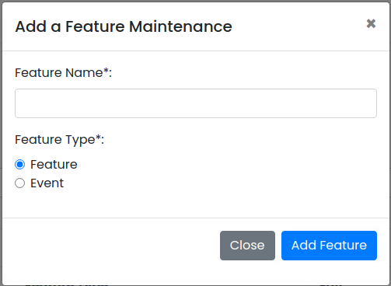

**Data control**

| **No.** | **Data Item** | **Data Type** | **Control Type** | **Mandatory** | **Value Range** | **Note** |
| --- | --- | --- | --- | --- | --- | --- |
| **Section:** Feature Maintenance [Add] | | | | | | |
|  | Feature Name | Text | Input | Yes | 100 | [Feature.FeatureName] |
|  | Feature Type | Text | Radio Button | Yes |  | Item Lists:   * + Feature [Feature.IsFeature=0]   + Event [Feature.IsFeature =1]   Default Value :   * + Feature |
|  | Close | Button | Button |  |  | Event Click   * + Close the Adding Screen |
|  | Add Feature | Button | Button |  |  | Constrain  - Check null value for the mandatory fields    - Check duplicate [Feature. FeatureName] and [Feature.FeatureType]  Add Process:   * + Add the data to table [Feature]   + [Feature.IsActive] = True   + [Feature.CreateBy] = ObjectID of user   + [Feature.CreateDate] = Current DateTime (yyyy-MM-dd HH:mm:ss) |

### Edit Function: When a user clicks at the search result screen, the system will popup the editing screen below.

**User Interface**

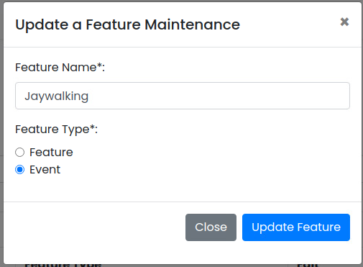

**Data control**

| **No.** | **Data Item** | **Data Type** | **Control Type** | **Mandatory** | **Value Range** | **Note** |
| --- | --- | --- | --- | --- | --- | --- |
| **Section:** Feature Maintenance [Update] | | | | | | |
|  | Feature Name | Text | Input | Yes | 100 | [Feature.FeatureName] |
|  | Feature Type | Text | Radio Button | Yes |  | Item Lists:   * + Feature [Feature.IsFeature=0]   + Event [Feature.IsFeature =1]   Deault Value :   * + [Feature.IsFeature] |
|  | Close | Button | Button |  |  | Event Click   * + Close the Updating Screen |
|  | Update Feature | Button | Button |  |  | Constrain   * + Check null value for the mandatory fields   + Check Duplicate [Feature.FeatureName] and [Feature.FeatureType]   Update Process:   * + Update the data to table [Feature] where [Feature.FeatureID]   + [Feature.UpdateBy] = ObjectID of user   + [Feature.UpdateDate] = Current DateTime (yyyy-MM-dd HH:mm:ss)   Post-process:  Close the popup and refresh the screen |

### Edit Function: When a user clicks at the search result screen, the system will popup a confirmation dialog box below.

**User Interface**

## 

**Data control**

| **No.** | **Data Item** | **Data Type** | **Control Type** | **Mandatory** | **Value Range** | **Note** |
| --- | --- | --- | --- | --- | --- | --- |
| **Section:** Feature Maintenance [Delete] | | | | | | |
|  | Close | Button | Button |  |  | Event Click   * + Close the screeen |
|  | Delete Feature | Button | Button |  |  | Constrain  -  Delete Process:   * + Delete the from table [CameraFeature] where [Feature. FeatureID] = [Feature.FeatureID]   + Delete the from table [VideoDemoFeature] where [VideoDemoFeature.FeatureID] = [Feature.FeatureID]   + Delete the from table [ContactFeature] where [ContactFeature.FeatureID] = [Feature.FeatureID]   + Delete data from table [Feature] where [Feature.FeatureID]   Post-process:  Close the popup and refresh the screen |

### Inactivate Function: When a user clicks at the search result screen, the system will popup the confirmation dialog box below.

**User Interface**

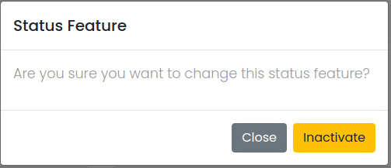

**Data control**

| **No.** | **Data Item** | **Data Type** | **Control Type** | **Mandatory** | **Value Range** | **Note** |
| --- | --- | --- | --- | --- | --- | --- |
| **Section:** Feature Maintenance [Inactivate] | | | | | | |
|  | Close | Button | Button |  |  | Event Click   * + Close the screen |
|  | Activated | Button | Button |  |  | Constrain  -  Inactivate Process   * + *[Feature.IsActivate]=False*   Post-process:  Close the popup and refresh the screen |

### Activate Function: When a user clicks at the search result screen, the system will popup the confirmation dialog box below.

**User Interface**

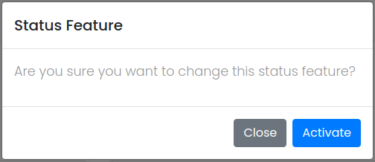

**Data control**

| **No.** | **Data Item** | **Data Type** | **Control Type** | **Mandatory** | **Value Range** | **Note** |
| --- | --- | --- | --- | --- | --- | --- |
| **Section:** Feature Maintenance [Activate] | | | | | | |
|  | Close | Button | Button |  |  | Event Click  Close the screen |
|  | Inactivated | Button | Button |  |  | Constrain  -  Activate Process:   * + [Feature.IsActivate]=True   Post-process:  Close the popup and refresh the screen |