VISION++

***Software Design Specification***

**Real-time Surveillance Detection and Monitoring System**

Vision Plus Plus

|  |  |
| --- | --- |
| **Author** | Vision Plus Plus |
| **Customer** | N/A |
| **Phase** | 1 |
| **Version** | 1.0 |
| **Status** | Draft |
| **Date of Creation** | 2021-10-18 |
| **Last Updated** | 2021-10-18 |

**Document Type**

|  |  |
| --- | --- |
| **Project Name :** | Real-time Surveillance Detection and Monitoring System |
| **Document Name :** | Software Design Specification |
| **Screen Name:** | Server Type Information |
| **Ref No :** |  |

**Revision History**

|  |  |  |
| --- | --- | --- |
| **Date** | **Version** | **Description** |
| 2021-10-18 | 1.0 | Create Document |
|  |  |  |
|  |  |  |
|  |  |  |
|  |  |  |
|  |  |  |

1. **Description**

|  |  |  |  |  |  |
| --- | --- | --- | --- | --- | --- |
| **Program ID :** | MAS005 | **Name :** | Server Type Information | **System ID. :** | RSDMS |
| **Description :** | To search, add, update and delete a server type for the server information screen | | | | |
| **Association (Actor) :** | System Admin | | | | |

1. **Functional Design**

## Database Schema

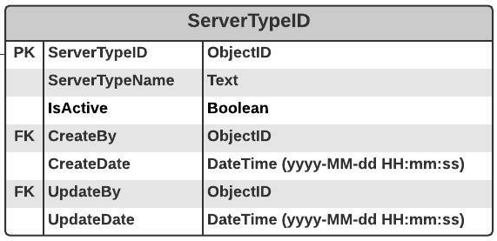

## Functional Detail

### Search Function: when a user clicks on the menu “Server Type information”, the system will display a search function screen.

**User Interface**

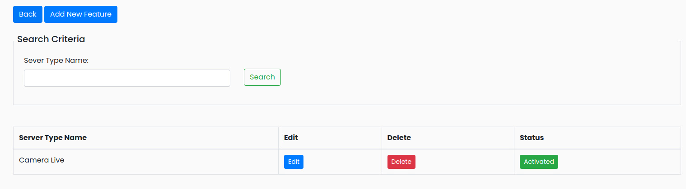

|  |  |  |  |  |  |  |  |  |  |  |  |  |  |  |  |  |  |  |  |  |  |  |  |  |  |  |  |  |  |  |  |  |  |  |  |  |  |  |  |  |  |  |  |  |  |  |  |  |  |  |  |  |  |  |  |  |  |  |  |  |  |  |  |
| --- | --- | --- | --- | --- | --- | --- | --- | --- | --- | --- | --- | --- | --- | --- | --- | --- | --- | --- | --- | --- | --- | --- | --- | --- | --- | --- | --- | --- | --- | --- | --- | --- | --- | --- | --- | --- | --- | --- | --- | --- | --- | --- | --- | --- | --- | --- | --- | --- | --- | --- | --- | --- | --- | --- | --- | --- | --- | --- | --- | --- | --- | --- | --- |
| **Data control**   | **No.** | **Data Item** | **Data Type** | **Control Type** | **Mandatory** | **Value Range** | **Note** | | --- | --- | --- | --- | --- | --- | --- | | **Section:** Server Type Maintenance [Search – Criteria] | | | | | | | |  | Server Name | Text | Input | - | 100 | - | |  | Seach | Button | Button |  |  | Event Click   * + Retrieve the data from the database [ServerType] based on the searching criteriass | | **Section:** Server Type Maintenance [Search – Result] | | | | | | | |  | Server Type Name | Text | Input | - | 100 | [ServerType.ServerTypeName] | |  | Edit | Button | Button |  |  | Event Click   * + Popup the Editing Screen | |  | Delete | Button | Button |  |  | Event Click   * + Popup the Deleting screen | |  | Status | Button | Button |  | 0-1 | Display   * + Inactivate [ ServerType.isActive=0]   + Activate [ ServerType.isActive=1] | |

### Add Function: When users click from the searching screen, the system will popup the adding screen below.

**User Interface**

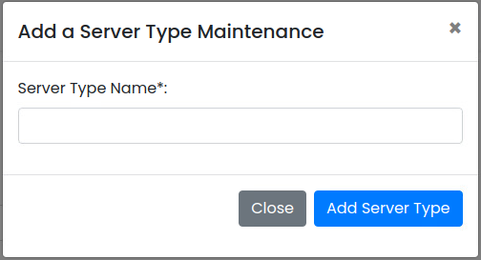

**Data control**

| **No.** | **Data Item** | **Data Type** | **Control Type** | **Mandatory** | **Value Range** | **Note** |
| --- | --- | --- | --- | --- | --- | --- |
| **Section:** Server Type Maintenance [Add] | | | | | | |
|  | Server Type Name | Text | Input | Yes | 100 | - |
|  | Close | Button | Button |  |  | Event Click   * + Close the Adding Screen |
|  | Add Server Type | Button | Button |  |  | Constrain   * + Check null value for the mandatory fields   + Check duplicate [ServerType.ServerTypeName]   Add Process:   * + Add the data to table [ServerType]   + [ServerType.IsActive] = True   + [ServerType.CreateBy] = ObjectID of user   + [ServerType.CreateDate] = Current DateTime (yyyy-MM-dd HH:mm:ss) |

### Edit Function: When a user clicks at the search result screen, the system will popup the editing screen below.

**User Interface**

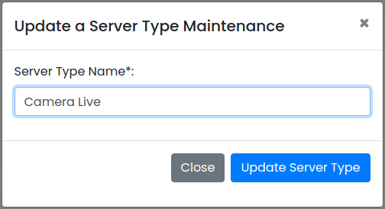

**Data control**

| **No.** | **Data Item** | **Data Type** | **Control Type** | **Mandatory** | **Value Range** | **Note** |
| --- | --- | --- | --- | --- | --- | --- |
| **Section:** Group Maintenance [Update] | | | | | | |
|  | Server Name | Text | Input | Yes | 100 | Default Value   * + [ServerType.ServerTypeName] |
|  | Close | Button | Button |  |  | Click Event  Close the updating screen |
|  | Update Group | Button | Button |  |  | Constrain   * + Check null value for the mandatory fields   + Check Duplicate [ServerType.ServerTypeName]   Update Process:   * + Update the data to table [ServerType] where [ServerType.ServerTypeID]   + [ServerType.UpdateBy] = ObjectID of user   + [ServerType.UpdateDate] = Current DateTime (yyyy-MM-dd HH:mm:ss) |

### Edit Function: When a user clicks at the search result screen, the system will popup a confirmation dialog box below.

**User Interface**

## 

**Data control**

| **No.** | **Data Item** | **Data Type** | **Control Type** | **Mandatory** | **Value Range** | **Note** |
| --- | --- | --- | --- | --- | --- | --- |
| **Section:** Server Type Maintenance [Delete] | | | | | | |
|  | Close | Button | Button |  |  | Click Event   * Close the screen |
|  | Delete Feature | Button | Button |  |  | Constrain   * Not found in table [ServerType] [ServerType.ServerTypeID] = [Server. ServerTypeID]   Delete Process:   * + Delete data from table [ServerType] where [ServerType.ServerTypeID]   Post-process:   * + Close the popup and refresh the screen |

### Inactivate Function: When a user clicks at the search result screen, the system will popup the confirmation dialog box below.

**User Interface**

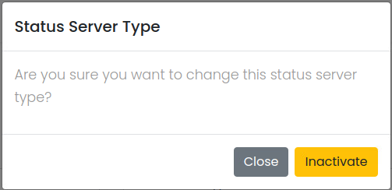

**Data Control**

| **No.** | **Data Item** | **Data Type** | **Control Type** | **Mandatory** | **Value Range** | **Note** |
| --- | --- | --- | --- | --- | --- | --- |
| **Section:** Server Type Maintenance [Inactivate] | | | | | | |
|  | Close | Button | Button |  |  | Click Event   * + Close the screen |
|  | Activated | Button | Button |  |  | Constrain  -  Inactivate Process:   * + [ServerType.IsActivate]=False   Post-process:  Close the popup and refresh the screen |

### Activate Function: When a user clicks at the search result screen, the system will popup the confirmation dialog box below.

**User Interface**

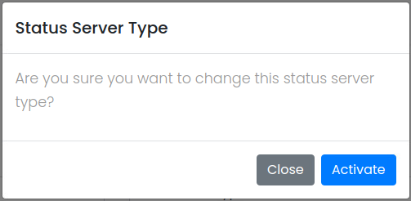

**Data control**

| **No.** | **Data Item** | **Data Type** | **Control Type** | **Mandatory** | **Value Range** | **Note** |
| --- | --- | --- | --- | --- | --- | --- |
| **Section:** Server Type Maintenance [Activate] | | | | | | |
|  | Close | Button | Button |  |  | Click Event   * + Close the screen |
|  | Inactivated | Button | Button |  |  | Constrain  -  Activate Process:   * + [ServerType.IsActivate]=True   Post-process:  Close the popup and refresh the screen |