VISION++

***Software Design Specification***

**Real-time Surveillance Detection and Monitoring System**

Vision Plus Plus

|  |  |
| --- | --- |
| **Author** | Vision Plus Plus |
| **Customer** | N/A |
| **Phase** | 1 |
| **Version** | 1.0 |
| **Status** | Draft |
| **Date of Creation** | 2021-10-18 |
| **Last Updated** | 2021-10-18 |

**Document Type**

|  |  |
| --- | --- |
| **Project Name :** | Real-time Surveillance Detection and Monitoring System |
| **Document Name :** | Software Design Specification |
| **Screen Name:** | Contact Information |
| **Ref No :** |  |

**Revision History**

|  |  |  |
| --- | --- | --- |
| **Date** | **Version** | **Description** |
| 2021-10-18 | 1.0 | Create Document |
|  |  |  |
|  |  |  |
|  |  |  |
|  |  |  |
|  |  |  |

1. **Description**

|  |  |  |  |  |  |
| --- | --- | --- | --- | --- | --- |
| **Program ID :** | MAS007 | **Name :** | Contact Information | **System ID. :** | RSDMS |
| **Description :** | To search, add, update and delete a contact for the event | | | | |
| **Association (Actor) :** | System Admin | | | | |
| **Database Tables** | * Feature * Contact * ContractFeature | | | | |

1. **Functional Design**

## Database Schema

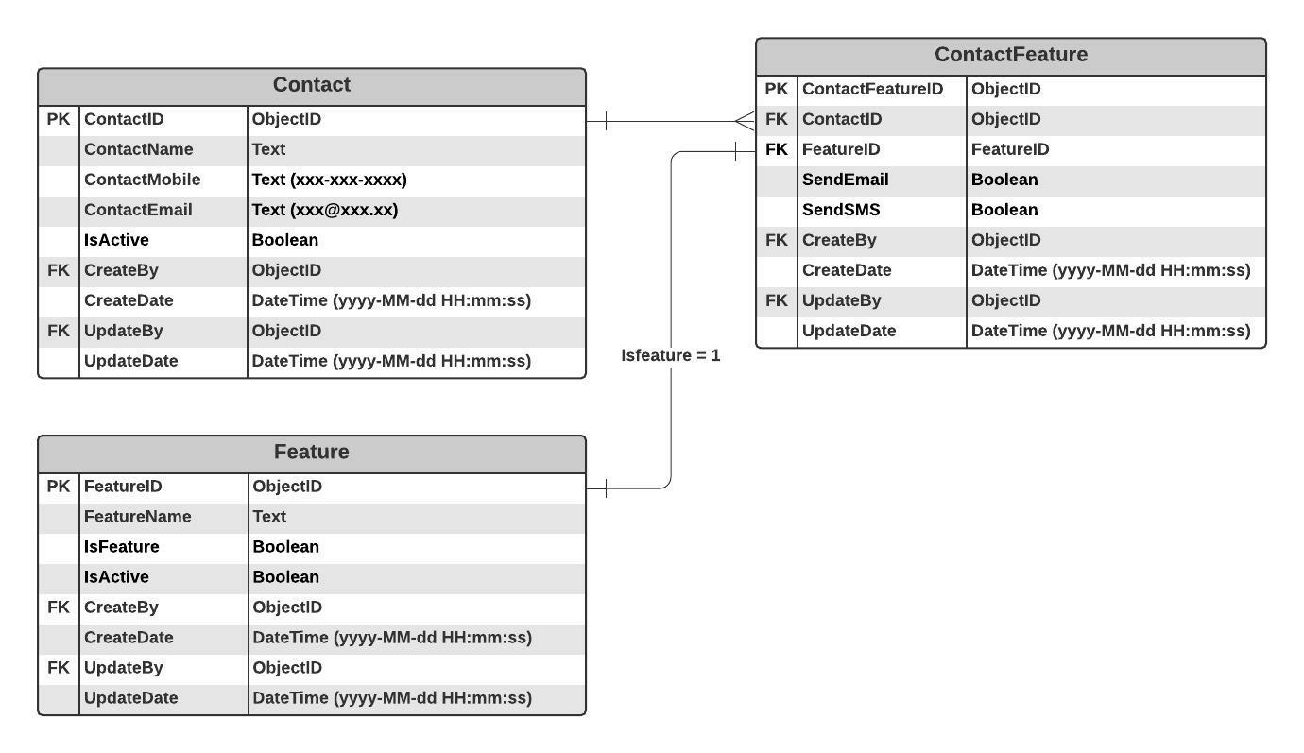

## Functional Detail

### Search Function: when a user clicks on the menu “Contact Information”, the system will display a search function screen.

**User Interface**

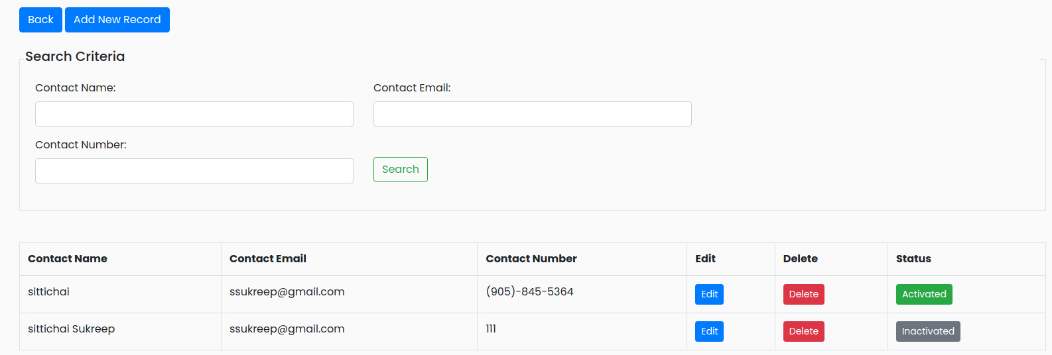

**Data Control**

|  |
| --- |
|  |

| **No.** | **Data Item** | **Data Type** | **Control Type** | **Mandatory** | **Value Range** | **Note** |
| --- | --- | --- | --- | --- | --- | --- |
| **Section:** Contact Information [Search – Criteria] | | | | | | |
|  | Contact Name | Text | Input | - | 100 | - |
|  | Contact Email | Text | Input | - | 100 | - |
|  | Contact Number | Text | Input | - | 100 | - |
|  | Seach | Button | Button |  |  | Click Event   * + Retrieve the data from the database [Contact] based on the searching criteria |
| **Section:** Contact Information [Search – Result] | | | | | | |
|  | Contact Name | Text | Input | - | 100 | [Contact.ContactName] |
|  | Contact Email | Text | Input | - | 500 | [Contact.ContactEmail] |
|  | Contact Number | Text | Input | - | 100 | [Contact.ContactMobile] |
|  | Edit | Botton | Botton |  |  | Click Event   * + Open the updating dialog |
|  | Delete | Botton | Botton |  |  | Click Event   * + Open the confirmation deleting dialog |
|  | Status | Botton | Botton |  | 0-1 | Display   * + Inactivate [Contact.IsActive =0] and set backgroud color = green   + Activate [Contact.IsActive =1] and set backgroud color = gray |

### Add Function: When a user clicks from the searching screen, the system will popup the adding screen below.

**User Interface**

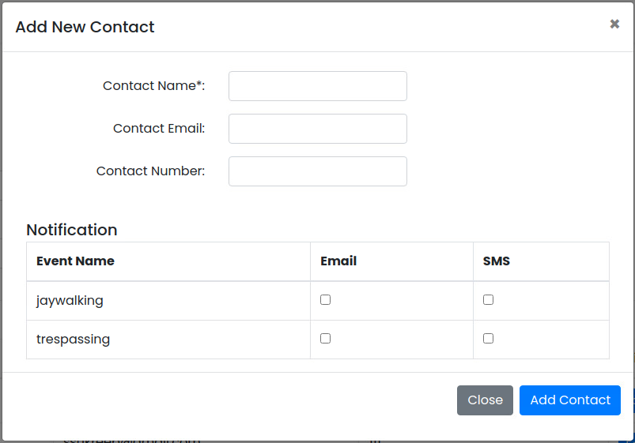

**Data control**

| **No.** | **Data Item** | **Data Type** | **Control Type** | **Mandatory** | **Value Range** | **Note** |
| --- | --- | --- | --- | --- | --- | --- |
| **Section:** Contact Information [Add] | | | | | | |
|  | Contact Name | Text | Input | Yes | 100 | - |
|  | Contact Email | Text | Input |  | 100 | xxx@xxxx.xx |
|  | Contact Number | Number | Input |  | 10 | (xxx)-xxx-xxxx |
| **Section:** Contact Information [Add-Notification] | | | | | | |
|  | Event Name | Text |  |  |  | Constrain   * + Select the data from table [Feature] where [Feature.IsFeature =1] and [Feature.IsActivate =0] |
|  | Email | Boolean | Checkbox |  |  | - |
|  | SMS | Boolean | Checkbox |  |  | - |
|  | Close | Button | Button |  |  | Click Event   * + Close the Adding Screen |
|  | Add Camera Stream | Button | Button |  |  | Constrain   * + Check null value for the mandatory fields   + Check duplicate data [Contact.ContactName]   Add Process:   * + Add the data to table [Contact]   + [Contact.IsActive] = True   + [Contact.CreateBy] = ObjectID of user   + [Contact.CreateDate] = Current DateTime (yyyy-MM-dd HH:mm:ss)   + Add the data to table [ContactFeature]   + [ContactFeature.ContactID] = [Contact.ContactID]   + [ContactFeature.FeatureID] = [Feature.FeatureID]   + [ContactFeature.SendEmail] = SMS_Selected   + [ContactFeature.SendSMS] = SMS_Selected |

### Edit Function: When a user clicks at the search result screen, the system will popup the editing screen below.

**User Interface**

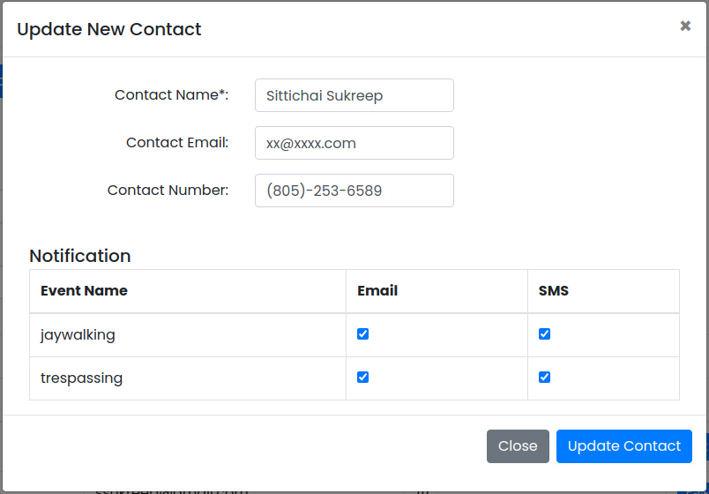

**Data control**

| **No.** | **Data Item** | **Data Type** | **Control Type** | **Mandatory** | **Value Range** | **Note** |
| --- | --- | --- | --- | --- | --- | --- |
| **Section:** Contact Information [Update] | | | | | | |
|  | Contact Name | Text | Input | Yes | 100 | [Contact.ContactName] |
|  | Contact Email | Text | Input |  | 100 | [Contact.ContactEmail]  xx@xxx.xx |
|  | Contact Number | Number | Input |  | 10 | [Contact.ContactNumber]  (xxx)-xxx-xxxx |
| **Section:** Contact Information [Update-Notification] | | | | | | |
|  | Event Name | Text |  |  |  | Constrain   * + Select the data from table [ContactFeature] where [ContactFeature.ContactID] = [Contact.ContactID] |
|  | Email | Boolean | Checkbox |  |  | Prerequition   * + Select the checkbox if [ContactFeature.SendEmail] = True |
|  | SMS | Boolean | Checkbox |  |  | Constrain   * + Select the checkbox if [ContactFeature.SendSMS] = True |
|  | Close | Button | Button |  |  | Click Event   * + Close the Adding Screen |
|  | Update Contact | Button | Button |  |  | Constrain   * + Check null value for the mandatory fileds   + Check duplicate data [Contact.ContactName]   + Check Email Format [Contact.ContactEmail]   Update Process:  Contact Information   * + Update the data to table [Contact] where [Contact. ContactID]   + [Contact.UpdateBy] = ObjectID of user   + [Contact.UpdateDate] = Current DateTime (yyyy-MM-dd HH:mm:ss)   Notification   * + Update the data to table [ContactFeature] where [ContactFeature. ContactID] = [Contact. ContactID] and   [ContactFeature.FeatureID] = [Feature.FeatureID]   * + [ContactFeature.SendEmail] = SMS_Selected   + [ContactFeature.SendSMS] = SMS_Selected |

### Edit Function: When a user clicks at the search result screen, the system will popup a confirmation dialog box below.

**User Interface**

## 

**Data control**

| **No.** | **Data Item** | **Data Type** | **Control Type** | **Mandatory** | **Value Range** | **Note** |
| --- | --- | --- | --- | --- | --- | --- |
| **Section:** Contact Information [Delete] | | | | | | |
|  | Close | Button | Button |  |  | Click Event   * Close the screen |
|  | Delete Feature | Button | Button |  |  | Constrain  -  Delete Process:   * + Delete data from table [ContactFeature] where [ContactFeature.ContactID]   + Delete data from table [Contact] where [Contact.ContactID]   Post-process:   * Close the popup and refresh the screen |

### Inactivate Function: When a user clicks at the search result screen, the system will popup the confirmation dialog box below.

**User Interface**

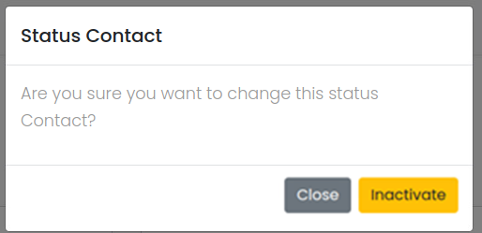

**Data control**

| **No.** | **Data Item** | **Data Type** | **Control Type** | **Mandatory** | **Value Range** | **Note** |
| --- | --- | --- | --- | --- | --- | --- |
| **Section:** Contact Information [Inactivate] | | | | | | |
|  | Close | Button | Button |  |  | Click Event   * + Close the screen |
|  | Activated | Button | Button |  |  | Constrain  -  Inactivate Process:   * + [Conatct.IsActivate]=False   + [Conatct.UpdateBy] = ObjectID of user   + [Conatct.UpdateDate] = Current DateTime (yyyy-MM-dd HH:mm:ss)   Post-process:   * + Close the popup and refresh the screen |

### Activate Function: When a user clicks at the search result screen, the system will popup the confirmation dialog box below.

**User Interface**

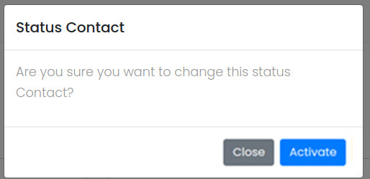

**Data control**

| **No.** | **Data Item** | **Data Type** | **Control Type** | **Mandatory** | **Value Range** | **Note** |
| --- | --- | --- | --- | --- | --- | --- |
| **Section:** Contact Information[Activate] | | | | | | |
|  | Close | Button | Button |  |  | Click Event   * + Close the screen |
|  | Inactivated | Button | Button |  |  | Constrain  -  Activate Process:   * + [Conatct.IsActivate]=True   + [Conatct.UpdateBy] = ObjectID of user   + [Conatct.UpdateDate] = Current DateTime (yyyy-MM-dd HH:mm:ss)   Post-process:   * + Close the popup and refresh the screen |