VISION++

***Software Design Specification***

**Real-time Surveillance Detection and Monitoring System**

Vision Plus Plus

|  |  |
| --- | --- |
| **Author** | Vision Plus Plus |
| **Customer** | N/A |
| **Phase** | 1 |
| **Version** | 1.0 |
| **Status** | Draft |
| **Date of Creation** | 2021-10-18 |
| **Last Updated** | 2021-10-18 |

**Document Type**

|  |  |
| --- | --- |
| **Project Name :** | Real-time Surveillance Detection and Monitoring System |
| **Document Name :** | Software Design Specification |
| **Screen Name:** | Video Demo File Upload |
| **Ref No :** |  |

**Revision History**

|  |  |  |
| --- | --- | --- |
| **Date** | **Version** | **Description** |
| 2021-10-18 | 1.0 | Create Document |
|  |  |  |
|  |  |  |
|  |  |  |
|  |  |  |
|  |  |  |

1. **Description**

|  |  |  |  |  |  |
| --- | --- | --- | --- | --- | --- |
| **Program ID :** | MAS008 | **Name :** | Video Demo Upload File | **System ID. :** | RSDMS |
| **Description :** | To search, add, and delete the video demo file | | | | |
| **Association (Actor) :** | System Admin | | | | |
| **Database Tables** | * VideoDemoFile | | | | |

1. **Functional Design**

## Database Schema

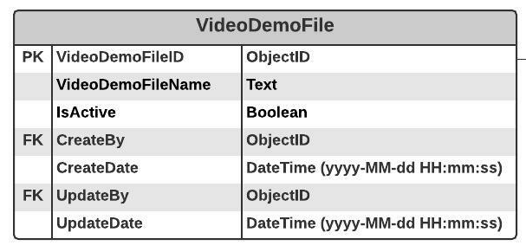

## Functional Detail

### Search Function: when a user clicks on the menu “Video Demo Upload”, the system will display a search function screen.

**User Interface**

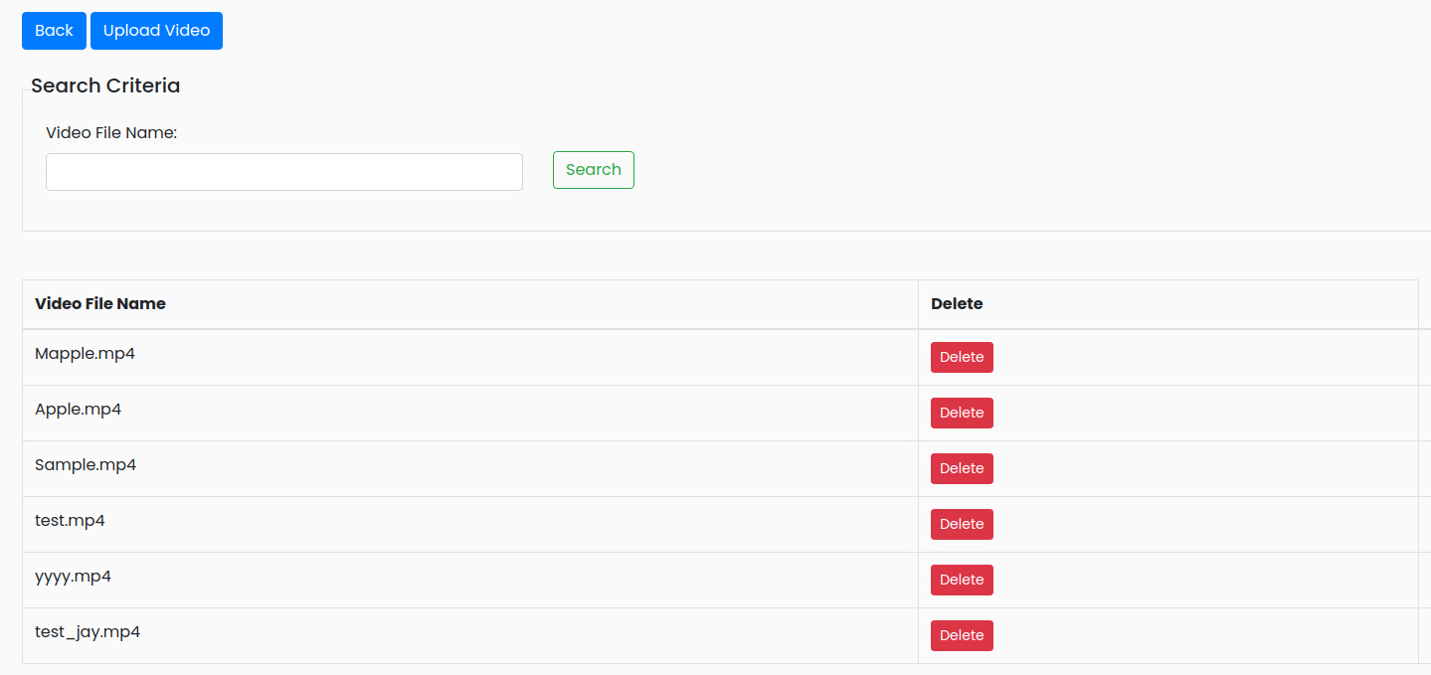

|  |
| --- |
| **Data control** |

| **No.** | **Data Item** | **Data Type** | **Control Type** | **Mandatory** | **Value Range** | **Note** |
| --- | --- | --- | --- | --- | --- | --- |
| **Section:** Video Demo Upload [Search – Criteria] | | | | | | |
|  | Video File Name | Text | Input | - | 100 | - |
|  | Seach | Button | Button |  |  | Event Click   * + Retrieve the data from the database [VideoDemoFile] based on the searching criteria |
| **Section:** **:** Video Demo Upload [Search – Result] | | | | | | |
|  | Video File Name | Text | Input | - | 100 | [VideoDemoFile. VideoDemoFileName] |
|  | Delete | Button | Button |  |  | Event Click   * + Popup the Deleting screen |

### Add Function: When a user clicks from the searching screen, the system will popup the adding screen below.

**User Interface**

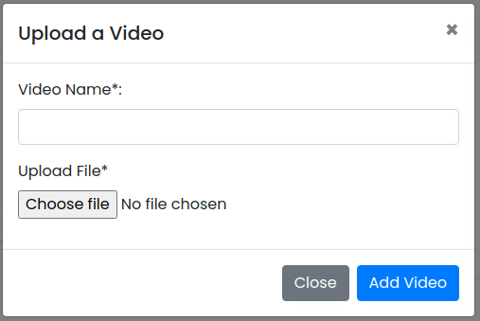

**Data control**

| **No.** | **Data Item** | **Data Type** | **Control Type** | **Mandatory** | **Value Range** | **Note** |
| --- | --- | --- | --- | --- | --- | --- |
| **Section:** Video Demo Upload [Upload] | | | | | | |
|  | Video Name | Text | Input | Yes | 100 | - |
|  | Upload File | File | File Dialog | Yes | 100 | - |
|  | Add Video | Button | Button |  |  | Constrain   * + Check null value for the mandatory fileds   + Check duplicate data [VideoDemoFile.VideoDemoFileName]   Add Process:   * + Add the data to table [VideoDemoFile]   + [VideoDemoFile.CreateBy] = ObjectID of user   + [VideoDemoFile.CreateDate] = Current DateTime (yyyy-MM-dd HH:mm:ss) |

### Edit Function: When a user clicks at the search result screen, the system will popup a confirmation dialog box below.

**User Interface**

## 

**Data control**

| **No.** | **Data Item** | **Data Type** | **Control Type** | **Mandatory** | **Value Range** | **Note** |
| --- | --- | --- | --- | --- | --- | --- |
| **Section:** Server Maintenance [Delete] | | | | | | |
|  | Close | Button | Button |  |  | Click Event   * Close the screen |
|  | Delete Feature | Button | Button |  |  | Constrain   * Check data in table [VideoDemoFile] [VideoDemoFile.VideoDemoFileID] = [VideoDemo. VideoDemoFileID] * Found: display a message on the confirmation dialog box and not delete data * Not found: delete process   Delete Process:   * + Delete data from table [VideoDemoFile] where [VideoDemoFile.VideoDemoFileID]   Post-process:   * Close the popup and refresh the screen |