VISION++

***Software Design Specification***

**Real-time Surveillance Detection and Monitoring System**

Vision Plus Plus

|  |  |
| --- | --- |
| **Author** | Vision Plus Plus |
| **Customer** | N/A |
| **Phase** | 1 |
| **Version** | 1.0 |
| **Status** | Draft |
| **Date of Creation** | 2021-10-18 |
| **Last Updated** | 2021-10-18 |

**Document Type**

|  |  |
| --- | --- |
| **Project Name :** | Real-time Surveillance Detection and Monitoring System |
| **Document Name :** | Software Design Specification |
| **Screen Name:** | Vehicle Counting Report |
| **Ref No :** |  |

**Revision History**

|  |  |  |
| --- | --- | --- |
| **Date** | **Version** | **Description** |
| 2021-10-18 | 1.0 | Create Document |
|  |  |  |
|  |  |  |
|  |  |  |
|  |  |  |
|  |  |  |

1. **Description**

|  |  |  |  |  |  |
| --- | --- | --- | --- | --- | --- |
| **Program ID :** | REP001 | **Name :** | Vehicle Counting Report | **System ID. :** | VSPP001 |
| **Description :** | To search, display and export the vehicle counting information | | | | |
| **Association (Actor) :** | System Admin | | | | |
| **Database Tables** | * Feature * Camera * CameraFeature * CameraFeatureBoundary * ObjectCounting | | | | |

1. **Functional Design**

## Database Schema

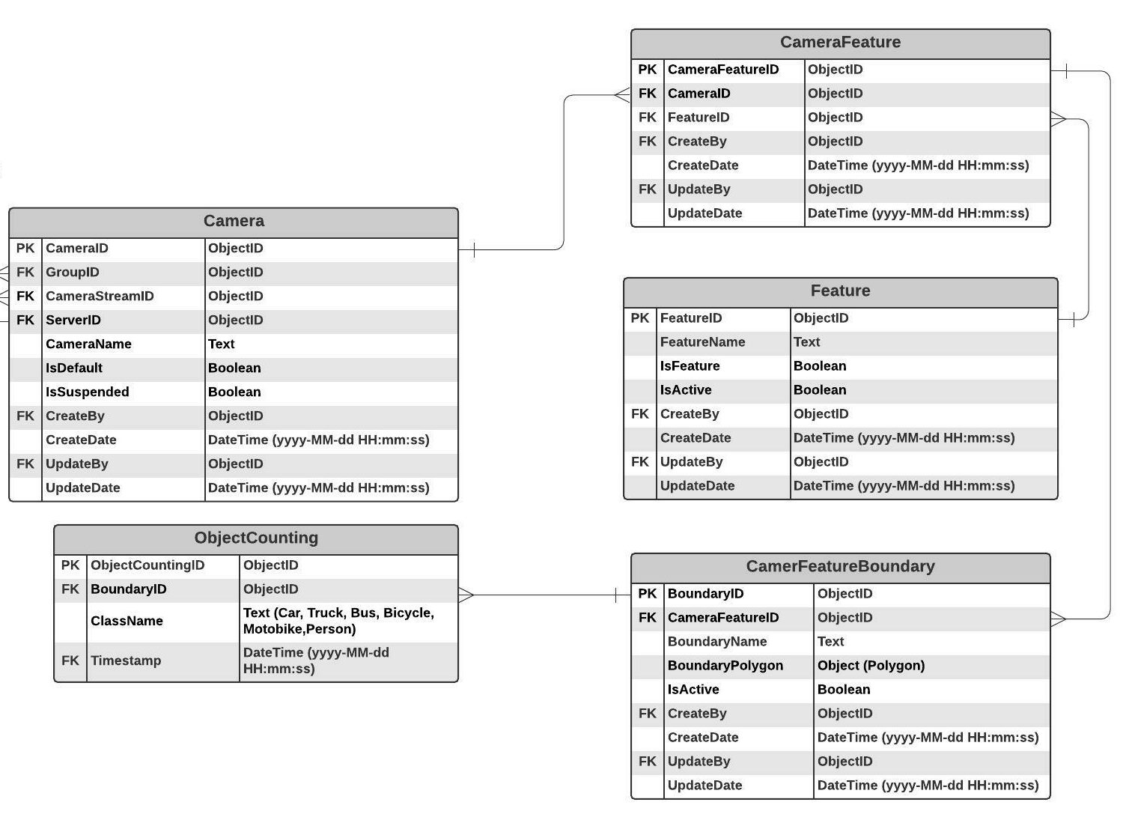

## Functional Detail

### Search Function: when a user clicks on the menu “Contact Maintenance”, the system will display a search function screen.

**User Interface**

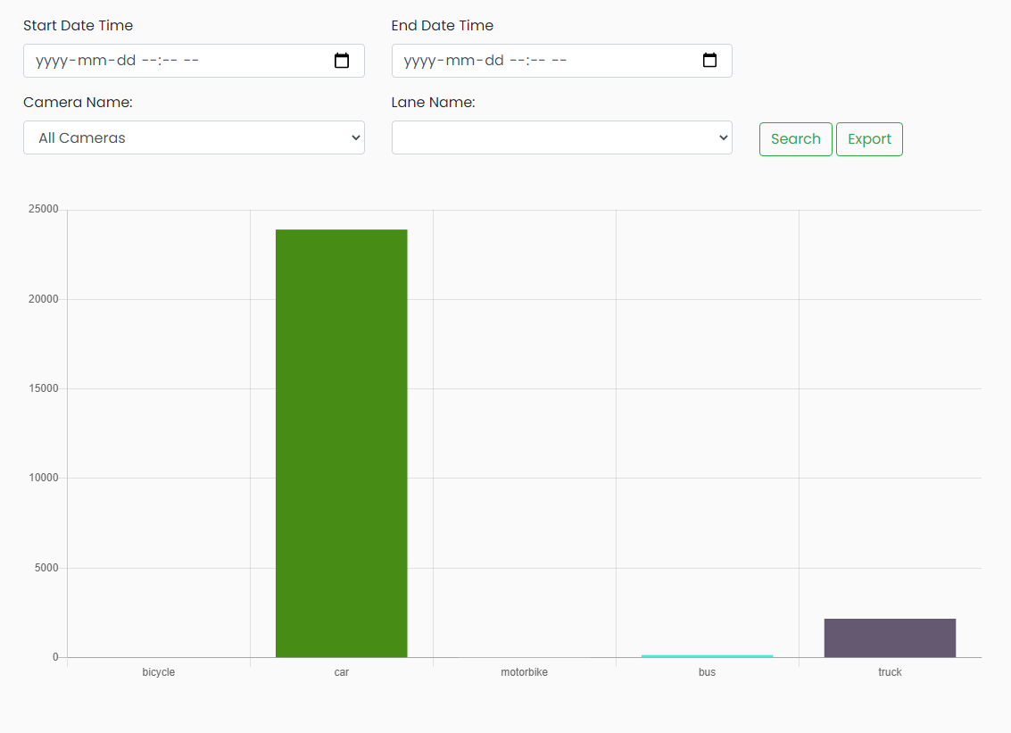

**Data Control**

|  |
| --- |
|  |

| **No.** | **Data Item** | **Data Type** | **Control Type** | **Mandatory** | **Value Range** | **Note** |
| --- | --- | --- | --- | --- | --- | --- |
| **Section:** Vehicle Counting Report [Search – Criteria] | | | | | | |
|  | Start Date Time | DateTime | Date | - |  | - |
|  | End Date Time | DateTime | Date | - |  | - |
|  | Camera Name | Text | Drop-down Box | Yes |  | Item Lists:   * + Select the data from table [Camera] where [Camera.IsActivate=0]   Default Value   * + All Cameras |
|  | Lane Name | Text | Drop-down Box | Yes |  | Item Lists:   * + Select the data from table [CameraFeatureBoundary] where [CameraFeatureBoundary.CameraFeatureID =CameraFeature. CameraFeatureID] Join [CameraFeature.FeatureID] = [Feature.FeatureID]   Default Value   * + All Lanes |
|  | Seach | Button | Button |  |  | Click Event   * + Retrieve the data from the database [ObjectCounting] based on the searching criteria   + Display the chart |
|  | Export | Button | Button |  |  | Click Event   * + Export CSV file from the database [ObjectCounting] based on the searching criteria |