VISION++

***Software Design Specification***

**Real-time Surveillance Detection and Monitoring System**

Vision Plus Plus

|  |  |
| --- | --- |
| **Author** | Vision Plus Plus |
| **Customer** | N/A |
| **Phase** | 1 |
| **Version** | 1.0 |
| **Status** | Draft |
| **Date of Creation** | 2021-10-18 |
| **Last Updated** | 2021-10-18 |

**Document Type**

|  |  |
| --- | --- |
| **Project Name :** | Real-time Surveillance Detection and Monitoring System |
| **Document Name :** | Software Design Specification |
| **Screen Name:** | Area Information |
| **Ref No :** |  |

**Revision History**

|  |  |  |
| --- | --- | --- |
| **Date** | **Version** | **Description** |
| 2021-10-18 | 1.0 | Create Document |
|  |  |  |
|  |  |  |
|  |  |  |
|  |  |  |
|  |  |  |

1. **Description**

|  |  |  |  |  |  |
| --- | --- | --- | --- | --- | --- |
| **Program ID :** | MAS003 | **Name :** | Area Information | **System ID. :** | RSDMS |
| **Description :** | To search, add, update and delete an area for the camera stream | | | | |
| **Association (Actor) :** | System Admin | | | | |

1. **Functional Design**

## Database Schema

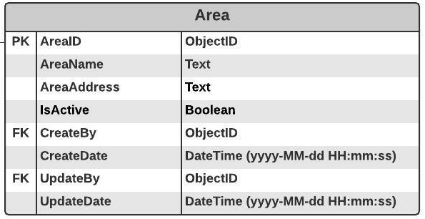

## Functional Detail

### Search Function: when a user clicks on the menu “Area Maintenance”, the system will display a search function screen.

**User Interface**

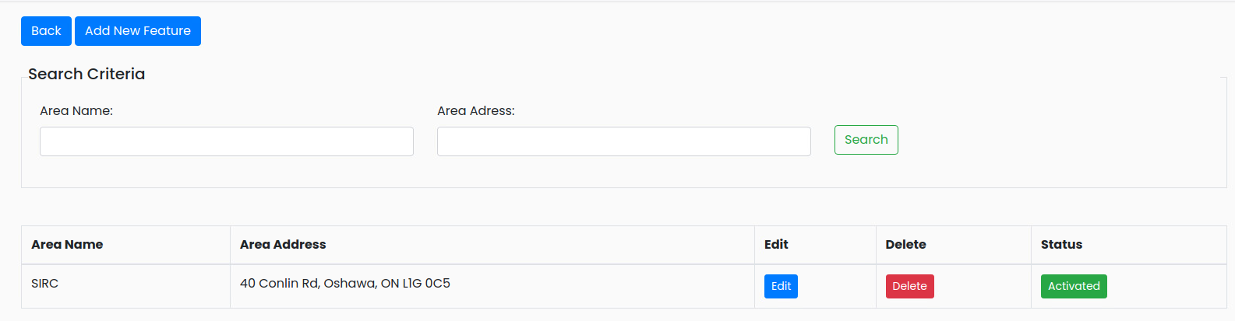

|  |
| --- |
| **Data control** |

| **No.** | **Data Item** | **Data Type** | **Control Type** | **Mandatory** | **Value Range** | **Note** |
| --- | --- | --- | --- | --- | --- | --- |
| **Section:** Area Maintenance [Search – Criteria] | | | | | | |
|  | Area Name | Text | Input | - | 100 | - |
|  | Area Adress | Text | Input | - | 500 |  |
|  | Seach | Button | Button |  |  | Retrieve the data from the database [Area] based on the searching criteria |
| **Section:** Area Information [Search – Result] | | | | | | |
|  | Area Name | Text | Input | - | 100 | [Area.AreaName] |
|  | Area Address | Text | Input Area | - | 500 | [Area.AreaAddress] |
|  | Edit | Botton | Botton |  |  | Event Click   * + Popup the Editing Screen |
|  | Delete | Botton | Botton |  |  | Event Click   * + Popup the Deleting screen |
|  | Status | Botton | Botton |  | 0-1 | Display   * + Inactivate [Area.IsActive =0] and set backgroud color = green   + Activate [Area.IsActive =1] and set backgroud color = gray |

### Add Function: When a user clicks from the searching screen, the system will popup the adding screen below.

**User Interface**

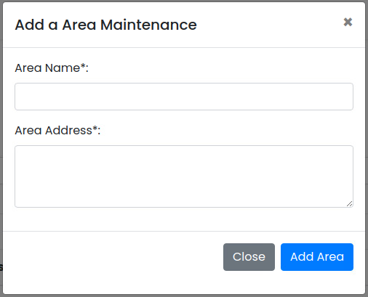

**Data control**

| **No.** | **Data Item** | **Data Type** | **Control Type** | **Mandatory** | **Value Range** | **Note** |
| --- | --- | --- | --- | --- | --- | --- |
| **Section:** Area Information [Add] | | | | | | |
|  | Area Name | Text | Input | Yes | 100 |  |
|  | Area Address | Text | Radio Button | Yes | 500 |  |
|  | Close | Button | Button |  |  | Event Click   * + Close the Adding Screen |
|  | Add Area | Button | Button |  |  | Constrain   * + Check null value for the mandatory fields   + Check duplicate [Area.AreaName]   Add Process:   * + Add the data to table [Area]   + [Area.IsActive] = True   + [Area.CreateBy] = ObjectID of user   + [Area.CreateDate] = Current DateTime (yyyy-MM-dd HH:mm:ss) |

### Edit Function: When a user clicks at the search result screen, the system will popup the editing screen below.

**User Interface**

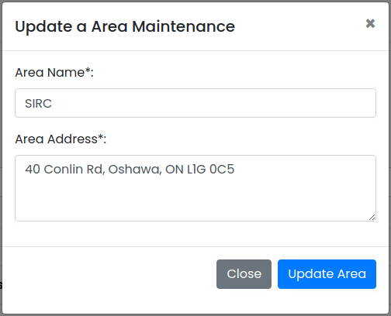

**Data control**

| **No.** | **Data Item** | **Data Type** | **Control Type** | **Mandatory** | **Value Range** | **Note** |
| --- | --- | --- | --- | --- | --- | --- |
| **Section:** Feature Maintenance [Update] | | | | | | |
|  | Area Name | Text | Input | Yes | 100 | [Area.AreaName] |
|  | Area Address | Text | Radio Button | Yes |  | [Area.AreaAddress] |
|  | Close | Button | Button |  |  | Event Click   * + Close the Updating Screen |
|  | Update Feature | Button | Button |  |  | Constrain   * + Check null value for the mandatory fields   + Check Duplicate [Area.AreaName]   Update Process:   * + Update the data to table [Area] where [Area.AreaID]   + [Area.UpdateBy] = ObjectID of user   + [Area.UpdateDate] = Current DateTime (yyyy-MM-dd HH:mm:ss)   Post-process:  Close the popup and refresh the screen |

### Edit Function: When a user clicks at the search result screen, the system will popup a confirmation dialog box below.

**User Interface**

## 

**Data control**

| **No.** | **Data Item** | **Data Type** | **Control Type** | **Mandatory** | **Value Range** | **Note** |
| --- | --- | --- | --- | --- | --- | --- |
| **Section:** Area Maintenance [Delete] | | | | | | |
|  | Close | Button | Button |  |  | Event Click   * Close the screen |
|  | Delete Feature | Button | Button |  |  | Constrain   * Not found in table [CameraStream] [CameraStream. AreaID] = [Area. AreaID]   Delete Process:   * + Delete data from table [Area] where [Area.AreaID]   Post-process:   * + Close the popup and refresh the screen |

### Inactivate Function: When a user clicks at the search result screen, the system will popup the confirmation dialog box below.

**User Interface**

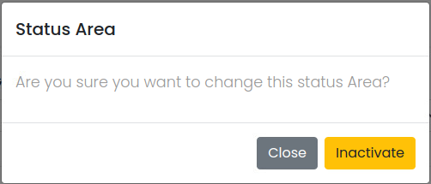

**Data control**

| **No.** | **Data Item** | **Data Type** | **Control Type** | **Mandatory** | **Value Range** | **Note** |
| --- | --- | --- | --- | --- | --- | --- |
| **Section:** Area Maintenance [Inactivate] | | | | | | |
|  | Close | Button | Button |  |  | Event Click   * + Close the screen |
|  | Activated | Button | Button |  |  | Constrain  -  Inactivate Process:   * + [Area.IsActivate]=False   Post-process:  Close the popup and refresh the screen |

### Activate Function: When a user clicks at the search result screen, the system will popup the confirmation dialog box below.

**User Interface**

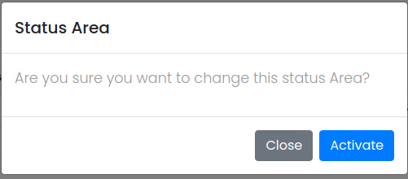

**Data control**

| **No.** | **Data Item** | **Data Type** | **Control Type** | **Mandatory** | **Value Range** | **Note** |
| --- | --- | --- | --- | --- | --- | --- |
| **Section:** Area Maintenance [Activate] | | | | | | |
|  | Close | Button | Button |  |  | Event Click   * + Close the screen |
|  | Inactivated | Button | Button |  |  | Constrain  -  Activate Process:   * + [Area.IsActivate]=True   Post-process:  Close the popup and refresh the screen |