VISION++

***Software Design Specification***

**Real-time Surveillance Detection and Monitoring System**

Vision Plus Plus

|  |  |
| --- | --- |
| **Author** | Vision Plus Plus |
| **Customer** | N/A |
| **Phase** | 1 |
| **Version** | 1.0 |
| **Status** | Draft |
| **Date of Creation** | 2021-10-18 |
| **Last Updated** | 2021-10-18 |

**Document Type**

|  |  |
| --- | --- |
| **Project Name :** | Real-time Surveillance Detection and Monitoring System |
| **Document Name :** | Software Design Specification |
| **Screen Name:** | Camera Stream Information |
| **Ref No :** |  |

**Revision History**

|  |  |  |
| --- | --- | --- |
| **Date** | **Version** | **Description** |
| 2021-10-18 | 1.0 | Create Document |
|  |  |  |
|  |  |  |
|  |  |  |
|  |  |  |
|  |  |  |

1. **Description**

|  |  |  |  |  |  |
| --- | --- | --- | --- | --- | --- |
| **Program ID :** | MAS004 | **Name :** | Camera Stream Maintenance | **System ID. :** | RSDMS |
| **Description :** | To search, add, update and delete a camera stream for the camera live stream dashboard | | | | |
| **Association (Actor) :** | System Admin | | | | |
| **Database Tables** | * Area * CameraStream | | | | |

1. **Functional Design**

## Database Schema

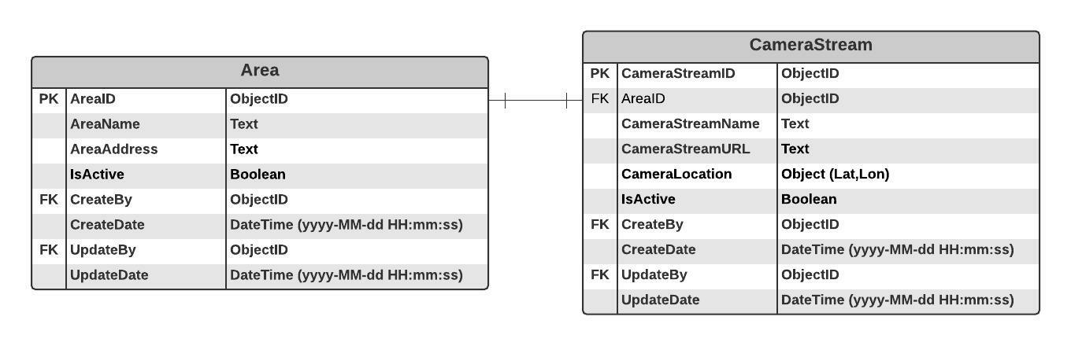

## Functional Detail

### Search Function: when a user clicks on the menu “Camera Stream Maintenance”, the system will display a search function screen.

**User Interface**

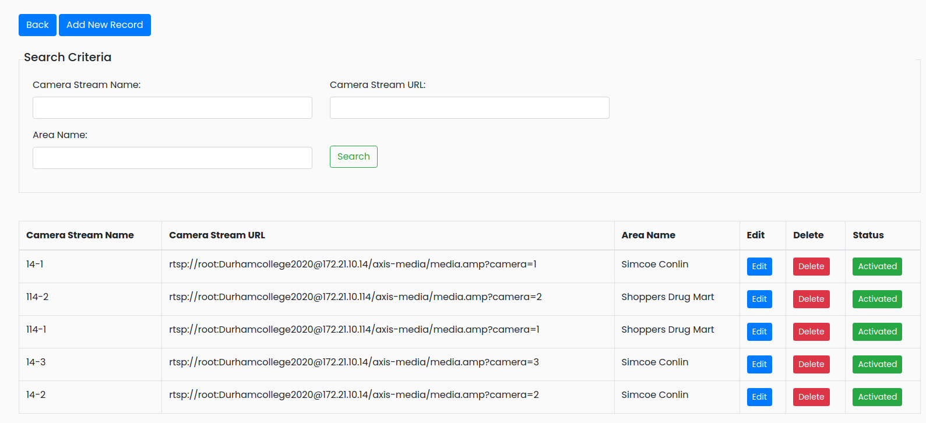

**Data Control**

|  |
| --- |
|  |

| **No.** | **Data Item** | **Data Type** | **Control Type** | **Mandatory** | **Value Range** | **Note** |
| --- | --- | --- | --- | --- | --- | --- |
| **Section:** Camera Stream Maintenance [Search – Criteria] | | | | | | |
|  | Camera Stream Name | Text | Input | - | 100 | - |
|  | Camera URL | Text | Input | - | 500 | - |
|  | Area Name | Text | Input | - | 100 | - |
|  | Seach | Button | Button |  |  | Click Event  Retrieve the data from the database [CameraStream] based on the searching criteria |
| **Section:** Camera Stream Maintenance [Search – Result] | | | | | | |
|  | Camera Stream Name | Text | Input | - | 100 | [CameraStream.CameraStreamName] |
|  | Camera URL | Text | Input | - | 500 | [CameraStream. CameraStreamURL] |
|  | Area Name | Text | Input | - | 100 | [Area.AreaName] |
|  | Edit | Button | Button |  |  | - |
|  | Delete | Button | Button |  |  | - |
|  | Status | Button | Button |  | 0-1 | Display  - Inactivate [CameraStream.isActive =0] and set backgroud color = green  - Activate [CameraStream.isActive =1] and set backgroud color = gray |

### Add Function: When a user clicks from the searching screen, the system will popup the adding screen below.

**User Interface**

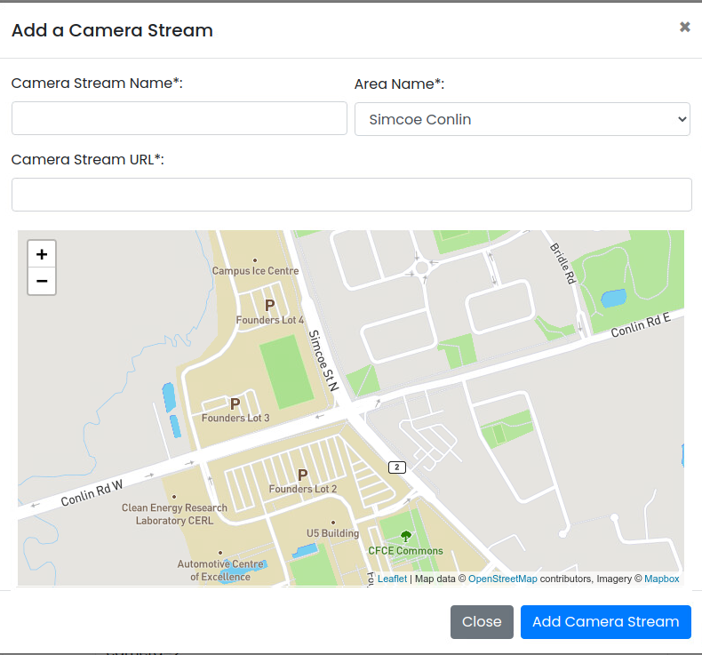

**Data control**

| **No.** | **Data Item** | **Data Type** | **Control Type** | **Mandatory** | **Value Range** | **Note** |
| --- | --- | --- | --- | --- | --- | --- |
| **Section:** Camera Stream Maintenance [Add] | | | | | | |
|  | Camera Stream Name | Text | Input | Yes | 100 | - |
|  | Camera URL | Text | Input | Yes | 500 | - |
|  | Area Name | Text | Drop-down Box | Yes |  | Item Lists:   * + Select data from table [Area]   + Text = [Area.AreaName]   + Value = [Area.AreaID]   Default Value   * + Index = 0 |
|  | Map | Object | Map | Yes |  | Display a map |
|  | Close | Button | Button |  |  | Click Event   * + Close the Adding Screen |
|  | Add Camera Stream | Button | Button |  |  | Constrain   * + Check null value for the mandatory fields   + Check duplicate data [CameraStream.CameraStreamName]   Add Process:   * + Add the data to table [CameraStream]   + [CameraStream.CameraLocation] = [Lat,Lon]   + [CameraStream.IsActive] = True   + [CameraStream.CreateBy] = ObjectID of user   + [CameraStream.CreateDate] = Current DateTime (yyyy-MM-dd HH:mm:ss) |

### Edit Function: When a user clicks at the search result screen, the system will popup the editing screen below.

**User Interface**

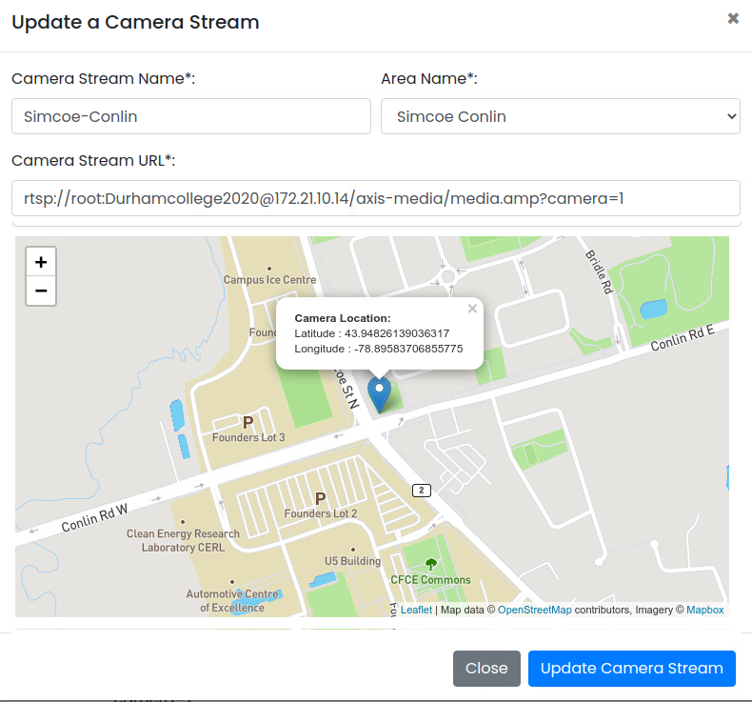

**Data control**

| **No.** | **Data Item** | **Data Type** | **Control Type** | **Mandatory** | **Value Range** | **Note** |
| --- | --- | --- | --- | --- | --- | --- |
| **Section:** Camera Stream Maintenance [Update] | | | | | | |
|  | Camera Stream Name | Text | Input | Yes | 100 | [CameraStream.CameraStreamName] |
|  | Camera URL | Text | Input | Yes | 500 | [CameraStream.CameraStreamURL] |
|  | Area Name | Text | Drop-down Box | Yes |  | Item Lists:   * + Select data from table [Area]   + Text = [Area.AreaName]   + Value = [Area.AreaID]   Default Value :   * + [CameraStream.AreaID] |
|  | Map | Object | Map | Yes |  | Display map and pinpoint at [CameraStream.CameraStreamLocation] |
|  | Close | Button | Button |  |  | Click Event   * + Close the Updating Screen |
|  | Update Camera Stream | Button | Button |  |  | Constrain   * + Check null value for the mandatory fields   + Check Duplicate [CameraStream. CameraStreamName]   Update Process:   * + Update the data to table [CameraStream] where [CameraStream. CameraStreamID]   + [CameraStream.UpdateBy] = ObjectID of user   + [CameraStream.UpdateDate] = Current DateTime (yyyy-MM-dd HH:mm:ss)   Post-process:  Close the popup and refresh the screen |

### Edit Function: When a user clicks at the search result screen, the system will popup a confirmation dialog box below.

**User Interface**

## 

**Data control**

| **No.** | **Data Item** | **Data Type** | **Control Type** | **Mandatory** | **Value Range** | **Note** |
| --- | --- | --- | --- | --- | --- | --- |
| **Section:** Camera Stream Maintenance [Delete] | | | | | | |
|  | Close | Button | Button |  |  | Click Event   * Close the screen |
|  | Delete Feature | Button | Button |  |  | Constrain   * Check data in table [Camera] [Camera.CameraStreamID] = [CameraStream.CameraStreamID] * Found: display a message on the confirmation dialog box and not delete data * Not found: delete process   Delete Process:   * + Delete the from table [Camera] where [Camera.CameraStreamID] = [Feature. CameraStreamID]   + Delete the from table [VideoDemoFeature] where [VideoDemoFeature.FeatureID] = [Feature.FeatureID]   + Delete the from table [ContactFeature] where [ContactFeature.FeatureID] = [Feature.FeatureID]   + Delete data from table [Feature] where [Feature.FeatureID]   Post-process:  Close the popup and refresh the screen |

### Inactivate Function: When a user clicks at the search result screen, the system will popup the confirmation dialog box below.

**User Interface**

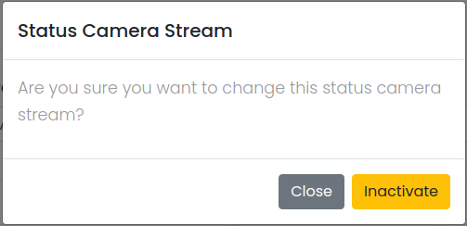

**Data control**

| **No.** | **Data Item** | **Data Type** | **Control Type** | **Mandatory** | **Value Range** | **Note** |
| --- | --- | --- | --- | --- | --- | --- |
| **Section:** Camera Stream Maintenance [Inactivate] | | | | | | |
|  | Close | Button | Button |  |  | Click Event   * Close the screen |
|  | Activated | Button | Button |  |  | Constrain  -  Inactivate Process:   * + [CameraStream.IsActivate]=False   + [CameraStream.UpdateBy] = ObjectID of user   + [CameraStream.UpdateDate] = Current DateTime (yyyy-MM-dd HH:mm:ss)   Post-process:  Close the popup and refresh the screen |

### Activate Function: When a user clicks at the search result screen, the system will popup the confirmation dialog box below.

**User Interface**

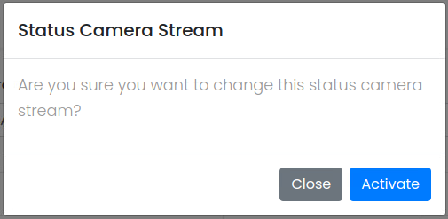

**Data control**

| **No.** | **Data Item** | **Data Type** | **Control Type** | **Mandatory** | **Value Range** | **Note** |
| --- | --- | --- | --- | --- | --- | --- |
| **Section:** Camera Stream Maintenance [Activate] | | | | | | |
|  | Close | Button | Button |  |  | Click Event   * Close the screen |
|  | Inactivated | Button | Button |  |  | Constrain  -  Activate Process:   * + [CameraStream.IsActivate]=True   + [CameraStream.UpdateBy] = ObjectID of user   + [CameraStream.UpdateDate] = Current DateTime (yyyy-MM-dd HH:mm:ss)   Post-process:  Close the popup and refresh the screen |