VISION++

***Software Design Specification***

**Real-time Surveillance Detection and Monitoring System**

Vision Plus Plus

|  |  |
| --- | --- |
| **Author** | Vision Plus Plus |
| **Customer** | N/A |
| **Phase** | 1 |
| **Version** | 1.0 |
| **Status** | Draft |
| **Date of Creation** | 2021-10-18 |
| **Last Updated** | 2021-10-18 |

**Document Type**

|  |  |
| --- | --- |
| **Project Name :** | Real-time Surveillance Detection and Monitoring System |
| **Document Name :** | Software Design Specification |
| **Screen Name:** | Server Information |
| **Ref No :** |  |

**Revision History**

|  |  |  |
| --- | --- | --- |
| **Date** | **Version** | **Description** |
| 2021-10-18 | 1.0 | Create Document |
|  |  |  |
|  |  |  |
|  |  |  |
|  |  |  |
|  |  |  |

1. **Description**

|  |  |  |  |  |  |
| --- | --- | --- | --- | --- | --- |
| **Program ID :** | MAS006 | **Name :** | Server Information | **System ID. :** | RSDMS |
| **Description :** | To search, add, update and delete a server for the video live stream dashboard | | | | |
| **Association (Actor) :** | System Admin | | | | |
| **Database Tables** | * Server * ServerType | | | | |

1. **Functional Design**

## Database Schema

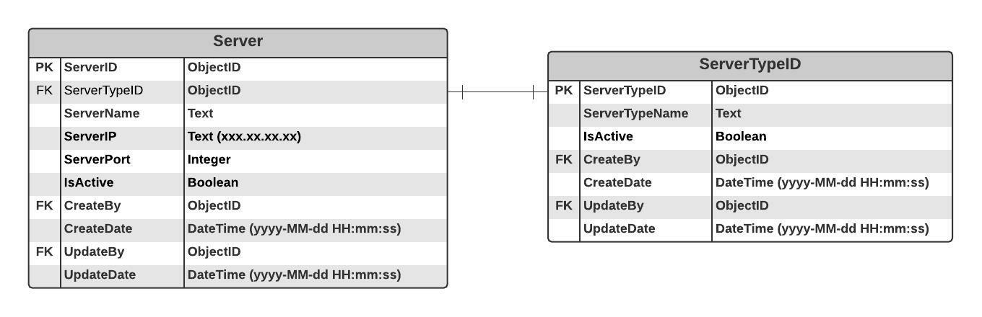

## Functional Detail

### Search Function: when a user clicks on the menu “Server Information”, the system will display a search function screen.

**User Interface**

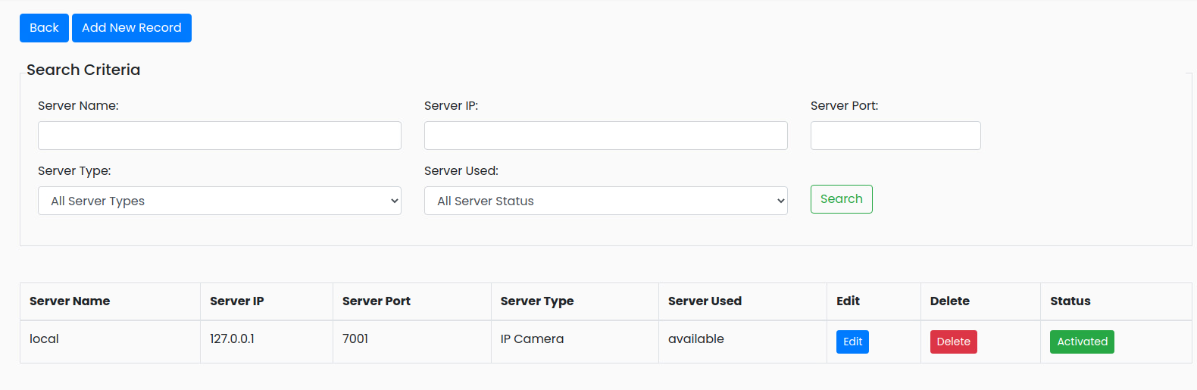

|  |
| --- |
| **Data control** |

| **No.** | **Data Item** | **Data Type** | **Control Type** | **Mandatory** | **Value Range** | **Note** |
| --- | --- | --- | --- | --- | --- | --- |
| **Section:** Server Maintenance [Search – Criteria] | | | | | | |
|  | Server Name | Text | Input | - | 100 | - |
|  | Server IP | Text | Input | - | 100 | - |
|  | Server Port | Integer | Input | - | 1-1000 | - |
|  | Server Type | Text | Drop-down Box | - |  | Item List   * + All Server Types   + Application User Interface   + IP Camera   + Demo Video   + Database |
|  | Server Used | Text | Drop-down Box | - |  | Item List   * + All Server Status   + Available   + Used |
|  | Seach | Button | Button |  |  | Event Click   * + Retrieve the data from the database [Server] based on the searching criteria |
| **Section:** Server Maintenance [Search – Result] | | | | | | |
|  | Server Name | Text | Input | - | 100 | [Server.ServerName] |
|  | Server IP | Text | Input | - | 100 | [Server.ServerIP] |
|  | Server Port | Integer | Input | - | 1-1000 | [Server.ServerPort] |
|  | Server Type | Text | Drop-down Box |  |  | [Server.ServerTypeID] |
|  | Group Type | Integer | Radio Box | - | 0-1 | Display   * + Camera Live [Group.GroupType=0]   + Demo Video [Group.GroupType=1] |
|  | Edit | Button | Button |  |  | Event Click   * + Popup the Editing Screen |
|  | Delete | Button | Button |  |  | Event Click   * + Popup the Deleting screen |
|  | Status | Button | Button |  | 0-1 | Display   * + Inactivate [Group.isActive =0]   + Activate [Group.isActive =1] |

### Add Function: When users click from the searching screen, the system will popup the adding screen below.

**User Interface**

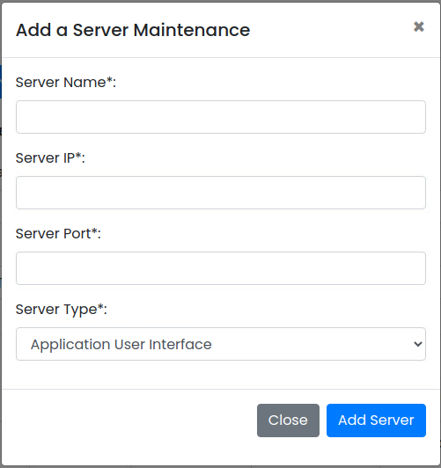

**Data control**

| **No.** | **Data Item** | **Data Type** | **Control Type** | **Mandatory** | **Value Range** | **Note** |
| --- | --- | --- | --- | --- | --- | --- |
| **Section:** Server Maintenance [Add] | | | | | | |
|  | Server Name | Text | Input | Yes | 100 | - |
|  | Server IP | Text | Input | Yes | 100 | - |
|  | Server Port | Integer | Input | Yes | 0-9999 |  |
|  | Server Type | Text | Drop-down Box | Yes |  | Item Lists:   * + Select the data from table [ServerType] where [ServerType.IsActivate =0]   Default Value   * + Index = 0 |
|  | Close | Button | Button |  |  | Event Click   * + Close the Adding Screen |
|  | Add Group | Button | Button |  |  | Constrain   * + Check null value for the mandatory fields   + Check duplicate [Server.ServerName]   + Connect to the server [Server Name]: [Server Port]   - If status = ‘fail”: display a message and not save the data to the database    Add Process:   * + Add the data to table [Server]   + [Server.IsActive] = True   + [Server.CreateBy] = ObjectID of user   + [Server.CreateDate] = Current DateTime (yyyy-MM-dd HH:mm:ss) |

### Edit Function: When a user clicks at the search result screen, the system will popup the editing screen below.

**User Interface**

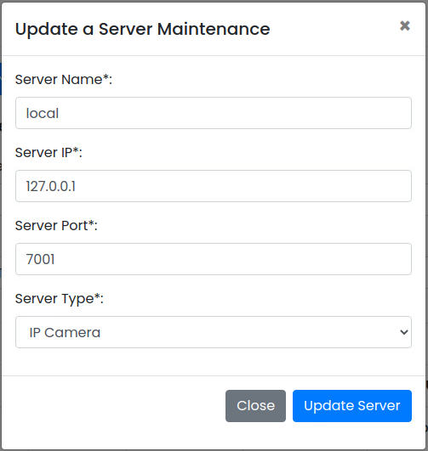

**Data control**

| **No.** | **Data Item** | **Data Type** | **Control Type** | **Mandatory** | **Value Range** | **Note** |
| --- | --- | --- | --- | --- | --- | --- |
| **Section:** Server Maintenance [Update] | | | | | | |
|  | Server Name | Text | Input | Yes | 100 | - |
|  | Server IP | Text | Input | Yes | 100 | - |
|  | Server Port | Integer | Input | Yes | 0-9999 |  |
|  | Server Type | Text | Drop-down Box | Yes |  | Item Lists:   * + Select the data from table [ServerType] where [ServerType.IsActivate =0]   Default Value   * + [Server.ServerTypeID] |
|  | Close | Button | Button |  |  | Click Event  Close the updating screen |
|  | Update Group | Button | Button |  |  | Constrain   * + Check null value for the mandatory fields   + - Check Duplicate [Server.ServerName]   + Connect to the server [Server Nmae]: [Server Port]   Update Process:   * + Update the data to table [Server] where [Server.ServerID]   + [Server.UpdateBy] = ObjectID of user   + [Server.UpdateDate] = Current DateTime (yyyy-MM-dd HH:mm:ss) |

### Edit Function: When a user clicks at the search result screen, the system will popup a confirmation dialog box below.

**User Interface**

## 

**Data control**

| **No.** | **Data Item** | **Data Type** | **Control Type** | **Mandatory** | **Value Range** | **Note** |
| --- | --- | --- | --- | --- | --- | --- |
| **Section:** Server Maintenance [Delete] | | | | | | |
|  | Close | Button | Button |  |  | Click Event   * Close the screen |
|  | Delete Feature | Button | Button |  |  | Constrain   * Check data in table [Camera] [Camera.ServerID] = [Server.ServerID] * Found: display message on the confirmation dialog box and not delete data * Not found: delete process   Delete Process:   * + Delete data from table [Server] where [Server.ServerID]   Post-process:   * Close the popup and refresh the screen |

### Inactivate Function: When a user clicks at the search result screen, the system will popup the confirmation dialog box below.

**User Interface**

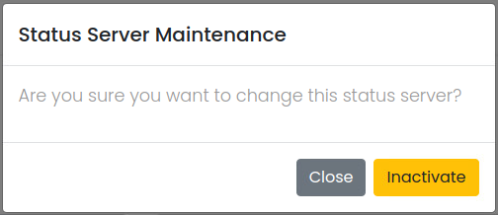

**Data control**

| **No.** | **Data Item** | **Data Type** | **Control Type** | **Mandatory** | **Value Range** | **Note** |
| --- | --- | --- | --- | --- | --- | --- |
| **Section:** Server Maintenance [Inactivate] | | | | | | |
|  | Close | Button | Button |  |  | Click Event   * + Close the screen |
|  | Activated | Button | Button |  |  | Constrain  -  Inactivate Process:   * + [Sever.IsActivate]=False   + [Sever.UpdateBy] = ObjectID of user   + [Sever.UpdateDate] = Current DateTime (yyyy-MM-dd HH:mm:ss)   Post-process:   * + Close the popup and refresh the screen |

### Activate Function: When a user clicks at the search result screen, the system will popup the confirmation dialog box below.

**User Interface**

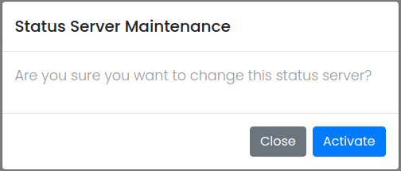

**Data control**

| **No.** | **Data Item** | **Data Type** | **Control Type** | **Mandatory** | **Value Range** | **Note** |
| --- | --- | --- | --- | --- | --- | --- |
| **Section:** Server Maintenance [Activate] | | | | | | |
|  | Close | Button | Button |  |  | Click Event   * + Close the screen |
|  | Inactivated | Button | Button |  |  | Constrain  -  Activate Process:   * + [Sever.IsActivate]=True   + [Sever.UpdateBy] = ObjectID of user   + [Sever.UpdateDate] = Current DateTime (yyyy-MM-dd HH:mm:ss)   Post-process:   * + Close the popup and refresh the screen |