SHA-2 ALGORITHM

INTRODUCTION
. SHA-2

SHA-2 operates in much the same way as SHA-1, but because values of 512-bits are possible, the primary differences are more initial blocks of messages (8 instead of 5), fewer numbers of rounds (64 instead of 80), the use of right shifts as well as left shifts (SHA-1 only uses left shifts), constants for each round instead of blocks of rounds and the use of 64-bit inputs on the 512-bit function over the 32-bit for all others [7].

This greatly reduces the risk of collisions and to date none have been found.

Although SHA-2 is increasing in popularity, SHA-1 is still significantly used, not least for its incorporation into the Trusted Platform Module (TPM) ASIC [4]. However, TPM are currently investigating the use of SHA-2 in later modules [21]. If this takes place, the ASIC will also have to contain backwards-compatibility to SHA-1 for communication with older systems.

Therefore, it is important that an ASIC can manage creation of SHA-1 and SHA-2 message digests at a speed where delay would not be noticed on a high-speed internet connection ([22] suggests a speed of 40Gbit/sec for a Fibre-optic line).

SHA-512 operates on messages less than 2128 bits or over 1025 terabytes, in length. It is an iterative algorithm consisting of four stages: message padding, message expansion, message compression and the hash update. In order to process a single block of data 80 iterations, or rounds, of the message compression stage are performed. Figure 2.1 shows a high level block diagram of the stages involved in the SHA-512 hashing algorithm. A more detailed diagram is shown in Figure 2.2.

The notation shown in Table 2.1 will be used to facilitate the description of the SHA-512 hashing algorithm. The SHA-512 algorithm requires evaluation of six logical functions every iteration. These functions consist of simple operations such as shift, rotate and

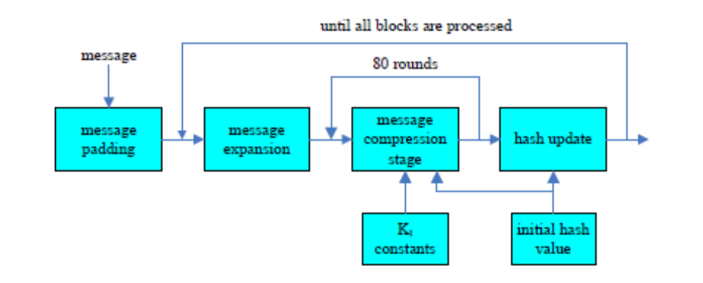
Figure 2.1: High level block diagram depicting the structure of the SHA-512 hashing algorithm

exclusive-or, referred to as ⊕ throughout the rest of this work. The algorithm also requires two sets of constants: the initial hash value and a matrix, Kt, consisting of the first 64 bits of the fractional parts of the cube roots of the first 80 prime numbers. The initial hash value constants are shown in Table 2.3. Table 2.4 contains the Kt constants. The values are oriented in a left to right, top to bottom fashion to save space. The Kt constants are used in the message compression stage of the algorithm.

2.1.1 MESSAGE PADDING

In order to ensure that the data to be hashed is aligned on the appropriate bit boundary a padding stage, also known as Merkle-Damgard strengthening is performed on the data to be hashed. First a single ’1’ bit is appended to the end of the message, followed by a variable number of ’0’ bits. The number of ’0’ bits appended is such that the message length becomes a multiple of 896. Then the length of the original message, before any padding has been done, is appended as an unsigned 128 bit integer. As a result, padding

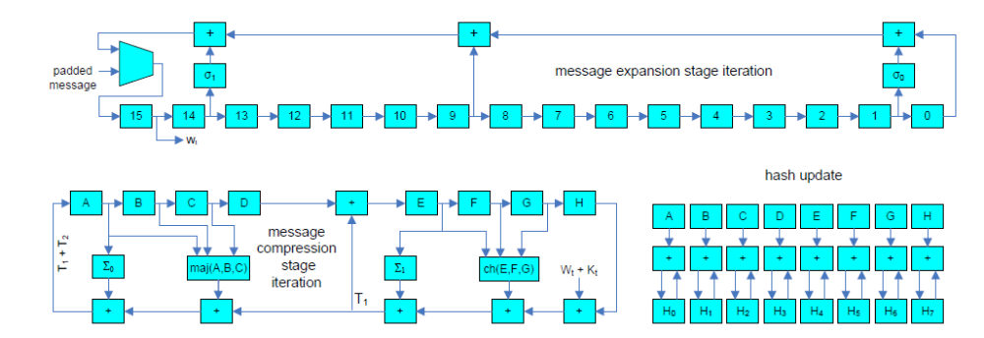
Figure 2.2: Detailed block diagram depicting the structure of the SHA-512 hashing algorithm

2.1.2 MESSAGE EXPANSION

The message expansion stage generates the message schedule by performing a series of operations on the data contained in the current 512-bit block as shown in Table 2.5. This results in a message schedule consisting of 5120 bits of data, since each Wt is 64 bits long and there are 80 such Wt’s, one for each iteration of the message schedule. It should be noted that the first 1024 bits of the message schedule consists simply of the data block currently being operated on.

2.1.3 MESSAGE COMPRESSION

The message compression stage takes the 5120 bits generated by the message schedule and compresses them to 512 bits. These bits are used to represent the hash value of the current block. During the first iteration, working variables a through h are initialized with the values shown in Table 2.3. Just like the message expansion stage, this stage consists of 80 iterations. For each iteration, t, the sequence of operations performed is shown in Table 2.6. After 80 iterations are completed the values of a through h are used in the hash update stage.

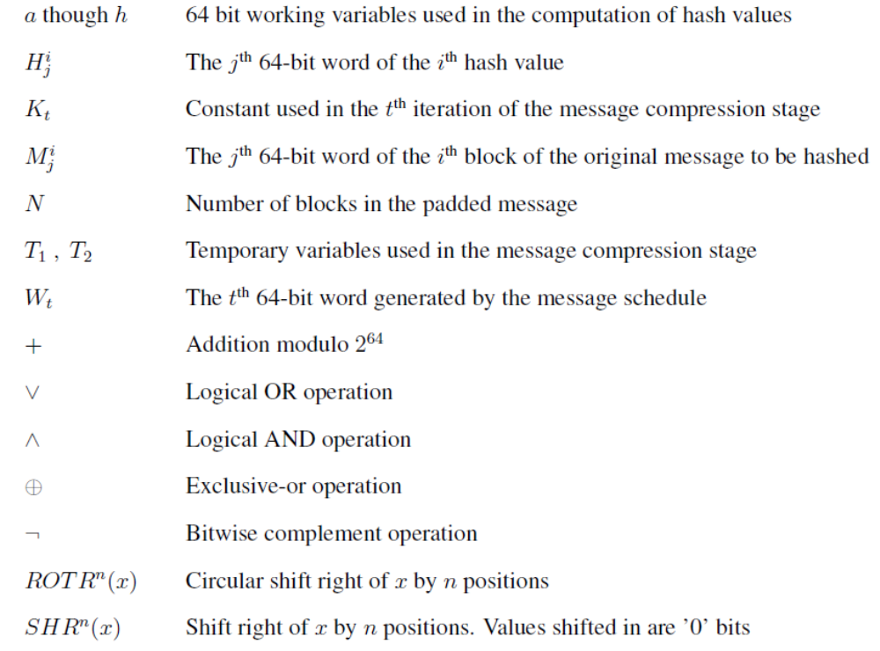

2.1.4 HASH UPDATE

The initial hash value represented by H0 is initialized using the constants. The hash update stage simply accumulates the final values of a through h after the message compression completes. In other words, the hash update stage executes once for each data block of the padded message. The accumulated values are stored in the Hi variables. The final hash value consists of the concatenation of HN through HN

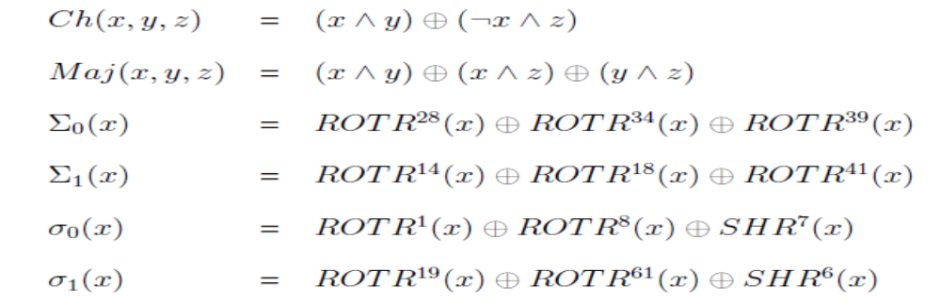
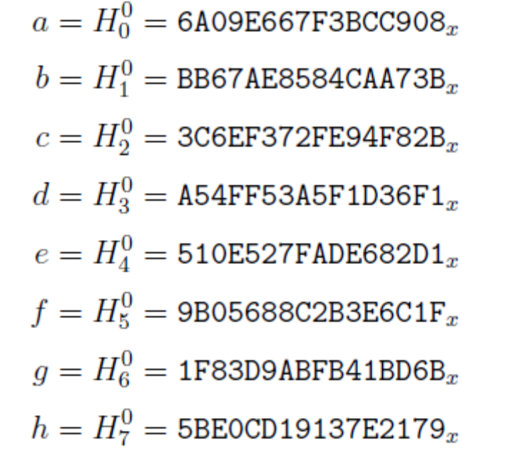

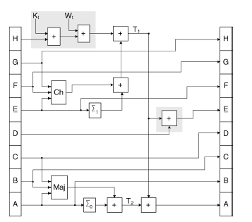
Figure 4: SHA-2 Round Calculation

COMPARISON OF SH A HASH FUNCTIONS

While SHA-1’s strength has been compromised in recent years, it is still deemed suitable for many applications. This combined with the use within the Trusted Platform Module means SHA-1 will be in use for the significant future, unless a major collision or other issue is found. If this occurs; deploying a replacement would be difficult [8]. The work by NIST and academics strongly shows that the importance of hash functions is clearly recognized and their strengths widely used. However, we should not be complacent and believe the currently used functions are suitable for the significant future.

Since SHA-1 has already been shown to have possible collisions and with further cryptographic techniques under constant investigation, weaknesses in currently “safe” hash functions could quickly be identified and exploited. This, combined with the increase in computing power in line with Moore’s Law means 512-bit keys may be insufficient in the near future. Some authors, such as Buchmann, believe that cryptographic functions are limited by governments as currently they are only breakable by an organization with a great deal of computing power such as the FBI [6].

When DES was originally developed and released in the 1970’s, only the US government had computers powerful enough to break its key in a feasible timeframe. As the number of transistors in home computers increased, DES became unusable and AES was introduced, with triple-DES as a temporary countermeasure. This principle will continue and algorithms must be successfully future-proofed to prevent their exploitation. Current recommendations by security experts such as Vacca suggest that SHA-2 be used until SHA-3 is available in late 2012 [24].

PRE-PROCESSING

SHA-2 takes the 512-bit input message and expands to 64 blocks of 32 bits each. This is performed using two variables S0 and S1, created using previous blocks passed through the right circular shift and the Exclusive OR operation. These are then added to previous blocks within the ALU and give the blocks 17-63. This is similar to the program for SHA-1, and only required the addition of the right-circular and logical shifter to the shifter block, as well as two extra opcodes to allow this part of the logic to execute. The design of a right shifter is identical to the left circular shift, except the LSB now becomes the MSB, rather than the other way round. Due to testing of this at SHA-1, the entity was not retested individually, but instead as part of the integrated program.

ROUND CALCULATIONS

The round calculation in SHA-2 is constant for all 64 rounds. Six variables are used, all using a mixture of logical, shifting and addition operations, as well as adding the round-dependant blocks and constants to create the eight hash values for the round. Therefore, these variables were calculated using already existing blocks from SHA-1 and were not individually tested. Instead, as with the pre-processing, they were tested within the final program to check for a successful output.

The logical values were as follows:

S0 = (a ROTR 2) XOR (a ROTR 13) XOR (a ROTR 22)
MAJ = (a AND b) XOR (a AND c) XOR (b AND c)
T2 = S0 + MAJ
S1 = (e ROTR 6) XOR (e ROTR 11) XOR (e ROTR 25)
CH = (e AND f) XOR ((NOT e) AND g)
T1 = h + S1 + CH + k[i] + w[i]

Where k[i] is the round constant and w[i] is the message round value These values are added to the variables a – h, which are added to the initial hash values h0 –h7. This is repeated 64 times, giving a hash output of h0 – h7 after this is complete.

