**TRIBHUVAN UNIVERSITY**



PURWANCHAL ENGINEERING CAMPUS

DHARAN –8, SUNSARI

**A PROJECT PROPOSAL**

**ON**

# **STOCK PRICE PREDICTION**

**Submitted by:**

Manish Kumar Rajak (PUR075BCT037)

Bikash Gupta (PUR075BCT022)

Naresh Kumar Chaudhary (PUR075BCT048)

Lalit Chataut (PUR075BCT044)

**Submitted to:**

Department of Electronics and Computer Engineering

Purwanchal Campus, Dharan

May 23, 2022

**ABSTRACT**

Market prediction offers great profit avenues and is a fundamental stimulus for most researchers in this area. To predict the market, most researchers use either technical or fundamental analysis. Technical analysis focuses on analyzing the direction of prices to predict future prices, while fundamental analysis depends on analyzing unstructured textual information like financial news and earning reports. More and more valuable market information has now become publicly available online. The proposed algorithm using the market data to predict the share price using machine learning techniques like recurrent neural network named as Long Short-Term Memory, in that process weights are corrected for each data points using stochastic gradient descent. This system will provide accurate outcomes in comparison to currently available stock price predictor algorithms. The network is trained and evaluated with various sizes of input data to urge the graphical outcomes.

**Keywords: -**

Machine Learning, Stock Price Prediction, Long Short-Term Memory, Stock Market, Artificial neural Networks.

**TABLE OF CONTENTS**

ABSTRACT ................................................................................................2

1: INTRODUCTION ..................................................................................4

2: Literature Review …...............................................................................5

3. Background ...........................................................................................5

4.Statement of Problem …..........................................................................6

5. Objectives ..............................................................................................6

6. Applications ...........................................................................................6

7. Feasibility Analysis ................................................................................7

7.1 Technical Feasibility .................................................................7

7.2 Economical Feasibility ..............................................................7

7.3 Social Feasibility .......................................................................7

8: System Requirements ...............................................................................7

9: Methodology ............................................................................................9

10: Expected Output ....................................................................................12

11: Result & Conclusion .............................................................................12

12: References .............................................................................................13

1. **Introduction: -**

The share market is a place where the shares of a public company are traded. As discussed in [1] the volatile nature of the stock market makes it an area which needs an abundance of analysis with the old data predicated. The previous stock trend prediction algorithms use the historic time series stock data. The typical scientific stock price forecasting procedures are focused on the statistical analysis of stock data. In this, a stock data prediction program that uses previous stock prices and data will be treated as training sets for the program to predict the stock prices of a particular share this program develops a procedure.

This model considers the historical equity share price of a company price and applies RNN (Recurrent) technique called Long Short-Term Memory (LSTM). The proposed approach considers available historic data of a share market and it provides prediction on a particular feature. The features of shares are opening price, closing price, day high price, day low price and total volume traded. The proposed model uses the time series analysis in order to predict a share price for a required time span. The data of different companies from different sectors that are currently running in Nepal is extracted from nepsealpha website. The opening price, closing price, day high and day low price are taken into consideration for prediction. Users can manage their portfolio and keep the record of the stock that they buy and sell. We can also get latest updated news about stock market. Users can also manage their portfolio and manage their watch list. As suggested by [2] The Long Short-Term Memory (LSTM) networks are a type of recurrent neural network (RNN) capable of addressing linear problems. LSTM is a deep learning technique. Long-term Memory (LSTM) Units are enforced to learn very long sequences. This is a more general version of the gated recurrent system. LSTM is more benign than other deep learning methods

A. *Stock Exchange in Nepal*

The only stock exchange in Nepal is Nepal Stock Exchange indexed as “NEPSE”. NEPSE functions on NATS, NEPSE Automated Trading System; a total screen-based trading that adopts the basics of an order driven demand. Buying and selling of physical and dematerialized securities is done through NATS. NEPSE was founded in 13th January, 1993 A.D under the company Act, operating under Securities Exchange Act. NEPSE list various sub-indexes including Commercial Bank, Hydropower’s, Insurance, Hotels and Manufacturing Companies. The popular public companies listed in NEPSE are Agriculture Development Bank, Arun Hydropower, Everest Bank Limited, Nepal life insurance, Bottlers Nepal Limited etc. NEPSE stock exchange has listed 331 companies up to now. Market closes before 3 pm every day except holidays and Saturday. During Saturday and Holidays, there are no stock openings.

1. **Literature Review: -**

There are various methodologies and proposed approaches for the analysts to predict future stock market value through various predicting methodologies. There are papers such as ‘An Ensemble Stock Predictor and Recommender System’[1], ‘Prediction of Bombay Stock Exchange Market Returns using ANN and Genetic Algorithm’ [3], ‘Stock Market Prices do not follow Random Walks’ [4]. In these study and related research, the individuals have attempted to utilize and provide methods to predict the future stock market value. Also, some have attempted to analyze the various methods that help in stock market prediction which could help the researchers and business people in deciding the methods that would be viable for their defined purpose. ‘We recognized that the short-term VMA rules are more effective in forecasting stock movement than the long-term ones.’. ‘At a deeper level, this work shows how social media expresses a collective wisdom which, when properly tapped, can yield an extremely powerful and accurate indicator of future outcomes, as well as networking opportunities and application of classroom learning to real-world issues.’ Ultimately, these types of projects allow investors to utilize methods proposed to improve their investment strategies. When it is the case of investing in stocks, it is important that the investors be capable enough to conduct a thorough technical analysis of the stock charts. The successful prediction of a stock’s future price could yield significant profit to the investors that helps investors to make financial decisions of buying, holding, or selling stocks.

**3. Background: -**

“NEPSE” opened its trading floor on 13th January 1994, since then people started trading on “NEPSE”. Nepal Stock Exchange Limited officially launched NEPSE online trading system (NOTS) on 6th November 2018. “NOTS” is designed to allow investors to place their orders online, while everything including trading, clearing and settlement can be carried out electronically. Before online trading system, the trading was done through paper works. After the formulation of NOTS, all the data related to stock market were stored digitally online.

**4. Statement of the problem: -**

The beginners or the people who are new to the stock market do not have basic idea of the market. However, they are willing to invest in order to gain profit without having the risk of loss. So, this application will help them to reduce the risk of loss to some extent. All share market related news and notices are available under one application which greatly eases the difficulty of searching stock related news especially for those people who are busy all day with their work life. Furthermore, people often forget purchase details of stocks like purchase price, purchase date etc. This information is stored where users can view their purchased stocks and their respective details. Many people are unaware of commissions that brokers and institutions issuing DP service charge for the services offered by them which causes the sell price or buy price to differ while buying or selling particular stock, so this application shows exact prices by considering those extra charges.

**5. Objectives: -**

* To predict the stock prices.
* To make more accurate and more informed investment decisions.
* To share trade ideas by analyzing past trading.
* To gather stock research materials and thus narrows our focus.

**6. Applications: -**

Stock market prediction aims to determine the future movement of the stock value of a finance exchange. The accurate prediction of share price movement will lead to more profit that investors would like to make. Market prediction offers great profit avenues and is a fundamental stimulus for most researchers in this area.

**7. Feasibility: -**

**7.1 Technical Feasibility: -**

Our project is technically feasible because we implemented our project using Flutter and Python and all resources that are required for the project are easily available.

**7.2 Economic Feasibility: -**

As this application do not require many human resources, tools etc. So, the economic feasibility of this project seems to be possible however some costs are required for hosting, CI/CD cost etc. For the deployment of application one time charge by google is required.

**7.3 Social Feasibility: -**

As there are many new investors in stock market without prior knowledge of market. So, with few improvements in the project we can guide them for making better investment decisions. So, it is socially feasible.

**8. System Requirements: -**

The system requirements of the project are:

* 1. Intel Core i7-10750H.
* 2. 8 GB RAM.
* 3. 1 GB of hard disk space.
* 4. Good internet connection.
* 5. Microsoft Windows 11.
* 6. Code Editor.

**USE CASE Diagram: -**

**9. Methodology: -**

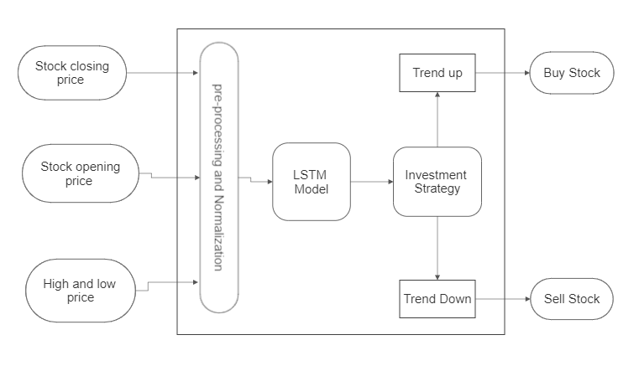

Fig.1: Stock Predictive Investment Decision Model

The development of this paper involves 5 major steps which is depicted in the flow diagram given below:

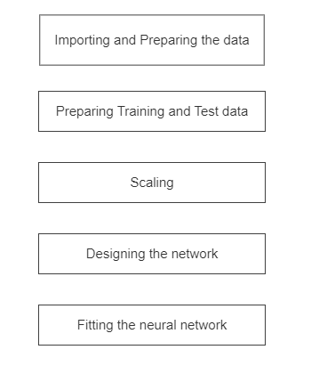

Fig. 2: Steps involved in development of model

1. **Data Collection and Preparation:**

Data is collected from the targeted website i.e., www.nepsealpha.com. Different information different companies of Nepal are collected which include open price, close price, maximum price, minimum price over different series of years. For that, we performed reverse engineering on nepsealpha website to obtain required data. Python script is written to fetch the market data from [www.nepsealpha.com](http://www.nepsealpha.com) website.

1. **Preparing training and test data:**

After we model our data and estimate the skill of our model on the training dataset, we need to get an idea of the skill of the model on new unseen data. For a normal classification or regression problem, we would do this using cross validation. With time series data, the sequence of values is important. A simple method that we can use is to split the ordered dataset into train and test datasets. The code below calculates the index of the split point and separates the data into the training datasets with 80% of the observations that we can use to train our model, leaving the remaining 10% for testing the model and validating the result each.

1. **Data scaling:**

Most neural network architectures benefit from scaling the inputs (sometimes also the output) because most common activation functions of the network’s neurons such as tanh or sigmoid are defined on the [-1, 1] or [0, 1] interval respectively. LSTMs are sensitive to the scale of the input data, specifically when the sigmoid (default) or tanh activation functions are used. It can be a good practice to rescale the data to the range of 0-to-1, also called normalizing. We can easily normalize the dataset using the MinMaxScaler preprocessing class from the scikit-learn library.

1. **Designing the network architecture:**

After having defined the placeholders, variables, initializers, cost functions and optimizers of the network, the model needs to be trained. Usually, this is done by minibatch training. During minibatch training random data samples of n = batch-size are drawn from the training data and fed into the network. The training dataset gets divided into n / batch-size batches that are sequentially fed into the network. At this point the placeholders X and Y come into play. They store the input and target data and present them to the network as inputs and targets.

A sampled data batch of X flows through the network until it reaches the output layer. There, TensorFlow compares the models' predictions against the actual observed targets Y in the current batch. Afterwards, TensorFlow conducts an optimization step and updates the networks parameters, corresponding to the selected learning scheme. After having updated the weights and biases, the next batch is sampled, and the process repeats itself. The procedure continues until all batches have been presented to the network. One full sweep over all batches is called an epoch. The training of the network stops once the maximum number of epochs is reached or another stopping criterion defined by the user applies. The model quickly learns the shape and location of the time series in the test data and can produce an accurate prediction after some epochs.

1. **Error Calculation:**

The root-mean-square error (RMSE) (or sometimes root-mean-squared error) is a frequently used measure of the differences between values (sample or population values) predicted by a model, or an estimator and the values observed.

Normalizing the RMSD facilitates the comparison between datasets or models with different scales. Though there is no consistent means of normalization, common choices are the mean or the range (defined as the maximum value minus the minimum value) of the measured data:

Formula used: -

RMSE = $\sqrt{\left(MSE\left(ypredicted,ytest\right)\right)}$

**10. Expected Output: -**

This project is expected to allow user to add their desired stock to watchlist. This project will predict the trend of stock price of those stocks in the watchlist and give user idea whether to sell or hold the stock. It will help to decrease the risk of loss in the stock market.

**11. Result and Conclusion: -**

This system will be developed by using Flutter as a frontend for android as well as iOS devices. We will be using Python to predict the future price of stock. The Rest API will be provided by using Django for the application. Firebase shall also be used for authentication. The algorithm used for the prediction of stock price will be stacked Long Short-Term Memory (LSTM). We will be following Domain-Driven design (DDD) architecture for coding and Visual studio code as IDE. Thus, the stock market price shall be predicted using the LSTM algorithm written in python and above-mentioned hardware requirements.

**12. References: -**

[1] Loke.K.S. “Impact of Financial Ratios and Technical Analysis on Stock Price Prediction Using Random Forests”, IEEE, 2017.

[2] M. S. Hegde, G. Krishna and R. Srinath, "An Ensemble Stock Predictor and Recommender System," 2018 International Conference on Advances in Computing, Communications and Informatics (ICACCI), Bangalore, 2018, pp. 1981-1985.

[3] Y. Perwej and A. Perwej, “Prediction of the Bombay Stock Exchange (BSE) Market Returns Using Artificial Neural Network and Genetic Algorithm,” Journal of Intelligent Learning Systems and Applications, vol. 04, no. 02, pp. 108–119, may 2012. [Online]. Available: <http://www.scirp.org/journal/doi.aspx?DOI=10.4236/jilsa.2012.42010>

[4] J. J. Dsouza and T. Mallikarjunappa, “Do the Stock Market Indices Follow Random Walk?” Asia-Pacific Journal of Management Research and Innovation, vol. 11, no. 4, pp. 251–273, dec 2015. [Online]. Available: <http://journals.sagepub.com/doi/10.1177/2319510X15602969>

[5] Flutter documentation: - https://docs.flutter.dev/get-started/install/windows

[6] Firebase documentation: - https://firebase.flutter.dev/docs/overview/