**1.tcp**

Client:

import java.net.*;

import java.io.*;

public class Client

{

private Socket socket = null;

private DataInputStream input = null;

private DataOutputStream out = null;

public Client(String address, int port)

{

try

{

socket = new Socket(address, port);

System.out.println("Connected");

input = new DataInputStream(System.in);

out = new DataOutputStream(socket.getOutputStream());

}

catch(UnknownHostException u)

{

System.out.println(u);

}

catch(IOException i)

{

System.out.println(i);

}

String line = "";

while (!line.equals("Over"))

{

try

{

line = input.readLine();

out.writeUTF(line);

}

catch(IOException i)

{

System.out.println(i);

}

}

try

{

input.close();

out.close();

socket.close();

}

catch(IOException i)

{

System.out.println(i);

}

}

public static void main(String args[])

{

Client client = new Client("127.0.0.1", 5000);

}

}

Server:

import java.net.*;

import java.io.*;

public class Server

{

private Socket socket = null;

private ServerSocket server = null;

private DataInputStream in = null;

public Server(int port)

{

try

{

server = new ServerSocket(port);

System.out.println("Server started");

System.out.println("Waiting for a client ...");

socket = server.accept();

System.out.println("Client accepted");

in = new DataInputStream(new bufferedInputStream(socket.getInputStream()));

String line = "";

while (!line.equals("Over"))

{

try

{

line = in.readUTF();

System.out.println(line);

}

catch(IOException i)

{

System.out.println(i);

}

}

System.out.println("Closing connection");

socket.close();

in.close();

}

catch(IOException i)

{

System.out.println(i);

}

}

public static void main(String args[])

{

Server server = new Server(5000);

}

}

**2. Implement echo server using UDP**.

Client:

import java.io.*;

import java.net.*;

class UDPClient{

public static void main(String args[]) throws Exception {

BufferedReader in =new BufferedReader(new InputStreamReader(System.in));

DatagramSocket clientSocket = new DatagramSocket();

InetAddress IPAddress = InetAddress.getByName("localhost");

byte[] sendData = new byte[1024];

byte[] receiveData = new byte[1024];

String sentence = in.readLine();

sendData = sentence.getBytes();

DatagramPacket sendPacket = new DatagramPacket(sendData, sendData.length, IPAddress, 9876);

clientSocket.send(sendPacket);

DatagramPacket receivePacket = new DatagramPacket(receiveData,receiveData.length);

clientSocket.receive(receivePacket);

String modifiedSentence = new String(receivePacket.getData());

System.out.println("FROM SERVER:" + modifiedSentence);

clientSocket.close();

}

}

Server:

import java.io.*;

import java.net.*;

class UDPServer{

public static void main(String args[]) throws Exception {

DatagramSocket serverSocket = new DatagramSocket(9876);

byte[] receiveData = new byte[1024];

byte[] sendData = new byte[1024];

while(true) {

DatagramPacket receivePacket = new DatagramPacket(receiveData, receiveData.length);

serverSocket.receive(receivePacket);

String sentence = new String( receivePacket.getData());

System.out.println("RECEIVED: " + sentence);

InetAddress IPAddress = receivePacket.getAddress();

int port = receivePacket.getPort();

String capitalizedSentence = sentence.toUpperCase();

sendData = capitalizedSentence.getBytes();

DatagramPacket sendPacket = new DatagramPacket(sendData, sendData.length, IPAddress, port);

serverSocket.send(sendPacket);

}

}

}

1. Design a Web service using Simple Object Access Protocol (SOAP).

**Source Code:**

**// MD5WebService.java**

package vce.webservices.server;

import java.security.MessageDigest;

import java.security.NoSuchAlgorithmException;

import javax.jws.WebMethod;

import javax.jws.WebService;

@WebService

public class MD5WebService {

@WebMethod

public String hashString(String input) {

try {

MessageDigest msgDigest = MessageDigest.getInstance("MD5");

byte[] inputBytes = input.getBytes();

byte[] hashedBytes = msgDigest.digest(inputBytes);

StringBuffer sb = new StringBuffer();

for (int i = 0; i < hashedBytes.length; i++) {

sb.append(Integer.toString((hashedBytes[i] & 0xff) + 0x100, 16)

.substring(1));

}

return sb.toString();

} catch (NoSuchAlgorithmException ex) {

ex.printStackTrace();

return "";

}

}

}

**//WebServiceServer.java**

package vce.webservices.server;

import javax.xml.ws.Endpoint;

public class WebServiceServer {

public static void main(String[] args) {

String bindingURI = "http://localhost:9898/md5WebService";

MD5WebService webService = new MD5WebService();

Endpoint.publish(bindingURI, webService);

System.out.println("Server started at: " + bindingURI);

}

}

**//WebServiceClient.java**

package vce.webservices.client;

public class WebServiceClient {

public static void main(String[] args) {

MD5WebServiceService client = new MD5WebServiceService();

MD5WebService md5Webservice = client.getMD5WebServicePort();

String hash = md5Webservice.hashString("hyderabad");

System.out.println("MD5 hash string: " + hash);

}

}

1. Develop a Multi-chat application.

**Server:**

import java.io.*;

import java.util.*;

import java.net.*;

public class Server

{

    static Vector<ClientHandler> ar = new Vector<>();

    static int i = 0;

    public static void main(String[] args) throws IOException

    {

        ServerSocket ss = new ServerSocket(1234);

        Socket s;

        while (true)

        {

            s = ss.accept();

            System.out.println("New client request received : " + s);

            DataInputStream dis = new DataInputStream(s.getInputStream());

            DataOutputStream dos = new DataOutputStream(s.getOutputStream());

            System.out.println("Creating a new handler for this client...");

            ClientHandler mtch = new ClientHandler(s,"client " + i, dis, dos);

            Thread t = new Thread(mtch);

            System.out.println("Adding this client to active client list");

            ar.add(mtch);

            t.start();

            i++;

}}}

class ClientHandler implements Runnable

{

    Scanner scn = new Scanner(System.in);

    private String name;

    final DataInputStream dis;

    final DataOutputStream dos;

    Socket s;

    boolean isloggedin;

    public ClientHandler(Socket s, String name,

                            DataInputStream dis, DataOutputStream dos) {

        this.dis = dis;

        this.dos = dos;

        this.name = name;

        this.s = s;

        this.isloggedin=true;

    }

    public void run() {

        String received;

        while (true)

        {

            try

            {

                received = dis.readUTF();

                System.out.println(received);

                if(received.equals("logout")){

                    this.isloggedin=false;

                    this.s.close();

                    break;

                }

                StringTokenizer st = new StringTokenizer(received, "#");

                String MsgToSend = st.nextToken();

                String recipient = st.nextToken();

                for (ClientHandler mc : Server.ar)

                {

                    if (mc.name.equals(recipient) && mc.isloggedin==true)

                    {

                        mc.dos.writeUTF(this.name+" : "+MsgToSend);

                        break;

}}} catch (IOException e) {

                e.printStackTrace();

}}

        try

        {

            this.dis.close();

            this.dos.close();

        }catch(IOException e){

            e.printStackTrace();

        }

    }

}

**Client:**

import java.io.*;

import java.net.*;

import java.util.Scanner;

public class Client

{

    final static int ServerPort = 1234;

    public static void main(String args[]) throws UnknownHostException, IOException

    {

        Scanner scn = new Scanner(System.in);

        InetAddress ip = InetAddress.getByName("localhost");

        Socket s = new Socket(ip, ServerPort);

        DataInputStream dis = new DataInputStream(s.getInputStream());

        DataOutputStream dos = new DataOutputStream(s.getOutputStream());

        Thread sendMessage = new Thread(new Runnable()

        {

            @Override

            public void run() {

                while (true) {

                    String msg = scn.nextLine();

                    try {

                        // write on the output stream

                        dos.writeUTF(msg);

                    } catch (IOException e) {

                        e.printStackTrace();

                   }}}});

        Thread readMessage = new Thread(new Runnable()

        {

            @Override

            public void run() {

                while (true) {

                    try {

                        String msg = dis.readUTF();

                        System.out.println(msg);

                    } catch (IOException e) {

                        e.printStackTrace();

                    }}}});

        sendMessage.start();

        readMessage.start();    }

}

1. Implement a 2PC protocol for distributed transaction management.

**Server.java :**

import java.io.*;

import java.net.*;

class Clients

{

static int n;

static String[] status= new String[2];

Clients(int num){

n=num;

for (int j=0;j<n ;j++ )

{

status[j] = new String("NotPrepared");}}}

class Coordinator implements Runnable{

public static int i=-1;

int flag=1;

Socket s; Thread t;

MulticastSocket ms =null;

InetAddress group ;

Coordinator(Socket c){

try{

ms = new MulticastSocket(8899);

group= InetAddress.getByName("228.5.6.7");

ms.joinGroup(group);

}

catch (Exception e){

e.printStackTrace();

}

s=c;

t = new Thread(this);

t.start();

i++;

}

public void run(){

int index = i;

String clientSattus;

try{

DataInputStream input=new

DataInputStream(s.getInputStream());

DataOutputStream output=new

DataOutputStream(s.getOutputStream());

while (true){

clientSattus = input.readUTF();

System.out.println("Client "+index+" "+clientSattus);

Clients.status[index] = new String (clientSattus);

for (int k=0;k<Clients.n; k++){

System.out.println(Clients.status[k]);

if (Clients.status[k].equalsIgnoreCase("prepared"))

continue;

else

flag=0;

if (flag==1){

byte[] msg = new String("commit").getBytes();

DatagramPacket msgpack = new

DatagramPacket(msg,msg.length, group, 8899);

ms.send(msgpack);

System.out.println("BroadCasted msg "+new String(msg));

}

flag=1;

}}

catch (Exception e){

e.printStackTrace();

}}}

class Server {

public static ServerSocket ss; Server(){}

public static void main(String args[]) throws Exception{

ss = new ServerSocket(8088);

int num;

num = Integer.parseInt(args[0]);

new Clients(num);

while (true){

System.out.println("Server waiting: ");

Socket s = ss.accept();

new Coordinator(s);

}}}

**MulticastPeer.java:**

Import java.net.*;

Import java.io.*;

public class MulticastPeer{

public static void main(String args[]){

MulticastSocket s =null;

try {

InetAddress group = InetAddress.getByName(args[1]);

s = new MulticastSocket(6789);

s.joinGroup(group);

byte [] m = args[0].getBytes();

DatagramPacket messageOut = new DatagramPacket(m, m.length, group, 6789);

s.send(messageOut);

byte[] buffer = new byte[1024];

for(int i=0; i< 3;i++) {

DatagramPacket messageIn = new DatagramPacket(buffer, buffer.length);

s.receive(messageIn);

System.out.println("Received:" + new String(messageIn.getData()));

}

s.leaveGroup(group);

}catch (SocketException e){System.out.println("Socket: " + e.getMessage());

}catch (IOException e){System.out.println("IO: " + e.getMessage());

}finally {if(s != null) s.close();}}}

DBConnector.java :

import java.sql.*;

class DBConnector

{

public static Connection getDBConnection(String dsn) throws Exception{

Class.forName("sun.jdbc.odbc.JdbcOdbcDriver");

return DriverManager.getConnection("jdbc:odbc:"+dsn);

}

}

**Client.java :**

import java.io.*;

import java.net.*;

import java.awt.*;

import java.awt.event.*;

import javax.swing.*;

import java.sql.*;

import java.util.*;

class Client extends JFrame implements ActionListener{

JButton b1,b2,b4,b5;

JPanel p1,p2;

JTextField t1;

JLabel l1;

ServerSocket ss;

Socket s;

DataOutputStream output;

DataInputStream input;

Connection con;

Statement stmt;

String serverMessage="Prepared";

static int port;

Client(){

b1=new JButton("Prepared");

b2=new JButton("NotPrepared");

b4=new JButton("Execute");

b5=new JButton("Exit");

t1=new JTextField("",35);

l1=new JLabel("SQL");

p1=new JPanel();

p2=new JPanel();

p1.setLayout(new FlowLayout());

p1.add(l1);

p1.add(t1);

p2.add(b1);

p2.add(b2);

p2.add(b4);

p2.add(b5);

add(p1);

add(p2,"South");

setSize(600,300);

setTitle("DNS Client");

setVisible(true);

b1.addActionListener(this);

b2.addActionListener(this);

b4.addActionListener(this);

b5.addActionListener(this);

setDefaultCloseOperation(EXIT_ON_CLOSE);

MulticastSocket ms =null;

InetAddress group ;

try{

s = new Socket("localhost",8088);

System.out.println("Client Connected");

output=new DataOutputStream(s.getOutputStream());

input=new DataInputStream(s.getInputStream());

con = DBConnector.getDBConnection("mydb");

stmt = con.createStatement();

con.setAutoCommit(false);

ms = new MulticastSocket(8899);

group=InetAddress.getByName("228.5.6.7");

ms.joinGroup(group);

byte[] buffer = new byte[1024];

while (true){

DatagramPacket serMsg= new DatagramPacket(buffer, buffer.length);

ms.receive(serMsg);

String commitMsg = new String (serMsg.getData()).trim();

if (commitMsg.equals("commit"))

{

System.out.println("Received "+commitMsg); con.commit();

System.out.println("Transactions Committed");

}}}

catch (Exception e){

e.printStackTrace();

}}

public void actionPerformed(ActionEvent ae){

try{

String str=ae.getActionCommand();

if(str.equals("Execute")){

String query = t1.getText(); System.out.println(stmt.executeUpdate(query));

t1.setText("Query Executed(NotPrepared)"); output.writeUTF("NotPrepared");

}

if(str.equals("Prepared")){

output.writeUTF("Prepared");

}

Query.txt :

update account set bal = 500 where accno = 1

1. Host a static website on Amazon AWS.

EXECUTE MODULE 3 GUIDED LAB

1. Deploy a Node.js Web Application using AWS services / EC2

EXECUTE MODULE 4 GUIDED LAB

1. Implement a distributed application on Hadoop framework to count word frequency with Map Reduce

**Source Code:**

package PackageDemo;

import java.io.IOException;

import org.apache.hadoop.conf.Configuration;

import org.apache.hadoop.fs.Path;

import org.apache.hadoop.io.IntWritable;

import org.apache.hadoop.io.LongWritable;

import org.apache.hadoop.io.Text;

import org.apache.hadoop.mapreduce.Job;

import org.apache.hadoop.mapreduce.Mapper;

import org.apache.hadoop.mapreduce.Reducer;

import org.apache.hadoop.mapreduce.lib.input.FileInputFormat;

import org.apache.hadoop.mapreduce.lib.output.FileOutputFormat;

import org.apache.hadoop.util.GenericOptionsParser;

public class WordCount {

public static void main(String [] args) throws Exception

{

Configuration c=new Configuration();

String[] files=new GenericOptionsParser(c,args).getRemainingArgs();

Path input=new Path(files[0]);

Path output=new Path(files[1]);

Job j=new Job(c,"wordcount");

j.setJarByClass(WordCount.class);

j.setMapperClass(MapForWordCount.class);

j.setReducerClass(ReduceForWordCount.class);

j.setOutputKeyClass(Text.class);

j.setOutputValueClass(IntWritable.class);

FileInputFormat.addInputPath(j, input);

FileOutputFormat.setOutputPath(j, output);

System.exit(j.waitForCompletion(true)?0:1);

}

public static class MapForWordCount extends Mapper<LongWritable, Text, Text, IntWritable>{

public void map(LongWritable key, Text value, Context con) throws IOException, InterruptedException

{

String line = value.toString();

String[] words=line.split(",");

for(String word: words )

{

Text outputKey = new Text(word.toUpperCase().trim());

IntWritable outputValue = new IntWritable(1);

con.write(outputKey, outputValue);

}

}

}

public static class ReduceForWordCount extends Reducer<Text, IntWritable, Text, IntWritable>

{

public void reduce(Text word, Iterable<IntWritable> values, Context con) throws IOException, InterruptedException

{

int sum = 0;

for(IntWritable value : values)

{

sum += value.get();

}

con.write(word, new IntWritable(sum));

}

}

}

The above program consists of three classes:

* Driver class (Public, void, static, or main; this is the entry point).
* The Map class which **extends** the public class Mapper<KEYIN,VALUEIN,KEYOUT,VALUEOUT>  and implements the Map function.
* The Reduce class which extends the public class Reducer<KEYIN,VALUEIN,KEYOUT,VALUEOUT> and implements the Reduce function.

1. Make  a jar file

Right Click on Project> Export> Select export destination as **Jar File** > next> Finish.

1. Take a text file and move it into HDFS format:

move this into Hadoop directly, open the terminal and enter the following commands:

[training@localhost~]$hadoop fs -putwordcountFilewordCountFile

Run the jar file:

[training@localhost~]$hadoop jar MRProgramsDemo.jar PackageDemo.WordCountwordCountFile MRDir1

**Input / Output:**

[training@localhost~]$hadoop fs -ls MRDir1

Found 3 items

-rw-r--r-- 1 training supergroup 0 2016-02-23 03:36 /user/training/MRDir1/_SUCCESS

drwxr-xr-x - training supergroup 0 2016-02-23 03:36 /user/training/MRDir1/_logs

-rw-r--r-- 1 training supergroup 20 2016-02-23 03:36 /user/training/MRDir1/part-r-00000

[training@localhost~]$hadoop fs -cat MRDir1/part-r-00000

BUS 7

CAR 4

TRAIN 6

1. Installation and deploying a PhP application on a Docker Container

**Description:**

Create a Machine Image of Ubuntu Bionic 18.04LTS or Xenial 16.04.

To install **Docker CE**, first, you need to remove older versions of **Docker** were called **docker**, **docker.io**, or **docker-engine** from the system using the following command.

$ sudo apt-get remove docker docker-engine docker.io containerd runc

Next, you need to set up the Docker repository to install and update Docker from the repository using following commands.

1. Update the apt package index

$ sudo apt-get update

1. Install packages to allow apt to use a repository over HTTPS

$ sudo apt-get install \

apt-transport-https \

ca-certificates \

curl \

gnupg-agent \

software-properties-common

1. Add Docker’s official GPG key

$ curl -fsSL https://download.docker.com/linux/ubuntu/gpg | sudo apt-key add -

1. Verify that you now have the key with the fingerprint 9DC8 5822 9FC7 DD38 854A E2D8 8D81 803C 0EBF CD88, by searching for the last 8 characters of the fingerprint

sudo apt-key fingerprint 0EBFCD88

pub rsa4096 2017-02-22 [SCEA]

9DC8 5822 9FC7 DD38 854A E2D8 8D81 803C 0EBF CD88

uid [ unknown] Docker Release (CE deb) <docker@docker.com>

sub rsa4096 2017-02-22 [S]

1. Use the following command to set up the stable repository

$ sudo add-apt-repository \

"deb [arch=amd64] https://download.docker.com/linux/ubuntu \

$(lsb_release -cs) \

stable"

The lsb_release -cs sub-command below returns the name of your Ubuntu distribution, such as xenial. Sometimes, in a distribution like Linux Mint, you might need to change $(lsb_release -cs) to your parent Ubuntu distribution. For example, if you are using Linux Mint Tessa, you could use bionic. Docker does not offer any guarantees on untested and unsupported Ubuntu distributions.

1. Update the apt package index and install the latest version of **Docker CE** using following commands.

$ sudo apt-get update

1. Install the latest version of Docker Engine - Community and containerd, or go to the next step 8 to install a specific version

$ sudo apt-get install docker-ce docker-ce-cli containerd.io

1. To install a specific version of Docker Engine - Community, list the available versions in the repo, then select and install: List the versions available in your repo:

$ apt-cache madison docker-ce

1. Install a specific version using the version string from the second column, for example, 5:18.09.1~3-0~ubuntu-xenial

$ sudo apt-get install docker-ce=<VERSION_STRING> docker-ce-cli=<VERSION_STRING> containerd.io

1. After successfully installing the **Docker CE** package, the service should be auto-started and auto-enabled to start at system boot, you can check its status using the following command.

$ sudo systemctl status docker

1. Press CTRL C to exit
2. Verify that Docker Engine - Community is installed correctly by running the hello-world image

$ sudo docker run hello-world

1. This command downloads a test image and runs it in a container. When the container runs, it prints the below informational message

Unable to find image 'hello-world:latest' locally

latest: Pulling from library/hello-world

1b930d010525: Pull complete

Digest: sha256:c3b4ada4687bbaa170745b3e4dd8ac3f194ca95b2d0518b417fb47e5879d9b5f

Status: Downloaded newer image for hello-world:latest

Hello from Docker!

This message shows that your installation appears to be working correctly.

To generate this message, Docker took the following steps:

1. The Docker client contacted the Docker daemon.

2. The Docker daemon pulled the "hello-world" image from the Docker Hub.

(amd64)

3. The Docker daemon created a new container from that image which runs the

executable that produces the output you are currently reading.

4. The Docker daemon streamed that output to the Docker client, which sent it

to your terminal.

To try something more ambitious, you can run an Ubuntu container with:

$ docker run -it ubuntu bash

Share images, automate workflows, and more with a free Docker ID:

https://hub.docker.com/

For more examples and ideas, visit:

https://docs.docker.com/get-started/

**Dockerizing a Node.js web application**

1. Create a new folder namely nodejsapp
2. Make a package.json file as follows

{

"name": "docker_web_app",

"version": "1.0.0",

"description": "Node.js on Docker",

"author": "Sashi’s First Nodejs Application on Container <sashi.mamidanna@gmail.com>",

"main": "server.js",

"scripts": {

"start": "node server.js"

},

"dependencies": {

"express": "^4.16.1"

}

}

1. Then create a file server.js to create a program that runs on the node. The idea is to enable the server.js file to run on the container at port no 8081

'use strict';

const express = require('express');

// Constants

const PORT = 8081;

const HOST = '0.0.0.0';

// App

const app = express();

app.get('/', (req, res) => {

res.send('Hello world\n');

});

app.listen(PORT, HOST);

console.log(`Running on http://${HOST}:${PORT}`);

1. Create a dockerfile now namely dockerfile in the same directory

$sudo nano dockerfile

1. Copy the source code into the dockerfile

FROM node:10

# Create app directory

WORKDIR /app

COPY . /app

RUN npm install

COPY . .

EXPOSE 8082

CMD [ "node", "server.js" ]

1. Now build the docker image with the node application on it

$sudo docker build -t nodejsapp .

1. Run the application by executing run command on docker

$sudo docker run -p 8082:8081 nodejsapp

1. The container engine will run the command node server.js that was initialized through the dockerfile. Now the server.js is listening to incoming requests on <http://localhost:8081> on the host operating system. But the application is running on port number 8082 on the docker engine.
2. Open a new ssh connection on the same VM and run the command to send an outgoing request to the application running on docker

$sudo curl <http://localhost:8082>

Hello World

1. This response is a result of the application running on node, devoted on the docker container, that's running on Docker engine available on the Ubuntu OS.
2. Run the bow command to check if the docker image is present in the list of images on Docker C

$sudo docker ps

1. To stop the docker container image

$sudo docker stop <docker image ID>

1. To remove the docker image
2. $sudo docker rmi <docker image ID>
3. **Installation and deploying a node.js application on a Docker Container**
4. Install Docker desktop and Git client

For the rest of this tutorial, we will be working with a simple todo list manager that is running in Node.js. If you're not familiar with Node.js, don't worry! No real JavaScript experience is needed!

At this point, your development team is quite small and you're simply building an app to prove out your MVP (minimum viable product). You want to show how it works and what it's capable of doing without needing to think about how it will work for a large team, multiple developers, etc.

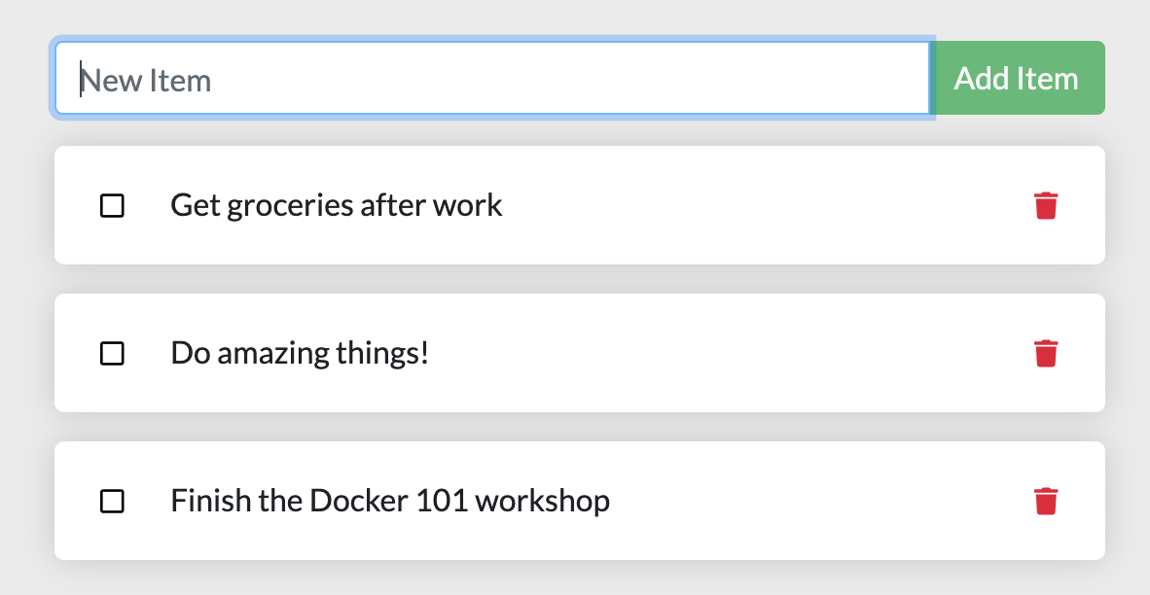

Getting our App[¶](http://localhost/tutorial/our-application/#getting-our-app)

Before we can run the application, we need to get the application source code onto our machine. For real projects, you will typically clone the repo. But, for this tutorial, we have created a ZIP file containing the application.

1. [Download the ZIP](http://localhost/assets/app.zip). Open the ZIP file and make sure you extract the contents.
2. Once extracted, use your favorite code editor to open the project. If you're in need of an editor, you can use [Visual Studio Code](https://code.visualstudio.com/). You should see the package.json and two subdirectories (src and spec).

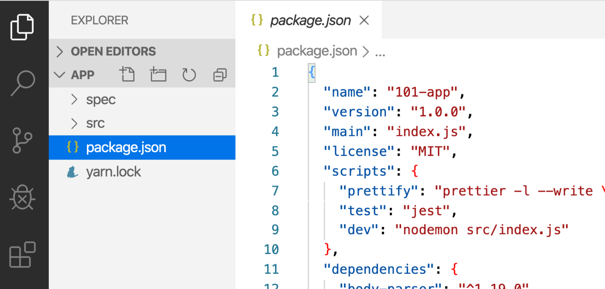

Building the App's Container Image[¶](http://localhost/tutorial/our-application/#building-the-apps-container-image)

In order to build the application, we need to use a Dockerfile. A Dockerfile is simply a text-based script of instructions that is used to create a container image. If you've created Dockerfiles before, you might see a few flaws in the Dockerfile below. But, don't worry! We'll go over them.

1. Create a file named Dockerfile in the same folder as the file package.json with the following contents.
2. FROM node:18-alpine
3. WORKDIR /app
4. COPY . .
5. RUN yarn install --production
6. CMD ["node", "src/index.js"]

Please check that the file Dockerfile has no file extension like .txt. Some editors may append this file extension automatically and this would result in an error in the next step.

1. If you haven't already done so, open a terminal and go to the app directory with the Dockerfile. Now build the container image using the docker build command.
2. docker build -t getting-started .

This command used the Dockerfile to build a new container image. You might have noticed that a lot of "layers" were downloaded. This is because we instructed the builder that we wanted to start from the node:18-alpine image. But, since we didn't have that on our machine, that image needed to be downloaded.

After the image was downloaded, we copied in our application and used yarn to install our application's dependencies. The CMD directive specifies the default command to run when starting a container from this image.

Finally, the -t flag tags our image. Think of this simply as a human-readable name for the final image. Since we named the image getting-started, we can refer to that image when we run a container.

The . at the end of the docker build command tells that Docker should look for the Dockerfile in the current directory.

Starting an App Container[¶](http://localhost/tutorial/our-application/#starting-an-app-container)

Now that we have an image, let's run the application! To do so, we will use the docker run command (remember that from earlier?).

1. Start your container using the docker run command and specify the name of the image we just created:
2. docker run -dp 3000:3000 getting-started

Remember the -d and -p flags? We're running the new container in "detached" mode (in the background) and creating a mapping between the host's port 3000 to the container's port 3000. Without the port mapping, we wouldn't be able to access the application.

1. After a few seconds, open your web browser to [http://localhost:3000](http://localhost:3000/). You should see our app!

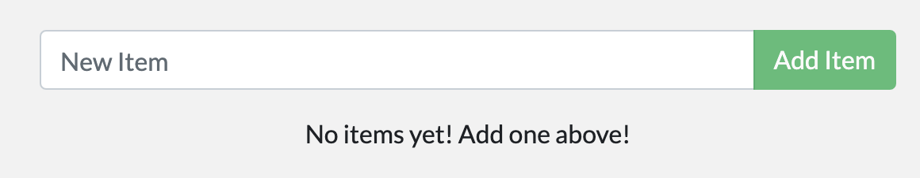

1. Go ahead and add an item or two and see that it works as you expect. You can mark items as complete and remove items. Your frontend is successfully storing items in the backend! Pretty quick and easy, huh?

At this point, you should have a running todo list manager with a few items, all built by you! Now, let's make a few changes and learn about managing our containers.

If you take a quick look at the Docker Dashboard, you should see your two containers running now (this tutorial and your freshly launched app container)!

