THE WORKSTATION APP:

Philosophy:

In life, experience and exposure are invaluable, and in medicine, this truth is even more pronounced. Over my 28 years as a radiologist, I’ve realized that knowing where to find information is often more crucial than trying to know everything.

Specializing in multiple subspecialties, I’ve learned that while it’s impossible to master every aspect of medicine, one can certainly master the art of accessing the right information at the right time. Through years of practice, I’ve curated a vast collection of articles, guidelines, and tools that are essential in day-to-day radiology reporting.

My passion for coding, artificial intelligence, teaching, research, and publishing has driven me to seek ways to streamline workflows. I’ve noticed that repetitive tasks often dominate our work, which can be quite a challenge in today’s fast-paced environment. We’ve all experienced the frustration of searching for crucial information online, only to spend valuable time sifting through irrelevant content—especially under the pressure of completing reports on time.

To address these challenges, I created a special folder on my workstation called the “Workstation Companion.” This folder became the inspiration for this app.

I believe this app will be a valuable resource for both seasoned and younger radiologists. It’s the culmination of my years of experience in radiology and my commitment to sharing useful knowledge while making the reporting process more efficient and less repetitive.

I hope you find this app as helpful and empowering as I have found the tools that inspired it.
Strategy Discussion for Redesigned Welcome Page

Overall Design Approach

• Design Style:
• Minimalistic and Simple: We’ll aim for a clean, clutter-free design that’s easy on the eyes. This will involve using plenty of white space, natural tones, and simple, readable fonts.
• Responsiveness: The design must be responsive, ensuring it looks great on devices of all sizes, from desktops to mobile phones and tablets.
• Navigation Bar:
• Content: The navbar will include essential navigation links like Home, Logout, and Admin Access. The Home button will return the user to the welcome page, Logout will sign them out, and Admin Access will direct them to the admin login page.
• Positioning: The navbar will be fixed at the top for easy access on all pages.
• Grid Layout with Cards:
• Grid Design: We will use a grid system (leveraging Bootstrap’s grid system) to lay out the cards. This ensures the layout adapts to different screen sizes, maintaining usability on small devices like phones and tablets.
• Cards: Each action will be represented as a card. The cards will be:
• Alphabetically Arranged: To help users easily find the tools they need.
• Colored in Soft, Natural Tones: Each card will have a distinct, soft color that aligns with the minimalistic design while aiding in visual differentiation.
• Text: The text on each card will be simple and legible, ensuring accessibility.
• Card Functionality:
• Clickable Cards: Each card will act as a button that takes the user to the relevant page.
• Free vs. Paid Content: The pages linked by these cards will have sections that are freely accessible and sections that require payment. This setup prepares us for integrating subscription models or paywalls in the future.
• Placeholders for Future Development:
• Stub Pages: For now, we will create basic placeholder pages for each card’s linked content. These pages can be expanded with full content and functionality as we proceed.
• Global Buttons: The Home and Logout buttons will be present on all pages, ensuring easy navigation.

Technical Considerations

•Responsive Design:
• Bootstrap: We’ll use Bootstrap for its robust grid system, ensuring a responsive design that scales well across devices.
• Media Queries: We may need to use custom media queries to fine-tune the layout for smaller screens, ensuring the grid and cards maintain their usability and readability.
•Scalability and Future Integration:
•API Integration: We’ll design the front-end with future API integrations in mind, ensuring the structure can accommodate additional tools like ML/DL models.
•User Management: The user interface will be designed to manage both free and paid access seamlessly, preparing for future expansions like subscription services or premium features.
•Color Palette and Typography:
•Colors: We’ll choose a palette of soft, natural tones for the cards, maintaining a cohesive, calming aesthetic.
•Fonts: We’ll use simple, readable fonts that align with the minimalistic design philosophy, ensuring accessibility and clarity.
•Next Steps:
•Wireframing: Before jumping into coding, we’ll create a simple wireframe or sketch of the page layout. This will help us visualize the structure and flow of the page.
•Take feedback before we proceed to actual coding. This ensures we’re aligned on the design before implementation.

Summary

The strategy revolves around creating a minimalistic, responsive, and easy-to-navigate welcome page. We’ll use Bootstrap for the grid layout, with cards representing each action the app offers. These cards will be color-coded and designed for readability and usability across devices. Placeholder pages will be set up for each card, and the design will accommodate both free and paid content.

Here’s a structured approach based on what we’ve done so far and what lies ahead.

1. Core Development Focus

• Primary Technologies:
• Python (Flask): Backend development, routing, and business logic.
• HTML/CSS (Bootstrap): Frontend development with a focus on responsiveness and ease of use.
• Jinja2: Template rendering for dynamic HTML content.
• Initial Features:
• User Management: Registration, login, logout, and session management with role-based access (admin vs. user).
• Guideline Management: Ability to add, view, and serve medical guidelines.
• Admin Dashboard: Admin controls for managing users and content, including database reset functions.

2. Current Progress and Achievements

• Flask App Structure:
• Set up the Flask app with modular routing.
• Integrated user authentication and role management.
• Bootstrap Integration:
• Implemented a responsive frontend using Bootstrap for forms, buttons, and overall layout.
• Utilized Jinja2 for templating to ensure a dynamic and scalable frontend.
• Database Setup:
• Configured SQLite for managing users and guidelines.
• Developed CRUD functionality for managing guidelines via the admin interface.
• Git and Version Control:
• Established a local Git repository and connected it to GitHub.
• Successfully committed and pushed updates.

3. Immediate Next Steps

1. Refine and Expand Features:
• Guideline Management:
• Implement features to prevent duplicate entries and enhance the search functionality.
• User Roles:
• Further refine user roles, ensuring only admins can access specific routes and functions.
2. Enhance Frontend Experience:
• Bootstrap Customization:
• Explore additional Bootstrap components like modals, alerts, and cards to improve user experience.
• Form Validation:
• Add client-side and server-side validation for user input in forms.
3. Testing and Debugging:
• Cross-Device Testing:
• Test the app on multiple devices (desktops, tablets, phones) to ensure responsive design.
• Bug Fixes:
• Address any issues with session handling, database operations, or form submissions.

4. Mid-Term Strategy

1. Security Enhancements:
• Implement HTTPS and consider more robust session management and CSRF protection.
• Use environment variables for secret keys and sensitive configurations.
2. Deployment Planning:
• Plan for initial deployment in a staging environment (e.g., Heroku, AWS, or DigitalOcean).
• Set up CI/CD pipelines for automated testing and deployment.
3. Performance Optimization:
• Optimize database queries and consider migrating to a more scalable database if necessary.
• Review and optimize front-end performance, including reducing the size of CSS/JS files.

5. Long-Term Vision

1. Scalability:
• Prepare the app for scaling by considering microservices architecture or containerization (Docker).
• Implement caching strategies (e.g., Redis) to enhance performance.
2. Feature Expansion:
• Integrate advanced features like AI-powered report analysis or recommendations.
• Expand the user interface to include dashboards, analytics, and more comprehensive reporting tools.
3. Community and Feedback:
• Build a community around the app for continuous feedback and improvement.
• Consider adding a feature for users to suggest and vote on new features or improvements.

6. Immediate Action Items

• Enhance User and Admin Experience:
• Implement Bootstrap components that improve the UI/UX for users and admins.
• Ensure all forms are secure, intuitive, and error-free.
• Test Network Access:
• Finalize testing the app on various devices using the dynamic IP approach to ensure reliable access.
• Regularly Commit and Push Changes:
• Keep using Git effectively to track progress and maintain a clear history of changes.

Welcome page:
Updated Strategy for Welcome Page Design

1. Navigation Bar (Top Fixed)

• Enhanced Content:
• Home: Takes the user back to the welcome page.
• Register: Link to the registration page.
• Login: Link to the login page.
• Try: A call-to-action for users to explore the app or a demo.
• Buy: Link to a purchasing or subscription page.
• Pricing: Detailed pricing page for the app’s features.
• Admin Access: Link to the admin login page.
• Logout: Logs out the user.
• Design and Interaction:
• Consistency: Ensure each link/button has consistent feedback (e.g., hover effects, active states) using Bootstrap’s built-in classes.
• Responsiveness: The navbar will collapse into a hamburger menu on smaller screens for easy navigation.

2. Main Content Area (Grid Layout with Cards)

• Structure:
• Uniform Card Size: All cards will have the same size and be symmetrically distributed in the grid layout, ensuring a clean and organized appearance.
• 3D Effect: Subtle 3D effect (like embossing) to make the cards appear slightly raised. This can be achieved using Bootstrap’s shadow utilities.
• Card Design:
• 3D Effect with Shadows:
• We’ll use Bootstrap’s shadow classes (shadow-sm, shadow, etc.) to add a subtle 3D effect to the cards.
• Interactive Feedback:
• On hover, the cards will slightly change shade or grow a bit, providing visual feedback. This can be done using Bootstrap’s hover classes or custom CSS for more control.
- Contents:
  - Guidelines
  - TNM staging
  - Report checker
  - Differential Diagnosis
  - Recommendations
  - Vetting Tool
  - Classifications
  - Anatomy
  - Courses

• Uniform Feedback:
• Ensure that clicking any card gives the same feedback, such as a color change or a subtle depress effect, making the UI feel cohesive.

3. Footer

• Content:
• Contact: Link to a contact page or section.
• Social Media: Links to social media profiles (e.g., Twitter, LinkedIn, Facebook).
• Privacy Policy: Link to the privacy policy.
• Terms of Service: Link to the terms of service.
• Design:
• Use Bootstrap’s grid system to organize these links in the footer.
• Make sure the footer is responsive and remains unobtrusive but accessible on all pages.
UI:
We used figma to design the front end of the app.
The app as following UI :
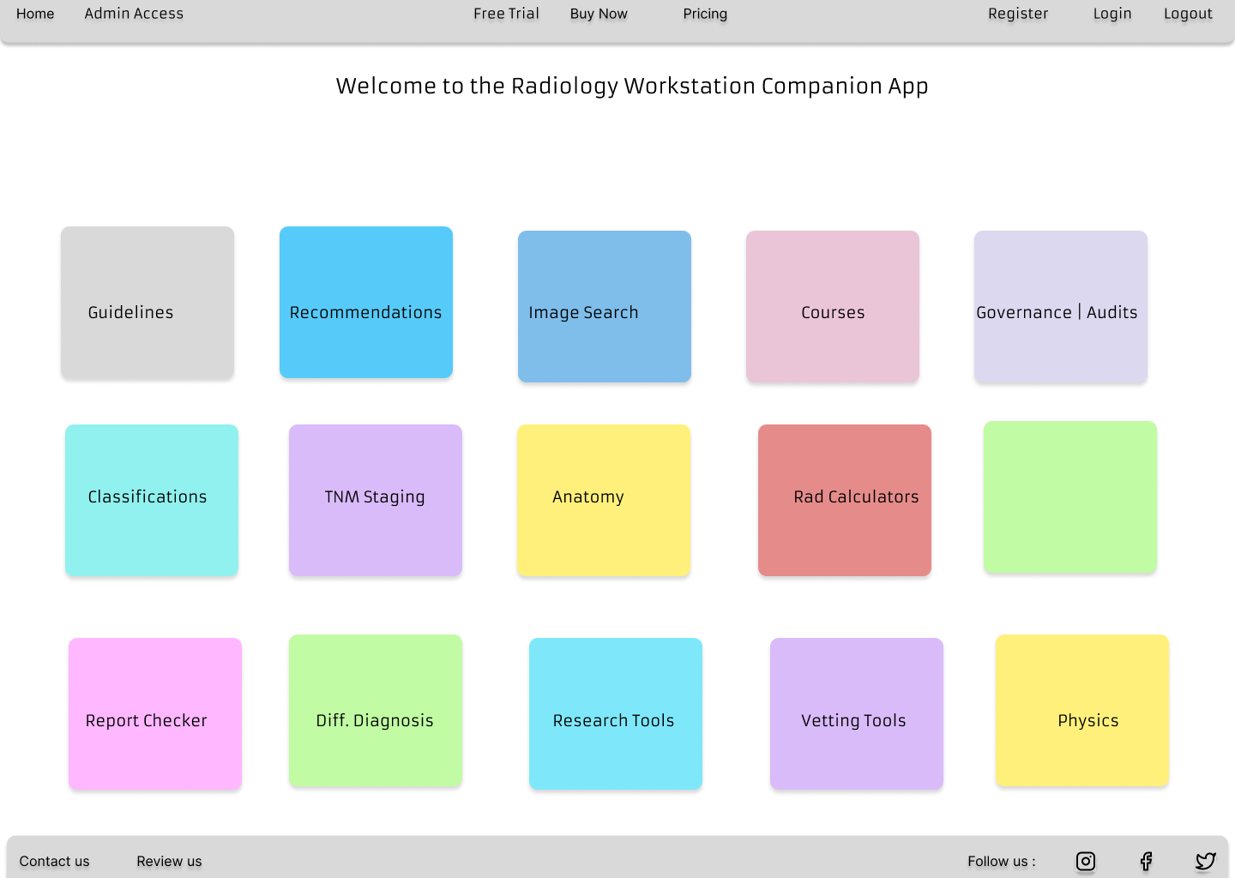

The final app UI after coding with bootstrp, and css looks like this :
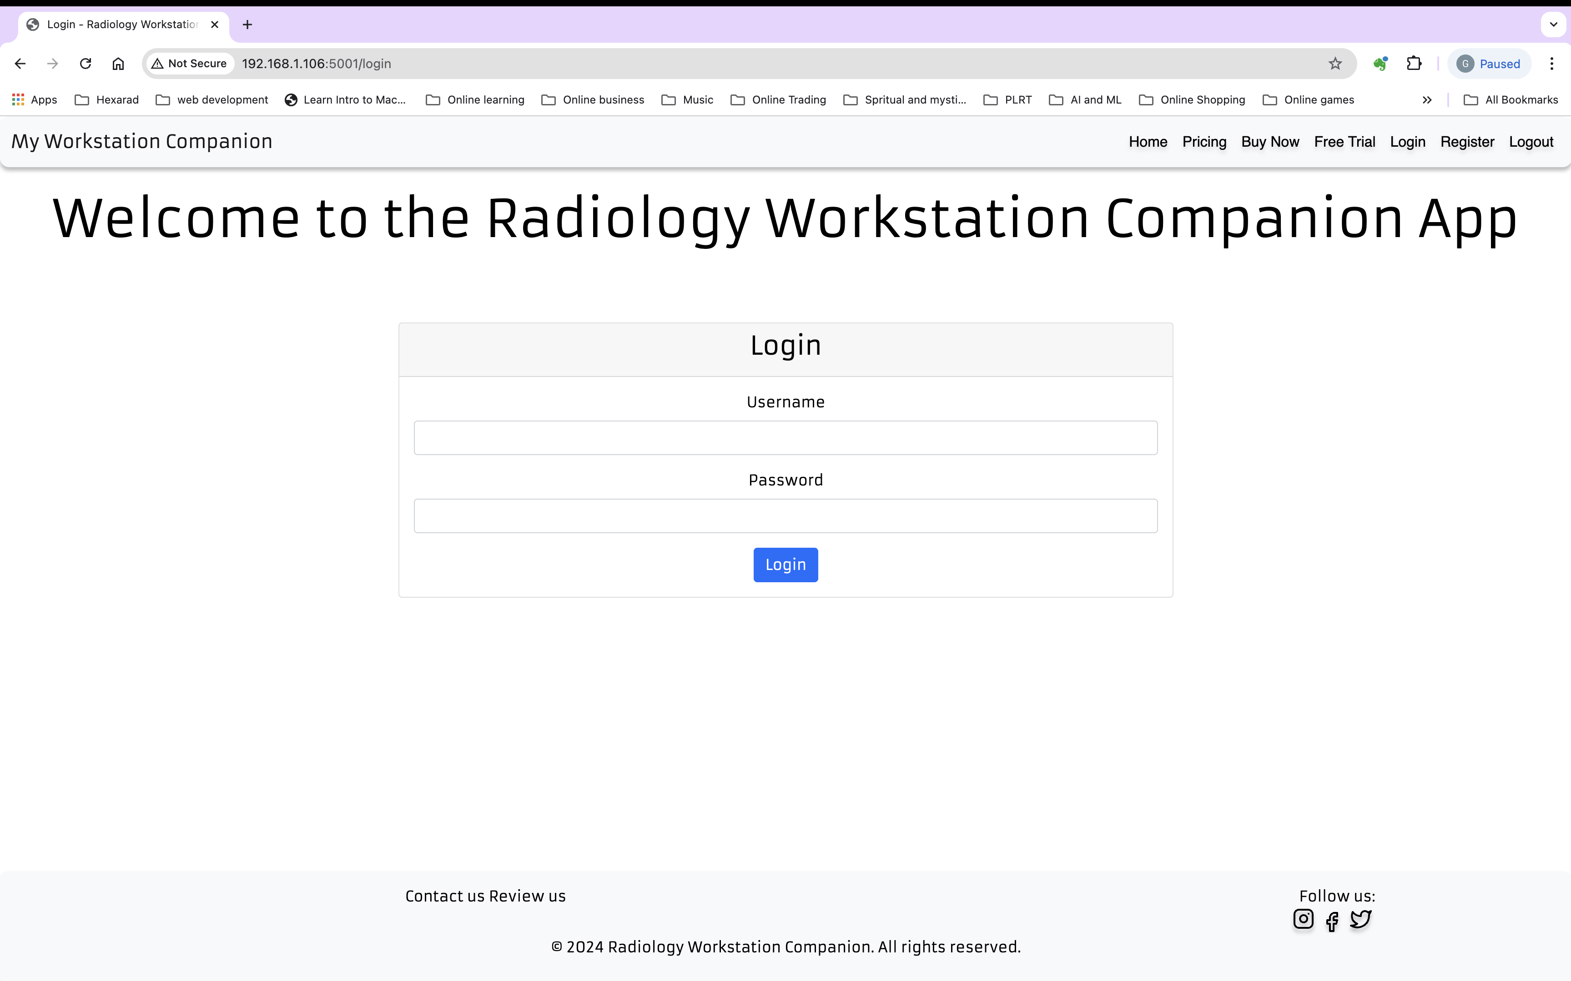

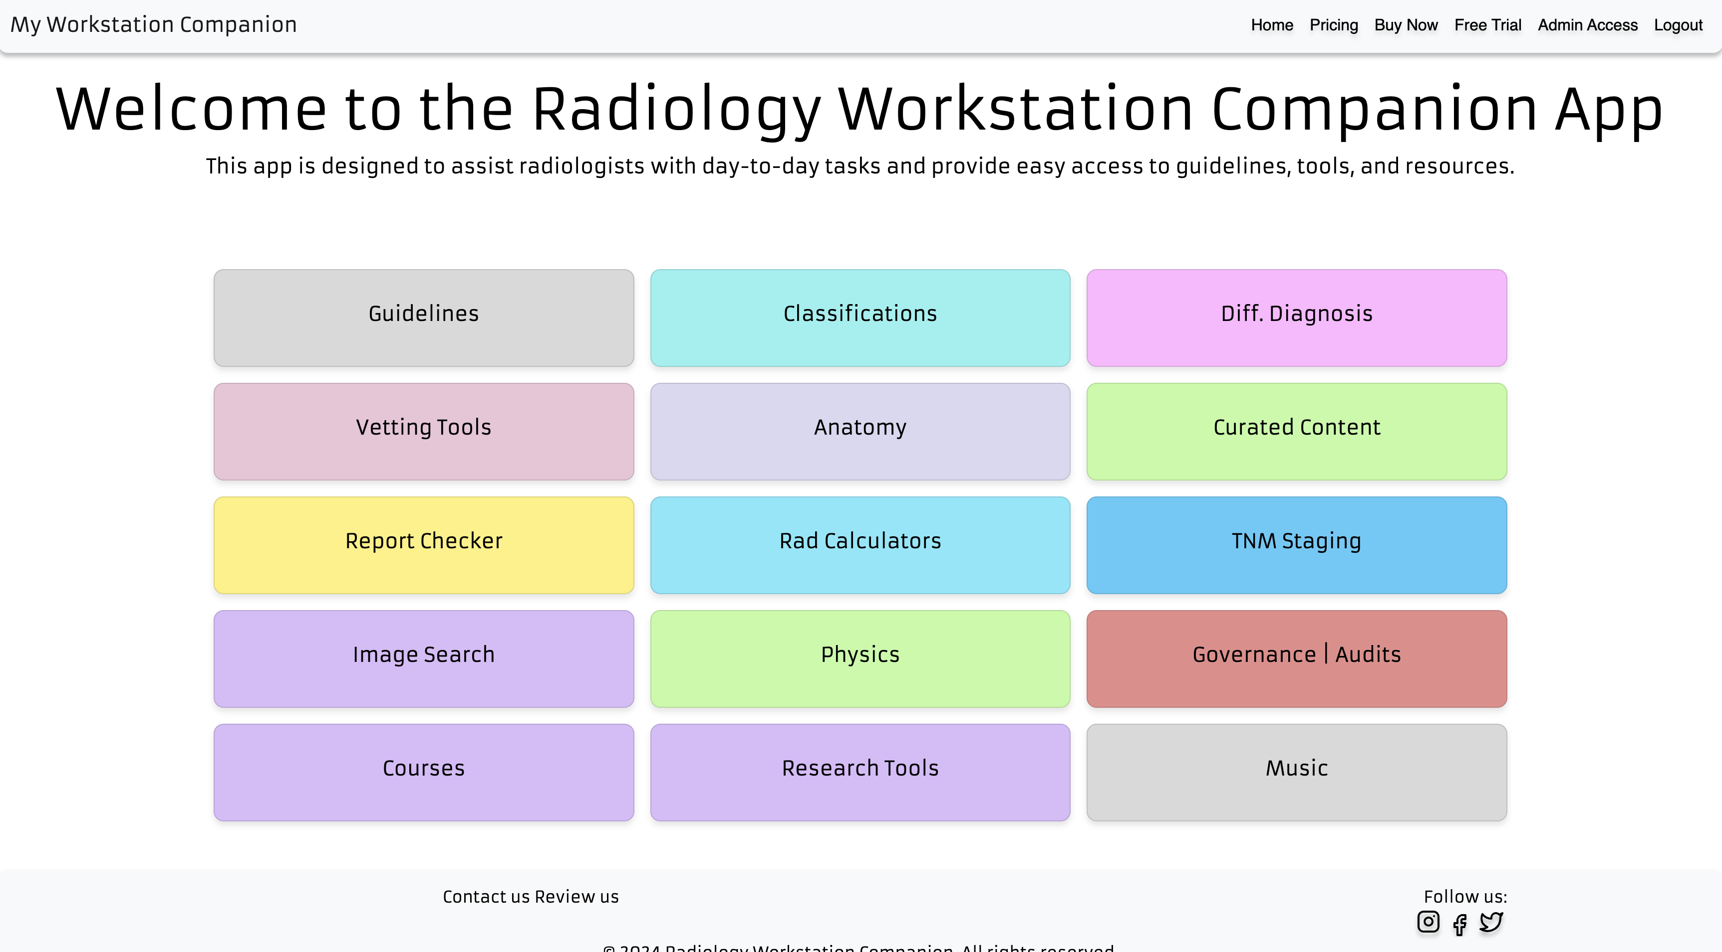

__
Implementation 1. User Authentication of work flow :
User registration and authentication flow:
• Register: Ensure new users can sign up and store their details securely in the database.
• Login: Implement user login functionality, verifying credentials against the database.
• Logout: Provide a way for users to log out securely.

2. User Roles and Access Control

• Admin Dashboard: Set up role-based access, so only admins can access the admin dashboard.
• User Roles: Differentiate between regular users and admin users, ensuring that permissions are enforced.
--

