LINUX COMMUNITY
OPENHACK HACKATHON
Name: Vismaayaa.J
Register no: 7376251CS475
Department: CSE

TASK -1
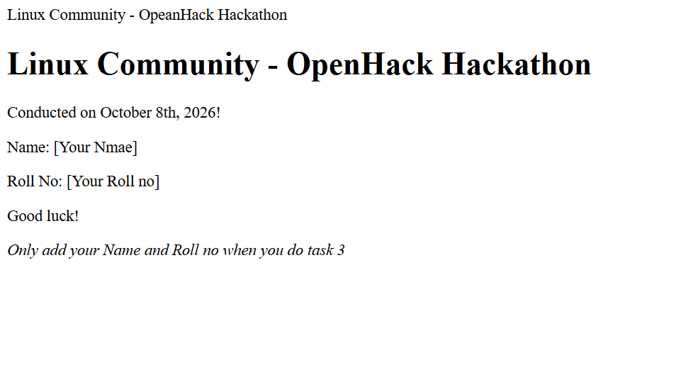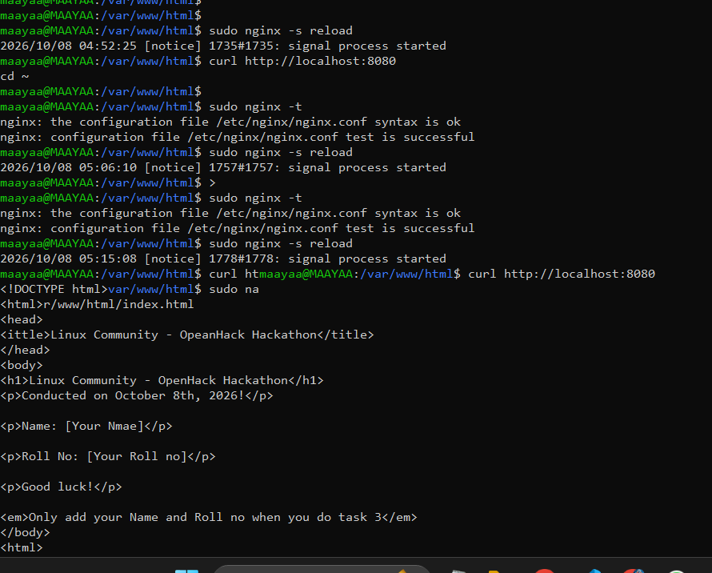

TASK -2
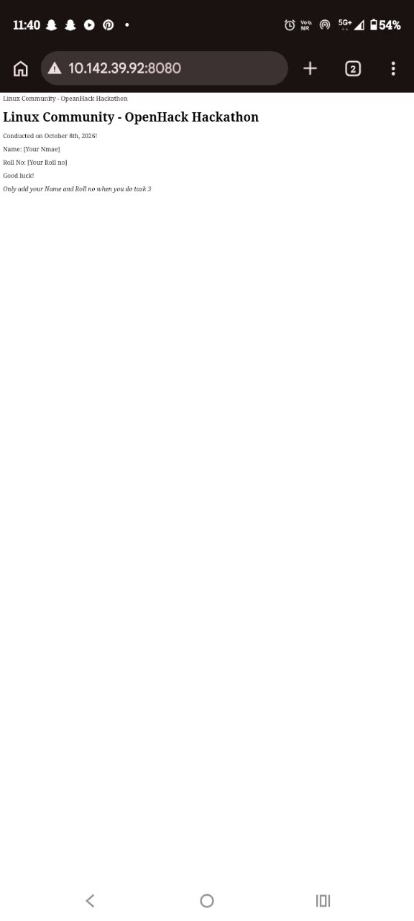
THANK YOU

