**As6**

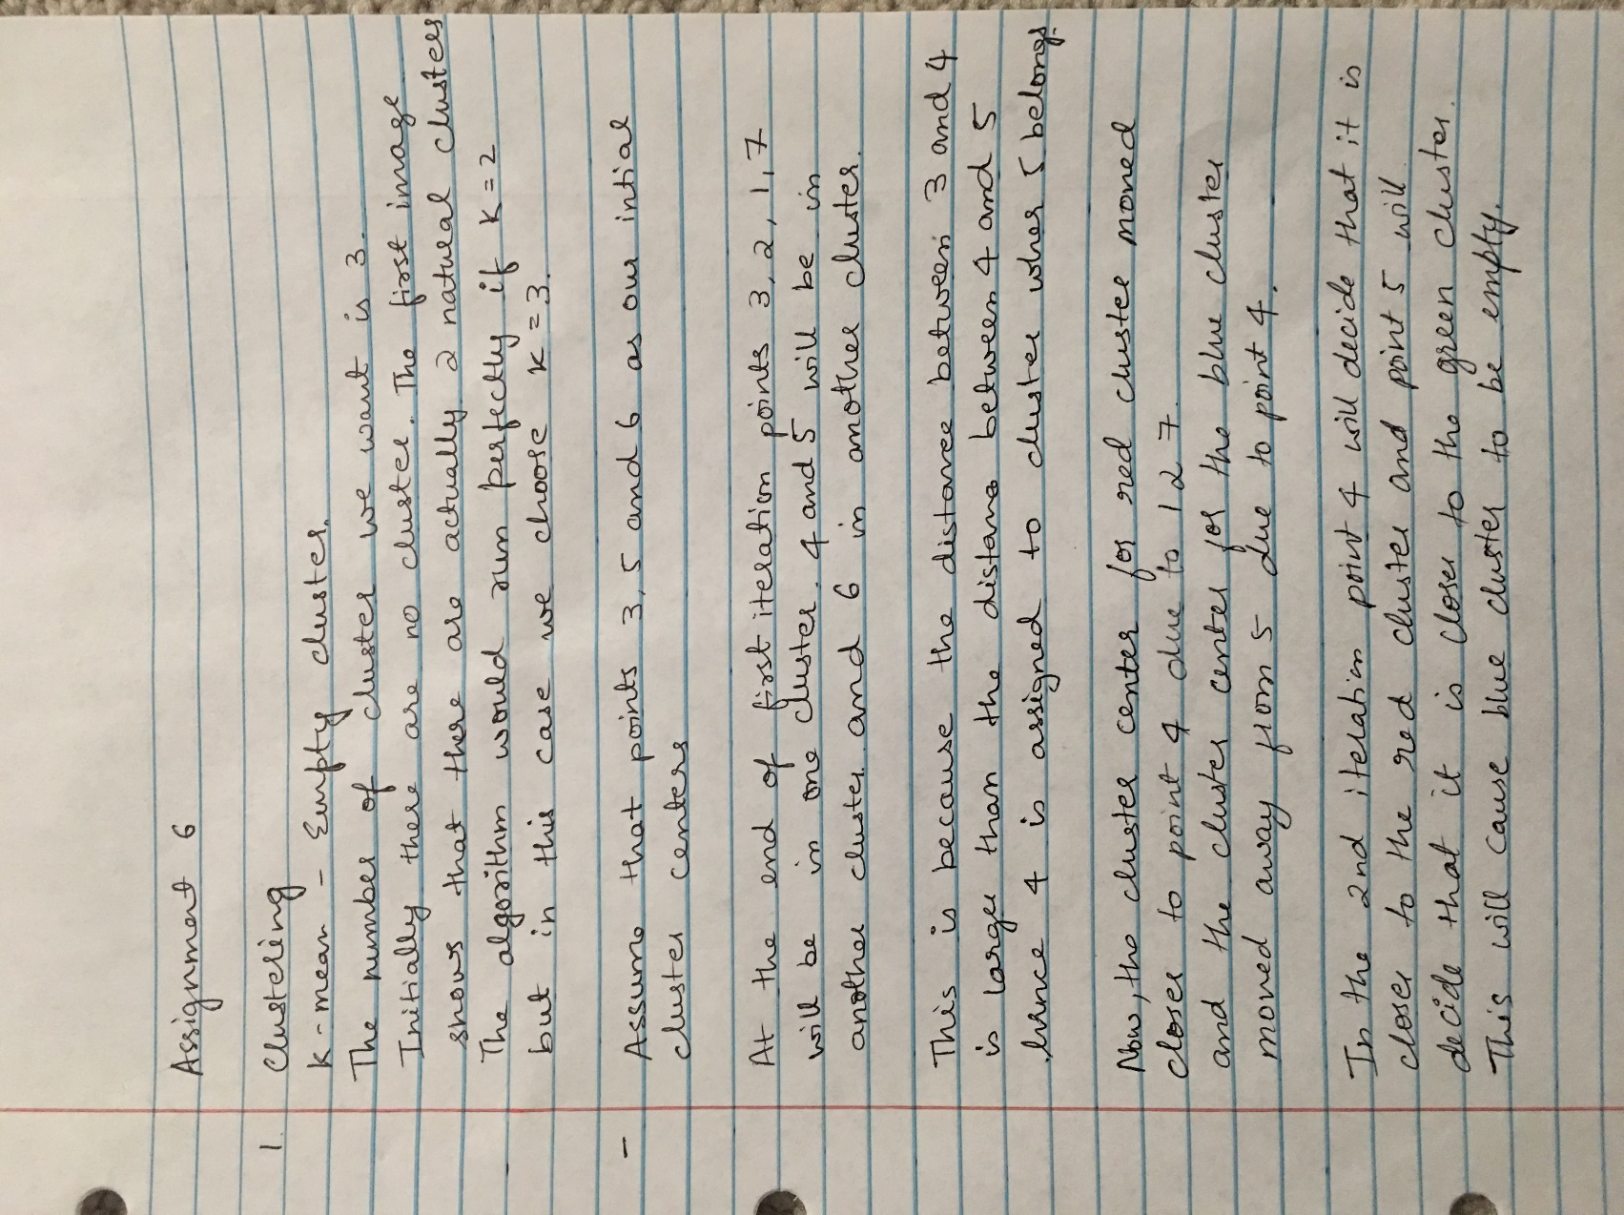



2.

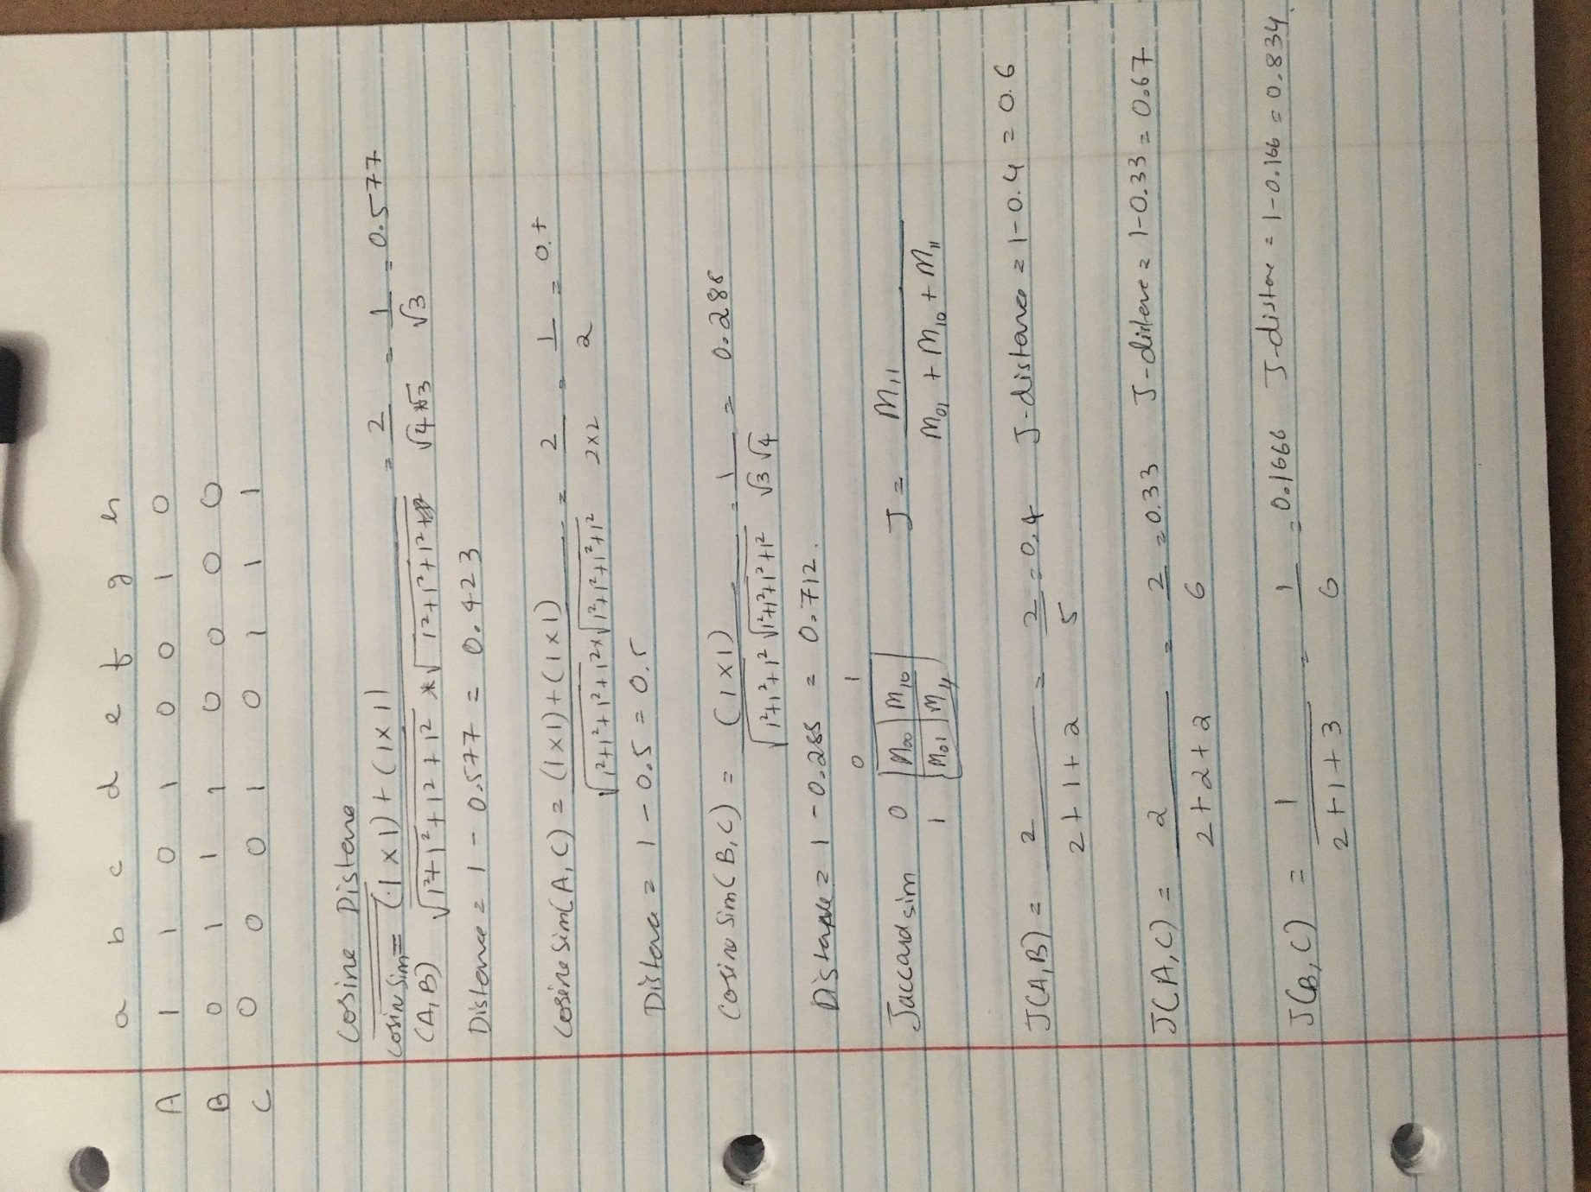



3 Page ranking:

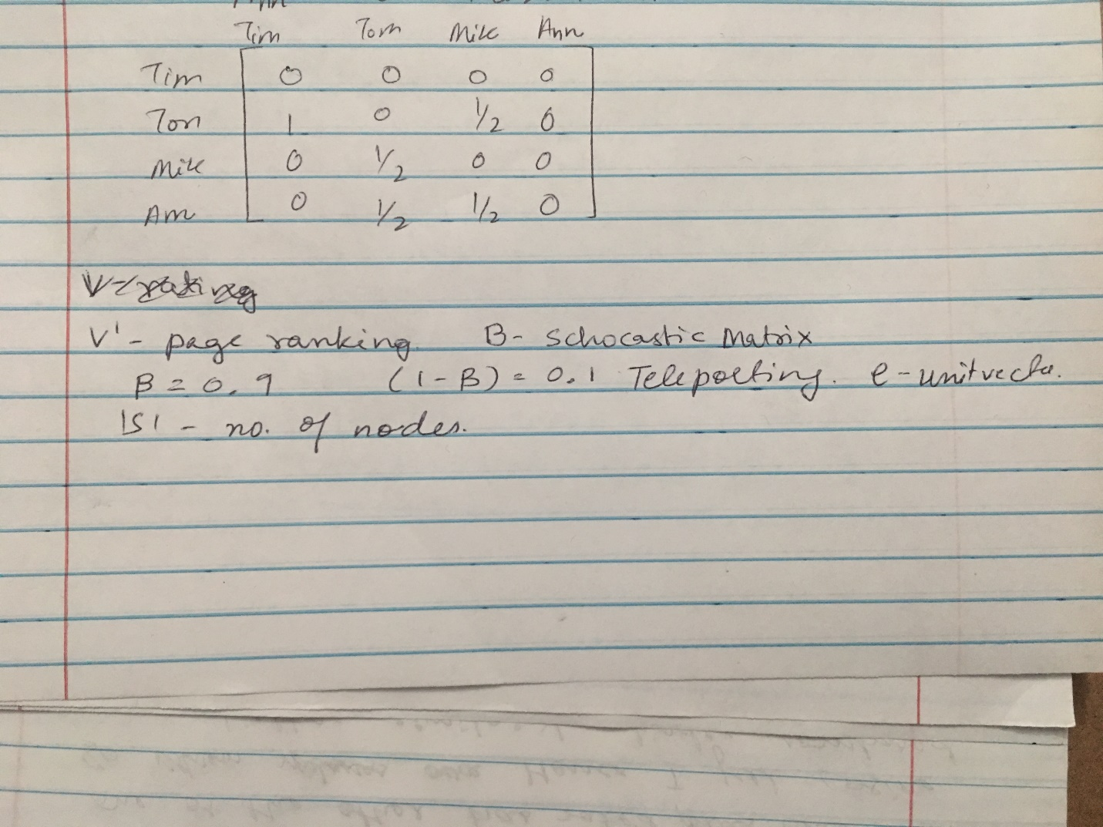

The ranking vectors are computed using the formula:

v ′ = βMv + (1 − β) eS /|S|

M is the transition matrix of the Web. S is a set of integers consisting of the row/column numbers for the pages we have identified as belonging to a certain topic (called the teleport set)

