**E_shopping Application**

**Requirements**

**System setup**

1.1 Software Requirements

* Visual studio code
* MinGw
* Windows 10

1.2 Software Requirements

* Ram
* Processor
* Hard Drive

**4W's and 1'H**

**Who:**

* This application is used by most of the teenagers and middle agers.

**What:**

* The main aim of this project is on the online shopping application. Using this web-based shopping Application, one can shop from home, office, organization.

**When:**

* When you want to compare prices with different brands or websites and when you want to save your time on shopping.

**Where:**

#### You can shop on particular websites or on online shopping Apps.

* For Example: Flipkart, Myntra, Amazon

**How:**

#### Online shopping is a form of electronic commerce which allows consumers to directly buy goods or services from a seller over the internet using web browser.

**SWOT Analysis**

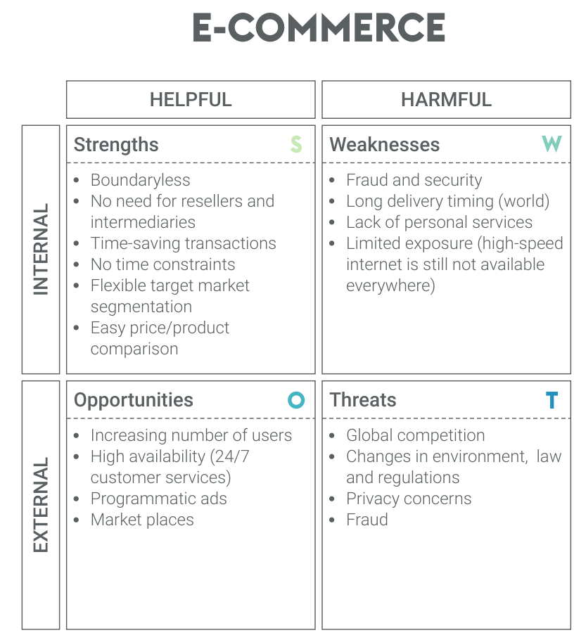

**Detail requirements: - High Level Requirements:**

|  |  |  |
| --- | --- | --- |
| ID | Description | Status |
| HR01 | User should be able to view the cart items | IMPLEMENTED |
| HR02 | Display of total cost of user purchased items | IMPLEMENTED |
| HR03 | Game should end with accurate results | IMPLEMENTED |

**Low level Requirements:**

|  |  |  |
| --- | --- | --- |
| ID | Description | Status |
| LR01 | User is expected to enter their name | IMPLEMENTED |
| LR02 | User is allowed to choose what type of item he need to Add/Purchase | IMPLEMENTED |
| LR03 | Able to Delete the item | IMPLEMENTED |
| LR04 | User is able to add the same item Twice | IMPLEMENTED |