LANGUAGES

- English

- Germ an

- H indi

TECHNICALSKILLS

- Project M anagem ent

- Leadership

- Com m unication Skill

- Team M anagem ent

- D ecision M aking

PERSONALSKILLS

- O rganized

- Creative Spirit

- Reliable and Professional

- Team Player

- M otivated

CONTACT INFO
@VismayDevjee
^{Tw itter:} vismaydev14@gmail.com
^{Em ail-id:} vismaydevjee.github.io
W eb Portfolio:
_{Location:} Mumbai, India.
Vism ay Devjee
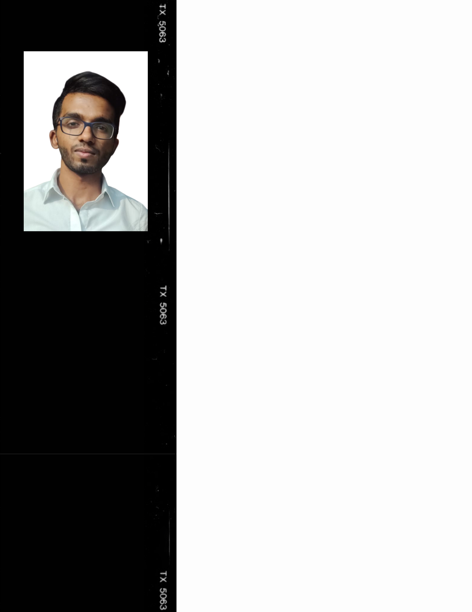

Biom edicalEngineering student

OBJECTIVE

I'm an engineering student w it a focus to w iden m y horizon and seek an opportunity in an organization that w ould offer grow th w hile being resourcefuland innovative.

EDUCATIONALINFO
SCHOOL

L.R.& S.M .VISSAN JIACAD EM Y | 2005 - 2016

JUNIO R CO LLEGE

SVKM 'S A.A.V.PATEL JR. CO LLEG E | 2016 - 2018

DEGREE CO LLEGE

SVKM 'S D .J. SAN GH VICO LLEGE O F EN GIN EERIN G | 2018 - 2022

LICENSES & CERTIFICATION

TRINITY CO LLEGE O F LO NDO N
GRAD ED EXAM IN ATIO N O F SPO KEN EN GLISH CERTIFIED UP TO GRADE 3 WITH _{D ISTIN CTIO N}

SPECIALZATIO N IN EPIDEM& IO LO GY IN PUBLIC HEALTH PRACTICES JO H N S H O PKIN S UN IVERSITY CO URSERA

SPECIALZATIO N IN PYTHO& N
UN IVERSITY O F M ICH IGAN CO URSERA

SPECIALZATIO N IN STATISTICS& W ITH PYTHO N
UN IVERSITY O F M ICH IGAN CO URSERA

SPECIALZATIO N PRO JECT& M ANAGEM ENT PRINCIPLES
UN IVERSITY O F CALIFO RN IA CO URSERA

ATHELETICS
JUDO

NATIO NAL LEVEL

SW IM M ING

STATE LEVEL

FOOTBALL,HANDBALL

D ISTRICT LEVEL

^{LinkedIn Id}: https://w w w .linkedin.com /in/vism aydevjee/

