**LOGISTIC REGRESSION WITH A NEURAL NETWORK MINDSET.**

1.Problem definition:

1.Building an logistic regression classifier to recognize cats.

2.Build the general architecture of a learning algorithm, including:

* Initializing parameters
* Calculating the cost function and its gradient
* Using an optimization algorithm (gradient descent)

3.Gather all three functions above into a main model function, in the right order.

## 2.Packages

Import all the packages that you will need during this mini project.

* [numpy](http://127.0.0.1:8888/notebooks/www.numpy.org) is the fundamental package for scientific computing with Python.
* [h5py](http://www.h5py.org/) is a common package to interact with a dataset that is stored on an H5 file.
* [matplotlib](http://matplotlib.org/) is a famous library to plot graphs in Python.
* [PIL](http://www.pythonware.com/products/pil/) and [scipy](https://www.scipy.org/) are used here to test your model with your own picture at the end.

Python code:

In [1] import numpy as np

import matplotlib.pyplot as plt

import h5py

import scipy

from PIL import Image

from scipy import ndimage

from lr_utils import load_dataset

Note: lr_utils is python file where data has been loaded for analysing. Note that we need to link dataset and lr_utils extension in same folder.

## 3.Overview of the Problem set

**Problem Statement**: You are given a dataset ("data.h5") containing:

- a training set of m_train images labeled as cat (y=1) or non-cat (y=0)

- a test set of m_test images labeled as cat or non-cat

- each image is of shape (num_px, num_px, 3) where 3 is for the 3 channels (RGB). Thus, each image is square (height = num_px) and (width = num_px).

We need to build a simple image-recognition algorithm that can correctly classify pictures as cat or non-cat.

Let's get more familiar with the dataset. Load the data by running the following code.

**Python code:**

In[2] #Loading the data (cat/non-cat)

train_set_x_orig, train_set_y, test_set_x_orig, test_set_y, classes = load_dataset()

**Note:** I added "_orig" at the end of image datasets (train and test) because i am going to preprocess them. After preprocessing, we will end up with train_set_x and test_set_x (the labels train_set_y and test_set_y don't need any preprocessing).

Each line of your train_set_x_orig and test_set_x_orig is an array representing an image. You can visualize an example by running the following code. Feel free also to change the index value and re-run to see other images.

## 4.Visualising sample Image

**Python code:**

In[3] # Example of a picture

index = 25

plt.imshow(train_set_x_orig[index])

print ("y = " + str(train_set_y[:,index]) + ", it's a '" + classes[np.squeeze(train_set_y[:,index])].decode("utf-8") + "' picture.")

Out[3]

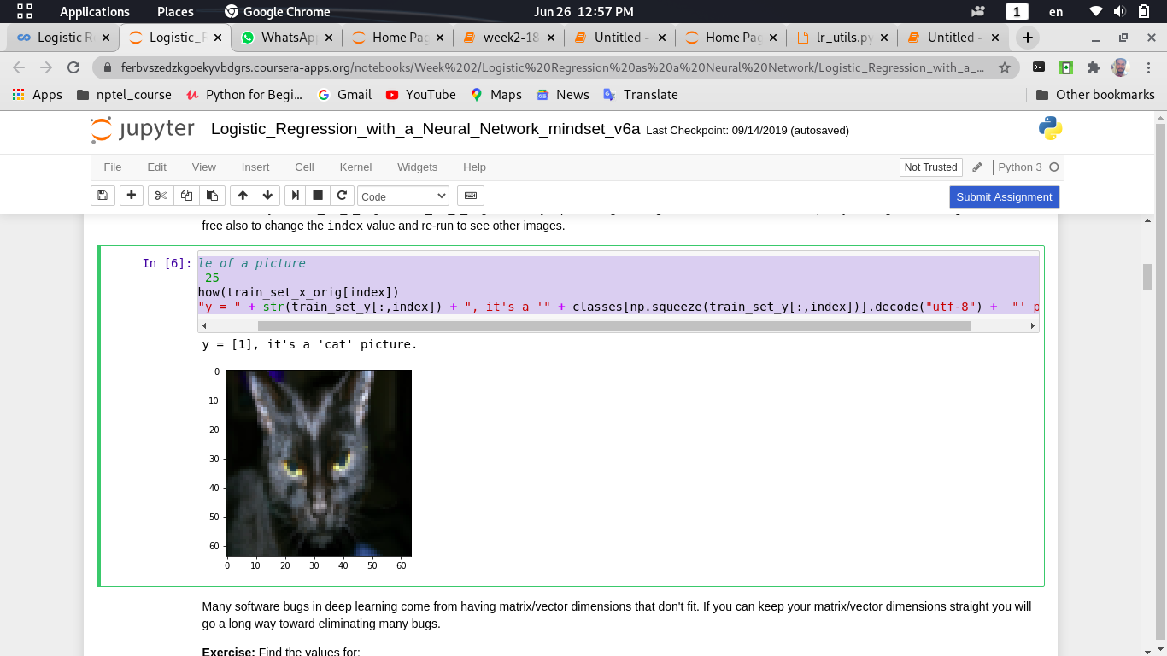

**Note:** Many software bugs in deep learning come from having matrix/vector dimensions that don't fit. If you can keep your matrix/vector dimensions straight you will go a long way toward eliminating many bugs.

## 5.Finding values for train and test datasets.

Find the values for:

- m_train (number of training examples)

- m_test (number of test examples)

- num_px (= height = width of a training image)

Remember that train_set_x_orig is a numpy-array of shape (m_train, num_px, num_px, 3). For instance, you can access m_train by writing train_set_x_orig.shape[0].

**Python code:**

In[4]: m_train = train_set_y.shape[1]

m_test = test_set_y.shape[1]

num_px = train_set_x_orig.shape[1]

print ("Number of training examples: m_train = " + str(m_train))

print ("Number of testing examples: m_test = " + str(m_test))

print ("Height/Width of each image: num_px = " + str(num_px))

print ("Each image is of size: (" + str(num_px) + ", " + str(num_px) + ", 3)")

print ("train_set_x shape: " + str(train_set_x_orig.shape))

print ("train_set_y shape: " + str(train_set_y.shape))

print ("test_set_x shape: " + str(test_set_x_orig.shape))

print ("test_set_y shape: " + str(test_set_y.shape))

Out[4]: Number of training examples: m_train = 209

Number of testing examples: m_test = 50

Height/Width of each image: num_px = 64

Each image is of size: (64, 64, 3)

train_set_x shape: (209, 64, 64, 3)

train_set_y shape: (1, 209)

test_set_x shape: (50, 64, 64, 3)

test_set_y shape: (1, 50)

**Note:** For convenience, you should now reshape images of shape (num_px, num_px, 3) in a numpy-array of shape (num_px **∗**num_px **∗**3, 1). After this, our training (and test) dataset is a numpy-array where each column represents a flattened image. There should be m_train (respectively m_test) columns.

## 6. Reshaping training and testing data.

Reshape the training and test data sets so that images of size (num_px, num_px, 3) are flattened into single vectors of shape (num_px ∗ num_px ∗ 3, 1).A trick when you want to flatten a matrix X of shape (a,b,c,d) to a matrix X_flatten of shape (b∗c∗d, a) is to use:X_flatten = X.reshape(X.shape[0], **-**1).T

**Python code:**

In[5]: # Reshape the training and test examples

train_set_x_flatten = train_set_x_orig.reshape(train_set_x_orig.shape[0], - 1).T

test_set_x_flatten = test_set_x_orig.reshape(test_set_x_orig.shape[0], - 1).T

print ("train_set_x_flatten shape: " + str(train_set_x_flatten.shape))

print ("train_set_y shape: " + str(train_set_y.shape))

print ("test_set_x_flatten shape: " + str(test_set_x_flatten.shape))

print ("test_set_y shape: " + str(test_set_y.shape))

print ("sanity check after reshaping: " + str(train_set_x_flatten[0:5,0]))

Out[5]: train_set_x_flatten shape: (12288, 209)

train_set_y shape: (1, 209)

test_set_x_flatten shape: (12288, 50)

test_set_y shape: (1, 50)

sanity check after reshaping: [17 31 56 22 33]

## 7.Standardizing our dataset to represent RGB

To represent color images, the red, green and blue channels (RGB) must be specified for each pixel, and so the pixel value is actually a vector of three numbers ranging from 0 to 255.One common preprocessing step in machine learning is to center and standardize your dataset, meaning that you substract the mean of the whole numpy array from each example, and then divide each example by the standard deviation of the whole numpy array. But for picture datasets, it is simpler and more convenient and works almost as well to just divide every row of the dataset by 255 (the maximum value of a pixel channel).

Let's standardize our dataset.

**Python code:**

In[6]:

train_set_x = train_set_x_flatten / 255.

test_set_x = test_set_x_flatten / 255.

**Note:**

Remember these points while coding**:**

Common steps for pre-processing a new dataset are:

* Figure out the dimensions and shapes of the problem (m_train, m_test, num_px, ...)
* Reshape the datasets such that each example is now a vector of size (num_px * num_px * 3, 1)
* "Standardize" the data

8.General architecture of the learning algorithms.

It's time to design a simple algorithm to distinguish cat images from non-cat images.

You will build a Logistic Regression, using a Neural Network mindset. The following Figure explains why **Logistic Regression is actually a very simple Neural Network!**

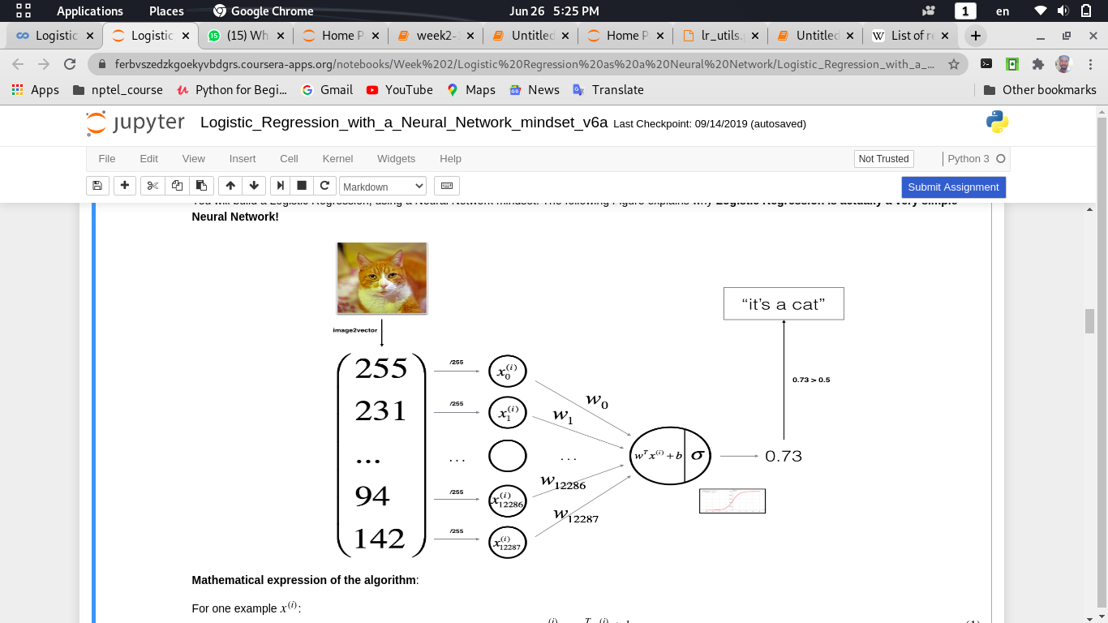

**Mathematical expression of the algorithm**:

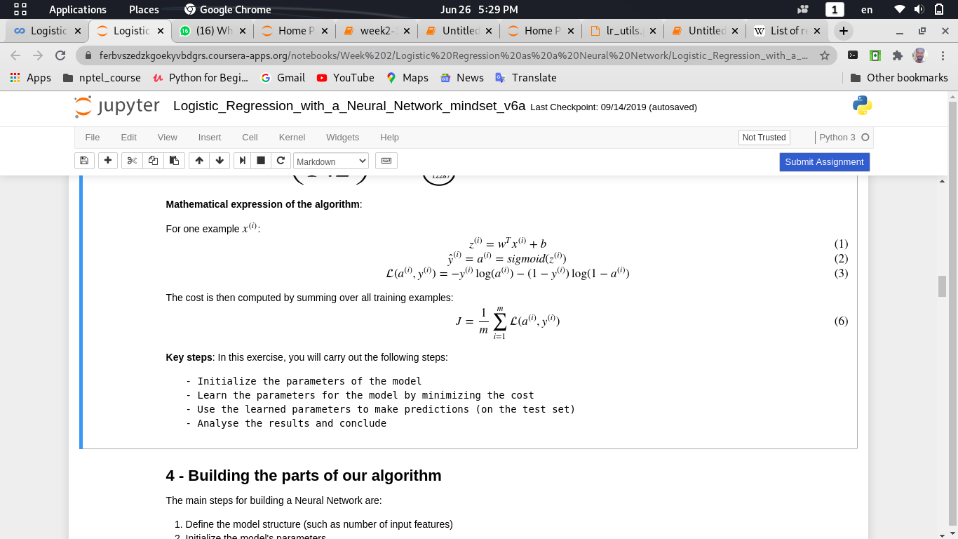

**Keysteps**: In this mini project,i gonna carry out the following steps:

- Initialize the parameters of the model

- Learn the parameters for the model by minimizing the cost

- Use the learned parameters to make predictions (on the test set)

- Analyse the results and conclude

9. Building the parts of our algorithm

The main steps for building a Neural Network are:

1. Define the model structure (such as number of input features)
2. Initialize the model's parameters
3. Loop:
   * Calculate current loss (forward propagation)
   * Calculate current gradient (backward propagation)
   * Update parameters (gradient descent)

You often build 1-3 separately and integrate them into one function we call model().

9.1 - Helper functions

**Exercise**: Using your code from "Python Basics", implement sigmoid(). As you've seen in the figure above, you need to compute sigmoid((w^T)x+b)to make predictions. Use np.exp().

**Python code:**

In[6]: def sigmoid(z):

"""

Compute the sigmoid of z

Arguments:

x -- A scalar or numpy array of any size.

Return:

s -- sigmoid(z)

"""

s = 1 / (1 + np.exp(-z))

return s

In[7]: print ("sigmoid(0) = " + str(sigmoid(0)))

print ("sigmoid(9.2) = " + str(sigmoid(9.2)))

Out[7]: sigmoid(0) = 0.5

sigmoid(9.2) = 0.999898970806

9.2- Initializing parameters

**Task:**Implement parameter initialization in the cell below. You have to initialize w as a vector of zeros. If you don't know what numpy function to use, look up np.zeros() in the Numpy library's documentation.

**Python code:**

In[8]: def initialize_with_zeros(dim):

"""

This function creates a vector of zeros of shape (dim, 1) for w and initializes b to 0.

Argument:

dim -- size of the w vector we want (or number of parameters in this case)

Returns:

w -- initialized vector of shape (dim, 1)

b -- initialized scalar (corresponds to the bias)

"""

w = np.zeros(shape=(dim, 1))

b = 0

assert(w.shape == (dim, 1))

assert(isinstance(b, float) or isinstance(b, int))

return w, b

In[9]: dim = 2

w, b = initialize_with_zeros(dim)

print ("w = " + str(w))

print ("b = " + str(b))

Out[9]: w = [[ 0.]

[ 0.]]

b = 0

**Note:** For image inputs, w will be of shape (num_px ×num_px ×3, 1).

9.3. Forward and Backward propogation:

Now that your parameters are initialized, you can do the "forward" and "backward" propagation steps for learning the parameters.

**Task:** Implement a function propagate() that computes the cost function and its gradient.

**Formulas:**

Forward Propagation:

* You get X
* You compute A=σ(wTX+b)=(a(1),a(2),...,a(m−1),a(m))
* You calculate the cost function: J=−1m∑mi=1y(i)log(a(i))+(1−y(i))log(1−a(i))

Here are two formulas i will be using

∂J/∂w=1/mX(A−Y)^T

∂J/∂b=1/m∑i=1m(a(i)−y(i))

**Python code:**

In[10]: # GRADED FUNCTION: propagate

def propagate(w, b, X, Y):

"""

Implement the cost function and its gradient for the propagation explained above

Arguments:

w -- weights, a numpy array of size (num_px * num_px * 3, 1)

b -- bias, a scalar

X -- data of size (num_px * num_px * 3, number of examples)

Y -- true "label" vector (containing 0 if non-cat, 1 if cat) of size (1, number of examples)

Return:

cost -- negative log-likelihood cost for logistic regression

dw -- gradient of the loss with respect to w, thus same shape as w

db -- gradient of the loss with respect to b, thus same shape as b

Tips:

- Write your code step by step for the propagation

"""

m = X.shape[1]

# FORWARD PROPAGATION (FROM X TO COST)

A = sigmoid(np.dot(w.T, X) + b) # compute activation

cost = (- 1 / m) * np.sum(Y * np.log(A) + (1 - Y) * (np.log(1 - A))) # compute cost

# BACKWARD PROPAGATION (TO FIND GRAD)

dw = (1 / m) * np.dot(X, (A - Y).T)

db = (1 / m) * np.sum(A - Y)

assert(dw.shape == w.shape)

assert(db.dtype == float)

cost = np.squeeze(cost)

assert(cost.shape == ())

grads = {"dw": dw,

"db": db}

return grads, cost

In[11]: w, b, X, Y = np.array([[1], [2]]), 2, np.array([[1,2], [3,4]]), np.array([[1, 0]])

grads, cost = propagate(w, b, X, Y)

print ("dw = " + str(grads["dw"]))

print ("db = " + str(grads["db"]))

print ("cost = " + str(cost))

Out[11]: dw = [[ 0.99993216]

[ 1.99980262]]

db = 0.499935230625

cost = 6.00006477319

9.4 Optimisation:

* You are also able to compute a cost function and its gradient.
* Now, you want to update the parameters using gradient descent.
* You have initialized your parameters.

**Task:**Write down the optimization function. The goal is to learn wand bby minimizing the cost function J. For a parameter θ, the update rule is θ=θ−α dθ, where αis the learning rate**.**

**Python Code:**

In[12]:

def optimize(w, b, X, Y, num_iterations, learning_rate, print_cost = False):

"""

This function optimizes w and b by running a gradient descent algorithm

Arguments:

w -- weights, a numpy array of size (num_px * num_px * 3, 1)

b -- bias, a scalar

X -- data of shape (num_px * num_px * 3, number of examples)

Y -- true "label" vector (containing 0 if non-cat, 1 if cat), of shape (1, number of examples)

num_iterations -- number of iterations of the optimization loop

learning_rate -- learning rate of the gradient descent update rule

print_cost -- True to print the loss every 100 steps

Returns:

params -- dictionary containing the weights w and bias b

grads -- dictionary containing the gradients of the weights and bias with respect to the cost function

costs -- list of all the costs computed during the optimization, this will be used to plot the learning curve.

Tips:

You basically need to write down two steps and iterate through them:

1) Calculate the cost and the gradient for the current parameters. Use propagate().

2) Update the parameters using gradient descent rule for w and b.

"""

costs = []

for i in range(num_iterations):

# Cost and gradient calculation (≈ 1-4 lines of code)

grads, cost = propagate(w, b, X, Y)

# Retrieve derivatives from grads

dw = grads["dw"]

db = grads["db"]

w = w - learning_rate * dw # need to broadcast

b = b - learning_rate * db

# Record the costs

if i % 100 == 0:

costs.append(cost)

# Print the cost every 100 training examples

if print_cost and i % 100 == 0:

print ("Cost after iteration %i: %f" % (i, cost))

params = {"w": w,

"b": b}

grads = {"dw": dw,

"db": db}

return params, grads, costs

In[13]: params, grads, costs = optimize(w, b, X, Y, num_iterations= 100, learning_rate = 0.009, print_cost = False)

print ("w = " + str(params["w"]))

print ("b = " + str(params["b"]))

print ("dw = " + str(grads["dw"]))

print ("db = " + str(grads["db"]))

Out[13]: w = [[ 0.1124579 ]

[ 0.23106775]]

b = 1.55930492484

dw = [[ 0.90158428]

[ 1.76250842]]

db = 0.430462071679

**Task:**The previous function will output the learned w and b. I am able to use w and b to predict the labels for a dataset X. Implement the predict() function. There are two steps to computing predictions:

1. Calculate Ŷ =A=σ(wTX+b)
2. Convert the entries of a into 0 (if activation <= 0.5) or 1 (if activation > 0.5), stores the predictions in a vector Y_prediction. If you wish, you can use an if/else statement in a for loop (though there is also a way to vectorize this).

**Python code:**

In[14]:

def predict(w, b, X):

'''

Predict whether the label is 0 or 1 using learned logistic regression parameters (w, b)

Arguments:

w -- weights, a numpy array of size (num_px * num_px * 3, 1)

b -- bias, a scalar

X -- data of size (num_px * num_px * 3, number of examples)

Returns:

Y_prediction -- a numpy array (vector) containing all predictions (0/1) for the examples in X

'''

m = X.shape[1]

Y_prediction = np.zeros((1, m))

w = w.reshape(X.shape[0], 1)

# Compute vector "A" predicting the probabilities of a cat being present in the picture

A = sigmoid(np.dot(w.T, X) + b)

for i in range(A.shape[1]):

# Convert probabilities a[0,i] to actual predictions p[0,i]

Y_prediction[0, i] = 1 if A[0, i] > 0.5 else 0

assert(Y_prediction.shape == (1, m))

return Y_prediction

In[15]:print("predictions = " + str(predict(w, b, X)))

Out[15]:predictions = [[ 1. 1.]]

10. Merge all fuctions into a model.

You will now see how the overall model is structured by putting together all the building blocks (functions implemented in the previous parts) together, in the right order.

**Task:**

Implement the model function. Use the following notation:

- Y_prediction_test for your predictions on the test set

- Y_prediction_train for your predictions on the train set

- w, costs, grads for the outputs of optimize()

**Python Code:**

In[16]:

def model(X_train, Y_train, X_test, Y_test, num_iterations=2000, learning_rate=0.5, print_cost=False):

"""

Builds the logistic regression model by calling the function you've implemented previously

Arguments:

X_train -- training set represented by a numpy array of shape (num_px * num_px * 3, m_train)

Y_train -- training labels represented by a numpy array (vector) of shape (1, m_train)

X_test -- test set represented by a numpy array of shape (num_px * num_px * 3, m_test)

Y_test -- test labels represented by a numpy array (vector) of shape (1, m_test)

num_iterations -- hyperparameter representing the number of iterations to optimize the parameters

learning_rate -- hyperparameter representing the learning rate used in the update rule of optimize()

print_cost -- Set to true to print the cost every 100 iterations

Returns:

d -- dictionary containing information about the model.

"""

# initialize parameters with zeros (≈ 1 line of code)

w, b = initialize_with_zeros(X_train.shape[0])

# Gradient descent (≈ 1 line of code)

parameters, grads, costs = optimize(w, b, X_train, Y_train, num_iterations, learning_rate, print_cost)

# Retrieve parameters w and b from dictionary "parameters"

w = parameters["w"]

b = parameters["b"]

# Predict test/train set examples (≈ 2 lines of code)

Y_prediction_test = predict(w, b, X_test)

Y_prediction_train = predict(w, b, X_train)

# Print train/test Errors

print("train accuracy: {} %".format(100 - np.mean(np.abs(Y_prediction_train - Y_train)) * 100))

print("test accuracy: {} %".format(100 - np.mean(np.abs(Y_prediction_test - Y_test)) * 100))

d = {"costs": costs,

"Y_prediction_test": Y_prediction_test,

"Y_prediction_train" : Y_prediction_train,

"w" : w,

"b" : b,

"learning_rate" : learning_rate,

"num_iterations": num_iterations}

return d

**Task:** Run the following cell to train your model.

**Python Code:**

In[17]: d = model(train_set_x, train_set_y, test_set_x, test_set_y, num_iterations = 2000, learning_rate = 0.005, print_cost = True)

Out[17]: Cost after iteration 0: 0.693147

Cost after iteration 100: 0.584508

Cost after iteration 200: 0.466949

Cost after iteration 300: 0.376007

Cost after iteration 400: 0.331463

Cost after iteration 500: 0.303273

Cost after iteration 600: 0.279880

Cost after iteration 700: 0.260042

Cost after iteration 800: 0.242941

Cost after iteration 900: 0.228004

Cost after iteration 1000: 0.214820

Cost after iteration 1100: 0.203078

Cost after iteration 1200: 0.192544

Cost after iteration 1300: 0.183033

Cost after iteration 1400: 0.174399

Cost after iteration 1500: 0.166521

Cost after iteration 1600: 0.159305

Cost after iteration 1700: 0.152667

Cost after iteration 1800: 0.146542

Cost after iteration 1900: 0.140872

train accuracy: 99.04306220095694 %

test accuracy: 70.0 %

**Analysis of Out[18]:**

Training accuracy is close to 100%. This is a good sanity check: your model is working and has high enough capacity to fit the training data. Test accuracy is 68%. It is actually not bad for this simple model, given the small dataset we used and that logistic regression is a linear classifier. But no worries, you'll build an even better classifier next week!

Also, you see that the model is clearly overfitting the training data. Later in this specialization you will learn how to reduce overfitting, for example by using regularization. Using the code below (and changing the index variable) you can look at predictions on pictures of the test set.

In[18]: # Example of a picture that was wrongly classified.

index = 5

plt.imshow(test_set_x[:,index].reshape((num_px, num_px, 3)))

print ("y = " + str(test_set_y[0, index]) + ", you predicted that it is a \"" + classes[d["Y_prediction_test"][0, index]].decode("utf-8") + "\" picture.")

Out[18]:

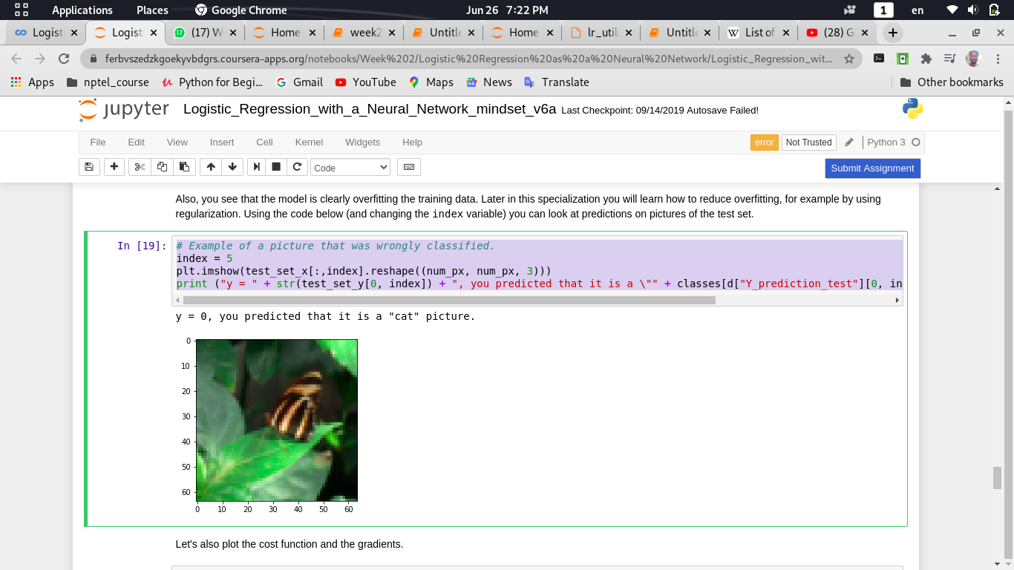

**Task:**Let's also plot the cost function and the gradients.

**Python Code:**

In[19]:

# Plot learning curve (with costs)

costs = np.squeeze(d['costs'])

plt.plot(costs)

plt.ylabel('cost')

plt.xlabel('iterations (per hundreds)')

plt.title("Learning rate =" + str(d["learning_rate"]))

plt.show()

Out[19]:

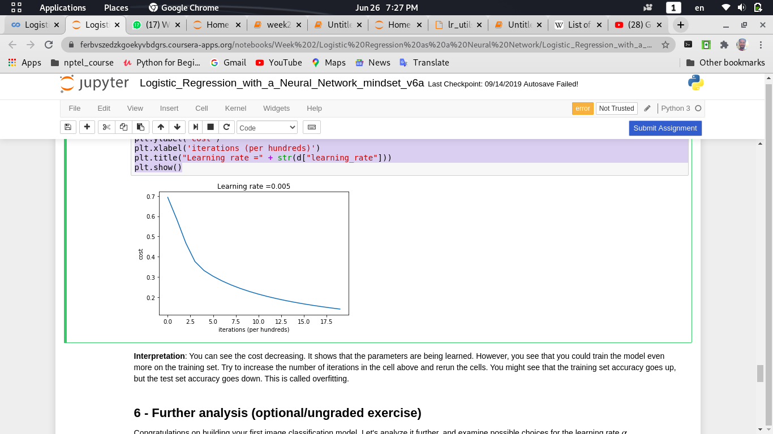

**Analysis of Out[19]:**

You can see the cost decreasing. It shows that the parameters are being learned. However, you see that you could train the model even more on the training set. Try to increase the number of iterations in the cell above and rerun the cells. You might see that the training set accuracy goes up, but the test set accuracy goes down. This is called overfitting.

11.Further Analysis

Let's analyze the model further, and examine possible choices for the learning rate α.

Choice of learning rate

**Reminder**: In order for Gradient Descent to work you must choose the learning rate wisely. The learning rate α determines how rapidly we update the parameters. If the learning rate is too large we may "overshoot" the optimal value. Similarly, if it is too small we will need too many iterations to converge to the best values. That's why it is crucial to use a well-tuned learning rate.

Let's compare the learning curve of our model with several choices of learning rates. Run the cell below. This should take about 1 minute. Feel free also to try different values than the three we have initialized the learning_rates variable to contain, and see what happens.

**Python Code:**

In[20]:

learning_rates = [0.01, 0.001, 0.0001]

models = {}

for i in learning_rates:

print ("learning rate is: " + str(i))

models[str(i)] = model(train_set_x, train_set_y, test_set_x, test_set_y, num_iterations = 1500, learning_rate = i, print_cost = False)

print ('\n' + "-------------------------------------------------------" + '\n')

for i in learning_rates:

plt.plot(np.squeeze(models[str(i)]["costs"]), label= str(models[str(i)]["learning_rate"]))

plt.ylabel('cost')

plt.xlabel('iterations')

legend = plt.legend(loc='upper center', shadow=True)

frame = legend.get_frame()

frame.set_facecolor('0.90')

plt.show()

Out[20]:

learning rate is: 0.01

train accuracy: 99.52153110047847 %

test accuracy: 68.0 %

-------------------------------------------------------

learning rate is: 0.001

train accuracy: 88.99521531100478 %

test accuracy: 64.0 %

-------------------------------------------------------

learning rate is: 0.0001

train accuracy: 68.42105263157895 %

test accuracy: 36.0 %

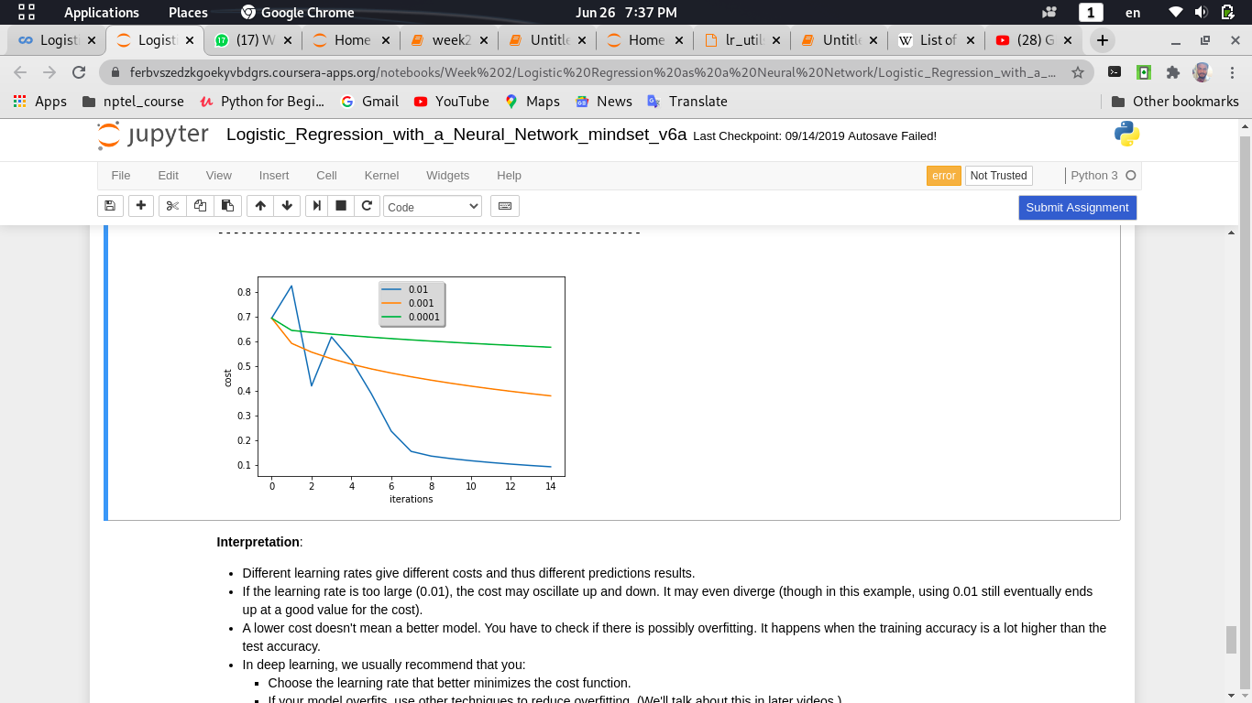

**Analysis of Out[20]:**

**Interpretation**:

* Different learning rates give different costs and thus different predictions results.
* If the learning rate is too large (0.01), the cost may oscillate up and down. It may even diverge (though in this example, using 0.01 still eventually ends up at a good value for the cost).
* A lower cost doesn't mean a better model. You have to check if there is possibly overfitting. It happens when the training accuracy is a lot higher than the test accuracy.
* In deep learning, we usually recommend that you:
  + Choose the learning rate that better minimizes the cost function.
  + If your model overfits, use other techniques to reduce overfitting. (We'll talk about this in later videos.)

12. Analysing Our Own Image!!

You can use your own image and see the output of your model. To do that:

1. Click on "File" in the upper bar of this notebook, then click "Open" to go on your Coursera Hub.

2. Add your image to this Jupyter Notebook's directory, in the "images" folder

3. Change your image's name in the following code

4. Run the code and check if the algorithm is right (1 = cat, 0 = non- cat)!

**Python Code:**

In[21]: ##(PUT YOUR IMAGE NAME)

my_image = "my_image.jpg" # change this to the name of your image file

# We preprocess the image to fit your algorithm.

fname = "images/" + my_image

image = np.array(ndimage.imread(fname, flatten=False))

my_image = scipy.misc.imresize(image, size=(num_px, num_px)).reshape((1, num_px * num_px * 3)).T

my_predicted_image = predict(d["w"], d["b"], my_image)

plt.imshow(image)

print("y = " + str(np.squeeze(my_predicted_image)) + ", your algorithm predicts a \"" + classes[int(np.squeeze(my_predicted_image)),].decode("utf-8") +"\" picture.")

Out[21]:

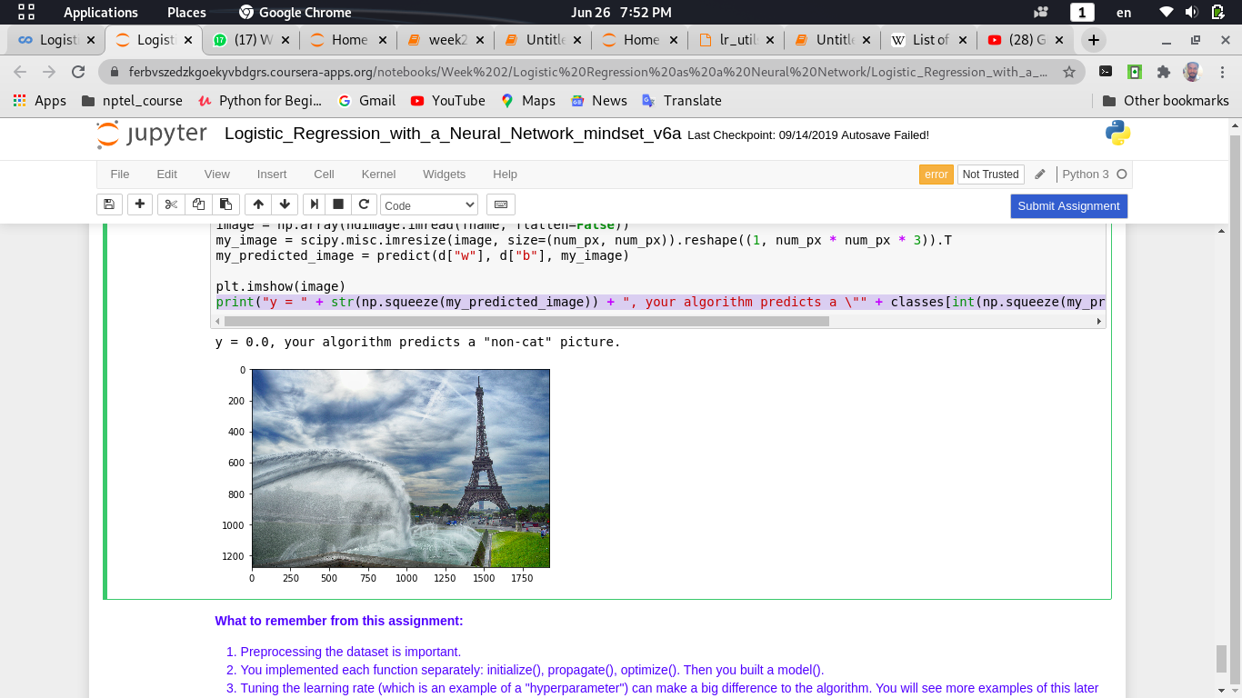

**Conclusion:**

Finally, if you'd like, we invite you to try different things on this Notebook. Make sure model must include:

- Play with the learning rate and the number of iterations

- Try different initialization methods and compare the results

- Test other preprocessings (center the data, or divide each row by its standard deviation)

**Bibilography:**

* <http://www.wildml.com/2015/09/implementing-a-neural-network-from-scratch/>
* <https://stats.stackexchange.com/questions/211436/why-do-we-normalize-images-by-subtracting-the-datasets-image-mean-and-not-the-c>