LOOPS

**AIM:** Print this pattern using loops, get the number of rows as an input from the user.

*

* *

* * *

* * * *

**ALGORITHM:**

* Declare the neccessary headers for the file to run.
* Declare an integer ‘n’ to hold the number of iterations input from the user.
* Declare two ‘for’ loops. One for printing newline whenever the closing condition is reached in the second ‘for’ loop which is used to print the ‘*’ characters.

**CODE:**

#include <stdio.h>

int main(void){

int n;

printf("Enter the Number of Rows: ");

scanf("%d", &n);

for(int i = 1; i <= n; i++){

for(int j = 0; j < i; j++){

printf("*");

}

printf("\n");

}

}

**OUPUT:**

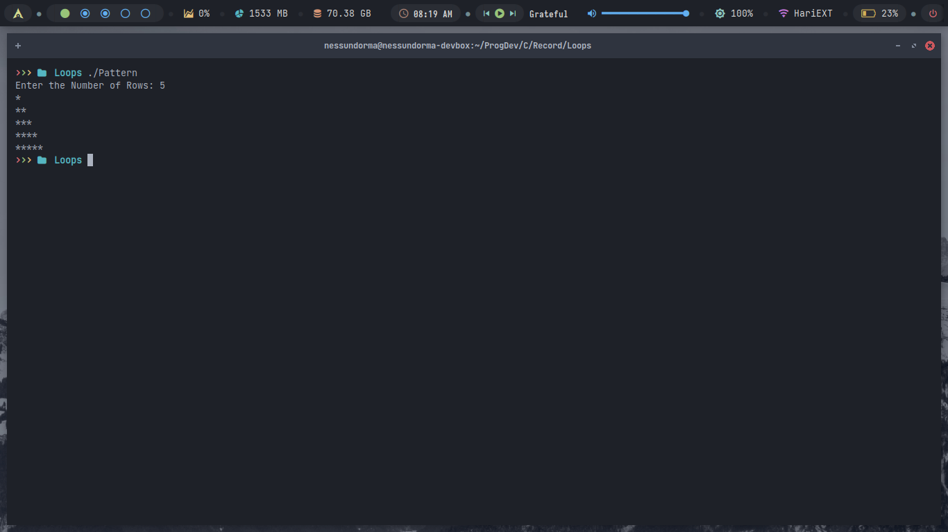

**FLOWCHART:**

