DOCUMENTATION

Project Title
A web based decision support system (DSS) using multi-criteria analysis technique AHP to achieve the following task:
- To identify potential suitable habitat of swamp deer using geospatial analysis
- Adding your own weights to generate different criteria weights
- Reclassifying images on the fly on the basis of suitability

Description
Decision Support System drive faster, smarter decisions based on objective data, rather than on subjective criteria or personal instinct.
Why to make DSS?
- Decisions require computation
- Lots of data
- High consistency
- Rapid choices

Getting Started
These instructions will get you a copy of the project up and running on your local machine for development and testing purposes.

Installing
- Install pip3 (For installing python libraries)
sudo apt update

sudo apt install python3-pip
- Install git
sudo apt install git
- Geodjango installation

What is GeoDjango?
GeoDjango is an included contrib module for Django that turns it into a geographic Web framework. GeoDjango strives to make it as simple as possible to create geographic Web applications, like location-based services. Its features include: - Django model fields for OGC geometries and raster data. - Extensions to Django’s ORM for querying and manipulating spatial data. - Loosely-coupled, high-level Python interfaces for GIS geometry and raster operations and data manipulation in different formats. - Editing geometry fields from the admin.

Requirements:
- Python and Django
- Spatial database - PostgreSQL (with PostGIS)
- Installing Geospatial libraries - GEOS, GDAL, PROJ.4, PostGIS (Supported versions : 9.4+)
Step-1: Install Django
sudo apt install python3-django
Upgrade to Django version 2
pip3 install --upgrade django
python3 -m django --version
Output should be # 2.2.2
Step-2 : Install PostgreSQL and PostGIS extension
sudo lsb_release -a

sudo sh -c 'echo "deb http://apt.postgresql.org/pub/repos/apt ubuntu_codename-pgdg main" >> /etc/apt/sources.list'

sudo sh -c 'echo "deb http://apt.postgresql.org/pub/repos/apt bionic-pgdg main" >> /etc/apt/sources.list'

wget --quiet -O - http://apt.postgresql.org/pub/repos/apt/ACCC4CF8.asc | sudo apt-key add -

sudo apt update

sudo apt install postgresql-10

sudo apt install postgresql-10-postgis-2.4

sudo apt install postgresql-10-postgis-scripts

sudo apt install postgresql-10-pgrouting
Step-3 : Install Geospatial libraries
sudo apt-get install binutils libproj-dev gdal-bin

Configuring PostgreSQL
- Switch over to the postgres account on your server by typing:
sudo -i -u postgres
- Create a new user by typing:
createuser --interactive
Enter name of role to add: happy Shall the new role be a superuser? (y/n) y
- Create a New Database
createdb corey
psql -d postgres
Once logged in, you can get check your current connection information by typing:
postgres=# \conninfo
Output : You are connected to database "corey" as user "happy" via socket in "/var/run/postgresql" at port "5432".
- Create username and password
sudo -u postgres psql -c "ALTER ROLE happy WITH password 'Vishal@2000'"
Or to create your own user to be linked with database, create a user using “postgres createuser” and give it a password and accordingly inside settings.py add username and password (because it will be used by django to connect to database)

Install GDAL/OGR (Python geospatial libraries to work with raster data)
sudo add-apt-repository ppa:ubuntugis/ppa && sudo apt-get update
sudo apt-get update
sudo apt-get install gdal-bin
sudo apt-add-repository ppa:ubuntugis/ubuntugis-unstable
sudo apt-get update
sudo apt-get install python-gdal

Installation of the project
- Clone or download the repository.
git clone https://github.com/vismit2000/IIRS_Internship
- Install required python packages given in the requirements.txt file.
pip install -r requirements.txt
- Run Django migrations.
python manage.py makemigrations
python manage.py migrate
- Start the application.
python manage.py runserver
- Access the application at:
http://localhost:8000

Sample run
- Register yourself
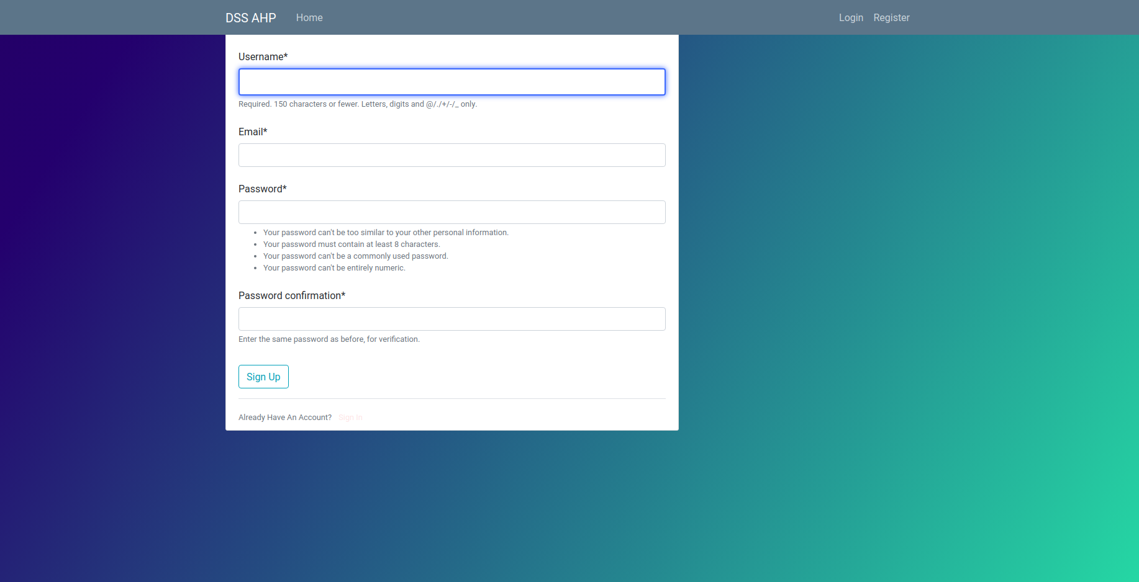
- Login into your account
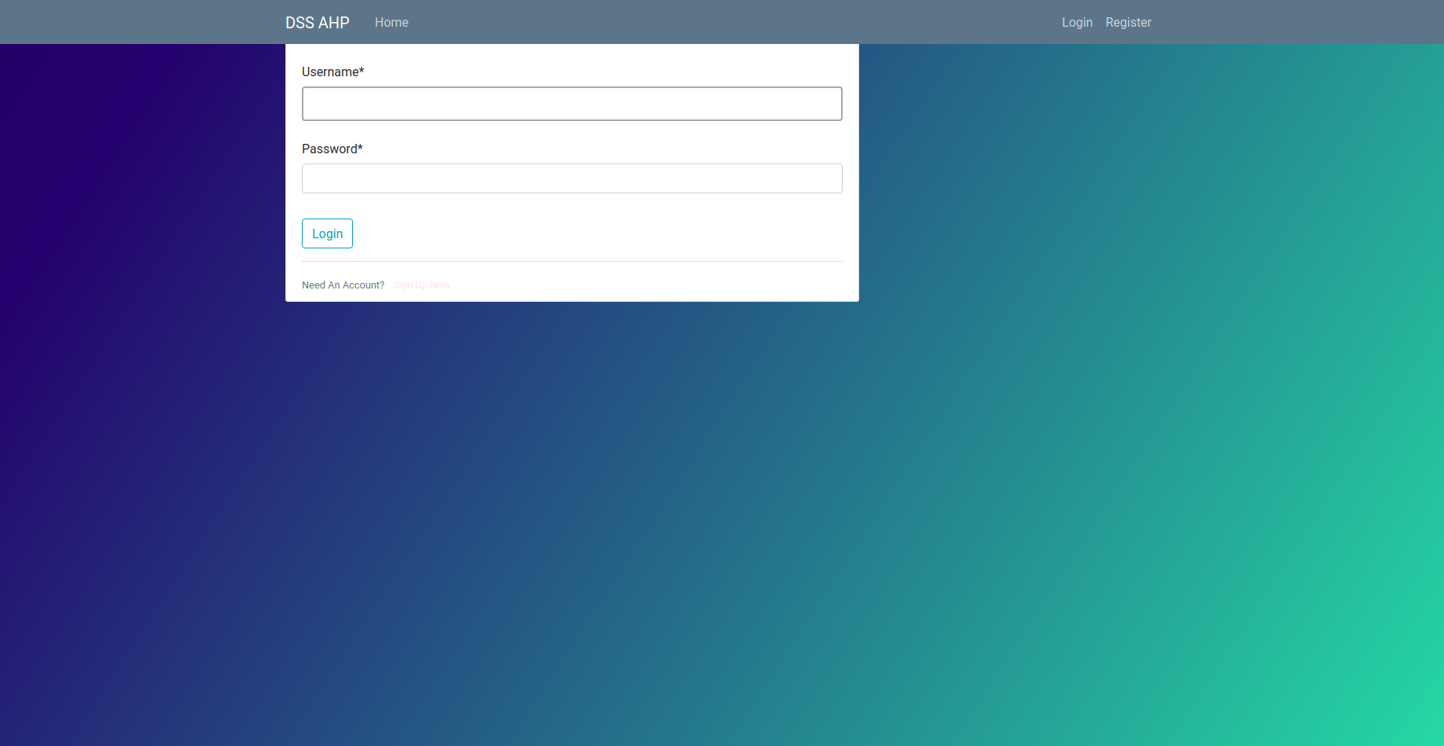
- Now you are on home page. Reclassify dimensions by selecting 'Select Ranges'
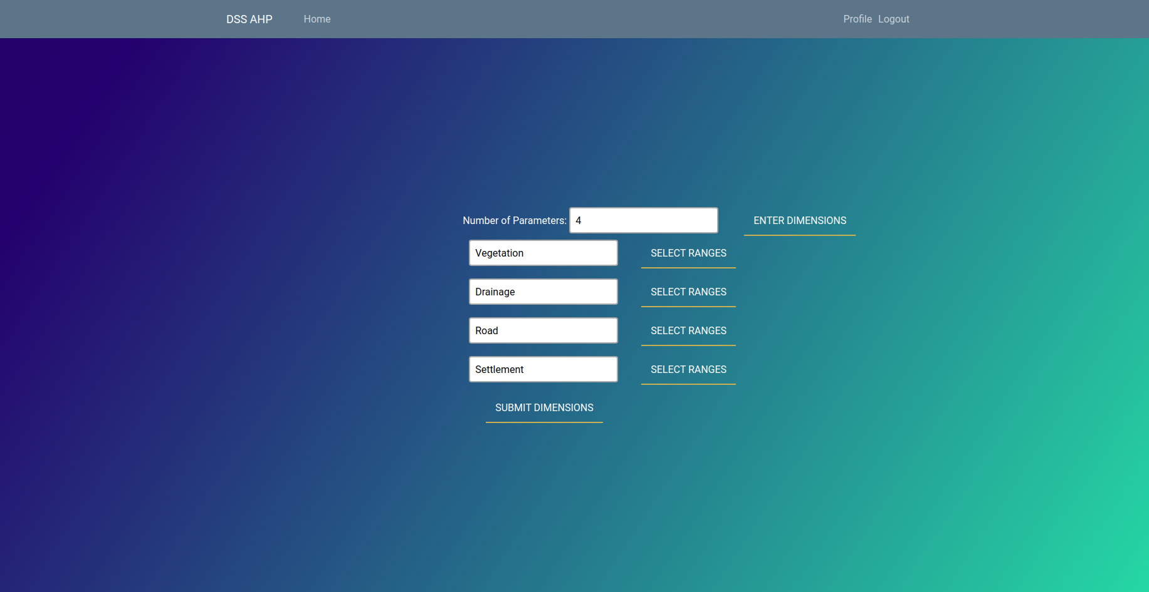
- Example for reclassifying Vegetation:
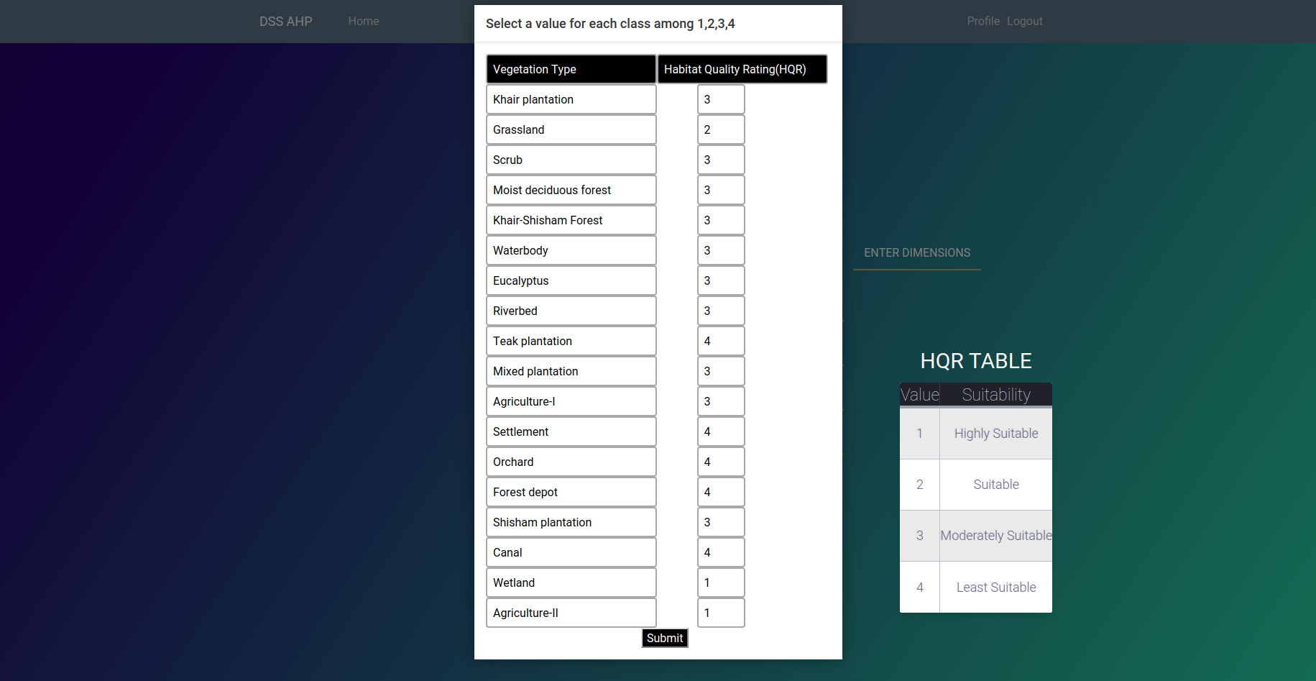
Press 'Submit Dimensions' after reclassifying all dimensions.
- Enter values of matrix with help from Importance Table and press 'Calculate Column Sum'
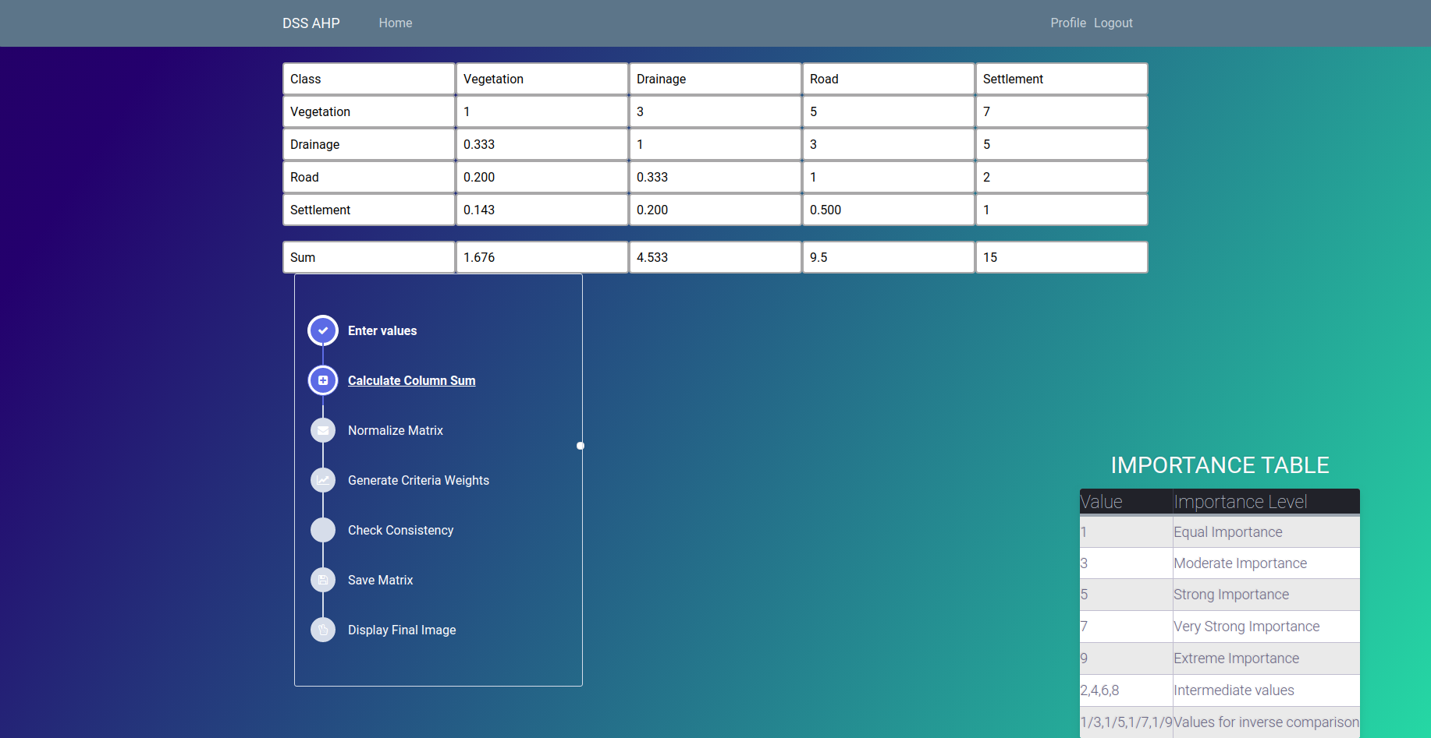
- Normalize matrix and generate criteria weights.
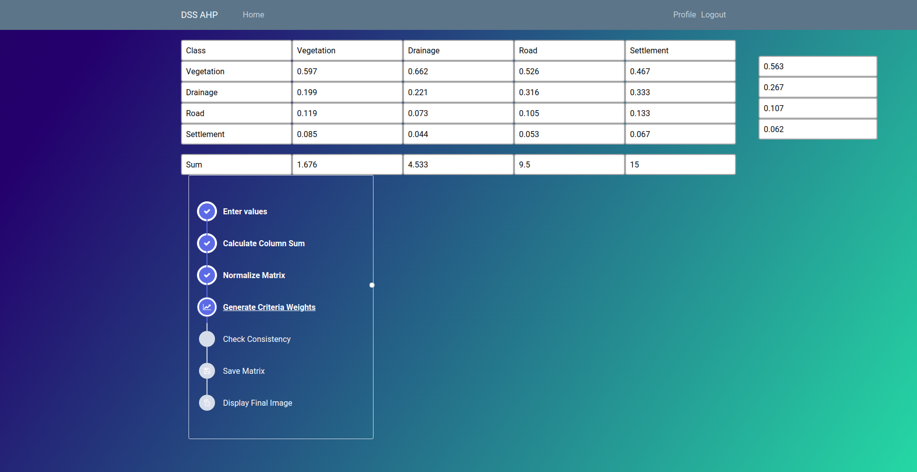
- Check consistency ratio. You will be directed to Step-5 to enter matrix again if consistency ratio < 0.1
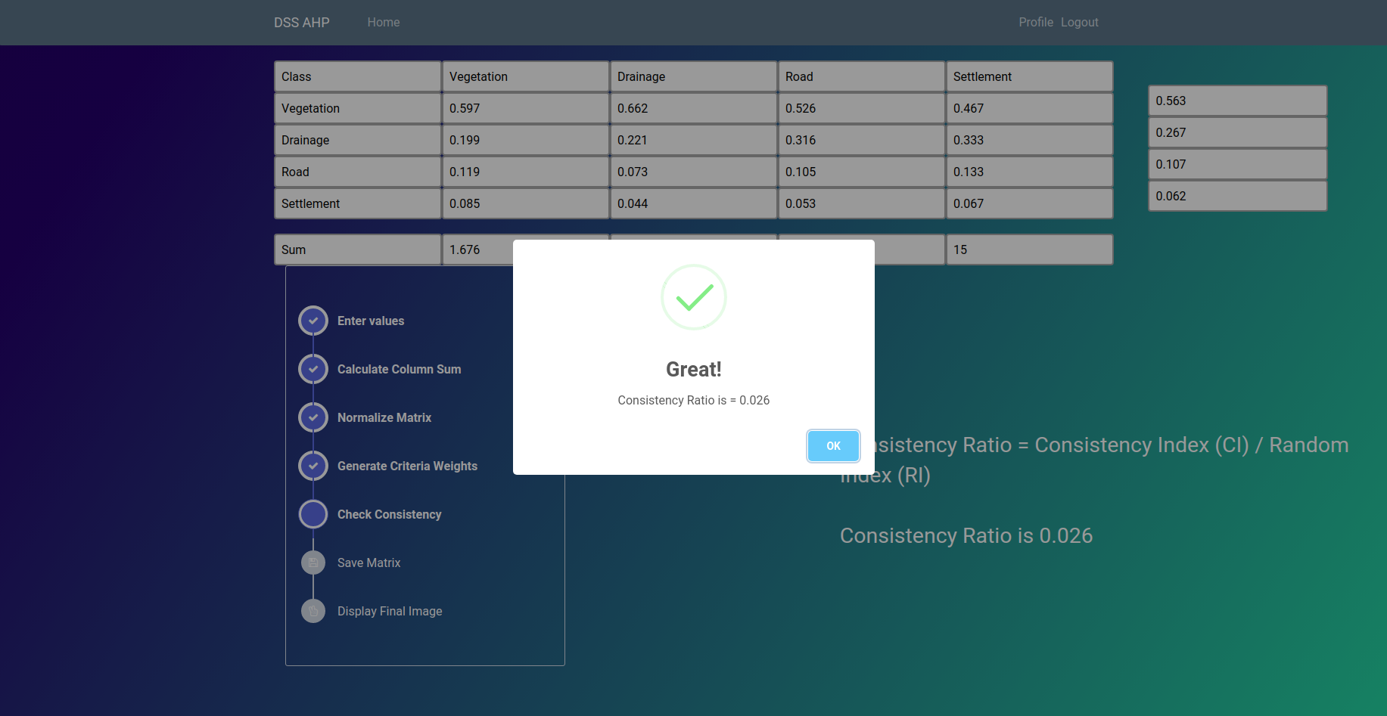
- Now save your matrix for future reference and press 'Display Final Image' to display the final image.
Note : 1. You can also diaplay final image from your profile.
2. Colour theme of final image can be changed from the palette.

Visulaization of final raster result
Final image shows four suitability areas for habitat of swamp deer :
* Highly suitable
* Suitable
* Moderately suitable
* Least suitable

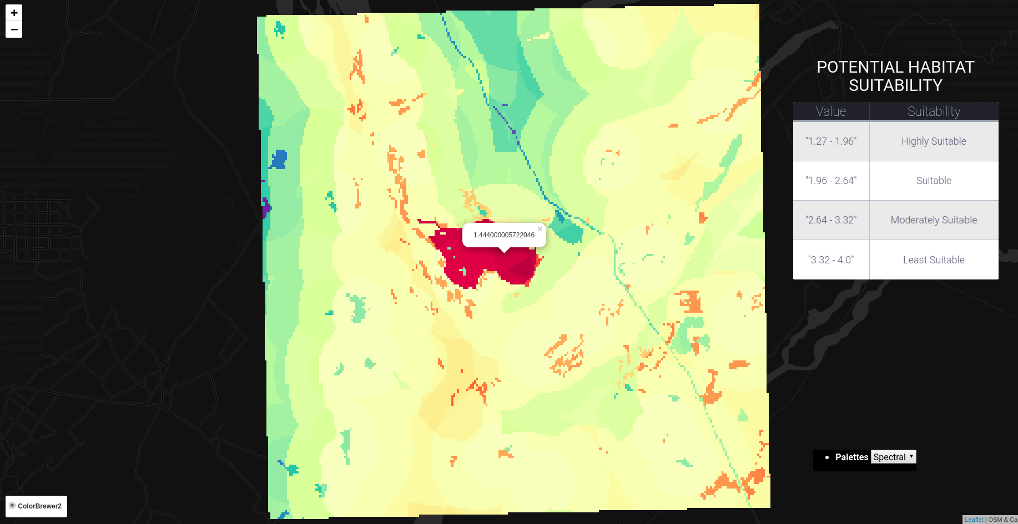

##Admin details :
** Username : vishal
** Password : Vishal@2000

Django MVC Architecture
The MVC is an architectural pattern that separates an application into three main logical components 1. Model 2. View 3. Controller
Goal of each layer on the MVT architecture that Django uses :
M — Model: The goal of the Models is to handle the data. That means, it should be responsible for maintaining the integrity of the state of the object, and implement the behaviours that this object may have. That means, it is also responsible for changing the state of the object.
V — View: The view has few goals. First, it is responsible for getting the inputs that come via HTTP request. Secondly, it should be sending this to the process that will process that data and collect the output of the operation. And thirdly, it is responsible for processing the template and send the response back to client. The view is not responsible for having the process itself, it is the controller. No business logic should live here. In fact, it should be the thinnest layer in our application.
T — Template: The template is there to define the markup that will be processed by the view. The template system that Django uses is sophisticated and allow extensions and few logical operations. Due to the high-level of customization that is possible here, it is very easy to add a lot of business logic to that. Template should deal only with the presentation aspect of our application.
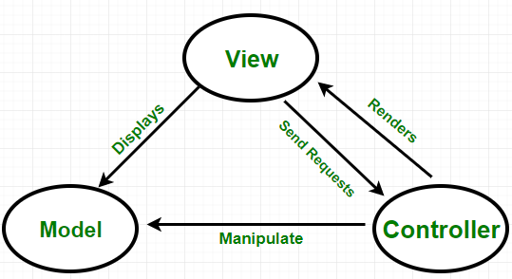

MVC in web application
Controller – Programming on the server to direct and redirect the user from page to page
Views – What the end user sees on its browser
Model – Set of applications that take input data and put data into website’s data mix

Web application
Issues related to web-based spatial decision support system:
* Performance
* Integration of various technologies
* Security
* Interoperability
Server : A distant computer that provides services
Client : The computer the user is operating, which consumes services from a server

Map Algebra

Raster Data Analysis
In a raster data set, each cell represents a value at a given location. A grid cell could represent anything – temperature values or precipitation volume.
The map algebra tool is a cell-by-cell combination of raster data layers stacked on top of each other. A simple operation like addition or multiplication are applied to each raster cell location. Map algebra generates a new raster output based on the math-like expression.
Raster operations can be classified into global, zonal, focal and local operations.

Local Operations
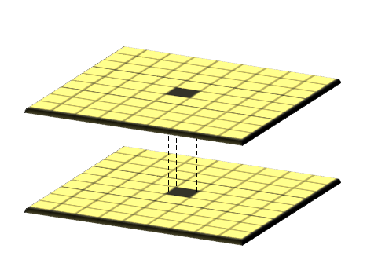

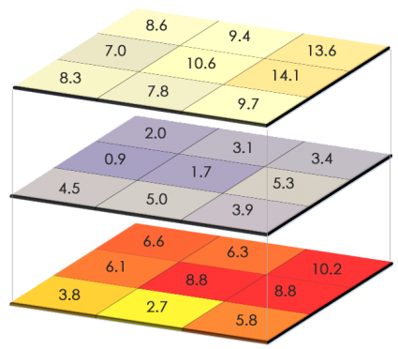

The value generated in the output raster is a function of cell values at the same location on in the input layers.
Here are examples of operations that can be used between the two raster layers:
* Arithmetic operations (addition, subtraction, multiplication, division)
* Statistical operations (minimum, maximum, average, median)
* Relational operations (greater than, smaller than, equal to)
* Trigonometric operations (sine, cosine, tangent, arcsine)
* Exponential and logarithmic operations (exponent, logarithm)

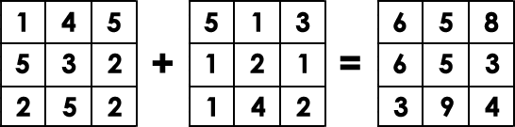

Tech Stack used
- Frontend - HTML, CSS, Javascript
- Backend - Python, Django, GeoDjango
- API used : Leaflet

Acknowledgments
- Kapil Oberoi Sir (IIRS Dehradun)
- Sameer Saran Sir (IIRS Dehradun)

Acronyms
- DSS Decision Support System
- AHP Analytical Hierarchy Process
- MVC Model View Controller Architecture
- GDAL Geospatial Data Abstraction Library
- OGR OpenGIS Simple Features Reference Implementation
- GIS Geographic Information System
- QGIS Quantum Geographic Information System

