

Faculty of Technology and Engineering

U & PU PATEL DEPARTMENT OF COMPUTER ENGINEERING

Date :03/10/ 2023

|  |  |  |  |  |  |
| --- | --- | --- | --- | --- | --- |
| Academic Year | : | 2023-24 | Semester | : | 5 |
| Course code | : | CE354 | Course name | : | Operating system |

|  |  |
| --- | --- |
| Practical 5: | Linux File Systems |
|  | ***Part-A*** |
|  |  |
| 1) | The File Hierarchy Standard (FHS) is a specification that defines the file system hierarchy of a Linux OS. Illustrate about the use of all directories under the “\” as given in the figure. |
| Ans. | /bin: Contains essential binary executables.  /boot: Contains boot-related files.  /dev: Contains device files.  /etc: Contains system-wide configuration files.  /lib: Contains essential shared libraries.  /proc: Contains information about processes and system status.  /root: Home directory of the system administrator (root).  /sbin: Contains system binaries.  /tmp: Temporary files.  /usr: Contains secondary hierarchy, including user and system programs.  /var: Contains variable data, like logs and spool files. |

|  |  |
| --- | --- |
|  |  |
| 2) | List out files in your directory. |
| Ans) | Command: ls  List Files in Current Directory |
| 3) | Create a hard link to one of the file exist in your directory. (ln [original file] [link name]) |

|  |  |
| --- | --- |
| Ans) | Command:ln file1.txt link_file1  Create a hard link with |
| 4) | Apply ls –l and check whether the link is created or not. Also check the size of linked file  created. |
| Ans) | Command:ls -l  check if the link is created, and verify the size of the linked file. |
| 5) | Update the existing file. |
| Ans) | Command:gedit file1.txt  Cat file1.txt  Make a file and add some content |
| 6) | Apply ls –l and check the size of linked file created. |
| Ans) | Command:ls -l  Check the file size |



|  |  |
| --- | --- |
|  |  |
| 7) | Check the content of both the files and write your observation. |
| Ans) | Command:cat file1.txt  Cat link_file1  Display the content of files. |
|  | Delete the existing file on which you have created the link. |
| Ans) | Command:rm file1.txt  Delete the file |
| 9) | Apply ls –l and observer the output. |
| Ans) | Command:ls -l  See the file size |

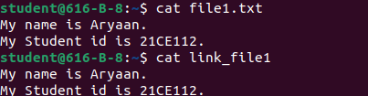

|  |  |
| --- | --- |
| 10) | Perform exercise 2 to 9 for creation of soft link and write your observation. (ln –s [original file] [link name]) |
| Ans) | Command:ls -l  gedit f1.txt  ln -s f1.txt link_f1 ls -l  create a soft link and perform all task |
| 11) | Write difference between hard link and soft link. |
| Ans) | **Hard Link:** A hard link is a reference to the same inode (data structure) as the original file, essentially creating multiple directory entries for the same data.  **Soft Link (Symbolic Link):** A soft link, also known as a symbolic link or symlink, is a separate file that contains the path to the target file or directory. It acts as a pointer. |
|  | File Systems, Storage, and Block Devices |
| 12) | Apply ls –l /dev/sda1 |
| Ans) | Command:ls -l /dev/sda1  List details of a specified block device. |
| 13) | To get an overview of local and remote file system devices and the amount of free space available, run the df command |
| Ans) | Command:df  Display disk usage and free space. |

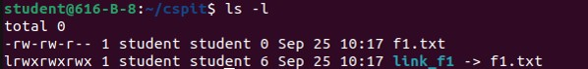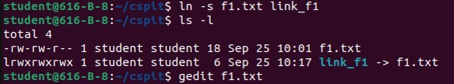

|  |  |
| --- | --- |
|  |  |
| 14) | Apply df –h and see the difference in the output |

|  |  |
| --- | --- |
| Ans) | Command: df -h  Display df output in human-readable format. |
| 15) | For more detailed information about space used by a certain directory tree, use the du command. Apply du /home/ID_No |
| Ans) | Command:du /home/student  Show disk usage of a directory tree. |
| 16) | Apply du –h /home/ID_No and see the difference in the output |
| Ans) | Command:du -h /home/student  Display du output in human-readable format. |

|  |  |
| --- | --- |
|  |  |
| 17) | Use the lsblk command to list the details of a specified block device or all the available devices |
| Ans) | Command:lsblk  List details of block devices. |
|  | Searching for Files |
| 18) | Apply locate passwd and see the output. |
| Ans) | Command:locate passwd  Search for files using the locate command. |

|  |  |
| --- | --- |
|  |  |
| 19) | To search for files by file name, use the -name FILENAME option. With this option, find returns the path to files matching FILENAME exactly. Search for files named sshd_config starting from the / directory. (find / -name sshd_config) |
| Ans) | Command:find / -name sshd_config  Find files with a specific name. |
| 20) | search for files starting in the / directory that end in .txt. |
| Ans) | Command:sudo find / -type f -name “*.txt”  Find files with a .txt extension. |

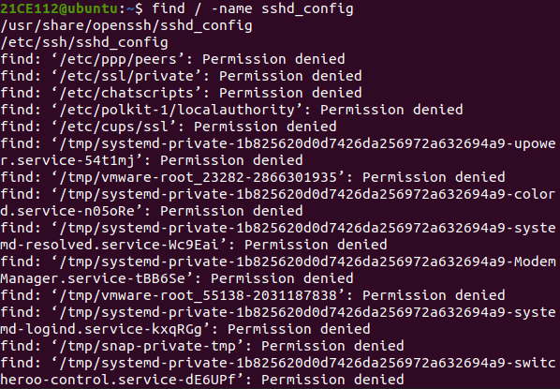

|  |  |
| --- | --- |
|  |  |
| 21) | search for files in the /etc/ directory that contain the word, “pass”. |
| Ans) | Command:sudo find /etc -name “pass*”  Search for files containing a specific word. |
| 22) | Search for files owned by user in the /home/ID_No directory. |
| Ans) | Command:sudo find /home/student -user student  Find files owned by a specific user. |
| 23) | Search for files owned by the group user in the /home/ID_No. |
| Ans) | Command:sudo find /home -user zeenal  Find files owned by a specific group. |
|  | Mount and unmount USB drive |
| 24) | Apply df -h to see the partitions. |
| Ans) | Command:df -h  Display disk partitions and their usage in human-readable format. |

|  |  |
| --- | --- |
|  |  |
| 25) | Unmount your USB drive by locating its path |
| Ans) | Command:sudo umount /dev/sdc1  Unmount the USB drive by specifying its path. |
| 26) | Again, apply df -h and check your USB if it is accessible or not. |
| Ans) | Command:df -h  Display disk partitions and their usage in human-readable format. |
| 27) | Mount your USB drive into directory. (Create one directory and inside that apply mount drive directory name command) |
| Ans) | Command: mkdir pen1  Sudo mount /dev/sdc1 /home/student/cspit/pen1 ls  Mount the USB drive to a specified directory (create the directory first if it doesn't exist). |
| 28) | Again, apply df -h command and check whether it is mounted or not. |
| Ans) | Command:df -h  Display disk partitions and their usage in human-readable format. |

|  |  |
| --- | --- |
|  |  |