Vivian Ta

IT FDN 100 A

Assignment 2 Notes

Oct. 13, 2018

After going through the videos and reading chapter 2, I created a file called assignment2.py with `vim` and added the necessary code. Like the last assignment, I added `#!/usr/local/bin/python3` so that I don’t need to prepend `python3` to launch the file. After chmoding it to be executable, I was able to run it with `./assignment2.py`.

Since this assignment was really similar to the lab, I had already gone through the initial issue of getting a concatenated string instead of having the integers added. Before looking at the answer video, I did some googling and found through this [website](https://anh.cs.luc.edu/python/hands-on/3.1/handsonHtml/io.html) that input takes values in as a string so I had to manually convert them to ints or floats. In my lab, I just converted them to ints. For the homework, I went with floats since there’s quotients involved.

My first iteration had some redundancy where I was printing a similar string each time using print and my difference is returning a negative number because the first value was smaller than the second value in the subtraction:

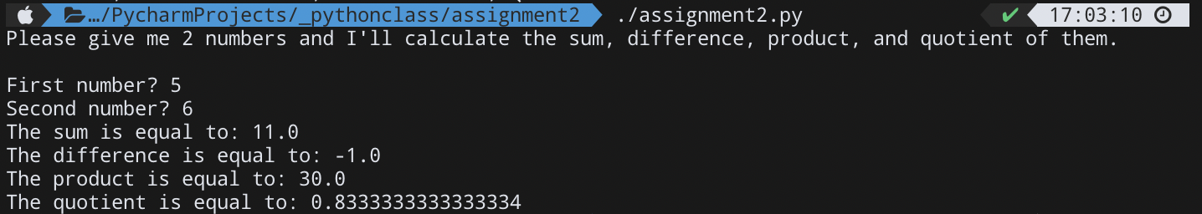

I thought I could make it cleaner by adding all the information into one line and shrinking it down to one print statement. I also wrapped the subtraction part of the print statement in abs() so we wouldn’t get negative numbers.



The output looked very clumped together so I decided to add `end=\n\n` to the first print statement so I can get some space in between. Also ended up removing the abs() function around the subtracting part since I felt like the program should do what the user put in.

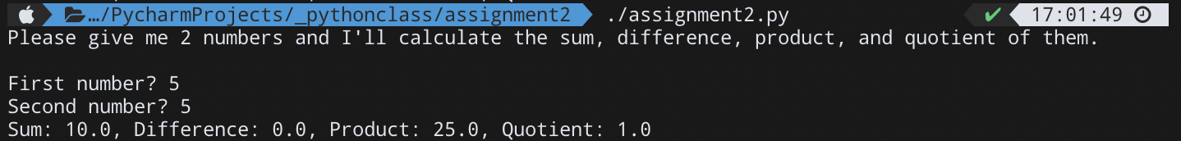

For the last print statement, I modified the separator to be nothing so I could visually add spaces where I needed to make it print nicely.