Vivian Ta

IT FDN 100 A

Assignment 5 Notes

Nov. 4, 2018

I struggled a bit with this one and had to google quite a bit to figure out how to use the global variable. I initially went down the wrong path by trying to write to the file every time and quickliy realized that this was the wrong way to go.

Since we learned about functions in this chapter, I wanted to apply what we learned to this assignment since it called for different actions from the user. I have 3 methods: `add_item()`, `delete_item()`, and `save_list()`. I initially had a `show_current_items()` method as well but could not figure out how to properly delete the objects since I had encapsulated my file open(‘Todo.txt’, ‘r+’) in the function and wasn’t’ able to delete items properly.

This was the original code: 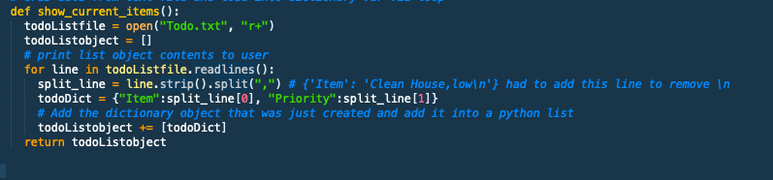

The other issue I was running into was when I was showing the current data, it would not be reflected properly because I was reading the data from the Todo.txt file every time instead of a variable. I eventually separated out the step where I was reading from the file and appending dicts to the list to its own thing and that made a lot more sense.

The code has been uploaded here: <https://github.com/visokoo/_pythonclass/blob/master/assignment5/assignment5.py>

Here’s a screenshot of the code working with different user inputs:

