Lab 07, Experiment 1(d)

Bit Error Measurements for PAM in GNU Radio:

The task is to calculate the BER for a signal generated using 'rect' pulse and filtering it out using matched filter and trapezoidal filter.

Below is the GNU flow graph generated for this experiment:

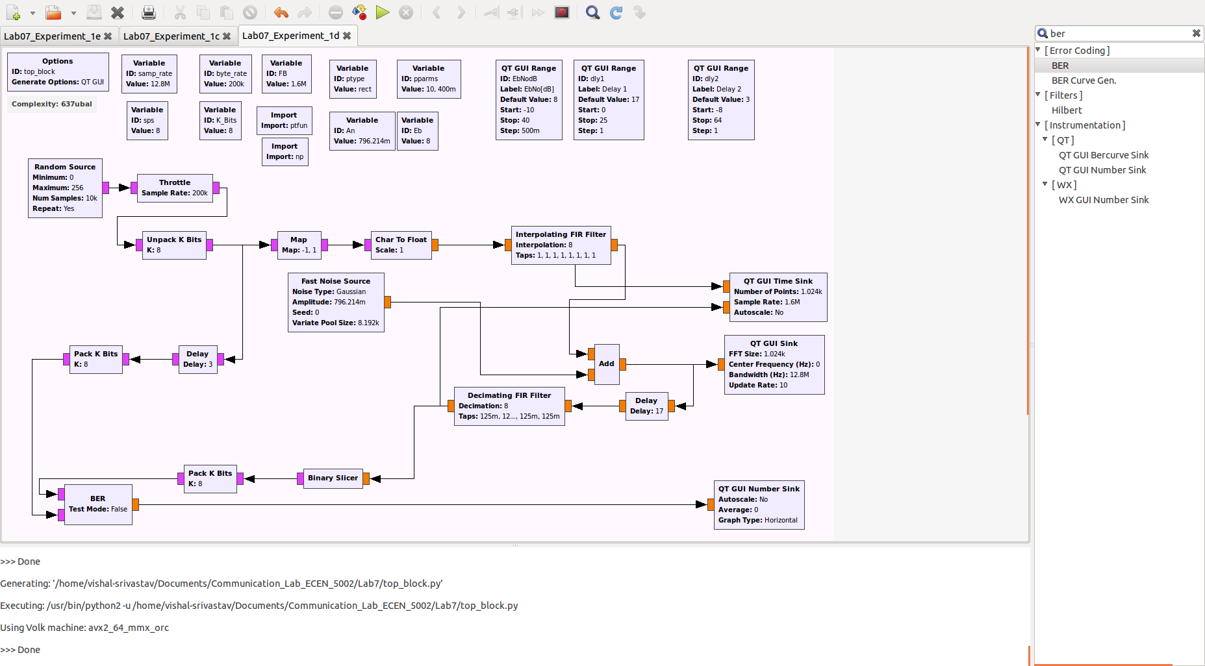

I) We will first use match filter i.e p(t) = u*(T-t) at receiver end.
Below is the configuration of interpolating and decimating filter.

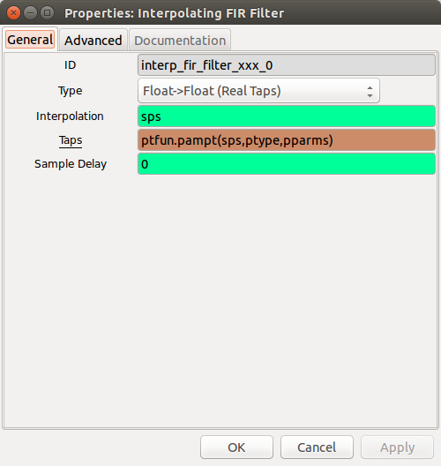

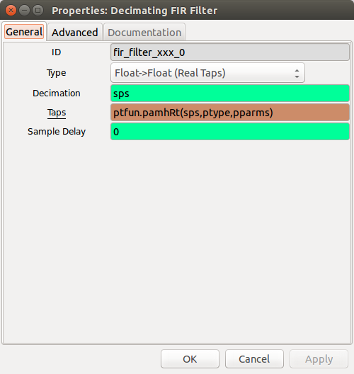

We have run using the above configuration and try to set the delay to get the proper plot. The dly1 = 17 and dly2 = 3 values were used to get the BER given in the lab manual.

Below is the outputs for SNR: 2dB, 4dB, 6dB and 8dB.

SNR = 2 dB

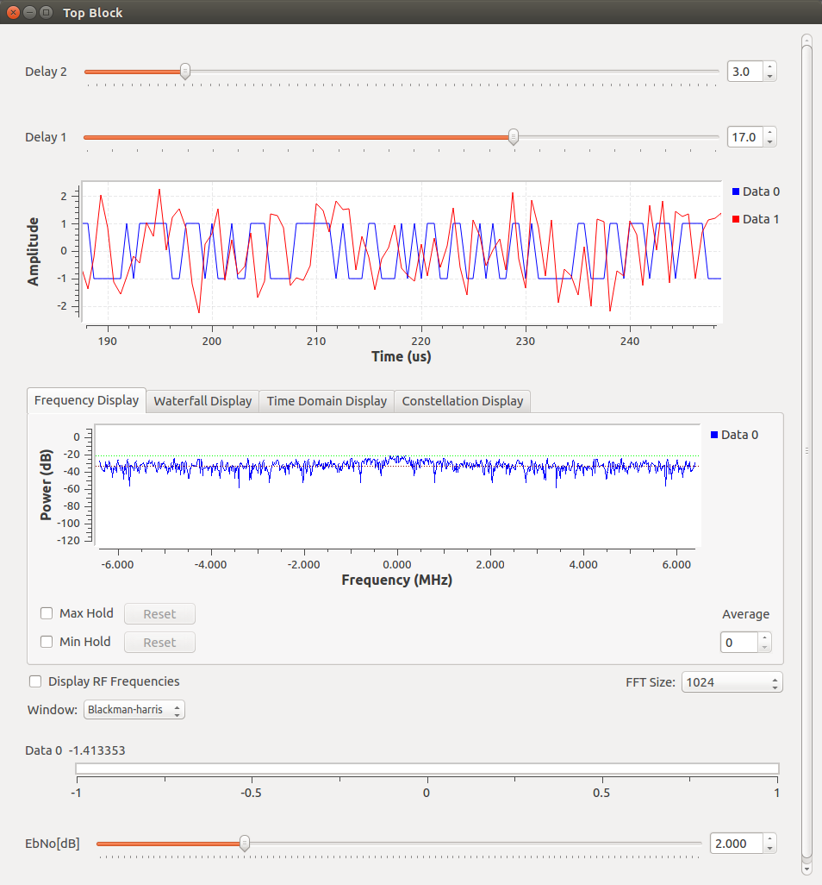
The BER value found is equal to 10^(-1.413353) = 0.0386.

SNR = 4 dB

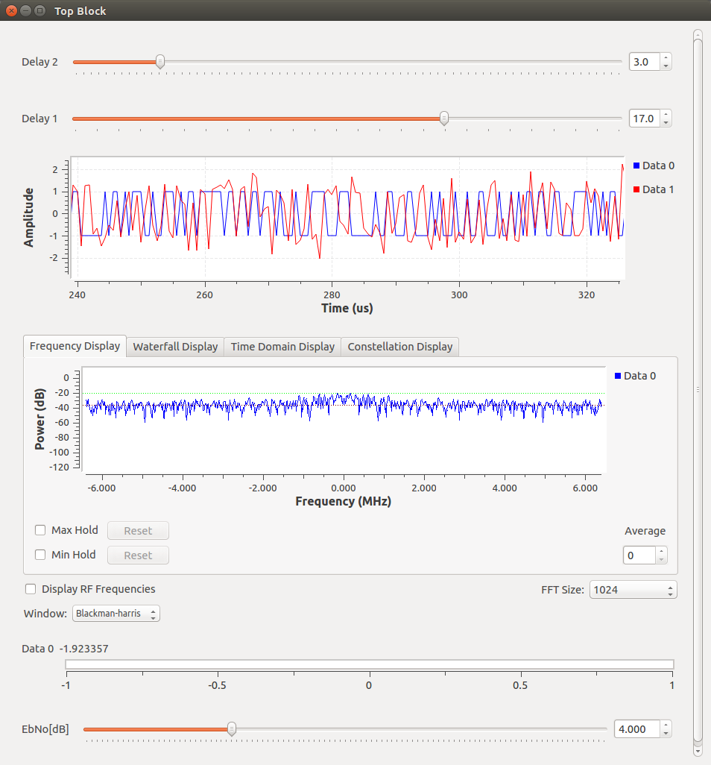

The BER value found is equal to 10^(-1.923357) = 0.0119.

SNR = 6 dB

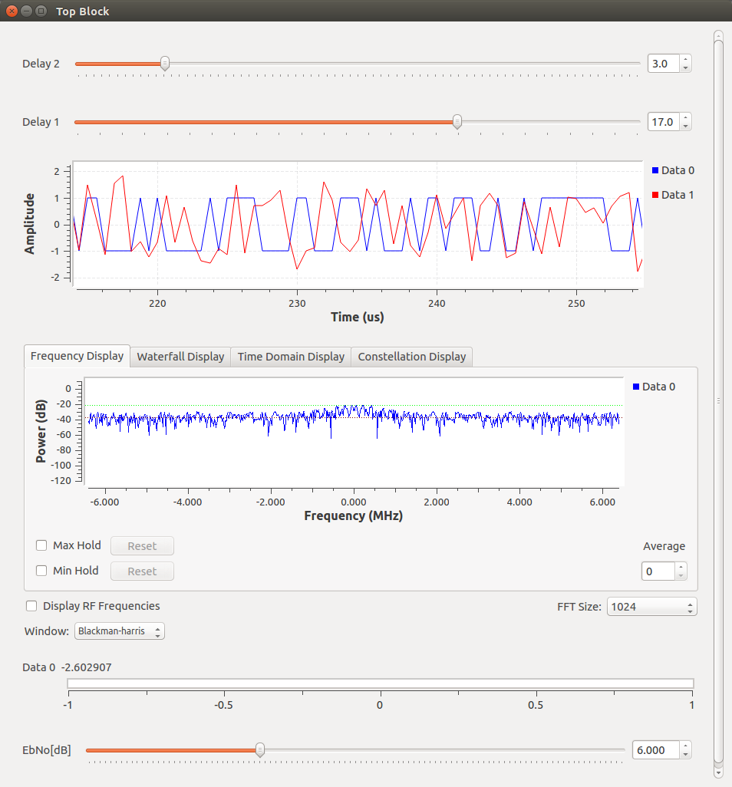

The BER value found is equal to 10^(-2.602907) = 2.495128 x 10^(-3).

SNR = 8 dB.

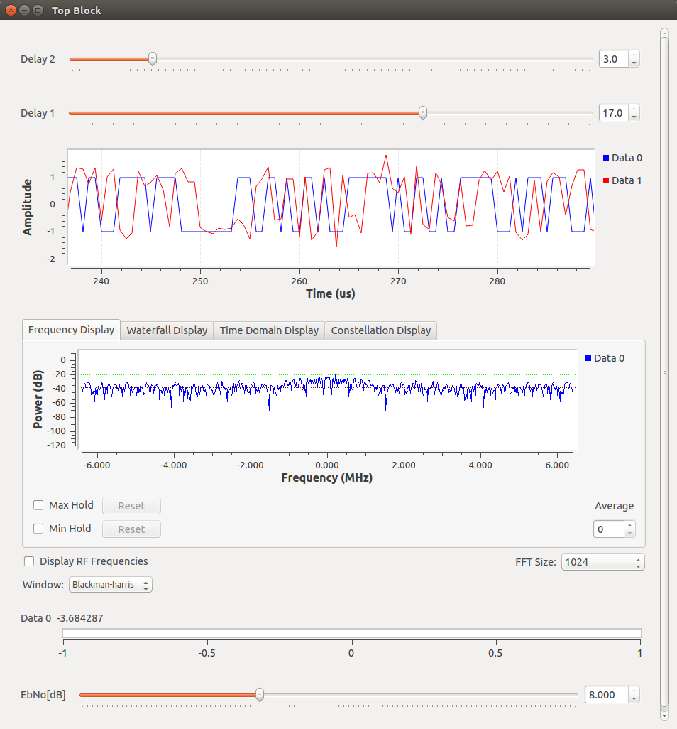

The BER value found is equal to 10^(-3.684287) = 2.068773 x 10^(-4).

