Index of Attached Documents
S. No. | Particulars | Page No(s).  (e.g. 1 – 3 if more than one page, write NA otherwise)  (All proofs / documents should be self-attested)
 | Application Form
 | Research Degrees(s) (for point no.7 of the Application Form)
 | Academic Staff College Orientation/Refresher and other Courses attended (for point no.11 of the Application Form)
 | Proof of 03 (for Associate Prof.) / 05 (for Prof.) Publications (in chronological order) for expert assessment as per category III (A) (Page No. 25) of UGC regulations dated 11.07.2016.
 | Proof of Refereed Journals/other Reputed Journals as notified by the UGC
 | (a) Direct Teaching
 | (b) Examination duties (question paper setting, Invigilation, evaluation of answer scripts)* as per allotment
(c) Innovative Teaching – learning methodologies, updating of subject contents/ courses, mentoring etc.
The number of hours will be considered as stated by the faculty member
(a) Student related co-curricular, extension and field based activities.
(i) Discipline related co-curricular activities (e.g remedial classes, career counseling, study visit, student seminar and other events.)
 | (ii) Other co-curricular activities (Cultural, Sports, NSS, NCC etc.)
 | (iii) Extension and dissemination activities (public/popular lectures /talks/seminars etc.)
 | (b) Contribution to corporate life and management of the department and institution through participation in academic and administrative committees and responsibilities.
 | (i) Administrative responsibility (including as Dean/Principal/ Chairperson/Convener/ Teacher- in-charge/ similar other duties that require regular office hrs for its discharge)
 | (ii) Participation in Board of Studies, Academic and Administrative Committees
 | (c) Professional Development activities (such as participation in seminars, conferences, short term training courses, industrial experience, talks, lectures in refresher/faculty development courses, dissemination and general articles and any other contribution)
A. Research Papers:
(i) Proof of research papers published in journal as per Category III (A) (Page No. 25) of UGC regulations dated 11.07.2016.
(ii) Proof of Impact factor (latest).
(iii)Proof of First and Principal / Corresponding author / supervisor / Mentor / other author.
(iv) Proof of Refereed Journal / Other Reputed Journal.
 | B. Articles/ Chapters published in Books
C. Research Projects (please attach copy of sanction order indicating total amount for (i) & (ii) below)
(i) Sponsored Projects
 | (ii) Consultancy Projects (Annual Cumulative amount will considered)
 | (iii) Project Outcome/Outputs
D. Research Guidance (Certificates to be attached)
(i) MTech/M. Phil or Equivalent
 | (ii) Ph. D. or Equivalent
E. Fellowship, Awards and Invited Lectures delivered in Conference/ Seminars:
(i) Fellowship/Awards etc.
(ii) Invited Lectures/Papers
Proof of communication relating to lectures delivered / sessions chaired etc.
 | F. Development of e-learning delivery process / Material
 | Other Relevant Information

PUNJAB ENGINEERING COLLEGE CHANDIGARH

(DEEMED TO BE UNIVERSITY)

PBAS Performa for Promotion under the CAS as per UGC 4th amendment 11.07.2016
(As per UGC norms)
Application for promotion from ……………………………………. to………………………….
{Assistant Professor (Stage 1 to Stage 2, Stage 2 to Stage 3), Assistant Professor (Stage 3) to Associate Professor (Stage 4), Associate Professor (Stage 4) to Professor (Stage 5)}.
(Please indicate whichever is applicable)
PART A : GENERAL INFORMATION AND ACADEMIC BACKGROUND
Date of joining PEC on regular basis_______________ Post_____________
Department_____________________________
Post presently held:
Date of joining the present post on regular basis:
Post to which promotion is sought:
Date of eligibility for promotion:
(on the basis of Service and Academic Performance Requirement)

Initial Assessment Period: From…………………….. to…………………………….
Subsequent Additional Assessment Period (If applicable):
(i) From……………….. to…………………………….
(ii) From……………….. to…………………………….
(iii) From……………….. to…………………………… ____________________________________________________________________________________
1. Name in Full: (Underline Surname)
Affix passport size photogrph

2. Address: For correspondence Permanent
_________________ ______________________ _________________ ______________________

Phone _________________ Email ID_____________________

3. Date of Birth: ____________________________________________________
4. Category: General /SC/ST/OBC: ____________________________________________________
5. Area of Specialization: ____________________________________________________
6. Current area of Research: ____________________________________________________
7. Research Degree(s):

Degrees | Title | Date of Award | University
Ph.D/D. Phil.
D.Sc/D. Litt

For the following items use separate sheets wherever required in the format indicated. All annexures should be consecutively arranged and must bear your name and authenticated with your signature.
8. Post(s) held after appointment at the Punjab Engineering College (Deemed to be University) Chandigarh :

Designation | Essential qualifications for the post at the time of appointment | Nature of appointment (Regular/ Fixed term / Temporary/ Adhoc/Contractual) | Nature of Duties | Pay-  Scale | Date |  | Total duration
 |  |  |  |  | From | to | Y | M | D

9. Period/Duration of teaching experience: From ____________ to ___________Total duration ________
P.G. Classes (in years) ___________ U.G. Classes (in years) _________
10 Research Experience excluding years spent in M.Tech./ M.Phil./ Ph.D (in years): ___________
11. Academic Staff College Orientation/Refresher and other Courses* attended: (Attach certificates in chronological order)
Name of the Course | Place | Period |  | Duration | Sponsoring Agency
Name of the Course | Place | From | To | Total | Sponsoring Agency

* As per Appendix III Table III of UGC regulations 4th Amendment dated 11.07.2016. Please refer to Important Note in Annexure III for relaxation of date of completion.

12. List of Publications (in chronological order) to be sent for the purpose of evaluation by Experts- (Please attach full papers including cover page):

Sr. No. | Authors | Title | Journal | Publisher | Location | Whether Refereed Journal / Other Reputed Journal as notified by the UGC | Impact factor | Year of Publication
1
2
3
4
5

PART B : ACADEMIC PERFORMANCE INDICATORS

(Use separate sheets wherever required in the format indicated below. All annexures should be consecutively arranged and must bear your name and authenticated with your signature.)
CATEGORY : I. TEACHING, LEARNING AND EVALUATION RELATED ACTIVITIES (for calculation /eligibility see Annexure -I)

Nature of Activiity | 20__ to 20__  (i) | 20__ to 20__  (ii) | 20__ to 20__  (iii) | 20__ to 20__  (iv) | 20__ to 20__  (v) | Total  (i) to (v)
a. Direct Teaching

b. Examination duties (question paper setting, Invigilation, evaluation of answer scripts) as per allotment

c. Innovative Teaching – learning methodologies, updating of subject contents/ courses, mentoring etc.
Total

CATEGORY: II. PROFESSIONAL DEVELOPMENT, CO-CURRICULAR AND EXTENSION ACTIVITIES (for calculation/eligibility see Annexure I)

Please mention your contribution to any of the following:

S. No. | Type of Activity | API Score during Academic year
S. No. | Type of Activity | 20__ to 20__  (i) | 20__ to 20__  (ii) | 20__ to 20__  (iii) | 20__ to 20__  (iv) | 20__ to 20__  (v) | Total  (i) to (v)
- 1a | Student related co-curricular, extension and field based activities.  - Discipline related co-curricular activities (e.g remedial classes, career counseling, study visit, student seminar and other events.)  - Other co-curricular activities (Cultural, Sports, NSS, NCC etc.)  - Extension and (dissemination activities (public/popular lectures /talks/seminars etc.)
b. | Contribution to corporate life and management of the department and institution through participation in academic and administrative committees and responsibilities.  - Administrative responsibility (including as Dean/Principal/ Chairperson/Convener/ Teacher- in-charge/ similar other duties that require regular office hrs for its discharge)  - Participation in Board of Studies, Academic and Administrative Committees
c. | Professional Development activities (such as participation in seminars, conferences, short term training courses, industrial experience, talks, lectures in refresher/faculty development courses, dissemination and general articles and any other contribution)
Total
CATEGORY: III. RESEARCH PUBLICATIONS AND ACADEMIC CONTRIBUTIONS (for calculation /eligibility see Annexure I)

Use separate sheets wherever required in the format indicated below. All annexures should be consecutively arranged in chronological order and must bear your name and authenticated with your signature.

A. Research papers:

S.  No. | Title with page Nos. and date of publication | Journal | Publisher | Location | Whether Refereed Journal / Other Reputed Journal as notified by the UGC | Whether peer reviewed.  Impact Factor, if any  (As per Journal Homepage) | Source of Impact factor | Whether you are the | API Score
 |  |  |  |  |  |  |  | First and Principal / Corresponding author / supervisor / Mentor / other author. | Initial assessment period  20__ to 20__ | Subsequent additional assessment period
 |  |  |  |  |  |  |  |  |  | (i) | (ii) | (iii)
Total Score

B. (i) Articles/Chapters published in Books:

S.  No. | Title with page Nos. and date of publication | Book Title, editor & publisher | ISSN/  ISBN No. | Whether peer reviewed | No. of Co-authors | Whether you are the | API Score
 |  |  |  |  |  | First and Principal / Corresponding author / supervisor / Mentor / other author. | Initial assessment period  20__ to 20__ | Subsequent additional assessment period
 |  |  |  |  |  |  |  | (i) | (ii) | (iii)
Total score

C. Research Projects

(c) (i) Sponsored Projects
S.  No. | Title | Agency | Period | Grant/ Amount Mobilized  (Rs. Lakh) | API Score
 |  |  |  |  | Initial assessment period  20__ to 20__ | Subsequent additional assessment period
 |  |  |  |  |  | (i) | (ii) | (iii)
Total Score

(c) (ii) Consultancy Projects
S.  No. | Title | Agency | Period | Grant/ Amount Mobilized  (Rs. Lakh) | Whether policy document/ patent as outcome | API Score
 |  |  |  |  |  | Initial assessment period  20__ to 20__ | Subsequent additional assessment period
 |  |  |  |  |  |  | (i) | (ii) | (iii)
Total Score

(c) (iii) Project outcome /outputs
S.  No. | Title (As per III C of (iii) as per UGC 11.07.2016) | Major policy document prepared for international bodies like WHO/ UNO/UNESCO/ UNICEF etc. Central/ State Govt/ Local bodies | API Score
S.  No. | Title (As per III C of (iii) as per UGC 11.07.2016) |  | Initial assessment period  20__ to 20__ | Subsequent additional assessment period
 |  |  |  | (i) | (ii) | (iii)
Total Score

- Research Guidance
S No | Research Level | Number Enrolled | Thesis Submitted | Degree Awarded | API Score
 |  |  |  |  | Initial assessment period  20__ to 20__ | Subsequent additional assessment period
 |  |  |  |  |  | (i) | (ii) | (iii)
(i) | M.Tech. / M. Phil or Equivalent
(ii) | Ph.D or Equivalent
Total Score

- Fellowship, Awards and Invited Lectures delivered in Conference/ Seminars:

E. (i) Fellowship / Awards etc:
S.  No. | Title of Fellowship/ Award | Conferred by | Type of Fellowship/ Award  (Whether International/ National/ State/ University level) | Amount  (in Rs. ) | Period of Fellowship |  | API Score
 |  |  |  |  |  |  | Initial assessment period  20__ to 20__ | Subsequent additional assessment period
 |  |  |  |  | From | To | Initial assessment period  20__ to 20__ | (i) | (ii) | (iii)
Total Score

E. (ii) Invited Lectures/ Papers:
S.  No. | Title of Lecture/ Papers | Title of Conference/  Seminar etc. along with date of the event | Organized by | Whether International/ National/  State/ University level | API Score
 |  |  |  |  | Initial assessment period  20__ to 20__ | Subsequent additional assessment period
 |  |  |  |  |  | (i) | (ii) | (iii)
Total Score

- Development of e-learning delivery process/ Material
S.  No. | e-learning delivery process delivered | e-learning material developed | API Score
S.  No. | e-learning delivery process delivered | e-learning material developed | Initial assessment period  20__ to 20__ | Subsequent additional assessment period
 |  |  |  | (i) | (ii) | (iii)
Total Score

Total API Scores for Category III

Initial assessment period  20__ to 20__ | Subsequent additional assessment period
Initial assessment period  20__ to 20__ | (i) | (ii) | (iii)

IV. SUMMARY OF API SCORES (for calculation /eligibility see Annexure I)

Criteria | Category | Total API Score
Criteria | Category | Initial assessment Period  (20___ to 20____) | Subsequent additional assessment period  (if applicable)  (20___ to 20___)
Teaching, Learning and Evaluation Related Activities | Category I
Professional Development, Co-Curricular and Extension Activities | Category II
Research Publications and Academic Contributions | Category III
Total (II + III) | Category II + III

PART C : OTHER RELEVANT INFORMATION
Please give details of any other credential, significant contributions and awards received etc. not mentioned earlier.
S.No. | Details (MentionYear, Value etc., where relevant)

I certify that the information provided is correct as per records available with the university and/or documents enclosed along with the duly filled PBAS proforma.

Signature of the faculty with
Designation, Place & Date

Verification by Head of the Department:

The information provided under Category I and Category II above have been examined and are correct except for…………………………………………………………………………………………………………..

Signature of the Head of the Department:
Annexure- I

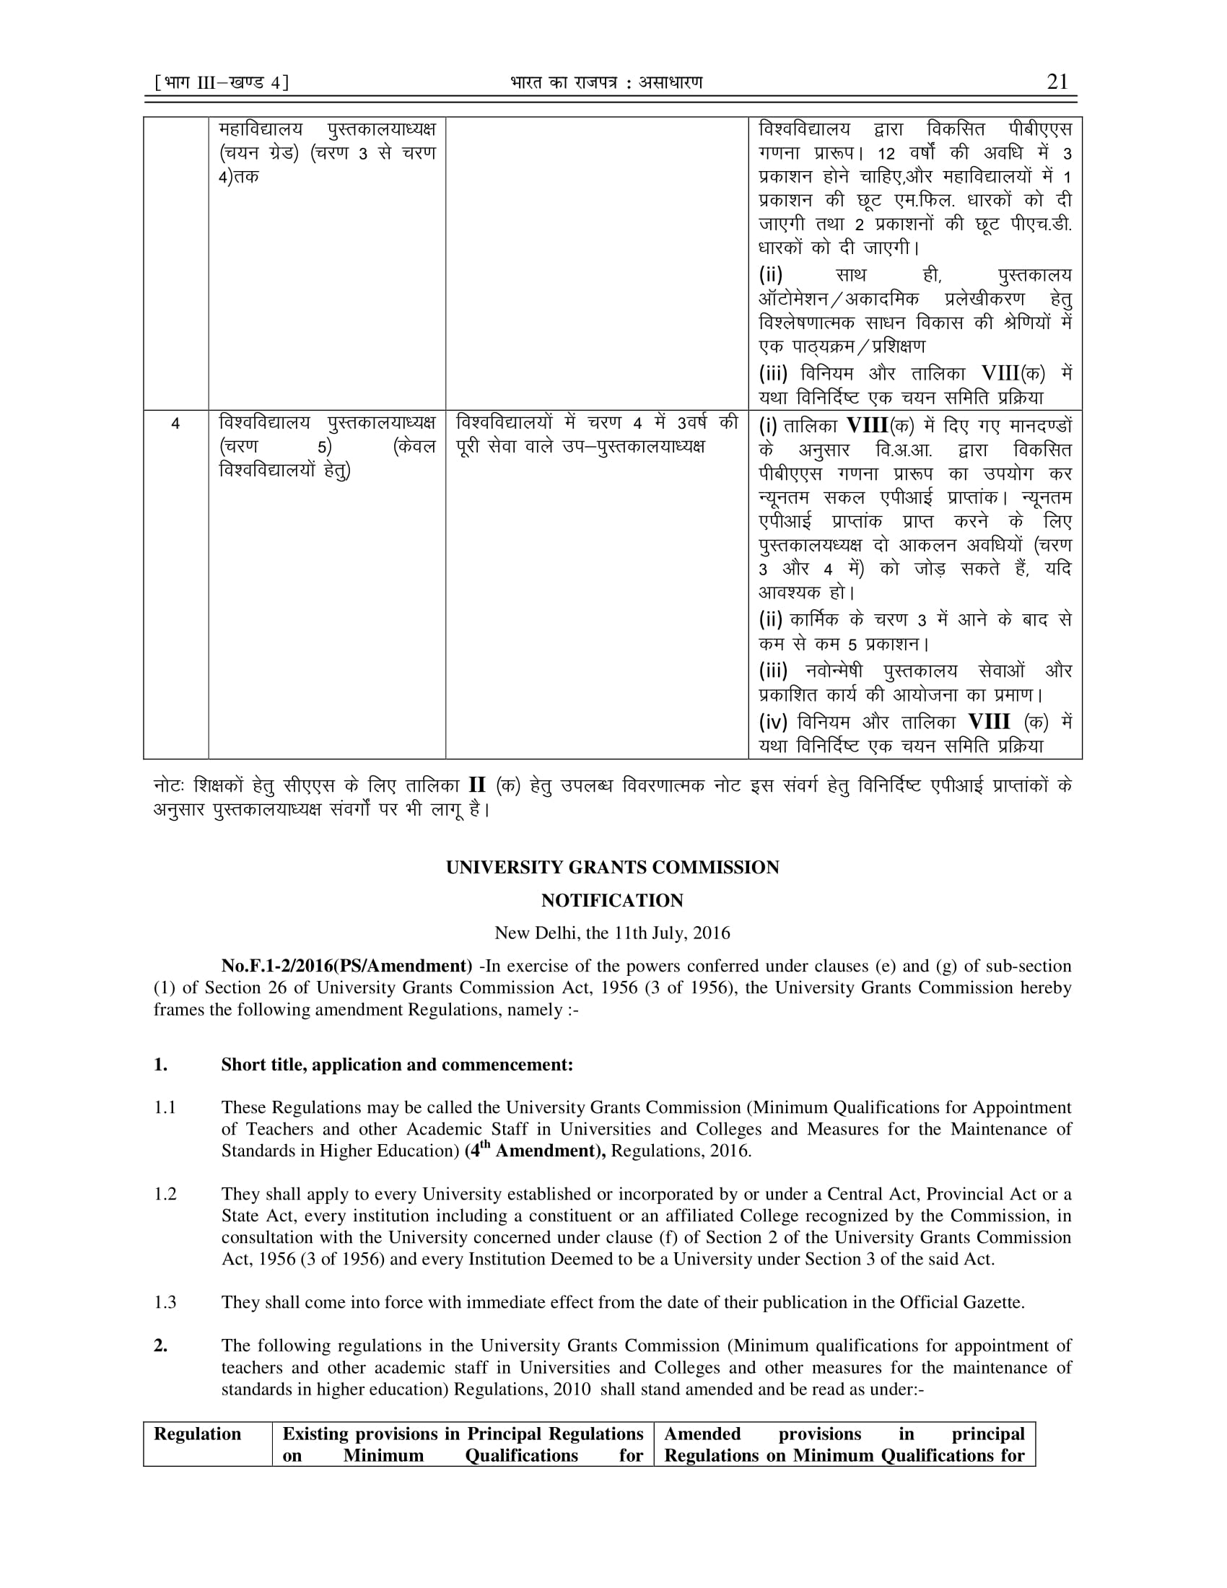
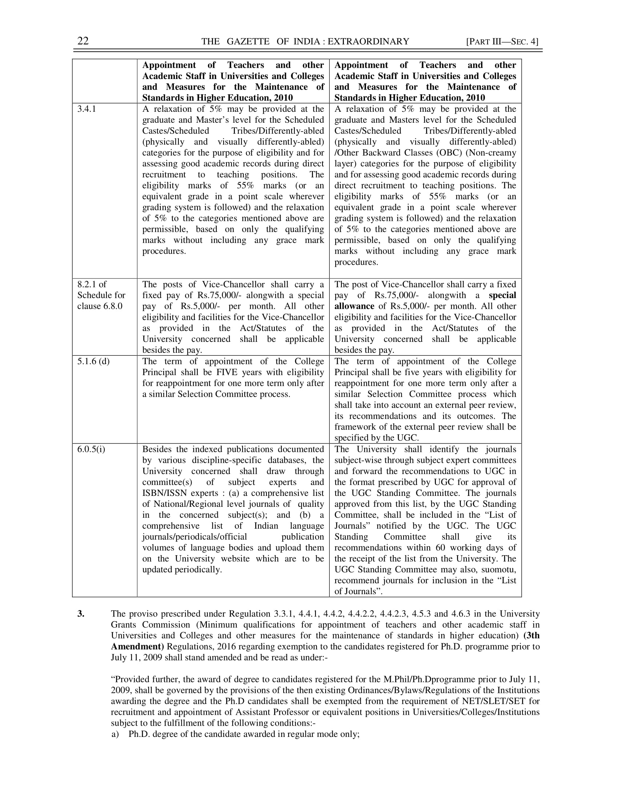
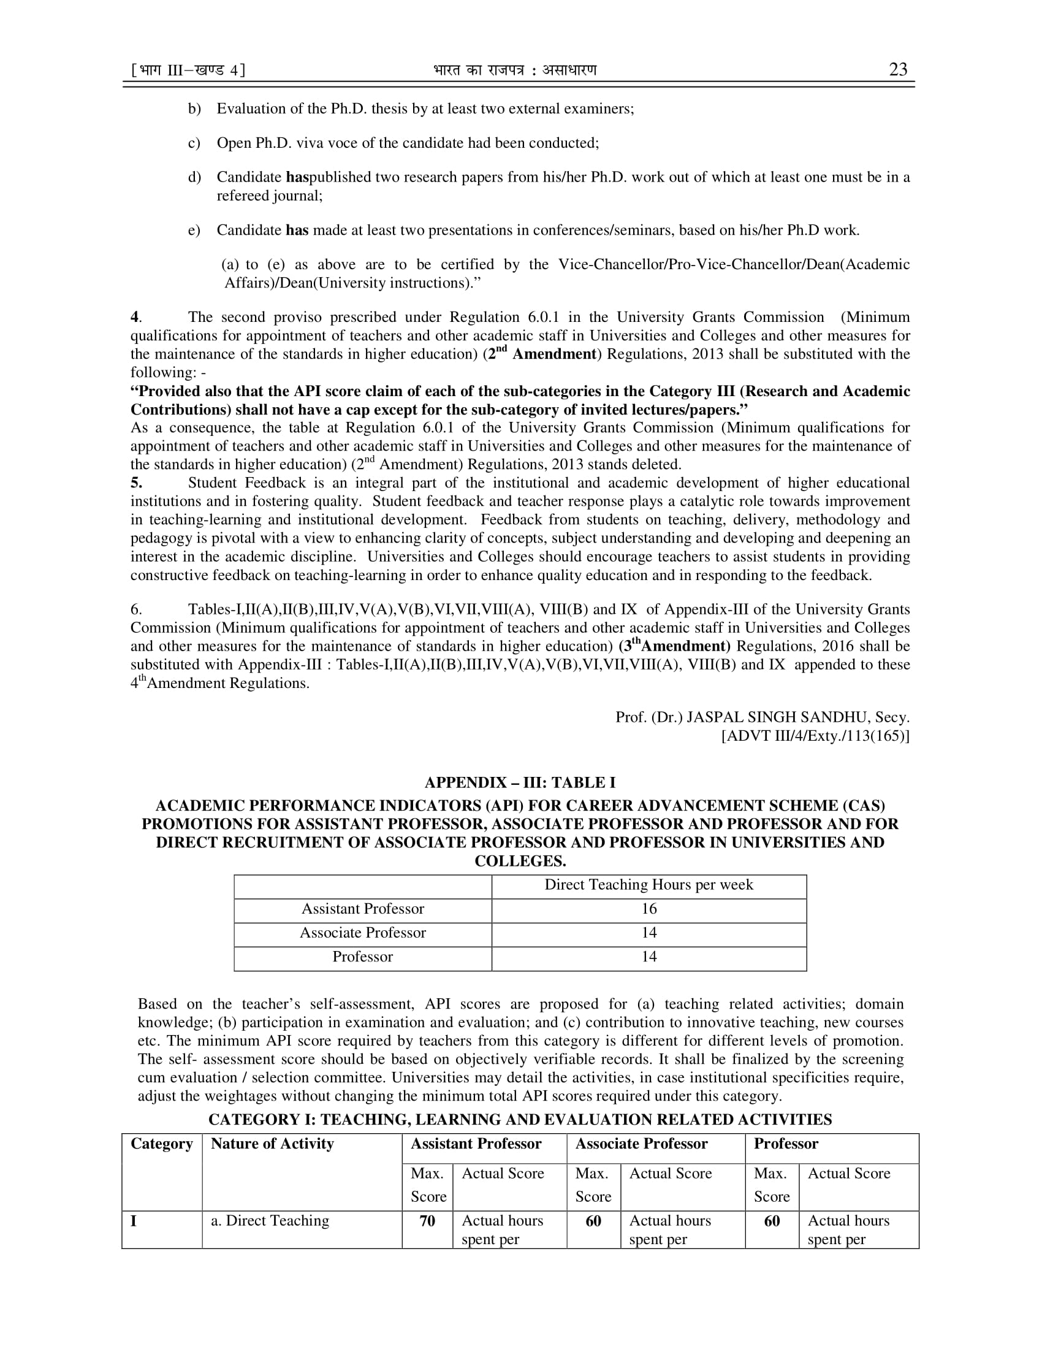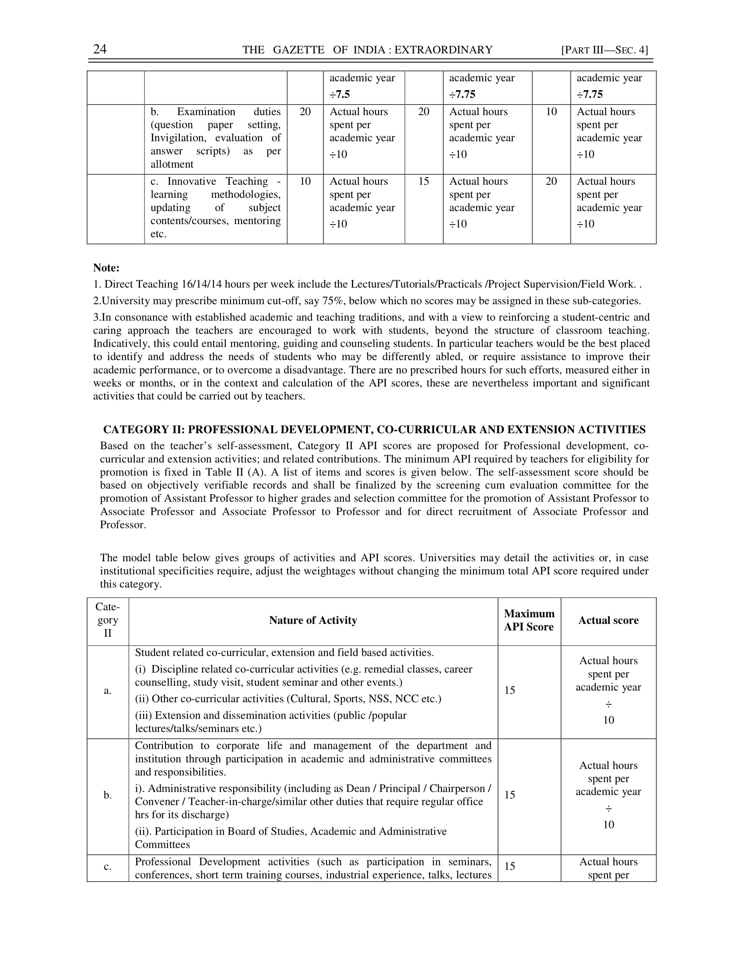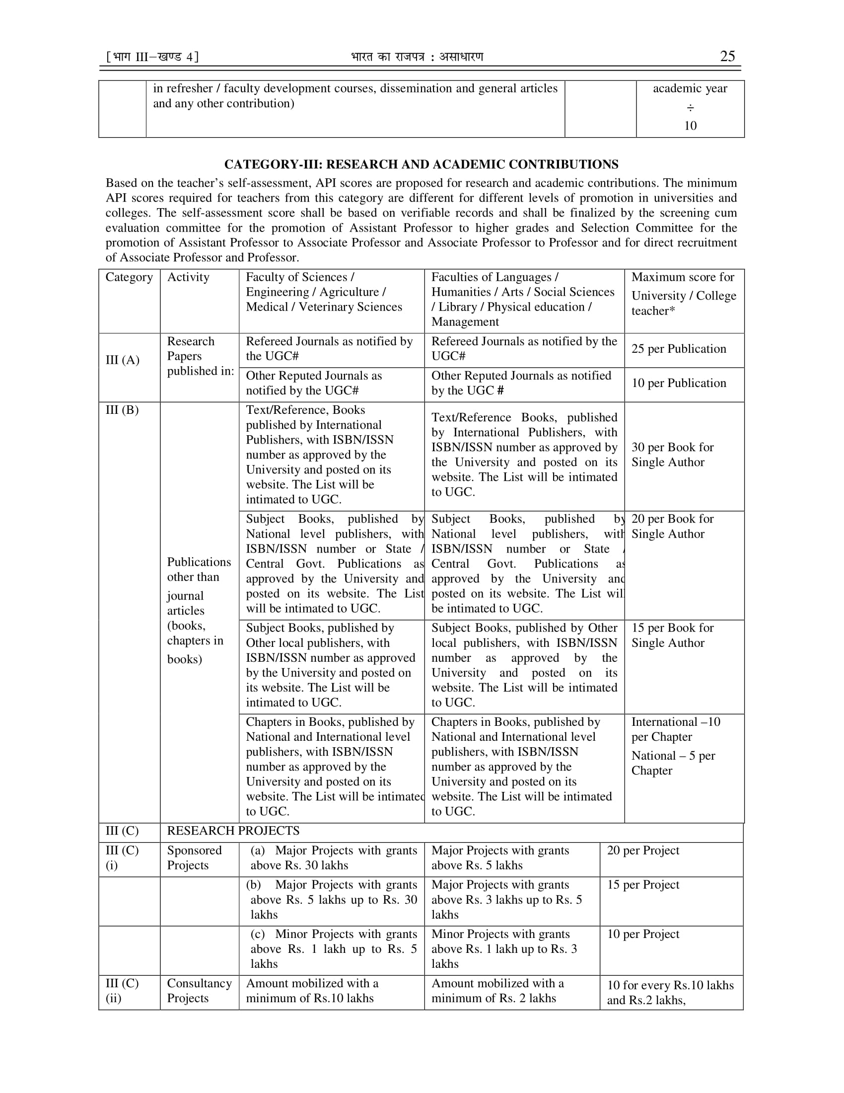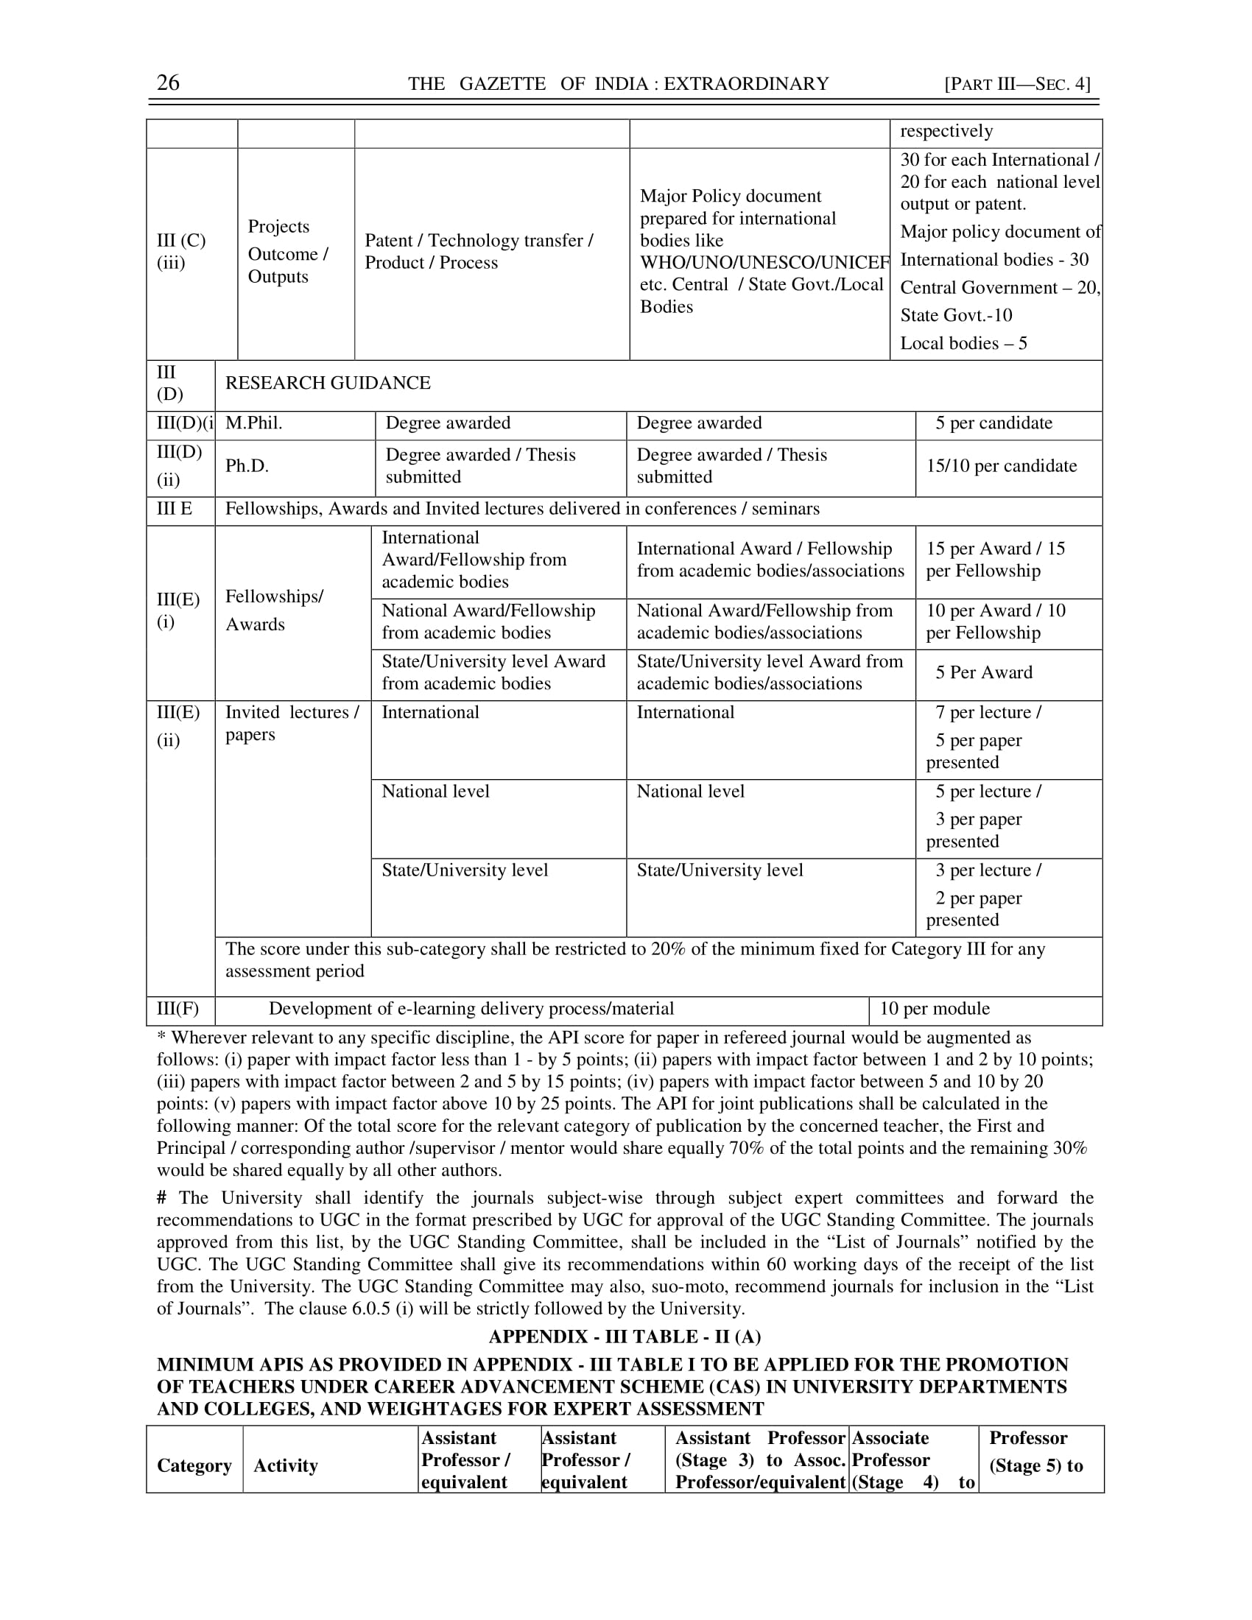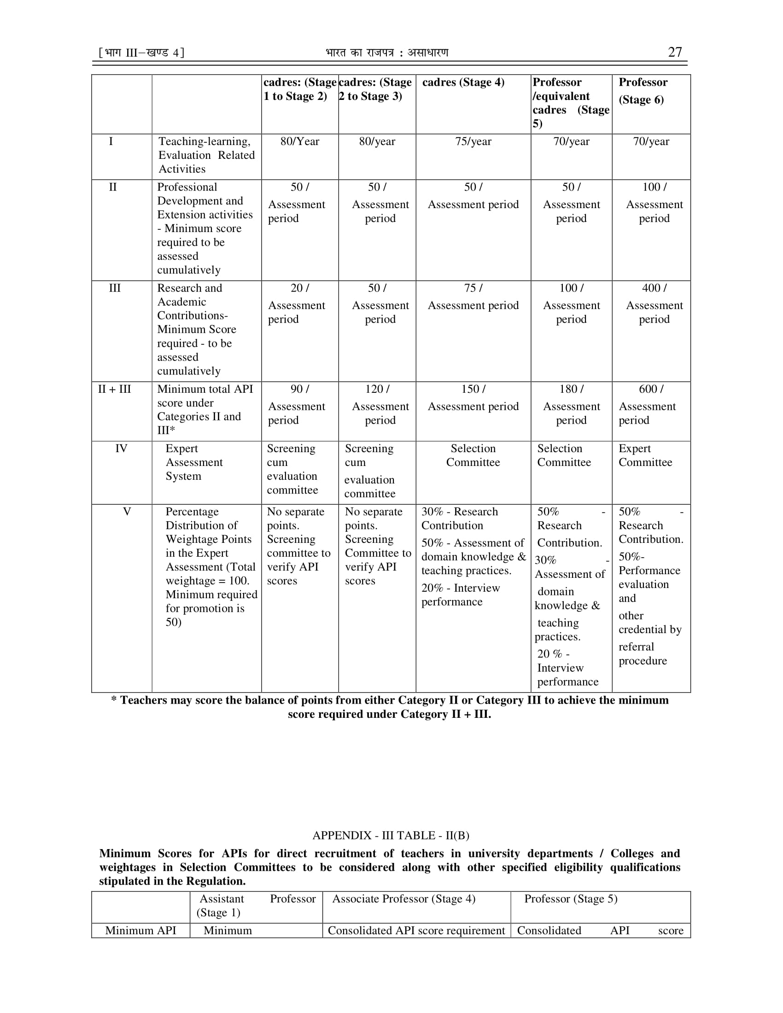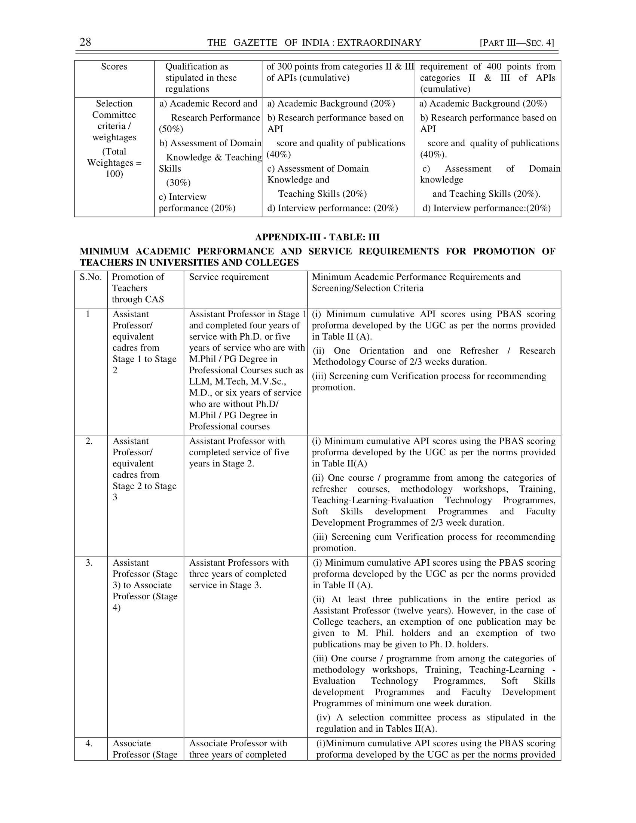
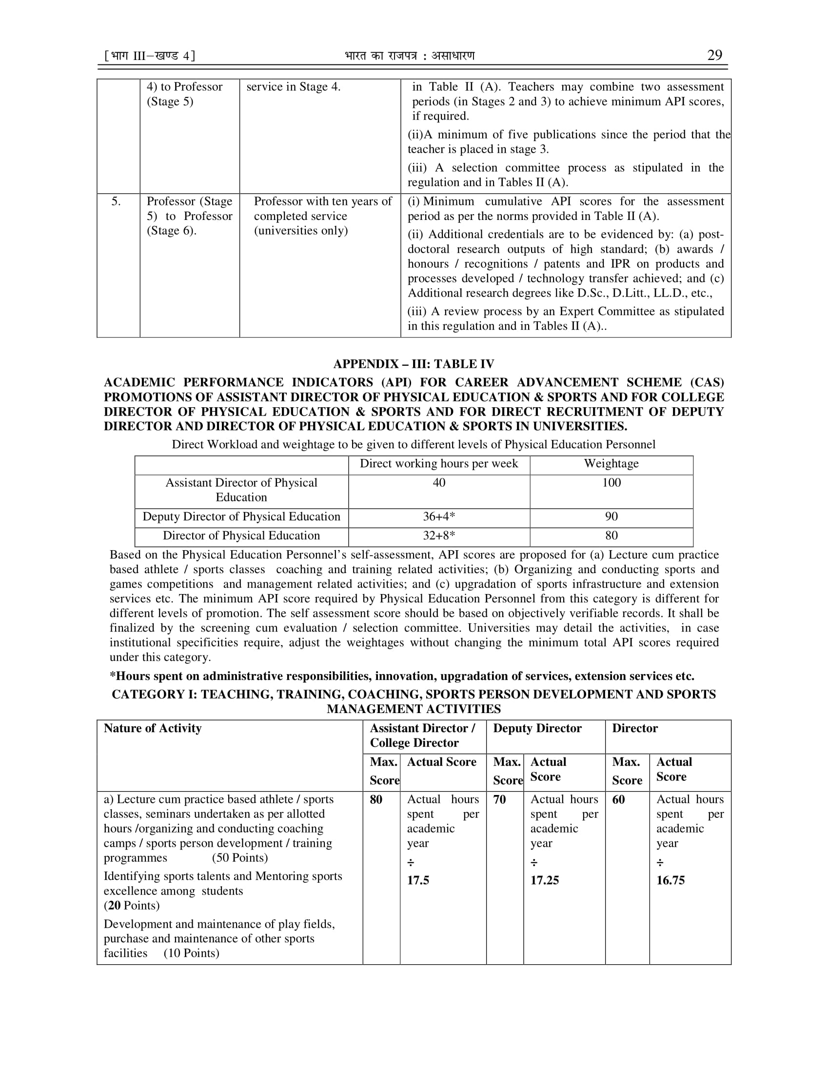

Annexure II
API calculations as per UGC Guidelines in Annexure I with following Clarifications
S. No. | Activity | Clarification
1. | Category III (Page No.25 & 26) of UGC regulations 4th Amendment notified vide No.F.1-2/2016(PA/Amendment) dated 11.07.2016)  The API for joint publications shall be calculated in the following manner:  Of the total score for the relevant category of publications by the concerned teacher, the First and Principal / Corresponding author / supervisor / mentor would share equally 70 % of the total points and the remaining 30% would be shared equally by all other authors | This clause will be applicable only for the Publications as mentioned in the Category III (A) and III (B) of UGC regulations 4th Amendment notified vide No.F.1-2/2016 (PA/Amendment) dated 11.07.2016 (Page No.25).  For other Categories i.e. from III (C) to III (F), full API scores will be given as per criteria mentioned in the UGC regulations notified vide No.F.1-2/2016 (PA/Amendment) dated 11.07.2016 (Page No.25 & 26).

Annexure III
Important Note
Sr. No. | Note
1. | Wherever the requirement of the Orientation Course, Refresher Course etc. as mentioned in the Appendix III Table III of UGC regulations 4th Amendment notified vide No.F.1-2/2016 (PA/Amendment) dated 11.07.2016 has remained incomplete, the promotions will not be held up, but these requirements should be fulfilled by 31st December 2023.
2. | The API for joint publications shall be calculated in the following manner:  “Of the total score for the relevant category of publications by the concerned teacher, the First and Principal / Corresponding author / supervisor / mentor would share equally 70 % of the total points and the remaining 30% would be shared equally by all other authors”  As per Category III of UGC regulations dated 11.07.2016 (Page No.25):  For Research Publications in Refereed Journals as notified by UGC 25 points per publication will be given + Augmented marks *  For other Reputed Journal as notified by UGC 10 points per publication will be given + Augmented marks *  * Wherever relevant to any specific discipline, the API score for paper in refereed journal would be augmented as follows: (i) paper with impact factor less than 1 - by 5 points; (ii) papers with impact factor between 1 and 2 by 10 points; (iii) papers with impact factor between 2 and 5 by 15 points; (iv) papers with impact factor between 5 and 10 by 20 points: (v) papers with impact factor above 10 by 25 points.
3. | Points of M.Tech. dissertation will be considered on successful completion of thesis guidance in the academic session which falls during the assessment period only.
4. | The requirement of publications as per Appendix III Table III of UGC regulations dated 11.07.2016, will be considered for Expert Assessment and API Score Calculation from the date /month on which the paper is published in the Journal i.e. the date / month may not be beyond the date of eligibility in the initial assessment period or subsequent additional assessment period.
5. | For Faculty whose CAS applications have already been assessed till 31.03.2019, they may fill the information for subsequent additional assessment period ONLY with regard to the API score and publications.

Annexure IV
FAQs
Sr. No. | Query | Resolution
 | Which guidelines will be applicable for CAS promotions as per notice No.PEC/DFA/24/1295 dated 15.03.2024 | UGC regulations 4th Amendment notified vide No.F.1-2/2016 (PA/Amendment) dated 11.07.2016 will be applicable.
 | Will the papers published in journals other than Refereed Journals / Other reputed Journals of UGC will be considered for calculating API scores? | No
 | Will the papers published as part of conference proceedings/ Book Series be considered equivalent to journal publication / Book Chapter? | No
 | What is the percentage score for joint paper publication? | As per UGC regulations 4th Amendment notified vide No.F.1-2/2016 (PA/Amendment) dated 11.07.2016  The API for joint publications shall be calculated in the following manner:  “Of the total score for the relevant category of publications by the concerned teacher, the First and Principal / Corresponding author / supervisor / mentor would share equally 70 % of the total points and the remaining 30% would be shared equally by all other authors”
 | What is the percentage score for joint projects? | Full API scores will be given as per criteria mentioned under Category III (C) of UGC regulations 4th Amendment notified vide No.F.1-2/2016 (PA/Amendment) dated 11.07.2016 (Page No. 25 & 26).
 | What is the percentage score for joint M.Tech./Ph.D.? | Full API scores will be given as per criteria mentioned under Category III (D) of UGC regulations 4th Amendment notified vide No.F.1-2/2016 (PA/Amendment) dated 11.07.2016 (Page No. 26).

