

**Medical Abuse Prevention**

**HLD**

**Project Overview**

**Introduction**

Drugs intake has been incautiously prolonged. Unawareness of patients and in hew of making more business, chemists have been selling medicines with salts not in compliance with medical prescription. This abuse prevails in various forms to make extra margin, shopkeeper sells costlier medicine varying with brand prescribed. Also, Patients are using medical prescription to get medications beyond the intended dosage buying duplicate or similar from multiple pharmacies.

**Prevention**

* Tracking medical history
* Medicine granted by doctor
* Keeping record of visit
* Keeping doctor alerted
* Known Allergies
* Keep Insurance Companies alerted

**Architecture**

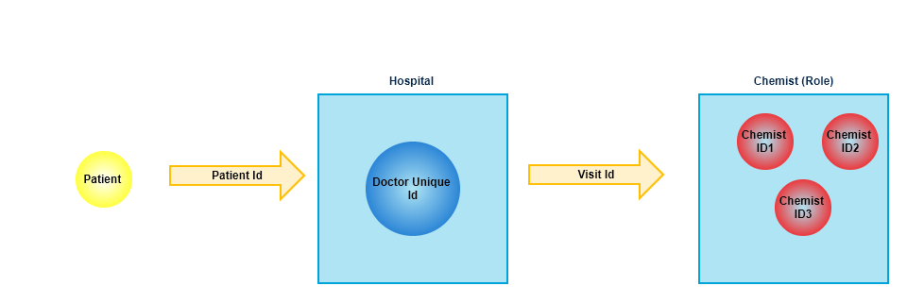

**Design Goals**

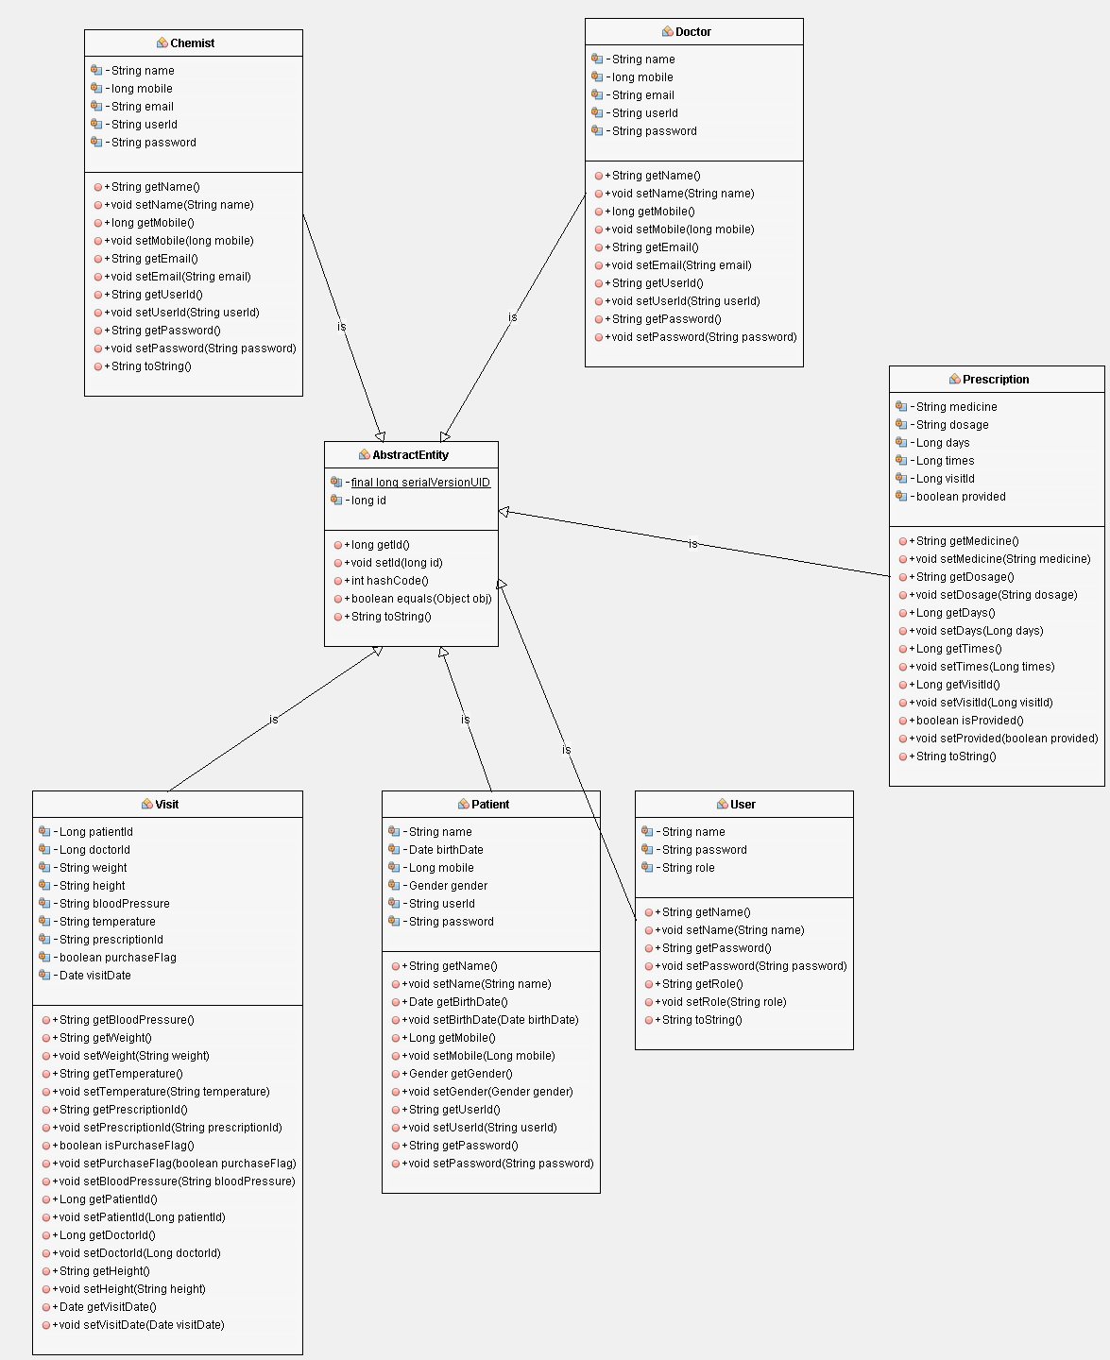

**Controller details:**

Prescription Controller

User Controller

**Model details:**

Abstract Entity

Chemist

Doctor

Patient

Prescription

User

Visit

**Enum:**

Gender

**LANDING PAGE**

**Doctor/Hospital Landing Page: -** This contains doctor’s dashboard in which doctor will add patient id. On adding patient ID, a form will be displayed where doctor will add medications, findings, follow-up date. On submission a unique Visit ID is generated. Doctor can view past record of patient.

**Patient Landing Page: -** Patient can log in to system and can check his visit history along with all visit details.

**Pharmacy Landing Page: -** Pharmacist can enter unique ID patient received from Doctor. Pharmacist will get details of medicines and will provide the same to patient as well as update medicine status. In case of double prescription, pharmacist can add reason to solution. If user tries to take medicine from another pharmacist, same will be alerted.

**Technology stack**

Frontend: Angular JS Node JS

Backend: Hibernate, Spring Integration

Technology: JAVA

Server: Apache-tomcat-8.0.22

Database: My SQL Workbench