EDA.R
srivi
2020-08-16
#####installing libraries
library(ggplot2)
## Warning: package 'ggplot2' was built under R version 3.6.3
library(ggthemes)
## Warning: package 'ggthemes' was built under R version 3.6.3
library(party)
## Warning: package 'party' was built under R version 3.6.3
## Loading required package: grid
## Loading required package: mvtnorm
## Loading required package: modeltools
## Warning: package 'modeltools' was built under R version 3.6.3
## Loading required package: stats4
## Loading required package: strucchange
## Warning: package 'strucchange' was built under R version 3.6.3
## Loading required package: zoo
## Warning: package 'zoo' was built under R version 3.6.3
##
## Attaching package: 'zoo'
## The following objects are masked from 'package:base':
##
## as.Date, as.Date.numeric
## Loading required package: sandwich
## Warning: package 'sandwich' was built under R version 3.6.3
library(caret)
## Warning: package 'caret' was built under R version 3.6.3
## Loading required package: lattice
library(plotly)
## Warning: package 'plotly' was built under R version 3.6.3
##
## Attaching package: 'plotly'
## The following object is masked from 'package:ggplot2':
##
## last_plot
## The following object is masked from 'package:stats':
##
## filter
## The following object is masked from 'package:graphics':
##
## layout
library(curl)
## Warning: package 'curl' was built under R version 3.6.3
library(RCurl)
## Warning: package 'RCurl' was built under R version 3.6.3
##
## Attaching package: 'RCurl'
## The following object is masked from 'package:modeltools':
##
## clone
library(e1071)
## Warning: package 'e1071' was built under R version 3.6.3
library(rpart)
## Warning: package 'rpart' was built under R version 3.6.3
library(ranger)
## Warning: package 'ranger' was built under R version 3.6.3
library(lazyeval)
## Warning: package 'lazyeval' was built under R version 3.6.3
library(readr)
## Warning: package 'readr' was built under R version 3.6.3
##
## Attaching package: 'readr'
## The following object is masked from 'package:curl':
##
## parse_date
library(plyr)
## Warning: package 'plyr' was built under R version 3.6.3
##
## Attaching package: 'plyr'
## The following objects are masked from 'package:plotly':
##
## arrange, mutate, rename, summarise
## The following object is masked from 'package:modeltools':
##
## empty
library(dplyr)
## Warning: package 'dplyr' was built under R version 3.6.3
##
## Attaching package: 'dplyr'
## The following objects are masked from 'package:plyr':
##
## arrange, count, desc, failwith, id, mutate, rename, summarise,
## summarize
## The following objects are masked from 'package:stats':
##
## filter, lag
## The following objects are masked from 'package:base':
##
## intersect, setdiff, setequal, union
library(readxl)
## Warning: package 'readxl' was built under R version 3.6.3
library(ggplot2)
library(funModeling)
## Warning: package 'funModeling' was built under R version 3.6.3
## Loading required package: Hmisc
## Warning: package 'Hmisc' was built under R version 3.6.3
## Loading required package: survival
##
## Attaching package: 'survival'
## The following object is masked from 'package:caret':
##
## cluster
## Loading required package: Formula
##
## Attaching package: 'Hmisc'
## The following objects are masked from 'package:dplyr':
##
## src, summarize
## The following objects are masked from 'package:plyr':
##
## is.discrete, summarize
## The following object is masked from 'package:e1071':
##
## impute
## The following object is masked from 'package:plotly':
##
## subplot
## The following objects are masked from 'package:base':
##
## format.pval, units
## funModeling v.1.9.4 :)
## Examples and tutorials at livebook.datascienceheroes.com
## / Now in Spanish: librovivodecienciadedatos.ai
library(scales)
## Warning: package 'scales' was built under R version 3.6.3
##
## Attaching package: 'scales'
## The following object is masked from 'package:readr':
##
## col_factor
library(tidyverse)
## Warning: package 'tidyverse' was built under R version 3.6.3
## -- Attaching packages ---------------------------------------------------------------------- tidyverse 1.3.0 --
## v tibble 3.0.1 v stringr 1.4.0
## v tidyr 1.0.2 v forcats 0.5.0
## v purrr 0.3.3
## Warning: package 'tibble' was built under R version 3.6.3
## Warning: package 'tidyr' was built under R version 3.6.3
## Warning: package 'stringr' was built under R version 3.6.3
## Warning: package 'forcats' was built under R version 3.6.3
## -- Conflicts ------------------------------------------------------------------------- tidyverse_conflicts() --
## x dplyr::arrange() masks plyr::arrange(), plotly::arrange()
## x stringr::boundary() masks strucchange::boundary()
## x scales::col_factor() masks readr::col_factor()
## x purrr::compact() masks plyr::compact()
## x tidyr::complete() masks RCurl::complete()
## x dplyr::count() masks plyr::count()
## x purrr::discard() masks scales::discard()
## x dplyr::failwith() masks plyr::failwith()
## x dplyr::filter() masks plotly::filter(), stats::filter()
## x dplyr::id() masks plyr::id()
## x purrr::is_atomic() masks lazyeval::is_atomic()
## x purrr::is_formula() masks lazyeval::is_formula()
## x dplyr::lag() masks stats::lag()
## x purrr::lift() masks caret::lift()
## x dplyr::mutate() masks plyr::mutate(), plotly::mutate()
## x readr::parse_date() masks curl::parse_date()
## x dplyr::rename() masks plyr::rename(), plotly::rename()
## x Hmisc::src() masks dplyr::src()
## x dplyr::summarise() masks plyr::summarise(), plotly::summarise()
## x Hmisc::summarize() masks dplyr::summarize(), plyr::summarize()
library(corrplot)
## Warning: package 'corrplot' was built under R version 3.6.3
## corrplot 0.84 loaded
library(GGally)
## Warning: package 'GGally' was built under R version 3.6.3
## Registered S3 method overwritten by 'GGally':
## method from
## +.gg ggplot2
##
## Attaching package: 'GGally'
## The following object is masked from 'package:funModeling':
##
## range01
library(caret)
library(rpart)
library(randomForest)
## Warning: package 'randomForest' was built under R version 3.6.3
## randomForest 4.6-14
## Type rfNews() to see new features/changes/bug fixes.
##
## Attaching package: 'randomForest'
## The following object is masked from 'package:dplyr':
##
## combine
## The following object is masked from 'package:ranger':
##
## importance
## The following object is masked from 'package:ggplot2':
##
## margin
library(pROC)
## Warning: package 'pROC' was built under R version 3.6.3
## Type 'citation("pROC")' for a citation.
##
## Attaching package: 'pROC'
## The following objects are masked from 'package:stats':
##
## cov, smooth, var
library(gbm)
## Warning: package 'gbm' was built under R version 3.6.3
## Loaded gbm 2.1.8
library(choroplethr)
## Warning: package 'choroplethr' was built under R version 3.6.3
## Loading required package: acs
## Warning: package 'acs' was built under R version 3.6.3
## Loading required package: XML
## Warning: package 'XML' was built under R version 3.6.3
##
## Attaching package: 'acs'
## The following object is masked from 'package:randomForest':
##
## combine
## The following object is masked from 'package:dplyr':
##
## combine
## The following object is masked from 'package:base':
##
## apply
library(choroplethrMaps)
## Warning: package 'choroplethrMaps' was built under R version 3.6.3
library(microbenchmark)
## Warning: package 'microbenchmark' was built under R version 3.6.3
library(doParallel)
## Warning: package 'doParallel' was built under R version 3.6.3
## Loading required package: foreach
##
## Attaching package: 'foreach'
## The following objects are masked from 'package:purrr':
##
## accumulate, when
## Loading required package: iterators
## Warning: package 'iterators' was built under R version 3.6.3
## Loading required package: parallel
library(e1071)
library(ggthemes)
library(RColorBrewer)
library(funModeling)
library(dplyr)
library(DataExplorer)
## Warning: package 'DataExplorer' was built under R version 3.6.3
library(tidyverse)
library(Hmisc)
library(ggplot2)
library(mvinfluence)
## Warning: package 'mvinfluence' was built under R version 3.6.3
## Loading required package: car
## Warning: package 'car' was built under R version 3.6.3
## Loading required package: carData
##
## Attaching package: 'car'
## The following object is masked from 'package:purrr':
##
## some
## The following object is masked from 'package:dplyr':
##
## recode
## The following object is masked from 'package:modeltools':
##
## Predict
## Loading required package: heplots
## Warning: package 'heplots' was built under R version 3.6.3
library(car)
library(rgl)
## Warning: package 'rgl' was built under R version 3.6.3
##
## Attaching package: 'rgl'
## The following object is masked from 'package:heplots':
##
## arrow3d
library(xgboost)
## Warning: package 'xgboost' was built under R version 3.6.3
##
## Attaching package: 'xgboost'
## The following object is masked from 'package:dplyr':
##
## slice
## The following object is masked from 'package:plotly':
##
## slice
library(shiny)
## Warning: package 'shiny' was built under R version 3.6.3
##
## Attaching package: 'shiny'
## The following object is masked from 'package:acs':
##
## span
library(shinydashboard)
## Warning: package 'shinydashboard' was built under R version 3.6.3
##
## Attaching package: 'shinydashboard'
## The following object is masked from 'package:graphics':
##
## box
library(ggplot2)
library(ggthemes)
library(party)
library(caret)
library(plotly)
library(curl)
library(RCurl)
library(e1071)
library(rpart)
library(ranger)
library(glmnet)
## Warning: package 'glmnet' was built under R version 3.6.3
## Loading required package: Matrix
## Warning: package 'Matrix' was built under R version 3.6.3
##
## Attaching package: 'Matrix'
## The following objects are masked from 'package:tidyr':
##
## expand, pack, unpack
## Loaded glmnet 4.0-2
library(mlbench)
## Warning: package 'mlbench' was built under R version 3.6.3
#library(psych)
library(dplyr)
library(lattice)
library(xgboost)
# set working directory
credit_data <- read.csv("C:/Users/srivi/OneDrive/Desktop/Excelr/Project/data.csv", stringsAsFactors = FALSE)
str(credit_data)
## 'data.frame': 887379 obs. of 36 variables:
## $ member_id : int 58189336 70011223 70255675 1893936 7652106 10247268 8089625 23043116 45900933 41272507 ...
## $ loan_amnt : int 14350 4800 10000 15000 16000 15000 5000 6000 6000 34550 ...
## $ terms : chr "36 months" "36 months" "36 months" "36 months" ...
## $ batch_ID : chr " " "BAT1586599" "BAT1586599" "BAT4808022" ...
## $ Rate_of_intrst : num 19.19 10.99 7.26 19.72 10.64 ...
## $ grade : chr "E" "B" "A" "D" ...
## $ sub_grade : chr "E3" "B4" "A4" "D5" ...
## $ Emp_designation : chr "clerk" "Human Resources Specialist" "Driver" "Us office of Personnel Management" ...
## $ Experience : chr "9 years" "< 1 year" "2 years" "10+ years" ...
## $ home_ownership : chr "OWN" "MORTGAGE" "OWN" "RENT" ...
## $ annual_inc : num 28700 65000 45000 105000 52000 120000 75000 54000 92000 72000 ...
## $ verification_status : chr "Source Verified" "Source Verified" "Not Verified" "Not Verified" ...
## $ purpose : chr "debt_consolidation" "home_improvement" "debt_consolidation" "debt_consolidation" ...
## $ State : chr "FL" "MD" "OH" "VA" ...
## $ debt_income_ratio : num 33.88 3.64 18.42 14.97 20.16 ...
## $ delinq_2yrs : int 0 0 0 0 0 0 0 0 0 0 ...
## $ inq_last_6mths : int 1 1 0 2 0 0 0 1 0 0 ...
## $ mths_since_last_delinq : int 50 NA NA 46 NA 56 NA 46 77 NA ...
## $ mths_since_last_record : int 75 NA NA NA NA NA 105 NA NA NA ...
## $ numb_credit : int 14 6 5 10 11 18 13 13 16 12 ...
## $ pub_rec : int 1 0 0 0 0 0 2 0 0 0 ...
## $ total.revol_bal : int 22515 7624 10877 13712 35835 19040 13272 3484 47567 30040 ...
## $ total_credits : int 28 13 19 21 27 30 23 49 27 30 ...
## $ initial_list_status : chr "f" "w" "w" "f" ...
## $ total_rec_int : num 1173.8 84 56.5 4858.6 2296.4 ...
## $ total_rec_late_fee : num 0 0 0 0 0 0 0 0 0 0 ...
## $ recoveries : num 0 0 0 0 0 0 0 0 0 0 ...
## $ collection_recovery_fee : num 0 0 0 0 0 0 0 0 0 0 ...
## $ collections_12_mths_ex_med : int 0 0 0 0 0 0 0 0 0 0 ...
## $ mths_since_last_major_derog: int 74 NA NA NA NA NA NA 54 NA NA ...
## $ application_type : chr "INDIVIDUAL" "INDIVIDUAL" "INDIVIDUAL" "INDIVIDUAL" ...
## $ verification_status_joint : chr "" "" "" "" ...
## $ last_week_pay : chr "26th week" "9th week" "9th week" "135th week" ...
## $ acc_now_delinq : int 0 0 0 0 0 0 0 0 0 0 ...
## $ tot_colle_amt : int 0 0 65 0 0 0 1023 0 0 0 ...
## $ tot_curr_bal : num 28699 9974 38295 55564 47159 ...
credit_data$grade <- factor(credit_data$grade,
c("A", "B", "C", "D", "E", "F", "G"), ordered=TRUE)
credit_data$terms <- factor(credit_data$terms,
c("36 months","60 months"), ordered=TRUE)
##Selecting the important variables
credit <- credit_data %>%
select(loan_amnt,terms,Rate_of_intrst,annual_inc,delinq_2yrs,numb_credit,total.revol_bal,total_credits,total_rec_int,total_rec_late_fee,tot_colle_amt,tot_curr_bal)
summary(credit)
## loan_amnt terms Rate_of_intrst annual_inc
## Min. : 500 36 months:621125 Min. : 5.32 Min. : 0
## 1st Qu.: 8000 60 months:266254 1st Qu.: 9.99 1st Qu.: 45000
## Median :13000 Median :12.99 Median : 65000
## Mean :14755 Mean :13.25 Mean : 75028
## 3rd Qu.:20000 3rd Qu.:16.20 3rd Qu.: 90000
## Max. :35000 Max. :28.99 Max. :9500000
## NA's :4
## delinq_2yrs numb_credit total.revol_bal total_credits
## Min. : 0.0000 Min. : 0.00 Min. : 0 Min. : 1.00
## 1st Qu.: 0.0000 1st Qu.: 8.00 1st Qu.: 6443 1st Qu.: 17.00
## Median : 0.0000 Median :11.00 Median : 11875 Median : 24.00
## Mean : 0.3144 Mean :11.55 Mean : 16921 Mean : 25.27
## 3rd Qu.: 0.0000 3rd Qu.:14.00 3rd Qu.: 20829 3rd Qu.: 32.00
## Max. :39.0000 Max. :90.00 Max. :2904836 Max. :169.00
## NA's :29 NA's :29 NA's :29
## total_rec_int total_rec_late_fee tot_colle_amt tot_curr_bal
## Min. : 0.0 Min. : 0.0000 Min. : 0 Min. : 0
## 1st Qu.: 441.5 1st Qu.: 0.0000 1st Qu.: 0 1st Qu.: 29853
## Median : 1073.3 Median : 0.0000 Median : 0 Median : 80559
## Mean : 1754.8 Mean : 0.3967 Mean : 226 Mean : 139458
## 3rd Qu.: 2238.3 3rd Qu.: 0.0000 3rd Qu.: 0 3rd Qu.: 208205
## Max. :24205.6 Max. :358.6800 Max. :9152545 Max. :8000078
## NA's :70276 NA's :70276
#####removing NA values
credit <- credit %>%
filter(!is.na(annual_inc) ,!is.na(tot_curr_bal),
!is.na(total_rec_int),!is.na(delinq_2yrs),!is.na(numb_credit),!is.na(total_credits),!is.na(tot_colle_amt))
summary(credit)
## loan_amnt terms Rate_of_intrst annual_inc
## Min. : 1000 36 months:567041 Min. : 5.32 Min. : 0
## 1st Qu.: 8400 60 months:250062 1st Qu.: 9.99 1st Qu.: 46000
## Median :13500 Median :12.99 Median : 65000
## Mean :14998 Mean :13.30 Mean : 75556
## 3rd Qu.:20000 3rd Qu.:16.29 3rd Qu.: 90000
## Max. :35000 Max. :28.99 Max. :9500000
## delinq_2yrs numb_credit total.revol_bal total_credits
## Min. : 0.0000 Min. : 0.0 Min. : 0 Min. : 2.00
## 1st Qu.: 0.0000 1st Qu.: 8.0 1st Qu.: 6592 1st Qu.: 17.00
## Median : 0.0000 Median :11.0 Median : 12038 Median : 24.00
## Mean : 0.3284 Mean :11.7 Mean : 17144 Mean : 25.51
## 3rd Qu.: 0.0000 3rd Qu.:14.0 3rd Qu.: 21081 3rd Qu.: 32.00
## Max. :39.0000 Max. :90.0 Max. :2904836 Max. :169.00
## total_rec_int total_rec_late_fee tot_colle_amt tot_curr_bal
## Min. : 0.0 Min. : 0.0000 Min. : 0 Min. : 0
## 1st Qu.: 422.4 1st Qu.: 0.0000 1st Qu.: 0 1st Qu.: 29853
## Median : 1039.6 Median : 0.0000 Median : 0 Median : 80559
## Mean : 1693.3 Mean : 0.3221 Mean : 226 Mean : 139458
## 3rd Qu.: 2173.4 3rd Qu.: 0.0000 3rd Qu.: 0 3rd Qu.: 208205
## Max. :21840.0 Max. :358.6800 Max. :9152545 Max. :8000078
str(credit)
## 'data.frame': 817103 obs. of 12 variables:
## $ loan_amnt : int 14350 4800 10000 15000 16000 15000 5000 6000 6000 34550 ...
## $ terms : Ord.factor w/ 2 levels "36 months"<"60 months": 1 1 1 1 1 1 1 1 1 2 ...
## $ Rate_of_intrst : num 19.19 10.99 7.26 19.72 10.64 ...
## $ annual_inc : num 28700 65000 45000 105000 52000 120000 75000 54000 92000 72000 ...
## $ delinq_2yrs : int 0 0 0 0 0 0 0 0 0 0 ...
## $ numb_credit : int 14 6 5 10 11 18 13 13 16 12 ...
## $ total.revol_bal : int 22515 7624 10877 13712 35835 19040 13272 3484 47567 30040 ...
## $ total_credits : int 28 13 19 21 27 30 23 49 27 30 ...
## $ total_rec_int : num 1173.8 84 56.5 4858.6 2296.4 ...
## $ total_rec_late_fee: num 0 0 0 0 0 0 0 0 0 0 ...
## $ tot_colle_amt : int 0 0 65 0 0 0 1023 0 0 0 ...
## $ tot_curr_bal : num 28699 9974 38295 55564 47159 ...
library(dplyr)
library(tidyr)
library(ggplot2)
library(scales)
#plot1 is for showing how many applicants have applied for loan for 36 months term or 60 months term
plot1 <- ggplot(credit_data, aes(x = factor(terms))) + geom_bar(fill = "#FF6666")+
geom_text(stat = "count", aes(label= sprintf("%.02f %%", ..count../sum(..count..)*100)), size=4, vjust= -0.5, colour="black")+
labs(x="terms", y="count")
plot1
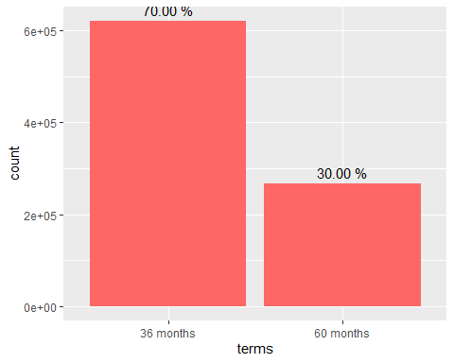
# plot 1 shows 70% applicants have applied for 36 months term
#plot 2 shows 60% of loan applicant applied loans for debt consolidation purpose.
plot2 <- ggplot(credit_data, aes(x = factor(purpose, levels = names(sort(table(purpose), decreasing=TRUE))))) + geom_bar(fill = "#FF6666")+
geom_text(stat = "count", aes(label= sprintf("%.02f %%", ..count../sum(..count..)*100)), size=4, vjust= -0.5, colour="black")+
labs(x="purpose", y="Frequency") + theme(axis.text.x = element_text(angle = 60, hjust = 1))
plot2
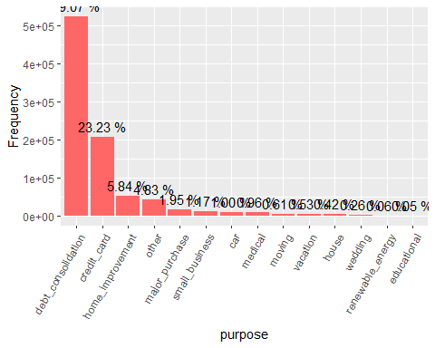
#It would seem that the vast majority of loan applicants applied for the purpose of debt consolidation, with a smaller, but still significant number for credit card debts.
# plot3 shows 50% of loan applicant applied loans have Mortagage and 40% have rented houses.
plot3 <- ggplot(credit_data, aes(x = factor(home_ownership, levels = names(sort(table(home_ownership), decreasing=TRUE))))) + geom_bar(fill = "#FF6666")+
geom_text(stat = "count", aes(label= sprintf("%.02f %%", ..count../sum(..count..)*100)), size=4, vjust= -0.5, colour="black")+
labs(x="Home ownership", y="Frequency")
plot3
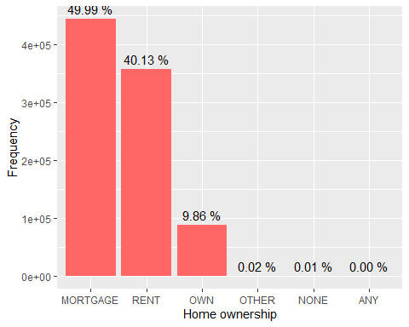
# plot4 shows 29% of loan applicant applied loans have comes under grade B.
plot4 <- ggplot(credit_data, aes(x = factor(grade, levels = names(sort(table(grade), decreasing=TRUE))))) + geom_bar(fill = "#FF6666")+
geom_text(stat = "count", aes(label= sprintf("%.02f %%", ..count../sum(..count..)*100)), size=4, vjust= -0.5, colour="black")+
labs(x="Grade", y="Frequency")
plot4
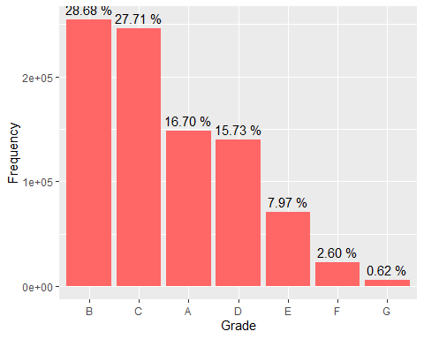
# plot5 shows 56% of loan applicant applied loans have comes nill inquiry in past 6 months.
plot5 <- ggplot(credit_data, aes(x = factor(inq_last_6mths, levels = names(sort(table(inq_last_6mths), decreasing=TRUE))))) + geom_bar(fill = "#FF6666")+
geom_text(stat = "count", aes(label= sprintf("%.02f %%", ..count../sum(..count..)*100)), size=4, vjust= -0.5, colour="black")+
labs(x="inquiry in last 6 months", y="Frequency")
plot5
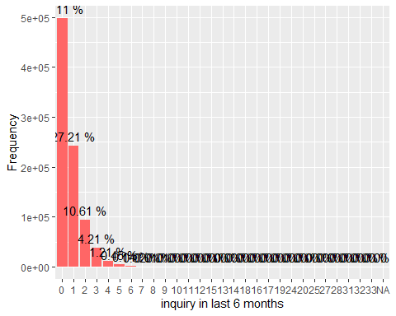
# plot6 shows nearly 85% of loan applicant have nill derogatory public records.
plot6 <- ggplot(credit_data, aes(x = factor(pub_rec, levels = names(sort(table(pub_rec), decreasing=TRUE))))) + geom_bar(fill = "#FF6666")+
geom_text(stat = "count", aes(label= sprintf("%.02f %%", ..count../sum(..count..)*100)), size=4, vjust= -0.5, colour="black")+
labs(x="Derogatory public records", y="Frequency")
plot6
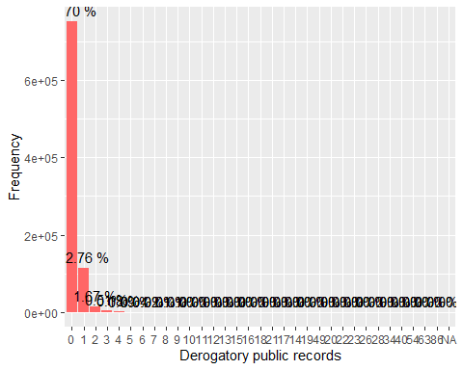
# Plot7 shows 32% of loan applicant have 10+ years of Exprience
plot7 <- ggplot(credit_data, aes(x = factor(Experience, levels = names(sort(table(Experience), decreasing=TRUE))))) + geom_bar(fill = "#FF6666")+
geom_text(stat = "count", aes(label= sprintf("%.02f %%", ..count../sum(..count..)*100)), size=4, vjust= -0.5, colour="black")+
labs(x="experience", y="count")
plot7
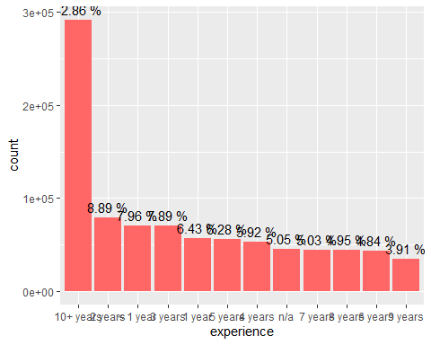
# plot8 shows 30% of loan applicant have not verified status.
plot8 <- ggplot(credit_data, aes(x = factor(verification_status, levels = names(sort(table(verification_status), decreasing=TRUE))))) +
geom_bar(fill = "#FF6666")+
geom_text(stat = "count", aes(label= sprintf("%.02f %%", ..count../sum(..count..)*100)), size=4, vjust= -0.5, colour="black")+
labs(x="verification status", y="count")
plot8
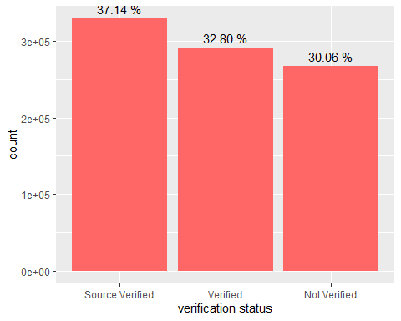
###intrest rate
summary(credit_data$Rate_of_intrst)
## Min. 1st Qu. Median Mean 3rd Qu. Max.
## 5.32 9.99 12.99 13.25 16.20 28.99
ggplot(data = credit_data, aes(Rate_of_intrst)) + geom_histogram() +
geom_vline(xintercept = median(credit_data$Rate_of_intrst), color = "red") +
geom_vline(xintercept = mean(credit_data$Rate_of_intrst), color = "blue") +
labs(x = "interest rate (%)")
## `stat_bin()` using `bins = 30`. Pick better value with `binwidth`.
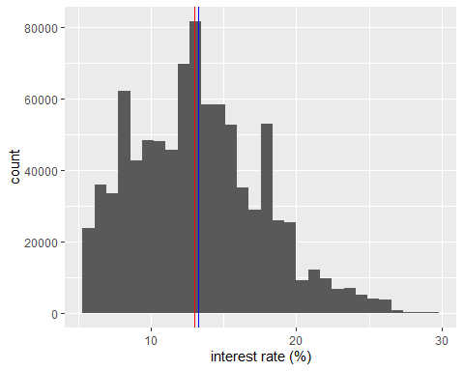
summary(credit_data$int_rate)
## Length Class Mode
## 0 NULL NULL
#####The red line represents the median value and the blue line the mean. With the
#mean, median, and mode all centered around the 13% mark, the distribution looks
#almost normal between 5% and 20% with a sharp fall-off after 20%. In fact, only
#7% of loans had interest rates above 20%.
###Now let's look at the actual amount of money loaned out
ggplot(data = credit_data, aes(loan_amnt)) + geom_histogram() +
labs(x = "loan amount ($)") +
geom_vline(xintercept = median(credit_data$loan_amnt), color = "red") +
geom_vline(xintercept = mean(credit_data$loan_amnt), color = "blue")
## `stat_bin()` using `bins = 30`. Pick better value with `binwidth`.
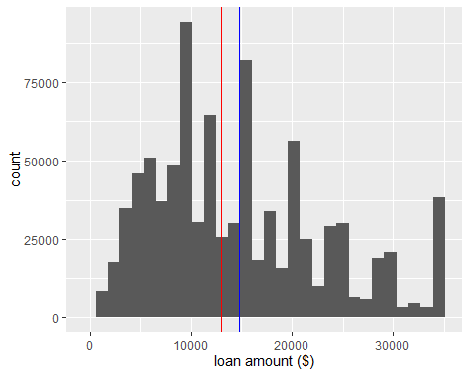
#We notice from this plot the distinct peaks at "nice" amounts like \10 000, \15000, and \20000, which is to be expected. The red line in the above plot indicates the median of \$13000 and the blue line the mean of \14755. This indicates an overall right-skewed distribution with a larger number of loanssmaller than the mean rather than larger. We can see the distribution tapering into the higher values with, however, another peak at what appears to be a hard cap on maximum loans allowed to be given out of \$35 000.
#With these loan amounts in mind, we will now examine the annual income of loanapplicants.
#now we will look into annual_income
ggplot(data = credit_data, aes(annual_inc)) + geom_histogram(binwidth=5000) +
geom_vline(xintercept = median(credit_data$annual_inc, na.rm=TRUE), color = "red") +
geom_vline(xintercept = mean(credit_data$annual_inc, na.rm=TRUE), color = "blue") +
labs(x = "annual income ($)") +
coord_cartesian(
xlim = c(0, quantile(credit_data$annual_inc, probs = 0.99, na.rm = TRUE)))
## Warning: Removed 4 rows containing non-finite values (stat_bin).
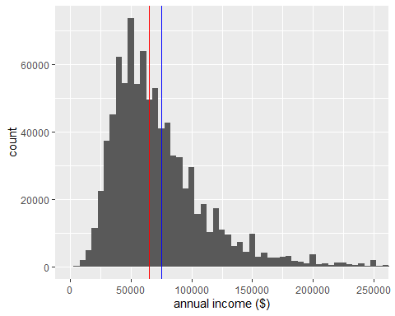
ggplot(data = credit_data, aes(annual_inc)) + geom_histogram(bins=60) +
scale_x_log10(breaks = seq(0, 250000, 50000)) +
labs(x = "annual income") +
coord_cartesian(
xlim = c(quantile(credit_data$annual_inc, probs = 0.01, na.rm = TRUE),
quantile(credit_data$annual_inc, probs = 0.99, na.rm = TRUE)))
## Warning: Transformation introduced infinite values in continuous x-axis
## Warning: Removed 6 rows containing non-finite values (stat_bin).
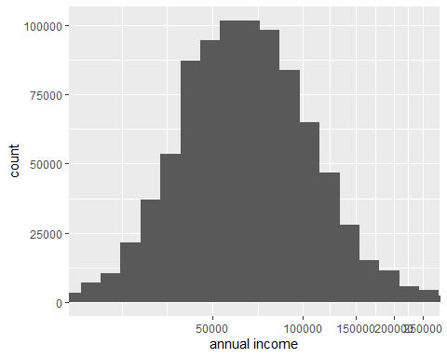
summary(credit_data$annual_inc)
## Min. 1st Qu. Median Mean 3rd Qu. Max. NA's
## 0 45000 65000 75028 90000 9500000 4
#Once again, the red line represents the median and the blue, the mean.As we can see from these plots, the distribution for the annual income is right-skewed with a long tail and extreme outliers (a maximum value of \9500 000).Transformed with a log(10) x-axis, the distribution appears to be somewhat normal. This means that there appear to be individuals with very high annual incomes (into the high 6-figures and beyond) that are applying for relatively small loans (up to a maximum of \35000). We should now look at who exactly the people taking out these loans are.
#relation between------- Terms& rate of intrest------Terms&Loan amount-----------------
ggplot(data = credit_data, aes(x = terms, y = Rate_of_intrst)) +
geom_boxplot() +
labs(y = "interest rate (%)")
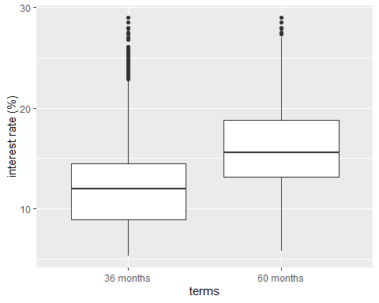
ggplot(data = credit_data, aes(x = terms, y = loan_amnt)) +
geom_boxplot() +
labs(y = "loan amount ($)")
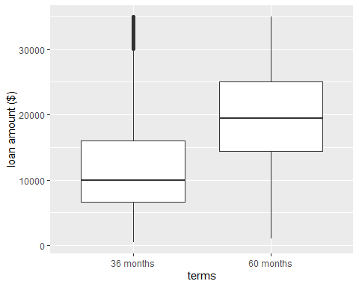
#We see immediately that loans with 60-month terms have on average almost 4% higher interest than their shorter term counterparts. Continuing to plot versus term, we find also that the longer terms are associated with significantly larger loan amounts as well. The median loan amount for 60 months is almost double the amount taken in 36-month loans.
# Function to determine percentage breakdowns of var1 within each
# value of var2
percent_breakdown <- function(data, var1, var2) {
sum_by <- data %>%
select_(var1, var2) %>%
group_by_(var2, var1) %>%
summarise(count = n())
count_by <- by(sum_by$count, sum_by[[var2]], sum)
count_by<- sapply(count_by, I)
count_by <- data.frame(levels(sum_by[[var2]]), count_by)
colnames(count_by) <- c(var2, "total")
breakdown <- merge(sum_by, count_by, by = var2)
breakdown$percentage <- breakdown$count / breakdown$total
return(breakdown)
}
#With the percentage breakdowns calculated, we can now plot.
term_grade_breakdown <- percent_breakdown(credit_data, "terms", "grade")
## Warning: `select_()` is deprecated as of dplyr 0.7.0.
## Please use `select()` instead.
## This warning is displayed once every 8 hours.
## Call `lifecycle::last_warnings()` to see where this warning was generated.
## Warning: `group_by_()` is deprecated as of dplyr 0.7.0.
## Please use `group_by()` instead.
## See vignette('programming') for more help
## This warning is displayed once every 8 hours.
## Call `lifecycle::last_warnings()` to see where this warning was generated.
## `summarise()` regrouping output by 'grade' (override with `.groups` argument)
ggplot(data = term_grade_breakdown, aes(x = grade, y = percentage)) +
geom_bar(stat = "identity", aes(fill = terms)) +
scale_y_continuous(breaks = seq(0, 1, 0.25),
labels = c("0%", "25%", "50%", "75%", "100%")) +
labs(y = "percentage of loans")
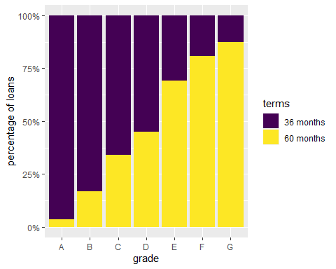
#This plot makes it clear that the lower the grade, the higher the proportion of loans that are of longer length. The difference is extremely evident with only 3.5% of grade A loans having a 60-month term but 87.5% of grade G loans having the same term.
grade_term_breakdown <- percent_breakdown(credit_data, "grade", "terms")
## `summarise()` regrouping output by 'terms' (override with `.groups` argument)
ggplot(data = grade_term_breakdown, aes(x = terms, y = percentage)) +
geom_bar(stat = "identity", aes(fill = grade)) +
scale_y_continuous(breaks = seq(0, 1, 0.25),
labels = c("0%", "25%", "50%", "75%", "100%")) +
labs(y = "percentage of loans") +
scale_fill_brewer()
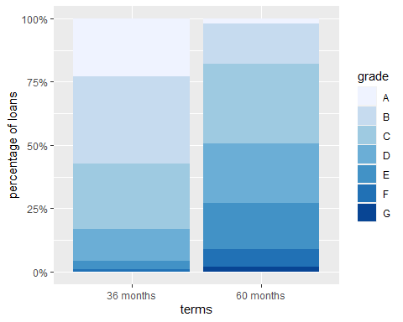
#Reversing the breakdown and instead plotting the percentage breakdown of each length of term by grade reveals similar information. 36-month loans are composed mostly of grade A, B, and C loans (comprising a total 83%). Moving to 60-month loans, the number of A and B grade loans drops off sharply (down 67%) while the proportion of grade D, E, F, and G loans increases.
#checking Relation Between Annual Income & rateof interest
ggplot(data = credit_data, aes(x = annual_inc, y = Rate_of_intrst)) +
geom_point(alpha = 0.01, position="jitter") +
coord_cartesian(
xlim = c(quantile(credit_data$annual_inc, probs = 0.01, na.rm = TRUE),
quantile(credit_data$annual_inc, probs = 0.99, na.rm = TRUE))) +
labs(x = "annual income ($)", y = "interest rate (%)")
## Warning: Removed 4 rows containing missing values (geom_point).
