**Project title : Predicting Revolving Balance Using R**

**Abstract –**

As a bank or investor who are into this revolving balance here they can charge higher interest rates and convenience fees as there is lot of risk associated in customer paying the amount. Our company wants to predict the revolving balance maintained by the customer so that they can derive marketing strategies individually.

**Objective –**

The objective of the analysis is to predict the revolving balance maintained by the customer so that they can derive marketing strategies individually.

**Problem statement –**

revolving credit means you are borrowing against a line of credit. let's say a lender extends a certain amount of credit to you, against which you can borrow repeatedly. The amount of credit you're allowed to use each month is your credit line or credit limit. You are free to use as much or as little of that credit line as you wish on any purchase you could make with cash. It's just like a credit card and only difference is they have Lower interest rate and they are secured by business assets. At the end of each statement period, you receive a bill for the balance. If you don't pay it off in full, you carry the balance, or revolve it, over to the next month and pay interest on any remaining balance. As you pay down the balance, more of your credit line becomes available and usually it's useful for small loans.

As a bank or investors who are into this revolving balance here they

can charge higher interest rates and convenience fees as there is lot of risk associated in customer paying the amount. Our company wants to predict the revolving balance maintain by the customer so that they can derive marketing strategies individually.

**Project Architecture –**

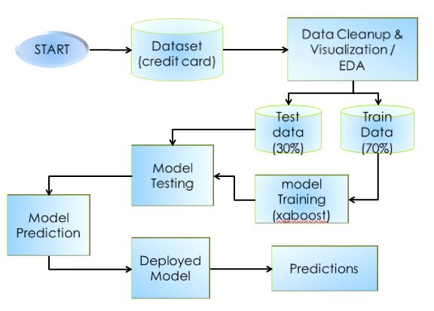

Fig 1 – project architecture

**Implementation –**

EDA – In EDA analyzing data set and summarize their characteristics with visual methods.

Eg - 887379 observation / rows

36 Variables / columns

Missing values = TRUE

Remove variables like Member id and Batch id

Remove Variables which are having percentage of occurring zeroes is more than 60%

Remove variables which having maximum missing values

Feature Engineering- Process of selecting and transforming variables for creating a prediction model. It involves data analysis, applying rules and judgement.

Eg – selecting the variables for prediction of model

Apply xgboost algorithm for model building

Test the data and check for accuracy of model

Deployment - making the application work on a target device whether it be a user’s computer or mobile device.

**Steps –**

Load require Libraries

Load CSV files

Perform EDA

Select Important Variables

Split Data in Train Data(70%) & test Data(30%)

Train the Model Using Algorithm/Method

Test the Data

Check for collinearity

Predict the Data

Deploy the Model

Predictions

**Conclusion –**

In the proposed system can predict the customer’s revolving balance by comparing Input data with the data stored in the database. After successful comparing of input values with dataset, the system provides relevant revolving balance as a output.