1. Notes to Readers: HL7 Version 3 Standard: Care Provision; Assessment Scales Topic, Release 2 (2st DSTU Ballot)

Patient Care Co-Chair William Goossen, PhD, RN
Results 4 Care B.V., The Netherlands

Modeling & Methodology Facilitator John Kufuor-Boakye, M.Sc
HL7 Canada

Vocabulary Facilitator Frank Oemig, Agfa Healthcare, HL7 Germany
Contributor: Ybranda Koster, Results 4 Care B.V., HL7 Netherlands
This model is a proper constraint of the clinical statement pattern. Since the DSTU for assessment scales under care provision care structures new insights in assessment scale representations required this update. In particular, the nesting for subscales, reference ranges, and referring to additional information supporting the scoring require additions. Further, the model should accommodate future development and deployment in HL7 v3 of detailed clinical models. The R-MIM has changed in particular extended with additional classes. The walkthrough is completed, reusing the existing materials from R1 DSTU, but adding application guidelines.
The aim of this release is to provide a generic template based on the clinical statement pattern for use with almost all scores systems and assessment scales. Therefore, it provides a framework for use both in V3 messages and CDA documents. This chapter has been balloted as a DSTU and was did achieve a positive vote in January 2009, with some comments to further complete the materials. This version is the full DSTU.
This document should be available for generic use. Some of the examined scores systems are coming from the German realm. So, with our apologies, sometimes there is no English description provided. Translations have been carried out where possible in the last cycle.

2. Changes from Previous Release

2.1. Summary of Changes from Release 1
- migration to generic structure (no restriction to specific score systems and assessment scales)
- nesting for subscales (to any depth)
- addition of reference ranges
- referring to additional information supporting the scoring
- to be used in messages and CDA documents
- integration of existing observations
- support of different mood codes

2.2. Summary of Changes from the Release 2 ballot reconciliation included in this DSTU material
- translation from German to English
- inclusion of story boards
- Requested R-MIM changes
- addition of relevant interactions for each storyboard
- walkthrough included and better formatted.

2.3. Open Issues
- Description Parent R-MIM: Care Structures Event Statement (REPC_RM000100UV) will change in the future and affect this model
- Is the Snomed CT code for Barthel Index correct? The discussion within the IHTSDO group says it is wrong, but needs additional work and discussion. So coding is provided as examples.
- On the level of proper coding, further cooperation with IHTSDO and LOINC is being sought.
- The supporting observations will be derived from the COCT_MT530000UV. This is an update following motions in PC May 2011 to use this format in the D-MIM.

3. Introduction

This work is the result of different ballots for a new R-MIM REPC_RM000125UV on scores and assessment scales. This page provides the material which have been balloted as R1 and R2 and after approval with supportive votes in R2, the required changes have been reconciled and approved by the negative voters. This version holds all the required changes and in particular the additions. Resources are the reason why there is a lag between the finalization and the inclusion in the normative ballot.
This DSTU on Assessment Scales is organized according to the following components:
- Rationale for paying attention to assessment scales / scores / indexes as a separate topic
- Application domains, i.e. examples of scales and assessment in different clinical areas.
- The HL7 v3 ballot material such as use cases, storyboards, dynamic model, static R-MIM model.
- Instructions for use to define assessment scale as Detailed Clinical Model, including the coding of it, and use it against the Clinical Statement / assessment scale R-MIM.
This is a release 2 revision of the existing assessment scale R-MIM in the care structures topic which has DSTU status since 2007. The old assessment scale section (R-MIM REPC_RM000120UV) is now obsolete and will be removed from the Care Provision domain in the next revision cycle of care structures.

4. Assessment Scales Introduction

4.1. Overview
The most fundamental question is always how certain information in HL7 should be transmitted. In most cases, it is information that belongs to the category of "findings" or "observations". Therefore, in HL7 v2.x the OBX-Segment can be used. The code in OBX-2 explains what the observation is about. In HL7 V3 we will find some classes within the RIM and the appropriate domain models.
The so-called Score or assessment systems are findings. Score systems are so-called severity classification systems or point totals systems that pretend to make a quantitative statement on the severity and prognosis of a disease, health condition or functional status. Typically, scores combine individual values into a total which can be interpreted more easily. In the simplest case, it is just a single value or based on two individual values, in a complex case it can consist of several dozen values which are combined using a complex mathematical calculation. Several example assessment scales consist of sub scales with a subtotal score, where nesting of several sub scales to a total score exists.
This document tries to address two kinds of requirements. First, it should define which codes for the most important score and assessment systems must be used. On the other hand, it should explain how the information should be mapped to V3. (The basics may also be used - esp. regarding the definition of codes - to specify how this information can be transmitted with HL7 v2.x messages.) The R-MIM for assessment scales is developed against the Clinical Statement patterns, thus allowing the inclusion of the R-MIM in any message or clinical document example that adheres to the clinical statement pattern specification.

4.2. Scope
There are many score systems in use in health care at large (Wikipedia). Many systems are in use on an international, national or just hospital wide or individual practice level. Others are just for scientific purposes. Most interesting scores have both validity and reliability characteristics on individual patient level and on population level.

4.3. Information about Scores and Assessments
The representation of Assessment scales, scores or indexes in information technology can be based on the Detailed Clinical Models (DCM) approach. Assessment scales require a very strict interpretation of the variable and the value set in order to keep the psychometric / clinimetric characteristics intact. In particular, these scientific characteristics are based on the population investigated and reveal data on validity (fitness for purpose) and reliability (consistency in measurement).
In the DCM the purpose, scientific evidence, instructions for appropriate application, and guidelines for interpretation of such scoring instruments are expressed. In additional the data specification and vocabulary and coding binding are included. The latter is of great importance for the full expression of scales in messages and for our communication the following information are of interest:
- Name + description (short textual description) of the scale or instrument
- List of variables or data elements the scale consists of
- Code (how to identify the variable / data?)
- Codesystem (what is the originating catalog?)
  - LOINC,
  - alternatively Snomed CT, (if a licence is available),
  - ICD,
  - ICF,
  - ICNP,
  - NANDA,
  - Realm specific codes or domain specific codes, or perhaps
  - proprietary codes (if necessary)
- value (what are the possible/allowed values/information)
- data type (ISO data type format), in particular the Coded Ordinal is frequently applied allowing text specification of the value and the number allowing calculations
- unit (in UCUM)
- interpretation (or interpretation range)
  - value domains/sets
  - codes for each value
- derivation method (how is the total score calculated or derived, e.g. sum score based on scoring each individual variable first).
In addition to this information for an individual score the underlying values used for calculation are of importance as well. But these are also based on the same 6 main points mentioned above.

5. Application Domains

The score systems can be assigned to specific domains. The following table lists some example assessment / score systems (in alphabetic order) per domain with the assigned code (if available).
This can be further completed in future cycles.

5.1. Example domains

Score System | Description | Code | Codesystem

1. Intensive Care and Anesthesia
ABSI | Abbreviated burn severity index | tbd
AIS | Abbreviated Injury System | 273254002 | Snomed CT
APACHE | Acute Physiology And Chronic Health Evaluation Score  APACHE 2:  APACHE 3: | 9264-3  9265-0 | LOINC
ASA | American Society of Anesthesiologists physical status classification | 273270000  413347006 | Snomed CT
CASUS | Cardiac Surgery Score | tbd
GCS | Glasgow Coma Scale | 9269-2  35088-4  386560004 | LOINC  LOINC  Snomed CT
HIS | Hannover Intensiv Score | tbd
HTI | Hospital Trauma Index | 273525007 | Snomed CT
ISS | Injury Severity Score | 273533008 | Snomed CT
KISS | Combined Intensive Scoring System  (German: Kombiniertes Intensiv Scoring System) | tbd
LOD | Logistic Organ Dysfunction Score | 58577001 | Snomed CT
MOD | Multiple Organ Dysfunction Score
MOF | Multi-Organ-Failure-Score | tbd
MPI | German: Mannheimer Peritonitis Index | tbd
Ramsay | Ramsay sedation scale | 281400004 | Snomed CT
RASS | Richmond Agitation Sedation Scale | tbd
SAPS | Simplified Acute Physiology Score SAPS:  SAPS 2:  SAPS 3: | 273811002  273812009  tbd | Snomed CT  Snomed CT  ICD-10-GM
SOFA | Sepsis-related Organ Failure Assessment | tbd
TI | Trauma Index | 273883005 | Snomed CT
TISS | Therapeutic Intervention Scoring System:  TISS-10  TISS-28  TISS-76 | 273878002  tbd | Snomed CT  ICD-10-GM
TS | Trauma Score | 273884004 | Snomed CT
...

2. Patient Care
Barthel-Index (German) | Barthel Index, German version | 273302005 | Snomed CT  ICD-10-GM
Barthel-Index (Dutch) | Barthel Index, Dutch version  Note: The Dutch modification makes use of a different scoring though the concept is the same |  | Snomed CT  ICD-10-GM
Braden Scale | Braden Scale | 38227-5 | LOINC
Braden Skin Ass. Pnl | Braden Skin Assessment Panel | 38228-3 | LOINC
BradenQ | Braden Scale for young children (<5 years) | tbd | LOINC
FIM | Functional Independence Measure | 273469003  U50.- | Snomed CT  ICD-10-GM
FRB | Barthel Index for Rehabilitation  (German: Frühbilitations-Barthel-Index ) | U52.-  273302005 | ICD-10-GM  Snomed CT
NEMS | Nine Equivalents of nursing Manpower use Score | tbd
Norton | Norton Score | 278898009 | Snomed CT
PPR | German Patient Scoring System to estimate nursing efforts/intensity  (German: Pflegepersonal-Regelung) | tbd
Waterlow | Waterlow pressure sore risk score | 278897004 | Snomed CT
...

3. Psychiatry and Psychology
AMDP | Arbeitsgemeinschaft für Methodik und Dokumentation in der Psychiatrie | tbd
LFP | Lübecker Fähigkeitenprofil | tbd
Melba | Scoring of handicapped people for professional reintegration  (German: Merkmalprofile zur beruflichen Eingliederung von Behinderten) | tbd
MMSE | Mini Mental State Examination | 273617000 | Snomed CT ICD-10-GM
...

4. Pediatry
Pediatric GCS | Pediatric Glasgow Coma Scale | tbd
APGAR | Assessment of the Newborn  after 1 minute  after 5 minutes  after 10 minutes | 9272-6  9273-4  9271-8 | LOINC
...

5. Mobility
 | Tinetti-Test
 | Timed Up & Go
 | Tandemstand
 | Tandemgang
 | Chair-Stand-Up
...

6. Cognition
DemTect
TFDD | Early detection of dementia assessment scale  (German: Test zur Früherkennung von Demenzen mit Depressionsabgrenzung)
 | Clock Completion
...

7. Nutrition
MNA | Mini Nutritional Assessment (after Guigoz et.al.)
...

8. Psychology
APS | Acute Physiology Score
...

9. Geriatry
GDS | Geriatric Depression Scale | 273481004  48544-1 | Snomed CT  LOINC
...

10. not otherwise classified
Bone density |  | 385342005 | Snomed CT
BMI | Body-Mass-Index measurement  Body-Mass-Index | 39156-5  41909-3 | LOINC  LOINC
BV | Bacterial vaginosis score | B96.  N76. | ICD 10
FLACC | Face Legs Activity Cry Cinsolability Score | tbd
Gleason | Gleason Score | 372278000 | Snomed CT
HTI | Hospital Traum Index | 273525007 | Snomed CT
IADL | IADL (after Lawton and Brody)
MPM | Mortality Prediction Model  MPM 2 (0)  MPM 2 (24, 48, 72) | 273630004  273631000 | Snomed CT  Snomed CT
PHQ | Personal Health Questionnaire (Depression Score)
PSR | Periodontal Screening and Recording
VAS | visuell analog Scala | tbd
...

Of course, the details for the individual score systems are missing here. They are part of a separate document which is available in form of generated HTML files or as an IHE whitepaper.

5.2. Code-Systems
The code systems are identified by their OIDs which are listed in the following table.
Codesystem | Descrption | Website | OID
LOINC | Logical Observation Identifiers Names and Codes | www.loinc.org | 2.16.840.1.113883.6.1
ICD 10 GM 2005  icd10gm2005 | ICD-Katalog (German modification 2005) | www.dimdi.de | 1.2.276.0.76.5.304
ICD 10 GM 2006  icd10gm2006 | ICD-Katalog (German modification 2006) | www.dimdi.de | 1.2.276.0.76.5.311
ICD 10 GM 2007  icd10gm2007 | ICD-Katalog (German modification 2007) | www.dimdi.de | 1.2.276.0.76.5.318
ICD 10 GM 2008  icd10gm2008 | ICD-Katalog (German modification 2008) | www.dimdi.de | 1.2.276.0.76.5.330
ICD 10 GM 2009  icd10gm2009 | ICD-Katalog (German modification 2009) | www.dimdi.de
Snomed CT | SNOMED CT is a concept-based, scientifically validated terminology that provides a unique and permanent concept identifier that can be included in multiple HL7 data types including CD and CE. The concepts are managed to avoid "semantic drift" so the meaning remains constant. If the concept is found to be ambiguous or the meaning changes, the concept is inactivated but still retained and the identifier is never reused. SNOMED CT's concepts are interrelated hierarchically and using description logic. | www.snomed.org | 2.16.840.1.113883.6.96
OPS 2006  ops2006 | Operationsschluessel | www.dimdi.de | 1.2.276.0.76.5.310
OPS 2007  ops2007 | Operationsschlessel | www.dimdi.de | 1.2.276.0.76.5.317
OPS 2008  ops2008 | Operationsschluessel | www.dimdi.de | 1.2.276.0.76.5.331
OPS 2009  ops2009 | Operationsschluessel | www.dimdi.de
Alpha-ID 2008  alphaid2008 | Alpha-Id 2008 | www.dimdi.de | 1.2.276.0.76.5.329
Alpha-ID 2009  alphaid2009 | Alpha-Id 2009 | www.dimdi.de

6. Dynamic Model

6.1. NewST-AS01: Request to take an assessment scale (Care Transfer Request )

6.1.1. Storyboard

Purpose: The purpose of this storyboard is to illustrate that a request can be made from one care provider to another care provider to take an assessment scale. The care provider responds with a promise or a reject.
Storyboard 1: Dr. First has seen patient Mr. Allman during his ward visits. Mr. Allman is bed bound after a severe injury Dr. First wants the nurses to do an assessment of pressure ulcer risk using the Braden Scale. He sends a request to nurse Goodman who is the responsible nurse of the ward of Mr. Allman. Nurse Goodman sends a message to Dr. First that she promises to do the Braden scale on Mr. Allman. Later that day nurse Goodman enters the data from the assessment of the Braden scale in to the care plan of Mr. Allman.
Storyboard 2: Nurse Goodman knows that Mr. Allman is allowed to start mobilizing tomorrow. She therefore does not agree that a Braden Scale assessment needs to be done. She sends Dr. First a reject.

6.1.2. Use case
This concerns a use case diagram that belongs to storyboard NewST-AS01: the request to take an assessment scale. The request is done form one care provider to another. The second care provider responds with a promise or a reject (figure 1).

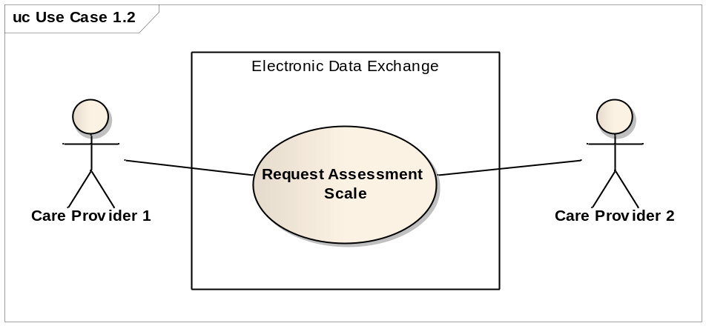

6.1.3. Activity diagram
This concerns an activity diagram that belongs to storyboard NewST-AS01: the request to take an assessment scale (figure 2).

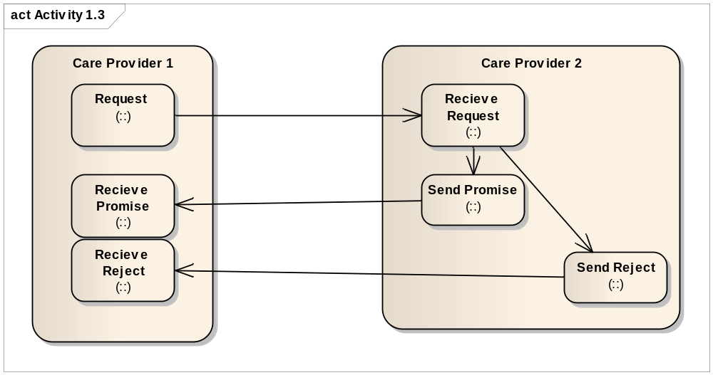

6.1.4. Interaction diagram

This interaction diagram (figure 3) shows the dynamics on the main components of the communication between two care providers. For storyboard NewST-AS01 three interactions are needed: The request itself, the promise and reject. The promise or the reject are send directly after the request is received.
The interaction diagram for Care Transfer Request is shown in figure 3.

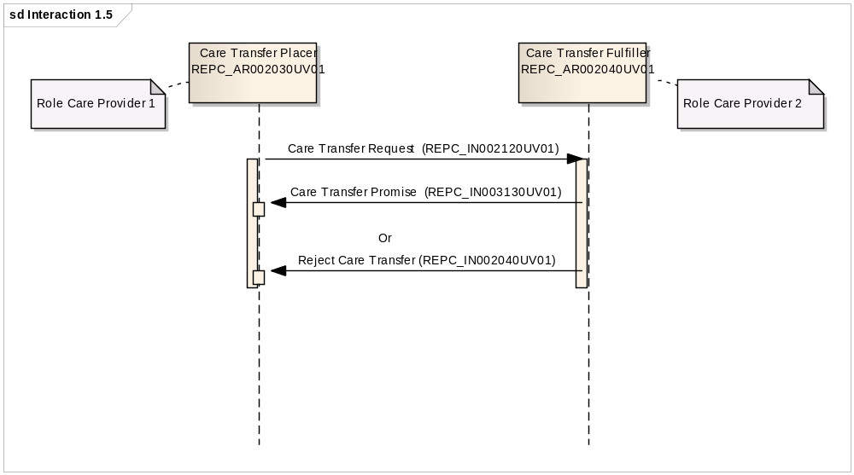

6.1.5. Interactions

Care Transfer Request (REPC_IN002120UV01) for use for assessment scales

The first interaction concerns the Request to carry out an assessment scale score. In HL7 this is the Care Transfer Request (REPC_IN002120UV01).
The interaction is similar to all used to request the receiver accept responsibility for care provision of the subject. In this example the scoring of the assessment scale. The interaction has two possible receiver responsibility types. The first, Care Transfer Promise, is used by the receiving application role when it accepts the request. The second receiver responsibility is Reject Care Transfer and is used by the fulfiller to reject the request.
Trigger event | Care Transfer Request | REPC_TE2100UV01
Transmission Wrapper | Send Message Payload | MCCI_MT000100UV01
Control Act Wrapper | Trigger event Control Act | MCAI_MT700201UV01
Message Type | Care Transfer Request | REPC_MT002000UV01
Application Roles of Sender and Reciever:
Sender | Care Transfer Placer | REPC_AR002030UV01
Reciever | Care Transfer Fulfiller | REPC_AR002040UV01

Care Transfer Promise (REPC_IN003130UV01)

The second interaction is the Promise. In HL7 this is the Care Transfer Promise (REPC_IN003130UV01).
The interaction is a response to the Care Transfer Request to score an assessment scale and is used by the receiving application role when it accepts the request and the responsibility of care provision for the subject, i.e. carrying out the scoring of the assessment scale.
Trigger Event | Care Transfer Promise | REPC_TE003130UV01
Transmission Wrapper | Application Level Acknowledgement | MCCI_MT000300UV01
Control Act Wrapper | Trigger Event Control Act | MCAI_MT700201UV01
Message Type | Care Transfer Promise | REPC_MT003000UV01
Application Roles of Sender and Reciever:
Sender | Care Transfer Fulfiller | REPC_AR002040UV01
Receiver | Care Transfer Placer | REPC_AR002030UV01

Reject Care Transfer (REPC_IN002040UV01)
The third interaction concerns the rejection of the request to do an assessment. In HL7 this is Reject Care Transfer (REPC_IN002040UV01)
The interaction signifies that a request for care provision has been rejected after consideration; the receiver is not carrying out the score of the assessment scale.
Trigger Event | Reject Care Transfer | REPC_TE002040UV01
Transmission Wrapper | Application Level Acknowledgement | MCCI_MT000300UV01
Control Act Wrapper | Trigger Event Control Act | MCAI_MT700201UV01
Message Type | Act generic Status – Order | COMT_MT001101UV
Application Roles of Sender and Reciever:
Sender | Care Transfer Fulfiller | REPC_AR002040UV01
Receiver | Care Transfer Placer | REPC_AR002030UV01

6.1.6. Note
The Request is similar if not the same as the Order described in paragraphs 4.
6.2. NewST-AS02 Assessment Scale Query (REPC_ST007005UV)

6.2.1. Storyboard

Purpose: The purpose of this storyboard is to illustrate that a set of observations in an assessment scale can be queried. This query could return a list of results that are used to organize multiple assessments, e.g. against a time line to trend the information or to reveal highest and lowest scores.
Storyboard: Dr. First has seen patient Mr. Allman during his ward visits. Dr. First knows that the nurses have done several assessments with the Braden Scale to assess Mr. Allman’s skin condition and risk on pressure ulcers. Dr. First wants the results of those assessments. He makes a query on the results of the assessments of Mr. Allman. Since Dr. First has authorization to access the care record of Mr. Allman the query can be done.

6.2.2. Use case
This concerns a use case diagram (fig 6.) that belongs to storyboard NewST-AS02: the query of the results of an assessment scale. The query is done by one care provider to the care record of a specific patient if the provider is authorized.

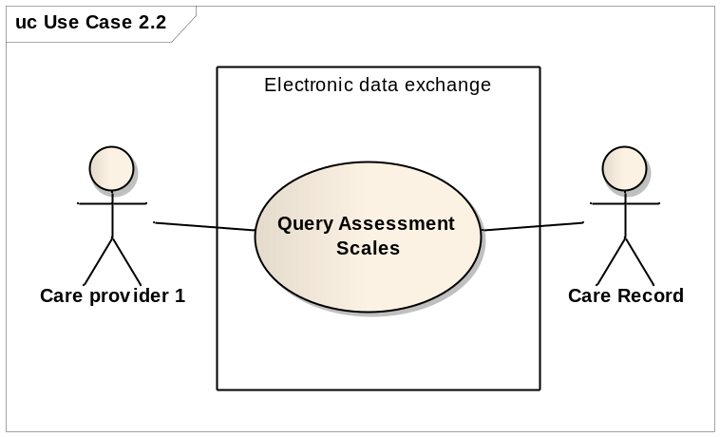

6.2.3. Activity diagram
This concerns an activity diagram that belongs to storyboard NewST-AS02: the query of the results of an assessment scale (figure 7).

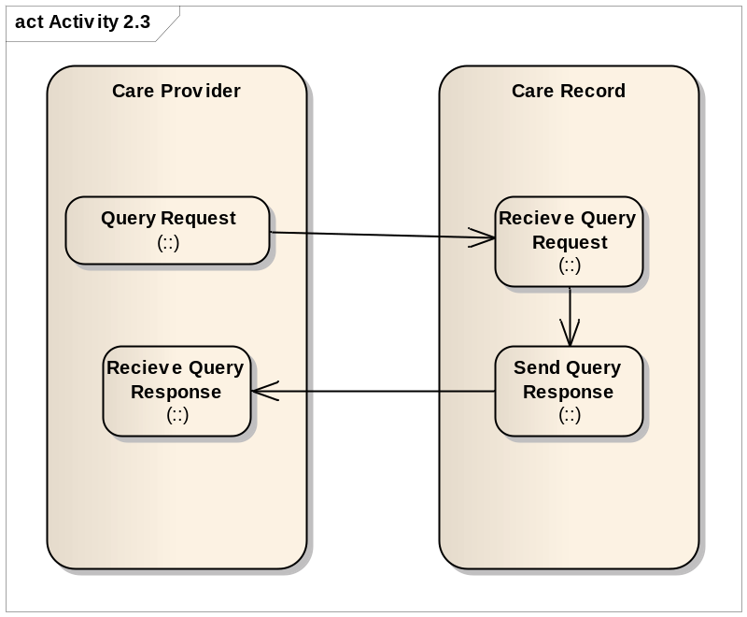

6.2.4. Interaction diagram query and response

This interaction diagram (figure 8) Shows the dynamic on main components when a query request has been made for (a part of) a patient record, i.e., the assessment scores. The query is responded by sending the information that matches the criteria of the query, in this case the assessment data of the Braden scale. For storyboard NewST-AS02 two interactions are needed: The query and the response.
The interaction diagram for the Care Record Profile Query is shown in figure 8.

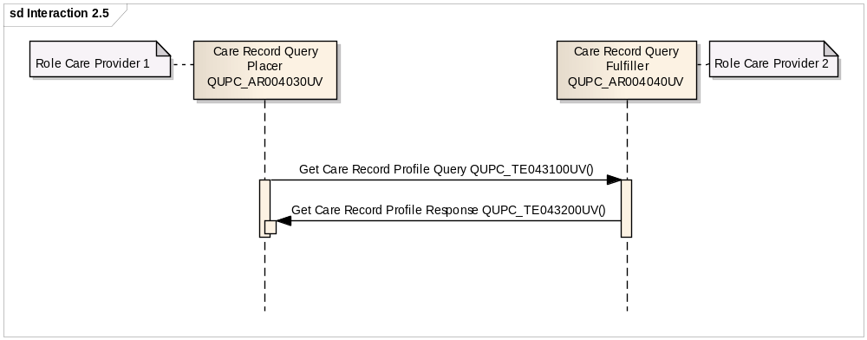

6.2.4. Interactions

6.2.4.1. Get Care Record Profile Query (QUPC_IN043100UV)

The first interaction concerns the query. In HL7 this is the Get Care Record Profile Query (QUPC_IN043100UV)
This interaction is used to make a request for a query for (a part of) the Care Record. Data of a Care Record that that fits the profile and query criteria is expected as answer. In this case the query criteria are patient Mr. Allman and Braden scale assessments.

Trigger Event | Get Care Record Profile Query | QUPC_TE043100UV
Transmission Wrapper | Send Message Payload | MCCI_MT000100UV01
Control Act Wrapper | Query Control Act Request : Parameter List | QUQI_MT020001UV01
Message Type | Care Record Profile Query | QUPC_MT040300UV

Application roles of sender and receiver:
Sender | Care Record Query Placer | QUPC_AR004030UV
Receiver | Care Record Query Fulfiller | QUPC_AR004040UV

6.2.4.2. Get Care Record Profile Response (QUPC_IN043200UV)

After the query is received the receiver responds. This response is in HL7 the Get Care Record Profile Response (QUPC_IN043200UV). The Care Record that fits the profile and matches with the criteria of the query is send attached to this message.

Trigger Event | Get Care Record Profile Response | QUPC_TE043200UV
Transmission Wrapper | Application Level Acknowledgement | MCCI_MT000300UV01
Control Act Wrapper | Master File / Registry Query Response, Act Subject | MFMI_MT700712UV01
Query Response Type | Care Record | REPC_MT004000UV
Query Definition | Care Record Profile Query | QUPC_MT040300UV

The application roles of Sender and Reciever:

Sender | Care Record Query Placer | QUPC_AR004030UV
Receiver | Care Record Query Fulfiller | QUPC_AR004040UV

6.3. NewST-AS03 Assessment Scale Observation (REPC_ST007003UV)

6.3.1. Storyboard

Purpose: The purpose of this storyboard is to illustrate that an assessment scale observation can be transmitted.
Storyboard: Nurse Goodman takes the assessment scale of the Glasgow Coma scale on Mr. Everyman. She sends the results of this assessment to Dr. First.

6.3.2. Use case
This concerns a use case diagram (fig 11.) that belongs to storyboard NewST-AS03: assessment scale observation. The observation is done by one care provider who sends the results to another care provider.
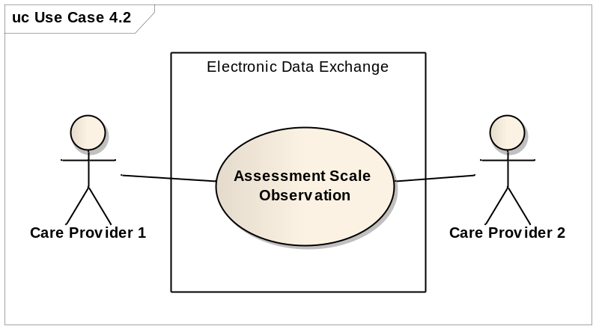

6.3.3. Activity diagram
This concerns an activity diagram that belongs to storyboard NewST-AS03: assessment scale observation (figure 12).
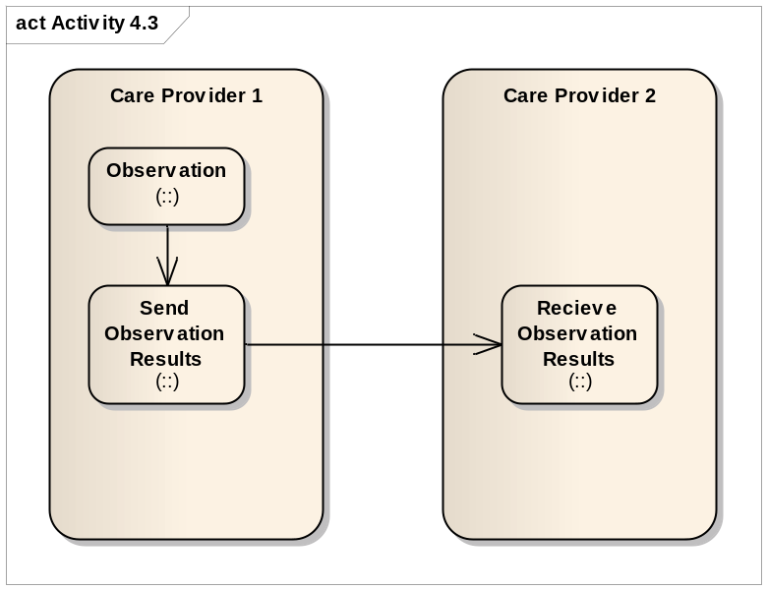

6.3.4. Interaction diagram
This sequence diagram (figure 13) Shows the dynamic on main components of the communication between two care providers. For storyboard NewST-AS03 only one interaction is needed: Sending the Assessment Scale Observation.
The interaction diagram for Append Care Provision (REPC_IN004211UV01) is shown in figure 14:

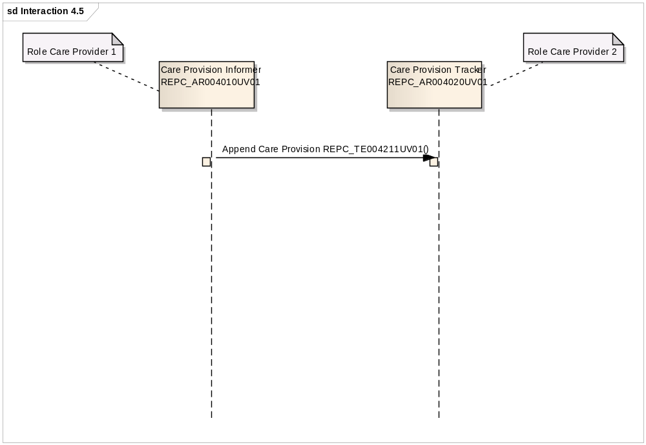

6.3.5. Interactions

6.3.5.1. Append Care Provision (REPC_IN004211UV01)
This interaction concerns sending the data collected by the assessment scale observation from one care provider to another. In HL7 this is the Append Care Provision (REPC_IN004211UV01). This interaction is used to notify a receiver of additional details collected as part of the responsibility of care for a subject.

Trigger Event | Append Care Provision | REPC_TE004211UV01
Transmission Wrapper | Send Message Payload | MCCI_MT000100UV01
Control Act Wrapper | Trigger Event Control Act | MCAI_MT700201UV01
Message Type | Care Record | REPC_MT004000UV01
Application roles for sender and receiver:
Sender | Care Provision Informer | REPC_AR004010UV01
Receiver | Care Provision Tracker | REPC_AR004020UV01

6.4. NewST-AS04 Assessment Scale Order (REPC_ST007004UV)

6.4.1. Storyboard

Purpose: The purpose of this storyboard is to illustrate that an order for an observation using a specified assessment scale can be made.
Storyboard: Dr. First wants nurse Goodman to assess a Glasgow Coma Scale on Mr Everyman. Therefore Dr. First sends an order to nurse Goodman to order her to assess Mr Everyman with the Glasgow Coma Scale.

6.4.2. Use case
This concerns a use case diagram that belongs to storyboard NewST-AS04: the order to take an assessment scale. The order is done form one care provider to another. The second care provider responds with a promise or a reject (figure 15).

6.4.3. Activity diagram
This concerns an activity diagram that belongs to storyboard NewST-AS04: the order to take an assessment scale (figure 16).

6.4.4. Interaction diagram

The interaction diagram for Care Transfer Request is shown in figure18.

6.4.5. Interactions

6.4.5.1. Care Transfer Request (REPC_IN002120UV01)

The first interaction concerns the Request. In HL7 this is the Care Transfer Request (REPC_IN002120UV01)
The interaction is used to request the receiver accept responsibility for care provision of the subject. The interaction has two possible receiver responsibility types. The first, Care Transfer Promise, is used by the receiving application role when it accepts the request. The second receiver responsibility is Reject Care Transfer and is used by the fulfiller to reject the request.
Trigger event | Care Transfer Request | REPC_TE2100UV01
Transmission Wrapper | Send Message Payload | MCCI_MT000100UV01
Control Act Wrapper | Trigger event Control Act | MCAI_MT700201UV01
Message Type | Care Transfer Request | REPC_MT002000UV01
Application Roles of Sender and Reciever:
Sender | Care Transfer Placer | REPC_AR002030UV01
Reciever | Care Transfer Fulfiller | REPC_AR002040UV01

6.4.5.2. Care Transfer Promise (REPC_IN003130UV01)

The second interaction is the Promise. In HL7 this is the Care Transfer Promise (REPC_IN003130UV01)
The interaction is a response to the Care Transfer Request and is used by the receiving application role when it accepts the request and the responsibility of care provision for the subject.
Trigger Event | Care Transfer Promise | REPC_TE003130UV01
Transmission Wrapper | Application Level Acknowledgement | MCCI_MT000300UV01
Control Act Wrapper | Trigger Event Control Act | MCAI_MT700201UV01
Message Type | Care Transfer Promise | REPC_MT003000UV01
Application Roles of Sender and Reciever:
Sender | Care Transfer Fulfiller | REPC_AR002040UV01
Receiver | Care Transfer Placer | REPC_AR002030UV01

6.4.5.3. Reject Care Transfer (REPC_IN002040UV01)
The third interaction concerns the rejection of the request to do an assessment. In HL7 this is Reject Care Transfer (REPC_IN002040UV01)
The interaction signifies that a request for care provision has been rejected after consideration.
Trigger Event | Reject Care Transfer | REPC_TE002040UV01
Transmission Wrapper | Application Level Acknowledgement | MCCI_MT000300UV01
Control Act Wrapper | Trigger Event Control Act | MCAI_MT700201UV01
Message Type | Act generic Status – Order | COMT_MT001101UV
Application Roles of Sender and Reciever:
Sender | Care Transfer Fulfiller | REPC_AR002040UV01
Receiver | Care Transfer Placer | REPC_AR002030UV01

6.4.5.4. Note
The Order is similar if not the same as the Request described in paragraph 1.
6.5. NewST-AS06 Assessment Scale Define (REPC_ST007001UV)

6.5.1. Storyboard

Purpose: This storyboard demonstrates that an assessment scale can be defined and sent to convey information about the score system respectively the assessment scale itself.
Storyboard: Mr. Allman has been transferred to a rehabilitation centre. Dr. First sends the transfer information to Dr. Next, the physician responsible for Mr. Allman in the rehabilitation centre. To make sure the interpretation of the Braden Scale is done correctly, Dr. First sends the Detailed Clinical Model of the Braden Scale used in the hospital along with the data of Mr. Allman.

6.5.2. Use case
This concerns a use case diagram (figure 10) that belongs to storyboard NewST-AS06: Define the Assessment Scale. The scale is defined and send to convey information about the score system and/or the Assessment Scale itself. This can be done by sending the DCM (Detailed Clinical Model) of the used scale. (Alternatives could be to point to an DCM registry or repository once these are available).

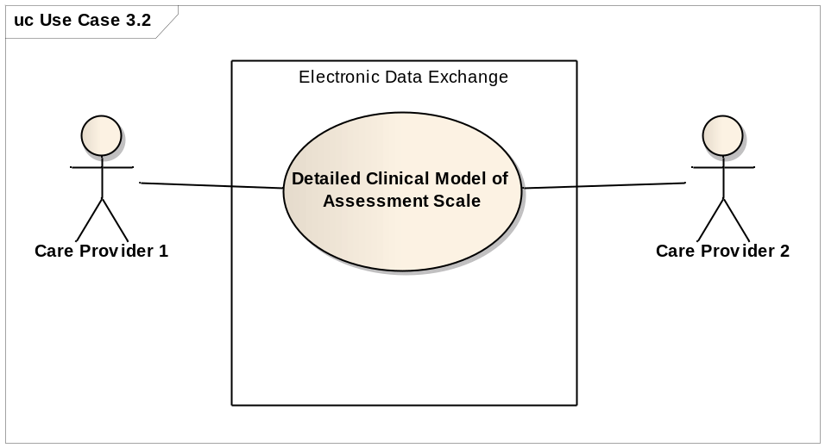
Figure 10: Use case Detailed Clinical Model of Assessment Scales.

6.5.3. Interactions

The interactions used here are the care record in EVN mood. This is described in the paragraph for the Observation. In HL7 terms only the moodcode will change from EVN for the Observation to DEF for the Definition.
6.6. NewST-AS07 Assessment Scale Plan (REPC_ST007002UV)

6.6.1. Storyboard
Purpose: The purpose of this storyboard is to illustrate that an assessment observation can be added to a care plan in order to perform the assessment at a later date.
Storyboard: Nurse Goodman has had an order to assess a Braden Scale on Mr. Everyman every other day for the coming three weeks. She adds the assessment to the care plan of mr. Everyman the next time she has planned to actualize the care plan of mr. Everyman.

6.6.2. Note

The assessment scale plan topic can be described with the interactions used in Care Plan Event Plan (REPC_RM000200UV01). This topic is not yet fully described in HL7. Therefore the assessment scale plan cannot be further elaborated until a DSTU for Care Plan has been done.
Readers are referred to future Care Plan materials, which will include an example of a care plan with assessment scales included.

7. Foundation

7.1. Assessment Scales Scores Structure Overview
Given the interest in earlier versions of the Care Provision Ballot, further work has been undertaken on representing assessment scales, scores or indexes. The scientific testing of such instruments puts specific requirements and constraints on its use in HL7 v3 message structures in order to not only have a semantically equivalent data exchange, but also to keep the clinimetric characteristics of the instruments as a whole. The assessment scales, scoring systems or indexes are observations with specific characteristics. They can consist of severity classification systems or point totals systems that pretend to make a quantitative statement on the severity and prognosis of a disease or other aspect of human functioning. It is quite often an attempt to convert ‘soft’ observations into ‘hard’ data and evidence. Most of such instruments used in healthcare have been tested extensively on validity, reliability and usability. Many of such scoring instruments are used for decades and worldwide. Typically, assessment scales or scores combine the findings of individual values into a total score which can be interpreted more easily against a reference population. In the simplest case, it is just a single value or based on two individual values, in a complex case it can consist of several dozen values which are combined using a complex mathematical calculation or statistical technique. The scientific validation of a scale from one country, language, domain or patient population to another requires sufficient testing and retesting. Quite often it does require a slight change in meaning in order to achieve a sufficient valid and reliable instrument. Thus the instruments in different languages do differ somewhat. This can be on definition of variable level, or on the actual numbers assigned. The English and Dutch Barthel index for instance use different numbers assigned for the values (e.g. 0, 5, 10 or 15 for English and 0, 1, 2, or 3 for Dutch. Such knowledge is important in order to identify and compare the correct score for individuals appropriately.
This R-MIM tries to give guidelines on the representation in information models, in particular against the HL7 clinical statement pattern and the R-MIM for the care record.
In addition to the information model, the appropriate use of terminology and consistency between the information model and the terminology model are crucial for safe exchange of such observations.

7.2. Clinical Statement extract (Walkthrough of REPC_RM000125UV)
The R-MIM for the assessment scales / scores can be seen as an extract of - or constraint on - the Clinical Statement Pattern, thus inheriting its characteristics. The R-MIM representation starts on top with the name and identification in the entry-point. For a detailed explanation of all attributes and vocabulary, the reader is referred to generic descriptions of the Reference Information Model, and to the walkthrough of the Clinical Statement D-MIM.

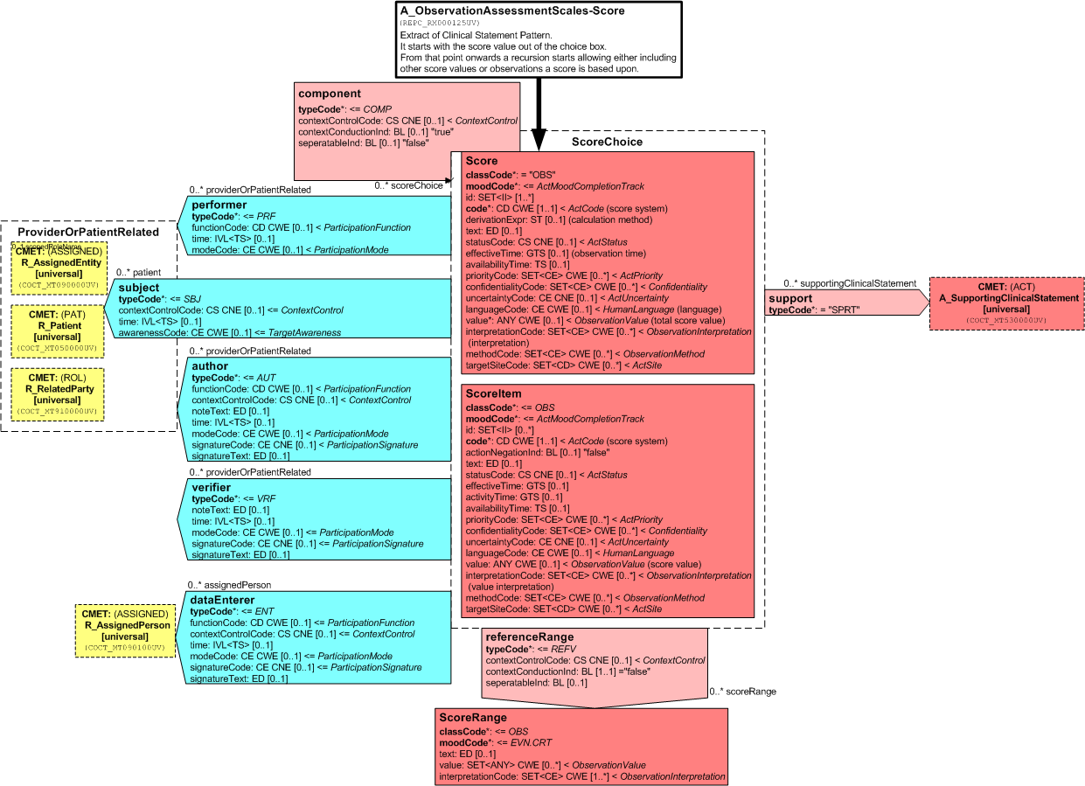

<<< Insert R-MIM REPC_RM000125UV here >>>

7.2.1 Score Observation
The R-MIM then starts with the score observation out of the choice box. As said above, the crucial attributes include:
- ClassCode: used to acknowledge that the score is an observation
- code: used to identify the variable and in which also the code system can be listed.
- text: attribute to allow the name and description of the assessment instrument
- value in which the actual score and where applicable the unit can be entered
- interpretationCode where the interpretation of the value can be explained via codes, often against a reference value.
- In the derivation code the total score for the assessment scale is recorded. In other words: derivation method is for example to add all values of the separate scores towards the total score.
- Effective time is the point in time on which the instrument is scored. In order to be valid and reliable, the scoreItems need to have (almost) the same time stamp. Such constraints posed by assessment instruments are important and expand beyond the mere semantic interoperability. For the receiver it is not only important to understand what the message content means, but also be ascertained that the data are collected based on the guidelines for the instrument. Such guidelines will become available in Detailed Clinical Models.
- In the value of the score, which was created by adding the individual score items, is filled up. This is often a Coded Ordinal data type because it is mandatory to score and fill up all items to get a proper sum score. That is why Mandatory (1..1) component relations often exist for scoring instruments.
- Of course all relevant attributes can be applied as needed.

7.2.2. Component relationship to ScoreItem Observation
In principle, a score is based on specific observations, or other scores. From this point onwards a recursion starts based on the component relationship, allowing either including other score values or observations a score is based upon. Beneath the score Observation is the Observation (OBS) with the name Score Item. Both the class Score and the class ScoreItem have classCode=OBS. Typically, the Score can be a total score based on one to many ScoreItems.

7.2.3. derivedFrom relationship to Supporting Clinical Statement CMET
The derivedFrom relation to Clinical Statement CMET allows the user to describe any relevant information related to why a score item is scored this way. It allows to express any human thoughts as observations to go alongside with the score itself, or any circumstances as a procedure being carried out, or a specific encounter when it was measured. The relationship is to the choice box, allowing making such statements on the level of the assessment instrument as a whole, or for an individual scoreItem.

7.2.4. Linkages to subject and provider roles
Several participations include different human actors, i.e. the patient, the observer, data enterer etc. They are linked to different CMETs providing the required details. The description and explanation of the CMETs is not part of this specification and the reader is referred to the appropriate chapter.

7.3. Score System Categories
The Score Systems can be divided into different categories: Those with arbitrary scores, those with discrete values and those with an unspecified number of values. Patient Classification Systems for workload are examples of the first one, the Barthel Index is an example of the second category, the BMI (Body Mass Index) an example for the third.

Arbitrary Scores
A scale is a set of linear values from a certain range. A reference range can be determined. In this case, an interpretation according to the conventional scheme is possible, i.e. a value is interpreted as "normal" if it is within the area - or at least close to one of its borders:
However, it should be noted here that an interpretation as too low is not necessarily combined with the abnormal flag. The flagging is somehow independed from the defined reference range.
For example: BMI
The following is an example from BMI:

7.4. Discrete Values (Scores)
Within this category, the "normal range" and the number of all possible values are identical. Therefore, the standard usage of reference ranges does not work. In principle, the whole range is divided into smaller parts each representing a specific interpretation:
The following is the set of interpretations for the German Barthel Index:
Hence, as for the example above, the (German) Barthel Index allows for the values of 0 to 100 in steps of 5. The total reference range, which can be specified, is within the same range, so that the available assessment opportunities (Abnormal flags) are not usable. The interpretation of a score is depending on the part of the reference range to which it belongs. Hence, the referenceRange relationship (one to many) to another OBS with the name ScoreRange.

Appendix A For example: German Barthel Index
The interpretation shows how the total score should be interpreted. For instance, the Dutch version of the Barthel index has 0-9 for seriously limited, 10-19 for moderately limited and 20 for independent.
As mentioned above, an assessment of the results by the conventional scheme of a reference range, where values outside are too high or too low, does not to apply. All values are falling into the range as defined by the score system. This range is - as explained above - to be divided into sections, which then can be evaluated/interpreted separately. Each score system is going to have its own (new) set of interpretation values. Each score system should get its own set of interpretation values which can be defined according to the following scheme. If the code values are coming from different code systems, then they must be included:
Eventually, some score systems may share the same interpretations. But this is up to individual examinations.
The following table is the interpretation for the German Barthel Index:
Codesystem | Code | Score System | Value  (From - To) | (German) Interpretation
ICD 10 GM 2007 | U50.50 | Barthel | 0 - 15 | very severe physical impairment  Sehr schwere motorische Funktionseinschränkung
ICD 10 GM 2007 | U50.51 | FIM | 13-30 | very severe physical impairment
ICD 10 GM 2007 | U50.40 | Barthel | 20 - 35 | severe physical impairment  Schwere motorische Funktionseinschränkung
ICD 10 GM 2007 | U50.41 | FIM | 31-42 | severe physical impairment
ICD 10 GM 2007 | U50.30 | Barthel | 40 - 55 | medium severity physical impairment  Mittelschwere motorische Funktionseinschränkung
ICD 10 GM 2007 | U50.31 | FIM | 43-58 | medium severity physical impairment
ICD 10 GM 2007 | U50.20 | Barthel | 60 - 75 | middle physical impairment  Mittlere motorische Funktionseinschränkung
ICD 10 GM 2007 | U50.21 | FIM | 59-68 | middle physical impairment
ICD 10 GM 2007 | U50.10 | Barthel | 80 - 95 | mild physical impairment  Leichte motorische Funktionseinschränkung
ICD 10 GM 2007 | U50.11 | FIM | 69-84 | mild physical impairment
ICD 10 GM 2007 | U50.00 | Barthel | 100 - 100 | no or low physical impairment  Keine oder geringe motorische Funktionseinschränkung
ICD 10 GM 2007 | U50.01 | FIM | 85-91 | no or low physical impairment
If this would be done with the Dutch Barthel, the maximum score would be 20, thus altering the reference ranges substantially. Of course it can be divided by 5, but such constraint needs to be made explicit. In particular it is important to identify the scoring instrument per realm. Thus the Dutch and German Barthel indexes would require having different codes, at least on the value set level to distinguish the differences.

