<https://console.cloud.google.com/apis/credentials/serviceaccountkey?_ga=2.82675030.-1702171085.1532232511>

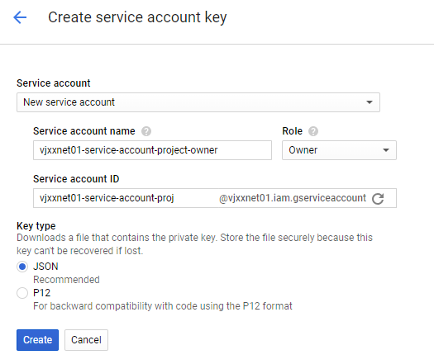

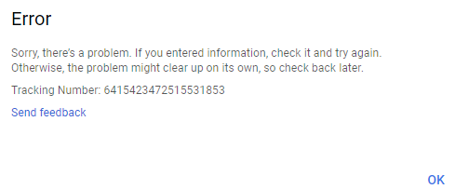

Try again:

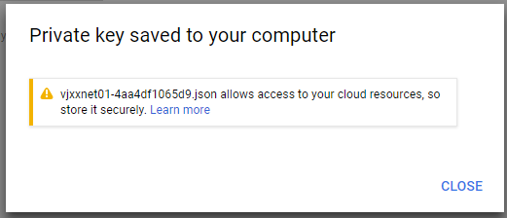

**vjxxnet01-4aa4df1065d9.json** allows access to your cloud resources, so store it securely. [Learn more](https://cloud.google.com/iam/docs/understanding-service-accounts?hl=en_US#managing_service_account_keys)

GOOGLE_APPLICATION_CREDENTIALS=F:\PROJECT\gcp\vjxxnet01-4aa4df1065d9.json