COURSE NAME:
Introduction To Software Engineering
COURSE CODE:
IS1103-1
ASSIGNMENT NAME:
SOFTWARE DEVELOPMENT LIFECYCLE(SDLC) ANALYSIS OF SNAPDEAL.
STUDENT NAME:
AMOGH.R.SHETTY
STUDENT USN:
NNM24IS022
SEMESTER AND SECTION:
IV-A
DEPARTMENT:
INFORMATION SCIENCE AND ENGINEERING
INSTITUTION NAME:
NITTE MAHALINGA ADYANTHAYA MEMORIAL INSTITUTE OF TECHNOLOGY
ACADEMIC YEAR:
2025-2026
INSTRUCTOR NAME:
DR.JASON ELROY MARTIS
DATE OF SUBMISSION:
10TH FEBRUARY 2026

ABSTRACT
This report studies three important software development lifecycle models, namely Waterfall, Incremental, and Spiral, using the Snapdeal e-commerce platform as a real-world example. Large online shopping systems work in environments where requirements keep changing because of user needs, seller activities, and technology updates. Thus, the selection of the appropriate development model becomes an engineering issue and not merely a theoretical one.
The report describes how each model addresses functional and non-functional requirements, change man-agement, risk control, and time and cost of development. The models are analyzed based on sys-tem behaviors like feature updates, scalability, and dependency between system modules. A sim-ple requirements document is created to demonstrate the requirements engineering process, fol-lowed by a validation plan and potential issues.
The primary objective of this research work is to bridge the gap between software engineering theory and system realities and prove the appropriateness of various SDLC models using examples. The report also describes a version control and repository workflow methodology to demonstrate real-world documentation practices.This study helped in understanding how theoretical concepts are applied in real software systems.

GITHUB REPO LINK:
https://github.com/visualcoder1234?tab=repositories

INTRODUCTION
Software systems today are rarely developed in a single straight line from start to finish. Most real-world systems evolve gradually and keep on changing based on user requirements, market competition, and technological advancements. Due to this, software engineering is not only about coding but also about choosing the right development life cycle model. The Software Development Life Cycle (SDLC) is a systematic approach to plan, design, develop, test, and enhance software systems. [1][2][6]
Various SDLC models have different development methodologies. Some models presume that requirements are largely unchangeable during the initial phase, whereas other models permit changes and feedback during the development phase. The wrong choice of models may cause delays, increased costs, unmanaged risks, and functionalities that do not fulfill user expectations. Hence, understanding the behaviour of SDLC models in real-world system environments is significant for making proper engineering choices. [1][2][8]
For this research, the e-commerce website Snapdeal is chosen as a case study. Snapdeal is a large online marketplace that links buyers and sellers for various product categories. Such marketplaces are complex systems as they consist of various interlinked modules such as product management, seller registration, order management, payment management, delivery management, and customer support. Modifications in one module may impact other modules. [3][9][10]
E-commerce platforms also face continuous changes in their requirements. The user interface requirements keep changing, new rules from payment systems, changes in fraud patterns, and performance requirements rise during sale seasons. Because of this dynamic nature, platforms such as Snapdeal offer a good case study for comparing various SDLC models. [3][8][10]
This report compares three major SDLC models—Waterfall, Incremental, and Spiral—and examines the applicability of these models to an e-commerce platform such as Snapdeal. The comparison is made on the basis of requirement handling, risk management, change support, and delivery restrictions. A simplified requirements document and validation process is also presented to connect theoretical notions with practical requirements engineering tasks. [1][2][7]

KEY COMPONENTS OF SNAPDEAL PLATFORM
Snapdeal is a major online marketplace platform that links buyers and sellers for various product categories such as electronics, fashion, home goods, and daily use items. Unlike an online shopping portal for a single seller, a marketplace platform enables multiple independent sellers to list their items and manage their inventory using the same system. Since multiple users access the system simultaneously, the system needs to process multiple requests at the same time without slowing down or crashing. [3][9][10]
The Snapdeal platform is made up of many connected parts that work together. The system supports user account creation, seller registration, product listing, and product search. It also manages cart and checkout processes, payment handling, order tracking, return processing, and customer support. Each part performs its own function, but all parts depend on each other for smooth operation. For example, a change in the payment module can directly affect checkout and order confirmation, so updates must be handled carefully. [3][9]
Marketplace systems change frequently over time. New sellers join the platform, prices get updated, discount offers are introduced, and delivery partners may change. During sale events and festival seasons, a large number of users visit the platform, increasing system load. Because of these frequent changes, system requirements usually do not remain fixed for long periods. [3][6][10]
Many different user groups interact with the platform, such as customers, sellers, administrators, logistics partners, and payment service providers. Each group has different expectations and needs from the system. This increases the complexity of requirement management and coordination during development. [7][9][10]
Due to its multi-user access, modular structure, and frequent feature updates, a platform like Snapdeal serves as a good real-world example for comparing software development lifecycle models. Different SDLC models handle change, risk, and integration challenges in different ways, making the selection of an appropriate model an important engineering decision. [1][2][8]

SYSTEM OVERVIEW-SNAPDEAL PLATFORM
Snapdeal is a large online marketplace platform that connects buyers and sellers across many product categories such as electronics, fashion, home items, and daily-use products. Unlike a single-seller online store, a marketplace platform allows many independent sellers to list their products and manage their stock using the same system. Since many users access the platform at the same time, the system must be able to handle multiple requests together without slowing down or failing.[3]
The Snapdeal platform is made up of many connected parts that work together. The system supports user account creation, seller registration, product listing, and product search. It also manages cart and checkout processes, payment handling, order tracking, return processing, and customer support. Each part performs its own function, but all parts depend on each other for smooth operation. For example, a change in the payment module can directly affect checkout and order confirmation, so updates must be handled carefully.[1],[2],[3]
Marketplace systems change frequently over time. New sellers join the platform, prices get updated, discount offers are introduced, and delivery partners may change. During sale events and festival seasons, a large number of users visit the platform, increasing system load. Because of these frequent changes, system requirements usually do not remain fixed for long periods. [1],[2],[3]
Many different user groups interact with the platform, such as customers, sellers, administrators, logistics partners, and payment service providers. Each group has different expectations and needs from the system. This increases the complexity of requirement management and coordination during development. [1], [2]
Due to its multi-user access, modular structure, and frequent feature updates, a platform like Snapdeal serves as a good real-world example for comparing software development lifecycle models. Different SDLC models handle change, risk, and integration challenges in different ways, making the selection of an appropriate model an important engineering decision. [1], [2]

COMPARATIVE ANALYSIS SDLC MODELS
There will be three different reports that will be discussed in the report namely:

Waterfall Model:
The Waterfall model is a way to build software step by step in a fixed order. The work is divided into different stages. One stage is completed first, and only then the next stage starts. We cannot jump between stages or change their order. The flow goes in one direction only from top to bottom like a waterfall. That is why it is called the Waterfall model. This method is used when the work is clear and does not change often. It has a few main stages that are followed in sequence. [1][2][4]
- System and Software Requirements
- Analysis
- Design
- Coding
- Testing
- Operations

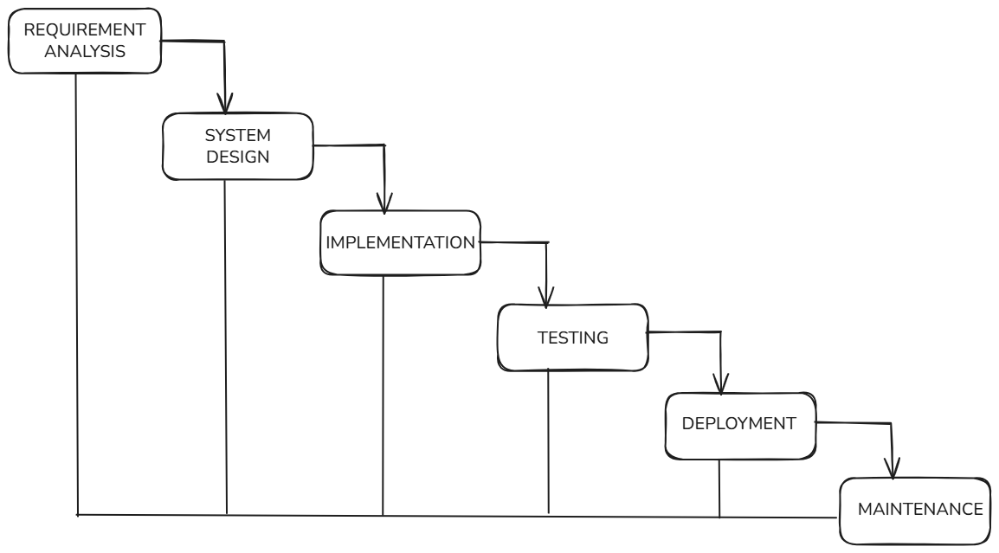
Figure 1: Waterfall Model For Snapdeal

HOW IS SNAPDEAL DEVELOPED USING WATERFALL METHOD:
Phase 1 : Requirements Analysis:
In this step, the team talks to different people like customers, sellers, and managers. They try to understand what the system should do. They write down all needed features like login, product listing, payment, order tracking, and returns. They also note safety and speed needs. All these details are written in one big requirement document before going to the next step. [1][2][7]
Phase 2 : System and Software Design:
After the requirements are approved, the team plans how the system will be built. They decide how the database will look and how different parts of the system will connect. They also plan the screen design and payment connections. Each part like cart, catalog, and payment is planned clearly before coding starts. [1][2][9]
Phase 3 : Implementation and Unit Testing:
Now developers start writing the code. Different teams may build different parts of the system. After coding each part, they test it separately to check if it works properly. Small testing is done before joining all parts together. [1][2]
Phase 4 : Integration and System Testing:
Next, all parts are joined into one full system. The team checks if everything works together correctly. They test payment, search, checkout, and order tracking. They also test how the system behaves when many users use it at the same time. [1][2][9]
Phase 5 : Deployment and Maintenance:
After testing is successful, the system is released for users. The team then watches the system and fixes problems if they appear. Small updates are added if needed. But in this model, big changes later are hard and costly. [1][2][4]

Incremental Model:
The Incremental model is a way of making software in small parts. The full system is not built at one time. Instead, it is built step by step. Each step adds a new feature to the system. After one part is completed, it is checked and then the next part is added. This helps the team to see progress early and fix problems quickly. Changes can also be added easily in later steps. [1][2][6]

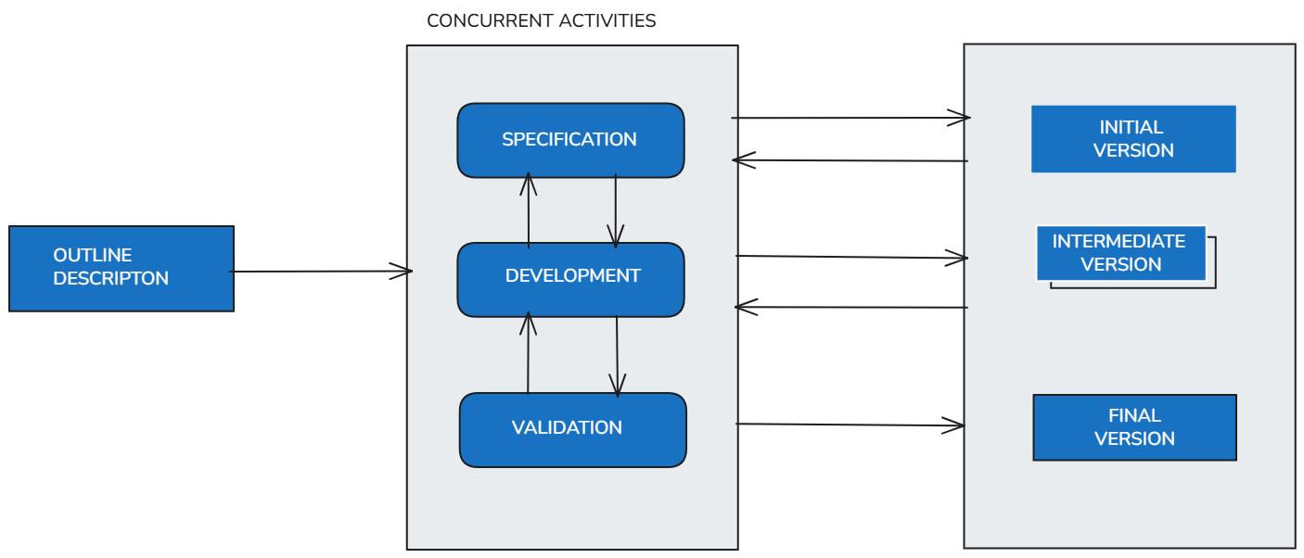
Figure 2:Incremental Model For Snapdeal

HOW IS SNAPDEAL DEVELOPED USING INCREMENTAL MODEL:
Snapdeal keeps changing with new sellers, offers, and features. The Incremental model supports these changes easily. New features can be added without rebuilding the whole system. This model reduces risk and helps in better time management. It is useful for large platforms where requirements grow slowly over time. [2][6][10]
Phase 1: First Increment:
In the first step, only the basic features of Snapdeal are developed. This includes user registration, login, and simple product viewing. Customers can create accounts and see products listed on the platform. Sellers can register, but advanced seller tools are not added yet. This small version is tested and shared so that early feedback can be collected. [1][6][7]
Phase 2: Second Increment:
In the next step, more features are added to the system. Search options, filters, and the cart system are developed. Users can search for products, add items to the cart, and review their selections. These new features work together with the first version. Testing is done again to make sure the new parts do not break the old ones. [2][6][9]
Phase 3: Third Increment:
After the cart works properly, payment and order features are added. The system connects with payment gateways so users can pay safely. Order placement and confirmation features are also developed. At this stage, Snapdeal starts working like a real shopping platform. Errors found during use are fixed before moving ahead. [2][3][6]
Phase 4: Final Increments:
In the final steps, advanced features such as order tracking, returns, and customer support are added. Seller dashboards and reporting tools are also improved. Each new feature is tested before release. This step-by-step approach helps Snapdeal grow smoothly without stopping the system. [2][6][10]

Spiral Model:
The Spiral model is a way of building software step by step while checking risks at every step. The work is done in rounds. Each round helps in planning, building, testing, and checking problems. After one round is finished, the next round starts with better understanding. This model helps the team to find problems early and make safer decisions during development. [2][5][8]

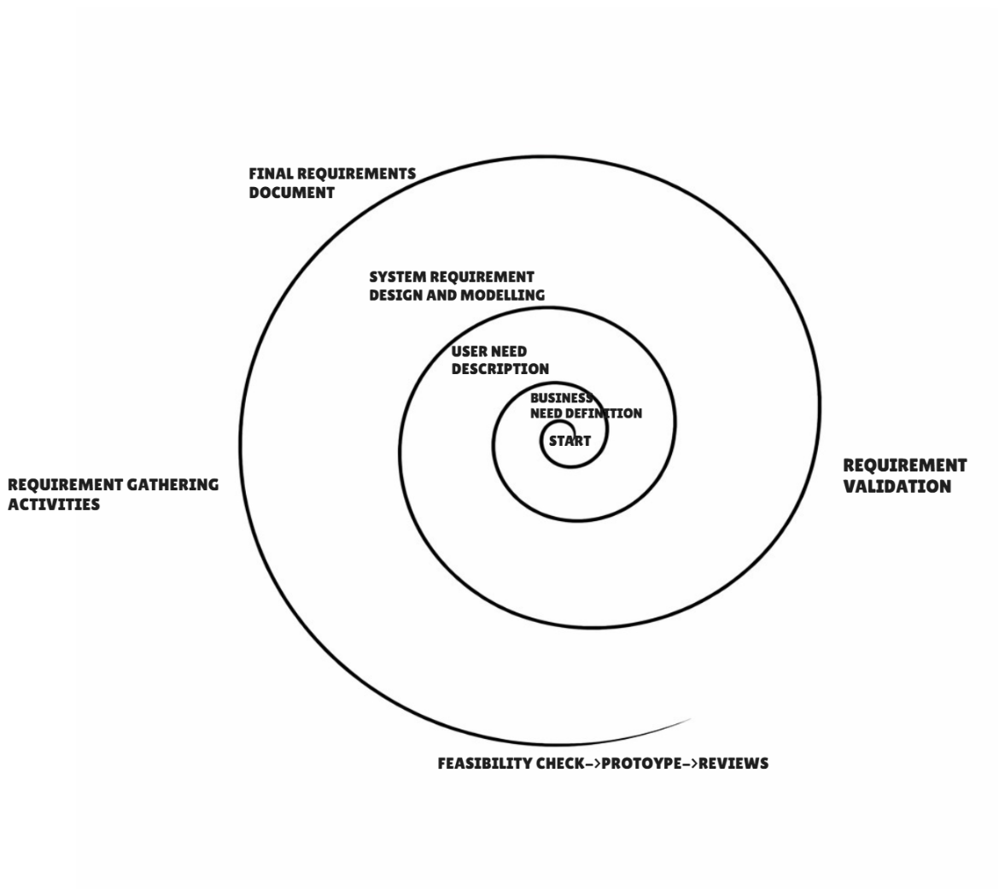

Figure 3: Spiral Model For Snapdeal

HOW IS SNAPDEAL DEVELOPED USING SPIRAL MODEL:
Snapdeal faces many risks such as changing requirements, security threats, and high traffic during sales. The Spiral model helps in identifying these risks early. It allows changes at every stage and improves system quality step by step. This model is useful for large systems where safety and reliability are important. [3][5][8][9]
Phase 1: Planning and Requirement Understanding:
In the first round, the team plans what needs to be built. Basic requirements such as user accounts, seller registration, and product listing are discussed. The team also checks possible problems like heavy user traffic and payment safety. Simple plans are made before starting work. [5][7]
Phase 2: Risk Analysis and Design:
In the next step, risks are studied carefully. For Snapdeal, risks include payment failure, data security issues, and system overload during sale days. The system design is prepared to reduce these risks. Decisions like using secure payment gateways and scalable servers are taken at this stage. [5][8][9]
Phase 3: Development and Testing:
After planning and risk checking, development starts. Small features are developed such as search, cart, and checkout. Each feature is tested as soon as it is built. Errors are fixed before moving forward. This helps in avoiding big problems later. [2][5]
Phase 4: Review and Feedback:
Once a round is completed, the system is reviewed. Feedback is taken from users, sellers, and administrators. Based on this feedback, changes are planned for the next round. This cycle repeats until the full Snapdeal system is ready. [2][5][6]

COMPARISON TABLE:
ASPECT | WATERFALL MODEL | INCREMENTAL MODEL | SPIRAL MODEL
Functional Requirements | Fixed at the start and not changed later | Added step by step in parts | Reviewed and updated in every cycle
Non-Functional Requirements | Planned early but hard to improve later | Improved gradually with each release | Carefully checked in every cycle
Risk Management | Very less focus on risks | Some risks handled in later stages | Strong focus on risk in every phase
Change Handling | Changes are difficult and costly | Changes are easier between increments | Changes are expected and managed
Time Constraints | Takes more time before results are seen | Faster delivery of useful features | Time increases due to repeated cycles
Cost Constraints |  | Cost spread over multiple stages | Higher cost due to risk analysis
  Lower planning cost but high change cost
Suitability for Snapdeal |  | Suitable for gradual feature growth | Suitable for high-risk and complex parts
  Less suitable due to fixed flow

The above table has been take reference from [1], [2], [4], [5], [6].

EXPLAINATION ABOUT THE COMPARISON TABLE:
Functional Requirements:
In the Waterfall model, all features are decided at the beginning [4]. For Snapdeal, this is a limitation because features change frequently. The Incremental model enables the addition of features over time [6], which is more appropriate for Snapdeal. The Spiral model examines features repeatedly, which is beneficial for the proper development of complex features [5].
Non-Functional Requirements:
Non-functional needs like speed, security, and scalability are planned early in Waterfall, but improving them later is hard [1], [4]. Incremental development allows these qualities to im-prove with each new release [6]. Spiral model gives special importance to these factors by checking them in every cycle [5].
Risk Management:
Waterfall does not focus much on risk [4], which is dangerous for large platforms like Snapdeal. Incremental model reduces some risks by delivering small parts [6]. Spiral model is best at handling risks because risk checking is done before every major step [5].
Change Handling:
Changes are very hard to manage in Waterfall once development starts [4]. Incremental model allows changes between releases, making it more flexible [6]. Spiral model expects changes and plans for them in advance [5].
Time Constraint:
Waterfall takes a long time before users can see any working system [4]. Incremental model delivers usable features early [6], which is helpful for Snapdeal. Spiral model takes more time because each cycle includes planning and risk checking [5].
Cost Constraints:
Waterfall looks cheaper at first, but becomes costly when changes are needed [2], [4]. Incremental model spreads cost over time, making it easier to manage [6]. Spiral model has higher cost because of detailed analysis and testing in every cycle [5].

Suitability for Overall Snapdeal:
Snapdeal requires flexibility, frequent updates, and strong risk control. The Waterfall model is not suitable due to its rigid structure [4]. The Incremental model supports regular feature additions [6], while the Spiral model is useful for high-risk areas such as payments and security [5].

REQUIREMENTS ENGINEERING PROCESS:

1. FUNCTIONAL REQUIREMENT OF SNAPDEAL:
Functional requirements describe what the system should do [1], [2]. These requirements describe the primary tasks that the Snapdeal system needs to accomplish so that users, sellers, and admins can use it correctly [1].
• User Registration and Login:
The system should allow users to register by providing simple information such as name, phone number, and email. Once the user has registered, they should be able to log in using their credentials. If the user has forgotten the password, the system should assist them in password reset [3].
• Product Browsing and Search:
The system should enable users to view products based on categories. Users should be able to search products by entering product names. The system should also enable basic searching mechanisms such as price, brand, and ratings to assist users in finding products easily [3].
• Seller Registration and Onboarding:
The system should enable sellers to register on the system. Sellers should be able to provide necessary documents for verification. Once verified, sellers should be able to start selling products on Snapdeal [3].
• Product Listing Management:
The system should enable sellers to list new products. Sellers should be able to modify product price, description, and inventory information. Sellers should also be able to delete products when needed [3].
• Cart and Checkout Management:
The system should enable users to add products to a shopping cart. Users should be able to remove items or modify quantities in the cart. The checkout process should assist users in placing an order step by step [3].
• Payment Processing:
The system should allow various payment methods such as UPI, cards, and wallets. Payments should be made securely through secure payment gateways. After payment, the system should display a success message [3].
• Order Management and Tracking:
The system should generate an order after successful payment. Users should be able to track the status of their orders. Users should also be able to view their previous orders [3].

• Returns and Refund Processing:
The system should enable users to return products if applicable. Users should be able to check the status of refunds after returning a product. The system should process refunds correctly after approval [3].

2.NON-FUNCTIONAL REQUIREMENTS FOR SNAPDEAL:
Non-functional requirements describe how well the system should perform [1], [2]. They do not discuss functionality, but rather discuss speed, security, and quality of the sys-tem [1].

• Performance
The system should load pages quickly when users search or open products. Orders and payments should be processed without delay. The system should work smoothly even when many users use it at the same time [1], [3].

• Scalability
The system should be able to handle more users and sellers in the future. During big sales and festival times, the system should not slow down. New features should be added without stopping the system [1], [2].

• Security
The system should protect user and seller data. Login details and payment information should be kept safe. Only authorized users should be allowed to access their accounts [1], [3].

• Availability
The system should be available most of the time. Users should be able to shop at any hour. Downtime should be very low and planned properly [1], [2].

• Reliability
The system should work correctly every time. Orders and payments should not fail often. Data should not be lost even if a problem occurs [1], [2].

• Usability
The system should be easy to use. Users should understand how to search, buy, and track orders without confusion. The design should be simple and clear [2], [3].

• Maintainability
The system should be easy to fix and update. Developers should be able to correct errors without affecting the whole system. Small changes should not break other features [1], [2].

• Compatibility
The system should work on different devices like mobiles, tablets, and computers. It should also support different browsers. Users should get the same experience on all platforms [2], [3].

REQUIREMENTS IN VALIDATION STRATEGY:
Requirements validation is the process of verifying if the written requirements are right and useful [1], [2]. It also helps ensure that the system is developed in the correct manner [1]. For a system such as Snapdeal, it is necessary to validate the requirements because many people use the system for various reasons [2].
First, the requirements are discussed among various stakeholders such as users, sellers, admins, and developers. Each of them checks if their requirements are properly written [1]. Feedback is obtained, and no confusion points are clarified [2].
Second, simple meetings and discussions are organized to validate the requirements. Screens or basic flow diagrams can be used to demonstrate how the system will work [1], [2]. This helps identify missing or incorrect requirements easily [1].
Third, requirements are validated again after implementing small system updates. This ensures that new changes will not affect the existing functionalities [2]. Validated requirements are then identified and stored for development purposes [1].

CHALLENGES OF REUQIREMENT VALIDATION:
Requirement validation is not always simple, especially when it comes to large systems such as Snapdeal [1], [2].
The first challenge is that user requirements keep fluctuating. New sellers join, new offers are introduced, and customers' demands increase. This makes it difficult to lock down requirements [1].
The second challenge is that there are many stakeholders. Users, sellers, admins, and payment partners all have different demands. Sometimes, their demands do not align [1], [2].
Ambiguous feedback is another challenge. Users may not articulate their requirements clearly, which can cause confusion. Technical and non-technical people may also interpret requirements in different ways [2].
Another challenge is that there is a time constraint. Validating each requirement takes time, and teams may hurry up the process to meet deadlines [1], [2].

REFERENCES:
[1] I. Sommerville, Software Engineering, 10th ed. Boston, MA, USA: Pearson, 2015.
[2] R. S. Pressman and B. R. Maxim, Software Engineering: A Practitioner’s Approach, 9th ed. New York, NY, USA: McGraw-Hill Education, 2020.
[3] K. C. Laudon and C. G. Traver, E-Commerce 2020: Business, Technology, and Society, 16th ed. Harlow, U.K.: Pearson, 2020.
[4] W. W. Royce, “Managing the development of large software systems,” in Proc. IEEE WESCON, Los Angeles, CA, USA, 1970, pp. 1–9.
[5] B. W. Boehm, “A spiral model of software development and enhancement,” Computer, vol. 21, no. 5, pp. 61–72, May 1988.
[6] C. Larman and V. R. Basili, “Iterative and incremental development: A brief history,” Computer, vol. 36, no. 6, pp. 47–56, Jun. 2003.
[7] G. Kotonya and I. Sommerville, Requirements Engineering: Processes and Techniques. Chichester, U.K.: John Wiley & Sons, 1998.
[8] B. W. Boehm, “Software risk management: Principles and practices,” IEEE Software, vol. 8, no. 1, pp. 32–41, Jan. 1991.
[9] G. Parker, M. Van Alstyne, and S. P. Choudary, Platform Revolution: How Networked Markets Are Transforming the Economy. New York, NY, USA: W. W. Norton & Company, 2016.
[10] L. Bass, P. Clements, and R. Kazman, Software Architecture in Practice, 3rd ed. Boston, MA, USA: Addison-Wesley, 2012.

DECLARATION OF ACADEMIC INTEGRITY:
I hereby declare that this assignment is my original work and has not been copied or plagiarised from any source. All references and resources used have been properly cited. Any ambiguities will lead to forfeiting my marks.

Student Signature: Submission Date:  10th February 2026

