COURSE NAME:
Introduction To Software Engineering
COURSE CODE:
IS1103-1
ASSIGNMENT NAME:
SOFTWARE DEVELOPMENT LIFECYCLE(SDLC) ANALYSIS OF SNAPDEAL.
STUDENT NAME:
AMOGH.R.SHETTY
STUDENT USN:
NNM24IS022
SEMESTER AND SECTION:
IV-A
DEPARTMENT:
INFORMATION SCIENCE AND ENGINEERING
INSTITUTION NAME:
NITTE MAHALINGA ADYANTHAYA MEMORIAL INSTITUTE OF TECHNOLOGY
ACADEMIC YEAR:
2025-2026
INSTRUCTOR NAME:
DR.JASON ELROY MARTIS
DATE OF SUBMISSION:
10TH FEBRUARY 2026

ABSTRACT
This report explains study of three major software development lifecycle models — Waterfall, Incremental, and Spiral using the Snapdeal e-commerce platform as a real-world case context. Large online marketplace systems operate in environments where requirements frequently evolve due to customer expectations, seller ecosystem changes, and technology integration updates. Bcause of this, selecting an appropriate development process model becomes a critical engineering decision rather than a purely theoretical choiceer.
The study explains how each lifecycle model can look after functional and non-functional requirements also change the management alongside the risk exposure, and delivery criteria. Instead of discussing the models in isolation, their suitability is examined in relation to practical platform behaviors such as feature evolution, scaling uncertainty, and subsystem dependency. A simplified requirements document is also developed to demonstrate requirements engineering structure, followed by a validation strategy and associated challenges.
The objective of this analysis is to connect SDLC theory with applied system behavior and justify model suitability using scenario-based reasoning. The report also includes requirements version tracking strategy using a repository workflow approach, reflecting real development documentation practices.This report helped me understand how theory and real platform behaviour connect.

TABLE OF CONTENTS
ABSTRACT 2
INTRODUCTION 4
KEY COMPONENTS OF SNAPDEAL PLATFORM 5
SYSTEM OVERVIEW-SNAPDEAL PLATFORM 6
COMPARATIVE ANALYSIS SDLC MODELS 7
1. Waterfall Model: 7
2.INCREMENTAL MODEL: 9
3. SPIRAL MODEL: 11
COMPARISON TABLE: 13
EXPLAINATION ABOUT THE COMPARISON TABLE: 14
REQUIREMENTS ENGINEERING PROCESS: 15
1. FUNCTIONAL REQUIREMENTS FOR SNAPDEAL: 15
2.NON-FUNCTIONAL REQUIREMENTS FOR SNAPDEAL: 16
REFERENCES: 17
DECLARATION OF ACADEMIC INTEGRITY: 18

INTRODUCTION
Software systems today are rarely built in a single straight process from start to finish. Most real platforms grow step by step and change over time based on user needs, market competition, and technology updates. Because of this, software engineering does not only focus on coding, but also on choosing the correct development lifecycle model. The Software Development Life Cycle (SDLC) gives right way to plan, build, test, and improve software systems.
Different SDLC models follow different steps. Some models assume that requirements are mostly fixed from the beginning, while others allow repeated changes and feedback during development. Selecting the wrong model can lead to delays, increased cost, unmanaged risks, and features that do not match user expectations. Therefore, understanding how each SDLC model behaves in a real system environment is important for proper engineering decisions.
For this study, the Snapdeal e-commerce platform is taken as a case example. Snapdeal is a large online marketplace that connects sellers and buyers across many product categories. Platforms like Snapdeal are complex because they include many modules such as product catalog management, seller onboarding, order processing, payment handling, delivery tracking, and customer support features. These modules are interconnected, and changes in one area often affect others.
E-commerce systems also face continuous requirement changes. User interface expectations change, payment gateways update their rules, fraud risks evolve, and performance demands increase during sales events. Because of this dynamic nature, such platforms are suitable examples for comparing different SDLC models.
This report compares three important lifecycle models — Waterfall, Incremental, and Spiral — and studies how suitable each one is for a platform like Snapdeal. The comparison is based on requirement handling, risk management, change support, and delivery constraints. Along with the model comparison, a simplified requirements document and validation approach are also prepared to connect theory with practical requirements engineering work.

KEY COMPONENTS OF SNAPDEAL PLATFORM
The Snapdeal marketplace platform can be better understood by looking at its main functional parts and how they work together. Each part of the system is responsible for a different type of activity, but all of them together support the full buying and selling process on the platform.
One part of the system manages user accounts, including customer profiles, login access, and basic security settings. Another part supports sellers by handling their registration, verification, onboarding process, and product uploads. The catalog part of the system keeps all product details organized,such as categories, prices, and whether the items are available or not.
The platform also includes features that help users search and find products using keywords and filters. The cart and checkout section handles the order process from selecting items to confirming the purchase. Payment is handled through external payment services so that transactions are completed safely. The system also supports order tracking, delivery updates, and return requests. In addition, customer support is available to handle user questions and complaints.
Looking at the platform through these different system parts makes it easier to understand how the software is built and managed. It also helps in understanding how different SDLC models would manage development, system integration, and future changes in the platform.

SYSTEM OVERVIEW-SNAPDEAL PLATFORM
Snapdeal is a large online marketplace platform that connects buyers and sellers across many product categories such as electronics, fashion, home items, and daily-use products. Unlike a single-seller online store, a marketplace platform allows many independent sellers to list their products and manage their stock using the same system interface. Since many users access the platform at the same time, the system should be able to handle multiple requests together without slowing down or failing.
Snapdeal is made of many small parts that work together. The system helps users create accounts, sellers join the platform, products are listed, and people can search and buy items. It also handles cart, checkout, payments, order tracking, returns, and customer help. Each part does its own work, but all parts must work together for the website to run properly. If one part changes, like the payment part, it can affect checkout and order confirmation. So changes must be done carefully.
Marketplace systems keep changing again and again. New sellers join often. Prices change. New discounts are added. Delivery partners can also change. During sale time and festivals, many more users visit the website. Because things change often, system needs also change often.Because of these frequent changes, system requirements usually do not remain fixed for a long time.
Many types of users interact with the platform like customers, sellers, admins, logistics partners, and payment providers and each group needs different things from the system.Each group has different expectations and practical needs. This increases requirement diversity and coordination complexity during development.
Due to its mutli user availability,mulitple access, and frequent feature updation, a platform like Snapdeal works as a good real-world case for comparing software development lifecycle models. Different SDLC approaches will handle this level of change, risk, and integration dependency in different ways, which makes model selection an important engineering decision.In practical terms even small feature updates can affect multiple modules here.

COMPARATIVE ANALYSIS SDLC MODELS
There will be three different reports that will be discussed in the report namely:

Waterfall Model:
The Waterfall model is a way to build software step by step in a fixed order. The work is divided into different stages. One stage is completed first, and only then the next stage starts. We cannot jump between stages or change their order. The flow goes in one direction only from top to bottom like a waterfall. That is why it is called the Waterfall model. This method is used when the work is clear and does not change often. It has a few main stages that are followed in sequence.
1.System and Software Requirements
2.Analysis
3.Design
4.Coding
5.Testing
6.Operations

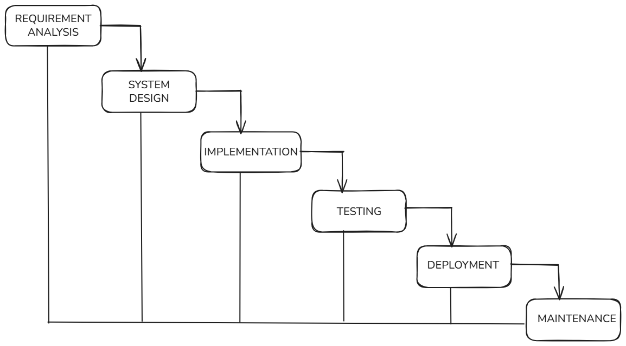

HOW IS SNAPDEAL DEVELOPED USING WATERFALL METHOD:
Phase 1 : Requirements Analysis:
In this step, the team talks to different people like customers, sellers, and managers. They try to understand what the system should do. They write down all needed features like login, product listing, payment, order tracking, and returns. They also note safety and speed needs. All these details are written in one big requirement document before going to the next step.
Phase 2 : System and Software Design:
After the requirements are approved, the team plans how the system will be built. They decide how the database will look and how different parts of the system will connect. They also plan the screen design and payment connections. Each part like cart, catalog, and payment is planned clearly before coding starts.
Phase 3 : Implementation and Unit Testing:
Now developers start writing the code. Different teams may build different parts of the system. After coding each part, they test it separately to check if it works properly. Small testing is done before joining all parts together.
Phase 4 : Integration and System Testing:
Next, all parts are joined into one full system. The team checks if everything works together correctly. They test payment, search, checkout, and order tracking. They also test how the system behaves when many users use it at the same time.
Phase 5 :Deployment and Maintenance:
After testing is successful, the system is released for users. The team then watches the system and fixes problems if they appear. Small updates are added if needed. But in this model, big changes later are hard and costly.

2.INCREMENTAL MODEL:
The Incremental model is a way of making software in small parts. The full system is not built at one time. Instead, it is built step by step. Each step adds a new feature to the system. After one part is completed, it is checked and then the next part is added. This helps the team to see progress early and fix problems quickly. Changes can also be added easily in later steps.

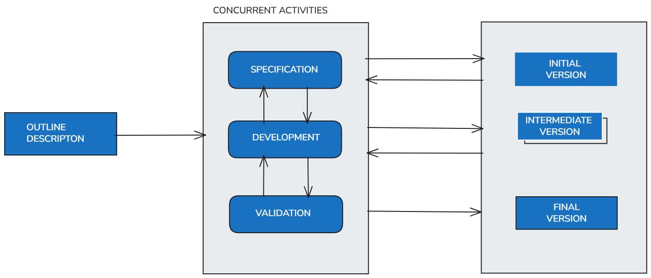

HOW IS SNAPDEAL DEVELOPED USING INCREMENTAL MODEL:
Snapdeal keeps changing with new sellers, offers, and features. The Incremental model supports these changes easily. New features can be added without rebuilding the whole system. This model reduces risk and helps in better time management. It is useful for large platforms where requirements grow slowly over time.

Phase 1: First Increment:
In the first step, only the basic features of Snapdeal are developed. This includes user registration, login, and simple product viewing. Customers can create accounts and see products listed on the platform. Sellers can register, but advanced seller tools are not added yet. This small version is tested and shared so that early feedback can be collected.
Phase 2: Second Increment:
In the next step, more features are added to the system. Search options, filters, and the cart system are developed. Users can search for products, add items to the cart, and review their selections. These new features work together with the first version. Testing is done again to make sure the new parts do not break the old ones.
Phase 3: Third Increment:
After the cart works properly, payment and order features are added. The system connects with payment gateways so users can pay safely. Order placement and confirmation features are also developed. At this stage, Snapdeal starts working like a real shopping platform. Errors found during use are fixed before moving ahead.
Phase 4: Final Increments:
In the final steps, advanced features such as order tracking, returns, and customer support are added. Seller dashboards and reporting tools are also improved. Each new feature is tested before release. This step-by-step approach helps Snapdeal grow smoothly without stopping the system.

SPIRAL MODEL:
The Spiral model is a way of building software step by step while checking risks at every step. The work is done in rounds. Each round helps in planning, building, testing, and checking problems. After one round is finished, the next round starts with better understanding. This model helps the team to find problems early and make safer decisions during development.

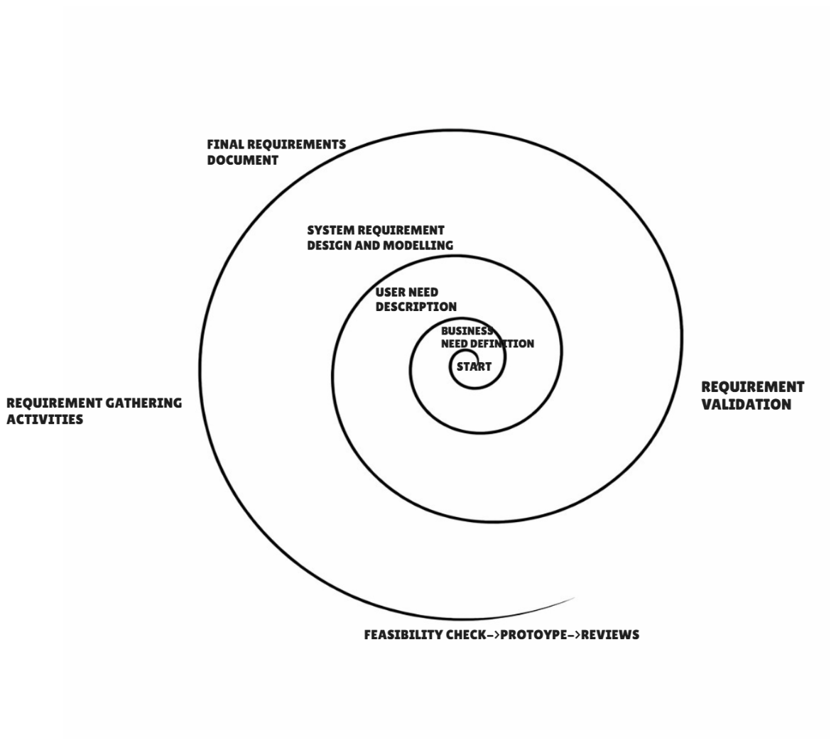

HOW IS SNAPDEAL DEVELOPED USING SPIRAL MODEL:
Snapdeal faces many risks such as changing requirements, security threats, and high traffic during sales. The Spiral model helps in identifying these risks early. It allows changes at every stage and improves system quality step by step. This model is useful for large systems where safety and reliability are important.

Phase 1: Planning and Requirement Understanding:
In the first round, the team plans what needs to be built. Basic requirements such as user accounts, seller registration, and product listing are discussed. The team also checks possible problems like heavy user traffic and payment safety. Simple plans are made before starting work.
Phase 2: Risk Analysis and Design:
In the next step, risks are studied carefully. For Snapdeal, risks include payment failure, data security issues, and system overload during sale days. The system design is prepared to reduce these risks. Decisions like using secure payment gateways and scalable servers are taken at this stage.
Phase 3: Development and Testing:
After planning and risk checking, development starts. Small features are developed such as search, cart, and checkout. Each feature is tested as soon as it is built. Errors are fixed before moving forward. This helps in avoiding big problems later.
Phase 4: Review and Feedback:
Once a round is completed, the system is reviewed. Feedback is taken from users, sellers, and administrators. Based on this feedback, changes are planned for the next round. This cycle repeats until the full Snapdeal system is ready.

COMPARISON TABLE:

ASPECT | WATERFALL MODEL | INCREMENTAL MODEL | SPIRAL MODEL
Functional Requirements | Fixed at the start and not changed later | Added step by step in parts | Reviewed and updated in every cycle
Non-Functional Requirements | Planned early but hard to improve later | Improved gradually with each release | Carefully checked in every cycle
Risk Management | Very less focus on risks | Some risks handled in later stages | Strong focus on risk in every phase
Change Handling | Changes are difficult and costly | Changes are easier between increments | Changes are expected and managed
Time Constraints | Takes more time before results are seen | Faster delivery of useful features | Time increases due to repeated cycles
Cost Constraints |  | Cost spread over multiple stages | Higher cost due to risk analysis
  Lower planning cost but high change cost
Suitability for Snapdeal |  | Suitable for gradual feature growth | Suitable for high-risk and complex parts
  Less suitable due to fixed flow

EXPLAINATION ABOUT THE COMPARISON TABLE:
Functional Requirements:
In the Waterfall model, all features are decided at the beginning. For Snapdeal, this is a problem because features keep changing. The Incremental model allows features to be added slowly, which suits Snapdeal better. The Spiral model reviews features again and again, which helps in building complex parts carefully.
Non-Functional Requirements:
Non-functional needs like speed, security, and scalability are planned early in Waterfall, but improving them later is hard. Incremental development allows these qualities to improve with each new release. Spiral model gives special importance to these factors by checking them in every cycle.
Risk Management:
Waterfall does not focus much on risk, which is dangerous for large platforms like Snapdeal. Incremental model reduces some risks by delivering small parts. Spiral model is best at handling risks because risk checking is done before every major step.
Change Handling:
Changes are very hard to manage in Waterfall once development starts. Incremental model allows changes between releases, making it more flexible. Spiral model expects changes and plans for them in advance.
Time Constraints:
Waterfall takes a long time before users can see any working system. Incremental model delivers usable features early, which is helpful for Snapdeal. Spiral model takes more time because each cycle includes planning and risk checking.
Cost Constraints:
Waterfall looks cheaper at first, but becomes costly when changes are needed. Incremental model spreads cost over time, making it easier to manage. Spiral model has higher cost because of detailed analysis and testing in every cycle.
Overall Suitability for Snapdeal:
Snapdeal needs flexibility, quick updates, and good risk handling. Waterfall is not a good fit due to its rigid structure. Incremental model works well for adding new features regularly. Spiral model is useful for complex and high-risk areas like payments and security.

REQUIREMENTS ENGINEERING PROCESS:

FUNCTIONAL REQUIREMENTS FOR SNAPDEAL:
Functional requirements explain what the system should do. These points show the main jobs the Snapdeal system must perform so that users, sellers, and admins can use it properly.
- User Registration and Login:
The system should let users create an account by entering simple details like name, phone number, and email. After creating an account, users should be able to log in using their details. If a user forgets the password, the system should help them reset it.
- Product Browsing and Search:
The system should allow users to see products by category. Users should be able to search for products by typing product names. The system should also provide simple filters like price, brand, and rating to help users find items easily.
- Seller Registration and Onboarding:
The system should allow sellers to sign up on the platform. Sellers should submit required documents for checking. After approval, sellers should be able to start selling products on Snapdeal.
- Product Listing Management:
The system should allow sellers to add new products. Sellers should be able to change product price, description, and stock details. Sellers should also be able to remove products when needed.
- Cart and Checkout Management:
The system should allow users to add products to a shopping cart. Users should be able to remove items or change quantity in the cart. The checkout process should help users place the order step by step.
- Payment Processing:
The system should support different payment options like UPI, cards, and wallets. Payments should be done safely using secure payment services. After payment, the system should show a confirmation message.
- Order Management and Tracking:
The system should create an order once payment is successful. Users should be able to see the status of their orders. Users should also be able to view their past orders.
- Returns and Refund Handling:
The system should allow users to return products if allowed. Users should be able to see refund status after returning a product. The system should process refunds properly after approval.

2.NON-FUNCTIONAL REQUIREMENTS FOR SNAPDEAL:
Non-functional requirements explain how well the system should work. They do not talk about features, but they talk about speed, safety, and quality of the system.
- Performance
The system should load pages quickly when users search or open products. Orders and payments should be processed without delay. The system should work smoothly even when many users use it at the same time.

- Scalability
The system should be able to handle more users and sellers in the future. During big sales and festival times, the system should not slow down. New features should be added without stopping the system.

- Security
The system should protect user and seller data. Login details and payment information should be kept safe. Only authorized users should be allowed to access their accounts.

- Availability
The system should be available most of the time. Users should be able to shop at any hour. Downtime should be very low and planned properly.

- Reliability
The system should work correctly every time. Orders and payments should not fail often. Data should not be lost even if a problem occurs.

- Usability
The system should be easy to use. Users should understand how to search, buy, and track orders without confusion. The design should be simple and clear.

- Maintainability
The system should be easy to fix and update. Developers should be able to correct errors without affecting the whole system. Small changes should not break other features.

- Compatibility
The system should work on different devices like mobiles, tablets, and computers. It should also support different browsers. Users should get the same experience on all platforms.

REFERENCES:
- Sommerville, lan. (2015). Software engineering (10th ed.). John Wiley & Sons.
- Pressman, R. S., & Maxim, B. R. (2020). Software engineering: A practitioner’s approach (9th ed.). McGraw-Hill Education.
- Jasper Infotech Pvt. Ltd. (n.d.). Snapdeal – Online marketplace platform.
Retrieved February 10, 2026, from https://www.snapdeal.com/

GITHUB REPO LINK: https://github.com/visualcoder1234?tab=repositories

DECLARATION OF ACADEMIC INTEGRITY:
I hereby declare that this assignment is my original work and has not been copied or plagiarized from any source. All references and resources used have been properly cited. Any ambiguities will lead to forfeiting my marks.

Student Signature: Submission Date:  10th February 2026

