3GPP TS 29.518 V1.1.0 (2018-04)
Technical Specification
3rd Generation Partnership Project;
Technical Specification Group Core Network and Terminals;
5G System; Access and Mobility Management Services;
Stage 3
(Release 15)


The present document has been developed within the 3rd Generation Partnership Project (3GPP TM) and may be further elaborated for the purposes of 3GPP..
The present document has not been subject to any approval process by the 3GPP Organizational Partners and shall not be implemented.
This Specification is provided for future development work within 3GPP only. The Organizational Partners accept no liability for any use of this Specification.
Specifications and Reports for implementation of the 3GPP TM system should be obtained via the 3GPP Organizational Partners' Publications Offices.

Keywords
3GPP, 5G System
3GPP
Postal address

3GPP support office address
650 Route des Lucioles - Sophia Antipolis
Valbonne - FRANCE
Tel.: +33 4 92 94 42 00 Fax: +33 4 93 65 47 16
Internet
http://www.3gpp.org
Copyright Notification
No part may be reproduced except as authorized by written permission.
The copyright and the foregoing restriction extend to reproduction in all media.

© 2018, 3GPP Organizational Partners (ARIB, ATIS, CCSA, ETSI, TSDSI, TTA, TTC).
All rights reserved.

UMTS™ is a Trade Mark of ETSI registered for the benefit of its members
3GPP™ is a Trade Mark of ETSI registered for the benefit of its Members and of the 3GPP Organizational Partners
LTE™ is a Trade Mark of ETSI registered for the benefit of its Members and of the 3GPP Organizational Partners
GSM® and the GSM logo are registered and owned by the GSM Association
Contents

1 Scope 12
2 References 12
3 Definitions, symbols and abbreviations 13
3.1 Definitions 13
3.2 Symbols 13
3.3 Abbreviations 13
4 Overview 14
4.1 Introduction 14
5 Services offered by the AMF 14
5.1 Introduction 14
5.2 Namf_Communication Service 15
5.2.1 Service Description 15
5.2.2 Service Operations 15
5.2.2.1 Introduction 15
5.2.2.2 UE Context Operations 16
5.2.2.2.1 UEContextTransfer 16
5.2.2.2.1.1 General 16
5.2.2.2.2 RegistrationCompleteNotify 17
5.2.2.2.2.1 General 17
5.2.2.2.3 CreateUEContext 18
5.2.2.2.3.1 General 18
5.2.2.2.4 ReleaseUEContext 18
5.2.2.2.4.1 General 18
5.2.2.3 UE Specific N1N2 Message Operations 19
5.2.2.3.1 N1N2MessageTransfer 19
5.2.2.3.1.1 General 19
5.2.2.3.1.2 UE Specific N1N2MessageTransfer Operation 19
5.2.2.3.1.3 When the UE is in CM-IDLE 20
5.2.2.3.2 N1N2MessageTransfer Failure Notification 21
5.2.2.3.3 N1N2MessageSubscribe 21
5.2.2.3.3.1 General 21
5.2.2.3.3.2 Use of N1N2MessageSubscribe for Individual UEs 21
5.2.2.3.4 N1N2MessageUnSubscribe 22
5.2.2.3.4.1 General 22
5.2.2.3.5 N1MessageNotify 23
5.2.2.3.5.1 General 23
5.2.2.3.5.2 Using N1MessageNotify in the Registration with AMF Re-allocation Procedure 23
5.2.2.3.5.3 Using N1MessageNotify in the UE Assisted and UE Based Positioning Procedure 24
5.2.2.3.6 N2InfoNotify 24
5.2.2.3.6.1 General 24
5.2.2.3.6.2 Using N2InfoNotify during Inter NG-RAN node N2 based handover procedure 24
5.2.2.3.6.3 Using N2InfoNotify during Location Services procedures 25
5.2.2.4 Non-UE N2 Message Operations 26
5.2.2.4.1 NonUeN2MessageTransfer 26
5.2.2.4.1.1 General 26
5.2.2.4.1.2 Obtaining Non UE Associated Network Assistance Data Procedure 26
5.2.2.4.1.3 Warning Request Transfer Procedure 26
5.2.2.4.2 NonUeN2InfoSubscribe 27
5.2.2.4.2.1 General 27
5.2.2.4.2.2 Use of NonUeN2InfoSubscribe for Non UE Specific Information 27
5.2.2.4.3 NonUeN2InfoUnSubscribe 28
5.2.2.4.3.1 General 28
5.2.2.4.3.2 Use of NonUeN2InfoUnSubscribe for Non UE Information 28
5.2.2.4.4 NonUeN2InfoNotify 28
5.2.2.4.4.1 General 28
5.2.2.4.4.2 Using NonUeN2InfoNotify during Location Services procedures 28
5.2.2.4.4.3 Use of NonUeN2InfoNotify for PWS related events 29
5.2.2.5 AMF Status Change Operations 30
5.2.2.5.1 AMFStatusChangeSubscribe 30
5.2.2.5.1.1 General 30
5.2.2.5.1.2 Creation of a subscription 30
5.2.2.5.1.3 Modification of a subscription 30
5.2.2.5.2 AMFStatusChangeUnSubscribe 31
5.2.2.5.2.1 General 31
5.2.2.5.3 AMFStatusChangeNotify 31
5.2.2.5.3.1 General 31
5.2.2.6 EBIAssignment 32
5.2.2.6.1 General 32
5.3 Namf_EventExposure Service 33
5.3.1 Service Description 33
5.3.2 Service Operations 36
5.3.2.1 Introduction 36
5.3.2.2 Subscribe 36
5.3.2.2.1 General 36
5.3.2.2.2 Creation of a subscription 36
5.3.2.2.3 Modification of a subscription 37
5.3.2.3 Unsubscribe 38
5.3.2.3.1 General 38
5.3.2.4 Notify 38
5.3.2.4.1 General 38
5.4 Namf_MT Service 39
5.4.1 Service Description 39
5.4.2 Service Operations 39
5.4.2.1 Introduction 39
5.4.2.2 EnableUEReachability 39
5.4.2.2.1 General 39
5.4.2.2.2 Procedure using Enable UE Reachability 39
5.5 Namf_Location Service 40
5.5.1 Service Description 40
5.5.2 Service Operations 40
5.5.2.1 Introduction 40
5.5.2.2 ProvideLocation 40
5.5.2.2.1 General 40
5.5.2.2.2 Procedure using Provide Location 41
5.5.2.3 EventNotify 41
5.5.2.3.1 General 41
5.5.2.3.2 Procedure using Event Notify 42
6 API Definitions 42
6.1 Namf_Communication Service API 42
6.1.1 API URI 42
6.1.2 Usage of HTTP 42
6.1.2.1 General 42
6.1.2.2 HTTP standard headers 42
6.1.2.2.1 General 42
6.1.2.2.2 Content type 43
6.1.2.3 HTTP custom headers 43
6.1.2.3.1 General 43
6.1.2.4 HTTP multipart messages 43
6.1.3 Resources 44
6.1.3.1 Overview 44
6.1.3.2 Resource: Individual ueContext 45
6.1.3.2.1 Description 45
6.1.3.2.2 Resource Definition 45
6.1.3.2.3 Resource Standard Methods 46
6.1.3.2.3.1 PUT 46
6.1.3.2.4 Resource Custom Operations 47
6.1.3.2.4.1 Overview 47
6.1.3.2.4.2 Operation: (POST) release 47
6.1.3.2.4.2.1 Description 47
6.1.3.2.4.2.2 Operation Definition 47
6.1.3.2.4.3 Operation: (POST) assignEbi 48
6.1.3.2.4.3.1 Description 48
6.1.3.2.4.3.2 Operation Definition 48
6.1.3.2.4.4 Operation: (POST) transfer 48
6.1.3.2.4.4.1 Description 48
6.1.3.2.4.4.2 Operation Definition 48
6.1.3.3 Resource: subscriptions collection 49
6.1.3.3.1 Description 49
6.1.3.3.2 Resource Definition 49
6.1.3.3.3 Resource Standard Methods 49
6.1.3.3.3.1 POST 49
6.1.3.4 Resource: individual subscription 50
6.1.3.4.1 Description 50
6.1.3.4.2 Resource Definition 50
6.1.3.4.3 Resource Standard Methods 50
6.1.3.4.3.1 DELETE 50
6.1.3.4.3.2 PUT 51
6.1.3.5 Resource: Non UE N2Messages Collection 51
6.1.3.5.1 Description 51
6.1.3.5.2 Resource Definition 51
6.1.3.5.3 Resource Standard Methods 52
6.1.3.5.4 Resource Custom Operations 52
6.1.3.5.4.1 Overview 52
6.1.3.5.4.2 Operation: transfer 52
6.1.3.5.4.2.1 Description 52
6.1.3.5.4.2.2 Operation Definition 52
6.1.3.6 Resource: Non UE N2Messages Subscriptions Collection 52
6.1.3.6.1 Description 52
6.1.3.6.2 Resource Definition 52
6.1.3.6.3 Resource Standard Methods 53
6.1.3.6.3.1 POST 53
6.1.3.6.4 Resource Custom Operations 53
6.1.3.7 Resource: Non UE N2 Message Notification Individual Subscription 53
6.1.3.7.1 Description 53
6.1.3.7.2 Resource Definition 53
6.1.3.7.3 Resource Standard Methods 54
6.1.3.7.3.1 DELETE 54
6.1.3.7.4 Resource Custom Operations 54
6.1.3.8 Resource: N1N2 Subscriptions Collection for Individual UE Contexts 54
6.1.3.8.1 Description 54
6.1.3.8.2 Resource Definition 54
6.1.3.8.3.1 POST 55
6.1.3.8.4 Resource Custom Operations 55
6.1.3.9 Resource: N1N2 Individual Subscription 55
6.1.3.9.1 Description 55
6.1.3.9.2 Resource Definition 55
6.1.3.9.3.1 DELETE 56
6.1.3.9.4 Resource Custom Operations 56
6.1.3.10 Resource: N1 N2 Messages Collection 56
6.1.3.10.1 Description 56
6.1.3.10.2 Resource Definition 56
6.1.3.10.3 Resource Standard Methods 56
6.1.3.10.3.1 POST 56
6.1.4 Custom Operations without associated resources 58
6.1.5 Notifications 58
6.1.5.1 General 58
6.1.5.2 AMF Status Change Notification 58
6.1.5.2.1 Description 58
6.1.5.2.2 Notification Definition 58
6.1.5.2.3 Notification Standard Methods 58
6.1.5.2.3.1 POST 58
6.1.5.3 Non UE N2 Information Notification 58
6.1.5.3.1 Description 58
6.1.5.3.2 Notification Definition 59
6.1.5.3.3 Notification Standard Methods 59
6.1.5.3.3.1 POST 59
6.1.5.4 N1 Message Notification 59
6.1.5.4.1 Description 59
6.1.5.4.2 Notification Definition 59
6.1.5.4.3 Notification Standard Methods 59
6.1.5.4.3.1 POST 59
6.1.5.5 UE Specific N2 Information Notification 60
6.1.5.5.1 Description 60
6.1.5.5.2 Notification Definition 60
6.1.5.5.3 Notification Standard Methods 60
6.1.5.5.3.1 POST 60
6.1.5.6 N1N2 Message Transfer Failure Notification 60
6.1.5.6.1 Description 60
6.1.5.6.2 Notification Definition 61
6.1.5.6.3 Notification Standard Methods 61
6.1.5.6.3.1 POST 61
6.1.5.7 Registration Complete Notification 61
6.1.5.7.1 Description 61
6.1.5.7.2 Notification Definition 61
6.1.5.7.3 Notification Standard Methods 61
6.1.5.7.3.1 POST 61
6.1.6 Data Model 62
6.1.6.1 General 62
6.1.6.2 Structured data types 65
6.1.6.2.1 Introduction 65
6.1.6.2.2 Type: SubscriptionData 65
6.1.6.2.3 Type: AmfStatusChangeNotification 65
6.1.6.2.4 Type: AmfStatusInfo 66
6.1.6.2.5 Type: AssignEbiData 66
6.1.6.2.6 Type: AssignedEbiData 66
6.1.6.2.7 Type: AssignEbiFailed 66
6.1.6.2.8 Type: SingleAssignedEbi 66
6.1.6.2.9 Type: UEContextRelease 67
6.1.6.2.10 Type: N2InformationTransferReqData 67
6.1.6.2.11 Type: NonUeN2InfoSubscriptionCreateData 67
6.1.6.2.12 Type: NonUeN2InfoSubscriptionCreatedData 68
6.1.6.2.13 Type: UeN1N2InfoSubscriptionCreateData 68
6.1.6.2.14 Type: UeN1N2InfoSubscriptionCreatedData 68
6.1.6.2.15 Type: N2InformationNotification 68
6.1.6.2.16 Type: N2InfoContainer 69
6.1.6.2.17 Type: N1MessageNotification 69
6.1.6.2.18 Type: N1MessageContainer 69
6.1.6.2.19 Type: N1N2MessageData 70
6.1.6.2.20 Type: N1N2MessageTransferRspData 70
6.1.6.2.21 Type: RegistrationContextContainer 71
6.1.6.2.22 Type: AreaOfValidity 71
6.1.6.2.23 Type: RefToBinaryData 71
6.1.6.2.24 Type: UeContextTransferReqData 71
6.1.6.2.25 Type: UeContextTransferRspData 72
6.1.6.2.26 Type: UeContext 72
6.1.6.2.27 Type: N2SmInformation 73
6.1.6.2.28 Type: N2InfoContent 73
6.1.6.2.29 Type: NrppaInformation 73
6.1.6.2.30 Type: PwsInformation 74
6.1.6.2.31 Type: N1N2MsgTxfrFailureNotification 74
6.1.6.2.32 Type: N1N2MessageTransferError 74
6.1.6.2.33 Type: N2N2MsgTxfrErrDetail 74
6.1.6.2.34 Type: N2InformationTransferRspData 75
6.1.6.2.35 Type: MmContext 75
6.1.6.2.36 Type: SeafData 75
6.1.6.2.37 Type: NasSecurityMode 76
6.1.6.2.38 Type: PduSessionContext 76
6.1.6.2.39 Type: NssaiMapping 76
6.1.6.2.40 Type: MobilityRestrictions 76
6.1.6.2.41 Type: ServiceAreaRestriction 77
6.1.6.2.42 Type: UERegCompleteNotifData 77
6.1.6.2.43 Type: AssignEbiError 77
6.1.6.2.44 Type: UeContextCreateData 77
6.1.6.2.45 Type: UeContextCreatedData 78
6.1.6.2.46 Type: UeContextCreateError 78
6.1.6.2.47 Type: NgRanTargetId 79
6.1.6.3 Simple data types and enumerations 79
6.1.6.3.1 Introduction 79
6.1.6.3.2 Simple data types 79
6.1.6.3.3 Enumeration: StatusChange 80
6.1.6.3.4 Enumeration: N2InformationClass 80
6.1.6.3.5 Enumeration: N1MessageClass 81
6.1.6.3.6 Enumeration: N1N2MessageTransferCause 81
6.1.6.3.7 Enumeration: UeContextTransferStatus 81
6.1.6.3.8 Enumeration: N2InformationTransferResult 82
6.1.6.3.9 Enumeration: CipheringAlgorithm 82
6.1.6.3.10 Enumeration: IntegrityAlgorithm 82
6.1.6.3.11 Enumeration: SmsSupport 82
6.1.6.4 Binary data 82
6.1.6.4.1 Introduction 82
6.1.6.4.2 N1 Message Content 82
6.1.6.4.3 N2 Information Content 83
6.1.7 Error Handling 83
6.1.7.1 General 83
6.1.7.2 Protocol Errors 84
6.1.7.3 Application Errors 84
6.1.8 Feature Negotiation 84
6.2 Namf_EventExposure Service API 85
6.2.1 API URI 85
6.2.2 Usage of HTTP 85
6.2.2.1 General 85
6.2.2.2 HTTP standard headers 85
6.2.2.2.1 General 85
6.2.2.2.2 Content type 85
6.2.2.3 HTTP custom headers 85
6.2.2.3.1 General 85
6.2.3 Resources 86
6.2.3.1 Overview 86
6.2.3.2 Resource: Subscriptions collection 86
6.2.3.2.1 Description 86
6.2.3.2.2 Resource Definition 86
6.2.3.2.3 Resource Standard Methods 87
6.2.3.2.3.1 POST 87
6.2.3.2.4 Resource Custom Operations 87
6.2.3.3 Resource: Individual subscription 87
6.2.3.3.1 Description 87
6.2.3.3.2 Resource Definition 87
6.2.3.3.3 Resource Standard Methods 88
6.2.3.3.3.1 PATCH 88
6.2.3.3.3.2 DELETE 88
6.2.3.3.4 Resource Custom Operations 89
6.2.4 Custom Operations without associated resources 89
6.2.5 Notifications 89
6.2.5.1 General 89
6.2.5.2 AMF Event Notification 89
6.2.5.2.1 Notification Definition 89
6.2.5.2.3 Notification Standard Methods 89
6.2.5.2.3.1 POST 89
6.2.6 Data Model 89
6.2.6.2 General 89
6.2.6.2 Structured data types 91
6.2.6.2.1 Introduction 91
6.2.6.2.2 Type: AmfEventSubscription 91
6.2.6.2.3 Type: AmfEvent 92
6.2.6.2.4 Type: AmfEventNotification 92
6.2.6.2.5 Type: AmfEventReport 93
6.2.6.2.6 Type: AmfEventMode 93
6.2.6.2.7 Type: AmfEventState 94
6.2.6.2.8 Type: UeLocation 94
6.2.6.2.9 Type: RmInfo 94
6.2.6.2.10 Type: CmInfo 94
6.2.6.2.11 Type: SubscribedData 95
6.2.6.2.12 Type: CommunicationFailure 95
6.2.6.2.13 Type: AmfCreateEventSubscription 95
6.2.6.2.14 Type: AmfCreatedEventSubscription 95
6.2.6.2.15 Type: AmfUpdateEventSubscription 95
6.2.6.2.16 Type: AmfUpdatedEventSubscription 96
6.2.6.2.17 Type: AmfEventArea 96
6.2.6.3 Simple data types and enumerations 96
6.2.6.3.1 Introduction 96
6.2.6.3.2 Simple data types 96
6.2.6.3.3 Enumeration: AmfEventType 97
6.2.6.3.4 Enumeration: AmfEventTrigger 97
6.2.6.3.5 Enumeration: LocationFilter 98
6.2.6.3.6 Enumeration: SubscribedDataFilter 98
6.2.6.3.7 Enumeration: UeReachability 98
6.2.6.3.8 Enumeration: PresenceState 98
6.2.6.3.9 Enumeration: RmState 98
6.2.6.3.10 Enumeration: CmState 99
6.2.6.4 Binary data 99
6.2.7 Error Handling 99
6.2.7.1 General 99
6.2.7.2 Protocol Errors 99
6.2.7.3 Application Errors 99
6.2.8 Feature Negotiation 99
6.3 Namf_MT Service API 100
6.3.1 API URI 100
6.3.2 Usage of HTTP 100
6.3.2.1 General 100
6.3.2.2 HTTP standard headers 100
6.3.2.2.1 General 100
6.3.2.2.2 Content type 100
6.3.2.3 HTTP custom headers 100
6.3.2.3.1 General 100
6.3.3 Resources 101
6.3.3.1 Overview 101
6.3.3.2 Resource: ueReachInd 101
6.3.3.2.1 Description 101
6.3.3.2.2 Resource Definition 101
6.3.3.2.3 Resource Standard Methods 102
6.3.3.2.3.1 PUT 102
6.3.3.2.4 Resource Custom Operations 102
6.3.4 Custom Operations without associated resources 102
6.3.5 Notifications 102
6.3.6 Data Model 103
6.3.6.1 General 103
6.3.6.2 Structured data types 103
6.3.6.2.1 Introduction 103
6.3.6.2.2 Type: EnableUeReachabilityReqData 103
6.3.6.2.3 Type: EnableUeReachabilityRspData 103
6.3.6.3 Simple data types and enumerations 103
6.3.6.3.1 Introduction 103
6.3.6.3.2 Simple data types 104
6.3.6.4 Binary data 104
6.3.7 Error Handling 104
6.3.7.1 General 104
6.3.7.2 Protocol Errors 104
6.3.7.3 Application Errors 104
6.3.8 Feature Negotiation 104
6.4 Namf_Location Service API 105
6.4.1 API URI 105
6.4.2 Usage of HTTP 105
6.4.2.1 General 105
6.4.2.2 HTTP standard headers 105
6.4.2.2.1 General 105
6.4.2.2.2 Content type 105
6.4.2.3 HTTP custom headers 105
6.4.2.3.1 General 105
6.4.3 Resources 106
6.4.3.1 Overview 106
6.4.3.2 Resource: Individual UE Context 106
6.4.3.2.1 Description 106
6.4.3.2.2 Resource Definition 106
6.4.3.2.3 Resource Standard Methods 106
6.4.3.2.4 Resource Custom Operations 107
6.4.3.2.4.1 Overview 107
6.4.3.2.4.2 Operation: (POST) provide 107
6.4.3.2.4.2.1 Description 107
6.4.3.2.4.2.2 Operation Definition 107
6.4.4 Custom Operations without associated resources 107
6.4.5 Notifications 107
6.4.5.1 General 107
6.4.5.2 Event Notify 108
6.4.5.2.1 Description 108
6.4.5.2.2 Notification Definition 108
6.4.5.2.3 Notification Standard Methods 108
6.4.5.2.3.1 POST 108
6.4.6 Data Model 108
6.4.6.1 General 108
6.4.6.2 Structured data types 109
6.4.6.2.1 Introduction 109
6.4.6.2.2 Type: RequestUELocation 110
6.4.6.2.3 Type: ProvideUELocation 111
6.4.6.2.4 Type: NotifiedUELocation 112
6.4.6.3 Simple data types and enumerations 112
6.4.6.3.1 Introduction 112
6.4.6.3.2 Simple data types 112
6.4.6.3.3 Enumeration: LocationType 113
6.4.7 Error Handling 113
6.4.7.1 General 113
6.4.7.2 Protocol Errors 113
6.4.7.3 Application Errors 113
6.4.8 Feature Negotiation 113
Annex A (normative): OpenAPI specification 115
A.1 General 115
A.2 Namf_Communication API 115
A.3 Namf_EventExposure API 115
A.4 Namf_MT 115
A.5 Namf_Location 115
Annex B (informative): Change history 116

Foreword
This Technical Specification has been produced by the 3rd Generation Partnership Project (3GPP).
The contents of the present document are subject to continuing work within the TSG and may change following formal TSG approval. Should the TSG modify the contents of the present document, it will be re-released by the TSG with an identifying change of release date and an increase in version number as follows:
Version x.y.z
where:
x the first digit:
1 presented to TSG for information;
2 presented to TSG for approval;
3 or greater indicates TSG approved document under change control.
y the second digit is incremented for all changes of substance, i.e. technical enhancements, corrections, updates, etc.
z the third digit is incremented when editorial only changes have been incorporated in the document.

1 Scope
The present document specifies the stage 3 protocol and data model for the Namf Service Based Interface. It provides stage 3 protocol definitions and message flows, and specifies the API for each service offered by the AMF.
The 5G System stage 2 architecture and procedures are specified in 3GPP TS 23.501 [2] and 3GPP TS 23.502 [3].
The Technical Realization of the Service Based Architecture and the Principles and Guidelines for Services Definition are specified in 3GPP TS 29.500 [4] and 3GPP TS 29.501 [5].

2 References
[1] 3GPP TR 21.905: "Vocabulary for 3GPP Specifications".
[2] 3GPP TS 23.501: "System Architecture for the 5G System; Stage 2".
[3] 3GPP TS 23.502: "Procedures for the 5G System; Stage 2".
[4] 3GPP TS 29.500: "5G System; Technical Realization of Service Based Architecture; Stage 3".
[5] 3GPP TS 29.501: "5G System; Principles and Guidelines for Services Definition; Stage 3".
[6] 3GPP TS 29.571: "5G System; Common Data Types for Service Based Interfaces Stage 3".
[7] 3GPP TS 23.503: "Policy and Charging Control Framework for the 5G System; Stage 2".
[8] IETF RFC 8259: "The JavaScript Object Notation (JSON) Data Interchange Format".
[9] IETF RFC 2387: "The MIME Multipart/Related Content-type".
[10] IETF RFC 2045: "Multipurpose Internet Mail Extensions (MIME) Part One: Format of Internet Message Bodies".
[11] 3GPP TS 24.501: "Non-Access-Stratum (NAS) Protocol for 5G System (5GS); Stage 3".
[12] 3GPP TS 38.413: "NG Radio Access Network (NG-RAN); NG Application Protocol (NGAP)".
[13] 3GPP TS 36.355: "Evolved Universal Terrestrial Radio Access (E-UTRA); LTE Positioning Protocol (LPP)".
[14] 3GPP TS 29.510: "Network Function Repository Services; Stage 3".
[15] 3GPP TS 24.007: "Mobile radio interface signalling layer 3; General Aspects".
[16] 3GPP TS 29.502: "5G System, Session Management Services; Stage 3".
[17] 3GPP TS 38.455: "NR Positioning Protocol A (NRPPa)".
[18] 3GPP TS 29.531: "Network Slice Selection Services; Stage 3".
[19] IETF RFC 7540: "Hypertext Transfer Protocol Version 2 (HTTP/2)".
[20] 3GPP TS 23.041: "Technical realization of Cell Broadcast Service (CBS)"
[21] 3GPP TS 29.168: "Cell Broadcast Centre interfaces with the Evolved Packet Core; Stage 3"
[22] 3GPP TS 24.008: "Mobile radio interface Layer 3 specification; Core network protocols; Stage 3"
[23] OpenAPI Initiative, "OpenAPI 3.0.0 Specification", https://github.com/OAI/OpenAPI-Specification/blob/master/versions/3.0.0.md
[24] 3GPP TS 36.413: "Evolved Universal Terrestrial Radio Access Network (E-UTRAN); S1 Application Protocol (S1AP)"
[25] 3GPP TS 29.572: "5G System, Location Management Services; Stage 3".

3 Definitions, symbols and abbreviations

3.1 Definitions
For the purposes of the present document, the terms and definitions given in 3GPP TR 21.905 [1] and the following apply. A term defined in the present document takes precedence over the definition of the same term, if any, in 3GPP TR 21.905 [1].
example: text used to clarify abstract rules by applying them literally.

3.2 Symbols
For the purposes of the present document, the following symbols apply:
<symbol> <Explanation>

3.3 Abbreviations
For the purposes of the present document, the abbreviations given in 3GPP TR 21.905 [1] and the following apply. An abbreviation defined in the present document takes precedence over the definition of the same abbreviation, if any, in 3GPP TR 21.905 [1].
5GC 5G Core Network
5GS 5G System
5G-AN 5G Access Network
5G-GUTI 5G Globally Unique Temporary Identifier
5QI 5G QoS Identifier
AMF Access and Mobility Management Function
EBI EPS Bearer Identity
GAD Universal Geographical Area Description
GPSI Generic Public Subscription Identifier
GUAMI Globally Unique AMF Identifier
JSON JavaScript Object Notation
LADN Local Area Data Network
LMF Location Management Function
MM Mobility Management
N3IWF Non-3GPP InterWorking Function
NEF Network Exposure Function
NR New Radio
NRF Network Repository Function
NRPPa NR Positioning Protocol A
NSI ID Network Slice Instance Identifier
NSSAI Network Slice Selection Assistance Information
PCF Policy Control Function
PEI Permanent Equipment Identifier
RAT Radio Access Type
RFSP RAT/Frequency Selection Priority
SARI Service Area Restriction Information
SBI Service Based Interface
SM Session Management
SMF Session Management Function
SMSF Short Message Service Function
S-NSSAI Single Network Slice Selection Assistance Information
SUCI Subscription Concealed Identifier
SUPI Subscription Permanent Identifier
TA Tracking Area
TAI Tracking Area Identity
UDM Unified Data Management
UDSF Unstructured Data Storage Function

4 Overview

4.1 Introduction
Within the 5GC, the AMF offers services to the SMF, other AMF, PCF, SMSF, LMF, GMLC, CBCF, PWS-IWF and NEF via the Namf service based interface (see 3GPP TS 23.501 [2] and 3GPP TS 23.502 [3]).
Figure 4.1-1 provides the reference model (in service based interface representation and in reference point representation), with focus on the AMF and the scope of the present specification.

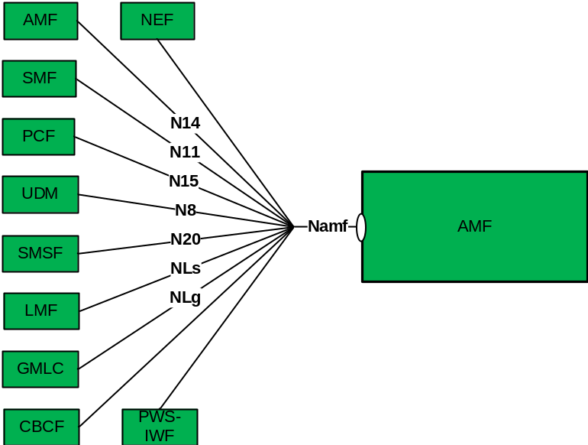
Figure 4.1-1: Reference model – AMF
The functionalities supported by the AMF are listed in subclause 6.2.1 of 3GPP TS 23.501 [2].

5 Services offered by the AMF

5.1 Introduction
The table 5.1-1 shows the AMF Services and AMF Service Operations:
Table 5.1-1 List of AMF Services
Service Name | Service Operations | Operation  Semantics | Example Consumer(s)
Namf_Communication | UEContextTransfer | Request/Response | Peer AMF
 | RegistrationCompleteNotify | Subscribe/Notify | Peer AMF
 | N1MessageNotify | Subscribe/Notify | AMF, LMF,
 | N1N2MessageSubscribe | Subscribe/Notify
 | N1N2MessageUnSubscribe | Subscribe/Notify
 | N1N2MessageTransfer | Request/Response | SMF, SMSF, LMF
 | NonUeN2MessageTransfer | Request/Response | LMF, CBCF, PWS-IWF
 | NonUeN2InfoSubscribe | Subscribe/Notify | CBCF, PWS-IWF
 | NonUeN2InfoUnSubscribe | Subscribe/Notify
 | N2InfoNotify | Subscribe/Notify | LMF, AMF
 | NonUeN2InfoNotify |  | LMF, CBCF, PWS-IWF
 | EBIAssignment | Request/Response | SMF
 | AMFStatusChangeSubscribe | Subscribe / Notify | SMF, PCF, NEF, SMSF, UDM
 | AMFStatusChangeUnSubscribe | Subscribe / Notify | SMF, PCF, NEF, SMSF, UDM
 | AMFStatusChangeNotify | Subscribe / Notify | SMF, PCF, NEF, SMSF, UDM
Namf_EventExposure | Subscribe (see NOTE 1) | Subscribe/Notify | NEF, SMF, PCF, UDM
 | Unsubscribe (see NOTE 1) | Subscribe/Notify | NEF, SMF, PCF, UDM
 | Notify | Subscribe/Notify | NEF, SMF, PCF, UDM
Namf_MT | EnableUEReachability | Request/Response | SMSF
Namf_Location | ProvideLocation | Request/Response | GMLC
 | EventNotify | Subscribe / Notify | GMLC
NOTE 1: A subscription applies for one UE, group of UE(s) or any UE.

5.2 Namf_Communication Service

5.2.1 Service Description
This service enables an NF to communicate with the UE through N1 NAS messages or with the AN (both UE and non UE specific). The service operations defined below allow the NF to communicate with the UE and the AN. The following are the key functionalities of this NF service.
- Provide service operations for transporting N1 messages to the UE;
- Allow NFs to subscribe and unsubscribe for notifications of specific N1 messages from the UE;
- Allow NFs to subscribe and unsubscribe for notifications about specific information from AN;
- Provide service operations for initiating N2 messages towards the AN;
- Security Context Management; and
- UE information management and transfer (including its security context).

5.2.2 Service Operations

5.2.2.1 Introduction
The Namf_Communication service supports following service operations:
- UEContextTransfer
- RegistrationCompleteNotify
- N1N2MessageTransfer (UE Specific)
- N1N2MessageSubscribe (UE Specific)
- N1N2MessageUnsubscribe (UE Specific)
- N1MessageNotify (UE Specific)
- N2InfoNotify (UE Specific)
- NonUeN2MessageTransfer
- NonUeN2InfoSubscribe
- NonUeN2INfoUnsubscribe
- N2InfoNotify
- EBIAssignment
- CreateUEContext
- ReleaseUEContext
- AMFStatusChangeSubscribe
- AMFStatusChangeUnsubscribe
- AMFStatusChangeNotify

5.2.2.2 UE Context Operations

5.2.2.2.1 UEContextTransfer

5.2.2.2.1.1 General
The UEContextTransfer service operation is used during the following procedure:
- General Registration procedure (see 3GPP TS 23.502 [3], subclause 4.2.2.2.2)
The UEContextTransfer service operation is invoked by a NF Service Consumer, e.g. a target AMF, towards the AMF (acting as source AMF), when the target AMF receives a Registration Request with the UE's 5G-GUTI included and the serving AMF has changed since last registration, to retrieve the UE Context, e.g. the UE's SUPI and MM Context, in the source AMF.
The NF Service Consumer (e.g. the target AMF) shall retrieve the UE Context by invoking the "transfer" custom method on the URI of an "Individual ueContext" resource, see subclause 6.1.3.2.4. See also Figure 5.2.2.2.1.1-1.

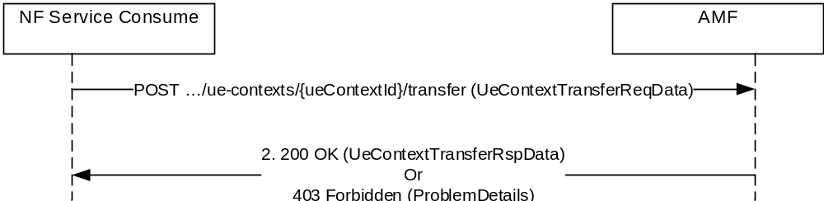
Figure 5.2.2.2.1.1-1 UE Context Transfer
1. The NF Service Consumer, e.g. target AMF, shall send a HTTP POST request to invoke "transfer" custom method on an "Individual ueContext" resource URI. The payload of the request shall be an object of "UeContextTranferReqData" data type, containing the integrity protected registration request message which triggers the UE context transfer.
2. The (source) AMF shall respond with the status code "200 OK" if the request is accepted. The payload of the response shall be an object of "UeContextTransferRspData" data type, containing the representation of the requested "Individual ueContext" resource and a callback URI to receive the notification of RegistrationCompleteNotity service operation (see subclause 5.2.2.3).
If the (source) AMF cannot process the transfer of individual ueContext resource, e.g. due to failure of integrity check of the complete registration request message content included in the POST request body, it shall respond with the status code "403 Forbidden" with an object of ProblemDetails data type.
If the UE context Id is not found in the source AMF, “404 Not Found” status code shall be returned.

5.2.2.2.2 RegistrationCompleteNotify

5.2.2.2.2.1 General
The RegistrationCompleteNotify service operation is used during the following procedure:
- General Registration procedure (see 3GPP TS 23.502 [3], subclause 4.2.2.2.2)
- Registration with AMF re-allocation procedure (see 3GPP TS 23.502 [3], subclause 4.2.2.2.3)
The RegistrationCompleteNotify service operation is invoked by a NF Service Producer, i.e. the target AMF, towards the NF Service Consumer, e.g. the source AMF, to notify the status of UE registration at the target AMF, thereby indicating the result of previous UE Context transfer for a given UE (see subclause 5.2.2.2.1.1).
The target AMF shall notify the NF Service Consumer (e.g. source AMF) the status of the UE registration at the target AMF due to a previous UE Context transfer. The target AMF shall use the HTTP method POST on the notification callback URI provided by the NF Service Consumer (e.g. source AMF) during a previous UE context transfer (see subclause 5.2.2.2.1.1). See also Figure 5.2.2.2.2.1-1.

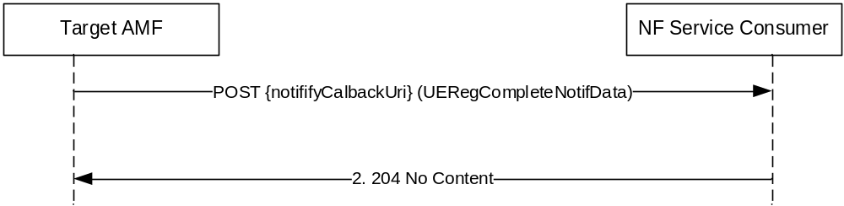
Figure 5.2.2.2.2.1-1 Registration Complete Notify
1. The target AMF, shall send a POST request on the notification callback URI obtained during an earlier UE context transfer request, to notify the NF Service Consumer of the status of the UE registration at the target AMF. The UE's 5G-GUTI is included as the UE identity, in the notification payload. Once the notification is received, the NF Service Consumer (e.g. AMF) shall:
- remove the individual ueContext resource if the ueContextTransferStatus attribute included in the notification is set to "TRANSFERRED". The source AMF may choose to start a timer to supervise the release of the UE context resource and may keep the individual ueContext resource until the timer expires.
- shall keep the UE Context as if the context transfer procedure had not happened if the ueContextTransferStatus attribute included in the notification is set to "NOT_TRANSFERRED".
2. The NF Service Consumer (e.g. source AMF) shall respond with the status code "204 No Content" if the request is accepted.

5.2.2.2.3 CreateUEContext

5.2.2.2.3.1 General
The CreateUEContext service operation is used during the following procedure:
- Inter NG-RAN node N2 based handover (see 3GPP TS 23.502 [3], subclause 4.9.1.3)
The CreateUEContext service operation is invoked by a NF Service Consumer, e.g. a source AMF, towards the AMF (acting as target AMF), when the source AMF can't serve the UE and selects the target AMF during the handover procedure, to create the UE Context in the target AMF.
The NF Service Consumer (e.g. the source AMF) shall create the UE Context by using the HTTP PUT method with the following URI. See also Figure 5.2.2.2.3.1-1.
The URI: "{apiRoot}/namf-comm/v1/ue-contexts/{ueContextId}", where the ueContextId is composed by supi-{supi}.
NOTE: The Prefix "supi-" allows the receiver knowing which identifier, e.g. 5g-guti, supi, pei, is used to identify the UE context.

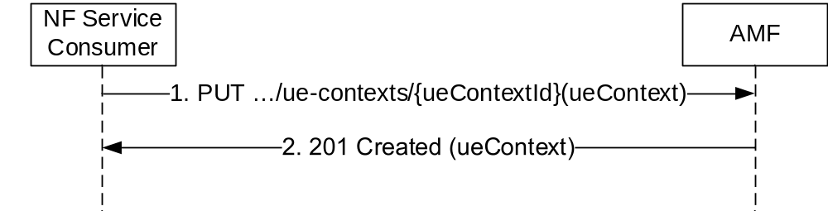
Figure 5.2.2.2.3.1-1 Create UE Context
1. The NF Service Consumer, e.g. source AMF, shall send a PUT request, to create the ueContext in the target AMF. The payload body of the PUT request shall contain a callback URI.
2. The target AMF shall respond with the status code "201 Created" if the request is accepted, together with a HTTP Location header to provide the location of a newly created resource. The payload body of the PUT response shall contain the representation of the created UE Context.
On failure, "403 Forbidden" with the message body containing a UeContextCreateError object, with the "detail" attribute in the ProblemDetails set to "HANDOVER_FAILURE" and the NGAP Cause shall be returned in the PUT response, if available.

5.2.2.2.4 ReleaseUEContext

5.2.2.2.4.1 General
The ReleaseUEContext service operation is used during the following procedure:
- Inter NG-RAN node N2 based handover, Cancel procedure (see 3GPP TS 23.502 [3], subclause 4.9.1.4)
The ReleaseUEContext service operation is invoked by a NF Service Consumer, e.g. a source AMF, towards the AMF (acting as target AMF), when the source AMF receives the Handover Cancel from the 5G-AN during the handover procedure, to release the UE Context in the target AMF.
The NF Service Consumer (e.g. the source AMF) shall release the UE Context by using the HTTP "release" custom operation with the following URI. See also Figure 5.2.2.2.4.1-1.
The URI: "{apiRoot}/namf-comm/v1/ue-contexts/{ueContextId}/release", where the ueContextId is SUPI. For the UE that is emergency attached and the UE is UICCless or the SUPI is not authenticated, the ueContextId is PEI.
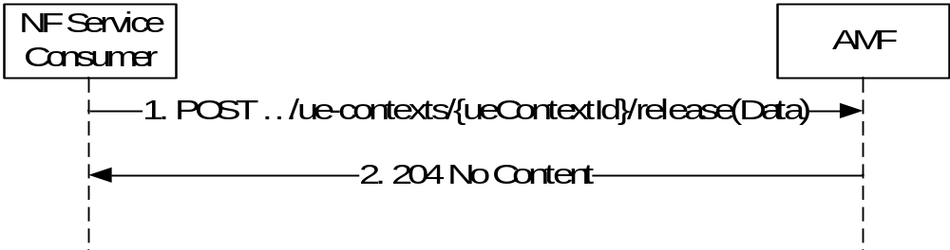
Figure 5.2.2.2.4.1-1 Release UE Context
1. The NF Service Consumer, e.g. source AMF, shall send a POST request, to release the ueContext in the target AMF. The payload body of the POST request shall contain any data that needs to be passed to the target AMF.
2. On success, the target AMF shall return "204 No Content" with an empty payload body in the POST response
Editor's Note: The description of failure cases is FFS.

5.2.2.3 UE Specific N1N2 Message Operations

5.2.2.3.1 N1N2MessageTransfer

5.2.2.3.1.1 General
The N1N2MessageTransfer service operation is used by a NF Service Consumer to transfer N1 and/or N2 information to the UE and/or 5G-AN through the AMF in the following procedures:
- Network triggered Service Request (see subclause 4.2.3.4 in 3GPP TS 23.502 [3]
- PDU Session establishment (See subclause 4.3.2 in 3GPP TS 23.502 [3])
- PDU Session modification (See subclause 4.3.3 in 3GPP TS 23.502 [3])
- PDU Session release (See subclause 4.3.4 in 3GPP TS 23.502 [3])
- Session continuity, service continuity and UP path management (See subclause 4.3.4 in 3GPP TS 23.502 [3])
- SMS over NAS procedures (See subclause 4.13.3 in 3GPP TS 23.502 [3]
- UE assisted and UE based positioning procedure (See subclause 4.13.5.4 in 3GPP TS 23.502 [3])
- Network assisted positioning procedure (See subclause 4.13.5.5 in 3GPP TS 23.502 [3])

5.2.2.3.1.2 UE Specific N1N2MessageTransfer Operation
The NF Service Consumer may invoke the service operation by using HTTP method POST, to request the AMF to transfer N1 and/or N2 information for a UE and/or 5G-AN, with the following URI:
"{apiRoot}/namf_comm/v1/ue-contexts/{ueContextId}/n1-n2-messages" where the ueContextId is composed by supi-{supi} or pei.{pei}.
NOTE 1: The Prefix supi- allows the receiver knowing which identifier, e.g. 5g_guti, supi, pei, is used to identify the UE context.
NOTE 2: It is assumed there is a collection of n1-n2-messages, to be created in the AMF, to contain sub-resources for each received N1 and/or N2 information included in the POST request.
The NF may include the following information in the HTTP Request message body:
- SUPI
- PDU Session ID
- N2 SM information (PDU Session ID, QoS profile, CN N3 Tunnel Info, S-NSSAI)
- N1 SM information
- N1 Message Container (e.g. LPP message, SMS)
- N2 Information Container (e.g. NRPPa message)
- Priority
- Paging Policy Indication
- Notification URL (used for receiving Paging Failure Indication)
- RAT and/or AN type for the PDU Session
Editor's Note: Including possible additional parameters is FFS.

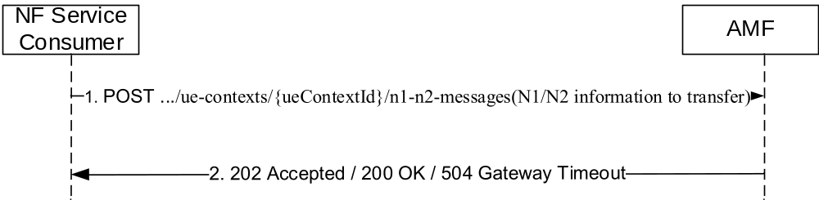
Figure 5.2.2.3.1.2-1 N1N2MessageTransfer for UE related signalling
1. The NF Service Consumer shall send a POST request to transfer N1 and N2 information. The NF Service Consumer may include a N1N2MessageTransfer Notification URI to AMF in the request message.
2. If the request is accepted and the AMF is able to transfer the N1/N2 message to the UE and/or the AN, the AMF shall respond with a “200 OK” status code. The AMF shall set the cause IE in the N1N2MessageTransferRspData as "N1_N2_TRANSFER_INITIATED" in this case. For other cases, the AMF shall respond as specified in sub-clause 5.2.2.3.1.3.

5.2.2.3.1.3 When the UE is in CM-IDLE
When the N1N2MessageTransfer service operation is invoked by a NF Service Consumer for a UE in CM-IDLE state, the AMF shall:
- respond with the status code "202 Accepted", if the asynchronous type communication is invoked and hence the UE is not paged, update the UE context and store N1 and/or N2 information and initiate communication with the UE and/or 5G-AN when the UE becomes reachable. In this case the AMF shall provide the URI of the resource in the AMF in the "Location" header of the response, which holds the status of the N1/N2 message transfer and a pointer to the stored N1/N2 message. The AMF shall also provide a response body containing the cause, "WAITING_FOR_ASYNCHRONOUS_TRANSFER" that represents the current status of the N1/N2 message transfer;
- respond with the status code "202 Accepted", if the UE is in 3GPP access and paging is issued, with a response body that carries a cause ATTEMPTING_TO_REACH_UE as specified in subclause 4.2.3.3 and 5.2.2.2.7 of 3GPP TS 23.502 [3]. The NF Service Consumer shall not send any further signalling for the UE if it receives a POST response body ATTEMPTING_TO_REACH_UE unless it has higher priority signalling. The response shall include the "Location" header containing the URI of the resource created in the AMF, which holds the status of the N1/N2 message transfer, e.g. "{apiRoot}/namf-comm/v1/ue-contexts/{ueContextId}/n1-n2-messages/{n1N2MessageId}". The AMF:
- shall store the N1 and/or N2 information and, when the UE responds with a Service Request, shall initiate communication with the UE and/or 5G-AN using the stored N1 and/or N2 information; or
- shall notify the NF which invoked the service operation, as specified in subclause 5.2.2.3.2, when the AMF determines that the paging has failed and if the Notification URI is provided,
- respond with status code "409 Conflict", if the UE is in 3GPP access and there is already an ongoing paging procedure with higher or same priority. The AMF shall set the application error as " HIGHER_PRIORITY_REQUEST_ONGOING" in the detail attribute of the ProblemDetails structure of the POST response body. The AMF may provide a retry timer value to the NF Service Consumer in order for the NF Service Consumer to retry the request after the expiry of the timer.
- respond with the status code "504 Gateway Timeout", if the paging is not performed, together with a Cause code included in the message body to indicate the detail of failure, e.g. UE is not reachable for paging, or UE is not reachable for paging just for the NF which invoked the service operation, or UE is in a Non-allowed area while the Priority included does not indicate a regulatory prioritized service, or UE is currently involved in an AMF relocation procedure.

5.2.2.3.2 N1N2MessageTransfer Failure Notification
The AMF uses this notification to inform the NF service consumer that initiated an earlier Namf_Communication_N1N2MessageTransfer, that the AMF failed to deliver the N1 message to the UE as the UE failed to respond to paging. The HTTP POST method shall be used on the notification callback URI provided by the NF service consumer as specified in subclause 5.2.2.3.1.2.
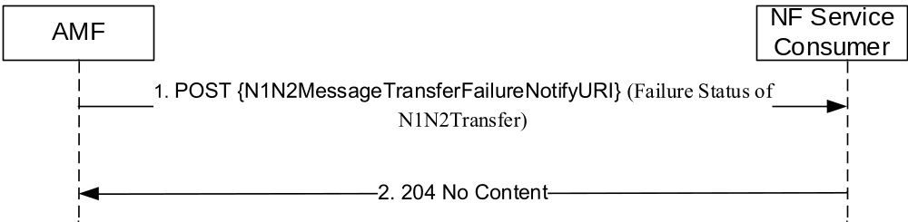
Figure 5.2.2.3.2-1 N1N2MessageTransfer Failure Notification for UE related signalling
1. When the AMF determines that the paging has failed and if the NF service consumer had provided a notification URI (see subclause 5.2.2.3.1.2), the AMF shall send a POST request to the NF Service Consumer on that Notification URI. The AMF shall include the N1N2MessageTransfer request resource URI returned earlier (see 5.2.2.3.1.3) in the POST request body. The AMF shall also include a N1/N2 message transfer cause information in the POST request body. The NF Service Consumer shall delete any stored representation of the N1N2MessageTransfer request resource URI upon receiving this notification.
2. The NF Service Consumer shall send a response with “204 No Content” status code.

5.2.2.3.3 N1N2MessageSubscribe

5.2.2.3.3.1 General
The N1N2MessageSubscribe service operation is used by a NF Service Consumer (e.g. LMF) to subscribe to the AMF for notifying N1 messages of a specific type (e.g. LPP) or N2 information of a specific type (e.g. NRPPa).

5.2.2.3.3.2 Use of N1N2MessageSubscribe for Individual UEs
An NF Service Consumer (e.g. LMF) may subscribe to notifications of specific N1 message type (e,g LPP) or N2 information type (e.g. NRPPa). In this case the NF Service Consumer shall subscribe by using the HTTP POST method with the following URI. See also Figure 5.2.2.3.3.2-1.
The URI: "{apiRoot}/namf_comm/v1/ue_contexts/{ueContextId}/n1-n2-messages/subscriptions"
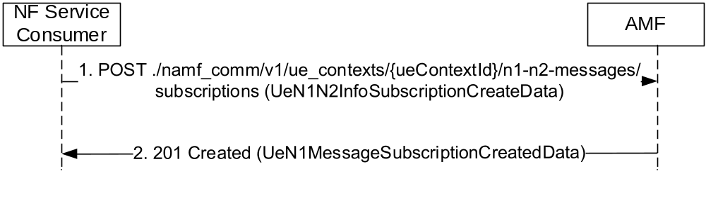
Figure 5.2.2.3.3.2-1 N1N2 Message Subscribe

1. The NF Service Consumer shall send a POST request to create a subscription resource in the AMF for a UE specific N1/N2 message notification. The payload body of the POST request shall contain:
- N1 and/or N2 Message Type, identifying the type of N1 and/or N2 message to be notified
- A callback URI for the notification
2. If the request is accepted, the AMF shall include a HTTP Location header to provide the location of a newly created resource (subscription) together with the status code 201 indicating the requested resource is created in the response message.

5.2.2.3.4 N1N2MessageUnSubscribe

5.2.2.3.4.1 General
The N1N2MessageUnSubscribe service operation is used by a NF Service Consumer (e.g. LMF) to unsubscribe to the AMF to stop notifying N1 messages of a specific type (e.g. LPP).
The NF Service Consumer shall use the HTTP method DELETE with the following URI to request the deletion of the subscription for the N1 / N2 message towards the AMF. See also Figure 5.2.2.3.4.1-1.
The URI: "{apiRoot}/namf_comm/v1/ue_contexts/{ueContextId}/n1-n2-messages/subscriptions/{subscriptionId}"

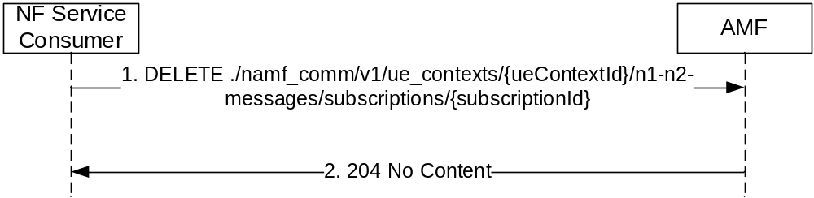
Figure 5.2.2.3.4.1-1 N1N2 Message UnSubscribe
1. The NF Service Consumer shall send a DELETE request to delete an existing subscription resource in the AMF.
2. If the request is accepted, the AMF shall reply with the status code 204 indicating the resource identified by subscription ID is successfully deleted, in the response message.

5.2.2.3.5 N1MessageNotify

5.2.2.3.5.1 General
The N1MessageNotify service operation is used by a AMF notifying the N1 message received from the UE to a destination CN NF, and it is used in the following procedures:
- Registration with AMF re-allocation (See subclause 4.2.2.2.3 in 3GPP TS 23.502 [3])
- UE assisted and UE based positioning procedure (See subclause 4.13.5.4 in 3GPP TS 23.502 [3])

5.2.2.3.5.2 Using N1MessageNotify in the Registration with AMF Re-allocation Procedure
In the Registration with AMF re-allocation procedure, the N1MessageNotify service operation is invoked by a NF Service Producer, i.e. an Initial AMF, towards a NF Service Consumer, e.g. the target AMF, which is selected to serve the UE, by the initial AMF.
The N1MessageNotify service operation is invoked the initial AMF on the callbackUri of the NF Service Consumer (e.g. the target AMF) discovered from the NRF (See subclause 6.1.6.2.4 of 3GPP TS 29.510 [14]). The HTTP POST method shall be used to notify the NF Service Consumer.
NOTE: The alternate AMF is expected to have registered a callback URI with the NRF.
The initial AMF shall include the following information in the HTTP POST Request message body:
- RAN NGAP ID and; (the information enabling (R)AN to identify the N2 terminating point)
- the N1 message;
- the UE's SUPI and MM Context;
- the Allowed NSSAI together with the corresponding NSI IDs (if network slicing is used and the initial AMF has obtained).

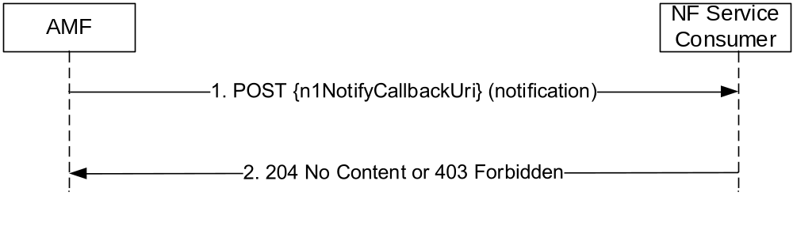
Figure 5.2.2.3.5.2-1 N1 Message Notify
1. The Initial AMF shall send a POST request to the default notification URI of the target AMF. The payload body of the POST request shall contain the notification payload, e.g. the N1 message, Allowed NSSAI.
2. On success, "204 No Content" shall be returned and the payload body of the POST response shall be empty. If the target AMF cannot accept the registration request, it shall send a HTTP POST response with "403 Forbidden" status code.
If the request is failed, the NF service consumer, e.g. the initial AMF, may select the next target AMF in the candidates list, to request that AMF to serve the UE by sending a new HTTP POST.

5.2.2.3.5.3 Using N1MessageNotify in the UE Assisted and UE Based Positioning Procedure
In the UE assisted and UE based positioning procedure, the N1MessageNotify service operation is invoked by a NF Service Consumer, e.g. an AMF, towards the LMF, which had subscribed for delivering the N1 UE positioning messages for the UE to be notified (See subclause 6.2.3.8).
The AMF shall include the following information in the HTTP POST Request message body when notifying the N1 message from the UE for positioning request:
- the N1 Uplink Positioning Message
- LCS co-relation identifier;
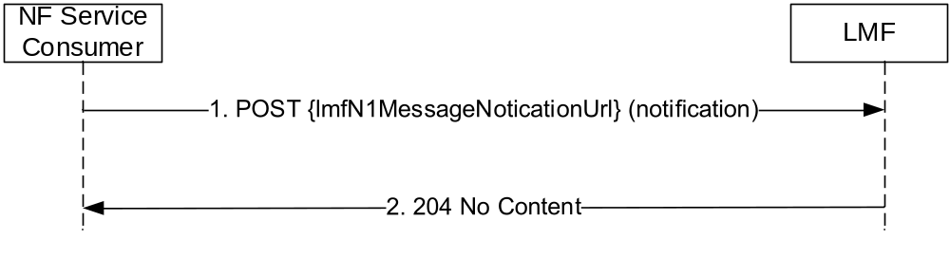
Figure 5.2.2.3.5.3-1 N1 Message Notify
1. The NF Service Consumer (e.g. AMF) shall send a POST request to the notification URI provided by the LMF for receiving the N1 messages of payload type LPP (see subclause 9.8.3.23 of 3GPP TS 24.501 [11]) when invoking the N1MessageSubscribe service operation on the individual UE context (See subclause 6.2.3.8).. The payload body of the POST request shall contain the notification payload, e.g. the N1 message of type LPP, LCS co-relation identifier.
2. On success, "204 No Content" shall be returned and the payload body of the POST response shall be empty.

5.2.2.3.6 N2InfoNotify

5.2.2.3.6.1 General
The N2InfoNotify service operation is used during the following procedure:
- Inter NG-RAN node N2 based handover procedure (see 3GPP TS 23.502 [3], subclause 4.9.1.3.3)
- Network assisted positioning procedure (See subclause 4.13.5.5 in 3GPP TS 23.502 [3])

5.2.2.3.6.2 Using N2InfoNotify during Inter NG-RAN node N2 based handover procedure
The N2InfoNotify service operation is invoked by a NF Service Producer, e.g. the target AMF, towards the NF Service Consumer, i.e. the source AMF, to notify that the handover procedure has been successful in the target side, for a given UE.
During inter AMF handover procedure, the source AMF, which is served as a NF Service Consumer, when consuming the Namf_Communication_CreateUEContext service operation, shall include a N2Info Notification URI to the target AMF in the HTTP request message.
The target AMF shall use HTTP POST method to notify the NF Service Consumer (e.g. source AMF) that the handover is completed, on the N2Info Notification URI.

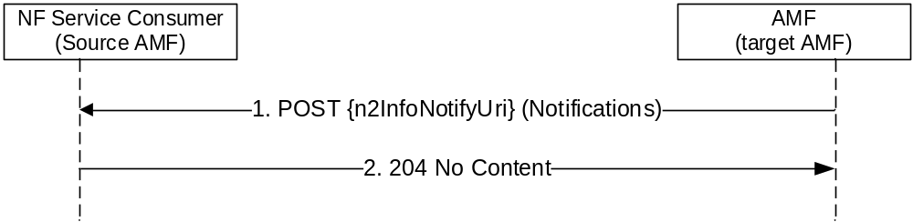
Figure 5.2.2.3.6.2-2 N2 Information Notify Alt2
1. The NF Service Producer, e.g. the target AMF, shall send a HTTP POST request to the n2InfoNotifyUri, and the payload body of the POST request shall contain the notification payload (see subclause 6.1.5.5), with the information that the handover is complete. The n2NotifySubscriptionId included in the notification payload shall be the UE context Id.
NOTE: This notification is due to an implicit subscription and hence no explicit subscription Id is created. UE context Id is included as the notification subscription Id for the NF Service Consumer (e.g. Source AMF) to co-relate the notification to an earlier initiated UE context transfer during a handover procedure.
2. On success, "204 No Content" shall be returned and the payload body of the POST response shall be empty.

5.2.2.3.6.3 Using N2InfoNotify during Location Services procedures
The N2InfoNotify service operation is used during the following Location Services related procedures:
- Network assisted positioning procedure (See subclause 4.13.5.5 in 3GPP TS 23.502 [3])
The N2InfoNotify service operation is invoked by a NF Service Producer, i.e. the AMF, towards the NF Service Consumer, e.g. the LMF, to notify the positioning parameters received from the 5G-AN in the NRPPa message.
The NF Service Producer (i.e. the AMF) shall notify the N2 information by using HTTP method POST on the notification callback URI provided by the NF Service Consumer (See subclause 5.2.2.3.5). See also Figure 5.2.2.3.6.3-1.
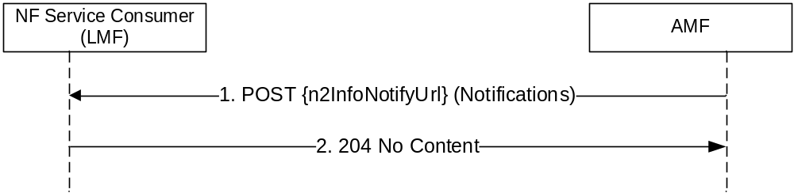
Figure 5.2.2.3.6.3-1 N2 Information Notify
1. The AMF, shall send a HTTP POST request to the n2InfoNotifyUrl, and the payload body of the POST request shall contain the notification payload, with the information containing the N2 information that was subscribed by the NF Service Consumer (e.g. LMF subscribes to N2 information of type NRPPa).
2. On success, "204 No Content" shall be returned and the payload body of the POST response shall be empty.

5.2.2.4 Non-UE N2 Message Operations

5.2.2.4.1 NonUeN2MessageTransfer

5.2.2.4.1.1 General
The NonUeN2MessageTransfer service operation is used by a NF Service Consumer to transfer N2 information to the 5G-AN through the AMF in the following procedures:
- Obtaining non-UE associated network assistance data (See subclause 4.13.5.6 in 3GPP TS 23.502 [3])
- Warning Request Transfer procedures (See subclause 9A in 3GPP TS 23.041 [20])

5.2.2.4.1.2 Obtaining Non UE Associated Network Assistance Data Procedure
When the NonUeN2MessageTransfer service operation is invoked by a NF Service Consumer for transferring non UE associated N2 information of N2 information class LMF for obtaining the network assistance data, the NF Service Consumer shall use the HTTP POST method, to request the AMF to transfer the N2 information towards the 5G-AN.

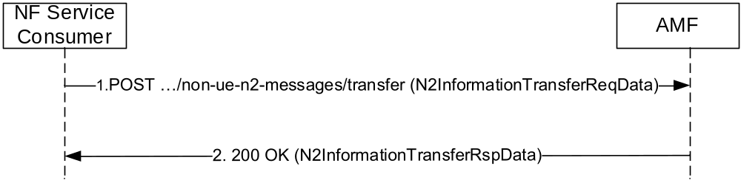
Figure 5.2.2.4.1.2-1 nonUeN2MessageTransfer for Non UE related signalling
1. The NF Service Consumer (e.g. LMF) initiates the custom operation for non UE associated N2 message transfer by issuing a POST request on the "{apiRoot}/namf_comm/v1/non-ue-n2-messages/transfer" URI. The POST request body shall carry the N2 information to be transferred together with the NG RAN node identifier(s) to which the transfer needs to be initiated. The POST request body shall also contain a callback URI of the NF Service Consumer, which is used by the AMF to later notify the NF Service Consumer when a non UE N2 message of class (e.g. NRPPa) that is requested to be transferred is received.
2. The AMF shall transfer the non UE associated N2 information towards the 5G-AN and shall respond to the NF Service Consumer with:
- a "200 OK" status code with N2InformationTransferRspData, if the information transferring to the 5G-AN is initiated;

5.2.2.4.1.3 Warning Request Transfer Procedure
The NonUeN2MessageTransfer service operation shall be invoked by the NF Service Consumer to send non-UE specific messages of N2 information class PWS to the 5G-RAN. The AMF shall accept the request and respond to the Service Consumer immediately.
The NF Service Consumer shall invoke the service by using the HTTP method POST.
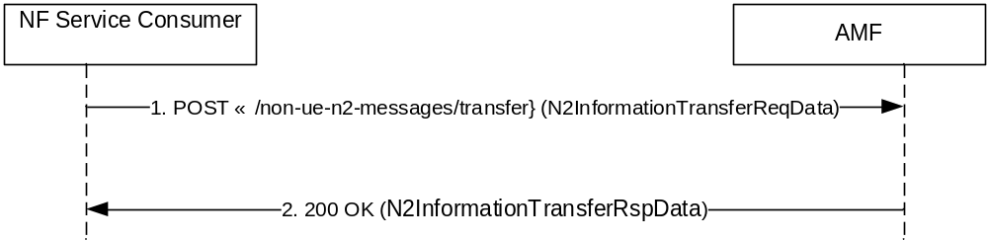
Figure 5.2.2.4.1.3-1: NonUeN2MessageTransfer
1. The NF Service Consumer shall send a POST request to the AMF. The request body shall include the N2 Message Container and optionally the List of TAIs IE, the OMC ID IE, the Send-Write-Replace-Warning Indication IE or the Send-Stop-Warning Indication IE.
The AMF shall forward the N2 Message Container to the RAN Nodes that serve Tracking Areas as listed in the List of TAIs IE. If the List of TAIs IE is not present, the AMF shall forward the N2 Message Container to all attached RAN Nodes.
2. On success, "200 OK" shall be returned to the NF Service Consumer and the POST response body shall contain the mandatory elements from the Write-Replace-Warning Confirm response (see subclause 9.2.17 in TS 23.041 [20]) or the mandatory elements and optionally the Unknown Tracking Area List IE from the Stop-Warning Confirm response (see subclause 9.2.19 in TS 23.041 [20]).
On failure the HTTP status code "403 Forbidden" shall be returned to the NF Service Consumer and ProblemDetails information shall be returned in the POST response body.

5.2.2.4.2 NonUeN2InfoSubscribe

5.2.2.4.2.1 General
The NonUeN2InfoSubscribe service operation is used by a NF Service Consumer (e.g. LMF, CBCF or PWS-IWF) to subscribe to the AMF for notifying non UE specific N2 information of a specific type (e.g. NRPPa or PWS Indications).

5.2.2.4.2.2 Use of NonUeN2InfoSubscribe for Non UE Specific Information
An NF Service Consumer (e.g. LMF, CBCF or PWS-IWF) can subscribe to notifications of specific N2 information type (e,g NRPPa or PWS Indications) that are not associated with any UE. In this case the NF Service Consumer shall subscribe by using the HTTP POST method with the following URI. See also Figure 5.2.2.4.2.2-1.
The URI: "{apiRoot}/namf_comm/v1/non-ue-n2-messages/subscriptions"
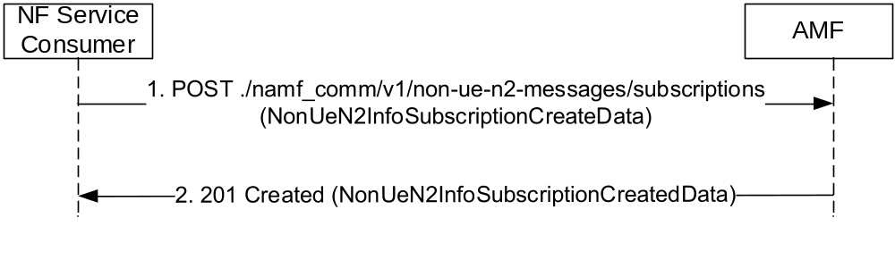
Figure 5.2.2.4.2.2-1 N2 Information Subscription for Non UE Information
1. The NF Service Consumer shall send a POST request to create a subscription resource in the AMF for a non UE specific N2 information notification. The payload body of the POST request shall contain:
- N2 Information Type, identifying the type of N2 information to be notified
- A callback URI for the notification
2. If the request is accepted, the AMF shall include a HTTP Location header to provide the location of a newly created resource (subscription) together with the status code 201 indicating the requested resource is created in the response message.

5.2.2.4.3 NonUeN2InfoUnSubscribe

5.2.2.4.3.1 General
The NonUeN2InfoUnSubscribe service operation is used by a NF Service Consumer (e.g. LMF) to unsubscribe to the AMF to stop notifying N2 information of a specific type (e.g. NRPPa).

5.2.2.4.3.2 Use of NonUeN2InfoUnSubscribe for Non UE Information
The NF Service Consumer shall use the HTTP method DELETE with the following URI to request the deletion of the subscription for non UE specific N2 information notification, towards the AMF. See also Figure 5.2.2.4.3.2-1.
The URI: "{apiRoot}/namf_comm/v1/non-ue-n2-messages/subscriptions/{n2NotifySubscriptionId}"

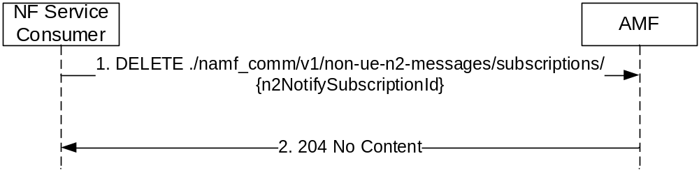
Figure 5.2.2.4.3.2-1 NonUeN2InfoUnSubscribe for Non UE Specific Information
1. The NF Service Consumer shall send a DELETE request to delete an existing subscription resource in the AMF.
2. If the request is accepted, the AMF shall reply with the status code 204 indicating the resource identified by subscription ID is successfully deleted, in the response message.

5.2.2.4.4 NonUeN2InfoNotify

5.2.2.4.4.1 General
The NonUeN2InfoNotify service operation is used during the following procedures:
- Obtaining non-UE associated network assistance data (See subclause 4.13.5.6 in 3GPP TS 23.502 [3])
- Receiving PWS related events from the NG-RAN

5.2.2.4.4.2 Using NonUeN2InfoNotify during Location Services procedures
The NonUeN2InfoNotify service operation is used during the following Location Services related procedures:
- Obtaining non-UE associated network assistance data (See subclause 4.13.5.6 in 3GPP TS 23.502 [3])
The NonUeN2InfoNotify service operation is invoked by a NF Service Producer, i.e. the AMF, towards the NF Service Consumer, e.g. the LMF, to notify the assistance data received from the 5G-AN.
The NF Service Producer (i.e. the AMF) shall notify the N2 information by using HTTP method POST on the notification callback URI provided by the NF Service Consumer (See subclause 5.2.2.4.1.2). See also Figure 5.2.2.4.4.2-1.
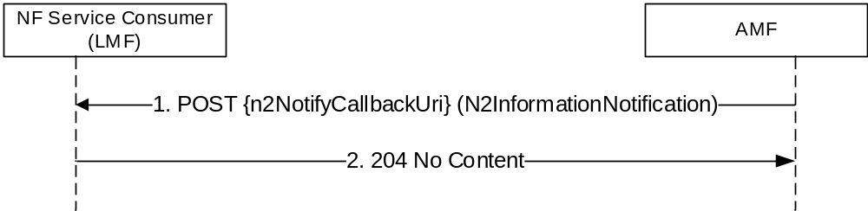
Figure 5.2.2.4.4.2-1 NonUeN2 Information Notify for Location Services
1. The AMF, shall send a HTTP POST request to the callback URI, and the payload body of the POST request shall contain the notification payload, with the information containing the N2 information that was subscribed by the NF Service Consumer (e.g. LMF subscribed to network assistance data).
2. On success, "204 No Content" shall be returned and the payload body of the POST response shall be empty.

5.2.2.4.4.3 Use of NonUeN2InfoNotify for PWS related events
The NonUeN2InfoNotify service operation notifies each NF Service Consumer that has previously subscribed to receiving notifications through the NonUeN2InfoSubscribe operation.
The NonUeN2InfoNotify service operation is used during the following PWS related events:
1) The AMF has received a Write-Replace-Warning-Confirm response or a PWS-Cancel-Confirm response from the NG-RAN over N2.
Upon receiving the N2 Message Content the RAN Nodes return a response which may include the Broadcast Completed Area List IE or the Broadcast Cancelled Area List IE, depending on the Message Type IE. The AMF may aggregate the lists it receives from the RAN Nodes for the same request.
If the Send-Write-Replace-Warning Indication IE was present in the Write-Replace-Warning Request message, then the AMF may forward the Broadcast Completed Area List IE(s) to the NF Service Consumer.
If the Send-Stop-Warning Indication IE was present in the Stop-Warning-Request message, then the AMF may forward the Broadcast Cancelled Area List IE(s) to the NF Service Consumer. If the NG-RAN node has responded without including the Broadcast Cancelled Area List IE then the AMF shall populate the Broadcast Empty Area List IE with the NG-RAN node ID and send the (aggregated) Broadcast Empty Area List to the NF Service Consumer.
2) The AMF has received a Restart Indication or a Failure Indication from a NG-RAN Node. The AMF shall forward the Restart Indication or Failure Indication to the NF Service Consumer.
The operation is invoked by issuing a POST request to each callback URI of the different NF Service Consumers.
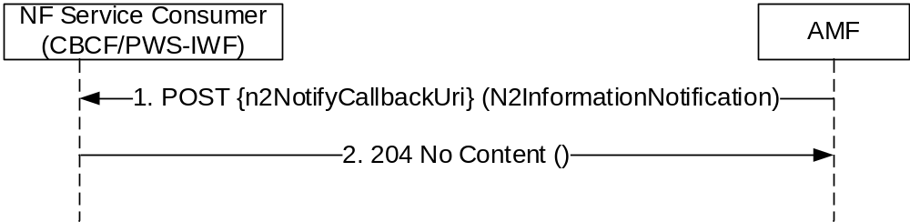
Figure 5.2.2.4.4.3-1: AMF Notifications for PWS related events
1. The AMF shall send a POST request to the callback URI. The request body shall include the N2 related information.
2. On success, "204 No Content" shall be returned by the NF Service Consumer.

5.2.2.5 AMF Status Change Operations

5.2.2.5.1 AMFStatusChangeSubscribe

5.2.2.5.1.1 General
This service operation is used by a NF Service Consumer to subscribe the status change of the AMF.
The AMFStatusChangeSubscribe service operation is used during the following procedure:
- AMF planned removal procedure (see 3GPP TS 23.501 [2], subclause 5.21.2.2)

5.2.2.5.1.2 Creation of a subscription
This service operation creates a subscription so a NF Service Consumer can request to be notified when the status of the AMF is changed.
It is executed creating a new individual resource under the collection resource "subscriptions". The operation is invoked by issuing a POST request on the URI representing the "subscriptions" resource.
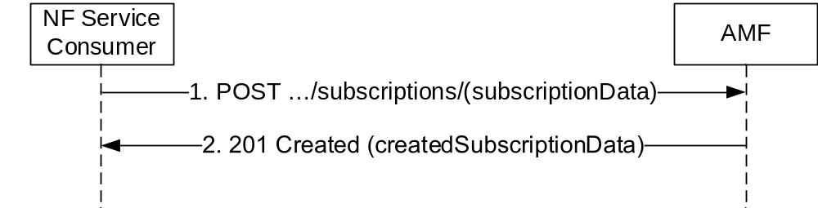
Figure 5.2.2.5.1.1-1 NF Service Consumer Subscription to Notifications
1. The NF Service Consumer shall send a POST request to the resource URI representing the "subscriptions" collection resource. The request body shall include the data indicating the GUAMI(s) supported by the AMF that the NF Service Consumer is interested in receiving the related status change notification. The request body also contains a callback URI, where the NF Service Consumer shall be prepared to receive the actual notification from the AMF (see AMFStatusChangeNotify operation in subclause 5.2.2.5.3).
2. On success, the AMF shall include a HTTP Location header to provide the location of a newly created resource (subscription) together with the status code 201 indicating the requested resource is created in the response message.
On failure, the appropriate HTTP status code (e.g. "403 Forbidden") indicating the error shall be returned and appropriate additional error information should be returned.

5.2.2.5.1.3 Modification of a subscription
This service operation updates the subscription data of an NF Service Consumer previously subscribed in the AMF by providing the updated subscription data to the AMF. The update operation shall apply to the whole subscription data (complete replacement of the existing subscription data by a new subscription data).
The NF Service Consumer shall issue an HTTP PUT request, as shown in Figure 5.2.2.5.1.3-1:
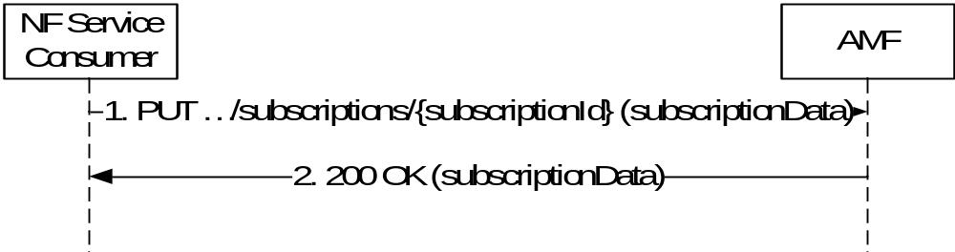
Figure 5.2.2.5.1.3-1 Subscription Data Complete Replacement
1. The NF Service Consumer shall send a PUT request to the resource URI representing the individual subscription. The request body shall include a representation of subscription data to replace the previous subscription data in the AMF.
2. On success, "200 OK" shall be returned, the payload body of the PUT response shall contain the representation of the replaced resource.
On failure, the appropriate HTTP status code (e.g. "403 Forbidden") indicating the error shall be returned and appropriate additional error information should be returned.

5.2.2.5.2 AMFStatusChangeUnSubscribe

5.2.2.5.2.1 General
This service operation removes an existing subscription to notifications.
The AMFStatusChangeUnSubscribe service operation is used during the following procedure:
- AMF planned removal procedure (see 3GPP TS 23.501 [2], subclause 5.21.2.2)
It is executed by deleting a given resource identified by a "subscriptionId". The operation is invoked by issuing a DELETE request on the URI representing the specific subscription.
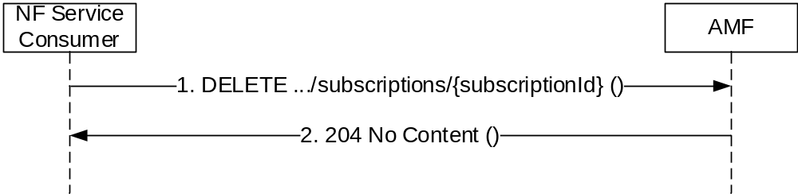
Figure 5.2.2.5.2.1-1: NF Service Consumer Unsubscription to Notifications
1. The NF Service Consumer shall send a DELETE request to the resource URI representing the individual subscription. The request body shall be empty.
2. On success, "204 No Content" shall be returned. The response body shall be empty.
On failure, the appropriate HTTP status code (e.g. "403 Forbidden") indicating the error shall be returned and appropriate additional error information should be returned.

5.2.2.5.3 AMFStatusChangeNotify

5.2.2.5.3.1 General
This service operation notifies each NF Service Consumer that was previously subscribed to receiving notifications of the status change of the AMF (e.g. AMF unavailable). The notification is sent to a callback URI that each NF Service Consumer provided during the subscription (see AMFStatusChangeSubscribe operation in 5.2.2.5.1).
The AMFStatusChangeNotify service operation is used during the following procedure:
- AMF planned removal procedure (see 3GPP TS 23.501 [2], subclause 5.21.2.2)
The operation is invoked by issuing a POST request to each callback URI of the different NF Service Consumer.
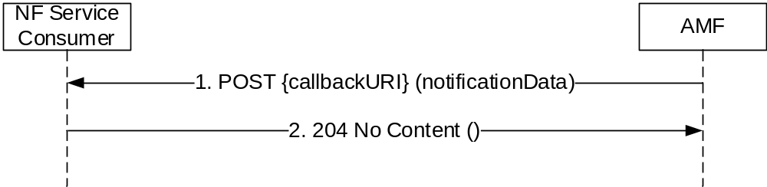
Figure 5.2.2.5.3.1-1: AMF Notifications
1. The AMF shall send a POST request to the callback URI. The request body shall include the GUAMI(s) and the related status change, GUAMI(s) is indicated by the NF Service Consumer during the subscription operation. For network deployment without UDSF case, the target AMF Name which is to serve the user of the indicated GUAMI(s) is also included.
2. On success, "204 No content" shall be returned by the NF Service Consumer.
On failure, the appropriate HTTP status code (e.g. "403 Forbidden") indicating the error shall be returned and appropriate additional error information should be returned.

5.2.2.6 EBIAssignment

5.2.2.6.1 General
The EBIAssignment service operation is used during the following procedures (see 3GPP TS 23.502 [3], subclause 4.11.1.4):
- UE requested PDU Session Establishment (Non-roaming and Roaming with Local Breakout (see 3GPP TS 23.502 [3], subclause 4.3.2.2.1).
- UE requested PDU Session Establishment (Home-routed Roaming (see 3GPP TS 23.502 [3], subclause 4.3.2.2.2).
- UE or network requested PDU Session Modification (non-roaming and roaming with local breakout) (see 3GPP TS 23.502 [3], subclause 4.3.3.2).
- UE or network requested PDU Session Modification (home-routed roaming) (see 3GPP TS 23.502 [3], subclause 4.3.3.3).
- Network requested PDU Session Modification, when the SMF needs to release the assigned EBI from a QoS flow (see 3GPP TS 23.502 [3], subclause 4.11.1.4.3).
The EBIAssignment service operation is invoked by a NF Service Consumer, e.g. a SMF, towards the NF Service Producer, i.e. the AMF, to request the AMF to allocate EPS bearer ID(s) towards EPS bearer(s) mapped from QoS flow(s) for an existing PDU Session for a given UE.
The NF Service Consumer (e.g. the SMF) shall perform EBIAssignment service operation by invoking a custom method on "individual ueContext" resource, see table 6.1.3.1-1. See also Figure 5.2.2.6.1-1.

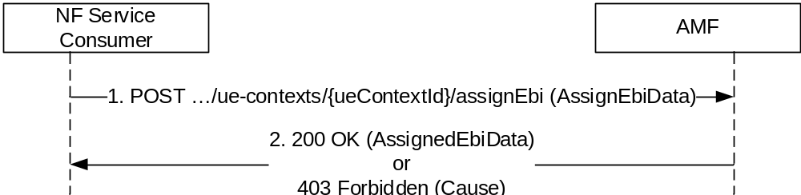
Figure 5.2.2.6.1-1 EBI Assignment
1. The NF Service Consumer, e.g. the SMF, shall invoke "assignEbi" custom method on individual ueContext resource, which is identified by the UE's SUPI or PEI in the AMF. The NF Service consumer shall provide PDU Session ID, ARP list and S-NSSAI as input for the service operation.
2. AMF shall assign EBI for each ARP in received ARP list, if enough EBI(s) are available. If there is not enough EBI(s) available, the AMF may revoke already assigned EBI(s) based on the ARP(s) and S-NSSAI received, EBIs information in the UE context and local policies. The AMF may only assign a subset of the requested EPS Bearer ID(s), e.g. when other PDU Sessions with higher ARP have occupied other available EPS Bearer IDs. If AMF has successfully assigned all or part of the requested EBI(s), the AMF shall respond with the status code 200 OK, together with the assigned EBI to ARP mapping(s) and list of ARPs for which the AMF failed to allocate an EBI (if any).
If the request contains "releasedEbiList", the AMF shall release the requested EBI(s). The AMF shall respond with the status code 200 OK and shall include the EBI(s) released in the "releasedEbiList" IE of the POST response body.
If none of the requested EBI(s) can be assigned by the AMF, the AMF shall return "403 Forbidden" status code together with the "AssignEbiError" JSON object representing the cause of the failure in the "cause" attribute of the ProblemDetails and the list of ARP(s) for which EBI assignment failed.

5.3 Namf_EventExposure Service

5.3.1 Service Description
The AMF may offer this service as a Service Producer to enable an NF to subscribe and get notified about an event. The known Service Consumers are NEF, SMF, PCF, UDM. See also subclauses 4.1.5.3.2, 4.15.4.2 and 5.2.2.3.1 of 3GPP TS 23.502 [3] and subclause 6.1.3.4 of 3GPP TS 23.503 [7].
The following events are provided by Namf_EventExposure Service:
Event: Location-Report
A NF subscribes to this event to receive the Last Known Location of a UE or a group of UEs, and Updated Location of the UE or any UE in the group when AMF becomes aware of a location change of the UE.
UE Type: One UE, Group of UEs
Report Type: One-Time Report (See NOTE 1), Continuous Report (See NOTE 2)
Input: UE-ID(s), Optionally Filters: TAI, Cell-ID, N3IWF, UE-IP, UDP-PORT
Notification; UE-ID, filtered updated location (TAI, Cell-ID for 3GPP access, most recent N3IWF node, UE local IP address and UDP source port number for non-3GPP access).
NOTE 1: For One-time report, only Last Known Location is supported.
NOTE 2: Support of Continuous Report should be controlled by operator policy.

Event: Presence-In-AOI-Report
A NF subscribe to this event to receive the current present state of a UE in a specific Area of Interest (AOI), and notification when a specified UE enters or leaves the specified area. The area could be identified by a TA list, an area ID or specific interested area name like "LADN".
UE Type: One UE, Group of UEs
Report Type: One-Time Report, Continuously Report
Input: UE ID(s), Area identifier (a TA list, an area Id or "LADN").
Notification: UE-ID, Area identifier, Presence Status (IN/OUT/UNKNOWN)

Event: Time-Zone-Report
A NF subscribes to this event to receive the current time zone of a UE or a group of UEs, and updated time zone of the UE or any UE in the group when AMF becomes aware of a time zone change of the UE.
UE Type: One UE, Group of UEs
Report Type: One-Time Report, Continuous Report
Input: UE ID(s)
Notification; UE-ID, most recent time-zone

Event: Access-Type-Report
A NF subscribes to this event to receive the current access type(s) of a UE or a group of UEs, and updated access type(s) of the UE or any UE in the group when AMF becomes aware of the access type change of the UE.
UE Type: One UE, Group of UEs
Report Type: One-Time Report, Continuous Report
Input: UE ID(s)
Notification; UE ID, most recent access-types (3GPP, Non-3GPP)

Event: Registration-State-Report
A NF subscribes to this event to receive the current registration state of a UE or a group of UEs, and report for updated registration state of a UE or any UE in the group when AMF becomes aware of a registration state change of the UE.
UE Type: One UE, Group of UEs
Report Type: One-Time Report, Continuous Report
Input: UE ID(s)
Notification; UE ID, most recent registration state (REGISTERED/DEREGISTERED) with access type

Event: Connectivity-State-Report
A NF subscribes to this event to receive the current connectivity state of a UE or a group of UEs, and report for updated connectivity state of a UE or any UE in the group when AMF becomes aware of a connectivity state change of the UE.
UE Type: One UE, Group of UEs
Report Type: One-Time Report, Continuous Report
Input: UE ID(s)
Notification; UE ID, most recent connectivity state (IDLE/CONNECTED) with access type

Event: Reachability-Report
A NF subscribes to this event to receive the current reachability of a UE or a group of UEs, and report for updated reachability of a UE or any UE in the group when AMF becomes aware of a reachability change of the UE.
UE Type: One UE, Group of UEs
Report Type: One-Time Report, Continuous Report
Input: UE ID(s)
Notification; UE ID, AMF Id, most recent reachability state (REACHABLE/UNRACHABLE/REGULATORY-ONLY); Optionally, list of sessions to be activated.

Event: Subscribed-Data-Report
A NF subscribes to this event to receive the current Subscribed Data for the UE(s) received from UDM, and notification when AMF received updated subscribed data for the UE(s) from UDM.
UE Type: One UE, Group of UEs
Report Type: One-Time Report, Continuous Report
Input: UE ID(s), filters (SARI/RFSPI)
Notification; UE ID, most recent subscribed data according to the filter, Service Area Restriction Information/RFSP-Index.

Event: Communication-Failure-Report
A NF subscribes to this event to receive the Communication failure report of a UE or group of UEs or any UE.
UE Type: One UE, Group of UEs, any UE
Report Type: One-Time Report, Continuous Report
Input: UE ID(s), "ANY_UE"
Notification; UE ID, RAN/NAS release code.

Event: UEs-In-Area-Report
A NF subscribes to this event to receive the number of UEs in a specific area. A NF may ask AMF for the UEs within the area based on Last Known Location or it may request AMF to actively look for the UEs within the area based on Current Location.
UE Type: any UE
Report Type: One-Time Report (See NOTE 3), Continuous Report (See NOTE 4)
Input: Area identified in a TA List
Notification: Number of UEs in the area
NOTE 3: For One-time Report, UE Last Known Location is used to count the UEs within the area
NOTE 4: Support of Continuous Report should be controlled by operator.

5.3.2 Service Operations

5.3.2.1 Introduction
For the Namf_EventExposure service the following service operations are defined:
- Subscribe;
- Unsubscribe;
- Notify.

5.3.2.2 Subscribe

5.3.2.2.1 General
The Service Operation is used by a NF Service Consumer (e.g. NEF) to subscribe to an event(s) for one UE, group of UE(s) or any UE.

5.3.2.2.2 Creation of a subscription
The Subscribe service operation is invoked by a NF Service Consumer, e.g. NEF, towards the AMF, when it needs to create a subscription to monitor at least one event relevant to the AMF. The NF Service Consumer may subscribe to multiple events in a subscription. A subscription may be associated with one UE, a group of UEs or any UE.
The NF Service Consumer shall request to create a new subscription by using HTTP method POST with URI of the subscriptions collection, see subclause 6.2.3.2.
The NF Service Consumer shall include the following information in the HTTP message body:
- NF ID, indicates the identity of the network function instance initiating the subscription;
- Subscription Target, indicates the target(s) to be monitored, as one of the following types:
- A specific UE, identified with a SUPI, a PEI or a GPSI;
- A group of UEs, identified with a group identity;
- Any UE, identified by the "anyUE" flag.
- Notification URI, indicates the address to deliver the event notifications generated by the subscription;
- Notification Correlation ID, indicates the correlation identity to be carried in the event notifications generated by the subscription;
- Event Types(s), indicate the event(s) to be subscribed, from supported events specified in subclause 5.3.1;
- Event Trigger per Event Type, indicates how the event to be reported (One-time Reporting or Continuously Reporting).
The NF Service Consumer may include the following information in the HTTP message body:
- Immediate Report Flag per Event Type, indicates an immediate report to be generated with current event status;
- Maximum Number of Reports per Event Type, defines the maximum number of reports after which the event subscription ceases to exist;
- Maximum Duration of Reporting per Event Type, defines maximum duration after which the event subscription ceases to exist;
- Event Filter per applicable Event Type, defines further options on how the event be reported.

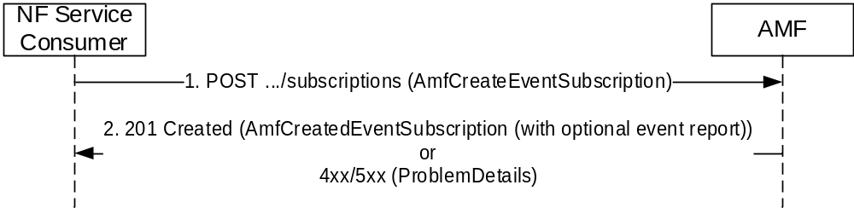
Figure 5.3.2.2.2-1 Subscribe for Creation
1. The NF Service Consumer shall send a POST request to create a subscription resource in the AMF. The payload body of the POST request shall contain a representation of the individual subscription resource to be created.
2. If the request is accepted, the AMF shall include a HTTP Location header to provide the location of a newly created resource (subscription) together with the status code 201 indicating the requested resource is created in the response message. If the NF Service Consumer has included the immediateFlag with value as "true" in the event subscription, the AMF shall include the current status of the events subscribed, if available (e.g. current location information is included if the subscribed event is LOCATION_REPORT). If the NF Service Consumer has set the event reporting option as ONE_TIME and if the AMF has included the current status of the events subscribed in the response, then the AMF shall not do any subsequent event notification for the events given in the AmfCreateEventSubscription parameter.
On failure, one of the HTTP status code listed in Table 6.1.3.2.3.1-3 shall be returned. The message body shall contain a ProblemDetails object with "detail" set to one of the corresponding application errors listed in Table 6.1.3.2.3.1-3.

5.3.2.2.3 Modification of a subscription
The Subscribe service operation is invoked by a NF Service Consumer, e.g. NEF, towards the AMF, when it needs to modify an existing subscription previously created by itself at the AMF.
The NF Service Consumer shall modify the subscription by using HTTP method PATCH with the URI of the individual subscription resource (see subclause 6.2.3.3) to be modified.
See also Figure 5.3.2.2.3-1 below.

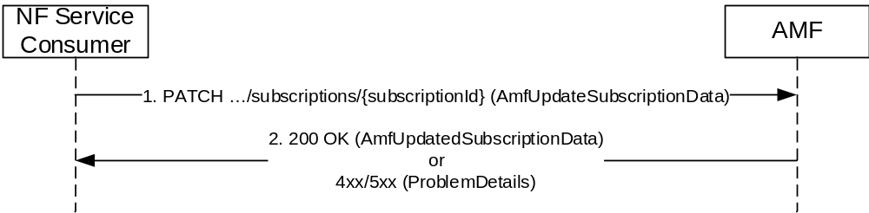
Figure 5.3.2.2.3-1 Modification of a Subscription
1. The NF Service Consumer shall send a PATCH request to modify a subscription resource in the AMF.
2. If the request is accepted, the AMF shall the representation of the modified subscription resource or its sub- resource together with the status code 200.
On failure, one of the HTTP status code listed in Table 6.1.3.3.3.1-3 shall be returned. The message body shall contain a ProblemDetails object with "detail" set to one of the corresponding application errors listed in Table 6.1.3.3.3.1-3.

5.3.2.3 Unsubscribe

5.3.2.3.1 General
The Unsubscribe service operation is invoked by a NF Service Consumer, e.g. NEF, towards the AMF, to remove an existing subscription previously created by itself at the AMF.
The NF Service Consumer shall unsubscribe to the subscription by using HTTP method PATCH with the URI of the individual subscription resource (see subclause 6.2.3.3) to be deleted.

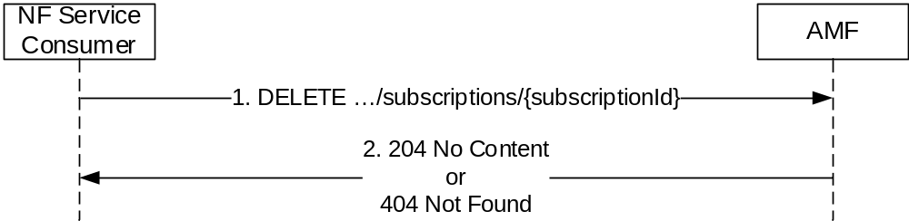
Figure 5.3.2.3.1-1 Unsubscribe a subscription
1. The NF Service Consumer shall send a DELETE request to delete an existing subscription resource in the AMF.
2. If the request is accepted, the AMF shall reply with the status code 204 indicating the resource identified by subscription ID is successfully deleted in the response message.
If the subscription resource identified by the subscriptionId doesn't exist on the AMF, the AMF shall reject the request using "404 Not Found" response code.

5.3.2.4 Notify

5.3.2.4.1 General
The Notify service operation is invoked by the AMF, to send a notification, towards the notification URI, when certain event included in the subscription has taken place.
The AMF shall use the HTTP method POST, using the notification URI received in the subscription creation as specified in subclause 5.3.2.2.2, including e.g. the subscription ID, Event ID(s) for which event has happened, notification co-relation ID provided by the NF service consumer at the time of event subscription, to send a notification. See Figure 5.3.2.4.1-1.
Additionally, the Notify service operation shall also be invoked by the AMF, when there is a change of AMF during UE mobility procedures and if the subscription Id changes (i.e. Registration procedures and Handover procedures).

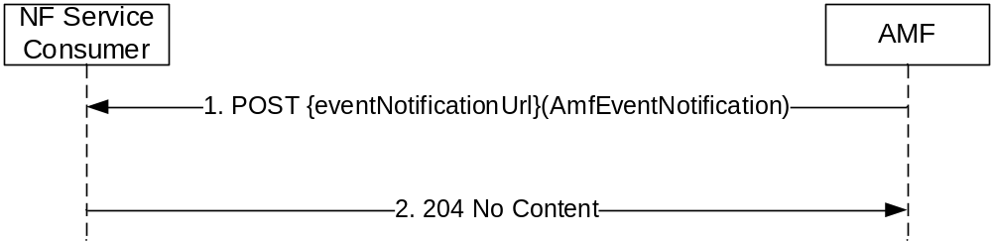
Figure 5.3.2.4.1-1 Notify
1. The AMF shall send a POST request to send a notification.
2. If the notification is received, the NF Service Consumer shall reply with the status code 204 indicating the notification is received, in the response message.

5.4 Namf_MT Service

5.4.1 Service Description
This subclause will provide a general description of the related service, include a description of the functional elements involved in the invocation of the service, i.e. AMF and NF Service Consumer(s), and list the service operations it supports.

5.4.2 Service Operations

5.4.2.1 Introduction
For the Namf_MT Service the following service operations are defined:
- EnableUEReachability

5.4.2.2 EnableUEReachability

5.4.2.2.1 General
The EnableUEReachability service operation is used in the following procedure:
- MT SMS over NAS in CM-IDLE state (see 3GPP TS 23.502 [3], subclause 4.13.3.6)
The EnableUEReachability service operation shall be invoked by the NF Service Consumer (e.g. SMSF) to enable the reachability of the UE. The service operation triggers the AMF to page the UE if the UE is in CM-IDLE state and the NAS message is to be sent over via 3GPP access. The AMF shall accept the request and respond to the SMSF immediately if the UE is in CM-CONNECTED state.
The NF Service Consumer shall invoke the service by using the HTTP method PUT, to update the state of the UE to be reachable, which is identified by the UE’s SUPI. The AMF shall update the state of the UE to CM-CONNECTED state by paging the UE if the UE is in CM-IDLE state. If the UE is not reachable, the AMF shall indicate to the NF Service Consumer in the response.

5.4.2.2.2 Procedure using Enable UE Reachability
Figure 5.4.2.2.1-1 shows a scenario where the NF Service Consumer (e.g. SMSF) sends a request to the AMF to make the UE reachable, towards the URI of a "ueReachInd" resource as specified in subclause 6.3.3.2.

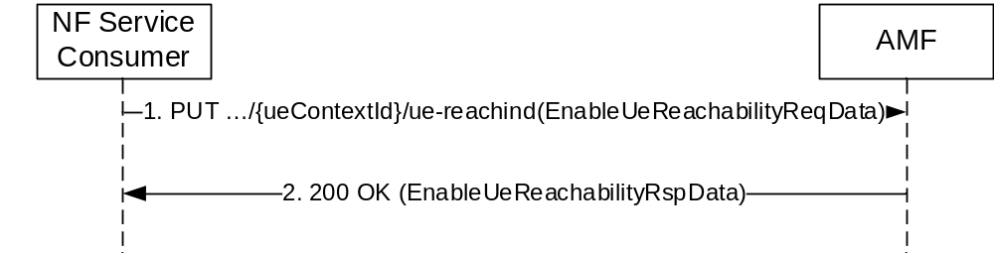
Figure 5.4.2.2.2-1: NF Service Consumer enables the reachability of the UE
1. The NF Service Consumer sends a PUT request to the resource representing the ueReachInd resource of the AMF. The payload body of the PUT request shall contain an "EnableUeReachabilityReqData" object.
2. On success, when UE is reachable or becomes reachable, "200 OK" shall be returned with payload containing an "EnableUeReachabilityRspData" object.
On failure, the appropriate HTTP status code (e.g. "403 Forbidden") with the message body containing a ProblemDetails object, with the "detail" attribute set to appropriate value (e.g. "UNABLE_TO_PAGE_UE", "CONTEXT_NOT_FOUND", "UE_NOT_RESPONDING" or the "NF_CONSUMER_REDIRECT_ONE_TXN") shall be returned in the PUT response. If the "CONTEXT_NOT_FOUND" is responded and the AMF knows which AMF is serving the UE, or the NF_CONSUMER_REDIRECT_ONE_TXN is responded, the AMF provides target AMF information which can be used by the NF consumer to resend the message to the target AMF.

5.5 Namf_Location Service

5.5.1 Service Description
The Namf_Location service is used by NF service consumers to request the AMF for initiating positioning requests and provide the location information. It is also used to subsequently notify the location change events towards the NF service consumers.

5.5.2 Service Operations
For the Namf_Location Service the following service operations are defined:
- ProvideLocation
- EventNotify

5.5.2.1 Introduction

5.5.2.2 ProvideLocation

5.5.2.2.1 General
The ProvideLocation service operation is used in the following procedure:
- 5GC-MT-LR Procedure without UDM Query (see 3GPP TS 23.502 [3], subclause 4.13.5.2)
- 5GC-MT-LR Procedure (see 3GPP TS 23.502 [3], subclause 4.13.5.3)
- Location Continuity for Handover of an Emergency session from NG-RAN (see 3GPP TS 23.502 [3], subclause 4.13.5.7)
The ProvideLocation service operation shall be invoked by the NF Service Consumer (e.g. GMLC) to request the current location of the UE. The service operation triggers the AMF to invoke the service towards the LMF.
The NF Service Consumer shall invoke the service by using the HTTP method POST, to request the current location of the UE identified by the SUPI or PEI.

5.5.2.2.2 Procedure using Provide Location
Figure 5.5.2.2.2-1 shows a scenario where the NF Service Consumer (e.g. GMLC) sends a request to the AMF to request the current location of the UE. The URI included in the request shall be {apiRoot}/namf-location/v1/{ueContextId}/provide. Where the ueContextId is composed by supi.{supi} or the pei.{pei}.

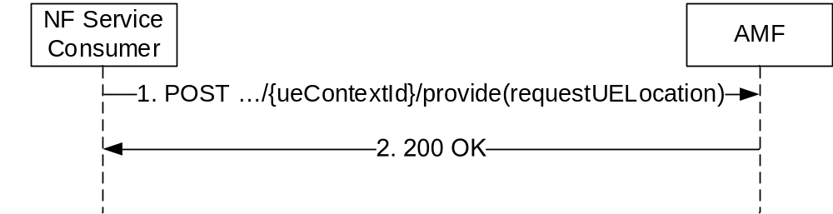
Figure 5.5.2.2.2-1: NF Service Consumer requests the location of the UE
1. The NF Service Consumer sends a POST request to the resource representing the locationInformation resource of the AMF. The payload body of the POST request may contain an indication of a location request from an emergency services client, the required QoS and Supported GAD shapes. If the NF service consumer wants the location change information to be notified (e.g. during a handover procedure), it also provides a callback URI on which the EventNotify service operation is executed (see clause 5.5.2.3).
2. On success, "200 OK" shall be returned, the payload body containing the LCS correlation identifier, the location estimate, its age and accuracy and the information about the positioning method. If the request is invoked during a handover the response body shall also include the target AMF node identifier as specified in clause 4.13.5.7 of 3GPP TS 23.502 [3].
Editor's Note: the description of failure cases is FFS.

5.5.2.3 EventNotify

5.5.2.3.1 General
The EventNotify service operation is used in the following procedure:
- 5GC-NI-LR Procedure (see 3GPP TS 23.502 [3], subclause 4.13.5.1)
- Location Continuity for Handover of an Emergency session from NG-RAN (see 3GPP TS 23.502 [3], subclause 4.13.5.7)
The EventNotify service operation notifies the NF Service Consumer (e.g. GMLC) the UE location related event information related to emergency sessions. The notification is delivered on the callback URI provided by the NF Service Consumer.
Editor's Note: How long the AMF can do the notification and whether there is a mechanism to stop the notification is FFS.
The operation is invoked by issuing a POST request to the callback URI of the NF Service Consumer.

5.5.2.3.2 Procedure using Event Notify
Figure 5.5.2.3.2-1 shows a scenario where the AMF notifies the UE location related event information related to emergency sessions to the NF Service Consumer.

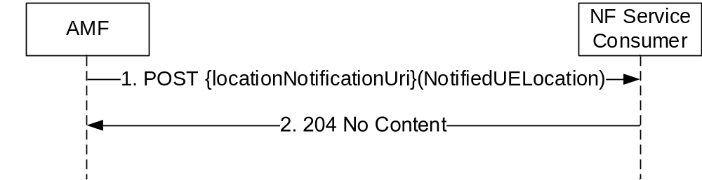
Figure 5.5.2.3.2-1: UE Location Notification
1. The AMF shall send a POST request to the callback URI provided by the NF service consumer. The request body shall include the type of location related event and UE Identification (SUPI or PEI), and may include the GPSI, Geodetic Location, Civic Location and the Position methods used.
2. On success, "204 No content" shall be returned by the NF Service Consumer.
Editor's Note: the description of failure cases is FFS.

6 API Definitions

6.1 Namf_Communication Service API

6.1.1 API URI
URIs of this API shall have the following root:
{apiRoot}/{apiName}/{apiVersion}/
where the "apiName" shall be set to "namf-comm" and the "apiVersion" shall be set to "v1" for the current version of this specification.

6.1.2 Usage of HTTP

6.1.2.1 General
HTTP/2, as defined in IETF RFC 7540 [19], shall be used as specified in clause 5 of 3GPP TS 29.500 [4].
HTTP/2 shall be transported as specified in subclause 5.3 of 3GPP TS 29.500 [4].
HTTP messages and bodies for the Namf_Communication service shall comply with the OpenAPI [23] specification contained in Annex A.

6.1.2.2 HTTP standard headers

6.1.2.2.1 General
The usage of HTTP standard headers shall be supported as specified in subclause 5.2.2 of 3GPP TS 29.500 [4].

6.1.2.2.2 Content type
The JSON format shall be supported. The use of the JSON format (IETF RFC 8259 [8]) shall be signalled by the content type "application/json" or "application/problem+json". See also subclause 5.4 of 3GPP TS 29.500 [4].
Multipart messages shall also be supported (see subclause 6.1.2.4) using the content type "multipart/related", comprising:
- one JSON body part with the "application/json" content type; and
- one or two binary body parts with 3gpp vendor specific content subtypes.
The 3gpp vendor specific content subtypes defined in Table 6.1.2.2.2-1 shall be supported.
Table 6.1.2.2.2-1: 3GPP vendor specific content subtypes
content subtype | Description
vnd.3gpp.ngap | Binary encoded payload, encoding NG Application Protocol (NGAP) IEs, as specified in subclause 9.4 of 3GPP TS 38.413 [12] (ASN.1 encoded).
vnd.3gpp.5gnas | Binary encoded payload, encoding a 5GS NAS message, as specified in 3GPP TS 24.501 [11].
NOTE: Using 3GPP vendor content subtypes allows to describe the nature of the opaque payload (e.g. NGAP or 5GS NAS information) without having to rely on metadata in the JSON payload.

See subclause 6.1.2.4 for the binary payloads supported in the binary body part of multipart messages.

6.1.2.3 HTTP custom headers

6.1.2.3.1 General
In this release of this specification, no custom headers specific to the Namf_Communication service are defined. For 3GPP specific HTTP custom headers used across all service based interfaces, see clause 5.2.3 of 3GPP TS 29.500 [4].

6.1.2.4 HTTP multipart messages
HTTP multipart messages shall be supported, to transfer opaque N1 Information (e.g. SM, LPP) and/or N2 Information (e.g. SM, NRPPa), in the following service operations (and HTTP messages):
- N1N2MessageTransfer Request and Response (POST);
- NonUeN2MessageTransfer Request and Response (POST);
- N1MessageNotify (POST);
- N2InfoNotify (POST).
HTTP multipart messages shall include one JSON body part and one or two binary body parts comprising:
- an N1payload, an N2 payload or both (see subclause 6.1.6.4).
The JSON body part shall be the "root" body part of the multipart message. It shall be encoded as the first body part of the multipart message. The "Start" parameter does not need to be included.
The multipart message shall include a "type" parameter (see IETF RFC 2387 [9]) specifying the media type of the root body part, i.e. "application/json".
NOTE: The "root" body part (or "root" object) is the first body part the application processes when receiving a multipart/related message, see IETF RFC 2387 [9]. The default root is the first body within the multipart/related message. The "Start" parameter indicates the root body part, e.g. when this is not the first body part in the message.
For each binary body part in a HTTP multipart message, the binary body part shall include a Content-ID header (see IETF RFC 2045 [10]), and the JSON body part shall include an attribute, defined with the RefToBinaryData type, that contains the value of the Content-ID header field of the referenced binary body part.

6.1.3 Resources

6.1.3.1 Overview

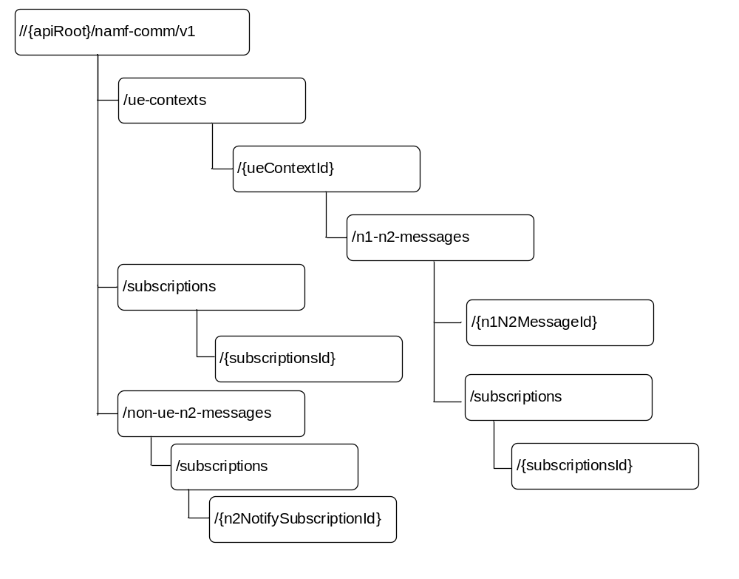
Figure 6.1.3.1-1: Resource URI structure of the Namf_Communication API
Table 6.1.3.1-1 provides an overview of the resources and applicable HTTP methods.
Table 6.1.3.1-1: Resources and methods overview
Resource name | Resource URI | HTTP method or custom operation | Description  (Mapped Service Operations)
Individual ueContext | …/ue-contexts/{ueContextId} | PATCH | UEContextTransfer, RegistrationCompleteNotify, N2InfoNotify
Individual ueContext | …/ue-contexts/{ueContextId} | PUT | CreateUEContext
Individual ueContext | …/ue-contexts/{ueContextId}/release | (POST)  release | ReleaseUEContext
Individual ueContext | …/ue-contexts/{ueContextId}/assignEbi | (POST)  assignEbi | EBIAssignment
Individual ueContext | …/ue-contexts/{ueContextId}/transfer | (POST)  transfer | UEContextTransfer
ueContext collection | …/ue-contexts | POST | N1MessageNotify
n1N2Message collection | …/ue-contexts/{ueContextId}/n1-n2-messages | POST | N1N2MessageTransfer
N1N2 Subscriptions Collection for Individual UE Contexts | ../ue-contexts/{ueContextId}/n1-n2-messages/subscriptions | POST | N1MessageSubscribe, N2InfoSubscribe.
N1N2 Individual Subscription | ../ue-contexts/{ueContextId}/n1-n2-messages/subscriptions/{subscriptionId} | PUT | AMFStatusChangeSubscribe
N1N2 Individual Subscription |  | DELETE | N1MessageUnSubscribe, N2InfoUnsubscribe
n1N2Message transfer status notification callback | {n1N2MessageTransferNotificationUrl}  (NF Service Consumer provided callback reference) | POST | Notify n1N2MessageTransfer status
subscriptions  collection | …/subscriptions | POST | AMFStatusChangeSubscribe
individual  subscription | …/subscriptions/{subscriptionId} | DELETE | AMFStatusChangeUnSubscribe
Non UE N2Messages collection | ../non-ue-n2-messages | (POST)  transfer | NonUEN2MessageTransfer
Non UE N2Messages Subscriptions collection | ../non-ue-n2-messages/subscriptions | POST | NonUEN2InfoSubscribe
Non UE N2 Message Notification Individual Subscription | ../non-ue-n2-messages/subscriptions/{n2NotifySubscriptionId} | DELETE | NonUEN2InfoUnsubscribe

6.1.3.2 Resource: Individual ueContext

6.1.3.2.1 Description
This resource represents the an individual ueContext identified by the ueContextId.
This resource is modelled as the Document resource archetype (see subclause C.1 of 3GPP TS 29.501 [5]).

6.1.3.2.2 Resource Definition
Resource URI:{apiRoot}/namf-comm/v1/ue-contexts/{ueContextId}
This resource shall support the resource URI variables defined in table 6.1.3.2.2-1.
Table 6.1.3.2.2-1: Resource URI variables for this resource
Name | Definition
apiRoot | See subclause 6.1.1
ueContextId | Represents the 5G Globally Unique Temporary Identifier (See 3GPP TS 23.501 [2] clause 5.9.4)  Pattern: "5g-guti-[0-9]{5,6}[0-9a-fA-F]{14}"  Or represents the Subscription Permanent Identifier (see 3GPP TS 23.501 [2] clause 5.9.2)  pattern: "(imsi-[0-9]{5,15}|nai-.+)"  Or represents the Permanent Equipment Identifier (see 3GPP TS 23.501 [2] clause 5.9.3)  pattern: "(imei-[0-9]{15})"

6.1.3.2.3 Resource Standard Methods

6.1.3.2.3.1 PUT
This method shall support the URI query parameters specified in table 6.1.3.2.3.1-1.
Table 6.1.3.2.3.1-1: URI query parameters supported by the PUT method on this resource
Name | Data type | P | Cardinality | Description
n/a

This method shall support the request data structures specified in table 6.1.3.2.3.1-2 and the response data structures and response codes specified in table 6.1.3.2.3.1-3.
Table 6.1.3.2.3.1-2: Data structures supported by the PUT Request Body on this resource
Data type | P | Cardinality | Description
UeContextCreateData | M | 1 | Defines the UE Context to be created.

Table 6.1.3.2.3.1-3: Data structures supported by the PUT Response Body on this resource
Data type | P | Cardinality | Response  codes | Description
UeContextCreatedData | M | 1 | 201 Created | This case represents the successful creation of a new UE Context.  Upon success, a response body is returned containing the newly created UE Context.
UeContextCreateError | M | 1 | 403 Forbidden | This case represents the creation of a new UE Context is not successful.  The "detail" attribute shall be set to:  - HANDOVER_FAILURE

6.1.3.2.4 Resource Custom Operations

6.1.3.2.4.1 Overview
Table 6.1.3.2.4.1-1: Custom operations
Custom operation URI | Mapped HTTP method | Description
{apiRoot}/namf-comm/v1/ue-contexts/{ueContextId}/release | POST | Release an existing individual ueContext resource.  It is used for the Release UE Context service operation.
{apiRoot}/namf-comm/v1/ue-contexts/{ueContextId}/assignEbi | POST | Assign EPS bearer ID(s) towards EPS bearer(s) mapped from QoS Flow(s), for a PDU session for the UE.  It is used for EBIAssignment service operation.
{apiRoot}/namf-comm/v1/ue-contexts/{ueContextId}/transfer | POST | Transfer an existing individual ueContext resource from old AMF to new AMF.  It is used for the UEContextTransfer service operation.

6.1.3.2.4.2 Operation: (POST) release

6.1.3.2.4.2.1 Description
This ueContextId identifies the individual ueContext resource is composed by UE's SUPI or PEI, See table 6.1.3.2.2-1.
The ueContextId shall be composed by UE's SUPI, except for the case:
- If the UE is emergency attached and the UE is UICCless;
- If the UE is emergency attached but SUPI is not authenticated.
The ueContextId shall be composed by UE's PEI for the case:
- If the UE is emergency attached and the UE is UICCless;
- If the UE is emergency attached but SUPI is not authenticated.

6.1.3.2.4.2.2 Operation Definition
This operation shall support the request data structures specified in table 6.1.3.2.4.2.2-1 and the response data structure and response codes specified in table 6.1.3.2.4.2.2-2.
Table 6.1.3.2.4.2.2-1: Data structures supported by the (POST) release Request Body on this resource
Data type | P | Cardinality | Description
UEContextRelease | M | 1 | The information used for releasing of the UE Context

Table 6.1.3.2.4.2.2-2: Data structures supported by the (POST) release Response Body on this resource
Data type | P | Cardinality | Response  codes | Description
n/a |  |  | 204 No Content | This case represents the handover is cancelled successfully.
ProblemDetails | M | 1 | 403 Forbidden | This represents the case when the AMF is able to understand the request but it is not able to fulfil the request due to errors (e.g. SUPI or PEI is unknown).

6.1.3.2.4.3 Operation: (POST) assignEbi

6.1.3.2.4.3.1 Description
This ueContextId identifies the individual ueContext resource is composed by UE's SUPI, see Table 6.1.3.2.2-1.

6.1.3.2.4.3.2 Operation Definition
This operation shall support the request data structures specified in table 6.1.3.2.4.3.2-1 and the response data structure and response codes specified in table 6.1.3.2.4.3.2-2.
Table 6.1.3.2.4.3.2-1: Data structures supported by the (POST) assignEbi Request Body on this resource
Data type | P | Cardinality | Description
AssignEbiData | M | 1 | The information required for AMF to allocate EPS bearer ID(s).

Table 6.1.3.2.4.3.2-2: Data structures supported by the (POST) assignEbi Response Body on this resource
Data type | P | Cardinality | Response  codes | Description
AssignedEbiData | M | 1 | 200 OK | Represent successful assignment of EPS bearer ID service operation, with the assigned EBIs included.  AMF may allocate only a subset of the requested EBIs, when not enough available EBI(s) can be allocated, e.g. when other PDU sessions with higher ARP have occupied too many EBIs. If the POST request body contained "releasedEbiList" the AMF shall release those EBI(s) and shall include the "releaseEbiList" IE in the POST response body.
AssignEbiError | M | 1 | 403 Forbidden | Represents failed assignment of EPS bearer ID service operation, with the cause phrase included.

6.1.3.2.4.4 Operation: (POST) transfer

6.1.3.2.4.4.1 Description
This ueContextId identifies the individual ueContext resource is composed by UE's 5G-GUTI, see Table 6.1.3.2.2-1.

6.1.3.2.4.4.2 Operation Definition
This operation shall support the request data structures specified in table 6.1.3.2.4.4.2-1 and the response data structure and response codes specified in table 6.1.3.2.4.4.2-2.
Table 6.1.3.2.4.4.2-1: Data structures supported by the (POST) transfer Request Body on this resource
Data type | P | Cardinality | Description
UeContextTransferReqData | M | 1 | Represents to start transferring of an individual ueContext resource from old AMF to new AMF.

Table 6.1.3.2.4.4.2-2: Data structures supported by the (POST) transfer Response Body on this resource
Data type | P | Cardinality | Response  codes | Description
UeContextTransferRspData | M | 1 | 200 OK | Indicates the transferring of the individual ueContext resource is started successfully.
ProblemDetails | M | 1 | 403 Forbidden | Indicates that AMF can understand the request but cannot fulfil the request due to errors. If the integrity check of the included complete registration message fails at the source AMF the "detail" attribute is set to  INTEGRITY_CHECK_FAIL.
ProblemDetails | M | 1 | 404 Not Found | If the AMF does not have the requested UE context, the AMF shall return this status code. The "detail" attribute is set to  CONTEXT_NOT_FOUND

6.1.3.3 Resource: subscriptions collection

6.1.3.3.1 Description
This resource represents a collection of subscriptions of NF service consumers to the status change of the AMF identified by the GUAMI(s).
This resource is modelled as the Collection resource archetype (see subclause C.2 of 3GPP TS 29.501 [5]).

6.1.3.3.2 Resource Definition
Resource URI:{apiRoot}/namf-comm/v1/subscriptions
This resource shall support the resource URI variables defined in table 6.1.3.3.2-1.
Table 6.1.3.3.2-1: Resource URI variables for this resource
Name | Definition
apiRoot | See subclause 6.1.1

6.1.3.3.3 Resource Standard Methods

6.1.3.3.3.1 POST
This method creates a new subscription. This method shall support the URI query parameters specified in table 6.1.3.3.3.1-1.
Table 6.1.3.3.3.1-1: URI query parameters supported by the POST method on this resource
Name | Data type | P | Cardinality | Description
n/a

This method shall support the request data structures specified in table 6.1.3.3.3.1-2 and the response data structures and response codes specified in table 6.1.3.3.3.1-3.
Table 6.1.3.3.3.1-2: Data structures supported by the POST Request Body on this resource
Data type | P | Cardinality | Description
SubscriptionData | M | 1 | The request body contains the input parameters for the subscription. These parameters include, e.g.:  - GUAMI(s)  - amfStatusUri

Table 6.1.3.3.3.1-3: Data structures supported by the POST Response Body on this resource
Data type | P | Cardinality | Response  codes | Description
CreatedSubscriptionData  (FFS) | M | 1 | 201 Created | This case represents the successful creation of a subscription.  Upon success, the HTTP response shall include a "Location" HTTP header that contains the resource URI of the created resource.

6.1.3.4 Resource: individual subscription

6.1.3.4.1 Description
This resource represents an individual subscription of a NF service consumer to the status change of the AMF identified by the GUAMI(s).
This resource is modelled as the Document resource archetype (see subclause C.1 of 3GPP TS 29.501 [5]).

6.1.3.4.2 Resource Definition
Resource URI: {apiRoot}/namf-comm/v1/subscriptions/{subscriptionId}
This resource shall support the resource URI variables defined in table 6.1.3.4.2-1.
Table 6.1.3.4.2-1: Resource URI variables for this resource
Name | Definition
apiRoot | See subclause 6.1.1
subscriptionId | Represents a specific subscription

6.1.3.4.3 Resource Standard Methods

6.1.3.4.3.1 DELETE
This method terminates an existing subscription. This method shall support the URI query parameters specified in table 6.1.3.4.3.1-1.
Table 6.1.3.4.3.1-1: URI query parameters supported by the DELETE method on this resource
Name | Data type | P | Cardinality | Description
n/a

This method shall support the request data structures specified in table 6.1.3.4.3.1-2 and the response data structures and response codes specified in table 6.1.3.4.3.1-3.
Table 6.1.3.4.3.1-2: Data structures supported by the DELETE Request Body on this resource
Data type | P | Cardinality | Description
n/a

Table 6.1.3.4.3.1-3: Data structures supported by the DELETE Response Body on this resource
Data type | P | Cardinality | Response  codes | Description
 |  |  | 204 No Content | This case represents a successful deletion of the subscription.
FFS

6.1.3.4.3.2 PUT
This method replaces an existing subscription completely. This method shall support the URI query parameters specified in table 6.1.3.4.3.2-1.
Table 6.1.3.4.3.2-1: URI query parameters supported by the PUT method on this resource
Name | Data type | P | Cardinality | Description
n/a

This method shall support the request data structures specified in table 6.1.3.4.3.2-2 and the response data structures and response codes specified in table 6.1.3.4.3.2-3.
Table 6.1.3.4.3.2-2: Data structures supported by the PUT Request Body on this resource
Data type | P | Cardinality | Description
SubscriptionData | M | 1 | The request body contains the input parameters for the subscription. These parameters include, e.g.:  - GUAMI(s)  - amfStatusUri

Table 6.1.3.4.3.2-3: Data structures supported by the PUT Response Body on this resource
Data type | P | Cardinality | Response  codes | Description
SubscriptionData | M | 1 | 200 OK | This case represents a successful replacement of the subscription.
ProblemDetails | M | 1 | 403 Forbidden | This case represents the failure update of an existing subscription.

6.1.3.5 Resource: Non UE N2Messages Collection

6.1.3.5.1 Description
This resource represents the collection on which custom operations to transfer the N2 message towards the 5G-AN are specified. This resource is modelled with the Collection resource archetype (see subclause C.2 of 3GPP TS 29.501 [5]).

6.1.3.5.2 Resource Definition
Resource URI: {apiRoot}/namf-comm/v1/non-ue-n2-messages
This resource shall support the resource URI variables defined in table 6.1.3.5.2-1.
Table 6.1.3.5.2-1: Resource URI variables for this resource
Name | Definition
apiRoot | See subclause 6.1.1

6.1.3.5.3 Resource Standard Methods
There are no resource standard methods for the non-ue-n2-messages collection resource in this release of this specification.

6.1.3.5.4 Resource Custom Operations

6.1.3.5.4.1 Overview
Table 6.1.3.5.4.1-1: Custom operations
Custom operaration URI | Mapped HTTP method | Description
{resourceUri}/transfer | POST | Transfer the N2 message to 5G-AN.

6.1.3.5.4.2 Operation: transfer

6.1.3.5.4.2.1 Description
The {resourceUri}/transfer custom operation is used to initiate a non UE associated N2 information transfer to the identified 5G-AN nodes. This custom operation uses the HTTP POST method.

6.1.3.5.4.2.2 Operation Definition
This operation shall support the request data structures specified in table 6.1.3.5.4.2.2-1 and the response data structure and response codes specified in table 6.1.3.5.4.2.2-2.
Table 6.1.3.5.4.2.2-1: Data structures supported by the POST Request Body on this resource
Data type | P | Cardinality | Description
N2InformationTransferReqData | M | 1 | Representation of the data to be sent to the 5G-AN node(s) by the AMF.

Table 6.1.3.5.4.2.2-2: Data structures supported by the POST Response Body on this resource
Data type | P | Cardinality | Response  codes | Description
N2InformationTransferRspData |  |  | 200 OK | Indicates AMF has successfully initiated the transferring of N2 Information to the AN..
ProblemDetails | M | 1 | 403 Forbidden | If the NF Service Consumer is not authorized to transfer non UE N2 message, the AMF shall return this status code with the ProblemDetails.

6.1.3.6 Resource: Non UE N2Messages Subscriptions Collection

6.1.3.6.1 Description
This resource represents the collection on which individual subscriptions for non UE N2 messages from the 5G-AN are stored. This resource is modelled with the Collection resource archetype (see subclause C.2 of 3GPP TS 29.501 [5]).

6.1.3.6.2 Resource Definition
Resource URI: {apiRoot}/namf-comm/v1/non-ue-n2-messages/subscriptions
This resource shall support the resource URI variables defined in table 6.1.3.6.2-1.
Table 6.1.3.6.2-1: Resource URI variables for this resource
Name | Definition
apiRoot | See subclause 6.1.1

6.1.3.6.3 Resource Standard Methods

6.1.3.6.3.1 POST
This method creates an individual N2 information subscription resource for non UE related N2 information. This method is used by NF Service Consumers (e.g. LMF, CBCF/PWS-IWF) to subscribe for notifications about non UE related N2 Information from a specific 5G-AN node, or from any 5G-AN node.
This method shall support the request data structures specified in table 6.1.3.6.3.1-2 and the response data structures and response codes specified in table 6.1.3.6.3.1-3.
Table 6.1.3.6.3.1-2: Data structures supported by the POST Request Body on this resource
Data type | P | Cardinality | Description
NonUeN2InfoSubscriptionCreateData | M | 1 | Representation of the subscription for N2 information notification.

Table 6.1.3.6.3.1-3: Data structures supported by the POST Response Body on this resource
Data type | P | Cardinality | Response  codes | Description
NonUeN2InfoSubscriptionCreatedData | M | 1 | 201 Created | This case represents the successful creation of the subscription for N2 information notification.  Upon success, a response body is returned containing the representation describing the status of the request. The Location header shall carry the location (URI) of the created subscription resource.
ProblemDetails | M | 1 | 403 Forbidden | If the NF Service Consumer is not authorized to subscribe for non UE N2 message notifications, the AMF shall return this status code with the ProblemDetails

6.1.3.6.4 Resource Custom Operations
There are no custom operations supported on this resource.

6.1.3.7 Resource: Non UE N2 Message Notification Individual Subscription

6.1.3.7.1 Description
This resource represents the individual subscription for the notifications of non UE specific N2 message types (e.g. NRPPa, PWS Notifications). This resource is modelled with the Store resource archetype (see subclause C.3 of 3GPP TS 29.501 [5]).

6.1.3.7.2 Resource Definition
Resource URI: {apiRoot}/namf-comm/v1/non-ue-n2-messages/subscriptions/{n2NotifySubscriptionId}
This resource shall support the resource URI variables defined in table 6.1.3.6.2-1.
Table 6.1.3.7.2-1: Resource URI variables for this resource
Name | Definition
apiRoot | See subclause 6.1.1
n2NotifySubscriptionId | Represents the individual subscription to the non UE specific N2 message notification.

6.1.3.7.3 Resource Standard Methods

6.1.3.7.3.1 DELETE
This method deletes an individual N2 message notification subscription resource for non UE associated N2 information. This method is used by NF Service Consumers (e.g. LMF) to unsubscribe for notifications about non UE related N2 information.
This method shall support the request data structures specified in table 6.1.3.7.3.1-2 and the response data structures and response codes specified in table 6.1.3.7.3.1-3.
Table 6.1.3.7.3.1-2: Data structures supported by the DELETE Request Body on this resource
Data type | P | Cardinality | Description
n/a

Table 6.1.3.7.3.1-3: Data structures supported by the DELETE Response Body on this resource
Data type | P | Cardinality | Response  codes | Description
n/a |  |  | 204 No Content

6.1.3.7.4 Resource Custom Operations
There are no custom operations supported on this resource.

6.1.3.8 Resource: N1N2 Subscriptions Collection for Individual UE Contexts

6.1.3.8.1 Description
This resource represents the collection under an individual UE context for storing the subscriptions for notifications of UE specific N1 and N2 message types. This resource is modelled as the Collection resource archetype (see subclause C.2 of 3GPP TS 29.501 [5]).

6.1.3.8.2 Resource Definition
Resource URI: {apiRoot}/namf-comm/v1/{ueContextId}/n1-n2-messages/subscriptions
This resource shall support the resource URI variables defined in table 6.1.3.8.2-1.
Table 6.1.3.8.2-1: Resource URI variables for this resource
Name | Definition
apiRoot | See subclause 6.1.1
ueContextId | Represents the Subscription Permanent Identifier (see 3GPP TS 23.501 [2] clause 5.9.2)  pattern: "(imsi-[0-9]{5,15}|nai-.+)"  Or represents the Permanent Equipment Identifier (see 3GPP TS 23.501 [2] clause 5.9.3)  pattern: "(imei-[0-9]{15})"

6.1.3.8.3.1 POST
This method creates an individual N1/N2 information subscription resource for UE related N1/N2 information. This method is used by NF Service Consumers (e.g. LMF) to subscribe for notifications about UE related N1/N2 Information.
This method shall support the request data structures specified in table 6.1.3.8.3.1-2 and the response data structures and response codes specified in table 6.1.3.8.3.1-3.
Table 6.1.3.8.3.1-2: Data structures supported by the POST Request Body on this resource
Data type | P | Cardinality | Description
UeN1N2InfoSubscriptionCreateData | C | 0..1 | Representation of the subscription for N1 and/or N2 information notification. It shall contain the information regarding N1 and/or N2 information to be notified and the callback URI for the respective notifications.

Table 6.1.3.8.3.1-3: Data structures supported by the POST Response Body on this resource
Data type | P | Cardinality | Response  codes | Description
UeN1N2InfoSubscriptionCreatedData | C | 0..1 | 201 Created | This case represents the successful creation of the subscription for N1 and/or N2 information notification.  Upon success, a response body is returned containing the representation describing the status of the request.  The Location header shall contain the location (URI) of the created subscription resource.

6.1.3.8.4 Resource Custom Operations
There are no custom operations supported on this resource.

6.1.3.9 Resource: N1N2 Individual Subscription

6.1.3.9.1 Description
This resource represents the individual subscription for the subscription for notifications of UE specific N1 and N2 message types. This resource is modelled as the Document resource archetype (see subclause C.2 of 3GPP TS 29.501 [5]).

6.1.3.9.2 Resource Definition
Resource URI: {apiRoot}/namf-comm/v1/{ueContextId}/n1-n2-messages/subscriptions/{subscriptionId}
This resource shall support the resource URI variables defined in table 6.1.3.8.2-1.
Table 6.1.3.9.2-1: Resource URI variables for this resource
Name | Definition
apiRoot | See subclause 6.1.1
ueContextId | Represents the Subscription Permanent Identifier (see 3GPP TS 23.501 [2] clause 5.9.2)  pattern: "(imsi-[0-9]{5,15}|nai-.+)"  Or represents the Permanent Equipment Identifier (see 3GPP TS 23.501 [2] clause 5.9.3)  pattern: "(imei-[0-9]{15})"
subscriptionId | Represents the individual subscription to the UE specific N1/N2 message notification.

6.1.3.9.3.1 DELETE
This method deletes an individual N1/N2 message notification subscription resource for an individual UE. This method is used by NF Service Consumers (e.g. LMF) to unsubscribe for notifications about UE related N1/N2 information.
This method shall support the request data structures specified in table 6.1.3.9.3.1-2 and the response data structures and response codes specified in table 6.1.3.9.3.1-3.
Table 6.1.3.9.3.1-2: Data structures supported by the DELETE Request Body on this resource
Data type | P | Cardinality | Description
n/a

Table 6.1.3.9.3.1-3: Data structures supported by the DELETE Response Body on this resource
Data type | P | Cardinality | Response  codes | Description
n/a |  |  | 204 No Content

6.1.3.9.4 Resource Custom Operations
There are no custom operations supported on this resource.

6.1.3.10 Resource: N1 N2 Messages Collection

6.1.3.10.1 Description
This resource represents the collection on which UE related N1 messages and N2 information transfer are initiated and the N1 information for the UE is stored temporarily until the UE is reachable. This resource is modelled with the Collection resource archetype (see subclause C.2 of 3GPP TS 29.501 [5]).

6.1.3.10.2 Resource Definition
Resource URI: {apiRoot}/namf-comm/v1/ue-contexts/{ueContextId}/n1-n2-messages
This resource shall support the resource URI variables defined in table 6.1.3.10.2-1.
Table 6.1.3.10.2-1: Resource URI variables for this resource
Name | Definition
apiRoot | See subclause 6.1.1
ueContextId | Represents the Subscription Permanent Identifier (see 3GPP TS 23.501 [2] clause 5.9.2)  pattern: "(imsi-[0-9]{5,15}|nai-.+)"  Or represents the Permanent Equipment Identifier (see 3GPP TS 23.501 [2] clause 5.9.3)  pattern: "(imei-[0-9]{15})"

6.1.3.10.3 Resource Standard Methods

6.1.3.10.3.1 POST
This method initiates a N1 message and/or N2 message transfer at the AMF and may create a resource to store the N1 message if the UE is not reachable or if the UE is paged.
This method shall support the request data structures specified in table 6.1.3.10.3.1-2 and the response data structures and response codes specified in table 6.1.3.3.3.1-3.
Table 6.1.3.10.3.1-1: Data structures supported by the POST Request Body on this resource
Data type | P | Cardinality | Description
N1N2MessageData | M | 1 | This contains:  - N1 message, if the NF Service Consumer requests to transfer an N1 message to the UE or;  - N2 information, if the NF Service Consumer requests to transfer an N2 information to the 5G-AN or;  - both, if the NF Service Consumer requests to transfer both an N1 message to the UE and an N2 information to the 5G-AN.

Table 6.1.3.10.3.1-3: Data structures supported by the POST Response Body on this resource
Data type | P | Cardinality | Response  codes | Description
N1N2MessageTransferRspData | M | 1 | 202 Accepted | This case represents the successful storage of the N1/N2 information at the AMF when asynchronous communication is invoked or when the AMF pages the UE. If the AMF pages the UE, it shall store the N1/N2 message information until the UE responds to paging.  The HTTP response shall include a "Location" HTTP header that contains the resource URI of the created resource.
N1N2MessageTransferRspData | M | 1 | 200 OK | This represents the case where the AMF is able to successfully transfer the N1/N2 message to the UE and/or the AN. The cause included in the response body shall be "N1_N2_TRANSFER_INITIATED" in this case..,
ProblemDetails | M | 1 | 307 Temporary Redirect | This represents the case when the related UE context is not fully available at the target NF Service Consumer (e.g. AMF) during a planned maintenance case (e.g. AMF planned maintenance without UDSF case). The "detail" attribute shall be set to one of the following application error:  - NF_CONSUMER_REDIRECT_ONE_TXN  See table 6.1.7.3-1 for the description of these errors  The Location header of the response shall be set to the target NF Service Consumer (e.g. AMF) to which the request is redirected.
ProblemDetails | M | 1 | 404 Not Found | This represents the case when the related UE is not found in the NF Service Consumer (e.g. AMF). The "detail" attribute shall be set to one of the following application error:  - CONTEXT_NOT_FOUND  See table 6.1.7.3-1 for the description of these errors
N1N2MessageTransferError | M | 1 | 409 Conflict | This represents the case where the AMF rejects the N1N2MessageTransfer request due to an ongoing paging for the same or higher priority request. The detail attribute of the ProblemDetails structure shall be set to the application error "HIGHER_PRIORITY_REQUEST_ONGOING" in this case.
N1N2MessageTransferError | M | 1 | 504 Gateway Timeout | This represents the case where the UE is not reachable at the AMF and the AMF is unable to page the UE. The detail attribute of the ProblemDetails structure shall be set to the application error "UE_NOT_REACHABLE" in this case.

6.1.4 Custom Operations without associated resources
There are no custom operations without associated resources supported on Namf_Communication Service.

6.1.5 Notifications

6.1.5.1 General
The notifications provided by the Namf_Communication service are specified in this clause.

6.1.5.2 AMF Status Change Notification

6.1.5.2.1 Description
If a NF service consumer (e.g. SMF) has subscribed to AMF Status Change on Namf_Communication Service, when AMF aware of a change of its own status, AMF shall create a notification including the current state, and shall deliver the notification to the call-back URI, following Subscribe/Notify mechanism defined in 3GPP TS 29.501 [2].

6.1.5.2.2 Notification Definition
Call-back URI: {amfStatusCallbackUri}
Call-back URI is provided by NF Service Consumer during creation of the subscription.

6.1.5.2.3 Notification Standard Methods

6.1.5.2.3.1 POST
This method shall support the request data structures specified in table 6.1.5.2.3.1-1 and the response data structures and response codes specified in table 6.1.5.2.3.1-2.
Table 6.1.5.2.3.1-1: Data structures supported by the POST Request Body
Data type | P | Cardinality | Description
AmfStatusChangeNotification | M | 1 | Representation of the AMF status change notification.

Table 6.1.5.2.3.1-2: Data structures supported by the POST Response Body
Data type | P | Cardinality | Response  codes | Description
n/a |  |  | 204 No Content | This case represents a successful notification of the AMF status change.
ProblemDetails | M | 1 | 403 Forbidden | This case represents the failure of the notification. More information shall be provided in the "detail" attribute of the "ProblemDetails" structure.

6.1.5.3 Non UE N2 Information Notification

6.1.5.3.1 Description
This resource represents the callback reference provided by the NF Service Consumer (e.g. LMF, CBCF/PWS-IWF) to receive notifications about N2 information that are not related to a UE.

6.1.5.3.2 Notification Definition
Callback URI: {n2NotifyCallbackUri}
This notification shall support the resource URI variables defined in table 6.1.5.2.2-1.
Table 6.1.5.3.2-1: Resource URI variables for this notification
Name | Definition
n2NotifyCallbackUri | Callback reference provided by the NF Service Consumer during the subscription to this notification.

6.1.5.3.3 Notification Standard Methods

6.1.5.3.3.1 POST
This method sends an N2 information notification to the NF Service Consumer (e.g. LMF, CBCF/PWS-IWF).
This method shall support the request data structures specified in table 6.1.5.3.3.1-2 and the response data structures and response codes specified in table 6.1.5.3.3.1-3.
Table 6.1.5.3.3.1-2: Data structures supported by the POST Request Body
Data type | P | Cardinality | Description
N2InformationNotification | M | 1 | Representation of the N2 information notification.

Table 6.1.5.3.3.1-3: Data structures supported by the POST Response Body
Data type | P | Cardinality | Response  codes | Description
n/a |  |  | 204 No Content | This case represents a successful notification of the N2 information to the NF service consumer.

6.1.5.4 N1 Message Notification

6.1.5.4.1 Description
This resource represents the callback reference provided by the NF Service Consumer (e.g. LMF) to receive notifications about N1 message from the UE (e.g. NRPP messages).

6.1.5.4.2 Notification Definition
Callback URI: { n1NotifyCallbackUri }
Callback URI is provided by the NF Service Consumer during the subscription to this notification. . The callback URI for N1 message notification may also be obtained from the NRF, if the NF Service Consumer has registered it in the NF Profile with the NRF.

6.1.5.4.3 Notification Standard Methods

6.1.5.4.3.1 POST
This method sends an N1 message notification to the NF Service Consumer (e.g. LMF).
This method shall support the request data structures specified in table 6.1.5.4.3.1-2 and the response data structures and response codes specified in table 6.1.5.4.3.1-3.
Table 6.1.5.4.3.1-2: Data structures supported by the POST Request Body
Data type | P | Cardinality | Description
N1MessageNotification | M | 1 | Representation of the N1 message notification.

Table 6.1.5.4.3.1-3: Data structures supported by the POST Response Body
Data type | P | Cardinality | Response  codes | Description
n/a |  |  | 204 No Content | This case represents a successful notification of the N1 message to the NF service consumer.
ProblemDetails | M | 1 | 403 Forbidden | This case represents, the NF service consumer failing to accept the processing of the notified N1 message. The detailed information shall be provided in the ProblemDetails structure.

6.1.5.5 UE Specific N2 Information Notification

6.1.5.5.1 Description
This resource represents the callback reference provided by the NF Service Consumer (e.g. LMF) to receive notifications about UE specific N2 information.

6.1.5.5.2 Notification Definition
Resource URI: {n2NotifyCallbackUri}
Callback URI is provided by the NF Service Consumer during the subscription to this notification.

6.1.5.5.3 Notification Standard Methods

6.1.5.5.3.1 POST
This method sends an N2 information notification to the NF Service Consumer (e.g. LMF).
This method shall support the request data structures specified in table 6.1.5.5.3.1-2 and the response data structures and response codes specified in table 6.1.5.5.3.1-3.
Table 6.1.5.5.3.1-2: Data structures supported by the POST Request Body
Data type | P | Cardinality | Description
N2InformationNotification | M | 1 | Representation of the N2 information notification.

Table 6.1.5.5.3.1-3: Data structures supported by the POST Response Body
Data type | P | Cardinality | Response  codes | Description
n/a |  |  | 204 No Content | This case represents a successful notification of the N2 information to the NF service consumer.

6.1.5.6 N1N2 Message Transfer Failure Notification

6.1.5.6.1 Description
This resource represents the callback reference provided by the NF Service Consumer (e.g. SMF) to receive notifications about failure to deliver N1 / N2 message.

6.1.5.6.2 Notification Definition
Resource URI: {n1n2TransferFailureCallbackUri}
Callback URI is provided by the NF Service Consumer during the UE specific N1N2MessageTransfer operation (see subclause 6.1.3.10.3.1.

6.1.5.6.3 Notification Standard Methods

6.1.5.6.3.1 POST
This method sends an N1/N2 message transfer failure notification to the NF Service Consumer (e.g. SMF).
This method shall support the request data structures specified in table 6.1.5.6.3.1-1 and the response data structures and response codes specified in table 6.1.5.6.3.1-3.
Table 6.1.5.6.3.1-1: Data structures supported by the POST Request Body
Data type | P | Cardinality | Description
N1N2MsgTxfrFailureNotification | M | 1 | Representation of the N1/N2 message transfer failure notification.

Table 6.1.5.6.3.1-2: Data structures supported by the POST Response Body
Data type | P | Cardinality | Response  codes | Description
n/a |  |  | 204 No Content | This case represents a successful notification of the N1 / N2 message transfer to the NF service consumer.

6.1.5.7 Registration Complete Notification

6.1.5.7.1 Description
This resource represents the callback reference provided by the NF Service Consumer (e.g. Source AMF) to receive notifications about completion of UE registration at the AMF.

6.1.5.7.2 Notification Definition
Resource URI: {notifyCallbackUri}.
Callback URI is provided by the NF Service Consumer during an earlier UE context transfer.

6.1.5.7.3 Notification Standard Methods

6.1.5.7.3.1 POST
This method sends an UE context registration complete notification to the NF Service Consumer (e.g. Source AMF).
This method shall support the request data structures specified in table 6.1.5.7.3.1-2 and the response data structures and response codes specified in table 6.1.5.7.3.1-3.
Table 6.1.5.7.3.1-1: Data structures supported by the POST Request Body
Data type | P | Cardinality | Description
UERegCompleteNotifData | M | 1 | Information about completed UE context transfer.

Table 6.1.5.7.3.1-2: Data structures supported by the POST Response Body
Data type | P | Cardinality | Response  codes | Description
n/a |  |  | 204 No Content | This case represents a successful notification of the UE registration completion to the NF service consumer.

6.1.6 Data Model

6.1.6.1 General
This subclause specifies the application data model supported by the API.
Table 6.1.6.1-1 specifies the data types defined for the Namf_Communication service based interface protocol.
Table 6.1.6.1-1: Namf_Communication specific Data Types
Data type | Section defined | Description
SubscriptionData | 6.1.6.2.2 | Information within AMFStatusChangeSubscribe
AmfStatusChangeNotification | 6.1.6.2.3 | Information within AMFStatusChangeNotify
AmfStatusInfo | 6.1.6.2.4 | Information within AMFStatusChangeNotify
AssignEbiData | 6.1.6.2.5 | Represents information needed for AMF to assign EBIs.
AssignedEbiData | 6.1.6.2.6 | Represents successful assignment of EBI(s).
AssignEbiFailed | 6.1.6.2.7 | Represents failed assignment of EBI(s)
SingleAssignedEbi | 6.1.6.2.8 | Represents an assigned EBI
UEContextRelease | 6.1.6.2.9 | Information within ReleaseUeContext
N2InformationTransferReqData | 6.1.6.2.10 | N2 information requested to be transferred to 5G AN.
NonUeN2InfoSubscriptionCreateData | 6.1.6.2.11 | Subscription information for non UE specific N2 information notification.
NonUeN2InfoSubscriptionCreatedData | 6.1.6.2.12 | The created subscription for non UE specific N2 information notification.
UeN1N2InfoSubscriptionCreateData | 6.1.6.2.13 | Subscription information for UE specific N1 and/or N2 information notification.
UeN1N2InfoSubscriptionCreatedData | 6.1.6.2.14 | The created subscription for UE specific N1 and/or N2 information notification.
N2InformationNotification | 6.1.6.2.15 | N2 information for notification.
N2InfoContainer | 6.1.6.2.16 | N2 information container.
N1MessageNotification | 6.1.6.2.17 | N1 message notification data structure.
N1MessageContainer | 6.1.6.2.18 | N1 Message Container
N1N2MessageData | 6.1.6.2.19 | N1/N2 message container
N1N2MessageTransferRspData | 6.1.6.2.20 | N1/N2 message transfer response
RegistrationContextContainer | 6.1.6.2.21 | Registration Context Container used to send the UE context information, N1 message from UE, AN address etc during Registration with AMF re-allocation procedure.
AreaOfValidity | 6.1.6.2.22 | Area of validity information for N2 information transfer
RefToBinaryData | 6.1.6.2.23 | Cross-Reference to binary data encoded within a binary body part in an HTTP multipart message.
UeContextTransferReqData | 6.1.6.2.24 | Represents to start transferring of an individual ueContext resource from old AMF to new AMF.
UeContextTransferRspData | 6.1.6.2.25 | Indicates the transferring of the individual ueContext resource is started successfully.
UeContext | 6.1.6.2.26 | Represents an individual ueContext resource
N2SmInformation | 6.1.6.2.27 | Represents the session management SMF related N2 information data part.
N2InfoContent | 6.1.6.2.28 | Represents a transparent N2 information content to be relayed by AMF.
NrppaInformation | 6.1.6.2.29 | Represents a NRPPa related N2 information data part.
PwsInformation | 6.1.6.2.30 | Represents a PWS related N2 information data part.
N1N2MsgTxfrFailureNotification | 6.1.6.2.31 | N1/N2 Message Transfer Failure Notification
N1N2MessageTransferError | 6.1.6.2.32 | N1/N2 Message Transfer Error
N2N2MsgTxfrErrDetail | 6.1.6.2.33 | N1/N2 Message Transfer Error Details
N2InformationTransferRspData | 6.1.6.2.34 | Indicates a successful delivery of N2 Information to the AN.
MmContext | 6.1.6.2.35 | Represents a Mobility Management Context in UE Context
SeafData | 6.1.6.2.36 | Represents SEAF data derived from data received from AUSF
NasSecurityMode | 6.1.6.2.37 | Indicates the NAS Security Mode
PduSessionContext | 6.1.6.2.38 | Represents a PDU Session Context in UE Context
NssaiMapping | 6.1.6.2.39 | Represents a map of a S-NSSAI in serving PLMN to a S-NSSAI in home PLMN.
MobilityRestrictions | 6.1.6.2.40 | Represents the mobility restrictions of the UE.
ServiceAreaRestriction | 6.1.6.2.41 | Indicates the service area restriction.
UERegCompleteNotifData | 6.1.6.2.42 | Provides information on the UE registration completion at a target AMF.
AssignEbiError | 6.1.6.3.43 | Represents the details regarding EBI assignment failure.
UeContextCreateData | 6.1.6.2.44 | Indicates a request to create an individual ueContext resource
UeContextCreatedData | 6.1.6.2.45 | Indicates a successful creation of an individual ueContext resource
UeContextCreateError | 6.1.6.2.46 | Represents an error when creating a UE context
NgRanTargetId | 6.1.6.2.47 | Indicates a NG RAN as target of the handover
EpsBearerId | 6.1.6.3.2 | EPS Bearer Identifier
NgApCause | 6.1.6.3.2 | Represents the NG AP cause code values
NgRanIdentifier | 6.1.6.3.2 | Represents the identifier of the NG RAN node
Ppi | 6.1.6.3.2 | Paging Policy Indicator
NasCount | 6.1.6.3.2 | Represents a NAS COUNT
5gmmCapability | 6.1.6.3.2 | Represents a 5GMM capability
UeSecurityCapability | 6.1.6.3.2 | Represents a UE Security Capability
S1UeNetworkCapability | 6.1.6.3.2 | Represents a S1 UE Network Capability
DrxParameter | 6.1.6.3.2 | Indicates the UE DRX Parameters
RfspIndex | 6.1.6.3.2
NsiId | 6.1.6.3.2
StatusChange | 6.1.6.3.3
N2InformationClass | 6.1.6.3.4
N1MessageClass | 6.1.6.3.5
N1N2MessageTransferCause | 6.1.6.3.6
UeContextTransferStatus | 6.1.6.3.7 | Describes the status of an individual ueContext resource in UE Context Transfer procedures
N2InformaitonTransferResult | 6.1.6.3.8 | Describes the result of N2 information transfer by AMF to the AN.
CipheringAlgorithm | 6.1.6.3.9 | Indicates the supported Ciphering Algorithm
IntegrityAlgorithm | 6.1.6.3.10 | Indicates the supported Integrity Algorithm
SmsSupport | 6.1.6.3.11 | Indicates the supported SMS delivery of a UE.

Table 6.1.6.1-2 specifies data types re-used by the Namf service based interface protocol from other specifications, including a reference to their respective specifications and when needed, a short description of their use within the Namf service based interface.
Table 6.1.6.1-2: Namf re-used Data Types
Data type | Reference | Comments
Snssai | 3GPP TS 29.571 [6]
Arp | 3GPP TS 29.571 [6]
PduSesisonId | 3GPP TS 29.571 [6]
Guami | 3GPP TS 29.571 [6] | Globally Unique AMF Identifier
AmfName | 3GPP TS 29.571 [6] | The name of the AMF
Supi | 3GPP TS 29.571 [6] | Subscription Permanent Identifier
IndicationFlags | 3GPP TS 29.502 [16] | Indication Flags
Cause | 3GPP TS 29.571 [6] | 5G-AN Cause
ProblemDetails | 3GPP TS 29.571 [6] | Detailed problems in failure case
supportedFeatures | 3GPP TS 29.571 [6] | Supported Features
TimeZone | 3GPP TS 29.571 [6]
UserLocation | 3GPP TS 29.571 [6]
AccessType | 3GPP TS 29.571 [6]
AllowedNSSAI | 3GPP TS 29.531 [18]
NfInstanceId | 3GPP TS 29.571 [6]
Uri | 3GPP TS 29.571 [6]
Ecgi | 3GPP TS 29.571 [6] | EUTRA Cell Identifier
Ncgi | 3GPP TS 29.571 [6] | NR Cell Identifer
Uint16 | 3GPP TS 29.571 [6]
5qi | 3GPP TS 29.571 [6] | 5G QoS Identifier
CorrelationID | 3GPP TS 29.572 [25] | LCS Correlation ID
Pei | 3GPP TS 29.571 [6]
Dnn | 3GPP TS 29.571 [6]
Gpsi | 3GPP TS 29.571 [6]
GroupId | 3GPP TS 29.571 [6]
PlmnId | 3GPP TS 29.571 [6]

6.1.6.2 Structured data types

6.1.6.2.1 Introduction
Structured data types used in Namf_Communication service are specified in this clause.

6.1.6.2.2 Type: SubscriptionData
Table 6.1.6.2.2-1: Definition of type SubscriptionData
Attribute name | Data type | P | Cardinality | Description
amfStatusUri | Uri | M | 1 | This IE shall include the callback URI to receive notification of AMF status change.
guamis | Guami | C | 0..N | This IE shall be absent for subscribing to status change for any GUAMI supported by the AMF, it shall be present for subscribing to specific GUAMIs supported by the AMF.

6.1.6.2.3 Type: AmfStatusChangeNotification
Table 6.1.6.2.3-1: Definition of type AmfStatusChangeNotification
Attribute name | Data type | P | Cardinality | Description
amfStatusInfo | AmfStatusInfo | M | 1..N | This IE shall contain the status change information about the AMF

6.1.6.2.4 Type: AmfStatusInfo
Table 6.1.6.2.4-1: Definition of type AmfStatusInfo
Attribute name | Data type | P | Cardinality | Description
guamis | Guami | M | 1..N | This IE shall contain the GUAMIs
statusChange | StatusChange | M | 1 | This IE shall contain the Status change of the related GUAMIs
targetamfName | AmfName | C | 0..1 | This IE shall contain the target AMF name in the AMF planned removal without UDSF scenario

6.1.6.2.5 Type: AssignEbiData
Table 6.1.6.2.5-1: Definition of type AssignEbi
Attribute name | Data type | P | Cardinality | Description
pduSessionId | PduSessionId | M | 1 | Represents the identifier of the PDU Session requesting EBI(s) to be assigned.
arps | array(Arp) | C | 1..N | Represents a ARP list mapped to the QoS flow(s)
releasedEbiList | array(EpsBearerId) | C | 0..N | This IE shall be present if the SMF needs to release the assigned EBI(s) from QoS flows (e.g. when the QoS flow is released).

6.1.6.2.6 Type: AssignedEbiData
Table 6.1.6.2.6-1: Definition of type AssignedEbi
Attribute name | Data type | P | Cardinality | Description
pduSessionId | PduSessionId | M | 1 | Represents the identifier of the PDU Session requesting EBI(s) to be assigned.
assignedEbis | array(SingleAssignedEbi) | M | 0..N | This IE shall be present if the AMF assigned the requested EBI(s). This IE shall contain the successfully assigned EBIs.
failedArpList | array(Arp) | C | 0..N | This IE shall be present if the AMF fails to allocate EBIs for a set of ARP(s).
releasedEbiList | array(EpsBearerId) | C | 0..N | This IE shall be present if the NF Service Consumer requested the release of EBI(s). This IE shall contain the list of EBI(s) released at the AMF.

6.1.6.2.7 Type: AssignEbiFailed
Table 6.1.6.2.7-1: Definition of type AssignEbiFailed
Attribute name | Data type | P | Cardinality | Description
pduSessionId | PduSessionId | M | 1 | Represents the identifier of the PDU Session requesting EBI(s) to be assigned.
failedArpList | array(Arp) | C | 0..N | This IE shall be present if the AMF fails to allocate EBIs for a set of ARPs.

6.1.6.2.8 Type: SingleAssignedEbi
Table 6.1.6.2.8-1: Definition of type SingleAssignedEbi
Attribute name | Data type | P | Cardinality | Description
arp | Arp | M | 1 | Represents the ARP for which an EBI is assigned.
ebi | EpsBearerId | M | 1 | Represents the assigned EPS Bearer Id.

6.1.6.2.9 Type: UEContextRelease
Table 6.1.6.2.9-1: Definition of type UEContextRelease
Attribute name | Data type | P | Cardinality | Description
supi | Supi | C | 0..1 | This IE shall be present if the UE is emergency registered and the SUPI is not authenticated.
indicationFlags | IndicationFlags | C | 0..1 | This IE shall be present if any of the applicable flags is set to 1:  - Unauthenticated SUPI: this flag shall be set to 1 if the SUPI is present in the message but is not authenticated and is for an emergency registered UE.
ngapCause | NgApCause | M | 1 | This IE shall contain the cause value received from the source 5G-AN in the handover Cancel message received over the NGAP interface.

6.1.6.2.10 Type: N2InformationTransferReqData
Table 6.1.6.2.10-1: Definition of type RequestedN2InformationTransfer
Attribute name | Data type | P | Cardinality | Description
tai | Tai | C | 0..N | This IE shall be included if the N2 information needs to be sent to the 5G-AN nodes that serve the list of tracking areas provided.
ecgi | Ecgi | C | 0..N | This IE shall be included if the N2 information needs to be sent to the 5G-AN nodes that correspond to the list of EUTRA cell Ids provided.
ncgi | Ncgi | C | 0..N | This IE shall be included if the N2 information needs to be sent to the 5G-AN nodes that correspond to the list of NR cell Ids provided.
nwIwf | NfInstanceId | C | 0..1 | This IE shall be included if the N2 information needs to be sent to an N3IWF.
ngRanId | NgRanIdentifier | C | 0..N | This IE shall be included if the N2 information needs to be sent to the list of NG RAN nodes provided.
n2Information | N2InfoContainer | M | 1 | This IE represents the information to be sent on the N2 interface to the identified 5G-AN node.
supportedFeatures | SupportedFeatures | C | 0..1 | This IE shall be present if at least one optional feature defined in subclause 6.1.8 is supported.

6.1.6.2.11 Type: NonUeN2InfoSubscriptionCreateData
Table 6.1.6.2.11-1: Definition of type NonUeN2InfoSubscriptionCreateData
Attribute name | Data type | P | Cardinality | Description
n3IwfId | NfInstanceId | C | 0..1 | This IE shall be included if the subscription is for N2 information from an N3IWF.
ngRanId | NgRanIdentifier | C | 0..N | This IE shall be included if the subscription is for N2 information from an NG RAN node.
n2InformationClass | N2InformationClass | M | 1 | This IE represents the class of N2 information that the NF Service Consumer requires to be notified.
n2NotifyCallbackUri | Uri | M | 1 | This IE represents the callback URI on which the N2 information shall be notified.
supportedFeatures | SupportedFeatures | C | 0..1 | This IE shall be present if at least one optional feature defined in subclause 6.1.8 is supported.

6.1.6.2.12 Type: NonUeN2InfoSubscriptionCreatedData
Table 6.1.6.2.12-1: Definition of type NonUeN2InfoSubscriptionCreatedData
Attribute name | Data type | P | Cardinality | Description
n2NotifySubscriptionId | string | M | 1 | Represents the Id created by the AMF for the subscription to notify a non UE related N2 information.
supportedFeatures | SupportedFeatures | C | 0..1 | This IE shall be present if at least one optional feature defined in subclause 6.1.8 is supported.

6.1.6.2.13 Type: UeN1N2InfoSubscriptionCreateData
Table 6.1.6.2.13-1: Definition of type UeN1N2InfoSubscriptionCreateData
Attribute name | Data type | P | Cardinality | Description
n2InformationClass | N2InformationClass | C | 1 | This IE shall be present if the NF service consumer subscribes for a N2 information notification. This IE represents the class of N2 information that the NF Service Consumer requires to be notified.
n2NotifyCallbackUri | Uri | C | 1 | This IE shall be present if the NF service consumer subscribes for a N2 information notification. This IE represents the callback URI on which the N2 information shall be notified.
n1MessageClass | N1MessageClass | C | 1 | This IE shall be present if the NF service consumer subscribes for a N1 message notification.  This IE represents the class of N1 message that the NF Service Consumer requires to be notified.
n1NotifyCallbackUri | Uri | C | 1 | This IE shall be present if the NF service consumer subscribes for a N1 message notification. This IE represents the callback URI on which the N1 message shall be notified.
supportedFeatures | SupportedFeatures | C | 0..1 | This IE shall be present if at least one optional feature defined in subclause 6.1.8 is supported.

6.1.6.2.14 Type: UeN1N2InfoSubscriptionCreatedData
Table 6.1.6.2.14-1: Definition of type UeN1N2InfoSubscriptionCreatedData
Attribute name | Data type | P | Cardinality | Description
n1n2NotifySubscriptionId | string | M | 1 | Represents the Id created by the AMF for the subscription to notify a UE related N1/N2 information.
supportedFeatures | SupportedFeatures | C | 0..1 | This IE shall be present if at least one optional feature defined in subclause 6.1.8 is supported.

6.1.6.2.15 Type: N2InformationNotification
Table 6.1.6.2.15-1: Definition of type N2InformationNotification
Attribute name | Data type | P | Cardinality | Description
n2NotifySubscriptionId | string | M | 1 | Represents the subscription Id for which the notification is generated. The NF Service Consumer uses this to co-relate the notification against a corresponding subscription.
n2InfoContainer | N2InfoContainer | M | 1 | Contains the N2 information related to the corresponding N2 information class.
lcsCorelationId | CorelationID | O | 0..1 | If the N2 information notified is for LCS procedures, the NF Service Producer (e.g. AMF) may include an LCS co-relation identifier.

6.1.6.2.16 Type: N2InfoContainer
Table 6.1.6.2.16-1: Definition of type N2InfoContainer
Attribute name | Data type | P | Cardinality | Description
n2InformationClass | N2InformationClass | M | 1 | This IE represents the class of N2 information to be transferred.
smInfo | array(N2SmInformation) | C | 0..N | This IE shall be present if session management N2 information is to be transferred. When present, it represents a session management SMF related N2 information data part.
nrppaInfo | NrppaInformation | C | 0..1 | This IE shall be present if location service related N2 information is to be transferred. When present, it represents a NRPPa related N2 information data part.
pwsInfo | PwsInformation | C | 0..1 | This IE shall be present if PWS related N2 information is to be transferred. When present, it represents a PWS related N2 information data part.
areaOfValidity | AreaOfValidity | O | 0..1 | This IE represents the list of TAs where the provided N2 information is valid. See subclause 5.2.2.2.7 and 4.2.3.3 of 3GPP TS 23.502 [3].

6.1.6.2.17 Type: N1MessageNotification
Table 6.1.6.2.17-1: Definition of type N1MessageNotification
Attribute name | Data type | P | Cardinality | Description
n1NotifySubscriptionId | string | M | 1 | Represents the subscription Id for which the notification is generated. The NF Service Consumer uses this to co-relate the notification against a corresponding subscription.
n1MessageContainer | N1MessageContainer | M | 1 | Contains the N1 message class and N1 message content.
lcsCorelationId | CorelationID | O | 0..1 | If the N1 message notified is for LCS procedures, the NF Service Producer (e.g. AMF) may include an LCS co-relation identifier.
registrationCtxtContainer | RegistrationContextContainer | C | 0..1 | If the N1 message notified is of type 5GMM (i.e. during Registration with AMF re-allocation procedure), the NF Service Producer (e.g. AMF) shall include this IE, if available.

6.1.6.2.18 Type: N1MessageContainer
Table 6.1.6.2.18-1: Definition of type N1MessageContainer
Attribute name | Data type | P | Cardinality | Description
n1MessageClass | N1MessageClass | M | 1 | This IE shall contain the N1 message class for the message content specified in n1MessageContent.
n1MessageContent | RefToBinaryData | M | 1 | This IE shall reference the N1 message binary data corresponding to the n1MessageClass. See 3GPP TS 24.501 [11]. See subclause 6.1.6.4.2.

6.1.6.2.19 Type: N1N2MessageData
Table 6.1.6.2.19-1: Definition of type N1N2MessageData
Attribute name | Data type | P | Cardinality | Description
n1MessageContainer | N1MessageContainer | C | 0..1 | This IE shall be included if a N1 message needs to be transferred.
n2InfoContainer | N2InfoContainer | C | 0..1 | This IE shall be included if a N2 information needs to be transferred.
lastMsgIndication | boolean | O | 0..1 | This flag when present shall indicate that the message transferred is the last message. (See subclause 4.13.3.3 of 3GPP TS 23.502 [2].
sessionId | string | O | 0..1 | This IE when present shall indicate the session Id for which the N1 / N2 message is initiated. The Session Id shall be set to the following depending on type of N1 / N2 message class:  - PDU Session ID if the N1 / N2 message class is SM;  - LCS Co-relation ID if the N1 message class is LPP (see subclause 4.13.5.4 of 3GPP TS 23.502 [2]);
anType | AccessType | O | 0..1 | This IE when present shall indicate the access network towards which the N1 / N2 message need to be transferred.
ppi | Ppi | O | 0..1 | This IE when present shall indicate the Paging policy to be applied. The paging policies are configured at the AMF. This IE shall not be present if the anType IE is “NON_3GPP_ACCESS”.
arp | Arp | O | 0..1 | This IE when present shall indicate the Allocation and Retention Priority of the PDU session for which the N1/N2 message transfer is initiated. This IE shall not be present when the N1/N2 message class is not SM.
5qi | 5qi | O | 0..1 | This IE when present shall indicate the 5QI associated with the PDU session for which the N1 / N2 message transfer is initiated. This IE shall not be present when the N1/N2 message class is not SM.
n1n2FailureTxfNotifURI | Uri | O | 0..1 | If included, this IE represents the callback URI on which the AMF shall notify the N1/N2 message transfer failure.
supportedFeatures | SupportedFeatures | C | 0..1 | This IE shall be present if at least one optional feature defined in subclause 6.1.8 is supported.

6.1.6.2.20 Type: N1N2MessageTransferRspData
Table 6.1.6.2.20-1: Definition of type N1N2MessageTransferRspData
Attribute name | Data type | P | Cardinality | Description
cause | N1N2MessageTransferCause | M | 1 | This IE shall provide the result of the N1/N2 message transfer processing at the AMF.
supportedFeatures | SupportedFeatures | C | 0..1 | This IE shall be present if at least one optional feature defined in subclause 6.1.8 is supported.

6.1.6.2.21 Type: RegistrationContextContainer
Table 6.1.6.2.21-1: Definition of type RegistrationContextContainer
Attribute name | Data type | P | Cardinality | Description
ueContext | UEContext | M | 1 | This IE shall contain the UE Context information.
localTimeZone | TimeZone | O | 0..1 | This IE contains the time zone UE is currently located.
anType | AccessType | M | 0..1 | This IE shall contain the current access type of the UE.
anN2IPv4Address | Ipv4Addr | C | 0..1 | If the Access Network N2 interface is using IPv4 address, this IE shall be included.
anN2IPv6Addr | Ipv6Addr | C | 0..1 | If the Access Network N2 interface is using IPv6 address, this IE shall be included.
allowedNSSAI | AllowedNSSAI | O | 0..1 | This IE contains the allowed NSSAI of the UE. This IE also contains the mapped home network S-NSSAI for each allowed S-NSSAI.

Editor's Note: The data type UEContext is to be defined after considering all information that is to be part of the UE context, including security context, if any.

6.1.6.2.22 Type: AreaOfValidity
Table 6.1.6.2.22-1: Definition of type AreaOfValidity
Attribute name | Data type | P | Cardinality | Description
taList | Tai | M | 0..N | An array of TAI representing the area of validity of the associated N2 information provided.

6.1.6.2.23 Type: RefToBinaryData
Table 6.1.6.2.23-1: Definition of type RefToBinaryData
Attribute name | Data type | P | Cardinality | Description
contentId | string | M | 1 | This IE shall contain the value of the Content-ID header of the referenced binary body part.

6.1.6.2.24 Type: UeContextTransferReqData
Table 6.1.6.2.24-1: Definition of type UeContextTransferReqData
Attribute name | Data type | P | Cardinality | Description
reason | FFS | M | 1 | Indicate the reason for the UEContextTransfer service request
regRequest | N1MessageContainer | O | 0..1 | If present, this IE shall refer to the registration request message which triggers the UE Context Transfer. The message class shall be "5GMM" and message content shall be reference to N1 Message Content binary data, See subclause 6.1.6.4.2.
supportedFeatures | SupportedFeatures | C | 0..1 | This IE shall be present if at least one optional feature defined in subclause 6.1.8 is supported.

6.1.6.2.25 Type: UeContextTransferRspData
Table 6.1.6.2.25-1: Definition of type UeContextTransferRspData
Attribute name | Data type | P | Cardinality | Description
ueContext | UeContext | M | 1 | Represents an individual ueContext resource after the modification is applied.
regCompleteNotifyUri | uri | M | 1 | Indicates the callback URI to deliver the notification for completion of UE registration on new AMF, which indicates UE context transfer is successful.
supportedFeatures | SupportedFeatures | C | 0..1 | This IE shall be present if at least one optional feature defined in subclause 6.1.8 is supported.

6.1.6.2.26 Type: UeContext
Table 6.1.6.2.26-1: Definition of type UeContext
Attribute name | Data type | P | Cardinality | Description
supi | Supi | C | 0..1 | This IE shall be present if available. When present, this IE contains SUPI of the UE.
supiUnauthInd | boolean | C | 0..1 | This IE shall be present if SUPI is present. When present, it shall indicate whether the SUPI is unauthenticated.
gpsi | array(Gpsi) | C | 0..N | This IE shall be present if available. When present, this IE shall contain the GPSI(s) of the UE.
pei | Pei | C | 0..1 | This IE shall be present if available. When present, this IE shall contain Mobile Equipment Identity of the UE.
groups | array(GroupId) | C | 0..N | This IE shall be present if the UE belongs to any subscribed internal group(s). When present, this IE shall list the subscribed internal group(s) to which the UE belongs to.
drxParameter | DrxParameter | C | 0..1 | This IE shall be present if available. When present, this IE shall contain the DRX parameter of the UE.
subRfsp | RfspIndex | C | 0..1 | This IE shall be present if available. When present, it shall indicate the subscribed RFSP Index of the UE.
usedRfsp | RfspIndex | C | 0..1 | This IE shall be present if available. When present, it shall indicate the used RFSP Index of the UE.
smsSupport | SmsSupport | M | 1 | Indicates whether the UE supports SMS delivery over NAS via 3GPP access, or via non-3GPP access, or via both the 3GPP and non-3GPP access.
smsfId | NfInstanceId | C | 0..1 | This IE shall be present if the SMS service for UE is activated. When present, it indicates the identifier of the SMSF network function instance serving the UE.
seafData | SeafData | C | 0..1 | This IE shall be present if available. When present, this IE contains the security data derived from data received from AUSF of the UE.
pcfId | NfInstanceId | C | 0..1 | This IE shall be present if available. When present, this IE indicates the identity PCF for AM Policy.
hpcfId | NfInstanceId | O | 0..1 | This IE indicates the identity of PCF for AM Policy in home PLMN, when the UE is roaming.
eventSubscriptions | Array(AmfEventSubscription) | C | 0..N | This IE shall be present if available. When present, it shall indicate the event subscription(s) targeting the UE.
mmContexts | array(MmContext) | C | 0..2 | This IE shall be present if available. When present, this IE contains the MM Contexts of the UE.
sessionContexts | array(PduSessionContext) | C | 0..N | This IE shall be present if available. When present, this IE contains the PDU Session Contexts of the UE.

6.1.6.2.27 Type: N2SmInformation
Table 6.1.6.2.27-1: Definition of type N2SmInformation
Attribute name | Data type | P | Cardinality | Description
pduSessionId | PduSessionId | M | 1 | Indicates the PDU Session Identity
n2InfoContent | N2InfoContent | C | 0..1 | This IE shall be present if a SMF related IE should be transferred. When present, the IE contains one of NGAP SMF related IEs specified in subclause 9.3.4 of 3GPP TS 38.413 [12].
nasPdu | N1MessageContainer | C | 0..1 | This IE shall be present if NAS messages should be transfer between UE and SMF for session management function. When present, it represents the NAS PDU to be carried over N2 between SMF and AN/UE.
sNssai | Snssai | C | 0..1 | This IE shall be present if network slice information to be transferred for session management. When present, the IE indicates the network slice the PDU session belongs to.
subjectToHo | boolean | C | 0..1 | This IE shall be present if n2InfoContent carries a " Handover Required Transfer" IE. When present, it Indicates whether the PDU session shall be subject to handover to the target node.

6.1.6.2.28 Type: N2InfoContent
Table 6.1.6.2.28-1: Definition of type N2InfoContent
Attribute name | Data type | P | Cardinality | Description
ngapIeType | Uinteger | M | 1 | Indicates the NGAP IE type of the ngapData. Its value is numeric code of the NGAP IE type defined in ASN.1.
ngapData | RefToBinaryData | M | 1 | This IE reference the N2 information binary data corresponding to the N2 information class. See subclause 6.1.6.4.3.

6.1.6.2.29 Type: NrppaInformation
Table 6.1.6.2.29-1: Definition of type NrppaInformation
Attribute name | Data type | P | Cardinality | Description
routingId | RoutingID (FFS) | M | 1 | This IE is used to identify an LMF within the 5GC.
nrppaPdu | N2InfoContent | M | 1 | This IE represents the encoded NGAP NAPPa-PDU IE, which is transparent to AMF.

6.1.6.2.30 Type: PwsInformation
Table 6.1.6.2.30-1: Definition of type PwsInformation
Attribute name | Data type | P | Cardinality | Description
messageIdentifier | Uint16 | M | 1 | Identifies the warning message
serialNumber | Uint16 | M | 1 | identifies a particular message from the source and type indicated by the Message Identifier
pwsContainer | N2InfoContent | M | 1 | This IE represents the PWS N2 information data part to be relayed between CBCF and AN. See subclause 6.1.6.4.3.
sendN2Container | boolean | O | 0..1 | This IE shall be present if the AMF is expected to send the n2Information it has received from the RAN nodes to the Service Consumer. When present, it represents the value of Send-Broadcast-Completed-Area-List IE or the Send-Broadcast-Cancelled-Area-List IE.
omcId | OmcIdentifier | O | 0..1 | IE shall be present if the AMF is required to write the n2Information it has received from the RAN nodes into trace records on the OMC. When present, it indicates the identifier of OMC.

6.1.6.2.31 Type: N1N2MsgTxfrFailureNotification
Table 6.1.6.2.31-1: Definition of type N1N2MsgTxfrFailureNotification
Attribute name | Data type | P | Cardinality | Description
cause | N1N2MessageTransferCause | M | 1 | This IE shall provide the result of the N1/N2 message transfer at the AMF.
n1n2MsgDataUri | Uri | M | 1 | This IE shall contain the N1N2MessageTransfer request resource URI returned in Location header when the message transfer was initiated (See subclause 6.1.3.3.1.3)

6.1.6.2.32 Type: N1N2MessageTransferError
Table 6.1.6.2.32-1: Definition of type N1N2MessageTransferError
Attribute name | Data type | P | Cardinality | Description
error | ProblemDetails | M | 1 | This IE shall provide the result of the N1/N2 message transfer processing at the AMF.
errInfo | N2N2MsgTxfrErrDetail | O | 0..1 | This IE may be included to provide additional information related to the error.

6.1.6.2.33 Type: N2N2MsgTxfrErrDetail
Table 6.1.6.2.33-1: Definition of type N2N2MsgTxfrErrDetail
Attribute name | Data type | P | Cardinality | Description
retryAfter | Uinteger | C | 0..1 | This IE shall be included if the AMF requests the NF Service Consumer to retry the N1/N2 message transfer request that was rejected after a timeout. The value shall be in seconds.

6.1.6.2.34 Type: N2InformationTransferRspData
Table 6.1.6.2.34-1: Definition of type N2InformationTransferRspData
Attribute name | Data type | P | Cardinality | Description
result | N2InformaitonTransferResult | M | 1 | This IE shall provide the result of the N2 information transfer processing at the AMF.
supportedFeatures | SupportedFeatures | C | 0..1 | This IE shall be present if at least one optional feature defined in subclause 6.1.8 is supported.

6.1.6.2.35 Type: MmContext
Table 6.1.6.2.35-1: Definition of type MmContext
Attribute name | Data type | P | Cardinality | Description
accessType | accessType | M | 1 | This IE shall contain the access type of the MM context.
nasSecurityMode | NasSecurityMode | C | 0..1 | This IE shall be present if available in 3GPP access MM context. When present, this IE shall contain the used NAS security mode of the UE.
nasDownlinkCount | nasCount | C | 0..1 | This IE shall be present if available in 3GPP access MM context. When present, this IE shall contain the NAS downlink count of the UE.
nasUplinkCount | nasCount | C | 0..1 | This IE shall be present if available in 3GPP access MM context. When present, this IE shall contain the NAS uplink count of the UE.
5gmmCapability | 5gmmCapability | C | 0..1 | This IE shall be present if available in 3GPP access MM context. When present, this IE shall contain 5G MM capability of the UE.
mobilityRestrictions | MobilityRestrictions | C | 0..1 | This IE shall be present if available. When present, this IE shall contain the mobility restrictions information of the UE.
ueSecurityCapability | UeSecurityCapability | C | 0..1 | This IE shall be present if available in 3GPP access MM context. When present, this IE shall contain the UE security capability
s1UeNetworkCapability | S1UeNetworkCapability | C | 0..1 | This IE shall be present if available in 3GPP access MM context. When present, this IE shall contain the S1 UE network capabilities.
allowedNssai | array(Snssai) | C | 0..N | This IE shall be present if available. When present, this IE shall contain the allowed NSSAI for the access type.
nssaiMapping | array(SnssaiMapping) | C | 0..N | This IE shall be present if available. When present, this IE shall contain the mapping of the allowed NSSAI for the UE.
nsInstances | array(NsiId) | C | 0..N | This IE shall be present if available. When present, it shall indicate the Network Slice Instances selected for the UE.

6.1.6.2.36 Type: SeafData
Table 6.1.6.2.36-1: Definition of type SeafData
Attribute name | Data type | P | Cardinality | Description
ngKsi | NgKsi | M | 1 | Indicates the KSI
keyAmf | KeyAmf | M | 1 | Indicates the K_{amf} or K’_{amf}
Input (FFS) | Input (FFS) | C | 0..1 | Indicates the <Input> when keyAmf is K’_{amf}

Editor's Note: The <Input> parameter should be aligned with 33.501[x] which is FFS.

6.1.6.2.37 Type: NasSecurityMode
Table 6.1.6.2.37-1: Definition of type NasSecurityMode
Attribute name | Data type | P | Cardinality | Description
integrityAlgorithm | IntegrityAlgorithm | M | 1 | Indicates the integrity protection algorithm
cipheringAlgorithm | CipheringAlgorithm | M | 1 | Indicates the ciphering algorithm

6.1.6.2.38 Type: PduSessionContext
Table 6.1.6.2.38-1: Definition of type PduSessionContext
Attribute name | Data type | P | Cardinality | Description
pduSessionId | PduSessionId | M | 1 | Indicates the identifier of the PDU Session.
smContextRef | Uri | M | 1 | Indicates the SM context reference.
sNssai | Snssai | M | 1 | Indicates the associated S-NSSAI for the PDU Session.
dnn | Dnn | M | 1 | Indicates the Data Network Name.
accessType | AccessType | M | 1 | Indicates the access type of the PDU session.
allocatedEbiList | array(EpsArpMapping) | M | 1..N | This IE shall contain the EBIs currently allocated to the PDU session.
hsmfId | NfInstanceId | C | 0..1 | This IE shall be present for non-roaming and home-routed PDU sessions. When present, it shall indicate the associated home SMF for the PDU Session.
vsmfId | NfInstanceId | C | 0..1 | This IE shall be present if roaming PDU sessions. When present, it shall indicate the associated visit SMF for the PDU Session.
nsInstance | NsiId | C | 1 | This IE shall be present if available. When present, this IE shall Indicate Network Slice Instance for the PDU Session

6.1.6.2.39 Type: NssaiMapping
Table 6.1.6.2.39-1: Definition of type NssaiMapping
Attribute name | Data type | P | Cardinality | Description
mappedSnssai | Snssai | M | 1 | Indicates the mapped S-NSSAI in the serving PLMN
hSnssai | Snssai | M | 1 | Indicates the S-NSSAI in home PLMN

6.1.6.2.40 Type: MobilityRestrictions
Table 6.1.6.2.40-1: Definition of type MobilityRestrictions
Attribute name | Data type | P | Cardinality | Description
ratRestriction | array(RatType) | C | 0..N | This IE shall be present if available. When present, this IE shall Indicate the RAT types are not allowed for the UE
forbiddenArea | array(Tai) (FFS) | C | 0..N | This IE shall be present if available. When present, this IE shall Indicate the Forbidden Area of the UE
saRestriction | ServiceAreaRestriction | C | 0..1 | This IE shall be present if available. When present, this IE shall Indicate the Service Area Restriction of the UE

6.1.6.2.41 Type: ServiceAreaRestriction
Table 6.1.6.2.41-1: Definition of type ServiceAreaRestriction
Attribute name | Data type | P | Cardinality | Description
allowedTais | array(Tai) | C | 0..N | This IE shall be present if available. When present, this IE shall indicate the allowed TA(s) of the UE.
nonAllowedTais | array(Tai) | C | 0..N | This IE shall be present if available. When present, this IE shall indicate the non-allowed TA(s) for the UE.
maxAllowedTais | integer | O | 0..1 | This IE may be present if "allowedTais" is present. When present, this IE shall indicate the maximum number of allowed TAIs
NOTE: Either "allowedTais" or "nonAllowedTais" shall be present at the same time.

6.1.6.2.42 Type: UERegCompleteNotifData
Table 6.1.6.2.42-1: Definition of type UERegCompleteNotifData
Attribute name | Data type | P | Cardinality | Description
transferStatus | UeContextTransferStatus | M | 1 | This IE shall indicate if the previous UE context transfer was completed.

6.1.6.2.43 Type: AssignEbiError
Table 6.1.6.2.43-1: Definition of type AssignEbiError
Attribute name | Data type | P | Cardinality | Description
error | ProblemDetails | M | 1 | Represents the application error information. The application level error cause shall be encoded in the "cause" attribute.
failureDetails | AssignEbiFailed | M | 1 | Describes the detailed cause phrase why the request has failed.

6.1.6.2.44 Type: UeContextCreateData
Table 6.1.6.2.44-1: Definition of type UeContextCreateData
Attribute name | Data type | P | Cardinality | Description
ueContext | UeContext | M | 1 | Represents an individual ueContext resource to be created
handoverType | HandoverType (FFS) | M | 1 | Represents the handover type, e.g. IntraNR.
targetId | NgRanTargetId | M | 1 | Represents the identification of target RAN
sourceToTargetData | N2InfoContainer | M | 1 | This IE shall be included to contain the "Source to Target Transparent Container" if the message is used for N2 based handover procedure
pduSessions | SmInformation | M | 1..N | This IE shall represent the information of PDN session(s) for handover
ngapCause | NgAPCause | C | 0..1 | This IE shall be present, if available. When present, it shall represent the NGAP Cause received from RAN.
supportedFeatures | SupportedFeatures | C | 0..1 | This IE shall be present if at least one optional feature defined in subclause 6.1.8 is supported.

Editor’s Note: The definition of the Handover Type is FFS in 3GPP TS 38.413 [12], adaptation required when the definition is done.

6.1.6.2.45 Type: UeContextCreatedData
Table 6.1.6.2.45-1: Definition of type UeContextCreatedData
Attribute name | Data type | P | Cardinality | Description
ueContext | UeContext | M | 1 | Represents the newly created individual ueContext resource
targetToSourceData | N2InfoContainer | M | 1 | This IE shall contain the "Target to Source Transparent Container".
pduSessions | array(N2SmInfoContent) | M | 1..N | This IE shall indicate the information of PDN Session(s) for handover.
ngapCause | NgAPCause | C | 0..1 | This IE shall be present, if available. When present, it shall represent the NGAP cause received from RAN.
failedSessions | array(PduSessionId) | C | 0..N | This IE shall be included to contain the PDN Session Id list of PDU Sessions failed to be setup, if any.
supportedFeatures | SupportedFeatures | C | 0..1 | This IE shall be present if at least one optional feature defined in subclause 6.1.8 is supported.

6.1.6.2.46 Type: UeContextCreateError
Table 6.1.6.2.46-1: Definition of type UeContextCreateError
Attribute name | Data type | P | Cardinality | Description
error | ProblemDetails | M | 1 | Represents the detailed application error information. The application level error cause shall be encoded in the "cause" attribute.
ngapCause | NgAPCause | C | 0..1 | This IE shall be present, if available. When present, it shall represent the NGAP Cause received from RAN.

6.1.6.2.47 Type: NgRanTargetId
Table 6.1.6.2.47-1: Definition of type NgRanTargetId
Attribute name | Data type | P | Cardinality | Description
plmnId | PlmnId | M | 1 | Indicates the identity of the PLMN that the RAN node belongs to.
ranNodeId | string | M | 1 | Indicates the identity of the RAN node.  This IE shall be formatted in pattern:  RanNodeIDType + "-" + Value  The RanNodeIDType part shall be a string prefix as specified below:  - gNB ID: "gNB"  - Macro Ng-eNB ID: "Macro"  - Long Macro Ng-eNB ID: "LMacro"  - Short Macro Ng-eNB ID: "SMacro"  The Value part is value of the RAN Node ID in hexadecimal representation. Each character in the string shall take a value of "0" to "9" or "A" to "F" and shall represent 4 bits. The most significant character representing the 4 most significant bits of the RAN Node ID shall appear first in the string, and the character representing the 4 least significant bit of the RAN Node ID shall appear last in the string.  Examples:  "gNB-382A3F47" indicates a gNB ID with value 0x382A3F47  "sMacro-F4B89" indicates a Short Macro Ng-eNB ID with value 0xF4B89
tai | Tai | M | 1 | Indicates the target Tai.

Editor's Note: Regular expression pattern should be provided for "ranNodeId".

6.1.6.3 Simple data types and enumerations

6.1.6.3.1 Introduction
This subclause defines simple data types and enumerations that can be referenced from data structures defined in the previous subclauses.

6.1.6.3.2 Simple data types
The simple data types defined in table 6.1.6.3.2-1 shall be supported.
Table 6.1.6.3.2-1: Simple data types
Type Name | Type Definition | Description
EpsBearerId | Uinteger | Unsigned integer identifying an EPS bearer, within the range 0 to 15, as specified in 3GPP TS 24.007 [15].
NgApCause | Uinteger | This represents the NG AP cause code values as specified in 3GPP TS 38.413 [12].
NgRanIdentifier | string | Represents the identifier of the NG RAN node
Ppi | Uinteger | This represents the Paging Policy Indication. The value is within the range 0 – 63.
NasCount | Uinteger | Unsigned integer identifying the NAS COUNT as specified in 3GPP TS 33.501[x]
5gmmCapability | Bytes | String with format "byte" as defined in OpenAPI Specification [23], i.e. base64-encoded characters, encoding the "5GMM capability" IE as specified in subclause 9.8.3.1 of 3GPP TS 24.501 [11].
UeSecurityCapability | Bytes | String with format "byte" as defined in OpenAPI Specification [23], i.e. base64-encoded characters, encoding the " UE security capability" IE as specified in subclause 9.8.3.55 of 3GPP TS 24.501 [11].
S1UeNetworkCapability | Bytes | String with format "byte" as defined in OpenAPI Specification [23], i.e. base64-encoded characters, encoding the " S1 UE network capability" IE as specified in subclause 9.8.3.44 of 3GPP TS 24.501 [11].
DrxParameter | Bytes | String with format "byte" as defined in OpenAPI Specification [23], i.e. base64-encoded characters, encoding the "DRX Parameters" IE as specified in subclause 10.5.5.6 of 3GPP TS 24.008 [22]
RfspIndex | Uinteger | Unsigned integer represents the "Subscriber Profile ID for RAT/Frequency Priority (SPID)" as specified in 3GPP TS 36.413 [24], valid value between 1 and 256.
NsiId | FFS

6.1.6.3.3 Enumeration: StatusChange
Table 6.1.6.3.3-1: Enumeration StatusChange
Enumeration value | Description
"AMF_UNAVAILABLE" | The AMF is unavailable to serve the UEs identified by the GUAMI(s).
"AMF_AVAILABLE" | The AMF is available to serve the UEs identified by the GUAMI(s).

6.1.6.3.4 Enumeration: N2InformationClass
Table 6.1.6.3.4-1: Enumeration N2InformationClass
Enumeration value | Description
"SM" | The N2 information of SM type
"NRPPa" | The N2 information of NRPPa type.

6.1.6.3.5 Enumeration: N1MessageClass
Table 6.1.6.3.5-1: Enumeration N1MessageClass
Enumeration value | Description
"5GMM" | The whole NAS message as received (for e.g. used in forwarding the Registration message to target AMF during Registration procedure with AMF redirection).
"SM" | The N1 message of SM type
"LPP" | The N1 message of LPP type.
"SMS" | The N1 message of SMS type.

Editor's Note: N2InformationClass and N1MessageClass can potentially be used in 3GPP TS 29.510 as well for registering the callback URI for notifications. If it is agreed, then the above enumerations need to be moved to 3GPP TS 29.571.

6.1.6.3.6 Enumeration: N1N2MessageTransferCause
Table 6.1.6.3.6-1: Enumeration N1N2MessageTransferCause
Enumeration value | Description
"ATTEMPTING_TO_REACH_UE" | This cause code represents the case where the AMF has initiated paging to reach the UE in order to deliver the N1 message.
"N1_N2_TRANSFER_INITIATED" | This cause code represents the case where the AMF has initiated the N1/N2 message transfer towards the UE and/or the AN.
"UE_NOT_REACHABLE" | This cause code represents the case where the AMF is unable to page the UE as the UE is not reachable.
"WAITING_FOR_ASYNCHRONOUS_TRANSFER" | This cause code represents the case where the AMF has stored the N1/N2 message due to Asynchronous Transfer.
"HIGHER_PRIORITY_REQUEST_ONGOING" | This case code represents the case where the AMF has rejected the N1/N2 message transfer request due to an already ongoing same or higher priority paging. See subclause 4.2.3.3 of 3GPP TS 23.502 [3].

Editor's Note: The WAITING_FOR_ASYNCHRONOUS_TRANSFER and HIGHER_PRIORITY_REQUEST_ONGOING enumeration values need to be moved into Application specific error tables in clause 6.1.7 once the template for the application errors is available.

6.1.6.3.7 Enumeration: UeContextTransferStatus
Table 6.1.6.3.7-1: Enumeration UeContextTransferStatus
Enumeration value | Description
"TRANSFERRED" | Indicates a UE Context Transfer procedure is completed successful for the individual ueContext resource
"NOT_TRANSFERRED" | Indicates a UE Context Transfer procedure either did not complete successfully or the Registration request from the UE is redirected to another NF Service Consumer (e.g. AMF).

6.1.6.3.8 Enumeration: N2InformationTransferResult
Table 6.1.6.3.8-1: Enumeration N2InformationTransferResult
Enumeration value | Description
"N2_INFO_TRANSFER_INITIATED" | This cause code represents the case where the AMF has initiated the N2 information transfer towards the AN.

6.1.6.3.9 Enumeration: CipheringAlgorithm
Table 6.1.6.3.9-1: Enumeration CipheringAlgorithm
Enumeration value | Description
"NEA0" | Null ciphering algorithm
"NEA1" | 128-bit SNOW 3G based algorithm
"NEA2" | 128-bit AES based algorithm
"NEA3" | 128-bit ZUC based algorithm

6.1.6.3.10 Enumeration: IntegrityAlgorithm
Table 6.1.6.3.10-1: Enumeration IntegrityAlgorithm
Enumeration value | Description
"NIA0" | Null Integrity Protection algorithm
"NIA1" | 128-bit SNOW 3G based algorithm
"NIA2" | 128-bit AES based algorithm
"NIA3" | 128-bit ZUC based algorithm

6.1.6.3.11 Enumeration: SmsSupport
Table 6.1.6.3.11-1: Enumeration SmsSupport
Enumeration value | Description
"3GPP" | Support SMS delivery over NAS in 3GPP access
"NON_3GPP" | Support SMS delivery via non-3GPP access
"BOTH" | Support SMS delivery over NAS or via non-3GPP access
"NONE" | Don’t support SMS delivery

6.1.6.4 Binary data

6.1.6.4.1 Introduction
This subclause defines the binary data that shall be supported in a binary body part in an HTTP multipart message (see subclauses 6.1.2.2.2 and 6.1.2.4).

6.1.6.4.2 N1 Message Content
N1 Message shall encode a 5GS NAS message of a specified type (e.g. SM, LPP) as specified in 3GPP TS 24.501 [11], using the vnd.3gpp.5gnas content-type.
N1 Message may encode e.g. the following 5GS NAS messages:
- For message class SM
- PDU Session Modification Command (see subclause 8.3.8 of 3GPP TS 24.501 [11]) during network initiated PDU session modification procedure (see subclause 4.3.3 of 3GPP TS 23.502 [3]);
- PDU Session Release Command (see subclause 8.3.13 of 3GPP TS 24.501 [11]) during network initiated PDU session release procedure (see subclause 4.3.4 of 3GPP TS 23.502 [3]).
- For message class LPP
- UE Positioning Request messages as specified in 3GPP TS 36.355 [13] during UE assisted and UE based positioning procedure (see subclause 4.13.5.4 of 3GPP TS 23.502 [3]).
- For message class 5GMM
- REGISTRATION REQUEST message as specified in see subclause 8.2.5 of 3GPP TS 24.501 [11], during registration procedures (see subclause 4.2.2.2 of 3GPP TS 23.502 [3]).

6.1.6.4.3 N2 Information Content
N2 Information shall encode NG Application Protocol (NGAP) IEs, as specified in subclause 9.4 of 3GPP TS 38.413 [12] (ASN.1 encoded), using the vnd.3gpp.ngap content-type.
For N2 information class SM, N2 Information may encode following NGAP SMF related IE specified in 3GPP TS 38.413 [12], as summarized in Table 6.1.6.4.3-1.
Table 6.1.6.4.3-1: N2 Information content for class SM
NGAP IE | Reference  (3GPP TS 38.413 [12]) | Related NGAP message
PDU Session Resource Setup Request Transfer | 9.3.4.1 | PDU Session Resource Setup Request
PDU Session Resource Release Command Transfer | 9.3.4.3 | PDU Session Resource Release Command
PDU Session Resource Modify Request Transfer | 9.3.4.5 | PDU Session Resource Modify Request
PDU Session Resource Modify Confirm Transfer | 9.3.4.9 | PDU Session Resource Modify Confirm
Path Switch Request Acknowledge Transfer | 9.3.4.11 | Path Switch Request Acknowledge
Handover Command Transfer | 9.3.4.12 | Handover Command
Handover Request Transfer | 9.3.4.1 | Handover Request

For N2 information class RAN, N2 Information may encode one of the following NGAP Transparent Container IEs specified in 3GPP TS 38.413 [12], as summarized in Table 6.1.6.4.3-2.
Table 6.1.6.4.3-2: N2 Information content for class RAN
NGAP IE | Reference  (3GPP TS 38.413 [12]) | Related NGAP message
Source to Target Transparent Container | 9.3.1.20 | Handover Require, Handover Request
Target to Source Transparent Container | 9.3.1.21 | Handover Command, Handover Request Acknowledge
- For N2 information class NRPPa
Editor's Note: Reference to right clause in 3GPP TS 38.413 needs to be updated along with procedure name once the NRPPa transport procedure is defined in 3GPP TS 38.413 similar to LPPa transport procedures defined in clause 8.17 of 3GPP TS 36.413.
Editor's Note: Use of N2 information binary encoding for transferring warning messages is FFS.

6.1.7 Error Handling

6.1.7.1 General
HTTP error handling shall be supported as specified in subclause 5.2.4 of 3GPP TS 29.500 [4].

6.1.7.2 Protocol Errors
Editor's Note: the handling of protocol errors is FFS. It is also FFS how to return the offending parameters (for requests rejected due to a faulty or missing mandatory or conditional parameters).

6.1.7.3 Application Errors
The application errors defined for the Namf_Communication service are listed in Table 6.1.7.3-1.

Table 6.1.7.3-1: Application errors
Application Error | HTTP status code | Description
NF_CONSUMER_REDIRECT_ONE_TXN | 307 Temporary Redirect | The request has been asked to be redirected to a specified target.
CONTEXT_NOT_FOUND | 404 Not Found | The related UE is not found in the NF Service Consumer.

6.1.8 Feature Negotiation
The feature negotiation mechanism specified in subclause 6.6 of 3GPP TS 29.500 [4] shall be used to negotiate the optional features applicable between the AMF and the NF Service Consumer, for the Namf_Communication service, if any.
The NF Service Consumer shall indicate the optional features it supports for the Namf_Communication service, if any, by including the supportedFeatures attribute in payload of the HTTP Request Message for following service operations:
- N1N2MessgeTransfer, as specified in subclause 5.2.2.3.1;
- N1N2MessageSubscribe, as specified in subclause 5.2.2.3.3;
- NonUeN2InfoSubscribe, as specified in subclause 5.2.2.4.2;
- UeContextTransfer, as specified in subclause 5.2.2.2.1;
- CreateUEContext, as specified in subclause 5.2.2.2.3
The AMF shall determine the supported features for the service operations as specified in subclause 6.6 of 3GPP TS 29.500 [4] and shall indicate the supported features by including the supportedFeatures attribute in payload of the HTTP response for the service operation.
The syntax of the supportedFeatures attribute is defined in subclause 5.2.2 of 3GPP TS 29.571 [13].
The following features are defined for the Namf_Communication service.
Table 6.1.8-1: Features of supportedFeatures attribute used by Namf_Communication service
Feature Number | Feature | M/O | Description
Feature number: The order number of the feature within the supportedFeatures attribute (starting with 1).
Feature: A short name that can be used to refer to the bit and to the feature.
M/O: Defines if the implementation of the feature is mandatory ("M") or optional ("O").
Description: A clear textual description of the feature.

6.2 Namf_EventExposure Service API

6.2.1 API URI
URIs of this API shall have the following root:
{apiRoot}/{apiName}/{apiVersion}/
where the "apiName" shall be set to "namf-evts" and the "apiVersion" shall be set to "v1" for the current version of this specification.

6.2.2 Usage of HTTP

6.2.2.1 General
HTTP/2, as defined in IETF RFC 7540 [19], shall be used as specified in clause 5 of 3GPP TS 29.500 [4].
HTTP/2 shall be transported as specified in subclause 5.3 of 3GPP TS 29.500 [4].
HTTP messages and bodies for the Namf_EventExposure service shall comply with the OpenAPI [23] specification contained in Annex A.

6.2.2.2 HTTP standard headers

6.2.2.2.1 General
The usage of HTTP standard headers shall be supported as specified in subclause 5.2.2 of 3GPP TS 29.500 [4].

6.2.2.2.2 Content type
JSON, IETF RFC 8259 [8], shall be used as content type of the HTTP bodies specified in the present specification as specified in subclause 5.4 of 3GPP TS 29.500 [4].

6.2.2.3 HTTP custom headers

6.2.2.3.1 General
In this release of this specification, no custom headers specific to the Namf_EventExposure service are defined. For 3GPP specific HTTP custom headers used across all service based interfaces, see clause 5.2.3 of 3GPP TS 29.500 [4].

6.2.3 Resources

6.2.3.1 Overview

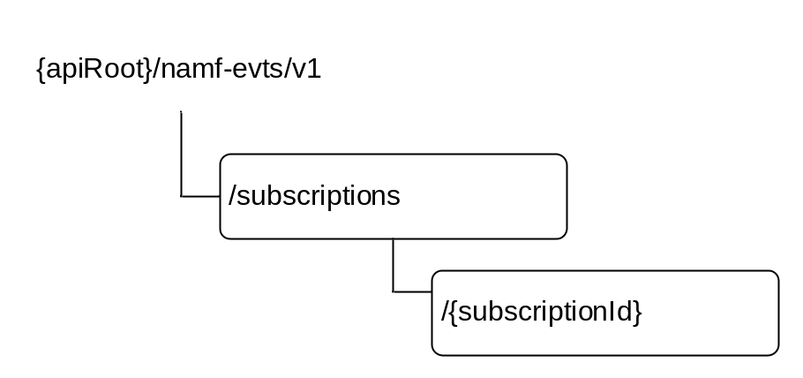
Figure 6.2.3.1-1: Resource URI structure of the Namf_EventExposure API
Table 6.2.3.1-1 provides an overview of the resources and applicable HTTP methods.
Table 6.2.3.1-1: Resources and methods overview
Resource name | Resource URI | HTTP method or custom operation | Description
Subscriptions collection | .../subscriptions | POST | Mapped to the service operation Subscribe, when to create a subscription
Individual subscription | … /subscriptions/{subscriptionId} | PATCH | Mapped to the service operation Subscribe, when to modify
Individual subscription | … /subscriptions/{subscriptionId} | DELETE | Mapped to the service operation Unsubscribe

6.2.3.2 Resource: Subscriptions collection

6.2.3.2.1 Description
This resource represents a collection of subscriptions created by NF service consumers of Namf_EventExposure service.
This resource is modelled as the Collection resource archetype (see subclause C.2 of 3GPP TS 29.501 [5]).

6.2.3.2.2 Resource Definition
Resource URI: {apiRoot}/namf-evts/v1/subscriptions
This resource shall support the resource URI variables defined in table 6.2.3.2.2-1.
Table 6.2.3.2.2-1: Resource URI variables for this resource
Name | Definition
apiRoot | See subclause 6.2.1

6.2.3.2.3 Resource Standard Methods

6.2.3.2.3.1 POST
This method shall support the URI query parameters specified in table 6.2.3.2.3.1-1.
Table 6.2.3.2.3.1-1: URI query parameters supported by the POST method on this resource
Name | Data type | P | Cardinality | Description
n/a

This method shall support the request data structures specified in table 6.2.3.2.3.1-2 and the response data structures and response codes specified in table 6.2.3.2.3.1-3.
Table 6.2.3.2.3.1-2: Data structures supported by the POST Request Body on this resource
Data type | P | Cardinality | Description
AmfCreateEventSubscription | M | 1 | Describes of an AMF Event Subscription to be created

Table 6.2.3.2.3.1-3: Data structures supported by the POST Response Body on this resource
Data type | P | Cardinality | Response  codes | Description
AmfCreatedEventSubscription | M | 1 | 201 Created | Represents successful creation of an AMF Event Subscription
ProblemDetails | M | 1 | 403 Forbidden | Indicates the creation of subscription has failed due to application error.  The "detail" attribute shall be set to:  - UE_NOT_SERVED_BY_AMF

6.2.3.2.4 Resource Custom Operations
None.

6.2.3.3 Resource: Individual subscription

6.2.3.3.1 Description
This resource represents an individual of subscription created by NF service consumers of Namf_EventExposure service.
This resource is modelled as the Document resource archetype (see subclause C.1 of 3GPP TS 29.501 [5]).

6.2.3.3.2 Resource Definition
Resource URI: {apiRoot}/namf-evts/v1/subscriptions/{subscriptionId}
This resource shall support the resource URI variables defined in table 6.2.3.3.2-1.
Table 6.2.3.3.2-1: Resource URI variables for this resource
Name | Definition
apiRoot | See subclause 6.2.1
subscriptionId | String identifies an individual subscription to the AMF event exposure service

6.2.3.3.3 Resource Standard Methods

6.2.3.3.3.1 PATCH
This method shall support the URI query parameters specified in table 6.2.3.3.3.1-1.
Table 6.2.3.3.3.1-1: URI query parameters supported by the PATCH method on this resource
Name | Data type | P | Cardinality | Description
n/a

This method shall support the request data structures specified in table 6.2.3.3.3.1-2 and the response data structures and response codes specified in table 6.2.3.3.3.1-3.
Table 6.2.3.3.3.1-2: Data structures supported by the PATCH Request Body on this resource
Data type | P | Cardinality | Description
AmfUpdateEventSubscription | M | 1 | Document describes the modification(s) to a AMF Event Subscription

Editor's Note: The detailed format of modification document in the PATCH request is FFS.
Table 6.2.3.3.3.1-3: Data structures supported by the PATCH Response Body on this resource
Data type | P | Cardinality | Response  codes | Description
AmfUpdatedEventSubscription | M | 1 | 200 OK | Represents a successful update on AMF Event Subscription
ProblemDetails | M | 1 | 403 Forbidden | Indicates the modification of subscription has failed due to application error.  The "detail" attribute shall be set to:  - UE_NOT_SERVED_BY_AMF
ProblemDetails | M | 1 | 404 Not Found | Indicates the modification of subscription has failed due to application error.  The "detail" attribute shall be set to:  - SUBSCRIPTION_NOT_FOUND

6.2.3.3.3.2 DELETE
This method shall support the URI query parameters specified in table 6.2.3.3.3.2-1.
Table 6.2.3.3.3.2-1: URI query parameters supported by the DELETE method on this resource
Name | Data type | P | Cardinality | Description
n/a

This method shall support the request data structures specified in table 6.2.3.3.3.2-2 and the response data structures and response codes specified in table 6.2.3.3.3.2-3.
Table 6.2.3.3.3.2-2: Data structures supported by the DELETE Request Body on this resource
Data type | P | Cardinality | Description
n/a

Table 6.2.3.3.3.2-3: Data structures supported by the DELETE Response Body on this resource
Data type | P | Cardinality | Response  codes | Description
n/a |  |  | 200 OK

6.2.3.3.4 Resource Custom Operations
None.

6.2.4 Custom Operations without associated resources
There are no custom operations without associated resources supported on Namf_EventExposure Service.

6.2.5 Notifications

6.2.5.1 General

6.2.5.2 AMF Event Notification
If a NF service consumer has subscribed to an event(s) supported by Namf_EventExposure service, when AMF aware of a state change of the event, AMF shall create a notification including the event state report, and shall deliver the notification to the call-back URI, following Subscribe/Notify mechanism defined in 3GPP TS 29.501 [2].

6.2.5.2.1 Notification Definition
Call-back URI: {callbackUri}
Call-back URI is provided by NF Service Consumer during creation of the subscription.

6.2.5.2.3 Notification Standard Methods

6.2.5.2.3.1 POST
This method shall support the request data structures specified in table 6.2.5.2.3.1-1 and the response data structures and response codes specified in table 6.2.5.2.3.1-2.
Table 6.2.5.2.3.1-2: Data structures supported by the POST Request Body
Data type | P | Cardinality | Description
AmfEventNotification | M | 1 | Represents the notification to be delivered

Table 6.2.5.2.3.1-3: Data structures supported by the POST Response Body
Data type | P | Cardinality | Response  codes | Description
n/a |  |  | 204 No Content

6.2.6 Data Model

6.2.6.2 General
This subclause specifies the application data model supported by the API.
Table 6.2.6.2-1 specifies the data types defined for the Namf_EventExposure service based interface protocol.
Table 6.2.6.2-1: Namf_EventExposure specific Data Types
Data type | Section defined | Description
AmfEventSubscription | 6.2.6.2.2 | Represents an individual event subscription resource on AMF
AmfEvent | 6.2.6.2.3 | Describes an event to be subscribed
AmfEventNotification | 6.2.6.2.4 | Represents a notification generated by AMF to be delivered
AmfEventReport | 6.2.6.2.5 | Represents a report triggered by a subscribed event type, except the report triggered by UES_IN_AREA_REPORT event type
AmfEventMode | 6.2.6.2.6 | Describes how the reports shall be generated by a subscribed event
AmfEventState | 6.2.6.2.7 | Represents the state of a subscribed event
UeLocation | 6.2.6.2.8 | Represents the location information of a UE
RmInfo | 6.2.6.2.9 | Represents the registration state of a UE for an access type
CmInfo | 6.2.6.2.10 | Represents the connectivity state of a UE for an access type
SubscribedData | 6.2.6.2.11 | Represents the subscribed data received from UDM
CommunicationFailure | 6.2.6.2.12 | Describes a communication failure detected by AMF
AmfCreateEventSubscription | 6.2.6.2.13 | Describes of an AMF Event Subscription to be created
AmfCreatedEventSubscription | 6.2.6.2.14 | Represents successful creation of an AMF Event Subscription
AmfUpdateEventSubscription | 6.2.6.2.15 | Document describes the modification(s) to an AMF Event Subscription
AmfUpdatedEventSubscription | 6.2.6.2.16 | Represents a successful update on an AMF Event Subscription
AmfEventArea | 6.2.6.2.17 | Represents an area to be monitored by an AMF event.
AmfEventType | 6.2.6.3.3 | Describes the supported event types of Namf_EventExposure Service
AmfEventTrigger | 6.2.6.3.4 | Describes how AMF should generate the report for the event
LocationFilter | 6.2.6.3.5 | Describes the supported filters of LOCATION_REPORT event type
SubscribedDataFilter | 6.2.6.3.6 | Describes the supported filters of SUBSCRIBED_DATA_REPORT event type
UeReachability | 6.2.6.3.7 | Describes the reachability of the UE
PresenceState | 6.2.6.3.8 | Describes the presence state of the UE to a specified area of interest
RmState | 6.2.6.3.9 | Describes the registration management state of a UE
CmState | 6.2.6.3.10 | Describes the connectivity management state of a UE

Editor's Note: the possibility to use common data type "UserLocationInformation" instead of UeLocation is FFS.

Table 6.2.6.2-2 specifies data types re-used by the Namf_EventExposure service based interface protocol from other specifications, including a reference to their respective specifications and when needed, a short description of their use within the Namf_EventExposure service based interface.
Table 6.2.6.2-2: Namf_EventExposure re-used Data Types
Data type | Reference | Comments
Supi | 3GPP TS 29.571 [6]
GroupId | 3GPP TS 29.571 [6]
DurationSec | 3GPP TS 29.571 [6]
Gpsi | 3GPP TS 29.571 [6]
Uri | 3GPP TS 29.571 [6]
Pei | 3GPP TS 29.571 [6]
UserLocationInformation | 3GPP TS 29.571 [6]
TaI | 3GPP TS 29.571 [6]
TimeZone | 3GPP TS 29.571 [6]
AccessType | 3GPP TS 29.571 [6]
Ecgi | 3GPP TS 29.571 [6] | EUTRA Cell Identifier
Ncgi | 3GPP TS 29.571 [6] | NR Cell Identifier
NfInstanceId | 3GPP TS 29.571 [6]
ProblemDetails | 3GPP TS 29.571 [6] | Problem Details
SupportedFeatures | 3GPP TS 29.571 [6] | Supported Features

6.2.6.2 Structured data types

6.2.6.2.1 Introduction
Structured data types used in Namf_EventExposure service are specified in this clause.

6.2.6.2.2 Type: AmfEventSubscription
Table 6.2.6.2.2-1: Definition of type AmfEventSubscription
Attribute name | Data type | P | Cardinality | Description
events | AmfEvent | M | 1..N | Describes the events to be subscribed for this subscription.
notifyUri | Uri | M | 1 | Identifies the recipient of notifications sent by AMF for this subscription
notifCorelationId | string | M | 1 | Identifies the notification co-relation ID. The AMF shall include this ID in the notifications.
nfId | NfInstanceId | M | 1 | Indicates the instance identity of the network function creating the subscription.
supi | Supi | C | 0..1 | Subscription Permanent Identifier (NOTE)
groupId | GroupId | C | 0..1 | Identifies a group of UEs. (NOTE)
gpsi | Gpsi | C | 0..1 | Generic Public Subscription Identifier (NOTE)
pei | Pei | C | 0..1 | Permanent Equipment Identifier (NOTE)
anyUE | boolean | C | 0..1 | Identifies whether the subscription is applied to any UE or not. Default value "FALSE" is used, if not present (NOTE)
NOTE: Either information about a single UE (i.e. SUPI, GPSI, PEI) or groupId, or anyUE set to "TRUE" shall be included.

Editor's Note: The presence and cardinality requirements for the attributes are FFS.

6.2.6.2.3 Type: AmfEvent
Table 6.2.6.2.3-1: Definition of type AmfEvent
Attribute name | Data type | P | Cardinality | Description
type | AmfEventType | M | 1 | Describes the AMF event type to be reported
options | AmfEventMode | M | 1 | Describes how the reports of the event to be generated.
immediateFlag | boolean | O | 0..1 | Indicates if an immediate event report in the subscription response indicating current value / status of the event is required or not. If the flag is not present then immediate reporting shall not be done.
area | array(AmfEventArea) | O | 0..N | Identifiers the area to be applied to PRESENT_IN_AOI_REPORT and UES_IN_AREA_REPORT event types. More than one instance of AmfEventArea IE shall be used only when the AmfEventArea is provided during event subscription for Presence Reporting Area subscription.
locationFilters | LocationFilter | O | 0..N | Describes the filters to be applied for LOCATION_REPORT event type.
subscribedDataFilters | SubscribedDataFilter | O | 0..N | Describes the filters to be applied for SUBSCRIBED_DATA_REPORT event type.

6.2.6.2.4 Type: AmfEventNotification
Table 6.2.6.2.4-1: Definition of type AmfEventNotification
Attribute name | Data type | P | Cardinality | Description
subscriptionId | string | M | 1 | Indicates which subscription generated the event notificaiton.  This parameter is generated by the AMF and returned in the "Location" header in HTTP responses during the event subscription. If the event notification is generated by the AMF due to a change of AMF, this parameter shall contain the subscription Id at the new AMF.
notifCorelationId | string | M | 1 | Indicates the notification co-relation ID provided by the NF service consumer during event subscription. This parameter can be useful if the NF service consumer uses a common call-back URI for multiple subscriptions.
reports | array(AmfEventReport) | C | 1..N | This IE shall be present if a event is reported. When present, this IE represents the event reports to be delivered.

6.2.6.2.5 Type: AmfEventReport
Table 6.2.6.2.5-1: Definition of type AmfEventReport
Attribute name | Data type | P | Cardinality | Description
type | AmfEventType | M | 1 | Describes the type of the event which triggers the report
state | AmfEventState | M | 1 | Describes the state of the event which triggered the report
anyUe | boolean | C | 0..1 | This IE shall be included and shall be set to "true", if the event subscription is a bulk subscription for number of UEs and the event reported is for one of those UEs.
supi | Supi | C | 0..1 | This IE shall be included if the event reported is for a particular UE or any UE. This IE identifies the UE associated to the report (NOTE).
gpsi | Gpsi | O | 0..1 | This IE may be included if the event reported is for a particular UE or any UE. This IE identifies the GPSI of the UE associated to the report (NOTE).
pei | Pei | O | 0..1 | This IE may be included if the event reported is for a particular UE or any UE. This IE identifies the PEI of the UE associated to the report (NOTE).
location | UeLocation | O | 0..1 | Represents the location information of the UE
presence | PresenceState | O | 0..1 | Represents the presence state of the UE to a specified area of interest.
timezone | TimeZone | O | 0..1 | Describes the time zone of the UE
accessTypes | AccessType | O | 0..N | Describes the access type(s) of the UE
rmInfos | RmInfo | O | 0..N | Describes the registration management state of the UE
cmInfos | CmInfo | O | 0..N | Describes the connectivity state of the UE
reachability | UeReachability | O | 0..1 | Describes the reachability of the UE
subscribedData | SubscribedData | O | 0..1 | Represents the subscribed data of the UE received from UDM
commFailure | CommunicationFailure | O | 0..1 | Describes a communication failure for the UE.
numberOfUes | integer | O | 0..1 | Represents the number of UEs in the specified area
area | AmfEventArea | O | 0..1 | Represents the specified Area, when event type is
NOTE: If the event report corresponds to an event subscription of a single UE, then the same UE identifier (i.e. SUPI and/or GPSI and/or PEI) shall be included in the report. If the event report corresponds to an event subscription for group of UEs or any UE, then the SUPI shall be included in the event report. SUPI, PEI and GPSI shall not be present in report for UES_IN_AREA_REPORT event type.

6.2.6.2.6 Type: AmfEventMode
Table 6.2.6.2.6-1: Definition of type AmfEventMode
Attribute name | Data type | P | Cardinality | Description
trigger | AmfEventTrigger | M | 1 | Describes how the reports are triggered.
maxReports | integer | C | 0..1 | This IE shall be present if the trigger is set to “CONTINUOUS”. When present, this IE describes the maximum number of reports that can be generated by the subscribed event.
duration | DurationSec | O | 0..1 | Describes the maximum duration after which the subscribed event shall stop generating report. If not present, the subscribed event shall continue generating reports until it is unsubscribed.

6.2.6.2.7 Type: AmfEventState
Table 6.2.6.2.7-1: Definition of type AmfEventState
Attribute name | Data type | P | Cardinality | Description
active | boolean | M | 1 | Represents the active state of the subscribe event. "TRUE" value indicates the event will continue generating reports; "FALSE" value indicates the event will not generate further report.
remainReports | integer | O | 0..1 | Represents the number of remain reports to be generated by the subscribed event.
remainDuration | DurationSec | O | 0..1 | Represents how long the subscribed event will continue generating reports.

6.2.6.2.8 Type: UeLocation
Table 6.2.6.2.8-1: Definition of type UeLocation
Attribute name | Data type | P | Cardinality | Description
tai | Tai | O | 0..1 | Describes the Tracking Area for the UE
ecgi | Ecgi | O | 0..1 | Describes the EUTRA Cell for where UE is located
ncgi | Ncgi | O | 0..1 | Describes the NR cell where the UE is located.
n3Iwf | N3IwfIndentifier | O | 0..1 | Describes the N3IWF node serving the UE
ueIpv4 | Ipv4Addr | O | 0..1 | Describes the ipv4 address used by the UE for non-3GPP access
ueIpv6 | Ipv6Addr | O | 0..1 | Describes the ipv6 address prefix used by the UE for non-3GPP access
udpPort | integer | O | 0..1 | Describes the local UDP port used by the UE for non-3GPP access

6.2.6.2.9 Type: RmInfo
Table 6.2.6.2.9-1: Definition of type RmInfo
Attribute name | Data type | P | Cardinality | Description
rmState | RmState | M | 1 | Describes the registration management state of the UE
accessType | AccessType | M | 1 | Describes the access type of the UE that applies to the registration management state reported.

6.2.6.2.10 Type: CmInfo
Table 6.2.6.2.10-1: Definition of type CmInfo
Attribute name | Data type | P | Cardinality | Description
cmState | CmState | M | 1 | Describes the Connectivity management state of the UE
accessType | AccessType | M | 1 | Describes the access type of the UE that applies to the Connectivity management state reported.

6.2.6.2.11 Type: SubscribedData
Table 6.2.6.2.11-1: Definition of type SubscribedData
Attribute name | Data type | P | Cardinality | Description
sari | Sari | O | 0..1 | Represents the Service Area Restriction Information data of the UE received from UDM
rfspIndex | RfspIndex | O | 0..1 | Represents the RFSP Index of the UE received from UDM

6.2.6.2.12 Type: CommunicationFailure
Table 6.2.6.2.12-1: Definition of type CommunicationFailure
Attribute name | Data type | P | Cardinality | Description
nasReleaseCode | FFS | O | 0..1 | Describes the NAS release code for the communication failure
ranReleaseCode | FFS | O | 0..1 | Describes the RAN release code for the communication failure

6.2.6.2.13 Type: AmfCreateEventSubscription
Table 6.2.6.2.13-1: Definition of type AmfCreateEventSubscription
Attribute name | Data type | P | Cardinality | Description
subscription | AmfEventSubscription | M | 1 | Represents the AMF Event Subscription resource to be created.
supportedFeatures | SupportedFeatures | C | 0..1 | This IE shall be present if at least one optional feature defined in subclause 6.2.8 is supported.

6.2.6.2.14 Type: AmfCreatedEventSubscription
Table 6.2.6.2.14-1: Definition of type AmfCreatedEventSubscription
Attribute name | Data type | P | Cardinality | Description
subscription | AmfEventSubscription | M | 1 | Represents the newly created AMF Event Subscription resource.
reports | AmfEventReport | O | 0..N | Represents the immediate event reports (i.e. the current value / status of the events subscribed), if available.
supportedFeatures | SupportedFeatures | C | 0..1 | This IE shall be present if at least one optional feature defined in subclause 6.2.8 is supported.

6.2.6.2.15 Type: AmfUpdateEventSubscription
Table 6.2.6.2.15-1: Definition of type AmfUpdateEventSubscription
Attribute name | Data type | P | Cardinality | Description
FFS

6.2.6.2.16 Type: AmfUpdatedEventSubscription
Table 6.2.6.2.16-1: Definition of type AmfUpdatedEventSubscription
Attribute name | Data type | P | Cardinality | Description
subscription | AmfEventSubscription | M | 1 | Represents the updated AMF Event Subscription resource.

6.2.6.2.17 Type: AmfEventArea
Table 6.2.6.2.17-1: Definition of type AmfEventArea
Attribute name | Data type | P | Cardinality | Description
trackingAreas | Tai | C | 0..N | Represents the list of tracking areas that constitutes the area. This IE shall be present if the subscription is for tracking UE presence in the tracking areas. For non 3GPP access the TAI shall be the N3GPP TAI.
areaId | string | C | 0..1 | Represents an identifier to the specified area. This IE shall be present if the Area of Interest subscribed is a Presence Reporting Area. (NOTE)
ladn | string | C | 0..1 | Represents the Local Access Data Network DNN. This IE shall be present if the Area of Interest subscribed is a LADN service area. The AMF shall identify the list of tracking areas corresponding to the LADN DNN based on local configuration.
ecgi | array(Ecgi) | C | 0..N | This IE shall be present if the Area of Interest subscribed is a list of EUTRAN cell Ids.
ncgi | array(Ncgi) | C | 0..N | This IE shall be present if the Area of Interest subscribed is a list of NR cell Ids.
ngRanId | NgRanIdentifier | C | 0..N | This IE shall be present if the Area of Interest subscribed is a list of NG RAN node identifiers.
NOTE: When the AmfEventArea is provided during event subscription, then for UE specific presence reporting area subscription, the areaId along with what constitutes that UE specific presence reporting area (i.e. set of Tai and/or set of ecgi and/or set of ncgi and/or set of ngRanId) shall be provided.

6.2.6.3 Simple data types and enumerations

6.2.6.3.1 Introduction
This subclause defines simple data types and enumerations that can be referenced from data structures defined in the previous subclauses.

6.2.6.3.2 Simple data types
The simple data types defined in table 6.2.6.3.2-1 shall be supported.
Table 6.2.6.3.2-1: Simple data types
Type Name | Type Definition | Description
5gGuti | string | 5G Global Unique Temporary Identifier, defined in subclause 5.9.4 of 3GPP TS 23.501 [2]
Sari | Bytes | Service Area Restriction information
RfspIndex | integer | RFSP Index
N3IwfIndentifier | string | Represents the identifier to a N3IWF NF instance.

6.2.6.3.3 Enumeration: AmfEventType
Table 6.2.6.3.3-1: Enumeration AmfEventType
Enumeration value | Description
"LOCATION_REPORT" | A NF subscribes to this event to receive the Last Known Location of a UE or a group of UEs, and Updated Location of the UE or any UE in the group when AMF becomes aware of a location change of the UE.
"PRESENCE_IN_AOI_REPORT" | A NF subscribes to this event to receive the current present state of a UE in a specific Area of Interest (AOI), and notification when a specified UE enters or leaves the specified area. The area could be identified by a TA list, an area ID or specific interest area name like "LADN".
"TIMEZONE_REPORT" | A NF subscribes to this event to receive the current time zone of a UE or a group of UEs, and updated time zone of the UE or any UE in the group when AMF becomes aware of a time zone change of the UE.
"ACCESS_TYPE_REPORT" | A NF subscribes to this event to receive the current access type(s) of a UE or a group of UEs, and updated access type(s) of the UE or any UE in the group when AMF becomes aware of the access type change of the UE.
"REGISTRATION_STATE_REPORT" | A NF subscribes to this event to receive the current registration state of a UE or a group of UEs, and report for updated registration state of a UE or any UE in the group when AMF becomes aware of a registration state change of the UE.
"CONNECTIVITY_STATE_REPORT" | A NF subscribes to this event to receive the current connectivity state of a UE or a group of UEs, and report for updated connectivity state of a UE or any UE in the group when AMF becomes aware of a connectivity state change of the UE.
"REACHABILITY_REPORT" | A NF subscribes to this event to receive the current reachability of a UE or a group of UEs, and report for updated reachability of a UE or any UE in the group when AMF becomes aware of a reachability change of the UE.
"SUBSCRIBED_DATA_REPORT" | A NF subscribes to this event to receive the current Subscribed Data for the UE(s) received from UDM, and notification when AMF received updated subscribed data for the UE(s) from UDM.
"COMMIUNICATION_FAILURE_REPORT" | A NF subscribes to this event to receive the Communication failure report of a UE or group of UEs or any UE.
"UES_IN_AREA_REPORT" | A NF subscribes to this event to receive the number of UEs in a specific area.

6.2.6.3.4 Enumeration: AmfEventTrigger
Table 6.2.6.3.4-1: Enumeration AmfEventTrigger
Enumeration value | Description
"ONE_TIME" | Defines that AMF should generate report for the event only once. After reporting, the subscription to this event will be terminated.
"CONTINUOUS" | Defines that AMF should continuously generate reports for the event, until the subscription to this event ends, due to end of report duration or the event being unsubscribed explicitly

6.2.6.3.5 Enumeration: LocationFilter
Table 6.2.6.3.5-1: Enumeration LocationFilter
Enumeration value | Description
"TAI" | Indicates any change of the TA used by the UE should be reported
"CELL_ID" | Indicates any change of the Cell used by the UE should be reported
"N3IWF" | Indicates any change of the N3IWF node used by the UE should be reported
"UE_IP" | Indicates any change of the UE local IP address should be reported
"UDP_PORT" | Indicates any change of local UDP port used by the UE reported

6.2.6.3.6 Enumeration: SubscribedDataFilter
Table 6.2.6.3.6-1: Enumeration SubscribedDataFilter
Enumeration value | Description
"SARI" | Indicates any change of the Service Area Restriction Information for the UE received from UDM should be reported
"RFSP_INDEX" | Indicates any change of the RFSP Index for the UE received from UDM should be reported

6.2.6.3.7 Enumeration: UeReachability
Table 6.2.6.3.7-1: Enumeration UeReachability
Enumeration value | Description
"UNREACHABLE" | Indicates the UE is not reachable
"REACHABLE" | Indicates the UE is reachable for services
"REGULATORY_ONLY" | Indicates the UE is reachable only for Regulatory Prioritized Service

6.2.6.3.8 Enumeration: PresenceState
Table 6.2.6.3.8-1: Enumeration PresenceState
Enumeration value | Description
"IN" | Indicates the UE is in the specified Area of interest
"OUT" | Indicates the UE is out of the specified Area of interest
"UNKNOWN" | Indicates it is unknown whether the UE is in the specified Area of interest or not

6.2.6.3.9 Enumeration: RmState
Table 6.2.6.3.9-1: Enumeration RmState
Enumeration value | Description
"REGISTERED" | Indicates the UE in RM-REGISTERED state
"DEREGISTERED" | Indicates the UE in RM-DEREGISTERED state

6.2.6.3.10 Enumeration: CmState
Table 6.2.6.3.10-1: Enumeration CmState
Enumeration value | Description
"IDLE" | Indicates the UE is in CM-IDLE state
"CONNECTED" | Indicates the UE is in CM-CONNECTED state

6.2.6.4 Binary data
None.

6.2.7 Error Handling

6.2.7.1 General
HTTP error handling shall be supported as specified in subclause 5.2.4 of 3GPP TS 29.500 [4].

6.2.7.2 Protocol Errors
Editor's Note: the handling of protocol errors is FFS. It is also FFS how to return the offending parameters (for requests rejected due to a faulty or missing mandatory or conditional parameters).

6.2.7.3 Application Errors
The application errors defined for the Namf_EventExposure service are listed in Table 6.2.7.3-1.

Table 6.2.7.3-1: Application errors
Application Error | HTTP status code | Description

6.2.8 Feature Negotiation
The feature negotiation mechanism specified in subclause 6.6 of 3GPP TS 29.500 [4] shall be used to negotiate the optional features applicable between the AMF and the NF Service Consumer, for the Namf_EventExposure service, if any.
The NF Service Consumer shall indicate the optional features it supports for the Namf_EventExposure service, if any, by including the supportedFeatures attribute in payload of the HTTP Request Message for subscription resource creation.
The AMF shall determine the supported features for the service operations as specified in subclause 6.6 of 3GPP TS 29.500 [4] and shall indicate the supported features by including the supportedFeatures attribute in payload of the HTTP response for subscription resource creation.
The syntax of the supportedFeatures attribute is defined in subclause 5.2.2 of 3GPP TS 29.571 [13].
The following features are defined for the Namf_EventExposure service:
Table 6.2.8-1: Features of supportedFeatures attribute used by Namf_EventExposure service
Feature Number | Feature | M/O | Description
Feature number: The order number of the feature within the supportedFeatures attribute (starting with 1).
Feature: A short name that can be used to refer to the bit and to the feature.
M/O: Defines if the implementation of the feature is mandatory ("M") or optional ("O").
Description: A clear textual description of the feature.

6.3 Namf_MT Service API

6.3.1 API URI
URIs of this API shall have the following root:
{apiRoot}/{apiName}/{apiVersion}/
where the "apiName" shall be set to "namf-mt" and the "apiVersion" shall be set to "v1" for the current version of this specification.

6.3.2 Usage of HTTP

6.3.2.1 General
HTTP/2, as defined in IETF RFC 7540 [19], shall be used as specified in clause 5 of 3GPP TS 29.500 [4].
HTTP/2 shall be transported as specified in subclause 5.3 of 3GPP TS 29.500 [4].
HTTP messages and bodies for the Namf_MT service shall comply with the OpenAPI [23] specification contained in Annex A.

6.3.2.2 HTTP standard headers

6.3.2.2.1 General
The usage of HTTP standard headers shall be supported as specified in subclause 5.2.2 of 3GPP TS 29.500 [4].

6.3.2.2.2 Content type
The JSON format shall be supported. The use of the JSON format (IETF RFC 8259 [8]) shall be signalled by the content type "application/json". See also subclause 5.4 of 3GPP TS 29.500 [4].

6.3.2.3 HTTP custom headers

6.3.2.3.1 General
In this release of this specification, no custom headers specific to the Namf_MT service are defined. For 3GPP specific HTTP custom headers used across all service based interfaces, see clause 5.2.3 of 3GPP TS 29.500 [4].

6.3.3 Resources

6.3.3.1 Overview
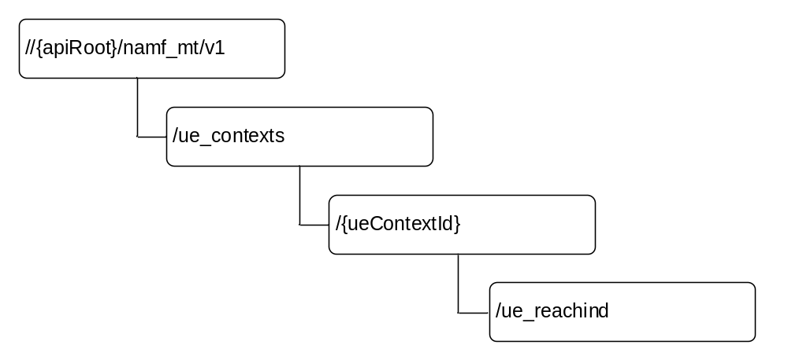
Figure 6.3.3.1-1: Resource URI structure of the Namf_MT Service API
Table 6.3.3.1-1 provides an overview of the resources and applicable HTTP methods.
Table 6.3.3.1-1: Resources and methods overview
Resource name | Resource URI | HTTP method or custom operation | Description
ueReachInd | {apiRoot}/namf_mt/v1/ue_contexts/{ueContextId}/ue_reachind | PUT | Update the ueReachInd to UE Reachable

6.3.3.2 Resource: ueReachInd

6.3.3.2.1 Description
This resource represents the ueReachInd for a SUPI.
This resource is modelled as the Document resource archetype (see subclause C.1 of 3GPP TS 29.501 [5]).

6.3.3.2.2 Resource Definition
Resource URI: {apiRoot}/Namf_Mt/v1/ue_contexts/{ueContextId}ue_reachind
This resource shall support the resource URI variables defined in table 6.3.3.2.2-1.
Table 6.3.3.2.2-1: Resource URI variables for this resource
Name | Definition
ueContextId | Represents the Subscription Permanent Identifier (see 3GPP TS 23.501 [2] clause 5.9.2)  pattern: "(imsi-[0-9]{5,15}|nai-.+)"

6.3.3.2.3 Resource Standard Methods

6.3.3.2.3.1 PUT
This method shall support the URI query parameters specified in table 6.3.3.2.3.1-1.
Table 6.3.3.2.3.1-1: URI query parameters supported by the PUT method on this resource
Name | Data type | P | Cardinality | Description
n/a

This method shall support the request data structures specified in table 6.3.3.2.3.1-2 and the response data structures and response codes specified in table 6.3.3.2.3.1-3.
Table 6.3.3.2.3.1-2: Data structures supported by the PUT Request Body on this resource
Data type | P | Cardinality | Description
EnableUeReachabilityReqData | M | 1 | Contain the State of the UE, the value shall be set to UE Reachable.

Table 6.3.3.2.3.1-3: Data structures supported by the PUT Response Body on this resource
Data type | P | Cardinality | Response  codes | Description
EnableUeReachabilityRspData | M | 1 | 200 OK | Indicate the ueReachInd is updated to UE Reachable.
ProblemDetails | M | 1 | 307 Temporary Redirect | This represents the case when the related UE context is not fully available at the target NF Service Consumer (e.g. AMF) during a planned maintenance case (e.g. AMF planned maintenance without UDSF case). The "detail" attribute shall be set to one of the following application error:  - NF_CONSUMER_REDIRECT_ONE_TXN  See table 6.3.7.3-1 for the description of these errors  The Location header of the response shall be set to the target NF Service Consumer (e.g. AMF) to which the request is redirected.
ProblemDetails | M | 1 | 404 Not Found | This represents the case when the related UE is not found in the NF Service Consumer (e.g. AMF). The "detail" attribute shall be set to one of the following application error:  - CONTEXT_NOT_FOUND  See table 6.3.7.3-1 for the description of these errors
ProblemDetails | M | 1 | 403 Forbidden | Indicate the operation is failed as the UE is not reachable, e.g. after paging.

6.3.3.2.4 Resource Custom Operations
There is no custom operation supported on this resource.

6.3.4 Custom Operations without associated resources
There are no custom operations without associated resources supported on Namf_MT service.

6.3.5 Notifications
There are no notifications supported on Namf_MT service.

6.3.6 Data Model

6.3.6.1 General
This subclause specifies the application data model supported by the API.
Table 6.3.6.3-1 specifies the data types defined for the Namf_MT service based interface protocol.
Table 6.3.6.3-1: Namf_MT specific Data Types
Data type | Section defined | Description
EnableUeReachabilityReqData | 6.3.6.2.2 | Contain the UeReachability, indicates the desired reachability status of the UE
EnableUeReachabilityReqData | 6.3.6.2.3 | Indicates the reachability of UE has been changed as requested.
UeReachability | 6.2.6.3.7 | Describes the reachability of the UE

Table 6.3.6.3-2 specifies data types re-used by the Namf_MT service based interface protocol from other specifications, including a reference to their respective specifications and when needed, a short description of their use within the Namf_MT service based interface.
Table 6.3.6.3-2: Namf_MT re-used Data Types
Data type | Reference | Comments
FailureReason | tbd | Common data type used in response bodies
supportedFeatures | 3GPP TS 29.571 [6] | Supported Features

6.3.6.2 Structured data types

6.3.6.2.1 Introduction
Structured data types used in Namf_MT service are specified in this clause.

6.3.6.2.2 Type: EnableUeReachabilityReqData
Table 6.3.6.3.2-1: Definition of type EnableUeReachabilityReqData
Attribute name | Data type | P | Cardinality | Description
reachability | UeReachability | M | 1 | Indicates the desired reachability of the UE
supportedFeatures | SupportedFeatures | C | 0..1 | This IE shall be present if at least one optional feature defined in subclause 6.3.8 is supported.

6.3.6.2.3 Type: EnableUeReachabilityRspData
Table 6.3.6.2.3-1: Definition of type EnableUeReachabilityRspData
Attribute name | Data type | P | Cardinality | Description
reachability | UeReachability | M | 1 | Indicates the current reachability of the UE
supportedFeatures | SupportedFeatures | C | 0..1 | This IE shall be present if at least one optional feature defined in subclause 6.3.8 is supported.

6.3.6.3 Simple data types and enumerations

6.3.6.3.1 Introduction
This subclause defines simple data types and enumerations that can be referenced from data structures defined in the previous subclauses.

6.3.6.3.2 Simple data types
The simple data types defined in table 6.3.6.3.2-1 shall be supported.
Table 6.3.6.3.2-1: Simple data types
Type Name | Type Definition | Description

6.3.6.4 Binary data
None.

6.3.7 Error Handling

6.3.7.1 General
HTTP error handling shall be supported as specified in subclause 5.2.4 of 3GPP TS 29.500 [4].

6.3.7.2 Protocol Errors
Editor's Note: the handling of protocol errors is FFS. It is also FFS how to return the offending parameters (for requests rejected due to a faulty or missing mandatory or conditional parameters).

6.3.7.3 Application Errors
The application errors defined for the Namf_MT service are listed in Table 6.3.7.3-1.

Table 6.3.7.3-1: Application errors
Application Error | HTTP status code | Description
NF_CONSUMER_REDIRECT_ONE_TXN | 307 Temporary Redirect | The request has been asked to be redirected to a specified target.
CONTEXT_NOT_FOUND | 404 Not Found | The related UE is not found in the NF Service Consumer.
UE_NOT_RESPONDING | 403 Forbidden | AMF is unable page the UE, temporarily.
UNABLE_TO_PAGE_UE | 403 Forbidden | UE is not responding to the request initiated by the network, e.g. Paging.

6.3.8 Feature Negotiation
The feature negotiation mechanism specified in subclause 6.6 of 3GPP TS 29.500 [4] shall be used to negotiate the optional features applicable between the AMF and the NF Service Consumer, for the Namf_MT service, if any.
The NF Service Consumer shall indicate the optional features it supports for the Namf_MT service, if any, by including the supportedFeatures attribute in payload of the HTTP Request Message for following service operations:
- EnableUEReachability, as specified in subclause 5.4.2.2;
The AMF shall determine the supported features for the service operations as specified in subclause 6.6 of 3GPP TS 29.500 [4] and shall indicate the supported features by including the supportedFeatures attribute in payload of the HTTP response for the service operation.
The syntax of the supportedFeatures attribute is defined in subclause 5.2.2 of 3GPP TS 29.571 [13].
The following features are defined for the Namf_MT service.
Table 6.3.8-1: Features of supportedFeatures attribute used by Namf_MT service
Feature Number | Feature | M/O | Description
Feature number: The order number of the feature within the supportedFeatures attribute (starting with 1).
Feature: A short name that can be used to refer to the bit and to the feature.
M/O: Defines if the implementation of the feature is mandatory ("M") or optional ("O").
Description: A clear textual description of the feature.

6.4 Namf_Location Service API

6.4.1 API URI
URIs of this API shall have the following root:
{apiRoot}/{apiName}/{apiVersion}/
where the "apiName" shall be set to "namf-location" and the "apiVersion" shall be set to "v1" for the current version of this specification.

6.4.2 Usage of HTTP

6.4.2.1 General
HTTP/2, as defined in IETF RFC 7540 [19], shall be used as specified in clause 5 of 3GPP TS 29.500 [4].
HTTP/2 shall be transported as specified in subclause 5.3 of 3GPP TS 29.500 [4].
HTTP messages and bodies for the Namf_Location service shall comply with the OpenAPI [23] specification contained in Annex A.

6.4.2.2 HTTP standard headers

6.4.2.2.1 General
The usage of HTTP standard headers shall be supported as specified in subclause 5.2.2 of 3GPP TS 29.500 [4].

6.4.2.2.2 Content type
The JSON format shall be supported. The use of the JSON format (IETF RFC 8259 [8]) shall be signalled by the content type "application/json". See also subclause 5.4 of 3GPP TS 29.500 [4].

6.4.2.3 HTTP custom headers

6.4.2.3.1 General
In this release of this specification, no custom headers specific to the Namf_Location service are defined. For 3GPP specific HTTP custom headers used across all service based interfaces, see clause 5.2.3 of 3GPP TS 29.500 [4].

6.4.3 Resources

6.4.3.1 Overview
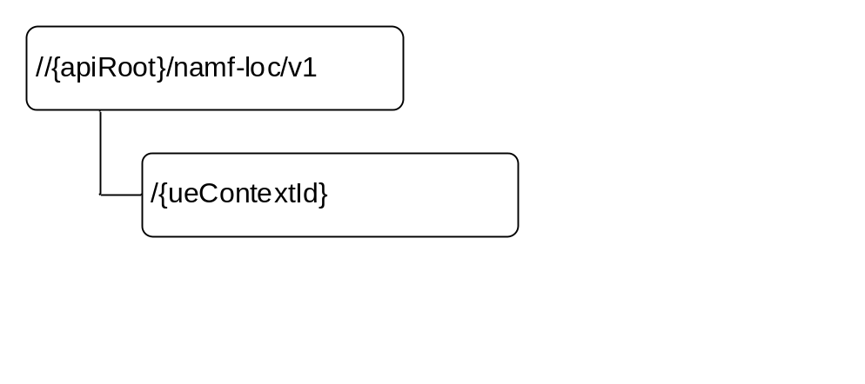
Figure 6.4.3.1-1: Resource URI structure of the Namf_Location Service API
Table 6.4.3.1-1 provides an overview of the resources and applicable HTTP methods.
Table 6.4.3.1-1: Resources and methods overview
Resource name | Resource URI | HTTP method or custom operation | Description
Location Information for individual UE context | …/ueContextId}/provide | (POST)  provide | ProvideLocation

6.4.3.2 Resource: Individual UE Context

6.4.3.2.1 Description
This resource represents an individual ueContextId.
This resource is modelled with the Document resource archetype (see subclause C.1 of 3GPP TS 29.501 [5]).

6.4.3.2.2 Resource Definition
Resource URI:{apiRoot}/namf-loc/v1/{ueContextId}
This resource shall support the resource URI variables defined in table 6.4.3.2.2-1.
Table 6.4.3.2.2-1: Resource URI variables for this resource
Name | Definition
ueContextId | Represents the Subscription Permanent Identifier (see 3GPP TS 23.501 [2] clause 5.9.2)  pattern: "(supi-[0-9]{5,15}|nai-.+)"  Or represents the Permanent Equipment Identifier (see 3GPP TS 23.501 [2] clause 5.9.3)  pattern: "(pei-[0-9]{15})"

6.4.3.2.3 Resource Standard Methods
There are no standard methods supported on this resource.

6.4.3.2.4 Resource Custom Operations

6.4.3.2.4.1 Overview
Table 6.4.3.2.4.1-1: Custom operations
Custom operaration URI | Mapped HTTP method | Description
{apiRoot}/namf-loc/v1/ {ueContextId}/provide | POST | Request the locationInformation resource of the UE.  It is used for the Provide Location service operation.

6.4.3.2.4.2 Operation: (POST) provide

6.4.3.2.4.2.1 Description
This ueContextId identifies the individual ueContext is composed by supi.{supi} or the pei.{pei}.

6.4.3.2.4.2.2 Operation Definition
This operation shall support the request data structures specified in table 6.4.3.2.4.2.2-1 and the response data structure and response codes specified in table 6.4.3.2.4.2.2-2.
Table 6.4.3.2.4.2.2-1: Data structures supported by the (POST) retrieve Request Body on this resource
Data type | P | Cardinality | Description
RequestUELocation | M | 1 | The information to request the location of the UE.

Table 6.4.3.2.4.2.2-2: Data structures supported by the (POST) retrieve Response Body on this resource
Data type | P | Cardinality | Response  codes | Description
ProvideUELocation | M | 1 | 200 OK | This case represents a successful query of the UE location, the AMF returns the related information in the response.
ProblemDetails | C | 0..1 | 403 Forbidden | This case represents an unsuccessful query of the UE location, more information shall be provided in the "detail" attribute of the "ProblemDetails" structure.

6.4.4 Custom Operations without associated resources
There are no custom operations without associated resources supported on Namf_Location service.

6.4.5 Notifications

6.4.5.1 General
This clause provides the definition of the EventNotify notification of the Namf_Location service.

6.4.5.2 Event Notify

6.4.5.2.1 Description
This resource represents the callback reference provided by the NF Service Consumer (e.g. GMLC) to receive LCS event notify.

6.4.5.2.2 Notification Definition
Callback URI: {locationNotificationUri}
Callback URI is provided by the NF Service Consumer (e.g. GMLC) during the ProvideLocation service operation.

6.4.5.2.3 Notification Standard Methods

6.4.5.2.3.1 POST
This method sends an LCS event notify to the NF Service Consumer.
This method shall support the request data structures specified in table 6.4.5.2.3.1-1 and the response data structures and response codes specified in table 6.4.5.2.3.1-2.
Table 6.4.5.2.3.1-1: Data structures supported by the POST Request Body
Data type | P | Cardinality | Description
NotifiedUELocation | M | 1 | Representation of the LCS event notify.

Table 6.4.5.2.3.1-2: Data structures supported by the POST Response Body
Data type | P | Cardinality | Response  codes | Description
n/a |  |  | 204 No Content | This case represents a successful notification of the LCS event.
ProblemDetails | M | 1 | 403 Forbidden | This case represents an unsuccessful notification of the UE location, more information shall be provided in the "detail" attribute of the "ProblemDetails" structure.

6.4.6 Data Model

6.4.6.1 General
This subclause specifies the application data model supported by the API.
Table 6.4.6.1-1 specifies the data types defined for the Namf_Location service based interface protocol.
Table 6.4.6.1-1: Namf_Location specific Data Types
Data type | Section defined | Description
RequestUELocation | 6.4.6.2.2 | Information within Provide Location Request
ProvideUELocation | 6.4.6.2.3 | Information within Provide Location Response
NotifiedUELocation | 6.4.6.2.4 | Information within EventNotify notification
BarometricPressure | 6.4.6.3.2 | Information within Provide Location Response and EventNotify notification
LocationType | 6.4.6.3.3 | Information within Provide Location Response and EventNotify notification

Table 6.4.6.1-2 specifies data types re-used by the Namf_Location service based interface protocol from other specifications, including a reference to their respective specifications and when needed, a short description of their use within the Namf_Location service based interface.
Table 6.4.6.1-2: Namf_Location re-used Data Types
Data type | Reference | Comments
Supi | 3GPP TS 29.571 [6] | Subscription Permanent Identifier
Gpsi | 3GPP TS 29.571 [6] | General Public Subscription Identifier
Pei | 3GPP TS 29.571 [6] | Permanent Equipment Identifier
ExternalClientType | 3GPP TS 29.572 [25] | LCS Client Type (Emergency, Lawful Interception …)
LocationQoS | 3GPP TS 29.572 [25] | LCS QoS (accuracy, response time)
SupportedGADShapes | 3GPP TS 29.572 [25] | LCS supported GAD shapes
GeographicArea | 3GPP TS 29.572 [25] | Estimate of the location of the UE
AccuracyFulfilmentIndicator | 3GPP TS 29.572 [25] | Requested accuracy was fulfilled or not
AgeOfLocationEstimate | 3GPP TS 29.572 [25] | Age Of Location Estimate
PositioningMethodAndUsage | 3GPP TS 29.572 [25] | Usage of each non-GANSS positioning method
VelocityEstimate | 3GPP TS 29.572 [25] | Estimate of the velocity of the target UE
VelocityRequested | 3GPP TS 29.572 [25] | Indication of the Velocity requirement
LcsPriority | 3GPP TS 29.572 [25] | Priority of the LCS client
GNSSPositioningMethodAndUsage | 3GPP TS 29.572 [25] | Usage of each GANSS positioning method
CivicAddress | 3GPP TS 29.572 [25] | Civic address
Ecgi | 3GPP TS 29.571 [6] | UE EUTRAN cell information
Ncgi | 3GPP TS 29.571 [6] | UE NR cell information
SupportedFeatures | 3GPP TS 29.571 [6] | Supported Features

6.4.6.2 Structured data types

6.4.6.2.1 Introduction
Structured data types used in Namf_Location service are specified in this clause.

6.4.6.2.2 Type: RequestUELocation
Table 6.4.6.2.2-1: Definition of type RequestUELocation
Attribute name | Data type | P | Cardinality | Description
lcsClientType | ExternalClientType | M | 1 | This IE shall contain the type of LCS client (Emergency, Lawful Interception etc.,.) issuing the location request
lcsLocation | LocationType | M | 1 | This IE shall contain the type of location measurement requested, such as current location, initial location, last known location, etc.
supi | Supi | C | 0..1 | If the SUPI is available, this IE shall be present.
gpsi | Gpsi | C | 0..1 | If the GPSI is available, this IE shall be present.
priority | LcsPriority | O | 0..1 | If present, this IE shall contain the priority of the LCS client issuing the positioning request.
lcsQoS | LocationQoS | O | 0..1 | If present, this IE shall contain the quality of service requested, such as the accuracy of the positioning measurement and the response time of the positioning operation
velocityRequested | VelocityRequested | O | 0..1 | If present, this IE shall contain an indication of whether or not the Velocity of the target UE is requested.
lcsSupportedGADShapes | SupportedGADShapes | O | 0..1 | If present, this IE shall contain the list of supported GAD shapes by the LCS client.
locationNotificationUri | Uri | O | 0..1 | The callback URI on which location change event notification is reported.
supportedFeatures | SupportedFeatures | C | 0..1 | This IE shall be present if at least one optional feature defined in subclause 6.4.8 is supported.

6.4.6.2.3 Type: ProvideUELocation
Table 6.4.6.2.3-1: Definition of type ProvideUELocation
Attribute name | Data type | P | Cardinality | Description
locationEstimate | GeographicArea | O | 0..1 | If present, this IE shall contain an estimate of the location of the UE in universal coordinates and the accuracy of the estimate.
accuracyFulfilmentIndicator | AccuracyFulfilmentIndicator | O | 0..1 | If present, this IE shall contain an indication of whether the requested accuracy (as indicated in the LcsQoS in the request message) was fulfilled or not.
ageOfLocationEstimate | AgeOfLocationEstimate | O | 0..1 | If present, this IE shall contain an indication of how long ago the location estimate was obtained.
velocityEstimate | VelocityEstimate | O | 0..1 | If present, this IE shall contain an estimate of the velocity of the target UE, composed by horizontal speed, vertical speed, and their respective uncertainty.
positioningData | array(PositioningMethodAndUsage) | O | 0..9 | If present, this IE shall indicate the usage of each non- GANSS positioning method that was attempted to determine the location estimate, either successfully or unsuccessfully.
gnssPositioningData | GNSSPositioningMethodAndUsage | O | 0..9 | If present, this IE shall indicate the usage of each GANSS positioning method that was attempted to determine the location estimate, either successfully or unsuccessfully.
ecgi | Ecgi | O | 0..1 | If present, this IE shall contain the current EUTRAN cell location of the target UE as delivered by the 5G-AN.
ncgi | Ncgi | O | 0..1 | If present, this IE shall contain the current NR cell location of the target UE as delivered by the 5G-AN.
targetServingNode | NfInstanceId | O | 0..1 | If present, this IE shall contain the address of the target side serving node for handover of an IMS Emergency Call.
civicAddress | CivicAddress | O | 0..1 | If present, this IE contains a location estimate for the target UE expressed as a Civic address.
barometricPressure | BarometricPressure | O | 0..1 | If present, this IE contains the barometric pressure measurement as reported by the target UE.
supportedFeatures | SupportedFeatures | C | 0..1 | This IE shall be present if at least one optional feature defined in subclause 6.4.8 is supported.

6.4.6.2.4 Type: NotifiedUELocation
Table 6.4.6.2.4-1: Definition of type NotifiedUELocation
Attribute name | Data type | P | Cardinality | Description
locationEvent | LocationEvent | M | 1 | This IE shall contain the type of event that caused the location procedure to be initiated.
supi | Supi | C | 0..1 | This IE shall contain the SUPI if available (see NOTE 1).
gpsi | Gpsi | C | 0..1 | This IE shall contain the GPSI if available (see NOTE 1).
pei | Pei | C | 0..1 | This IE shall contain the PEI if available (see NOTE 1).
locationEstimate | GeographicArea | O | 0..1 | If present, this IE shall contain an estimate of the location of the UE in universal coordinates and the accuracy of the estimate.
ageOfLocationEstimate | AgeOfLocationEstimate | O | 0..1 | If present, this IE shall contain an indication of how long ago the location estimate was obtained.
velocityEstimate | VelocityEstimate | O | 0..1 | If present, this IE shall contain an estimate of the velocity of the target UE, composed by horizontal speed, vertical speed, and their respective uncertainty.
positioningData | PositioningMethodAndUsage | O | 0..9 | If present, this IE shall indicate the usage of each non-GANSS positioning method that was attempted to determine the location estimate, either successfully or unsuccessfully.
gnssPositioningData | GNSSPositioningMethodAndUsage | O | 0..9 | If present, this IE shall indicate the usage of each GANSS positioning method that was attempted to determine the location estimate, either successfully or unsuccessfully.
ecgi | Ecgi | O | 0..1 | If present, this IE shall contain the current EUTRAN cell location of the target UE as delivered by the 5G-AN.
ncgi | Ncgi | O | 0..1 | If present, this IE shall contain the current NR cell location of the target UE as delivered by the 5G-AN.
servingNode | NfInstanceId | O | 0..1 | If present, this IE shall contain the address of the serving node. For handover of an IMS Emergency Call, this IE shall contain the address of the target side serving node.
civicAddress | CivicAddress | O | 0..1 | If present, this IE contains a location estimate for the target UE expressed as a Civic address.
barometricPressure | BarometricPressure | O | 0..1 | If present, this IE contains the barometric pressure measurement as reported by the target UE.
NOTE 1: At least one of these IEs shall be present in the message.

6.4.6.3 Simple data types and enumerations

6.4.6.3.1 Introduction
This subclause defines simple data types and enumerations that can be referenced from data structures defined in the previous subclauses.

6.4.6.3.2 Simple data types
The simple data types defined in table 6.4.6.3.2-1 shall be supported.
Table 6.4.6.3.2-1: Simple data types
Type Name | Type Definition | Description
BarometricPressure | integer | This IE specifies the measured uncompensated atmospheric pressure in units of Pascal (Pa).  Minimum = 30000. Maximum = 115000.

6.4.6.3.3 Enumeration: LocationType
The enumeration LocationType represents the type of location measurement requested.
Table 6.4.6.3.3-1: Enumeration LocationType
Enumeration value | Description
"CURRENT_LOCATION"
"CURRENT_OR_LAST_KNOWN_LOCATION"
"INITIAL_LOCATION"

6.4.7 Error Handling

6.4.7.1 General
HTTP error handling shall be supported as specified in subclause 5.2.4 of 3GPP TS 29.500 [4].

6.4.7.2 Protocol Errors
Editor's Note: the handling of protocol errors is FFS. It is also FFS how to return the offending parameters (for requests rejected due to a faulty or missing mandatory or conditional parameters).

6.4.7.3 Application Errors
The application errors defined for the Namf_MT service are listed in Table 6.4.x.3-1.

Table 6.4.x.3-1: Application errors
Application Error | HTTP status code | Description

6.4.8 Feature Negotiation
The feature negotiation mechanism specified in subclause 6.6 of 3GPP TS 29.500 [4] shall be used to negotiate the optional features applicable between the AMF and the NF Service Consumer, for the Namf_Location service, if any.
The NF Service Consumer shall indicate the optional features it supports for the Namf_Location service, if any, by including the supportedFeatures attribute in payload of the HTTP Request Message for following service operations:
- ProvideLocation, as specified in subclause 5.5.2.2;
The AMF shall determine the supported features for the service operations as specified in subclause 6.6 of 3GPP TS 29.500 [4] and shall indicate the supported features by including the supportedFeatures attribute in payload of the HTTP response for the service operation.
The syntax of the supportedFeatures attribute is defined in subclause 5.2.2 of 3GPP TS 29.571 [13].
The following features are defined for the Namf_Location service.
Table 6.1.8-1: Features of supportedFeatures attribute used by Namf_Location service
Feature Number | Feature | M/O | Description
Feature number: The order number of the feature within the supportedFeatures attribute (starting with 1).
Feature: A short name that can be used to refer to the bit and to the feature.
M/O: Defines if the implementation of the feature is mandatory ("M") or optional ("O").
Description: A clear textual description of the feature.

Annex A (normative): OpenAPI specification

A.1 General
This subclause will describe the purpose of the Annex.

A.2 Namf_Communication API
One subclause is introduced per Service, with the corresponding OpenAPI 3.0.0 Document.

A.3 Namf_EventExposure API
One subclause is introduced per Service, with the corresponding OpenAPI 3.0.0 Document.

A.4 Namf_MT
One subclause is introduced per Service, with the corresponding OpenAPI 3.0.0 Document.

A.5 Namf_Location
One subclause is introduced per Service, with the corresponding OpenAPI 3.0.0 Document.

Annex B (informative): Change history

Change history
Date | Meeting | TDoc | CR | Rev | Cat | Subject/Comment | New version
2017-10 | CT4#80 | C4-175297 |  |  |  | TS Skeleton | 0.1.0
2017-10 | CT4#80 | C4-175397 |  |  |  | Implementation of pCRs agreed at CT4#80. | 0.2.0
2017-12 | CT4#81 | C4-176441 |  |  |  | Implementation of pCRs agreed at CT4#81, including C4-176285, C4-176290, C4-176291, C4-176292, C4-176293, C4-176375, C4-176376, C4-176378, C4-176379, C4-176380 and C4-176404. | 0.3.0
2018-01 | CT4#82 | C4-181393 |  |  |  | Implementation of pCRs agreed at CT4#82, including C4-181090, C4-181091, C4-181258, C4-181259, C4-181260, C4-181269, C4-181270, C4-181311, C4-181312, C4-181313, C4-181314, C4-181352, C4-181353 and C4-181354 | 0.4.0
2018-03 | CT4#83 | C4-182437 |  |  |  | Implementation of pCRs agreed at CT4#83, including C4-182287, C4-182288, C4-182290, C4-182292, C4-182293, C4-182350, C4-182353, C4-182355, C4-182358, C4-182367, C4-182385, C4-182403, C4-182414, C4-182415 | 0.5.0
2018-03 | CT#79 | CP-180033 |  |  |  | Presented for information | 1.0.0
2018-04 | CT4#84 | C4-183518 |  |  |  | Implementation of pCRs agreed at CT4#84, including C4-183048, C4-183054, C4-183055, C4-183064, C4-183073, C4-183074, C4-183161, C4-183166, C4-183171, C4-183345, C4-183347, C4-183351, C4-183354, C4-183356, C4-183357, C4-183359, C4-183360, C4-183361, C4-183362, C4-183406, C4-183407, C4-183408, C4-183409, C4-183410, C4-183411, C4-183412, C4-183413, C4-183414, C4-183415, C4-183417, C4-183434, C4-183435, C4-183436, C4-183437, C4-183439, C4-183445, C4-183460, C4-183461, C4-183462, C4-183463, C4-183464, C4-183493, C4-183494, C4-183495, C4-183502 | 1.1.0

