3GPP TS 23.041 V15.1.0 (2018-03)
Technical Specification
3rd Generation Partnership Project;
Technical Specification Group Core Network and Terminals;
Technical realization of Cell Broadcast Service (CBS)
(Release 15)


The present document has been developed within the 3rd Generation Partnership Project (3GPP TM) and may be further elaborated for the purposes of 3GPP.
The present document has not been subject to any approval process by the 3GPP Organizational Partners and shall not be implemented.
This Specification is provided for future development work within 3GPP only. The Organizational Partners accept no liability for any use of this Specification.
Specifications and reports for implementation of the 3GPP TM system should be obtained via the 3GPP Organizational Partners' Publications Offices.

Keywords
UMTS, GSM, CBS
3GPP
Postal address

3GPP support office address
650 Route des Lucioles - Sophia Antipolis
Valbonne - FRANCE
Tel.: +33 4 92 94 42 00 Fax: +33 4 93 65 47 16
Internet
http://www.3gpp.org
Copyright Notification
No part may be reproduced except as authorized by written permission.
The copyright and the foregoing restriction extend to reproduction in all media.

© 2018, 3GPP Organizational Partners (ARIB, ATIS, CCSA, ETSI, TSDSI, TTA, TTC).
All rights reserved.

UMTS™ is a Trade Mark of ETSI registered for the benefit of its members
3GPP™ is a Trade Mark of ETSI registered for the benefit of its Members and of the 3GPP Organizational Partners
LTE™ is a Trade Mark of ETSI registered for the benefit of its Members and of the 3GPP Organizational Partners
GSM® and the GSM logo are registered and owned by the GSM Association
Contents
Foreword 7
1 Scope 8
1.1 References 8
1.2 Abbreviations 9
1.3 Definitions 10
2 General description 10
3 Network Architecture 11
3.0 General 11
3.1 GSM Network Architecture 11
3.2 UMTS Network Architecture 11
3.3 EPS Network Architecture 12
3.4 5GS Network Architecture 12
4 CBE Functionality 13
5 CBC Functionality 13
5A CBCF Functionality 14
6 BSC/RNC/MME/AMF Functionality 14
7 BTS Functionality 16
8 MS/UE Functionality 16
8.1 General MS/UE Functionality 16
8.2 Duplication Detection Function 17
9 Protocols and Protocol Architecture 17
9.1 Requirements on Core Network and Radio Access Network 17
9.1.1 GSM Radio Access Network 17
9.1.2 UMTS Radio Access Network 19
9.1.3 Warning Message Delivery 20
9.1.3.1 General 20
9.1.3.2 Warning Message Delivery Procedure in GSM 20
9.1.3.3 Warning Message Delivery Procedure in UMTS 22
9.1.3.4 Warning Message Delivery Procedure in E-UTRAN 24
9.1.3.4.1 General 24
9.1.3.4.2 Warning Message Delivery Procedure 24
9.1.3.4.3 Warning Message Cancel Procedure 27
9.1.3.5 Warning Message Delivery Procedure in NG-RAN 28
9.1.3.5.1 General 28
9.1.3.5.2 Warning Message Delivery Procedure 28
9.1.3.5.3 Warning Message Cancel Procedure 31
9.1.4 UMTS Protocol Overview 32
9.1.5 E-UTRAN Protocol Overview 33
9.1.6 NG-RAN Protocol Overview 33
9.2 Requirements on the CBC-RAN, CBC-MME and CBCF-AMF interfaces 34
9.2.0 General 34
9.2.1 Identification of a CBS message 35
9.2.2 WRITE-REPLACE Request/Indication 36
9.2.3 KILL Request/Indication 38
9.2.4 REPORT Response/Confirm 38
9.2.5 STATUS-LOAD-QUERY Request/Indication 39
9.2.6 STATUS-LOAD-QUERY Response/Confirm 39
9.2.7 STATUS-MESSAGE-QUERY Request/Indication 39
9.2.8 STATUS-MESSAGE-QUERY Response/Confirm 40
9.2.9 REJECT Response/Confirm 40
9.2.10 RESTART-INDICATION Request/Indication 40
9.2.11 RESET Request/Indication 41
9.2.12 FAILURE-INDICATION Request/Indication 41
9.2.13 SET-DRX Request/Indication 41
9.2.14 SET-DRX- REPORT Response/Confirm 42
9.2.15 Void 42
9.2.16 WRITE-REPLACE-WARNING-REQUEST Request/Indication 42
9.2.17 WRITE-REPLACE-WARNING-CONFIRM Response/Confirm 43
9.2.18 STOP-WARNING-REQUEST Request/Indication 43
9.2.19 STOP-WARNING-CONFIRM Response/Confirm 43
9.2.20 WRITE-REPLACE-WARNING-INDICATION Request/Indication 43
9.2.21 STOP-WARNING-INDICATION Request/Indication 44
9.2.22 RESTART-INDICATION-E-UTRAN Request/Indication 44
9.2.23 FAILURE-INDICATION-E-UTRAN Request/Indication 44
9.2.24 RESET-COMPLETE Response/Confirm 45
9.2.25 RESET-FAILURE Response/Confirm 45
9.2.26 WRITE-REPLACE-WARNING-REQUEST-NG-RAN Request/Indication 46
9.2.27 WRITE-REPLACE-WARNING-CONFIRM-NG-RAN Response/Confirm 46
9.2.28 STOP-WARNING-REQUEST-NG-RAN Request/Indication 47
9.2.29 STOP-WARNING-CONFIRM-NG-RAN Response/Confirm 47
9.2.30 WRITE-REPLACE-WARNING-INDICATION-NG-RAN Request/Indication 47
9.2.31 STOP-WARNING-INDICATION-NG-RAN Request/Indication 48
9.2.32 RESTART-INDICATION-NG-RAN Request/Indication 48
9.2.33 FAILURE-INDICATION-NG-RAN Request/Indication 49
9.3 Parameters 49
9.3.1 Message-Identifier 49
9.3.2 Old-Serial-Number 49
9.3.3 New-Serial-Number 49
9.3.4 Number-of-Pages 49
9.3.5 Cell-List 49
9.3.5.1 Cell-List sent from CBC to BSC/RNC 50
9.3.5.2 Cell-List sent from BSC/RNC to CBC 50
9.3.6 Channel Indicator 50
9.3.7 Category 51
9.3.8 Repetition-Period 51
9.3.9 No-of-Broadcasts-Requested 51
9.3.10 No-of-Broadcasts-Completed-List 51
9.3.11 Cell-Identifier 52
9.3.12 Schedule-Period 52
9.3.13 Reserved-Slots 52
9.3.14 Failure-List 53
9.3.15 Radio-Resource-Loading-List 53
9.3.16 Cause 54
9.3.17 Diagnostic 54
9.3.18 Data Coding Scheme 54
9.3.19 CBS-Message-Information-Page n 54
9.3.19.1 Identification of a directory number within a CBS-Message-Information-Page 55
9.3.20 CBS-Message-Information-Length n 55
9.3.21 Recovery-Indication 55
9.3.22 Void 55
9.3.23 Paging-ETWS-Indicator 55
9.3.24 Warning-Type 55
9.3.25 Warning-Security-Information 56
9.3.26 Warning Period 57
9.3.27 Broadcast Message Type 57
9.3.28 Message Type 57
9.3.29 List of TAIs 57
9.3.30 Warning Area List 57
9.3.31 OMC ID 57
9.3.32 Concurrent Warning Message Indicator 58
9.3.33 Cause-E-UTRAN 58
9.3.34 Criticality Diagnostics 58
9.3.35 Warning Message Content E-UTRAN 58
9.3.36 Repetition-Period E-UTRAN 58
9.3.37 Extended Repetition-Period 58
9.3.38 Unknown Tracking Area List 59
9.3.39 Send Write-Replace-Warning-Indication 59
9.3.40 Broadcast Scheduled Area List 59
9.3.41 Send Stop Warning Indication 59
9.3.42 Broadcast Cancelled Area List 59
9.3.43 Stop-All Indicator 60
9.3.44 Broadcast Empty Area List 60
9.3.45 Restarted-Cell-List 60
9.3.46 Global eNB ID 60
9.3.47 Emergency Area ID List 60
9.3.48 Broadcast Message Content Validity Indicator 61
9.3.49 Failed-Cell-List 61
9.3.50 Cause-NG-RAN 61
9.3.51 Warning Message Content NG-RAN 61
9.3.52 Repetition-Period NG-RAN 61
9.3.53 Global RAN Node ID 61
9.4 Message Format on the Radio Network – MS/UE Interface 62
9.4.1 GSM 62
9.4.1.1 General Description 62
9.4.1.2 Message Parameter 62
9.4.1.2.1 Serial Number 62
9.4.1.2.2 Message Identifier 64
9.4.1.2.3 Data Coding Scheme 73
9.4.1.2.4 Page Parameter 73
9.4.1.2.5 Content of Message 73
9.4.1.3 ETWS Primary Notification message 73
9.4.1.3.1 General Description 73
9.4.1.3.2 Message Parameter 73
9.4.1.3.3 Serial Number 74
9.4.1.3.4 Message Identifier 74
9.4.1.3.5 Warning Type 74
9.4.1.3.6 Warning Security Information 74
9.4.2 UMTS 74
9.4.2.1 General Description 74
9.4.2.2 Message Parameter 74
9.4.2.2.1 Message Type 74
9.4.2.2.2 Message ID 75
9.4.2.2.3 Serial Number 75
9.4.2.2.4 Data Coding Scheme 75
9.4.2.2.5 CB Data 75
9.4.3 E-UTRAN 76
9.4.3.1 General Description 76
9.4.3.2 Message Parameter 76
9.4.3.2.1 Message Identifier 76
9.4.3.2.2 Serial Number 76
9.4.3.2.3 Data Coding Scheme 76
9.4.3.2.4 CB Data 76
9.4.3.3 ETWS Primary Notification message 77
9.4.3.3.1 General Description 77
9.4.3.3.2 Message Parameter 77
9.4.3.3.3 Message Identifier 77
9.4.3.3.4 Serial Number 77
9.4.3.3.5 Warning Type 77
9.4.3.3.6 Dummy 77
9.4.4 NG-RAN 77
9.5 CBS Compression 77
9A Service Based Interface for 5G System 78
9A.1 Introduction 78
9A.2 Namf_Communication Service 79
9A.2.1 Service Description 79
9A.2.2 Service Operations 79
9A.2.2.1 NonUeN2MessageTransfer 79
9A.2.2.2 Namf_Communication_NonUeN2InfoSubscribe service operation 80
9A.2.2.3 Namf_Communication_NonUeN2InfoNotify service operation 81
9A.2.3 Service operation message flows 81
9A.2.3.1 Service flow for message transfer 81
9A.2.3.2 Service flow for Restart and Failure Indication messages 82
10 CBS Index 82
Annex A (informative): Void 85
Annex B (normative): 5GS Network Architecture, AMF to CBC inter-connection via PWS-IWF 86
B.1 5GS PWS architecture with PWS-IWF 86
B.2 PWS-IWF Functionality 86
B.3 Protocol stack when AMF and CBC inter-connects via PWS-IWF 87
Annex C (informative): Change history 88

Foreword
This Technical Specification (TS) has been produced by the 3rd Generation Partnership Project (3GPP).
The contents of the present document are subject to continuing work within the TSG and may change following formal TSG approval. Should the TSG modify the contents of the present document, it will be re-released by the TSG with an identifying change of release date and an increase in version number as follows:
Version x.y.z
where:
x the first digit:
1 presented to TSG for information;
2 presented to TSG for approval;
3 or greater indicates TSG approved document under change control.
y the second digit is incremented for all changes of substance, i.e. technical enhancements, corrections, updates, etc.
z the third digit is incremented when editorial only changes have been incorporated in the document.

1 Scope
The present document describes the Cell Broadcast short message service (CBS) for GSM and UMTS.
For GSM it defines the primitives over the Cell Broadcast Centre - Base Station System (CBC-BSS) interface and the message formats over the Base Station System - Mobile Station (BSS-MS) interface for Teleservice 23 as specified in 3GPP TS 22.003 [2].
For UMTS it defines the interface requirements for the Cell Broadcast Centre – UMTS Radio Network System (RNS) interface and the radio interface requirements for UMTS Radio Acces Networks to support CBS as specified in 3GPP TS 22.003 [2].
The present document also describes the Public Warning System (PWS) for GSM, UMTS, E-UTRAN, and NG-RAN, see 3GPP TS 22.268 [28].

1.1 References
The following documents contain provisions which, through reference in this text, constitute provisions of the present document.
- References are either specific (identified by date of publication, edition number, version number, etc.) or non-specific.
- For a specific reference, subsequent revisions do not apply.
- For a non-specific reference, the latest version applies. In the case of a reference to a 3GPP document (including a GSM document), a non-specific reference implicitly refers to the latest version of that document in the same Release as the present document.
[1] Void
[2] 3GPP TS 22.003: "Circuit Teleservices supported by a Public Land Mobile Network (PLMN)".
[3] 3GPP TS 23.038: "Alphabets and language-specific information".
[4] 3GPP TS 23.040: "Technical realization of the Short Message Service (SMS)".
[5] Void.
[6] 3GPP TR 03.49 Version 7.0.0: "Digital cellular telecommunication system (Phase 2+); Example protocol stacks for interconnecting Cell Broadcast Centre (CBC) and Base Station Controler (BSC)".
[7] 3GPP TS 44.012: "Short Message Service Cell Broadcast (SMSCB) support on the mobile radio interface".
[8] 3GPP TS 45.002: "Multiplexing and multiple access on the radio path".
[9] Void.
[10] 3GPP TS 48.052: "Base Station Controller - Base Transceiver Station (BSC - BTS) interface; Interface principles".
[11] 3GPP TS 48.058: "Base Station Controller - Base Transceiver Station (BSC - BTS) interface; Layer 3 specification".
[12] ITU-T Recommendation X.210: "Information technology - Open systems interconnection - Basic Reference Model: Conventions for the definition of OSI services".
[13] 3GPP TS 48.008: "Mobile-services Switching Centre - Base Station System (MSC-BSS) interface; Layer 3 specification".
[14] 3GPP TS 23.042: "Compression algorithm for text messaging services".
[15] 3GPP TS 23.048: "Security Mechanisms for the SIM application toolkit".
[16] 3GPP TS 25.331: "Radio Resource Control (RRC); Protocol specification".
[17] 3GPP TS 25.401: "UTRAN Overall Description".
[18] 3GPP TS 31.102: "Characteristics of the USIM Application".
[19] 3GPP TS 25.324: "Broadcast/Multicast Control BMC".
[20] 3GPP TR 21.905: "Vocabulary for 3GPP Specifications".
[21] 3GPP TR 25.925: "Radio Interface for Broadcast/Multicast Services".
[22] Void.
[23] Void.
[24] Void.
[25] GSMA AD.26: "Coding of Cell Broadcast Functions".
[26] 3GPP TS 44.018: "Mobile radio interface layer 3 specification; Radio Resource Control Protocol".
[27] 3GPP TS 44.060: "General Packet Radio Service (GPRS); Mobile Station (MS) - Base Station System (BSS) interface; Radio Link Control / Medium Access Control (RLC/MAC) protocol".
[28] 3GPP TS 22.268: "Public Warning System (PWS) Requirements".
[29] 3GPP TS 25.419: "UTRAN Iu-BC Interface: Service Area Broadcast Protocol (SABP)".
[30] 3GPP TS 48.049: "Base Station Controller - Cell Broadcast Centre (BSC-CBC) Interface Specification; Cell Broadcast Service Protocol (CBSP)".
[31] Void.
[32] ETSI TS 102 900: "European Public Warning System (EU-ALERT) using the Cell Broadcast Service".
[33] IETF RFC 4960: "Stream Control Transmission Protocol".
[34] 3GPP TS 36.413: " Evolved Universal Terrestrial Radio Access Network (E-UTRAN); S1 Application Protocol (S1AP)".
[35] 3GPP TS 29.168: "Cell Broadcast Centre interfaces with the Evolved Packet Core".
[36] 3GPP TS 36.331: "Evolved Universal Terrestrial Radio Access (E-UTRA); Radio Resource Control (RRC); Protocol specification".
[37] Void.
[38] 3GPP TS 23.007: "Restoration Procedures".
[39] 3GPP TS 23.501: "System Architecture for the 5G System; Stage 2".
[40] 3GPP TS 38.413: "NG Radio Access Network (NG-RAN); NG Application Protocol (NGAP)".
[41] 3GPP TS 29.518: "5G System; Access and Mobility Management Services; Stage 3".
[42] IETF RFC 7540: "Hypertext Transfer Protocol Version 2 (HTTP/2)".

1.2 Abbreviations
For the purposes of the present document, the abbreviations given in 3GPP TR 21.905 [20] and the following apply. An abbreviation defined in the present document takes precedence over the definition of the same abbreviation, if any, in 3GPP TR 21.905 [20].
5GS 5G System
NR New Radio
WEA Wireless Emergency Alert

1.3 Definitions
For the purposes of the present document, the terms and definitions given in 3GPP TR 21.905 [1] and the following apply. A term defined in the present document takes precedence over the definition of the same term, if any, in 3GPP TR 21.905 [1].
For the purposes of the present document, the following terms and definitions given in 3GPP TS 23.501 [39] apply:
5G System

NG-RAN

2 General description
The CBS service is analogous to the Teletex service offered on television, in that like Teletex, it permits a number of unacknowledged general CBS messages to be broadcast to all receivers within a particular region. CBS messages are broadcast to defined geographical areas known as cell broadcast areas. These areas may comprise of one or more cells, or may comprise the entire PLMN. Individual CBS messages will be assigned their own geographical coverage areas by mutual agreement between the information provider and the PLMN operator. CBS messages may originate from a number of Cell Broadcast Entities (CBEs), which are connected to the Cell Broadcast Centre. CBS messages are then sent from the CBC to the cells, in accordance with the CBS's coverage requirements.
A CBS page comprises of 82 octets, which, using the default character set, equates to 93 characters. Other Data Coding Schemes may also be used, as described in 3GPP TS 23.038 [3]. Up to 15 of these pages may be concatenated to form a CBS messagee. Each page of such CBS message will have the same message identifier (indicating the source of the message), and the same serial number. Using this information, the MS/UE is able to identify and ignore re-broadcasts of already received messages.
CBS messages are broadcast cyclically by the cell at a frequency and for a duration agreed with the information provider. The frequency at which CBS messages are repeatedly transmitted will be dependent on the information that they contain; for example, it is likely that dynamic information such as road traffic information, will require more frequent transmission than weather information. The repetition period will also be affected by the desire for CBS messages to be received by high speed mobiles which rapidly traverse cells.Reception of CBS messages for an MS/UE is not a requirement if it is connected in the CS domain. It should be possible for an MS/UE to receive messages if it is connected in the PS domain and no data is currently transmitted.
CS-Domain | CS-Connected | CS-Idle | CS-Idle
PS-Domain | - | PS-Idle | PS-Connected
Reception of CBS Message | Not possible | Possible | Depends on RRC mode

NOTE: In case the UE is in CS-Idle and PS-Connected Mode it depends on the Radio Resource Control State whether reception of CBS messages is possible. The relevant states are described in 3GPP TS 25.331 [16].
GSM only [CBS messages may be broadcast on two different cell broadcast channels, which are characterized by different QoS. A MS is always able to read the basic channel (see 3GPP TS 45.002 [8]). The reading of the extended channel may collide with other tasks of the MS. Therefore the probability of receiving a CBS message on the extended channel is smaller than on the basic channel. The reading of the extended channel for MSs is optional. The scheduling on the channels will be done independently].
To permit mobiles to selectively display only those CBS messages required by the MS/UE user, CBS messages are assigned a message class which categorises the type of information that they contain and the language (Data Coding Scheme) in which the CBS message has been compiled. Through the use of appropriate MMI, the user is then able to ignore message types that he does not wish to receive, e.g. advertising information or messages in an unfamiliar language.
A network may be able to remotely activate mobile terminals in order to enable them to receive CBS messages, according to regulatory requirements (see 3GPP TS 25.331 [16]).
PWS provides a service that allows the network to distribute warning messages on behalf of public authority. PWS enables the distribution of ETWS, CMAS (aka WEA), KPAS and EU-Alert warning messages in GSM, UMTS, E-UTRAN, and NG-RAN.
Some of the PWS warning message distribution mechanisms are access technology specific, but some CBS procedures and related message structures are common for GSM and UMTS, and some CBS procedures and related message structures are common for E-UTRAN and NG-RAN .

3 Network Architecture

3.0 General
The chosen network architectures differ for GSM, UMTS, EPS, and 5GS. In subclause 3.1 the GSM network architecture is descripted, in subclause 3.2 the UMTS network architecture, in subclause 3.3 the EPS network architecture, and in subclause 3.4 the 5GS network architecture.

3.1 GSM Network Architecture
The basic network structure of CBS is depicted by figure 1.
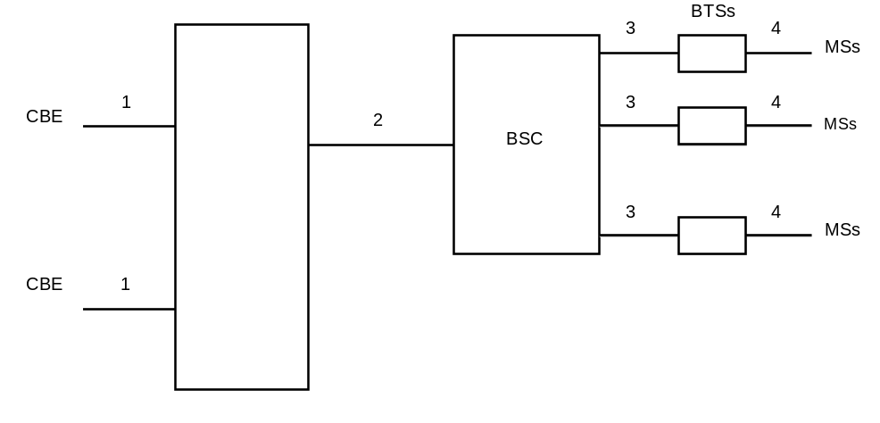
Figure 1
- message transfer on link 1 is outside the scope of 3GPP specifications;
- message transfer on link 2 is described in subclause 9.1;
- message transfer on link 3 is described in 3GPP TS 48.058 [11];
- message transfer on link 4 is described in 3GPP TS 44.012 [7] and the timing of messages transferred on link 4 is described in 3GPP TS 45.002 [8].

3.2 UMTS Network Architecture
The basic network structure of CBS is depicted by figure 2.
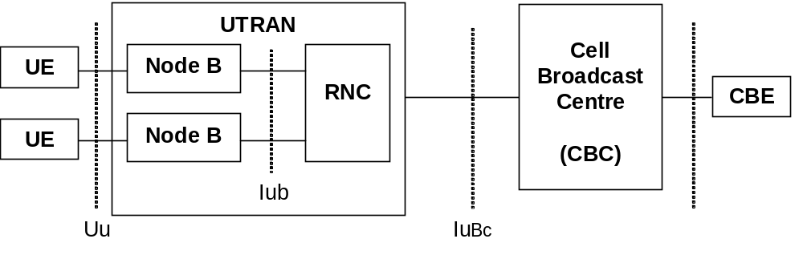
Figure 2
The basic network structure replaces the GSM BSS with the UTRAN containing the RNC and the Node B. The cell broadcast centre (CBC) is part of the core network and connected to a routing node e.g. a 3G SGSN via the Bc reference point. Thus the CBC can reach every RNC via the user plane of the Iu interface. On the logical interface between the CBC and the RNC protocol is described in 3GPP TS 25.419 [29]. The other UTRAN related interfaces are described in the according UTRAN specifications based on the 3GPP TR 25.925 [21]. Based on this architecture and the current requirements for cell broadcast the core network elements like MSC, VLR, HLR etc are not involved for the service delivery.
The CBE and the interface between CBE and CBC are out of scope of 3GPP specifications.

3.3 EPS Network Architecture
The basic network structure of PWS architecture in E-UTRAN is depicted by figure 3.3-1.
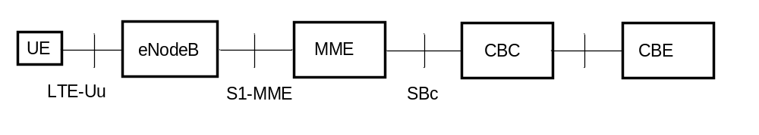
Figure 3.3-1: PWS architecture
The cell broadcast centre (CBC) is part of the core network and connected to the MME via the SBc reference point. The interface between the CBC and the MME is described in 3GPP TS 29.168 [35] and the interface between the MME and the eNodeB is described in 3GPP TS 36.413 [34].
The CBE and the interface between CBE and CBC are out of scope of 3GPP specifications.

3.4 5GS Network Architecture
Figures 3.4-1 and 3.4.-2 show the basic network structure of PWS architecture in 5GS. Figure 3.4-1 shows the deployment option using service-based interfaces between CBCF and AMF. This option is further described in subclauses 4 to 8.
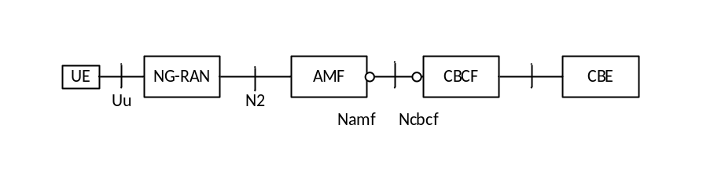

Figure 3.4-1: 5GS PWS architecture without PWS-IWF
Reference point to support PWS architecture:
N2: Reference point between the NG-RAN and the AMF.
NOTE: NG-RAN can be NR based or E-UTRA based (See 3GPP TS 23.501 [39] , 3GPP TS 38.413 [40] and 3GPP TS 36.413 [34]).
Service based interface to support PWS in 5GS:
Namf: Service-based interface exhibited by AMF.
Ncbcf: Service-based interface exhibited by CBCF and the PWS-IWF.
The CBE and the interface between CBE and CBC are out of scope of 3GPP specifications.
Figure 3.4-2 shows the deployment option using PWS-IWF between CBC and AMF. This option is further described in Annex B.
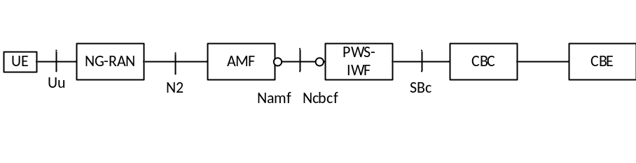
Figure 3.4-2: 5GS PWS architecture with PWS-IWF

4 CBE Functionality
The functionality of the CBE is outside of the scope of 3GPP specifications; however it is assumed that the CBE is responsible for all aspects of formatting CBS messages, including the splitting of a CBS message into a number of pages.

5 CBC Functionality
In 3GPP the CBC is integrated as a node in the core network.
The CBC may be connected to several BSCs/RNCs/MMEs/PWS-IWFs. The CBC may be connected to several CBEs. The CBC shall be responsible for the management of CBS messages including:
- allocation of serial numbers;
- modifying or deleting CBS messages held by the BSC/RNC/eNodeB/ng-eNodeB/gNodeB;
- initiating broadcast by sending fixed length CBS messages to a BSC/RNC/eNodeB/ng-eNodeB/gNodeB for each language provided by the cell, and where necessary padding the pages to a length of 82 octets (see 3GPP TS 23.038 [3]);
- determining the set of cells to which a CBS message should be broadcast, and indicating within the Serial Number the geographical scope of each CBS message;
- determining the time at which a CBS message should commence being broadcast;
- determining the time at which a CBS message should cease being broadcast and subsequently instructing each BSC/RNC/eNodeB/ng-eNodeB/gNodeB to cease broadcast of the CBS message;
- determining the period at which broadcast of the CBS message should be repeated;
- determining the cell broadcast channel in GSM, on which the CBS message should be broadcast.
- when CBS transmits emergency messages, allocation of "emergency indication" to differentiate it from normal CBS messages, including the "Cell ID/Service Area ID list", "warning type", "warning message". If "warning type" is of 'test', only UEs which are specially designed for testing purposes may display warning message.
To work efficiently on the interfaces, the BSC/RNC - which is normally controlling more than one cell of a broadcast area - should be used as a concentrator as far as CBS message handling is concerned. Hence, the CBC should work on lists of cells when issuing CB related requests towards the BSC/RNC.

5A CBCF Functionality
In 3GPP the CBCF is a network function in the 5G core network.
The CBCF may be connected to several AMFs. The CBCF may be connected to several CBEs. The CBCF shall be responsible for the management of CBS messages including:
- allocation of serial numbers;
- modifying or deleting CBS messages held by the eNodeB/gNodeB;
- initiating broadcast by sending fixed length CBS messages to a eNodeB/gNodeB for each language provided by the cell, and where necessary padding the pages to a length of 82 octets (see 3GPP TS 23.038 [3]);
- determining the set of cells to which a CBS message should be broadcast, and indicating within the Serial Number the geographical scope of each CBS message;
- determining the time at which a CBS message should commence being broadcast;
- determining the time at which a CBS message should cease being broadcast and subsequently instructing each eNodeB/gNodeB to cease broadcast of the CBS message;
- determining the period at which broadcast of the CBS message should be repeated;
- when CBS transmits emergency messages, allocation of "emergency indication" to differentiate it from normal CBS messages, including the "Cell ID/Service Area ID list", "warning type", "warning message". If "warning type" is of 'test', only UEs which are specially designed for testing purposes may display warning message.
The CBCF supports service based interface. The CBCF uses AMF communication services to forward warning messages to the NG-RAN and to subscribe to receive warning delivery related notifications.

6 BSC/RNC/MME/AMF Functionality
The BSC/RNC shall interface to only one CBC. A BSC may interface to several BTSs as indicated by 3GPP TS 48.052 [10]. An RNC may interface to several Node Bs.
The MME/AMF may interface to one CBC or multiple CBCs (i.e. the MME/AMF is allowed to have SCTP transport associations established with one or multiple CBCs). An MME may interface to several eNodeBs. An AMF may interface to several eNodeBs and/or gNodeBs.
The BSC/RNC/MME/AMF shall be responsible for:
BSC | RNC | MME | AMF
Interpretation of commands from the CBC.
Storage of messages from the CBC.
Scheduling of CBS messages on the CBCH. | Scheduling of CBS messages on the CBS related radio resources. | Not applicable | Not applicable
Providing an indication to the CBC when the desired repetition period cannot be achieved.
Providing to the CBC acknowledgement of successful execution of commands received from the CBC.
Reporting to the CBC failure when a command received from the CBC is not understood or cannot be executed.
Not applicable. | Not applicable. | Report the Broadcast Completed Area List, the Broadcast Cancelled Area List, PWS Restart Indication and the PWS Failure Indication received from eNB(s) to all CBCs that the MME interfaces with. | Report the Broadcast Completed Area List, the Broadcast Cancelled Area List, PWS Restart Indication and the PWS Failure Indication received from gNB(s) or eNB(s) to all CBCs that the AMF interfaces with.
Routing of CBS messages to the appropriate BTSs. | Routing of CBS messages to the appropriate Node Bs. | Routing of warning messages to the appropriate eNodeBs in the indicated Tracking Area. | Routing of warning messages to the appropriate gNB(s) or eNB(s) in the indicated Tracking Area.
Transferring CBS information to each appropriate BTS via a sequence of 4 SMS BROADCAST REQUEST messages or 1 SMS BROADCAST COMMAND message (see 3GPP TS 48.058 [11]), indicating the channel which shall be used. | The Node B has no functionality regarding CBS. This implies that CBS messages do not have to be transmitted explicitly to the Node Bs for further processing. | Not applicable. | Not applicable.
Optionally generating Schedule Messages, indicating the intended schedule of transmissions (see 3GPP TS 44.012 [7]). | Generating Schedule Messages, indicating the intended schedule of transmissions (see 3GPP TS 25.324 [19]). The conversion of GSM related CB DRX Information is a function of the RNC (3GPP TS 25.401 [17]). | Not applicable. | Not applicable.
Optionally receiving CBCH Load Indication messages and reacting by broadcasting a burst of scheduled CBS messages or by suspending the broadcast for a period indicated by BTS (see 3GPP TS 48.058 [11]). | Not applicable. | Not applicable. | Not applicable.
Broadcasting the ETWS Primary Notification message upon receipt of the WRITE-REPLACE message including the Paging-ETWS-Indicator. The ETWS Primary Notification message is broadcasted according to the Warning Period parameter. | Sending ETWS messages to mobile terminals upon receiving CBS transmission request from CBC including the Paging-ETWS-Indicator. Emergency indication can be included in the paging messages, based on the warning type information conveyed from CBC. | Sending the Write-Replace Warning Request message to the appropriate eNodeBs upon receiving warning message transmission request from CBC. | Sending the Write-Replace Warning Request message to the appropriate NG-RANs upon receiving warning message transmission request from CBC.

To work efficiently on the interfaces, the BSC/RNC should forward CB related messages to the CBC using cell lists as far as applicable.

7 BTS Functionality
Only GSM [The BTS is responsible for conveying CBS information received via SMS BROADCAST REQUEST or SMS BROADCAST COMMAND messages over the radio path to the MS.
- optionally generating CBCH Load Indication messages, indicating an underflow or overflow situation on the CBCH (see 3GPP TS 48.058 [11]).]

8 MS/UE Functionality

8.1 General MS/UE Functionality
Only GSM [The MS is responsible for recombination of the blocks received via the radio path to reconstitute the CBS message.]
The precise method of display of CBS messages is outside the scope of 3GPP specifications, however it is assumed that an MS/UE will:
MS |  | UE
Discard sequences transferred via the radio path (see 3GPP TS 44.012 [7]) which do not consist of consecutive blocks. |  | Discard corrupt CBS messages received on the radio interface.
Have the ability to discard CBS information which is not in a suitable data coding scheme.
Have the ability to discard a CBS message which has a message identifier indicating that it is of subject matter which is not of interest to the MS/UE.
Have the ability to detect duplicate messages as specified in subclause 8.2;
Have the ability to transfer a CBS message to an external device, when supported ;
Optionally enter CBS DRX mode based upon received Schedule Messages (see 3GPP TS 44.012 [7]); | Enter CBS DRX mode based upon received Schedule Messages (see 3GPP TS 25.324 [19]).
Optionally skip reception of the remaining block(s) of a CBS message which do(es) not contain cell broadcast information (see 3GPP TS 44.012 [7]); | Not applicable.
Optionally read the extended channel. | Not applicable for UMTS, E-UTRAN, and NG-RAN.
Enable the user to activate/deactivate CBS through MMI
Enable the user to maintain a "search list" and receive CBS messages with a Message Identifier in the list while discarding CBS messages with a Message Identifier not in the list.
Discard CBS messages in Message Identifier value range "A000hex-AFFFhex" unless received from HPLMN, EHPLMN or PLMN that is equivalent to HPLMN or EHPLMN.
Allow the user to enter the Message Identifier via MMI only for the 1 000 lowest codes.
Be capable of receiving CBS messages consisting of up to 15 pages. | Be capable of receiving CBS messages consisting of up to 1230 octets in UTRAN or warning messages of up to 9600 octets in E-UTRAN, or NG-RAN.
When emergency indication is included in the received paging and/or CBS/warning message, behave as specified in 3GPP TS 22.268 [28].
If the emergency indication includes the value for “test”, mobile terminals which are not used for testing purpose silently discard the paging message and do not receive the corresponding CBS/warning message.

8.2 Duplication Detection Function
The MS/UE uses a common duplication detection function for all messages received in GSM, UMTS, E-UTRAN and NG-RAN.
Upon reception of a new message, the MS/UE shall perform duplication detection on the messages. Those messages that are received from the same PLMN in the certain time period specified by the duplication detection time are subject to duplication detection. The MS/UE shall not perform duplication detection on messages whose duplication detection time has elapsed.The value of the duplication detection time to be used by the MS/UE shall be derived from the MCC of the current PLMN as follows:
- If MCC = 440 or MCC = 441 (Japan), duplication detection time shall be 1 hour;
- For all other MCCs, duplication detection time shall be 24 hours.
The MS/UE shall check:
1) whether the Serial Number associated with the Message Identifier of the new message matches the Serial Number of any of those messages with the same Message Identifier that have been received and displayed to the subscriber and that are subject to the duplication detection.
Additionally, the MS/UE may check:
2) other criteria for detecting duplicates. An example of such a criterion is whether the actual contents of the two messages is the same.
If criterion 1 is fulfilled and any implemented additional checks (as described in criterion 2) are also met, then the MS/UE shall consider the new message as duplicated and shall ignore it. If the Geographical Scope is not PLMN wide the validity of the Serial Number may be considered as described in sub clause 9.4.1.2.1.
For ETWS, duplicate message detection shall be performed independently for primary and secondary notifications.

9 Protocols and Protocol Architecture

9.1 Requirements on Core Network and Radio Access Network

9.1.1 GSM Radio Access Network
Commands interpreted by the BSC will result in a sequence of 4 SMS BROADCAST REQUEST messages or 1 SMS BROADCAST COMMAND message being sent to a BTS, which in turn result in a sequence of 4 blocks each 22 octets long being transferred via the BTS-MS interface (see 3GPP TS 44.012 [7]).
With the SMS BROADCAST REQUEST mode of operation, the 88 octet fixed length CBS page which is specified in subclause 9.3 is split into four 22 octet blocks which are carried in SMS BROADCAST REQUEST messages as follows:
octets 1-22 are transferred in the 1st SMS BROADCAST REQUEST
with a sequence number (see 3GPP TS 44.012 [7]) indicating first block;

octets 23-44 are transferred in the 2nd SMS BROADCAST REQUEST
with a sequence number (see 3GPP TS 44.012 [7]) indicating second block;

octets 45-66 are transferred in the 3rd SMS BROADCAST REQUEST
with a sequence number (see 3GPP TS 44.012 [7]) indicating third block;

octets 67-88 are transferred in the 4th SMS BROADCAST REQUEST
with a sequence number (see 3GPP TS 44.012 [7]) indicating fourth block.
Figure 3 illustrates the protocol architecture and the scope of the various GSM Specifications for the SMS BROADCAST REQUEST mode of operation.
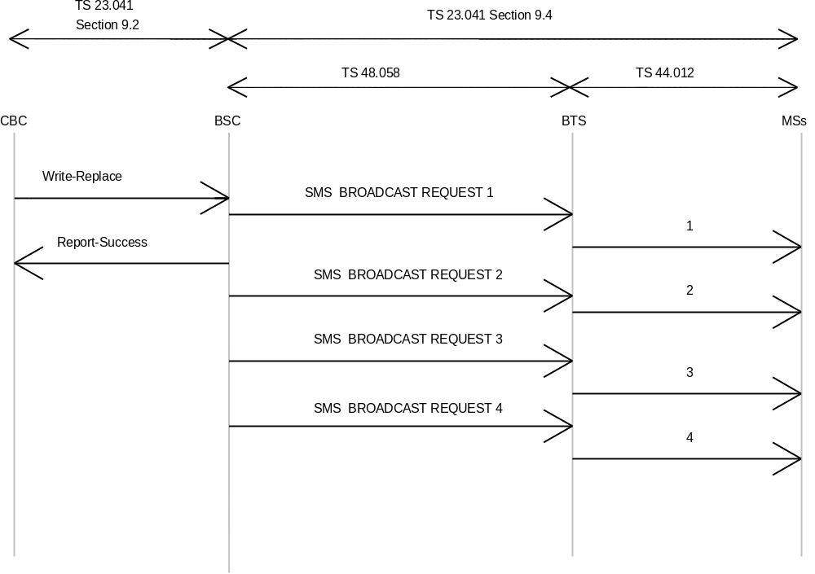
Figure 3
With the SMS BROADCAST COMMAND mode of operation, the BSC sends to the BTS in one single message the 88 octet fixed length CBS page. The BTS then splits the page into four 22 octet blocks, adds the sequence number (see 3GPP TS 44.012 [7]) and transmits the four resulting blocks on the air.
Figure 4 illustrates the protocol architecture and the scope of the various GSM Specifications for the SMS BROADCAST COMMAND mode of operation.
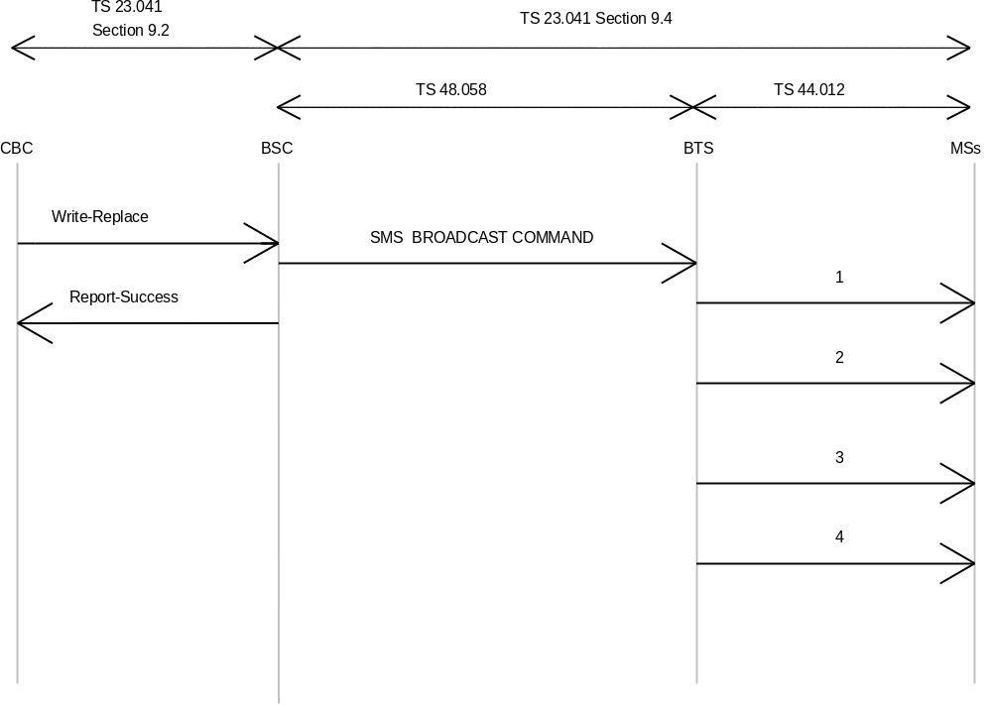
Figure 4

9.1.2 UMTS Radio Access Network
Commands interpreted by the RNC will result in one SMS BROADCAST COMMAND sent to the UE. The CBS messages are completely transparent to the Node B, i.e. no manipulation of the data like e.g. fragmentation is done at the Node B.
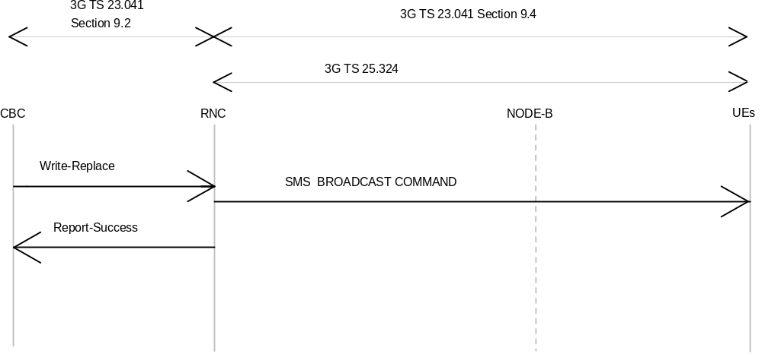
Figure 4a

9.1.3 Warning Message Delivery

9.1.3.1 General
In GSM and UMTS, the cell broadcast service can be used to transfer CBS messages related to public warning. This requires reception of CBS messages to be permanently activated in the mobile terminal.
Warning message delivery is similar to cell broadcast service. It permits a number of unacknowledged warning messages to be broadcast to MS/UEs within a particular area. Reception of warning messages is enabled as defined later on in this specification.
3GPP TS 31.102 [18] defines a USIM data file for configuration of warning messages reception. In case of a non-existing or empty USIM data file, the MS/UE accepts all warning messages on all PLMNs. As specified in 3GPP TS 31.102 [18], the MS/UE can be configured to ignore all warning messages received in its HPLMN or in a PLMN equivalent to it. As specified in 3GPP TS 31.102 [18], the MS/UE can be configured to ignore all warning messages received in a VPLMN or in a PLMN equivalent to it.
A UE in limited service state, and configured according to the USIM data file to display warning messages on that PLMN, shall display warning messages to the user.
In GSM, an ETWS capable MS uses the procedure as outlined in subclause 9.1.3.2. See 3GPP TS 44.018 [26] and 3GPP TS 44.060 [27] for details on the radio interface.
In UMTS, an ETWS capable UE uses the procedure as outlined in subclause 9.1.3.3. See 3GPP TS 25.331 [16] for details on the radio interface.
In E-UTRAN, an ETWS capable UE or a CMAS capable UE uses the procedures as outlined in subclause 9.1.3.4. See 3GPP TS 36.331 [36] for details on the radio interface.

9.1.3.2 Warning Message Delivery Procedure in GSM
When a warning message is sent in GERAN, the following message flow applies. The warning message request from the CBE will trigger a broadcast of an ETWS emergency message (containing the ETWS Primary Notification) and/or a CBS message (constituting a Secondary Notification) on the radio interface. The ETWS emergency message is conveyed by the paging message which can invoke mobile terminals to start receiving CBS messages without MMI. Mobile stations invoked to start receiving CBS messages this way may stop receiving CBS messages (without MMI) after a predefined period of time.
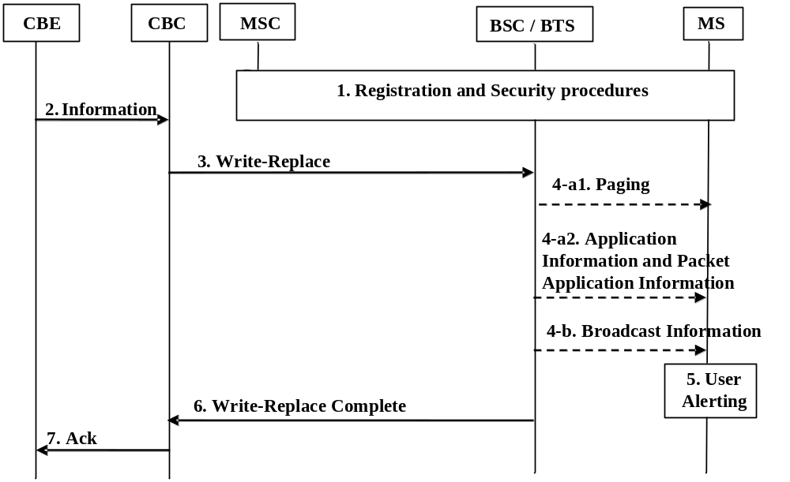
Figure 9.1.3.2-1: Warning message delivery procedure in GERAN
1. Network registration and security procedures are performed.
NOTE 1: This step is performed each time an MS is attached to a NW (e.g. after each power-on).
2. CBE (e.g. Information Source such as PSAP or Regulator) sends emergency information ("warning type", "warning message", "impacted area", and "time period") to the CBC. The CBC shall authenticate this request. The "warning type" takes one of the following values: earthquake, tsunami, earthquake and tsunami, test, or other.
3. Using the "impacted area information", the CBC identifies which BSCs need to be contacted and constructs the "Cell list" for the cells in which the information is to be broadcast.
The CBC shall send a WRITE-REPLACE message to all the identified BSCs. If the emergency information received from the CBE contains warning information to be sent both in an ETWS emergency message and in a CBS message, then the CBC need to send this information in separate WRITE-REPLACE messages to the identified BSCs accordingly:
- When containing an ETWS emergency message the WRITE-REPLACE message includes the "Paging ETWS Indicator" to differentiate it from a normal CBS message, as well as (among other parameters) the "Cell list", "warning type" (which constitutes a part of the ETWS Primary Notification message, see subclause 9.4.1.3), and the "warning period" parameter.
- When containing a CBS message the WRITE-REPLACE message includes the "Channel Indicator" to differentiate it from an ETWS emergency message, as well as (among other parameters) the "Cell list", "Repetition Period", "No of Broadcasts Requested" and the "CBS Message Information" parameter(s).
The CBC shall not include the "digital signature" or "timestamp" information.
NOTE 2: Due to requirements in earlier versions of this document, it is possible for "digital signature" and "timestamp" information (included in the "Warning Security Information" parameter) to be transmitted within the WRITE-REPLACE message.
4. The BSCs use the "Cell list" information to identify in which cells the warning message needs to be broadcasted.
a) When the WRITE-REPLACE message contains an ETWS emergency message, the BSC/BTS:
1) shall include the ETWS emergency message within the paging message and start sending the paging messages in all paging groups for the time duration requested by the CBC in the "warning period" parameter. The paging message contains the "ETWS indicator", based on the "Paging ETWS Indicator" received in the WRITE-REPLACE message, and the ETWS Primary Notification message as defined in subclause 9.4.1.3. When the "warning type" in the ETWS Primary Notification message is set to 'other', all of the warning information is included in the broadcasted CBS message.
2) may send the ETWS Primary Notification message in other messages (Application Information, see 3GPP TS 44.018 [26], and Packet Application Information, see 3GPP TS 44.060 [27]) in order to reach mobiles in connected mode.
b) When the WRITE-REPLACE message contains a CBS message the BSC/BTS shall start to broadcast the CBS message on the Cell Broadcast channel according to the "Repetition Period" and "No of Broadcasts Requested" requested by the CBC.
5. Upon reception of the paging message containing the ETWS Primary Notification message, if the MS is configured to accept warnings on that PLMN (see 3GPP TS 31.102 [18]) the ETWS capable MS alerts the user immediately as indicated by the "warning type" value, and starts reading the Cell Broadcast channel in order to acquire a possible broadcasted CBS message containing the Secondary Notification message.
Upon reception of the CBS message containing the Secondary Notification message, the ETWS capable MS immediately indicates the contents of the Secondary Notification message to the user.
NOTE 3: If the MS receives the same ETWS Primary Notification message more than once it silently discards the last received Primary Notification message.
NOTE 4: When the "warning type" is set to 'test', the MS silently discards the ETWS Primary Notification message. The MS does not start reading the Cell Broadcast channel in this case. However, the MS specially designed for testing purposes can perform user alerting and proceed to the reception of the broadcasted CBS message as described above.
NOTE 5: If the MS is configured to ignore warnings on that PLMN (see 3GPP TS 31.102 [18]), the MS does not try to acquire the broadcasted CBS message described above.
The MS shall perform duplication detection of the received message as specified in subclause 8.2.
The MS shall ignore the values of "digital signature" and "timestamp" if received in the "Warning Security Information" parameter.
NOTE 2: Due to requirements in earlier versions of this document, it is possible for "digital signature" and "timestamp" information (included in the "Warning Security Information" parameter) to be transmitted within the WRITE-REPLACE message.
6. The BSC sends a WRITE-REPLACE COMPLETE message to the CBC in response to the WRITE-REPLACE message.
7. CBC sends acknowledgement message to CBE.

9.1.3.3 Warning Message Delivery Procedure in UMTS
When a warning message is sent in UTRAN, the following message flow applies. In this case, the paging message with a new emergency indication can invoke mobile terminals to start receiving CBS messages without MMI. Mobile stations invoked to start receiving CBS messages this way may stop receiving CBS messages (without MMI) after a period of time, which should not be less than 30 minutes in case DRX-Level-2 is used, and 2 minutes in case DRX-Level-1 is used.
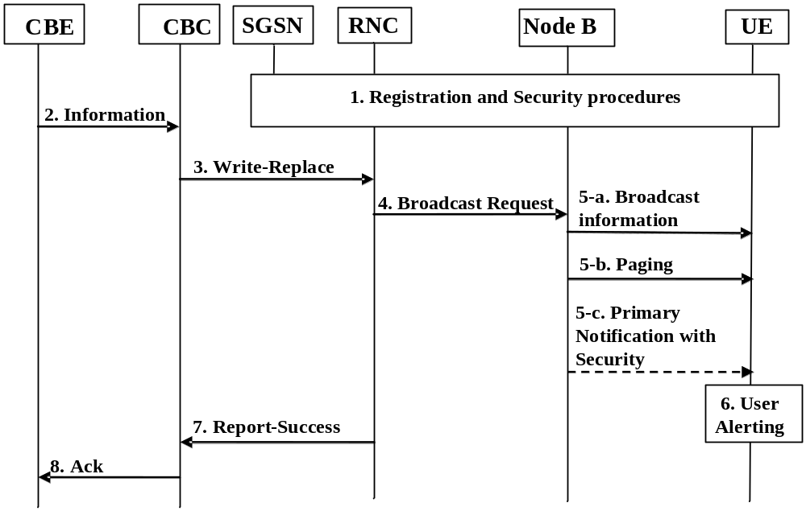
Figure 9.1.3.3-1: Warning message delivery procedure in UTRAN
1. Network registration and security (e.g. mutual authentication) procedures are performed.
NOTE 1: This step is performed each time a UE is attached to a network (e.g. after each power-on).
2. CBE (e.g. Information Source such as PSAP or Regulator) sends emergency information ("warning type", "warning message", "impacted area", and "time period") to the CBC. The CBC shall authenticate this request. The "warning type" takes one of the following values: earthquake, tsunami, earthquake and tsunami, test, or other.
3. Using the "impacted area information", the CBC identifies which RNCs need to be contacted and constructs the "Service Area ID list" for the cells in which the information is to be broadcast.
The CBC shall send a WRITE-REPLACE message to all the identified RNCs. The message shall include an "emergency indication" to differentiate it from normal Cell Broadcast information, as well as the "Service Area ID list", "warning type", "warning message".
The CBC shall not include the "digital signature" or "timestamp" information.
NOTE 2: Due to requirements in earlier versions of this document, it is possible for "digital signature" and "timestamp" information to be transmitted within "warning message".
4. The RNCs use the "Service Area ID list" information to identify which Node Bs they need to reach, and then, they relay information to them using the appropriate Iub interface message.
5. The Node B receives the Iub message containing the emergency indication. As parallel actions, the RNC/Node B:
a) shall start to broadcast the "warning message". This is broadcast by using a Cell Broadcast channel and modified System Information messages. This broadcast information is repeated continuously by the Node B for the "time period" requested by the CBE.
b) shall use paging messages in every paging group to alert idle mode mobiles to receive the broadcast warning message. Typically these paging messages are repeated in all paging groups for several DRX periods. The paging message contains the "ETWS indication" based on the "warning type" information. When the "warning type" is set to 'other', all of the warning information is included in the broadcast "warning message".
c) may send the "ETWS indication" in other messages (System Information Change Indication or ETWS Primary Notification With Security) in order to reach mobiles in connected mode. Inclusion of "ETWS indication" is the same as that of the paging message mentioned above.
6. If the UE is configured to accept warnings on that PLMN (see 3GPP TS 31.102 [18]) the UE alerts the user immediately, using "warning type" value upon the reception of the "ETWS Indication".
NOTE 3: If the UE received the "ETWS Indication" more than once it will silently discard the optional primary notification.
NOTE 4: When the "warning type" is 'test', the UE silently discards the "ETWS Indication" and does not perform the reception of the broadcast message described below. However, the UE specially designed for testing purposes can perform user alerting described above and proceed to the reception of the broadcast message described below
NOTE 5: If the UE is configured to ignore warnings on that PLMN (see 3GPP TS 31.102 [18]) the UE does not perform the reception of the broadcast message described below.
Upon the reception of the"ETWS Indication", the UE activates the reception of the broadcast messages containing the "warning message" as the secondary notification. The UE indicates the contents of the "warning message" to the user.
The UE shall perform duplication detection of the received message as specified in subclause 8.2.
The UE shall ignore the values of "digital signature" and "timestamp" if received.
NOTE 6: The "digital signature" and "timestamp" can be received due to requirements in earlier versions of this document.
7. The RNC node sends a BMC REPORT-SUCCESS to the CBC in response to Write-Replace.
8. CBC sends acknowledgement message to CBE.

9.1.3.4 Warning Message Delivery Procedure in E-UTRAN

9.1.3.4.1 General
The maximum size of the warning message for E-UTRAN is different from that for UTRAN/GERAN.
When S1-flex is used, the eNodeB may receive duplicated warning messages. Duplicated messages can be detected by checking the message identifier and serial number fields and they shall not be transmitted on the radio interface.

9.1.3.4.2 Warning Message Delivery Procedure
The warning message to be broadcast is delivered via MMEs to multiple eNodeBs. The eNodeB(s) are responsible for scheduling the broadcast of the new message and the repetitions in each cell.
The overall warning message delivery procedure is presented in figure 9.1.3.4.2-1:
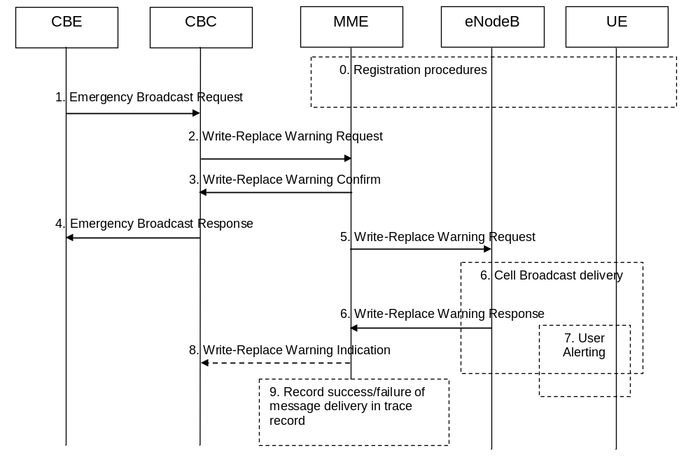
Figure 9.1.3.4.2-1: Warning message delivery procedure in E-UTRAN
0. Network registration and security (e.g. mutual authentication) procedures are performed.
NOTE 1: This step is performed each time a UE is attached to a network (e.g. after each power on).
1. CBE (e.g. Information Source such as PSAP or Regulator) sends emergency information (e.g. "warning type", "warning message", "impacted area", "time period") to the CBC. The CBC shall authenticate this request.
2. Using the "impacted area" information, the CBC identifies which MMEs need to be contacted and determines the information to be place into the Warning Area Information Element. The CBC sends a Write-Replace Warning Request message containing the warning message to be broadcast and the delivery attributes (Message identifier, Serial Number, Tracking Area ID list, Warning Area, OMC ID, CWM Indicator, Send Write-Replace-Warning-Indication, Global eNB ID) to MMEs.
The warning messages use the coding scheme for CBS data specified in 3GPP TS 23.038 [3].
The Tracking Area ID list is only used by the MME. The MME uses it for selecting which eNodeBs to forward the Write-Replace Warning Request message to.
If the Write-Replace Warning Request message is sent to reload cells served by an eNodeB, for which the CBC has previously received a Restart Indication (see subclause 15A.1 of TS 23.007 [38]), the CBC shall include the Global eNB ID IE with the identity of this eNodeB in the Write-Replace Warning Request message.
The Warning Area shall be a list of Cell IDs or a list of TAIs or one or more Emergency Area IDs. The Warning Area is only used by the eNodeB. The eNodeB is configured with the TAI(s) and Cell ID(s) it serves and the Emergency Area ID(s) that it belongs to. The eNodeB checks for any match of the contents of the Warning Area with these IDs to identify the cells where to distribute the warning message. The Warning Area is an optional information element. If the Warning Area is absent, it shall be interpreted as "all cells on the eNodeB". The number of cell IDs will be limited by the message size on SBc and S1-MME. An Emergency Area ID is unique within the PLMN.
The message may include an OMC ID. If present, it indicates the OMC to which the Trace record generated in step 9 is destined. Co-location of that OMC with the CBC is an operator option.
CBC shall set the Concurrent Warning Message (CWM) indicator in all Write-Replace Warning Request messages, if the PLMN supports concurrent warning message broadcasts.
The CBC shall not include the "digital signature" or "timestamp" information.
CBC shall set the Send Write-Replace-Warning Indication element in case the MME is requested to forward the Broadcast Scheduled Area List in a Write-Replace Warning Indication for the warning message.
NOTE 2: Due to requirements in earlier versions of the specification, it is possible that "digital signature" and "timestamp" information are transmitted within the "warning message".
3. The MME sends a Write-Replace Warning Confirm message that indicates to the CBC that the MME has started to distribute the warning message to eNodeBs.
The Write-Replace Warning Confirm message may contain the Unknown Tracking Area List IE. The Unknown Tracking Area List IE identifies the Tracking Areas that are unknown to the MME and where the Request cannot be delivered.
If this message is not received by the CBC within an appropriate time period, the CBC can attempt to deliver the warning message via another MME in the same pool area.
4. Upon reception of the Write-Replace Confirm messages from the MMEs, the CBC may confirm to the CBE that it has started to distribute the warning message.
5. The MME forwards Write-Replace Warning Message Request to eNodeBs. The MME shall use the Tracking Area ID list to determine the eNodeBs in the delivery area. If the Tracking Area ID list isnot included and no Global eNB ID has been received from the CBC, the message is forwarded to all eNodeBs that are connected to the MME. If a Global eNB ID has been received from the CBC, the MME shall forward the message only to the eNodeB indicated by the Global eNB ID IE.
6. When S1-flex is used the eNodeB may receive same message from multiple MMEs. The eNodeB detects duplicate messages by checking the message identifier and serial number fields within the warning message. If any redundant messages are detected only the first one received will be broadcasted by the cells. The eNodeB shall use the Warning Area information to determine the cell(s) in which the message is to be broadcast. The eNodeBs return a Distribute Warning Message Response to the MME, even if it was a duplicate.
If there is a warning broadcast message already ongoing and the CWM Indicator is included in the Write-Replace Warning Message Request, the eNodeB does not stop existing broadcast message but start broadcasting the new message concurrently. Otherwise the eNodeB shall immediately replace the existing broadcast message with the newer one.
NOTE 3: If concurrent warning messages are not supported, this requires the CBE/CBC to take care that 'lower' priority warnings are not sent while a higher priority warning is still being sent.
The eNodeB broadcasts the message frequently according to the attributes set by the CBC that originated the warning message distribution.
7. If the UE has been configured to receive warning messages , and the UE is configured to accept warnings on that PLMN (see 3GPP TS 31.102 [18]), then the UE proceeds as follows:
The UE can use "warning type" values, 'earthquake', 'tsunami' or 'earthquake and tsunami', immediately to alert the user. When "warning type" is 'test', the UE silently discards the primary notification, but the UE specially designed for testing purposes may proceed with the following procedures.
The UE activates reception of the broadcast messages containing the "warning message".
The UE indicates the contents of the "warning message" to the user.
8. If the Send Warning-Message-Indication parameter was present in the Write-Replace Warning Request and it is configured in the MME based on operator policy, the MME shall forward the Broadcast Scheduled Area Lists in a Write-Replace Warning Indication(s) to the CBC. The Broadcast Scheduled Area List shall contain the Broadcast Completed Area List the MME has received from the eNodeB. The MME may aggregate Broadcast Completed Area Lists it receives from eNodeBs.
NOTE 4: Support for sending of Write-Replace Warning Indication(s) to the CBC is optional in the MME.
9. From the Write-Replace Warning Response messages returned by eNodeB's the MME determines the success or failure of the delivery and creates a trace record. Any OMC ID received in step 2 is written to the trace record to permit the O&M system to deliver them to the desired destination.

9.1.3.4.3 Warning Message Cancel Procedure
The cancel warning message delivery procedure takes place when CBE requests to stop the on-going broadcast of warning messages.
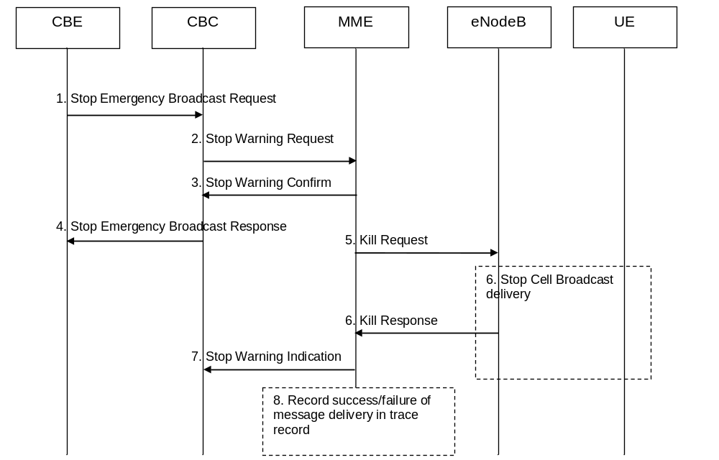
Figure 9.1.3.4.3-1: Warning message cancel procedure in E-UTRAN
1. CBE initiates procedure by sending Stop Emergency Broadcast Request (e.g. "Message Identifier and Serial Number"), to the CBC. The CBC shall authenticate this request.
2. The CBC identifies which MMEs need to be contacted and determines the information to be place into the Warning Area Information Element. The CBC sends a Stop Warning Request message (Message Identifier, Serial Number, Tracking Area ID list, Warning Area, OMC ID, Send Stop Warning Indication) to MMEs.
The message may include an OMC ID. If present, it indicates the OMC to which the Trace record generated in step 8 is destined. Co-location of that OMC with the CBC is an operator option.
The CBC sets the Send Stop Warning Indication element in case the MME is requested to forward the Broadcast Completed Area List in a Stop Warning Indication for the warning message.
3. The MME sends a Stop Warning Confirm message that indicates to the CBC that the MME has started to distribute the Kill Request message to eNodeBs.
If this message is not received by the CBC within an appropriate time period, the CBC can attempt to send Stop Warning Request via another MME in the same pool area.
4. Upon reception of the Stop Warning Confirm messages from the MMEs, the CBC may confirm to the CBE that it has initiated the Warning message cancel procedure.
5. The MME forwards the request from the CBC by Kill Request to eNodeB's. The MME shall use the Tracking Area ID list to determine the eNodeBs that may have warning message broadcast ongoing. In case the Tracking Area ID list is not included the Kill Request is forwarded to all eNodeBs that are connected to the MME.
6. The eNodeB shall stop broadcasting the warning message identified by the Message Identifier and Serial Number in the areas identified by Warning Area IDs. If the Warning Area is absent, it shall be interpreted as "all cells on the eNodeB").
When S1-Flex is used the eNodeB may receive same Kill Request from multiple MMEs, if any redundant Kill Requests are detected only the response to the first MME shall contain statistics related to the cancelled broadcast.
7. If the Send Stop Warning Indication parameter was present in the Stop Warning Request and it is configured in the MME based on operator policy, the MME forwards the Broadcast Cancelled Area List it has received from the eNodeB in a Stop Warning Indication(s) to the CBC. The MME may aggregate Broadcast Cancelled Area Lists it receives from eNodeBs.
If the CBC has requested the MME to send Stop Warning Indications, then the CBC releases the Serial Number of a message after it has stopped receiving the Stop Warning Indications for that message.
NOTE: Support for Stop Warning Indication(s) is optional in the MME.
8. From the Kill Response messages returned by eNodeB's the MME creates a trace record (e.g. number of times a particular message has been broadcasted in a given warning area) related to the cancelled message. Any OMC ID received in step 2 is written to the trace record to permit the O&M system to deliver them to the desired destination.

9.1.3.5 Warning Message Delivery Procedure in NG-RAN

9.1.3.5.1 General
The maximum size of the warning message for NG-RAN is different from that for UTRAN/GERAN.
When the CBCF sends warning messages to multiple AMFs for the same warning area, the gNodeB may receive duplicated warning messages. Duplicated messages can be detected by checking the message identifier and serial number fields and they shall not be transmitted on the radio interface.
NOTE: In case the NG-RAN consists of gNodeBs as well as ng-eNodeBs then the procedure in the present subclause applies to gNodeBs as well as to ng-eNodeBs.
The Warning Message Delivery procedure and the Warning Message Cancel procedure are transported with the NonUeN2MessageTransfer service operation; see clause 9A.

9.1.3.5.2 Warning Message Delivery Procedure
The warning message to be broadcast is delivered via AMFs to multiple gNodeBs. The gNodeB(s) are responsible for scheduling the broadcast of the new message and the repetitions in each cell.
The overall warning message delivery procedure is presented in figure 9.1.3.5.2-1:
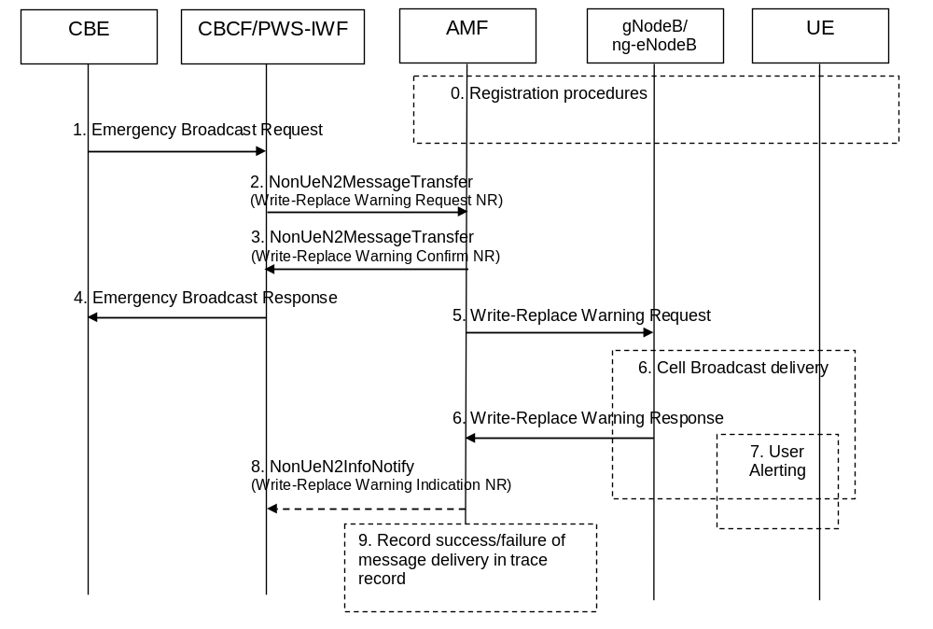
Figure 9.1.3.5.2-1: Warning message delivery procedure in NG-RAN
0. Network registration and security (e.g. mutual authentication) procedures are performed.
NOTE 1: This step is performed each time a UE is attached to a network (e.g. after each power on).
1. CBE (e.g. Information Source such as PSAP or Regulator) sends emergency information (e.g. "warning type", "warning message", "impacted area", "time period") to the CBC. The CBCF shall authenticate this request.
2. Using the "impacted area" information, the CBCF identifies which AMFs need to be contacted and determines the information to be placed into the Warning Area Information Element. The CBCF sends a Write-Replace Warning Request NG-RAN message containing the warning message to be broadcast and the delivery attributes (Message Identifier, Serial Number, Tracking Area ID list, Warning Area, OMC ID, CWM Indicator, Send Write-Replace-Warning-Indication, Global RAN Node ID) to AMFs.
The warning messages use the coding scheme for CBS data specified in 3GPP TS 23.038 [3].
The Tracking Area ID list is only used by the AMF. The AMF uses it for selecting which gNodeBs to forward the Write-Replace Warning Request NG-RAN message to.
If the Write-Replace Warning Request NG-RAN message is sent to reload cells served by a gNodeB, for which the CBCF has previously received a Restart Indication (see subclause 15A.1 of TS 23.007 [38]), the CBCF shall include the Global RAN Node ID IE with the identity of this gNodeB in the Write-Replace Warning Request NG-RAN message.
The Warning Area shall be a list of Cell IDs or a list of TAIs or one or more Emergency Area IDs. The Warning Area is only used by the gNodeB. The gNodeB is configured with the TAI(s) and Cell ID(s) it serves and the Emergency Area ID(s) that it belongs to. The gNodeB checks for any match of the contents of the Warning Area with these IDs to identify the cells where to distribute the warning message. The Warning Area is an optional information element. If the Warning Area is absent, it shall be interpreted as "all cells on the gNodeB". The number of cell IDs will be limited by the message size on Ncbcf and N2. An Emergency Area ID is unique within the PLMN.
The message may include an OMC ID. If present, it indicates the OMC to which the Trace record generated in step 9 is destined. Co-location of that OMC with the CBCF is an operator option.
CBCF shall set the Concurrent Warning Message (CWM) indicator in all Write-Replace Warning Request NG-RAN messages, if the PLMN supports concurrent warning message broadcasts.
The CBCF shall not include the "digital signature" or "timestamp" information.
CBCF shall set the Send Write-Replace-Warning Indication element in case the AMF is requested to forward the Broadcast Scheduled Area List in a Write-Replace Warning Indication NG-RAN for the warning message.
3. The AMF sends a Write-Replace Warning Confirm NG-RAN message that indicates to the CBCF that the AMF has started to distribute the warning message to gNodeBs.
The Write-Replace Warning Confirm NG-RAN message may contain the Unknown Tracking Area List IE. The Unknown Tracking Area List IE identifies the Tracking Areas that are unknown to the AMF and where the Request cannot be delivered.
If this message is not received by the CBCF within an appropriate time period, the CBCF can attempt to deliver the warning message via another AMF in the same AMF region.
4. Upon reception of the Write-Replace Confirm NG-RAN messages from the AMFs, the CBCF may confirm to the CBE that it has started to distribute the warning message.
5. The AMF forwards Write-Replace Warning Message Request NG-RAN to gNodeBs. The AMF shall use the Tracking Area ID list to determine the gNodeBs in the delivery area. If the Tracking Area ID list is not included and no Global RAN Node ID has been received from the CBCF, the message is forwarded to all gNodeBs that are connected to the AMF. If a Global RAN Node ID has been received from the CBCF, the AMF shall forward the message only to the gNodeB or ng-eNodeB indicated by the Global RAN Node ID IE.
6. When the CBCF sends warning messages to multiple AMFs for the same warning area, the gNodeB may receive the same message from multiple AMFs. The gNodeB detects duplicate messages by checking the message identifier and serial number fields within the warning message. If any redundant messages are detected only the first one received will be broadcasted by the cells. The gNodeB shall use the Warning Area information to determine the cell(s) in which the message is to be broadcast. The gNodeBs return a Write Replace Warning Message Response to the AMF, even if it was a duplicate.
If there is a warning broadcast message already ongoing and the CWM Indicator is included in the Write-Replace Warning Request NG-RAN message, the gNodeB does not stop the existing broadcast message but starts broadcasting the new message concurrently. Otherwise the gNodeB shall immediately replace the existing broadcast message with the newer one.
NOTE 2: If concurrent warning messages are not supported, this requires the CBE/CBCF to take care that 'lower' priority warnings are not sent while a higher priority warning is still being sent.
The gNodeB broadcasts the message frequently according to the attributes set by the CBCF that originated the warning message distribution.
7. If the UE has been configured to receive warning messages , and the UE is configured to accept warnings on that PLMN (see 3GPP TS 31.102 [18]), then the UE proceeds as follows:
The UE can use "warning type" values, 'earthquake', 'tsunami' or 'earthquake and tsunami', immediately to alert the user. When "warning type" is 'test', the UE silently discards the primary notification, but the UE specially designed for testing purposes may proceed with the following procedures.
The UE activates reception of the broadcast messages containing the "warning message".
The UE indicates the contents of the "warning message" to the user.
8. If the Send Warning-Message-Indication parameter was present in the Write-Replace Warning Request NG-RAN and it is configured in the AMF based on operator policy, the AMF shall forward the Broadcast Scheduled Area Lists in a Write-Replace Warning Indication(s) NG-RAN to the CBCF. The Broadcast Scheduled Area List shall contain the Broadcast Completed Area List the AMF has received from the gNodeB. The MME may aggregate Broadcast Completed Area Lists it receives from gNodeBs.
NOTE 3: Support for sending of Write-Replace Warning Indication(s) NG-RAN to the CBCF is optional in the AMF.
9. From the Write-Replace Warning Response messages returned by gNodeB's the AMF determines the success or failure of the delivery and creates a trace record. Any OMC ID received in step 2 is written to the trace record to permit the O&M system to deliver them to the desired destination.

9.1.3.5.3 Warning Message Cancel Procedure
The cancel warning message delivery procedure takes place when CBE requests to stop the on-going broadcast of warning messages.
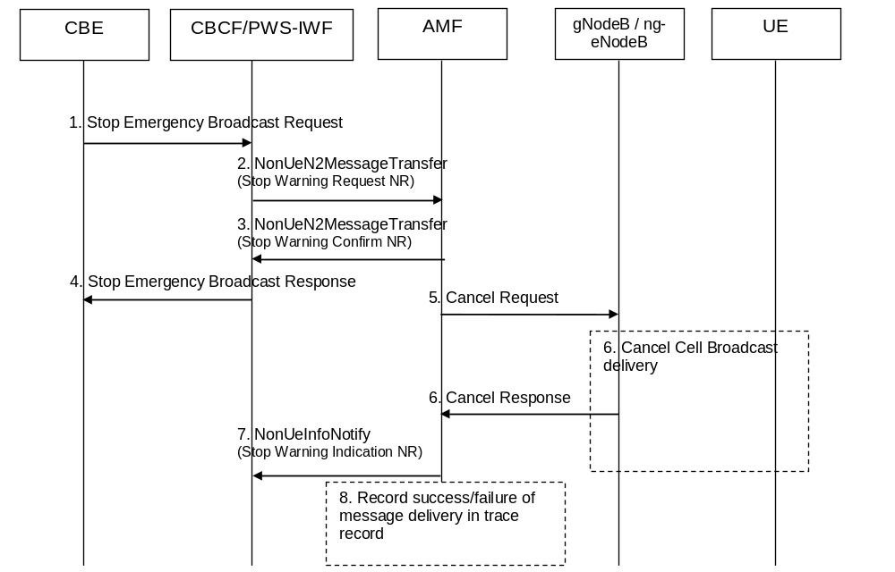
Figure 9.1.3.5.3-1: Warning message cancel procedure in NG-RAN
1. CBE initiates procedure by sending Stop Emergency Broadcast Request (e.g. "Message Identifier and Serial Number"), to the CBCF. The CBCF shall authenticate this request.
2. The CBCF identifies which AMFs need to be contacted and determines the information to be placed into the Warning Area Information Element. The CBC sends a Stop Warning Request NG-RAN message (Message Identifier, Serial Number, Tracking Area ID list, Warning Area, OMC ID, Send Stop Warning Indication) to AMFs.
The message may include an OMC ID. If present, it indicates the OMC to which the Trace record generated in step 8 is destined. Co-location of that OMC with the CBCF is an operator option.
The CBCF sets the Send Stop Warning Indication element in case the AMF is requested to forward the Broadcast Completed Area List in a Stop Warning Indication NG-RAN for the warning message.
3. The AMF sends a Stop Warning Confirm NG-RAN message that indicates to the CBCF that the AMF has started to distribute the Cancel Request message to gNodeBs.
If this message is not received by the CBCF within an appropriate time period, the CBCF can attempt to send Stop Warning Request NG-RAN via another AMF in the same AMF region.
4. Upon reception of the Stop Warning Confirm NG-RAN messages from the AMFs, the CBCF may confirm to the CBE that it has initiated the Warning message cancel procedure.
5. The AMF forwards the request from the CBCF by a Cancel Request to gNodeB's. The AMF shall use the Tracking Area ID list to determine the gNodeBs that may have warning message broadcast ongoing. In case the Tracking Area ID list is not included the Cancel Request is forwarded to all gNodeBs that are connected to the AMF.
6. The gNodeB shall cancel broadcasting the warning message identified by the Message Identifier and Serial Number in the areas identified by Warning Area IDs. If the Warning Area is absent, it shall be interpreted as "all cells on the gNodeB".
When the CBCF sends cancel messages to multiple AMFs for the same warning area, the gNodeB may receive same Cancel Request from multiple AMFs, if any redundant Cancel Requests are detected only the response to the first AMF shall contain statistics related to the cancelled broadcast.
7. If the Send Stop Warning Indication parameter was present in the Stop Warning Request NG-RAN and it is configured in the AMF based on operator policy, the AMF forwards the Broadcast Cancelled Area List it has received from the gNodeB in a Stop Warning Indication(s) NG-RAN to the CBCF. The AMF may aggregate Broadcast Cancelled Area Lists it receives from gNodeBs.
If the CBCF has requested the AMF to send Stop Warning Indications NG-RAN, then the CBCF releases the Serial Number of a message after it has stopped receiving the Stop Warning Indications NG-RAN for that message.
NOTE: Support for Stop Warning Indication(s) NG-RAN is optional in the AMF.
8. From the Cancel Response messages returned by gNodeB's the AMF creates a trace record (e.g. number of times a particular message has been broadcasted in a given warning area) related to the cancelled message. Any OMC ID received in step 2 is written to the trace record to permit the O&M system to deliver them to the desired destination.
Editor's note: RAN3 is in the process of changing "kill" to "cancel". If this is not agreed in RAN3 then the occurrences of "cancel" need to be reverted back to "kill".

9.1.4 UMTS Protocol Overview
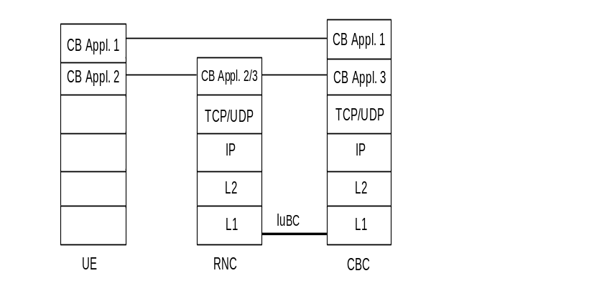
Figure 5

9.1.5 E-UTRAN Protocol Overview
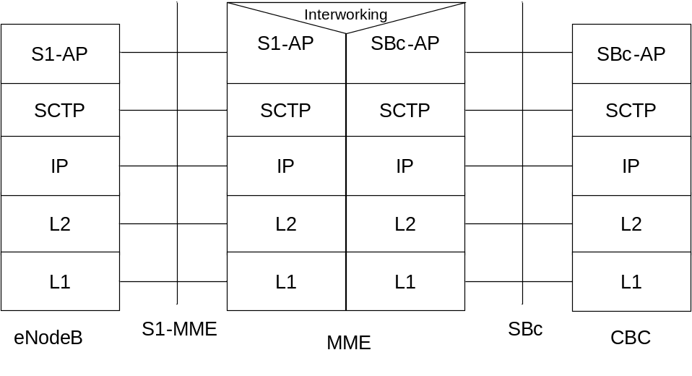
Legend:
- SBc Application Protocol (SBc-AP): Application Layer Protocol between CBC and MME. This protocol supports transfer of warning messages.
- S1 Application Protocol (S1-AP): Application Layer Protocol between the eNodeB and the MME.
- SCTP for the control plane ( SCTP): This protocol guarantees delivery of signalling messages between MME and eNodeB (S1). SCTP is defined in RFC 4960 [33].

Figure 9.1.5-1: CBC - eNodeB

9.1.6 NG-RAN Protocol Overview
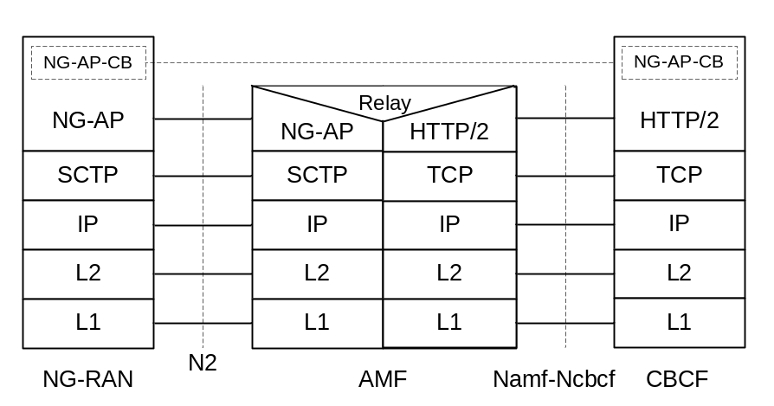

Figure 9.1.6-1: CBCF - NG-RAN

Legend:
- NG application protocol information for cell broadcast (NG-AP-CB): Subset of NG-AP information that the AMF relays between the AN and the CBCF. NG-AP-CB corresponds to a subset of NG-AP defined in 3GPP TS 38.413 [40].
- NG application protocol (NGAP): Application layer protocol between the NG-RAN entity (eNodeB and/or gNodeB) and the AMF. The NGAP protocol is defined in 3GPP TS 38.413 [40].
- SCTP for the control plane (SCTP): This protocol guarantees delivery of signalling messages between AMF and NG-RAN (N2). SCTP is defined in IETF RFC 4960 [33].
- HTTP/2: Application layer protocol for Service based interface between AMF and CBCF. HTTP/2 is defined in IETF RFC 7540 [42].

NOTE: NG-RAN protocol stack for the case where AMF and CBC inter-connects via PWS-IWF is described in annex B.3.

9.2 Requirements on the CBC-RAN, CBC-MME and CBCF-AMF interfaces

9.2.0 General
The requirements are described by primitives. The term primitive is used to indicate "an abstract, implementation independent interaction between a service user and a service provider" (see ITU-T Recommendation X.210 [12]). For the CBC-BSC/RNC/MME or CBCF-AMF interface, the service provider would be the protocol interconnecting the CBC and BSC/RNC/MME or the CBCF and AMF. A Primitive may therefore be viewed as an abstract, implementation independent request/indication or response/confirm interaction between the service user (CBC/CBCF or BSC/RNC/MME/AMF) and the service provider (protocol). A set of primitives for use between the CBC and BSC/RNC/MME and CBCF and AMF are specified appropriate to the functionality assigned to the CBC/CBCF and BSC/RNC/MME/AMF in clause 5 and clause 6. In order to allow future extensions to the primitives, where possible a primitive shall not be rejected because a parameter is not recognized; the recipient shall ignore the parameter in question and process the remainder of the primitive's parameters as usual.
NOTE: The primitives for the CBCF-AMF interface are also applicable to the PWS-IWF – AMF interface.
The following table gives an overview over the existing primitives:
Name | Originator | Type | Reference
WRITE-REPLACE | CBC | Request/Indication | 9.2.2
KILL | CBC | Request/Indication | 9.2.3
REPORT | BSC/RNC | Response/Confirm | 9.2.4
STATUS-LOAD-QUERY | CBC | Request/Indication | 9.2.5
STATUS-LOAD-QUERY | BSC/RNC | Response/Confirm | 9.2.6
STATUS-MESSAGE-QUERY | CBC | Request/Indication | 9.2.7
STATUS-MESSAGE-QUERY | BSC/RNC | Response/Confirm | 9.2.8
REJECT | BSC/RNC | Response/Confirm | 9.2.9
RESTART-INDICATION | BSC/RNC | Request/Indication | 9.2.10
RESET | CBC | Request/Indication | 9.2.11
FAILURE-INDICATION | BSC/RNC | Request/Indication | 9.2.12
SET-DRX | CBC | Request/Indication | 9.2.13
SET-DRX-REPORT | BSC | Response/Confirm | 9.2.14
WRITE-REPLACE-WARNING-REQUEST | CBC | Request/Indication | 9.2.16
WRITE-REPLACE-WARNING-CONFIRM | MME | Response/Confirm | 9.2.17
STOP-WARNING-REQUEST | CBC | Request/Indication | 9.2.18
STOP-WARNING-CONFIRM | MME | Response/Confirm | 9.2.19
WRITE-REPLACE-WARNING-INDICATION | MME | Request/Indication | 9.2.20
STOP-WARNING-INDICATION | MME | Request/Indication | 9.2.21
RESTART-INDICATION-E-UTRAN | MME | Request/Indication | 9.2.22
FAILURE-INDICATION-E-UTRAN | MME | Request/Indication | 9.2.23
RESET-COMPLETE | BSC/RNC | Response/Confirm | 9.2.24
RESET-FAILURE | BSC/RNC | Response/Confirm | 9.2.25
WRITE-REPLACE-WARNING-REQUEST-NG-RAN | CBCF/PWS-IWF | Request/Indication | 9.2.26
WRITE-REPLACE-WARNING-CONFIRM-NG-RAN | AMF | Response/Confirm | 9.2.27
STOP-WARNING-REQUEST-NG-RAN | CBCF/PWS-IWF | Request/Indication | 9.2.28
STOP-WARNING-CONFIRM-NG-RAN | AMF | Response/Confirm | 9.2.29
WRITE-REPLACE-WARNING-INDICATION-NG-RAN | AMF | Request/Indication | 9.2.30
STOP-WARNING-INDICATION-NG-RAN | AMF | Request/Indication | 9.2.31
RESTART-INDICATION-NG-RAN | AMF | Request/Indication | 9.2.32
FAILURE-INDICATION-NG-RAN | AMF | Request/Indication | 9.2.33

In GSM the CBC is integrated into the Core Network. The protocol between the CBC and BSC is defined in 3GPP TS 48.049 [30].
In UMTS the CBC is integrated into the Core Network. The protocol between the CBC and RNC is defined in 3GPP TS 25.419 [29].
In E-UTRAN the CBC is integrated into the Core Network. The protocol between the CBC and MME is defined in 3GPP TS 29.168 [35].
In NG-RAN the CBCF/PWS-IWF is integrated into the Core Network. The protocol between the CBCF/PWS-IWF and AMF is defined in 3GPP TS 29. 518 [41].
NOTE 1: The primitives used in NG-RAN are transported with the NonUeN2MessageTransfer and NonUeN2InfoNotfy service operations; see clause 9A.
NOTE 2: In the following definitions, M indicates "mandatory parameter", O indicates "optional parameter" and C indicates "conditional parameter".

9.2.1 Identification of a CBS message
In GSM within a CBC-BSC interface, a CBS message is uniquely identified by the quartet (Message Identifier, Serial Number, Cell Identifier, Channel Indicator).
In UMTS within the CBC-RNC interface, in E-UTRAN within the CBC-MME interface, and in NG-RAN within the CBC-AMF interface, a CBS message is uniquely identified by the triplet (Message Identifier, Serial Number, Cell Identifier).
This means that even when two CBS messages have the same semantic contents (for example the same weather forecast) but in different languages or coding schemes, they are considered as different and must therefore be identified by a different quartet.
The Serial Number (Old-Serial-Number or New-Serial-Number) is managed cyclically and therefore this does not prevent the re-use of the same quartet for a different CBS message when the serial number have been incremented a sufficient number of times. How to manage the ambiguity is described subsequently.
This unique identification of a CBS message across the CBC-BSC interface is used in all the primitives defined hereafter. This means that the quartet/triplet will be implicitly or explicitly present in every interface primitive which applies to a given CBS message.
This unique quartet/triplet will be referred in the rest of the document as the "message reference".

9.2.2 WRITE-REPLACE Request/Indication
PARAMETER | REFERENCE | PRESENCE (UMTS/GSM)
Message-Identifier | 9.3.1 | M/M
Old-Serial-Number | 9.3.2 | O/O
New-Serial-Number | 9.3.3 | M/M
Cell-List | 9.3.5.1 | M/M
GSM only [Channel Indicator | 9.3.6 | O] (note 1)
Category | 9.3.7 | O/C (note 2)
Repetition-Period | 9.3.8 | M/C (note 2)
No-of-Broadcasts-Requested | 9.3.9 | M/C (note 2)
Number-of-Pages | 9.3.4 | M/C (note 2)
Data Coding Scheme | 9.3.18 | M/C (note 2)
CBS-Message-Information-Page 1 | 9.3.19 | M/C (note 2)
CBS-Message-Information-Length 1 | 9.3.20 | M/C (note 2)
CBS-Message-Information-Page 2 | 9.3.19 | O/O
CBS-Message-Information-Length 2 | 9.3.20 | O/O
: |  | :
CBS-Message-Information-Page n | 9.3.19 | O/O
CBS-Message-Information-Length n | 9.3.20 | O/O
Paging-ETWS-Indicator | 9.3.23 | O/O (note 1)
Warning-Type | 9.3.24 | O/C (note 3)
Warning-Security-Information | 9.3.25 | O/C (note 3)
GSM only [Warning Period | 9.3.26 | C] (note 3)
UMTS only [Broadcast Message Content Validity Indicator | 9.3.48 | O] (note 4)
NOTE 1: Only one of these two optional parameters may be simultaneously present in the primitive. The Channel Indicator parameter is included if the primitive contains a CBS message. The Paging-ETWS-Indicator parameter is included if the primitive contains an ETWS emergency message.
NOTE 2: In GSM this parameter is included if the Channel Indicator parameter is present in the primitive.
NOTE 3: In GSM this parameter is included if the Paging-ETWS-Indicator parameter is present in the primitive.
NOTE 4: In UMTS this parameter is included if the Broadcast Message Content IE present in the primitive does not contain any valid information.

This primitive is sent by the CBC to the BSC/RNC. As this primitive can be used either to broadcast a new CBS message or replace a CBS message already broadcast, the CBC will use the presence and content of the Old-Serial-Number and New-Serial-Number fields in this primitive to instruct the BSC/RNC as follows:
a) Old-Serial-Number not present/New-Serial-Number present:
- This is a write request which will be interpreted by the BSC/RNC as an instruction to broadcast a new CBS message in all the cells of the Cell list.
- GSM only [The CBS message will be broadcasted on the channel derived by the Channel Indicator (see the clause on parameters that describes the implicit value of the Channel Indicator when not present in the CBS message)].
The following table identifies the BSC/RNC's behaviour:
Success/Failure of write request | BSC/RNC behaviour
Success | The BSC/RNC completes the following parameters to be returned in the Report PDU:  - a '0' value is entered in the number of broadcasts completed list for the cell  - no entry is made in the failure list for the cell
Failure | The BSC/RNC completes the following parameters to be returned in the Report PDU:  - no entry is made in the number of broadcasts completed list for the cell  - an entry is made in the failure list for the new CBS message identifying the failure cause for the cell

- The BSC/RNC will build as many message references as the number of cells in the list. These message references will be used in particular in the subsequent primitives.
- When a message reference is already known by the BSC/RNC for certain cells in the list (even if the Update field of the Serial-Number is different), the primitive will be rejected for those cells with the cause "message reference already used". The list of cells where the message reference is not valid will be provided in the failure list of the REPORT primitive. For these cells no entry will be made in the number of broadcasts completed parameter.
b) Old-Serial-Number present/New-Serial-Number present.
- This is a replace request which will be interpreted by the BSC/RNC as a kill request for the CBS message with the old serial number, followed by a write request for the CBS message with the new serial number. The handling of the new serial number in the write part of this request, is as described above in the write request where no Old-Serial-Number is supplied. These two kill and write requests are executed sequentially. If the kill request is unsuccessful, the BSC/RNC does not proceed to execute the write request. The kill request will stop broadcast of, and cause all information currently associated with the combination of message identifier, old serial number, GSM only [Channel Indicator] and the list of cells in the Cell list to be deleted from the cells in the BSC/RNC (i.e. for all cells provided in the Cell-List parameter). If the kill request is successful, the subsequent write request information conveyed in the primitive replaces the killed CBS message. The following table identifies the BSC/RNC's behaviour:
Success/Failure of kill request | BSC/RNC behaviour
Success | The BSC/RNC proceeds to execute the write request:  - Write successful: the BSC/RNC completes the following parameters to be returned in the Report PDU:  - An entry is made in the number of broadcasts completed list for the cell.  - No entry is made in the failure list for the cell.  - Write unsuccessful: the BSC/RNC completes the following parameters to be returned in the Report PDU:  - An entry is made in the number of broadcasts completed list for the cell.  - An entry is made in the failure list for the new CBS message identifying the failure cause for the cell.
Failure | The BSC/RNC does not proceed to execute the write request, and completes the following parameters to be returned in the Report PDU:  - no entry is made in the number of completed broadcasts list.  - an entry is made for the old CBS message in the failure list identifying the failure cause for the cell.

All cells which should perform the broadcasting are mentioned in the Cell-List parameter.
The broadcast of the referenced CBS message in the cells which are not mentioned in the Cell-List remains unaffected.
If no category is present, the default category is interpreted by the BSC/RNC, see the parameter clause.
This primitive is responded by a REPORT or REJECT primitive.
NOTE: GSM only [In the case of multipage CBS messages, the individual pages are considered as independent by the BSC scheduling algorithm].

9.2.3 KILL Request/Indication
PARAMETER | REFERENCE | PRESENCE
Message-Identifier | 9.3.1 | M
Old-Serial-Number | 9.3.2 | M
Cell-List | 9.3.5.1 | M
GSM only [Channel Indicator | 9.3.6 | O]

This primitive is sent by the CBC to the BSC/RNC. The CBC will use this primitive to kill the message indicated by the combination of message identifier, serial number, GSM only [Channel Indicator] and the cells indicated in the Cell-List of this KILL request, i.e. the primitive will halt broadcast of the message in the indicated cells and remove any knowledge of the message from the BSC/RNC for these cells. The broadcast of the referenced message in the cells which are not mentioned in the Cell-List remains unaffected. This primitive is responded with a REPORT or REJECT primitive.

9.2.4 REPORT Response/Confirm
PARAMETER | REFERENCE | PRESENCE
Message-Identifier | 9.3.1 | M
Serial-Number | 9.3.2/9.3.3 | M
GSM only [Channel Indicator | 9.3.6 | O]
No-of-Broadcasts-Completed-List | 9.3.10 | O
Failure-List | 9.3.14 | O

This primitive will be sent by the BSC/RNC to the CBC in response to WRITE-REPLACE and KILL primitives. The Serial-Number field will contain the old serial number if this primitive is sent in response to a KILL primitive, and the new serial number if the primitive is sent in response to a WRITE-REPLACE primitive.
The No-of-Broadcasts-Completed-List, if present, may contain for each cell the number of broadcasts of the (replaced or killed) CB message with the old message reference sent to this particular cell for broadcast. The serial number information element in the case of a WRITE-REPLACE does not refer to the message for which the number of broadcasts completed information is supplied. The Failure-List, if present, may contain those cells which were present in the related WRITE-REPLACE or KILL primitive and failed the requested operation.

9.2.5 STATUS-LOAD-QUERY Request/Indication
PARAMETER | REFERENCE | PRESENCE
Cell-List | 9.3.5.1 | M
GSM only [Channel Indicator | 9.3.6 | O]

This primitive is sent by the CBC to the BSC/RNC in order to obtain the current loading of the CBCH/UTRAN Radio Resource of particular cells referenced in the Cell-List parameter. This primitive is responded by a STATUS-LOAD-QUERY Response/Confirm or a REJECT primitive.

9.2.6 STATUS-LOAD-QUERY Response/Confirm
PARAMETER | REFERENCE | PRESENCE
Radio-Resource-Loading-List | 9.3.15 | O
Failure-List | 9.3.14 | O
GSM only [Channel Indicator | 9.3.6 | O]

This primitive will be sent by the BSC/RNC in response to the STATUS-LOAD-QUERY Request/Indication primitive.
The Radio-Resource-Loading-List, if present, may contain each cell which successfully performed the requested operation and for each of these cells the CBCH loading/ UTRAN Radio Resource loading of this particular cell.
NOTE: For cells with DRX the load caused by the schedule messages will be included in the load calculation.
The Radio-ResourceLoading-List will not be present if all cells indicated in the related STATUS-LOAD-QUERY Request/Indication failed the requested operation.
The Failure-List, if present, may contain all cells for which the requested operation failed (e.g. because the cells CBCH is not available in a BTS). The STATUS-LOAD-QUERY Response/Confirm will not contain the Failure-List parameter if none of the cells in the Cell-List of the related STATUS-LOAD-QUERY Request failed the requested operation.

9.2.7 STATUS-MESSAGE-QUERY Request/Indication
PARAMETER | REFERENCE | PRESENCE
Message-Identifier | 9.3.1 | M
Old-Serial-Number | 9.3.2 | M
Cell-List | 9.3.5.1 | M
GSM only [Channel Indicator | 9.3.6 | O]

This primitive is sent by the CBC to the BSC/RNC in order to obtain the current status of a CB-message for the cells referenced in the Cell-List parameter. This primitive is responded by the STATUS-MESSAGE-QUERY Response/Confirm or by a REJECT Response/Confirm.

9.2.8 STATUS-MESSAGE-QUERY Response/Confirm
PARAMETER | REFERENCE | PRESENCE
Message-Identifier | 9.3.1 | M
Old-Serial-Number | 9.3.2 | M
No-of-Broadcasts-Completed-List | 9.3.10 | O
Failure-List | 9.3.14 | O
GSM only [Channel Indicator | 9.3.6 | O]

This primitive will be sent by the BSC/RNC to the CBC in response to a STATUS-MESSAGE-QUERY Request/Indication primitive.
The No-of-Broadcasts-Completed-List, if present, may contain each cell which successfully performed the requested operation and for each of these cells the number of times this CB message has been sent to this particular cell for broadcast (parameter Number-of-Broadcasts-Completed; this parameter is not included for the cell if the old message reference is not known to the BSC/RNC, and an entry is made in the failure list). The No-of-Broadcasts-Completed-List will not be present if all cells indicated in the related STATUS-MESSAGE-QUERY Request failed the requested operation.
The Failure-List may contain all cells for which the requested operation failed (e.g. because the broadcast of the requested message was never requested before or because the cells CBCH is not available). The STATUS-MESSAGE-QUERY Response/Confirm will not contain the Failure-List parameter if none of the cells in the Cell-List of the related STATUS-MESSAGE-QUERY Request failed the requested operation.

9.2.9 REJECT Response/Confirm
PARAMETER | REFERENCE | PRESENCE
Cause | 9.3.16 | M
Diagnostic | 9.3.17 | O
Message-Identifier | 9.3.1 | O
Serial Number | 9.3.2 | O

This primitive is sent by the BSC/RNC to the CBC in response to any primitive which is not understood (e.g. invalid parameter or parameter value).

9.2.10 RESTART-INDICATION Request/Indication
PARAMETER | REFERENCE | PRESENCE
Cell-List | 9.3.5.2 | M
Recovery Indication | 9.3.21 | O
GSM only [Broadcast Message Type | 9.3.27 | O]

The RESTART-INDICATION Request is used by the BSC/RNC to indicate to the CBC a CB related restart situation in one or more of its cells (e.g. when an existing or a new cell becomes operational during normal BSC/RNC operation or when the BSC/RNC initialises).
Any referenced cell are again in CB-operational state (have resumed CB operation). The parameter Recovery Indication, if present, indicates whether CB related data are lost for the cells referenced in the Cell-List and have to be re-loaded. If the Recovery Indication parameter is absent, the CBC shall interpret it as the Recovery Indication with the value data lost.
The CBC upon receiving a RESTART INDICATION indication, marks the cell as operational again. It will usually generate WRITE-REPLACE requests for this cell, according to the actual CB message loading at the moment of the restart.
NOTE: A RESTART-INDICATION can be triggered from the CBC by a RESET Request. This allows recovery from situations, where a PDU occasionally may be lost.

9.2.11 RESET Request/Indication
PARAMETER | REFERENCE | PRESENCE
Cell-List | 9.3.5.1 | M

The RESET Request is used by the CBC to force one or more cells of one BSC/RNC into CB-idle state.
The RESET Request may also be used by the CBC to request the CB operational state of cells earlier indicated to have failed (polling CB operational state).
If a BSC/RNC receives a RESET Request, the indicated cells enter idle state (same state as after "power on"). All CB related information concerning earlier CB messages in a referenced cell is lost.
The BSC/RNC acknowledges the RESET Request for each cell by a RESET-COMPLETE response or, if not adequate, by a RESET-FAILUREresponse.
Several responses may be combined using a cell list in the RESET-COMPLETE or RESET-FAILURE response.

9.2.12 FAILURE-INDICATION Request/Indication
PARAMETER | REFERENCE | PRESENCE
Cell-List | 9.3.5.2 | M
GSM only [Broadcast Message Type | 9.3.27 | O]

The FAILURE-INDICATION Request is used by the BSC/RNC to indicate to the CBC a CB related problem situation in one or more of its cells.
Any referenced cell enters CB-not-operational state. The status of the CBS messages is undefined until the Restart-Indication is sent. It remains in not-operational state until a RESTART-INDICATION request (see subclause 9.1.10) indicates normal CB operation (again).
The CBC upon receiving a FAILURE-INDICATION, marks this cell as failed. It will generally not generate further WRITE-REPLACE requests for this cell, up to the point when the CBC is informed by a RESTART indication, that the cell has resumed CB operation.
The BSC/RNC refuses further WRITE-REPLACE requests from the CBC with the cause "cell-broadcast-not-operational" when any referenced cell is in the CB-not-operational state.
NOTE: A FAILURE-INDICATION can be triggered by a RESET Request. This allows recovery from situations, where a PDU occasionally may be lost.

9.2.13 SET-DRX Request/Indication
PARAMETER | REFERENCE | PRESENCE
Cell-List | 9.3.5.1 | M
Schedule-Period | 9.3.12 | O
Reserved-Slots | 9.3.13 | O
GSM only [Channel Indicator | 9.3.6 | O]

This primitive is applicable in GSM only. In UMTS DRX is a mandatory feature in the RNC and no activation/ deactivation function on CBS related radio resources controlled by the CBC is necessary.
The SET-DRX Request is used by the CBC to set DRX specific parameters i.e. the schedule period and the number of slots reserved for high priority CBS messages, see 3GPP TS 44.012 [7]. At least one of the Schedule-Period or Reserved-Slots parameters must be present in the primitive. If this primitive is not supported, the BSC may use default values.
If a BSC receives a SET-DRX Indication, the new DRX parameters will be taken into account starting from the next schedule period in each cell, see 3GPP TS 44.012 [7].
If a BSC receives a SET-DRX Indication, the new DRX parameters will be applied for all cells that do not handle any broadcast message (null loading).

9.2.14 SET-DRX- REPORT Response/Confirm
PARAMETER | REFERENCE | PRESENCE
Cell-List | 9.3.5.2 | O
Failure-List | 9.3.14 | O
GSM only [Channel Indicator | 9.3.6 | O]

This primitive will be sent by the BSC to the CBC in response to a SET-DRX Request/Indication primitive.
The Failure-List will contain those cells which were present in the Request message and which failed the requested operation.
If the new schedule period parameters are not acceptable on a cell due to the load of the cell, the cause "bss-capacity-exceeded" is used in the Failure-list.

9.2.15 Void

9.2.16 WRITE-REPLACE-WARNING-REQUEST Request/Indication
PARAMETER | REFERENCE | PRESENCE
Message Type | 9.3.28 | M
Message Identifier | 9.3.1 | M
Serial-Number | 9.3.3 | M
List of TAIs | 9.3.29 | O
Warning Area List | 9.3.30 | O
Repetition-Period E-UTRAN | 9.3.36 | M
Extended Repetition-Period | 9.3.37 | O
No-of-Broadcasts-Requested | 9.3.9 | M
Warning-Type | 9.3.24 | O
Warning-Security-Information | 9.3.25 | O
Data Coding Scheme | 9.3.18 | O (NOTE)
Warning Message Content E-UTRAN | 9.3.35 | O
OMC ID | 9.3.31 | O
Concurrent Warning Message Indicator | 9.3.32 | O
Send Write-Replace-Warning-Indication | 9.3.39 | O
Global eNB ID | 9.3.46 | O
NOTE: The Data Coding Scheme IE is not required for ETWS primary notification but it is mandatory for ETWS secondary notification and CMAS warning messages when Warning Message Content E-UTRAN IE is present.

This primitive is sent by the CBC to the MME to request start or overwrite of a warning message broadcast and is responded to by the MME in a WRITE-REPLACE-WARNING-CONFIRM response.
NOTE: For ETWS Primary Notification, the Repetition Period IE and the Number of Broadcasts Requested IE are ignored by eNB if included in WRITE-REPLACE-WARNING-REQUEST message (see 3GPP TS 36.413 [34]).

9.2.17 WRITE-REPLACE-WARNING-CONFIRM Response/Confirm
PARAMETER | REFERENCE | PRESENCE
Message Type | 9.3.28 | M
Message Identifier | 9.3.1 | M
Serial-Number | 9.3.3 | M
Cause E-UTRAN | 9.3.33 | M
Criticality Diagnostics | 9.3.34 | O
Unknown Tracking Area List | 9.3.38 | O

This primitive is sent by the MME to the CBC to acknowledge the CBC on the start or overwrite of a WRITE-REPLACE-WARNING-REQUEST for a warning message.

9.2.18 STOP-WARNING-REQUEST Request/Indication
PARAMETER | REFERENCE | PRESENCE
Message Type | 9.3.28 | M
Message Identifier | 9.3.1 | M
Serial-Number | 9.3.3 | M
List of TAIs | 9.3.29 | O
Warning Area List | 9.3.30 | O
OMC ID | 9.3.31 | O
Send Stop Warning Indication | 9.3.41 | O
Stop-All Indicator | 9.3.43 | O

This primitive is sent by the CBC to the MME to request to stop a warning message broadcast and is responded to by the MME in a STOP-WARNING-CONFIRM response.

9.2.19 STOP-WARNING-CONFIRM Response/Confirm
PARAMETER | REFERENCE | PRESENCE
Message Type | 9.3.28 | M
Message Identifier | 9.3.1 | M
Serial-Number | 9.3.3 | M
Cause E-UTRAN | 9.3.33 | M
Criticality Diagnostics | 9.3.34 | O
Unknown Tracking Area List | 9.3.38 | O

This primitive is sent by the MME to the CBC to acknowledge the CBC on receipt of the STOP-WARNING-REQUEST for a warning message.

9.2.20 WRITE-REPLACE-WARNING-INDICATION Request/Indication
PARAMETER | REFERENCE | PRESENCE
Message Type | 9.3.28 | M
Message Identifier | 9.3.1 | M
Serial-Number | 9.3.3 | M
Broadcast Scheduled Area List | 9.3.40 | O

This Indication is sent by the MME to report to the CBC the Broadcast Scheduled Area List(s) the MME has received from the eNodeB(s) as Broadcast Completed Area List. Multiple responses from eNodeBs may be combined in a Broadcast Scheduled Area List.
If the MME interfaces with multiple CBCs (i.e. has active SCTP associations established with multiple CBCs), the MME shall forward the same WRITE-REPLACE-WARNING-INDICATION message to all CBCs.
The Broadcast Scheduled Area List IE is not included in the WRITE-REPLACE WARNING INDICATION when the broadcast is unsuccessful in all the cells within the eNodeBs.

9.2.21 STOP-WARNING-INDICATION Request/Indication
PARAMETER | REFERENCE | PRESENCE
Message Type | 9.3.28 | M
Message Identifier | 9.3.1 | M
Serial-Number | 9.3.3 | M
Broadcast Cancelled Area List | 9.3.42 | O
Broadcast Empty Area List | 9.3.44 | O

This message is sent by the MME to report to the CBC the Broadcast Cancelled Area List the MME has received from the eNodeB in a KILL RESPONSE. If the MME has received a KILL RESPONSE without a Broadcast Cancelled Area List IE, then the eNodeB ID shall be included in the Broadcast Empty Area List instead. The MME may aggregate Broadcast Cancelled Area Lists it receives from eNodeBs.
If the MME interfaces with multiple CBCs (i.e. has active SCTP associations established with multiple CBCs), the MME shall forward the same STOP-WARNING-INDICATION message to all CBCs.
The Broadcast Cancelled Area List IE is included in the STOP-WARNING-INDICATION when stopping the broadcast was successful in at least one of the cells within the eNodeBs.
The Broadcast Empty Area List IE shall be included in the STOP-WARNING-INDICATION when the MME has received at least one KILL RESPONSE without Broadcast Cancelled Area List IE.

9.2.22 RESTART-INDICATION-E-UTRAN Request/Indication
PARAMETER | REFERENCE | PRESENCE
Message Type | 9.3.28 | M
Restarted Cell List | 9.3.45 | M
Global eNB ID | 9.3.46 | M
List of TAIs | 9.3.29 | M
Emergency Area ID List | 9.3.47 | O

The RESTART-INDICATION-E-UTRAN message is sent by the MME to the CBC upon receipt of a PWS Restart Indication from an eNodeB, to indicate that the PWS service is restarted in one or more or all cells served by an eNodeB, i.e. the service has become operational and no warning message data is available for these cell(s). Upon receipt of that message, the CBC shall reload the cells if required. See subclause 15A.1 of 3GPP TS 23.007 [38].
If the MME interfaces with multiple CBCs (i.e. has active SCTP associations established with multiple CBCs), the MME shall forward the same RESTART-INDICATION-E-UTRAN message to all CBCs.
The List of TAIs and the Emergency Area ID List shall contain the Tracking Area IDs and Emergency Area IDs (if any) that are configured for the restarted cells listed in the Restarted Cell List.
The CBC shall consider a RESTART-INDICATION-E-UTRAN received shortly after a preceding one for the same eNodeB as a duplicate message and shall ignore it.
NOTE: The CBC can receive the same PWS Restart Indication message via two MMEs of the MME pool for redundancy reasons (see subclause 15A.1 of 3GPP TS 23.007 [38]).

9.2.23 FAILURE-INDICATION-E-UTRAN Request/Indication
PARAMETER | REFERENCE | PRESENCE
Message Type | 9.3.28 | M
Failed Cell List | 9.3.49 | M
Global eNB ID | 9.3.46 | M

The FAILURE-INDICATION-E-UTRAN message is sent by the MME to the CBC upon receipt of a PWS Failure Indication from an eNodeB, to indicate that ongoing PWS operation in one or more or all cells served by that eNodeB has failed.
If the MME interfaces with multiple CBCs (i.e. has active SCTP associations established with multiple CBCs), the MME shall forward the same FAILURE-INDICATION-E-UTRAN message to all CBCs.

9.2.24 RESET-COMPLETE Response/Confirm
PARAMETER | REFERENCE | PRESENCE
Message Type | 9.3.28 | M
Cell List | 9.3.5.2 | M

This primitive will be sent by the BSC/RNC to the CBC in response to a RESET Request primitive if the RESET Request was successful in all the cells, which are indicated in the Cell List.
If the RESET Request was not successful in all the cells then the BSC/RNC shall respond with a RESET-FAILURE Response.

9.2.25 RESET-FAILURE Response/Confirm
PARAMETER | REFERENCE | PRESENCE
Message Type | 9.3.28 | M
Failed Cell List | 9.3.5.2 | M
Cell List | 9.3.5.2 | O

This primitive will be sent by the BSC/RNC to the CBC in response to a RESET Request/Indication primitive if the RESET Request was not successful in all the cells.
The cells where the RESET Request failed are indicated in the Failed Cell List and the Cell List contains the list of cells where the RESET was successful, if any.

9.2.26 WRITE-REPLACE-WARNING-REQUEST-NG-RAN Request/Indication
PARAMETER | REFERENCE | PRESENCE
Message Type | 9.3.28 | M
Message Identifier | 9.3.1 | M
Serial-Number | 9.3.3 | M
List of TAIs | 9.3.29 | O
Warning Area List | 9.3.30 | O
Repetition-Period NG-RAN (NOTE 2) | 9.3.52 | M
Extended Repetition-Period | 9.3.37 | O
No-of-Broadcasts-Requested | 9.3.9 | M
Warning-Type | 9.3.24 | O
Warning-Security-Information | 9.3.25 | O
Data Coding Scheme | 9.3.18 | O (NOTE 1)
Warning Message Content NG-RAN (NOTE 2) | 9.3.51 | O
OMC ID | 9.3.31 | O
Concurrent Warning Message Indicator | 9.3.32 | O
Send Write-Replace-Warning-Indication | 9.3.39 | O
Global RAN Node ID (NOTE 2) | 9.3.53 | O
NOTE 1: The Data Coding Scheme IE is not required for ETWS primary notification but it is mandatory for ETWS secondary notification and CMAS warning messages when Warning Message Content NG-RAN IE is present.
NOTE 2: All parameters in the WRITE-REPLACE-WARNING-REQUEST-NG-RAN primitive are identical to the primitives in the WRITE-REPLACE-WARNING-REQUEST (subclause 9.2.16), with the exception of the Repetition-Period NG-RAN, the Warning Message Content NG-RAN and the Global RAN Node ID.

This primitive is sent by the CBCF to the AMF to request start or overwrite of a warning message broadcast and is responded to by the AMF in a WRITE-REPLACE-WARNING-CONFIRM-NG-RAN response.
NOTE: For ETWS Primary Notification, the Repetition Period IE and the Number of Broadcasts Requested IE are ignored by gNB if included in WRITE-REPLACE-WARNING-REQUEST-NG-RAN message (see 3GPP TS 38.413 [40]).
Editor's Note: The reference needs to be verified.

9.2.27 WRITE-REPLACE-WARNING-CONFIRM-NG-RAN Response/Confirm
PARAMETER | REFERENCE | PRESENCE
Message Type | 9.3.28 | M
Message Identifier | 9.3.1 | M
Serial-Number | 9.3.3 | M
Cause NG-RAN (NOTE) | 9.3.50 | M
Criticality Diagnostics | 9.3.34 | O
Unknown Tracking Area List | 9.3.38 | O
NOTE: All parameters in the WRITE-REPLACE-WARNING-CONFIRM-NG-RAN primitive are identical to the primitives in the WRITE-REPLACE-WARNING-CONFIRM (see 9.2.17), with the exception of the Cause NG-RAN.

This primitive is sent by the AMF to the CBCF to acknowledge the CBCF on the start or overwrite of a WRITE-REPLACE-WARNING-REQUEST-NG-RAN for a warning message.

9.2.28 STOP-WARNING-REQUEST-NG-RAN Request/Indication
PARAMETER | REFERENCE | PRESENCE
Message Type | 9.3.28 | M
Message Identifier | 9.3.1 | M
Serial-Number | 9.3.3 | M
List of TAIs | 9.3.29 | O
Warning Area List | 9.3.30 | O
OMC ID | 9.3.31 | O
Send Stop Warning Indication | 9.3.41 | O
Stop-All Indicator | 9.3.43 | O
NOTE: All parameters in the STOP-WARNING-REQUEST-NG-RAN primitive are identical to the primitives in the STOP-WARNING-REQUEST (subclause 9.2.18).

This primitive is sent by the CBCF to the AMF to request to stop a warning message broadcast and is responded to by the AMF in a STOP-WARNING-CONFIRM-NG-RAN response.

9.2.29 STOP-WARNING-CONFIRM-NG-RAN Response/Confirm
PARAMETER | REFERENCE | PRESENCE
Message Type | 9.3.28 | M
Message Identifier | 9.3.1 | M
Serial-Number | 9.3.3 | M
Cause NG-RAN (NOTE) | 9.3.50 | M
Criticality Diagnostics | 9.3.34 | O
Unknown Tracking Area List | 9.3.38 | O
NOTE: All parameters in the STOP-WARNING-CONFIRM-NG-RAN primitive are identical to the primitives in the STOP-WARNING-CONFIRM (subclause 9.2.19), with the exception of the Cause NG-RAN.

This primitive is sent by the AMF to the CBCF to acknowledge the CBCF on receipt of the STOP-WARNING-REQUEST-NG-RAN for a warning message.

9.2.30 WRITE-REPLACE-WARNING-INDICATION-NG-RAN Request/Indication
PARAMETER | REFERENCE | PRESENCE
Message Type | 9.3.28 | M
Message Identifier | 9.3.1 | M
Serial-Number | 9.3.3 | M
Broadcast Scheduled Area List | 9.3.40 | O
NOTE: All parameters in the WRITE-REPLACE-WARNING-INDICATION-NG-RAN primitive are identical to the primitives in the WRITE-REPLACE-WARNING-INDICATION (subclause 9.2.20).

This Indication is sent by the AMF to report to the CBCF the Broadcast Scheduled Area List(s) the AMF has received from the gNodeB(s) as Broadcast Completed Area List. Multiple responses from gNodeBs may be combined in a Broadcast Scheduled Area List.
If the AMF interfaces with multiple CBCFs, the AMF shall forward the same WRITE-REPLACE-WARNING-INDICATION-NG-RAN message to all CBCFs.
The Broadcast Scheduled Area List IE is not included in the WRITE-REPLACE WARNING INDICATION-NG-RAN when the broadcast is unsuccessful in all the cells within the gNodeBs.

9.2.31 STOP-WARNING-INDICATION-NG-RAN Request/Indication
PARAMETER | REFERENCE | PRESENCE
Message Type | 9.3.28 | M
Message Identifier | 9.3.1 | M
Serial-Number | 9.3.3 | M
Broadcast Cancelled Area List | 9.3.42 | O
Broadcast Empty Area List | 9.3.44 | O
NOTE: All parameters in the STOP-WARNING-INDICATION-NG-RAN primitive are identical to the primitives in the STOP-WARNING-INDICATION (subclause 9.2.21).

This message is sent by the AMF to report to the CBCF the Broadcast Cancelled Area List the AMF has received from the gNodeB in a CANCEL RESPONSE. If the AMF has received a CANCEL RESPONSE without a Broadcast Cancelled Area List IE, then the gNodeB ID shall be included in the Broadcast Empty Area List instead. The AMF may aggregate Broadcast Cancelled Area Lists it receives from gNodeBs.
If the AMF interfaces with multiple CBCFs, the AMF shall forward the same STOP-WARNING-INDICATION-NG-RAN message to all CBCFs.
The Broadcast Cancelled Area List IE is included in the STOP-WARNING-INDICATION-NG-RAN when cancelling the broadcast was successful in at least one of the cells within the gNodeBs.
The Broadcast Empty Area List IE shall be included in the STOP-WARNING-INDICATION-NG-RAN when the AMF has received at least one CANCEL RESPONSE without Broadcast Cancelled Area List IE.

9.2.32 RESTART-INDICATION-NG-RAN Request/Indication
PARAMETER | REFERENCE | PRESENCE
Message Type | 9.3.28 | M
Restarted Cell List | 9.3.45 | M
Global RAN Node ID (NOTE) | 9.3.53 | M
List of TAIs | 9.3.29 | M
Emergency Area ID List | 9.3.47 | O
NOTE: All parameters in the RESTART-INDICATION-NG-RAN primitive are identical to the primitives in the RESTART-INDICATION-E-UTRAN (subclause 9.2.22), with the exception of the Global RAN Node ID.

The RESTART-INDICATION-NG-RAN message is sent by the AMF to the CBCF upon receipt of a PWS Restart Indication from a gNodeB or a ng-eNodeB, to indicate that the PWS service is restarted in one or more or all cells served by an gNodeB or ng-eNodeB, i.e. the service has become operational and no warning message data is available for these cell(s). Upon receipt of that message, the CBCF shall reload the cells if required. See subclause 15A.1 of 3GPP TS 23.007 [38].
Editor's Note: The referenced TS needs to be verified.
If the AMF interfaces with multiple CBCFs, the AMF shall forward the same RESTART-INDICATION-NG-RAN message to all CBCFs.
The List of TAIs and the Emergency Area ID List shall contain the Tracking Area IDs and Emergency Area IDs (if any) that are configured for the restarted cells listed in the Restarted Cell List.
Editor's Note: To be verified with RAN3 if a Restart Indication will include Tracking Area IDs and/or Emergency Area IDs.
The CBCF shall consider a RESTART-INDICATION-NG-RAN received shortly after a preceding one for the same gNodeB or ng-eNodeB as a duplicate message and shall ignore it.
NOTE: The CBCF can receive the same PWS Restart Indication message via two AMFs of the AMF region for redundancy reasons (see subclause 15A.1 of 3GPP TS 23.007 [38]).
Editor's Note: The referenced TS needs to be verified.

9.2.33 FAILURE-INDICATION-NG-RAN Request/Indication
PARAMETER | REFERENCE | PRESENCE
Message Type | 9.3.28 | M
Failed Cell List | 9.3.49 | M
Global RAN Node ID (NOTE) | 9.3.53 | M
NOTE: All parameters in the FAILURE-INDICATION-NG-RAN primitive are identical to the primitives in the FAILURE-INDICATION-E-UTRAN (subclause 9.2.23), with the exception of the Global RAN Node ID.

The FAILURE-INDICATION-NG-RAN message is sent by the AMF to the CBCF upon receipt of a PWS Failure Indication from a gNodeB or ng-eNodeB, to indicate that ongoing PWS operation in one or more or all cells served by that gNodeB or ng-eNodeB has failed.
If the AMF interfaces with multiple CBCFs, the AMF shall forward the same FAILURE-INDICATION-NG-RAN message to all CBCFs.

9.3 Parameters

9.3.1 Message-Identifier
This parameter identifies source/type of a CBS message and is passed transparently from the CBC to the MS/UE. Its format is defined in subclause 9.4.1.2.2.

9.3.2 Old-Serial-Number
This parameter equates to the parameter - Serial Number sent between the BSC/RNC and the MS/UE. Its format is defined in subclause 9.4.1.2.1.
This parameter enables a particular existing CBS message, from the source/type indicated by the message identifier, to be identified.

9.3.3 New-Serial-Number
This parameter equates to the parameter - Serial Number sent between the BSC/RNC and the MS/UE. Its format is defined in subclause 9.4.1.2.1.
This parameter enables CBS message change to be indicated since it is altered every time the CBS message is changed. The serial number identifies a particular CBS message, which may be several pages in length, from the source indicated by the message identifier.

9.3.4 Number-of-Pages
This parameter enables the number of pages in the CBS message to be indicated.

9.3.5 Cell-List
The cell-list identifies a sequence of one or more cells to which the primitives apply.
The following applies for GSM only:
The cells in the list are described in 3GPP TS 48.008 [13] and can be identified by the CBC or BSC in LAC and CI format or CI format only.
In addition (see 3GPP TS 48.008 [13]) it is possible for the CBC to refer to all cells in a LAC or in a complete BSC. If supplied, the Cell-List parameter must refer to at least one cell.
The following applies for UMTS only:
- For CBS the cells are refered to as Service Areas. As described in 3GPP TS 25.401 [17] a Service Area Identifier (SAI) is used to uniquely identify an area consisting of one or more cells belonging to the same Location Area. Such an area is called a Service Area and can be used for indicating the location of a UE to the CN.
- The Service Area Code (SAC) together with the PLMN-Id and the LAC will constitute the Service Area Identifier.
- SAI = PLMN-Id + LAC + SAC.
- The SAC is defined by the operator, and set in the RNC via O&M.
NOTE: For CBS, a Service Area shall consist of only one Cell. The mapping of SAI onto cell is controlled by the RNC and managed by an O&M function.Given the above differences between cell identification in the two directions, a cell list sent from the CBC to the BSC/RNC has a different structure compared to a cell list sent from the BSC/RNC to the CBC. The different cell lists are described in subclauses 9.3.5.1 and 9.3.5.2.
The following applies for E-UTRAN only.
The cells in the list are described in 3GPP TS 36.413 [34].
The following applies for NG-RAN only.
The cells in the list are described in 3GPP TS 38.413 [40].

9.3.5.1 Cell-List sent from CBC to BSC/RNC
The CBC to BSC/RNC Cell-List contains a length parameter identifying the number of cell-identifications present in the list, a Cell-Id-Discriminator, which is common for all cell-identifications in the list, and a sequence of cell-identifications.
Description of list elements:
PARAMETER | PRESENCE
Length | M
Cell-Id-Discriminator | M
Cell-Identification | M

The Cell-Id-Discriminator has one of the following formats:
Format | Description
LAC and CI in GSM; | 3GPP TS 48.008 [13]
CI only; | 3GPP TS 48.008 [13]
all cells in the BSC/RNC belonging to a certain Location Area; | Example in 3GPP TR 03.49 [6]
all cells in the BSC; | Example in 3GPP TR 03.49 [6]
SAI in UMTS | 3GPP TS 25.401 [17]

The Cell-identification is repeated for each cell included in the list. The Cell-List must refer to at least one cell.

9.3.5.2 Cell-List sent from BSC/RNC to CBC
The BSC/RNC to CBC Cell-List contains a sequence of cell-identifiers as defined in subclause 9.3.11. The Cell-List must contain at least one cell-identifier as defined in subclause 9.3.11.

9.3.6 Channel Indicator
The following applies for GSM only:
This parameter indicates the CB channel, which shall be used for broadcasting the data:
- basic channel;
- extended channel (supporting such a channel by the network or MSs is optional);

9.3.7 Category
This indicates the priority of the message:
- High Priority: to be broadcast at the earliest opportunity.
- Background: to be broadcast when no CBS messages of category "High Priority" or "Normal" are broadcast. The repetition period defines the minimum broadcast requirement.
- Normal: to be broadcast according to the associated repetition period.
If the category is omitted, the default category implied is "Normal" message.

9.3.8 Repetition-Period
This indicates the period of time after which broadcast of the CBS message should be repeated. The minimum period with which a CBS message consisting of one page may be broadcast over the air interface is a period of 1.883 s in GERAN. The minimum period with which a CBS message may be broadcast over the air interface in UTRAN is a period of 1 s.
The value of "Repetition-Period" shall be in the range 1 to 4095 for GERAN and in the range of 1 to 4096 for UTRAN, where each unit will represent the value of one minimum period.
NOTE: In previous versions of the present specification the the maximum Repetition-Period was defined to be 1024.
In the event of a conflict where the BSS/RNS has more than one CBS message to send at the same time, the BSC/RNC shall decide the order of such CBS messages as an implementation matter.
NOTE: The time period 1.883 s approximately reflects one 8 x 51 multiframe sequence of the GSM radio interface. The higher capacity of the RNS enables the CBC to send more than one CBS message consisting of one page with the minimum repetition rate to a Node B.

9.3.9 No-of-Broadcasts-Requested
This specifies the number of times the CBS message is to be broadcast.
The parameter may take any value up to 65535 (this maximum allows the CBS message to be broadcast approximately every 1.883 s for more than 24 h). If the parameter is set to 0 then the CBS message will be broadcast indefinitely (i.e. until the BSC receives an appropriate Kill-Message Request/Indication primitive).

9.3.10 No-of-Broadcasts-Completed-List
This parameter is a list indicating the number of times that the CBS message (i.e. all pages of the CBS message) has been sent to each cell in the Cell-List for broadcast over the air interface.
The cells in the list are described as per subclause 9.3.11.
Description of list elements:
PARAMETER | PRESENCE
Cell Identifier | M
No-of-Broadcasts-completed | M
No-of-Broadcasts-Compl-Info | O

The information above is repeated for the number of cells in the list.
To each cell in the list the information element No-of-Broadcasts-completed is associated. This information element is related to the particular referenced cell in the list and contains the number of times a CBS message (i.e. all pages of a CBS message) has been sent to this cell for broadcast. The No-of-Broadcasts-completed information element represents the number of full broadcasts made of a CBS message, and that the CBS message is being (or had been) broadcast.
The optional No-of-Broadcasts-Compl-Info information element may be supplied to indicate to the CBC one of the following cases:
- overflow;
the count of the number of full broadcasts made of a CBS message has overflowed, and that the CBS message is being (or had been) broadcast. The actual number of broadcasts completed is greater than the value indicated in the No-of-Broadcasts-completed information element;
- unknown;
indicates that there is no information regarding the number of broadcasts completed in the BSC/RNC for the CBS message with the old serial number. The value indicated in the No-of-Broadcasts-completed information element is undefined in this case.
The No-of-Broadcasts-Completed-List must contain at least one cell.

9.3.11 Cell-Identifier
The cell-identifier consists of a cell-id-discriminator and cell-identification pair.
Description of list elements:
PARAMETER | PRESENCE
Cell-Id-Discriminator | M
Cell-Identification | M

The Cell-Id-Discriminator has one of the following formats:
Format | Description
LAC and CI in GSM | 3GPP TS 48.008 [13]
CI only | 3GPP TS 48.008 [13]
SAI in UMTS | 3GPP TS 25.401 [17]

The BSC can use the 'LAC and CI' format for a cell identifier in any response to the CBC. The BSC may also use the 'CI only' format for a cell identifier when responding to a CBC primitive that had contained a cell with 'CI only' format for a cell identifier. The RNC uses the SAI format for a cell identifier in any response to the CBC.

9.3.12 Schedule-Period
The following applies for GSM only:Indicates the DRX schedule period length, see 3GPP TS 44.012 [7].
The following values should be coded:
- no DRX;
- length of the schedule period.
If a schedule period length greater than 40 is used, the schedule message cannot be built entirely if more than 40 CBS messages have to be described in the period. Therefore, schedule period length shall be reduced to 40.

9.3.13 Reserved-Slots
The following applies for GSM only:Indicates the number of slots marked as "free slots reading advised" in the schedule message and considered as reserved in a DRX schedule period for incoming high priority CBS messages, not scheduled in the current schedule period, see 3GPP TS 44.012 [7].
The spacing of the reserved slots is implementation dependent.
Reserved slots shall receive a 40 value at maximum, taking into account the constraint for schedule period length.

9.3.14 Failure-List
This identifies the list of cells for which the BSC/RNC could not complete the request. The failure cause for each cell is indicated.
The cells in the list are described as per subclause 9.3.11.
Description of list elements:
PARAMETER | PRESENCE
Cell Identifier | M
Cause | M
Diagnostic | O

The information above is repeated for the number of cells that failed.
To each cell in the list the information elements Cause and, as an implementation option, Diagnostic are associated. These are related to the particular referenced cell in the list.
The Failure-List must contain at least one cell.

9.3.15 Radio-Resource-Loading-List
A list of the predicted short term load of each cell in the list expressed as a percentage. The calculation of this percentage is an implementation matter. The load should reflect the number of used slots, and schedule messages and reserved slots must be taken into account. The cells in the list are described as per subclause 9.3.11.
Description of list elements:
PARAMETER | PRESENCE
Cell Identifier | M
Radio-Resource-Loading | M

The information above is repeated for the number of cells in the list.
To each cell in the list the information element Radio-Resource-Loading is associated. This information element is related to the particular referenced cell in the list and contains the cells load.
Note that for cells with DRX the load caused by the schedule messages will be included in the Radio-Resource load.
The Radio-Resource-Loading-List must contain at least one cell.

9.3.16 Cause
Indicates reason why the BSC/RNC was not able to interpret or execute the received primitive. The causes are given in table 1.
Table 1
Cause | Reason
Parameter-not-recognized | Sent when the recipient (CBC or BSC/RNC) was unable to act upon the primitive received due to an unrecognized parameter. A primitive should not be rejected only because a parameter is not recognized as this would prevent extensions to the service
parameter-value-invalid | Sent when a failure occurred due to the value of a parameter being invalid, e.g. out of range, or in Write-Replace, the parameter "no of pages" does not equal the number of pages received
valid-CBS-message-not- identified | Sent when the BSC/RNC does not recognize the CBS message reference
cell-identity-not-valid | Sent when the BSC/RNC does not recognize a cell Identity
unrecognized-primitive | Sent when the BSC/RNC did not recognize the primitive at all
missing-mandatory-element | Sent when a mandatory element is missing from the primitive
bss-capacity-exceeded | Sent when a write-replace fails because the BSC/RNC cannot meet the requested repetition period or when the set-drx parameters cannot be applied because of the cell loading
GSM only [cell-memory-exceeded | Sent when the local cell memory has been exceeded]
bss-memory-exceeded | Sent when the BSS/RNS is unable to store a CBS message as the BSS/RNS memory has been exceeded
cell-broadcast-not-supported | Sent when the CBCH/CBS related Radio Resource is not configured for a cell
cell-broadcast-not-operational | Sent when the CBCH/CBS related radio resource is not available because of error conditions or due to maintenance activities
incompatible-DRX-parameter | Sent when the DRX parameter(s) cannot be applied.
GSM only [Extended-channel-not-supported | Sent when a write-replace fails because the extended channel is not configured for a cell]
message-reference already-used | Sent when the recipient (BSC/RNC) was unable to act upon the write_replace received due to a previous write_replace received with the same message_reference.
unspecified-error | Sent when none of the above cause values apply

9.3.17 Diagnostic
Provides additional information associated with Cause parameter and may contain parameter which could not be interpreted/executed.

9.3.18 Data Coding Scheme
This parameter identifies the alphabet or coding employed for the message characters and message handling at the MS/UE and is passed transparently from the CBC to the MS/UE. This parameter is defined in 3GPP TS 23.038 [3].

9.3.19 CBS-Message-Information-Page n
This parameter is of a fixed length of 82 octets and carries up to and including 82 octets of user information. Where the user information is less than 82 octets, the remaining octets must be filled with padding (see 3GPP TS 23.038 [3]).
The content of a CBS-Message-Information-Page is passed transparently from the CBC to the MS/UE.
In GSM the CBS-Message-Information-Page n becomes the 'Content of Message' parameter at the MS.
In UMTS and E-UTRAN, the CBS-Message-Information-Pages together with the associated CBS-Message-Information-Length parameter are broadcasted as a single unit over the radio inteface, and are part of 'CB Data' parameter at the UE.
In the case where the user information is GSM 7 bit default alphabet encoded, the appropriate padding characters and bit-fill are added to the end of the user information to complete the CBC-Message-Information-Page (see 3GPP TS 23.038 [3]).
In the case where the user information is 8 bit encoded, the appropriate padding octets are added to the end of the user information to complete the CBC-Message-Information-Page (see 3GPP TS 23.038 [3]).

9.3.19.1 Identification of a directory number within a CBS-Message-Information-Page
For information relating to this feature see 3GPP TS 23.040 [4].

9.3.20 CBS-Message-Information-Length n
This parameter gives the number of octets of the CBS-Message-Information-Page n containing user information. The remaining octets of the CBS-Message-Information-Page n contain only padding information and are not included in this parameter.
In the case where the user information is encoded using the GSM 7 bit default alphabet and the last character terminates at an octet boundary, this parameter indicates the number of octets of user information. In the case where the last character does not terminate at an octet boundary, this parameter indicates the number of octets up to the octet boundary immediately following the last GSM 7 bit default alphabet character of user information.
In UMTS and E-UTRAN, the CBS-Message-Information-Pages together with the associated CBS-Message-Information-Length parameter are broadcasted as a single unit over the radio inteface, and are part of 'CB Data' parameter at the UE.

9.3.21 Recovery-Indication
Indicates whether the CBS related data was lost or is still available.
The following values should be coded:
- Data-available;
- Data-lost.

9.3.22 Void

9.3.23 Paging-ETWS-Indicator
This parameter indicates that emergency information shall be sent over the paging message.
In UMTS the parameter remotely activates the UE to receive CBS messages.
In GSM the parameter indicates that an ETWS emergency message is included in the WRITE-REPLACE primitive.

9.3.24 Warning-Type
This parameter is set when ETWS is used. It has three fields in order to contain warning type value, emergency user alert and popup indications.
The warning type value field indicates the following 5 warning types as its values; earthquake, tsunami, earthquake and tsunami, test, and other. Also, other warning types can be defined in the future if it is required.
The values for this parameter are expressed in 7-bit string. The following table shows the values and their corresponding warning types.
Warning typeValue | Warning type
0000000 | Earthquake
0000001 | Tsunami
0000010 | Earthquake and Tsunami
0000011 | Test
0000100 | Other
0000101-1111111 | Reserved for future use

The fields for emergency user alert and popup indications are type binary. They are used to command mobile terminals to activate emergency user alert and message popup in order to alert the users upon the reception of ETWS primary notification (e.g. paging message). The codings for the fields are shown below:
Field | Emergency User Alert |  | Popup
Value | 0 | 1 | 0 | 1
Instruction to Terminal | No instruction as to emergency alert. | Activate emergency user alert. | No instruction as to popup. | Activate popup on the display.

NOTE: Emergency user alert includes alerting tone and other user alerting means such as vibration, according to the UE's capability. The types of alert (e.g. the kind of tone, vibration, etc) are implementation dependent and may be subject to regulatory requirements.
The encoding of the Warning-Type parameter is as shown below. The warning type value shall be mutually exclusive and binary encoded.
Octet 1 |  |  |  |  |  |  |  | Octet 2
7 | 6 | 5 | 4 | 3 | 2 | 1 | 0 | 7 | 6 | 5 | 4 | 3 | 2 | 1 | 0
Warning Type Value |  |  |  |  |  |  | Emergency User | Popup | Padding
 |  |  |  |  |  |  | Alert

The values of this parameter are sent to the mobile terminals (e.g. over the paging message which remotely activates the UE to receive CBS messages).

9.3.25 Warning-Security-Information
This parameter is only set when ETWS primary notification is sent with security. This parameter is 50 bytes in length and contains 7 byte timestamp and 43 byte digital signature.
8 | 7 | 6 | 5 | 4 | 3 | 2 | 1
Year |  |  |  |  |  |  |  | octet 1
Month |  |  |  |  |  |  |  | octet 2
Day |  |  |  |  |  |  |  | octet 3
Hour |  |  |  |  |  |  |  | octet 4
Minute |  |  |  |  |  |  |  | octet 5
Second |  |  |  |  |  |  |  | octet 6
Time zone |  |  |  |  |  |  |  | octet 7
Digital Signature |  |  |  |  |  |  |  | octet 8 -  octet 50

Year (octet 1, bits 1-8): This field uses the same format as the Year field used in the TP-Service-Centre-Time-Stamp, which is defined in 3GPP TS 23.040 [4].
Month (octet 2, bits 1-8): This field uses the same format as the Month field used in the TP-Service-Centre-Time-Stamp, which is defined in 3GPP TS 23.040 [4].
Day (octet 3, bits 1-8): This field uses the same format as the Day field used in the TP-Service-Centre-Time-Stamp, which is defined in 3GPP TS 23.040 [4].
Hour (octet 4, bits 1-8): This field uses the same format as the Hour field used in the TP-Service-Centre-Time-Stamp, which is defined in 3GPP TS 23.040 [4].
Minute (octet 5, bits 1-8): This field uses the same format as the Minute field used in the TP-Service-Centre-Time-Stamp, which is defined in 3GPP TS 23.040 [4].
Second (octet 6, bits 1-8): This field uses the same format as the Second field used in the TP-Service-Centre-Time-Stamp, which is defined in 3GPP TS 23.040 [4].
Time Zone (octet 7, bits 1-8): This field uses the same format as the Time Zone field used in the TP-Service-Centre-Time-Stamp, which is defined in 3GPP TS 23.040 [4].
Digital Signature (octet 8 - 50, bits 1-8): This field contains the 43 byte digital signature.

9.3.26 Warning Period
This parameter indicates the length of the period during which the ETWS emergency message is to be broadcasted in the BSC. This parameter is applicable for GSM only.

9.3.27 Broadcast Message Type
This parameter is applicable for GSM only.
It indicates if the primitive including this parameter is referring to:
- CBS message broadcasting; or
- ETWS emergency message broadcasting.

9.3.28 Message Type
This parameter is applicable for E-UTRAN and NG-RAN only.
The Message Type IE uniquely identifies the message being sent; see 3GPP TS 29.168 [35] for E-UTRAN and 3GPP TS 29.518 [41] for NG-RAN.

9.3.29 List of TAIs
This parameter is applicable for E-UTRAN and NG-RAN only.
The Tracking Area ID List IE is used to uniquely identify a Tracking Area; see 3GPP TS 36.413 [36] for E-UTRAN and 3GPP TS 38.413 [40] for NG-RAN.

9.3.30 Warning Area List
This parameter is applicable for E-UTRAN and NG-RAN only.
The Warning Area List IE indicates the areas where the warning message needs to be broadcast. The Warning Area List consists of a Cell ID list (see subclause 9.3.5) or a TAI list (see subclause 9.3.29) or an Emergency Area ID list; see subclause 9.3.47.

9.3.31 OMC ID
This parameter is applicable for E-UTRAN and NG-RAN only.
The OMC ID IE indicates the identity of an Operation and Maintenance Centre to which Trace Records shall be sent. This element consists of a string of maximum 20 octets; see 3GPP TS 29.168 [35] for E-UTRAN and 3GPP TS 29.518 [41] for NG-RAN.

9.3.32 Concurrent Warning Message Indicator
This parameter is applicable for E-UTRAN and NG-RAN only.
The Concurrent Warning Message Indicator IE indicates to eNB that the received warning message is a new message to be scheduled for concurrent broadcast with any other ongoing broadcast of warning messages. This element is an enumerated type; see 3GPP TS 36.413 [36] for E-UTRAN and 3GPP TS 38.413 [40] for NG-RAN.

9.3.33 Cause-E-UTRAN
This parameter is applicable for E-UTRAN only.
The purpose of the Cause E-UTRAN IE is to indicate the reason for a particular event for the SBc-AP protocol. This element is an integer; see 3GPP TS 29.168 [35].

9.3.34 Criticality Diagnostics
This parameter is applicable for E-UTRAN and NG-RAN only.
The Criticality Diagnostics IE is sent by the MME/AMF when parts of a received message have not been comprehended or were missing, or if the message contained logical errors. When applicable, it contains information about which IEs were not comprehended or were missing; see 3GPP TS 29.168 [35] for E-UTRAN and 3GPP TS 29.518 [41] for NG-RAN.

9.3.35 Warning Message Content E-UTRAN
This parameter is applicable for E-UTRAN only.
The Warning Message Content E-UTRAN IE contains user information, e.g., the message with warning contents, and will be broadcast over the radio interface. This element is a string of maximum 9600 octets; see 3GPP TS 36.413 [36].
The content of Warning Message Content E-UTRAN IE consists of the following parameters:
PARAMETER | REFERENCE | PRESENCE
Number-of-Pages | 9.3.4 | M
CBS-Message-Information-Page 1 | 9.3.19 | M
CBS-Message-Information-Length 1 | 9.3.20 | M
CBS-Message-Information-Page 2 | 9.3.19 | O
CBS-Message-Information-Length 2 | 9.3.20 | O
… |  | :
CBS-Message-Information-Page n | 9.3.19 | O
CBS-Message-Information-Length n | 9.3.20 | O
NOTE: n equal to or less than 15

9.3.36 Repetition-Period E-UTRAN
This parameter is applicable for E-UTRAN only.
The Repetition Period E-UTRAN IE indicates the periodicity in seconds of the warning message to be broadcast.This element is an integer with a value between 0 and 4095; see 3GPP TS 36.413 [36].

9.3.37 Extended Repetition-Period
This parameter is applicable for E-UTRAN and NG-RAN only.
The Extended Repetition Period IE indicates the periodicity in seconds of the warning message to be broadcast. This IE is used if the Repetition Period has a value larger than 4095 and is an integer between 4096 and (2¹⁷-1); see 3GPP TS 36.413 [36] for E-UTRAN and 3GPP TS 38.413 [40] for NG-RAN.

9.3.38 Unknown Tracking Area List
This parameter is applicable for E-UTRAN and NG-RAN only.
The Unknown Tracking Area List IE identifies the Tracking Areas that are unknown to the MME/AMF and where the Request cannot be delivered.This IE is of type List of TAI (see subclause 9.3.29).
This IE shall not be included if the Cause IE indicates Tracking area not valid. The Cause IE indicating Tracking area not valid is used when all Tracking Areas in the Request are invalid.

9.3.39 Send Write-Replace-Warning-Indication
This parameter is applicable for E-UTRAN and NG-RAN only.
For E-UTRAN:
The Send Write-Replace-Warning-Indication IE indicates to the MME that the MME shall send the WRITE-REPLACE WARNING INDICATION to the CBC for the warning message. This element is an enumerated type; see 3GPP TS 29.168 [35].
For NG-RAN:
The Send Write-Replace-Warning-Indication IE indicates to the AMF that the AMF shall send the WRITE-REPLACE WARNING INDICATION-NG-RAN to the CBCF for the warning message. This element is an enumerated type; see 3GPP TS 29.518 [41].

9.3.40 Broadcast Scheduled Area List
This parameter is applicable for E-UTRAN and NG-RAN only.
The Broadcast Scheduled Area List IE indicates the areas where initiation of a broadcast was performed successfully. A Broadcast Scheduled Area List is received by the MME/AMF from an eNodeB/RAN Node as Broadcast Completed Area List; see 3GPP TS 36.413 [36] for E-UTRAN and 3GPP TS 38.413 [40] for NG-RAN.

9.3.41 Send Stop Warning Indication
This parameter is applicable for E-UTRAN and NG-RAN only.
For E-UTRAN:
The Send Stop Warning Indication IE is an indication for the MME to send the STOP-WARNING-INDICATION to the CBC for the warning message. This element is an enumerated type; see 3GPP TS 29.168 [35].
For NG-RAN:
The Send Stop Warning Indication IE is an indication for the AMF to send the STOP-WARNING-INDICATION-NG-RAN to the CBCF for the warning message. This element is an enumerated type; see 3GPP TS 29.518 [41].

9.3.42 Broadcast Cancelled Area List
This parameter is applicable for E-UTRAN and NG-RAN only.
The Broadcast Cancelled Area List IE indicates the areas where broadcast was stopped successfully; see 3GPP TS 36.413 [36] for E-UTRAN and 3GPP TS 38.413 [40] for NG-RAN.

9.3.43 Stop-All Indicator
This parameter is applicable for E-UTRAN and NG-RAN only.
For E-UTRAN:
The Stop-All Indicator IE in the STOP-WARNING-REQUEST is sent by the MME to the eNodeB in the Kill Request (see 3GPP TS 36.413 [36]). This is to indicate to the eNB that the Message Identifier IE and the Serial Number IE in the Kill Request shall be ignored and the request applies to all messages in the Warning Area.
NOTE 1: The CBC may use the Message Identifier IE and/or the Serial Number IE to associate the STOP-WARNING-INDICATION and the STOP-WARNING-RESPONSE with the STOP-WARNING-REQUEST.
The Stop-All Indicator IE is an enumerated type; see 3GPP TS 29.168 [35].
For NG-RAN:
The Stop-All Indicator IE in the STOP-WARNING-REQUEST-NG-RAN is sent by the AMF to the RAN Node in the Cancel Request (see 3GPP TS 38.413 [40]). This is to indicate to the gNB that the Message Identifier IE and the Serial Number IE in the Cancel Request shall be ignored and the request applies to all messages in the Warning Area.
NOTE 2: The CBCF may use the Message Identifier IE and/or the Serial Number IE to associate the STOP-WARNING-INDICATION-NG-RAN and the STOP-WARNING-RESPONSE-NG-RAN with the STOP-WARNING-REQUEST-NG-RAN.
The Stop-All Indicator IE is an enumerated type; see 3GPP TS 29.518 [41].

9.3.44 Broadcast Empty Area List
This parameter is applicable for E-UTRAN and NG-RAN only.
For E-UTRAN:
The Broadcast Empty Area List IE contains a list of the eNodeB IDs (see subclause 9.3.46) of eNodeBs that have responded to the the MME with a KILL RESPONSE message in which the Broadcast Cancelled Area List IE was not included (see 3GPP TS 36.413 [34]). The MME may aggregate eNodeB IDs into the Broadcast Empty Area List.
For NG-RAN:
The Broadcast Empty Area List IE contains a list of the RAN Node IDs (see subclause 9.3.53) of RAN Nodes that have responded to the the AMF with a CANCEL RESPONSE message in which the Broadcast Cancelled Area List IE was not included (see 3GPP TS 38.413 [40]). The AMF may aggregate RAN Node IDs into the Broadcast Empty Area List.

9.3.45 Restarted-Cell-List
This parameter is applicable for E-UTRAN and NG-RAN only.
The Restarted-Cell-List IE lists the cells which have restarted and where warning messages have been stopped if any were ongoing. See 3GPP TS 36.413 [36] for E-UTRAN and 3GPP TS 38.413 [40] for NG-RAN.

9.3.46 Global eNB ID
This parameter is applicable for E-UTRAN only.
The Global eNB ID IE is used to globally identify an eNB. See 3GPP TS 36.413 [36].

9.3.47 Emergency Area ID List
This parameter is applicable for E-UTRAN and NG-RAN only.
The Emergency Area ID List IE is used to indicate the area which has the emergency impact; see 3GPP TS 36.413 [36] for E-UTRAN and 3GPP TS 38.413 [40] for NG-RAN.

9.3.48 Broadcast Message Content Validity Indicator
This parameter is applicable for UMTS only.
The Broadcast Message Content Validity Indicator IE if included in the WRITE-REPLACE message indicates that the Broadcast Message Content IE does not contain any valid information and is to be ignored. This element is an enumerated type; see 3GPP TS 25.419 [29].

9.3.49 Failed-Cell-List
This parameter is applicable for E-UTRAN and NG-RAN only.
The Failed-Cell-List IE lists the cells where ongoing PWS operation has failed. See 3GPP TS 36.413 [36] for E-UTRAN and 3GPP TS 38.413 [40] for NG-RAN.

9.3.50 Cause-NG-RAN
This parameter is applicable for NG-RAN only.
The purpose of the Cause-NG-RAN IE is to indicate the reason for a particular event for the Ncbcf protocol. This element is an integer; see 3GPP TS 29.518 [41].

9.3.51 Warning Message Content NG-RAN
This parameter is applicable for NG-RAN only.
The Warning Message Content NG-RAN IE contains user information, e.g., the message with warning contents, and will be broadcast over the radio interface. This element is a string of maximum 9600 octets; see 3GPP TS 38.413 [40].
The content of Warning Message Content NG-RAN IE consists of the following parameters:
PARAMETER | REFERENCE | PRESENCE
Number-of-Pages | 9.3.4 | M
CBS-Message-Information-Page 1 | 9.3.19 | M
CBS-Message-Information-Length 1 | 9.3.20 | M
CBS-Message-Information-Page 2 | 9.3.19 | O
CBS-Message-Information-Length 2 | 9.3.20 | O
… |  | :
CBS-Message-Information-Page n | 9.3.19 | O
CBS-Message-Information-Length n | 9.3.20 | O
NOTE: n equal to or less than 15

9.3.52 Repetition-Period NG-RAN
This parameter is applicable for NG-RAN only.
The Repetition Period NG-RAN IE indicates the periodicity in seconds of the warning message to be broadcast.This element is an integer with a value between 0 and 4095; see 3GPP TS 38.413 [40].

9.3.53 Global RAN Node ID
This parameter is applicable for NG-RAN only.
The Global RAN Node ID IE is used to globally identify a Global gNB ID or a Global ng-eNB ID. See 3GPP TS 38.413 [40].

9.4 Message Format on the Radio Network – MS/UE Interface

9.4.1 GSM
The CBS messages which are transmitted by the BTS for the MS include the CBS Message (information for the user) and Schedule Message (schedule of CBS messages).
The use and the formatting of the CBS messages, which contain information for the MS user, is described in this clause.
The Schedule Message is broadcast to support CBS DRX mode for Mobile Stations. The Schedule Message is helpful in minimizing battery usage for Cell Broadcast in the Mobile Station, because it allows the MS to ignore transmissions of CBS messages the customer is not interested in. The use and formatting of the Schedule Message is described in 3GPP TS 44.012 [7].
The handling of the GSM only applicable ETWS Primary Notification messages differ from what is stated in this clause and is instead described in subclause 9.4.1.3.

9.4.1.1 General Description
Each page of a CBS Message sent to the MS by the BTS is a fixed block of 88 octets as coded in 3GPP TS 24.012 [7]. This is sent on the channel allocated as CBCH by 3GPP TS 45.002 [8]. The 88 octets of the CBS Message are formatted as described in subclause 9.3.2.

9.4.1.2 Message Parameter
Octet Number(s) | Field
1-2 | Serial Number
3-4 | Message Identifier
5 | Data Coding Scheme
6 | Page Parameter
7-88 | Content of Message

The octets in the above table are transmitted in order, starting with octet 1. The bits within these octets are numbered 0 to 7; bit 0 is the low order bit and is transmitted first.

9.4.1.2.1 Serial Number
This parameter is a 16-bit integer which identifies a particular CBS message (which may be one to fifteen pages in length) from the source and type indicated by the Message Identifier and is altered every time the CBS message with a given Message Identifier is changed.
The two octets of the Serial Number field are divided into a 2-bit Geographical Scope (GS) indicator, a 10-bit Message Code and a 4-bit Update Number as shown below:
Octet 1 |  |  |  |  |  |  |  | Octet 2
7 | 6 | 5 | 4 | 3 | 2 | 1 | 0 | 7 | 6 | 5 | 4 | 3 | 2 | 1 | 0
GS |  | Message Code |  |  |  |  |  |  |  |  |  | Update Number

The most significant bit of the update number is octet 2 bit 3. The most significant bit of the Message Code is octet 1 bit 5 and the least significant bit of the Message Code is octet 2 bit 4. The most significant bit of the Geographical Scope is octet 1 bit 7.
- Message Code:
The Message Code differentiates between CBS messages from the same source and type (i.e. with the same Message Identifier). Message Codes are for allocation by PLMN operators.
The Message Code identifies different message themes. For example, let the value for the Message Identifier be "Automotive Association" (= source), "Traffic Reports" (= type). Then "Crash on A1 J5" could be one value for the message code, "Cow on A32 J4" could be another, and "Slow vehicle on M3 J3" yet another.
In the case of transmitting CBS messages for ETWS, i.e. the Message Identifier has a value for ETWS (see subclause 9.4.1.2.2), a part of Message Code can be used to command mobile terminals to activate emergency user alert and message popup in order to alert the users. Message Code format for this purpose is as follows:
5 | 4 | 3 | 2 | 1 | 0 | 7 | 6 | 5 | 4
Emergency User Alert | Popup

NOTE 1: The exact behaviour of the UE is specified in 3GPP TS 22.268 [28]. Whether the UE setting is overridden is subject to regulatory requirements.
NOTE 2: Emergency user alert includes alerting tone and other user alerting means such as vibration, according to the UE’s capability. The types of alert (e.g. the kind of tone, vibration, etc) are implementation dependent and may be subject to regulatory requirements.
NOTE 3: The popup indication shall take precedence over the setting of the DCS Message class (see 3GPP TS 23.038 [3]), and the Geographical Scope with regard to Display Mode 'immediate'.
The codings of the Emergency User Alert and Popup fields are shown below:
Field | Code | Instruction to Terminal
Emergency User Alert | 0 | No instruction as to emergency user alert.
Emergency User Alert | 1 | Activate emergency user alert.
Popup | 0 | No instruction as to popup.
Popup | 1 | Activate popup on the display.

- Geographical Scope:
The Geographical Scope (GS) indicates the geographical area over which the Message Code is unique, and the display mode. The CBS message is not necessarily broadcast by all cells within the geographical area. When two CBS messages are received with identical Serial Numbers/Message Identifiers in two different cells, the Geographical Scope may be used to determine if the CBS messages are indeed identical.
In particular, the Geographical Scope tells the mobile if the CBS message is:
- only cell wide (which means that if a message is displayed it is desirable that the message is removed from the screen when the UE selects the next cell and if any CBS message is received in the next cell it is to be regarded as "new"), or
- PLMN wide (which means that the Message Code and/or Update Number must change in the next cell, of the PLMN, for the CBS message to be "new". The CBS message is only relevant to the PLMN in which it is broadcast, so any change of PLMN (including a change to another PLMN which is an ePLMN) means the CBS message is "new"), or
- Location Area wide (in GSM) (which means that a CBS message with the same Message Code and Update Number may or may not be "new" in the next cell according to whether the next cell is in the same Location Area as the current cell), or
- Service Area wide (in UMTS) (which means that a CBS message with the same Message Code and Update Number may or may not be "new" in the next cell according to whether the next cell is in the same Service Area as the current cell), or
NOTE 4: According to 3GPP TS 23.003 [2] a Service Area consists of one cell only.
- Tracking Area wide (in E-UTRAN) (which means that a warning message with the same Message Code and Update Number may but need not be "new" in the next cell according to whether the next cell is in the same Tracking Area as the current cell), or
- Tracking Area wide (in NG-RAN) (which means that a warning message with the same Message Code and Update Number may but need not be "new" in the next cell according to whether the next cell is in the same Tracking Area as the current cell).
The display mode indicates whether the CBS message is supposed to be on the display all the time ("immediate") or only when the user wants to see it ("normal"). In either case, the CBS message will be displayed only if its Message Identifier is contained within the "search list" of the mobile (see subclause 9.3.2). These display modes are indicative of intended use, without indicating a mandatory requirement or constraining the detailed implementation by mobile manufacturers. The user may be able to select activation of these different modes.
The coding of the Geographical Scope field is shown below:
GS Code | Display Mode | Geographical Scope
00 | Immediate | Cell wide
01 | Normal | PLMN wide
10 | Normal | Location Area wide in GSM,  Service Area wide in UMTS, Tracking Area wide in E-UTRAN, Tracking Area wide in NG-RAN
11 | Normal | Cell wide

Immediate = default direct display.
Normal = default display under user interaction.
Code 00 is intended for use by the network operators for base station IDs but this code can also be used for other applications. Use of GS=00 takes precedence over the setting of the DCS Message class (see 3GPP TS 23.038 [3])
- Update Number:
The Update Number indicates a change of the message content of the same CBS message, i.e. the CBS message with the same Message Identifier, Geographical Scope, and Message Code.
In other words, the Update Number will differentiate between older and newer versions of the same CBS message, within the indicated geographical area. A new CBS message may have Update Number 0000; however this number will increment by 1 for each update.

9.4.1.2.2 Message Identifier
This parameter identifies the source and type of the CBS message. For example, "Automotive Association" (= source), "Traffic Reports" (= type) could correspond to one value. A number of CBS messages may originate from the same source and/or be of the same type. These will be distinguished by the Serial Number. The Message Identifier is coded in binary.
The ME shall attempt to receive the CBS messages whose Message Identifiers are in the "search list". This "search list" shall contain the Message Identifiers stored in the EF_{CBMI}, EF_{CBMID} and EF_{CBMIR} files on the SIM (see 3GPP TS 11.11) and any Message Identifiers stored in the ME in a "list of CBS messages to be received". If the ME has restricted capabilities with respect to the number of Message Identifiers it can search for, the Message Identifiers stored in the SIM shall take priority over any stored in the ME.
The use/application of the Message Identifier is shown in the following table, with octet 3 of the Message Identifier in hex shown first, followed by octet 4. Thus "1234" (hex) represents octet 3 = 0001 0010 and octet 4 = 0011 0100.
The MS shall discard a CBS message in Message Identifier value range "A000hex-AFFFhex" unless it is received from:
- HPLMN;
- EHPLMN; or
- PLMN that is equivalent to either HPLMN or EHPLMN.
Networks shall only use Message Identifiers from the range 4352 – 6399 (1100 hex – 18FF hex) for Public Warning System as defined in 3GPP TS 22.268 [28]. If a message Identifier from this range is in the "search list", the ME shall attempt to receive this CBS message. Processing of different language codes is specified in subclause 9.4.1.2.3 and subclause 9.4.2.2.4.
Decimal | Hex | Meaning
0 – 999 | 0000 – 03E7 | To be allocated by GSMA(see GSMA AD.26 [25]). If a Message Identifier from this range is in the "search list", the ME shall attempt to receive such CBS message.  This version of this document does not prohibit networks from using Message Identifiers in the range 0000 - 03E7 (hex) for Cell Broadcast Data Download to the SIM.
1000 | 03E8 | LCS CBS Message Identifier for E-OTD Assistance Data message.
1001 | 03E9 | LCS CBS Message Identifier for DGPS Correction Data message.
1002 | 03EA | LCS CBS Message Identifier for GPS Ephemeris and Clock Correction Data message.
1003 | 03EB | LCS CBS Message Identifier for GPS Almanac and Other Data message.
1004 - 4095 | 03EC – 0FFF | Intended for standardization in future versions of this document. These values shall not be transmitted by networks that are compliant to this version of this document. If a Message Identifier from this range is in the "search list", the ME shall attempt to receive this CBS message.
4096 - 4223 | 1000 – 107F | Networks shall only use Message Identifiers from this range for Cell Broadcast Data Download in "clear" (i.e. unsecured) to the SIM (see 3GPP TS 11.14). If a message Identifier from this range is in the "search list", the ME shall attempt to receive this CBS message.  Not settable by MMI
4224 - 4351 | 1080 – 10FF | Networks shall only use Message Identifiers from this range for Cell Broadcast Data Download secured according to 3GPP TS 23.048 [15] to the SIM (see 3GPP TS 11.14). If a message Identifier from this range is in the "search list", the ME shall attempt to receive this CBS message.  Not settable by MMI
4352 | 1100 | ETWS CBS Message Identifier for earthquake warning message.
4353 | 1101 | ETWS CBS Message Identifier for tsunami warning message.
4354 | 1102 | ETWS CBS Message Identifier for earthquake and tsunami combined warning message.
4355 | 1103 | ETWS CBS Message Identifier for test message.  The UE silently discards this message. A UE specially designed for testing purposes may display its contents.
4356 | 1104 | ETWS CBS Message Identifier for messages related to other emergency types.
4357 - 4359 | 1105 - 1107 | ETWS CBS Message Identifier for future extension.
4360 - 4369 | 1108 - 1111 | Intended for standardization in future versions of this document. These values shall not be transmitted by networks that are compliant to this version this document. If a Message Identifier from this range is in the "search list", the ME shall attempt to receive this CBS message.
4370 | 1112 | CMAS CBS Message Identifier for CMAS Presidential Level Alerts.  EU-Alert Level 1 Message Identifier for the local language as defined in ETSI TS 102 900 [32].  Korean Public Alert System (KPAS) Class 0 Message Identifier.  Not settable by MMI.
4371 | 1113 | CMAS CBS Message Identifier for CMAS Extreme Alerts with Severity of Extreme, Urgency of Immediate, and Certainty of Observed.  EU-Alert Level 2 Message Identifier for the local language as defined in ETSI TS 102 900 [32].  Korean Public Alert System (KPAS) Class 1 Message Identifier.  Settable by MMI  For subscriber opt-out requirements, see 3GPP TS 22.268 [28].
4372 | 1114 | CMAS CBS Message Identifier for CMAS Extreme Alerts with Severity of Extreme, Urgency of Immediate, and Certainty of Likely.  EU-Alert Level 2 Message Identifier for the local language as defined in ETSI TS 102 900 [32].  Korean Public Alert System (KPAS) Class 1 Message Identifier.  Settable by MMI  For subscriber opt-out requirements, see 3GPP TS 22.268 [28].
4373 | 1115 | CMAS CBS Message Identifier for CMAS Severe Alerts with Severity of Extreme, Urgency of Expected, and Certainty of Observed.  EU-Alert Level 3 Message Identifier for the local language as defined in ETSI TS 102 900 [32].  Korean Public Alert System (KPAS) Class 1 Message Identifier.  Settable by MMI  For subscriber opt-out requirements, see 3GPP TS 22.268 [28].
4374 | 1116 | CMAS CBS Message Identifier for CMAS Severe Alerts with Severity of Extreme, Urgency of Expected, and Certainty of Likely.  EU-Alert Level 3 Message Identifier for the local language as defined in ETSI TS 102 900 [32].  Korean Public Alert System (KPAS) Class 1 Message Identifier.  Settable by MMI  For subscriber opt-out requirements, see 3GPP TS 22.268 [28].
4375 | 1117 | CMAS CBS Message Identifier for CMAS Severe Alerts with Severity of Severe, Urgency of Immediate, and Certainty of Observed.  EU-Alert Level 3 Message Identifier for the local language as defined in ETSI TS 102 900 [32].  Korean Public Alert System (KPAS) Class 1 Message Identifier.  Settable by MMI  For subscriber opt-out requirements, see 3GPP TS 22.268 [28].
4376 | 1118 | CMAS CBS Message Identifier for CMAS Severe Alerts with Severity of Severe, Urgency of Immediate, and Certainty of Likely.  EU-Alert Level 3 Message Identifier for the local language as defined in ETSI TS 102 900 [32].  Korean Public Alert System (KPAS) Class 1 Message Identifier.  Settable by MMI  For subscriber opt-out requirements, see 3GPP TS 22.268 [28].
4377 | 1119 | CMAS CBS Message Identifier for CMAS Severe Alerts with Severity of Severe, Urgency of Expected, and Certainty of Observed.  EU-Alert Level 3 Message Identifier for the local language as defined in ETSI TS 102 900 [32].  Korean Public Alert System (KPAS) Class 1 Message Identifier.  Settable by MMI  For subscriber opt-out requirements, see 3GPP TS 22.268 [28].
4378 | 111A | CMAS CBS Message Identifier for CMAS Severe Alerts with Severity of Severe, Urgency of Expected, and Certainty of Likely.  EU-Alert Level 3 Message Identifier for the local language as defined in ETSI TS 102 900 [32].  Korean Public Alert System (KPAS) Class 1 Message Identifier.  Settable by MMI  For subscriber opt-out requirements, see 3GPP TS 22.268 [28].
4379 | 111B | CMAS CBS Message Identifier for Child Abduction Emergency (or Amber Alert).  EU-Amber Message Identifier for the local language as defined in ETSI TS 102 900 [32].  Korean Public Alert System (KPAS) Class 1 Message Identifier.  Settable by MMI  For subscriber opt-out requirements, see 3GPP TS 22.268 [28].
4380 | 111C | CMAS CBS Message Identifier for the Required Monthly Test.  According to CMAS requirements (see 3GPP TS 22.268 [28]), if this Message Identifier is in the "search list", the ME shall attempt to receive this CBS message.
4381 | 111D | CMAS CBS Message Identifier for CMAS Exercise.  According to CMAS requirements (see 3GPP TS 22.268 [28]), if this Message Identifier is in the "search list", the ME shall attempt to receive this CBS message.
4382 | 111E | CMAS CBS Message Identifier for operator defined use.  According to CMAS requirements (see 3GPP TS 22.268 [28]), if this Message Identifier is in the "search list", the ME shall attempt to receive this CBS message.
4383 | 111F | CMAS CBS Message Identifier for CMAS Presidential Level Alerts for additional languages.  EU-Alert Level 1 Message Identifier for additional languages as defined in ETSI TS 102 900 [32].  Korean Public Alert System (KPAS) Class 0 Message Identifier for additional languages.  Not settable by MMI.  The ME shall receive the messages dependent on the language indicated in the CBS message and the language indicator settings in the ME.
4384 | 1120 | CMAS CBS Message Identifier for CMAS Extreme Alerts with Severity of Extreme, Urgency of Immediate, and Certainty of Observed for additional languages.  EU-Alert Level 2 Message Identifier for additional languages as defined in ETSI TS 102 900 [32].  Korean Public Alert System (KPAS) Class 1 Message Identifier for additional languages.  Settable by MMI.  The ME shall receive the messages dependent on the language indicated in the CBS message and the language indicator settings in the ME.  For subscriber opt-out requirements, see 3GPP TS 22.268 [28].
4385 | 1121 | CMAS CBS Message Identifier for CMAS Extreme Alerts with Severity of Extreme, Urgency of Immediate, and Certainty of Likely for additional languages.  EU-Alert Level 2 Message Identifier for additional languages as defined in ETSI TS 102 900 [32].  Korean Public Alert System (KPAS) Class 1 Message Identifier for additional languages.  Settable by MMI.  The ME shall receive the messages dependent on the language indicated in the CBS message and the language indicator settings in the ME.  For subscriber opt-out requirements, see 3GPP TS 22.268 [28].
4386 | 1122 | CMAS CBS Message Identifier for CMAS Severe Alerts with Severity of Extreme, Urgency of Expected, and Certainty of Observed for additional languages.  EU-Alert Level 3 Message Identifier for additional languages as defined in ETSI TS 102 900 [32].  Korean Public Alert System (KPAS) Class 1 Message Identifier for additional languages.  Settable by MMI.  The ME shall receive the messages dependent on the language indicated in the CBS message and the language indicator settings in the ME.  For subscriber opt-out requirements, see 3GPP TS 22.268 [28].
4387 | 1123 | CMAS CBS Message Identifier for CMAS Severe Alerts with Severity of Extreme, Urgency of Expected, and Certainty of Likely for additional languages.  EU-Alert Level 3 Message Identifier for additional languages as defined in ETSI TS 102 900 [32].  Korean Public Alert System (KPAS) Class 1 Message Identifier for additional languages.Settable by MMI.  The ME shall receive the messages dependent on the language indicated in the CBS message and the language indicator settings in the ME.  For subscriber opt-out requirements, see 3GPP TS 22.268 [28].
4388 | 1124 | CMAS CBS Message for CMAS Severe Alerts with Severity of Severe, Urgency of Immediate, and Certainty of Observed for additional languages.  EU-Alert Level 3 Message Identifier for additional languages as defined in ETSI TS 102 900 [32].  Korean Public Alert System (KPAS) Class 1 Message Identifier for additional languages.Settable by MMI.  The ME shall receive the messages dependent on the language indicated in the CBS message and the language indicator settings in the ME.  For subscriber opt-out requirements, see 3GPP TS 22.268 [28].
4389 | 1125 | CMAS CBS Message for CMAS Severe Alerts with Severity of Severe, Urgency of Immediate, and Certainty of Likely for additional languages.  EU-Alert Level 3 Message Identifier for additional languages as defined in ETSI TS 102 900 [32].  Korean Public Alert System (KPAS) Class 1 Message Identifier for additional languages.  Settable by MMI.  The ME shall receive the messages dependent on the language indicated in the CBS message and the language indicator settings in the ME.  For subscriber opt-out requirements, see 3GPP TS 22.268 [28].
4390 | 1126 | CMAS CBS Message Identifier for CMAS Severe Alerts with Severity of Severe, Urgency of Expected, and Certainty of Observed for additional languages.  EU-Alert Level 3 Message Identifier for additional languages as defined in ETSI TS 102 900 [32].  Korean Public Alert System (KPAS) Class 1 Message Identifier for additional languages.  Settable by MMI.  The ME shall receive the messages dependent on the language indicated in the CBS message and the language indicator settings in the ME.  For subscriber opt-out requirements, see 3GPP TS 22.268 [28].
4391 | 1127 | CMAS CBS Message Identifier for CMAS Severe Alerts with Severity of Severe, Urgency of Expected, and Certainty of Likely for additional languages.  EU-Alert Level 3 Message Identifier for additional languages as defined in ETSI TS 102 900 [32].  Korean Public Alert System (KPAS) Class 1 Message Identifier for additional languages.  Settable by MMI.  The ME shall receive the messages dependent on the language indicated in the CBS message and the language indicator settings in the ME.  For subscriber opt-out requirements, see 3GPP TS 22.268 [28].
4392 | 1128 | CMAS CBS Message Identifier for Child Abduction Emergency (or Amber Alert) for additional languages.  EU-Amber Message Identifier for additional languages as defined in ETSI TS 102 900 [32].  Korean Public Alert System (KPAS) Class 1 Message Identifier for additional languages.  Settable by MMI.  The ME shall receive the messages dependent on the language indicated in the CBS message and the language indicator settings in the ME.  For subscriber opt-out requirements, see 3GPP TS 22.268 [28].
4393 | 1129 | CMAS CBS Message Identifier for the Required Monthly Test for additional languages.  According to CMAS requirements (see 3GPP TS 22.268 [28]), if this Message Identifier is in the "search list", the ME shall attempt to receive this CBS message dependent on the language indicated in the CBS message and the language indicator settings in the ME.
4394 | 112A | CMAS CBS Message Identifier for CMAS Exercise for additional languages.  According to CMAS requirements (see 3GPP TS 22.268 [28]), if this Message Identifier is in the "search list", the ME shall attempt to receive this CBS message dependent on the language indicated in the CBS message and the language indicator settings in the ME.
4395 | 112B | CMAS CBS Message Identifier for operator defined use for additional languages.  According to CMAS requirements (see 3GPP TS 22.268 [28]), if this Message Identifier is in the "search list", the ME shall attempt to receive this CBS message dependent on the language indicated in the CBS message and the language indicator settings in the ME.
4396 | 112C | CMAS CBS Message Identifier for CMAS Public Safety Alerts.  Settable by MMI.  For subscriber opt-out requirements, see 3GPP TS 22.268 [28].
4397 | 112D | CMAS CBS Message Identifier for CMAS Public Safety Alerts for additional languages.  Settable by MMI.  The ME shall receive the messages dependent on the language indicated in the CBS message and the language indicator settings in the ME.  For subscriber opt-out requirements, see 3GPP TS 22.268 [28].
4398 | 112E | CMAS CBS Message Identifier for CMAS State/Local WEA Test.  Settable by MMI.  For subscriber opt-out requirements, see 3GPP TS 22.268 [28].
4399 | 112F | CMAS CBS Message Identifier for CMAS State/Local WEA Test for additional languages.  Settable by MMI.  The ME shall receive the messages dependent on the language indicated in the CBS message and the language indicator settings in the ME.  For subscriber opt-out requirements, see 3GPP TS 22.268 [28].
4400 - 6399 | 1130 – 18FF | Intended as PWS range in future versions of the present document.  These values shall not be transmitted by networks that are compliant to this version of this document. If a Message Identifier from this range is in the "search list", the ME shall attempt to receive this CBS message.
6400 | 1900 | EU-Info Message Identifier for the local language as defined in ETSI TS 102 900 [32].
6401 – 40959 | 1901 – 9FFF | Intended for standardization in future versions of this document . These values shall not be transmitted by networks that are compliant to this version of this document. If a Message Identifier from this range is in the "search list", the ME shall attempt to receive this CBS message.
40960 - 45055 | A000 - AFFF | PLMN operator specific range. The type of information provided by PLMN operators using these Message Identifiers is not guaranteed to be the same across different PLMNs. If a Message Identifier from this range is in the "search list", the ME shall attempt to receive this CBS message. The MS shall discard messages in this MI value range unless received from HPLMN, EHPLMN or PLMN that is equivalent to HPLMN or EHPLMN.
45056 - 61439 | B000 - EFFF | Intended as PLMN operator specific range in future versions of this document. These values shall not be transmitted by networks that are compliant to this version of this document. If a Message Identifier from this range is in the "search list", then the ME shall attempt to receive this CBS message.
61440 - 65534 | F000 - FFFE | Intended as PLMN operator specific range in future versions of this document. These values shall not be transmitted by networks that are compliant to this version of this document. If a Message Identifier from this range is in the "search list", then the ME shall attempt to receive this CBS message.  Not settable by MMI.
65535 | FFFF | Reserved, and should not be used for new services, as this value is used on the SIM to indicate that no Message Identifier is stored in those two octets of the SIM. If this Message Identifier is in the "search list", the ME shall attempt to receive this CBS message.  Not settable by MMI.

Generally, the MMI for entering any Message in the ME is left to the manufacturers' discretion. However, the codes allowed to be set by MMI in the table above shall be capable of being specified via their decimal representation i.e.:
Octet 3 Octet 4.
0000 0000 0000 0000 (decimal '000').
0000 0000 0000 0001 (decimal '001').
0000 0000 0000 0010 (decimal '002').
0000 0000 0000 0011 (decimal '003').
: : :
0000 1111 1111 1111 (decimal '4095').

0001 0001 0000 0000 (decimal '4352').
: : :
0001 0001 0001 0001 (decimal '4369').

0001 0001 0001 0011 (decimal '4371').
: : :
0001 0001 0001 1110 (decimal '4382').

0001 0001 0010 0000 (decimal '4384').
: : :
1110 1111 1111 1111 (decimal '61439').

9.4.1.2.3 Data Coding Scheme
This parameter indicates the intended handling of the CBS message at the MS, the alphabet/coding, and the language (when applicable). This is defined in 3GPP TS 23.038 [3].
When the SIM indicates one or more language preferences, the ME shall, by default, use the language(s) stored in the SIM (in the EF_{PL} file) to set any language filter mechanisms provided by the ME.
Optionally, when allowed by language code processing specified below, the user can select the language(s) required by using an MMI, to determine whether a particular CBS message should be displayed.
Where the message relates to a public warning system, the Message Identifier values 4370 through 4382, 4396 and 4398 relate to warning messages delivered in languages which are mandatory to receive. The ME shall not use any language filter mechanisms or use the language(s) selected through the MMI to determine whether a particular CBS message should be displayed for these Message Identifier values. This does not affect the ability to set a particular message identifier by MMI.
Where the message relates to a public warning system, the Message Identifier values 4383 through 4395, 4397 and 4399 relate to warning messages delivered in languages which are optional to receive. For these values, the ME can use language filter mechanisms and the MS may use the language(s) selected through the MMI to determine whether a particular CBS message should be displayed. Even if the Message Identifier is not settable by MMI, the message shall still be discarded if the language is not set to be displayed.

9.4.1.2.4 Page Parameter
This parameter is coded as two 4-bit fields. The first field (bits 0-3) indicates the binary value of the total number of pages in the CBS message and the second field (bits 4-7) indicates binary the page number within that sequence. The coding starts at 0001, with 0000 reserved. If a mobile receives the code 0000 in either the first field or the second field then it shall treat the CBS message exactly the same as a CBS message with page parameter 0001 0001 (i.e. a single page message).

9.4.1.2.5 Content of Message
This parameter is a copy of the 'CBS-Message-Information-Page' as sent from the CBC to the BSC.

9.4.1.3 ETWS Primary Notification message

9.4.1.3.1 General Description
The ETWS Primary Notification message is transmitted to a MS in idle mode and dedicated mode as described in 3GPP TS 44.018 [26], and to a MS in packet transfer mode as described in 3GPP TS 44.060 [27]. The ETWS Primary Notification message is structured as in the table in subclause 9.4.1.3.2.
This message is only applicable in GSM.

9.4.1.3.2 Message Parameter

Octet Number(s) | Field
1-2 | Serial Number
3-4 | Message Identifier
5-6 | Warning Type
7-56 | Warning Security Information

The octets in the above table are transmitted in order, starting with octet 1. The bits within these octets are numbered 0 to 7; bit 0 is the low order bit and is transmitted first.

9.4.1.3.3 Serial Number
This parameter identifies a particular ETWS Primary Notification message from the source and type indicated by the Message Identifier and is altered every time the ETWS Primary Notification message with a given Message Identifier is changed. The coding of this parameter is same as that defined in subclause 9.4.1.2.1.

9.4.1.3.4 Message Identifier
This parameter identifies the source and type of the ETWS Primary Notification message. The coding of this parameter is same as that defined in subclause 9.4.1.2.2.

9.4.1.3.5 Warning Type
This parameter identifies the warning type of the ETWS Primary Notification message. It is identical with the Warning Type described in subclause 9.3.24 with respect to its structure and possible value range.

9.4.1.3.6 Warning Security Information
This parameter identifies the warning security information of the ETWS Primary Notification message. The coding of this parameter is same as that defined in subclause 9.3.25. The UE shall ignore this parameter.
NOTE: The Warning Security Information parameter is included due to requirements in earlier versions of this document.

9.4.2 UMTS
The CBS messages which are transmitted by the RNS to the UE include two types of messages: CBS Message (user information) and Schedule Message (schedule of CBS messages).
The format of the CBS Message containing user information is described in this clause and in 3GPP TS 25.324 [19].
The format of the Schedule Message is described in 3GPP TS 25.324 [19].

9.4.2.1 General Description
The CBS message is transmitted as one unit over the radio interface. On layer two of the UMTS radio interface the logical channel CTCH is used.

9.4.2.2 Message Parameter
Octet Number(s) | Parameter
1 | Message Type
2 – 3 | Message ID
4 – 5 | Serial Number
6 | Data Coding Scheme
7 – N | CB Data

The octets in the above table are transmitted in order, starting with octet 1. The bits within these octets are numbered 0 to 7; bit 0 is the low order bit and is transmitted first.
For ETWS, the transmission order of the parameter is only applicable to the secondary notification.
For value N in the above table see 3GPP TS 25.324 [19].

9.4.2.2.1 Message Type
This parameter indicates the type of a message, either a CBS message or a Schedule Message. The Coding of the Message Type is described in 3GPP TS 25.324 [19].

9.4.2.2.2 Message ID
This parameter identifies the source and type of the CBS Message (see also 3GPP TS 25.324 [19]). It is identical with the Message Identifier described in subclause 9.4.1.2.2 with respect to its structure and possible value range. Within a multi technology network of one operator, e.g. GSM combined with UMTS, the values identifying a given topic shall be identical for both the Message ID and the Message Identifier described in subclause 9.4.1.2.2.
The UE shall attempt to receive the CBS messages whose Message ID's are in the "search list". This "search list" shall contain the Message IDs stored in the EF_{CBMI}, EF_{CBMID} and EF_{CBMIR} files on the USIM (see 3GPP TS 31.102 [18]) and any Message Identifiers stored in the UE in a "list of CBS messages to be received". If the UE has restricted capabilities with respect to the number of Message ID's it can search for, the IDs stored in the USIM shall take priority over any stored in the UE.
The MS shall discard a CBS message in Message Identifier value range "A000hex-AFFFhex" unless it is received from:
- HPLMN;
- EHPLMN; or
- PLMN that is equivalent to either HPLMN or EHPLMN.

9.4.2.2.3 Serial Number
This parameter identifies a particular CBS Message from the source and type indicated by the Message ID (see also 3GPP TS 25.324 [19]). It is identical with the Serial Number described in subclause 9.4.1.2.1 with respect to its structure and possible value range.

9.4.2.2.4 Data Coding Scheme
This parameter identifies the the alphabet/coding and the language applied to a CBS Message as defined in 3GPP TS 23.038 [3].
When the USIM indicates one or more language preferences, the UE shall, by default, use the language(s) stored in the USIM (in the EF_{PL} file) to set any language filter mechanisms provided by the UE.
Optionally, when allowed by language code processing specified below, the user can select the language(s) required by using an MMI, to determine whether a particular CBS message should be displayed.
Where the message relates to a public warning system, the Message Identifier values 4370 through 4382, 4396 and 4398, relate to warning messages delivered in languages which are mandatory to receive. The ME shall not use any language filter mechanisms or use the language(s) selected through the MMI to determine whether a particular CBS message should be displayed for these Message Identifier values. This does not affect the ability to set a particular message identifier by MMI.
Where the message relates to a public warning system, the Message Identifier values 4383 through 4395, 4397 and 4399, relate to warning messages delivered in languages which are optional to receive. For these values, the ME can use language filter mechanisms and the MS/UE may use the language(s) selected through the MMI to determine whether a particular CBS message should be displayed. Even if the Message Identifier is not settable by MMI, the message shall still be discarded if the language is filtered or is not set to be displayed.

9.4.2.2.5 CB Data
This parameter consists of the following WRITE-REPLACE primitive parameters as received from the CBC (see subclause 9.2.2):
- Number-of-Pages;
- CBS-Message-Information-Page;
- CBS-Message-Information-Length.
Octet Number(s) | Parameter
1 | Number-of-Pages
2 – 83 | CBS-Message-Information-Page 1
84 | CBS-Message-Information-Length 1
… | …
 | CBS-Message-Information-Page n
 | CBS-Message-Information-Length n
NOTE: n equal to or less than 15

The octets in the above table are transmitted in order, starting with octet 1. The bits within these octets are numbered 0 to 7; bit 0 is the low order bit and is transmitted first.

9.4.3 E-UTRAN

9.4.3.1 General Description
The warning message may be segmented within E-UTRAN for transmission over radio interface.

9.4.3.2 Message Parameter
Parameter
Message Identifier
Serial Number
CB Data {Warning Message Content E-UTRAN},
Data Coding Scheme

The table gives a high level description of the warning message content. The format of the warning message is described in 3GPP TS 36.331 [36].
For ETWS, the description of the warning message content is only applicable for the secondary notification. Description of the ETWS Primary Notification message is specified in subclause 9.4.3.3.

9.4.3.2.1 Message Identifier
This parameter identifies the source and type of the warning message. The contents of the parameter are specified in subclause 9.4.1.2.2 with respect to its structure and possible value range.

9.4.3.2.2 Serial Number
This parameter identifies a particular warning message from the source and type indicated by the Message Identifier. The contents of the parameter are specified in subclause 9.4.1.2.1 with respect to its structure and possible value range.

9.4.3.2.3 Data Coding Scheme
This parameter identifies the alphabet/coding and the language applied to the warning message as defined in 3GPP TS 23.038 [3]. The contents of the parameter are specified in subclause 9.4.2.2.4 with respect to its structure and possible value range.

9.4.3.2.4 CB Data
This parameter contains the content of the warning message. It consists of the parameters contained in the "Warning Message Content E-UTRAN" IE (see subclause 9.3.35) of the WRITE-REPLACE-WARNING-REQUEST Request message received from the CBC (see subclause 9.2.16). It is encoded as specified in subclause 9.4.2.2.5.

9.4.3.3 ETWS Primary Notification message

9.4.3.3.1 General Description
The ETWS Primary Notification message for E-UTRAN radio interface is described in 3GPP TS 36.331 [36]. The ETWS Primary Notification message is structured as in the table in subclause 9.4.3.3.2.

9.4.3.3.2 Message Parameter

Octet Number(s) | Parameter
1-2 | Message Identifier
3-4 | Serial Number
5-6 | Warning Type
7-56 | dummy

The octets in the above table are transmitted in order, starting with octet 1. The bits within these octets are numbered 0 to 7; bit 0 is the low order bit and is transmitted first.

9.4.3.3.3 Message Identifier
This parameter identifies the source and type of the ETWS Primary Notification message. The contents of the parameter are specified in subclause 9.4.1.2.2 with respect to its structure and possible value range.

9.4.3.3.4 Serial Number
This parameter identifies a particular ETWS Primary Notification message from the source and type indicated by the Message Identifier and is altered every time the ETWS Primary Notification message with a given Message Identifier is changed. The contents of the parameter are specified in subclause 9.4.1.2.1 with respect to its structure and possible value range.

9.4.3.3.5 Warning Type
This parameter identifies the warning type of the ETWS Primary Notification message. It is identical with the Warning Type described in subclause 9.3.24 with respect to its structure and possible value range.

9.4.3.3.6 Dummy
This parameter is not used in the specification. The UE shall ignore this parameter.

9.4.4 NG-RAN
The format of the CBS Message for NG-RAN is same as format of the CBS Message defined for e-UTRAN as described in subclause 9.4.3.2 and 3GPP TS 36.331 [36].
The format of the ETWS Primary Notification message is same as format of the ETWS Primary Notification message defined for e-UTRAN as described in subclause 9.4.3.3 and 3GPP TS 36.331 [36].
Editor's note: The modification of the formats of the CBS Message and ETWS Primary Notification message for NR based NG-RAN is FFS.

9.5 CBS Compression
Cell Broadcast messages may be compressed in accordance with the compression algorithm described in 3GPP TS 23.042 [14].
The Data Coding Scheme parameter (see subclause 9.4.1.2.3) indicates whether or not a CBS Message is compressed.
Compression and decompression may take place between a CBE and an MS/UE or between a CBC and an MS/UE.
The compression applies only to user information sent between the CBC and the MS/UE i.e. excludes any padding octets.
Padding in the case of CBS compression is defined as an integral number of octets where each padding octet has a value FF hexadecimal. The insertion of padding for different scenarios is described in the paragraphs below.
The compression footer (see 3GPP TS 23.042 [14]) delimits the compressed user information bit stream at an octet boundary. The remainder of the 'CBS-Message-Information-Page' sent between the CBC and the BSC contains padding octets. The parameter 'CBS-Message-Information-Length' identifies the sum of the compressed octets, the compression header, and the compression footer (see 3GPP TS 23.042 [14]), but not any padding.
Compression may apply to a single 'CBS-Message-Information-Page' or across multiple 'CBS-Message-Information-Page's.
In the case where Compression applies only to a single 'CBS-Message-Information-Page', the compression header shall be the first octet in that 'CBS-Message-Information-Page' and the compression footer shall immediately follow the compressed data stream. Any remaining octets after the compression footer shall contain padding up to and including the 82nd octet position. However, if the 82nd octet position contains the compression footer then there is no padding.
In the case where compression applies across multiple 'CBS-Message-Information-Page's, the compression header shall be present only in the first octet position of the first 'CBS-Message-Information-Page'. The compression footer shall immediately follow the compressed data stream which will terminate within the last 'CBS-Message-Infirmation-Page'. Any remaining octets after the compression footer in the last 'CBS-Message-Information-Page' shall contain padding up to and including the 82nd octet position in the last 'CBS-Message-Information-Page'. However, if the 82nd octet position of the last 'CBS-Message-Information-Page' contains the compression footer then there is no padding.
If it is required to convey different blocks of information which are to be treated by the MS/UE as though they were physically independent pages rather than concatenated information then page break characters (see 3GPP TS 23.038 [3]) may be inserted in the character stream prior to compression. The boundaries created by the page breaks will not normally align with the boundaries set by the page number parameters and so the page number parameters cannot be used to identify physically separate blocks of meaningful information.
The decoding at the MS/UE may be achieved by first locating the compression footer octet by working back from the 82nd octet in the last 'CBS-Message-Information-Page'. If padding is present, the MS/UE must skip backwards over the padding until a non padding octet is found. By definition this octet must be the compression footer. The compression footer has a pre-defined bit combination which can never replicate a padding octet. If padding is not present in the 82nd octet position of the last 'CBS-Message-Information-Page', by definition the 82nd octet must be the compression footer.
The compression footer defined in 3GPP TS 23.042 [14] indicates whether there are any compressed data bits contained within the compression footer octet and, if not, how many compressed data bits are contained within the octet immediately preceding the compression footer. In order to prevent possible replication of the padding octet value in the compression footer octet value, the compression mechanism must ensure that when bits 0, 1, 2 in the compression footer are all ones all other bits in the compression footer octet are set to 0.

9A Service Based Interface for 5G System

9A.1 Introduction
Within the 5GC, the AMF offers services to the CBCF via the Namf service based interface (see 3GPP TS 23.501 [2] and 3GPP TS 23.502 [x]).
Figure 9A.1-1 provides the reference model.
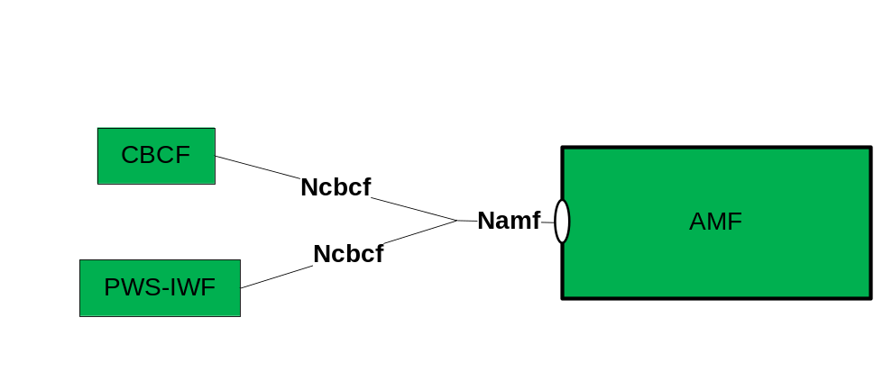
Figure 9A.1-1: Reference model – CBCF/PWS-IWF - AMF
The table 9A.1-1 shows the AMF Service and Service Operations specific for PWS:
Table 9A.1-1 AMF Service for PWS
Service Name | Service Operations | Operation Semantics | Consumer
Namf_Communication | NonUeN2MessageTransfer | Request/Response | CBCF
Namf_Communication | NonUeN2InfoSubscribe | Subscribe/Notify | CBCF
Namf_Communication | NonUeN2InfoNotify | Subscribe/Notify | CBCF

9A.2 Namf_Communication Service

9A.2.1 Service Description
The Namf_Communication service is specified in 3GPP TS 23.502 [xx] subclause 5.2.2.2.
For PWS the Namf_Communication service supports the following additional service operations:
- Provide service operation for transporting non-UE specific information to the NG-RAN through the AMF;
- Allow an NF Service Consumer (e.g. CBCF) to subscribe to notifications about PWS related events in the NG-RAN;
- Provide service operations to notify an NF Service Consumer (e.g. CBCF) about PWS related events in the NG-RAN.

9A.2.2 Service Operations

9A.2.2.1 NonUeN2MessageTransfer
Service operation name: Namf_Communication_NonUeN2MessageTransfer.
Description: NF Service Consumer requests to transfer non-UE specific N2 message to NG-RAN(s) through the AMF.
Input, Required: Message Type IE, Message Identifier IE, Serial Number IE, N2 Message Container.
The N2 Message Container contains all the available elements from the Write-Replace-Warning Request message or the Stop-Warning Request message with the exception of the List of TAIs IE and the Send Write-Replace-Warning Indication IE or the Send Stop-Warning Indication IE.
Input, Optional: List of TAIs IE, Send Write-Replace-Warning-Indication IE or Send Stop-Warning-Indication IE, depending on the Message Type IE.
Output, Required: Result indication, i.e. all mandatory elements from the Write-Replace-Warning Confirm message (see subclause 9.2.17) or the Stop-Warning Confirm message (see subclause 9.2.19), depending on Message Type IE.
Output, Optional: Criticality Diagnostics IE, Unknown Tracking Area List IE.
The NonUeN2MessageTransfer service operation shall be invoked by the NF Service Consumer (e.g. CBCF) to initiate or stop broadcast in one or more cells as indicated in the Warning Area IE. The AMF shall accept the request and respond to the NF Service Consumer immediately.
When NonUeN2MessageTransfer service operation is used for PWS services:
a) PWS Write-Replace-Warning Request message (see subclause 9.2.16) or the Stop-Warning Request message (see subclause 9.2.18) are transferred in an N2 Message Container via the NonUeN2MessageTranfer request operation (along with a number of IEs);
b) Write-Replace-Warning Confirm message (see subclause 9.2.17) or the Stop-Warning Confirm message (see subclause 9.2.19) returned to the NF Service Consumer via the NonUeN2MessageTranfer response operation;
c) the List of TAIs IE shall be used by the AMF to determine to which RAN Nodes the N2 Message Container needs to be forwarded to. The List of TAIs IE is not included in the N2 Message Container. If the List of TAIs IE is not present then the message shall be forwarded to all RAN Nodes served by the AMF;
d) each NonUeN2MessageTransfer message is uniquely identified by the Message Identifier IE, the Serial Number IE and the Message Type IE. These IEs are also included in the N2 Message Container;
e) if the Send Write-Replace-Warning-Indication IE is present in the Write-Replace-Warning Request message then the AMF shall send the associated Write-Replace-Warning Indication message(s) to the NF Service Consumer as specified in subclause 9A.2.2.3. The Send Write-Replace-Warning-Indication IE is not included in the N2 Message Container, and
f) if the Send Stop-Warning-Indication IE is present in the Stop-Warning Request message then the AMF shall send the associated Stop-Warning Indication message(s) to the NF Service Consumer as specified in subclause 9A.2.2.3. The Send Stop-Warning-Indication IE is not included in the N2 Message Container.

9A.2.2.2 Namf_Communication_NonUeN2InfoSubscribe service operation
Service operation name: Namf_Communication_ NonUeN2InfoSubscribe.
Description: The NF Service Consumer invokes this service operation to subscribe to the delivery of non-UE specific N2 information from the NG-RAN, e.g. for PWS events.
Input, Required: NF Service Consumer ID, N2 information type to be subscribed.
Input, Optional: None.
Output, Required: None.
Output, Optional: None.
When NonUeN2InfoSubscribe service operation is used for PWS services:
- The NF Service Consumer ID is an identifier which is configured in the CBCF or PWS-IWF;
- The N2 information types are:
- WarningIndications;
- RestartFailure;
- if the N2 information type is WarningIndications then the NF Service Consumer subscribes to receiving Write-Replace-Warning Indication messages (see subclause 9.2.20) and Stop-Warning Indication messages (see subclause 9.2.21) from the AMF, and
NOTE: If the Indication messages are actually send to the NF Service Consumer depends on the presence of the Send Write-Replace-Warning Indication IE or the Send Stop-Warning Indication IE; see subclause 9A.2.2.1.
- if the N2 information type is RestartFailure then the NF Service Consumer subscribes to receiving Restart Indications (see subclause 9.2.22) and Failure Indications (see subclause 9.2.23) from the NG-RAN.

9A.2.2.3 Namf_Communication_NonUeN2InfoNotify service operation
Service operation name: Namf_Communication_ NonUeN2InfoNotify.
Description: The AMF uses this service operation to notify a particular PWS event towards the NF Service Consumer that have subscribed for the specific information.
Input, Required: N2 information.
Input, Optional: None.
Output, Required: None.
Output, Optional: None.
When NonUeN2InfoSubscribe service operation is used for PWS services, the N2 information consists of all (mandatory and optionally) available information provided in the Write-Replace Warning Indication (see subclause 9.2.20), a Stop Warning Indication (see subclause 9.2.21), a PWS Restart Indication (see subclause 9.2.22) or a PWS Failure Indication (see subclause 9.2.23).

9A.2.3 Service operation message flows

9A.2.3.1 Service flow for message transfer
Write-Replace-Warning Request messages and Stop-Warning-Request messages are transported with the NonUeMessageTransfer service operation. The procedure is shown in figure 9A.2.3-1.
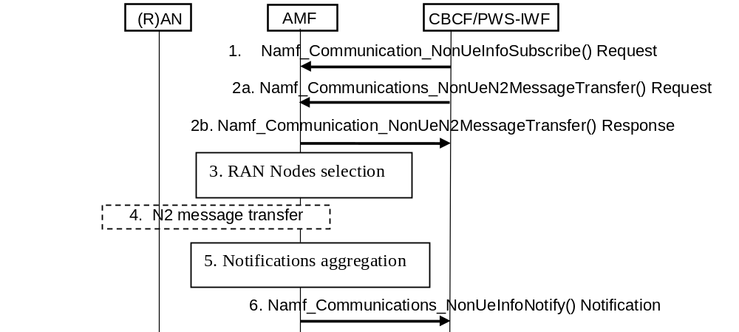
Figure 9A.2.3.1-1: Message tranfer procedure
- If the CBCF supports reception of Wrtite-Replace-Warning Notifications and Stop-Warning Notifications then the CBCF uses the Namf_Communication_NonUeInfoSubscribe service operation to subscribe to these notifications.
2a) The CBCF sends a Write-Replace-Warning Request message or a Stop-Warning-Request message to the AMF using the Namf_Communication_NonUeN2MessageTransfer service operation.
2b) The AMF returns a Namf_Communication_NonUeN2MessageTransfer response message.
- The AMF determines from the List of TAIs IE to the RAN Nodes the N2 Message Container shall be forwarded to.
- The AMF forwards the N2 Message Container to the selected RAN Nodes and receives a response from the RAN Nodes.
- The AMF may aggregate the responses it has received from the RAN Nodes.
- The AMF forwards the (aggregated) response(s) as Write-Replace-Warning Notification(s) or Stop-Warning Notifications to the CBCF using the Namf_Communication_NonUeNotify service operation if the CBCF has subscribed to receiving these notificatins in step 1.

9A.2.3.2 Service flow for Restart and Failure Indication messages
Restart and Failure Indications are send by RAN Nodes and are forwarded to the CBCF by the AMF if the CBCF has subscribed to receiving such indications. The procedure is shown in figure 9A.2.4-1.
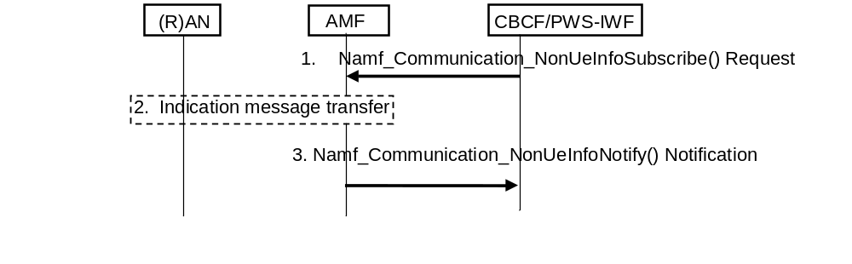
Figure 9A.2.3.2-1: Indication message transfer procedure
- If the CBCF supports reception of Restart Indication messages and Failure Indication messages then the CBCF uses the Namf_Communication_NonUeInfoSubscribe service operation to subscribe to these notifications.
- A RAN Node sends a Restart Indication or a Failure Indication to the AMF.
- The AMF forwards the Restart Indication or a Failure Indication to the CBCF using the Namf_Communication_NonUeInfoNotify service operation.

10 CBS Index
An index structure is defined in this clause. Index can be used by the operator to inform the end user about the type of CBS services available. Index has the structure of a tree. It can thus have sub parts which are called subindexes. A subindex can be embedded in the same index message as its parent ("embedded subindex") or it can physically be in a separate index message ("child subindex"). Every index message has a unique message identifier. They are always of the same type. Message Code 1010101010b shall be used to indicate this type. The root of the index structure shall be the index message with message identifier 0. Other index messages are linked to the root index with links. Definition of their message identifiers is left to the operator.
A format ("enhanced format") for the index messages is described in this clause. If this enhanced format is used in the index message the MS/UE can present the index messages in its preferred format.
Available CBS services are introduced in the index. This means that their message identifier and name are stated. Enhanced format includes a mechanism for separating a normal service introduction from embedded subindex introduction and child subindex introduction. The introduction of an embedded subindex specifies the "subindex-id" used for identifying services that belong to this subindex. Embedded subindexes can have subindexes embedded in them etc. If these "second level embedded subindexes" are introduced their subindex-id shall begin with the subindex-id of their parent. Same principle applies for subindexes in third, fourth etc. level. An example of an index structure is given in figure 6.
Enhanced format includes a mechanism which allows the terminals to identify that the format of the index message is enhanced. The index-id -field and the above mentioned Message Code (1010101010b) constitute this mechanism:
message-format = index-id index-element-intro+.
index-id = "EI" version crlf.
version = number+.
number = "1" | "2" | "3" | "4" | "5" | "6" | "7" | "8" | "9" | "0".
index-element-intro = subindex-intro | service-intro.
subindex-intro = subindex-id " " subindex-name crlf.
subindex-id = subindex-character+.
subindex-character = "a" | "b" | … | "z" | "A" | "B" | … | "Z".
subindex-name = name-character+.
name-character = <gsm03.38character excluding <CR> and <LF> >.
crlf = <CR> <LF>.
service-intro = subindex-id message-id delimiter service-name crlf.
message-id = number+.
delimiter = "." | " ".
service-name = name-character+.
Current version used is 1.
The use of "." as delimiter means that this service is a child subindex of the index structure.
Delimiter " " is used in all other cases.
Subindex-id shall not be used if the service introduced is in the first level of the index. Subindex-id:s are used in alphabetical order within an index message. They can be re-used in a child subindex.
0 Index:
(MsgId=0, Message Code = 1010101010b)

EI1
20 Hospitals
34 Taxis
a News
a201 Int News
a202 Nat News
a203 Local News
b Sports
b301 Football News
b302 Hockey Results
b303 Basketball
c Finance
c401 Finance News
ca Quotes NYSE
ca412 NYSE industrial
ca413 NYSE electronics  ca414 NYSE blue  c420.Quotes Tokyo |  |  | 420 Quotes Tokyo:  (MsgId = 420, Message Code = 1010101010b)
d Weather  d501 Local Weather  d502 National Weather  d503 Weather in Europe  d504 Weather in the World |  |  | EI1  421 Tokyo Industrial  422 Tokyo Finance  423 Tokyo Blue
900.Buy and Sell
900 Buy and Sell:
(MsgId = 900, Message Code = 1010101010b)
EI1
901 Cars
902 Bikes
903 Boats
a Home Electronics
a911 Computers
a912 Televisions
a913 Radios
920 Baby Clothes
930 Magazines
940 Books

Figure 6

Annex A (informative):
Void

Annex B (normative):
5GS Network Architecture, AMF to CBC inter-connection via PWS-IWF

B.1 5GS PWS architecture with PWS-IWF
Figure B.1-1 shows the optional deployment network structure of PWS architecture in 5GS with AMF to CBC inter-connection via PWS-IWF. In this option the PWS-IWF implements functionality to transfer messages between Ncbcf and SBc reference points, and vice versa.
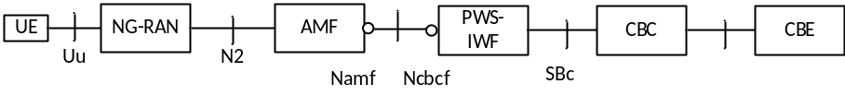

Figure B.1-1: 5GS PWS architecture with PWS-IWF
Reference point to support PWS architecture:
N2: Reference point between the NG-RAN and the AMF.
NOTE 1: NG-RAN can be NR based or E-UTRA based (See 3GPP TS 23.501 [39] and 3GPP TS 38.413 [40]).
SBc: Reference point between the PWS-IWF and the CBC.
NOTE 2: The requirements for SBc in this deployment option corresponds to the requirements for SBc in the EPS network architecture as (see 3GPP TS 29.168 [35]).
Namf: Service-based interface exhibited by AMF.
Ncbcf: Service-based interface exhibited by PWS-IWF.
The CBE and the interface between CBE and CBC are out of scope of 3GPP specifications.
The present document describes logical functional entities, and how these are realized in actual deployments is an implementation and deployment issue. It can however be foreseen that the PWS-IWF functionality may be co-located with the AMF, with the CBC, or deployed as a stand-alone network function. At AMF/PWS-IWF co-location, the AMF/PWS-IWF entity provides a SBc interface towards the CBC. At CBC/PWS-IWF co-location, the CBC/PWS-IWF provides the Ncbcf interface towards the AMF. At stand-alone PWS-IWF, the PWS-IWF provides the Ncbcf interface towards the AMF and the SBc interface towards the CBC.
Editor’s note: References to the related RAN3 and CT4 specifications needs to be added.
Editor’s note: Further details on the AMF to CBC inter-connection via PWS-IWF is FFS.

B.2 PWS-IWF Functionality
The PWS-IWF is a logical function which functionality is to translate from Ncbcf to SBc. The PWS-IWF may interface to one or multiple AMFs. The PWS-IWF may interface to one or multiple CBCs.

B.3 Protocol stack when AMF and CBC inter-connects via PWS-IWF
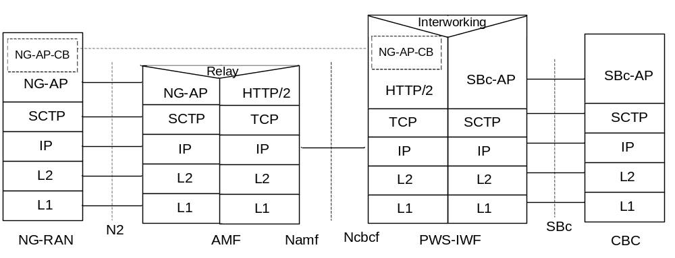
Figure B.3-1: CBC - NG-RAN with PWS-IWF

Legend:
- NG Application Protocol information for Cell Broadcast (NG-AP-CB): Subset of NG-AP information that the AMF transparently relays between the NG-RAN and the PWS-IWF. NG-AP-CB corresponds to a subset of NG-AP defined in TS 38.413 [40].
- NG Application Protocol (NGAP): Application Layer Protocol between the NG-RAN entity (eNodeB and/or gNodeB) and the AMF. The NGAP protocol is defined in 3GPP TS 38.413 [40].
- SBc Application Protocol (SBc-AP): Application Layer Protocol between PWS-IWF and CBC. This protocol supports transfer of warning messages.
- SCTP for the control plane (SCTP): This protocol guarantees delivery of signalling messages between AMF and NG-RAN (N2), and between PWS-IWF and CBC (SBc). SCTP is defined in IETF RFC 4960 [33].
- HTTP/2: Application layer protocol for Service based interface between AMF and CBCF. HTTP/2 is defined in IETF RFC 7540 [42].

Annex C (informative):
Change history
TSG | TSG Tdoc |  | T2-Tdoc |  | CR |  | REL |  | VERS |  |  | NEW VERS | SUBJECT
T#5 | TP-99179 |  |  |  | New |  | R99 |  | 2.0.0 |  |  | 3.0.0 | Transfer of GSM 03.41 v7.1.0 to 3GPP
T#6 | TP-99237 |  | T2-991064 |  | 001 |  | R99 |  | 3.0.0 |  |  | 3.1.0 | Adaptation of the scope of TS 23.041 from "GSM only" to "GSM and UMTS"
T#6 | TP-99237 |  | T2-991062 |  | 002 |  | R99 |  | 3.0.0 |  |  | 3.1.0 | LCS Utilization of CBS
T#7 | TP-000024 |  | T2-000134 |  | 003 |  | R99 |  | 3.1.0 |  |  | 3.2.0 | Addition of LCS message identifier to support GPS Navigation message
T#7 | TP-000024 |  | T2-000130 |  | 004 |  | R99 |  | 3.1.0 |  |  | 3.2.0 | Adaptation of the scope from "GSM only" to "GSM and UMTS" - Part II
T#9 | TP-000143 |  | T2-000553 |  | 005 |  | R99 |  | 3.2.0 |  |  | 3.3.0 | Defining Assisted GPS Broadcast Identifiers
T#11 | - |  | - |  | - |  | Rel-4 |  | 3.3.0 |  |  | 4.0.0 | Upgrade to Rel-4
T#12 | TP-010128 |  | T2-010532 |  | 007 |  | Rel-4 |  | 4.0.0 |  |  | 4.1.0 | Clarification of Geographical Scope
T#14 | TP-010280 |  | T2-011024 |  | 008 |  | Rel-4 |  | 4.1.0 |  |  | 4.2.0 | Clarification on the use of Message IDs in multi-technology networks
T#16 | TP-020104 |  | T2-020509 |  | 010 |  | Rel-4 |  | 4.2.0 |  |  | 4.3.0 | Update of references
T#16 | - |  | - |  | - |  |  |  | 4.3.0 |  |  | 5.0.0 | Upgrade to Rel-5
T#17 | TP-020252 |  | - |  | 011  rev1 |  | Rel-6 |  | 5.0.0 |  |  | 6.0.0 | Identification of a directory number in a CBS-Message-Information-Page
T#19 | TP-030038 |  | T2-030088 |  | 014 |  | Rel-6 |  | 6.0.0 |  |  | 6.1.0 | CB Data lenght
T#22 | TP-030267 |  | T2-030575 |  | 016 |  | Rel-6 |  | 6.1.0 |  |  | 6.2.0 | CB Data structure
CT#31 | CP-060126 |  | C1-060128 |  | 017r1 |  | Rel-7 |  | 6.2.0 |  |  | 7.0.0 | CBS – Reference correction
CT#41 |  |  |  |  |  |  |  |  | 7.0.0 |  |  | 8.0.0 | Upgrade to Rel-8
CT#41 | CP-080535 |  | C1-083618 |  | 0019r4 |  | Rel-8 |  | 7.0.0 |  |  | 8.0.0 | Additions to the protocol aspects of CBS for the realisation of ETWS
CT#41 | CP-080535 |  | C1-083620 |  | 0018r5 |  | Rel-8 |  | 7.0.0 |  |  | 8.0.0 | Changes to CBS for the realisation of ETWS
CT#41 | CP-080535 |  | C1-083621 |  | 0020r5 |  | Rel-8 |  | 7.0.0 |  |  | 8.0.0 | Changes to the radio message format aspect of CBS for the realisation of ETWS
CT#42 | CP-080836 |  | C1-085355 |  | 0021r3 |  | Rel-8 |  | 8.0.0 |  |  | 8.1.0 | Clarification on EPS architecture and ETWS Instruction to terminal
CT#42 | CP-080836 |  | C1-085354 |  | 0022r1 |  | Rel-8 |  | 8.0.0 |  |  | 8.1.0 | Addition of Warning Security Information
CT#42 | CP-080873 |  | C1-085129 |  | 0023 |  | Rel-8 |  | 8.0.0 |  |  | 8.1.0 | CBS Message ID table
CT#43 | CP-090149 |  | C1-091099 |  | 0026r2 |  | Rel-8 |  | 8.1.0 |  |  | 8.2.0 | ETWS Duplication Detection
CT#43 | CP-090159 |  | C1-090442 |  | 0025r1 |  | Rel-8 |  | 8.1.0 |  |  | 8.2.0 | Clarification of non settable Message ID’s through MMI
CT#43 |  |  |  |  |  |  |  |  | 8.1.0 |  |  | 8.2.0 | Editorial cleanup by MCC
CT#44 | CP-090320 |  |  |  | 0027r2 |  | Rel-8 |  | 8.2.0 |  |  | 8.3.0 | Definition of ETWS Primary Notification message format
CT#44 | CP-090434 |  | C1-092257 |  | 0028r2 |  | Rel-9 |  | 8.3.0 |  |  | 9.0.0 | Message IDs for the U.S. Commercial Mobile Alert System (CMAS)
CT#45 | CP-090686 |  | C1-092466 |  | 0029 |  | Rel-9 |  | 9.0.0 |  |  | 9.1.0 | Message Identifiers for PWS
CT#45 | CP-090670 |  | C1-093124 |  | 0031r1 |  | Rel-9 |  | 9.0.0 |  |  | 9.1.0 | CBS activation time for ETWS information
CT#45 | CP-090682 |  | C1-093812 |  | 0032r1 |  | Rel-9 |  | 9.0.0 |  |  | 9.1.0 | Cell wide Geographical Scope (GS) code 00
CT#45 | CP-090682 |  | C1-093249 |  | 0033 |  | Rel-9 |  | 9.0.0 |  |  | 9.1.0 | Updates on references
CT#45 | CP-090682 |  | C1-093813 |  | 0034r1 |  | Rel-9 |  | 9.0.0 |  |  | 9.1.0 | Resolution of editor’s note
CT#45 | CP-090682 |  | C1-093251 |  | 0035 |  | Rel-9 |  | 9.0.0 |  |  | 9.1.0 | Fixes for typographical errors
CT#45 | CP-090682 |  | C1-093252 |  | 0036r1 |  | Rel-9 |  | 9.0.0 |  |  | 9.1.0 | Clarification on duplicate use of “immediate display”
CT#45 | CP-090686 |  | C1-093531 |  | 0037 |  | Rel-9 |  | 9.0.0 |  |  | 9.1.0 | Updating of references to stage 1 document
CT#46 | CP-090912 |  | C1-094929 |  | 0039 |  | Rel-9 |  | 9.1.0 |  |  | 9.2.0 | Additional ETWS requirements for the BSC - CBC Cell Broadcast protocol
CT#46 | CP-090912 |  | C1-095394 |  | 0041r1 |  | Rel-9 |  | 9.1.0 |  |  | 9.2.0 | Clarification on ETWS secondary notification
CT#46 | CP-090912 |  | C1-095396 |  | 0043r1 |  | Rel-9 |  | 9.1.0 |  |  | 9.2.0 | Correction of duplicate detection in the UE
CT#47 | CP-100152 |  | C1-101202 |  | 0044r1 |  | Rel-9 |  | 9.2.0 |  |  | 9.3.0 | Corrections to the Cell Broadcast Service (CBS) for ETWS
CT#47 | CP-100135 |  | C1-100625 |  | 0045 |  | Rel-9 |  | 9.2.0 |  |  | 9.3.0 | Correction of figure 4b
CT#47 | CP-100152 |  | C1-101263 |  | 0046r1 |  | Rel-9 |  | 9.2.0 |  |  | 9.3.0 | Addition of Broadcast Message Type
CT#48 | CP-100345 |  | C1-101950 |  | 0050r1 |  | Rel-9 |  | 9.3.0 |  |  | 9.4.0 | PLMN handling for ETWS duplicate detection
CT#48 | CP-100345 |  | C1-101551 |  | 0052 |  | Rel-9 |  | 9.3.0 |  |  | 9.4.0 | Removal of editor's note for ETWS
CT#49 | CP-100501 |  | C1-102734 |  | 0053r1 |  | Rel-9 |  | 9.4.0 |  |  | 9.5.0 | Clarification of precedence for immediate display
CT#49 | CP-100504 |  | C1-102216 |  | 0055 |  | Rel-9 |  | 9.4.0 |  |  | 9.5.0 | Removal of CMAS reference to a ETWS capability
CT#49 | CP-100520 |  | C1-102735 |  | 0054r1 |  | Rel-10 |  | 9.5.0 |  |  | 10.0.0 | Clarification of Scope for CB in LTE
CT#49 | CP-100520 |  | C1-103152 |  | 0057 |  | Rel-10 |  | 9.5.0 |  |  | 10.0.0 | Clarification of definition of “PLMN Wide” in Geographical Scope (GS) indicator
CT#50 | CP-100744 |  | C1-105127 |  | 0058r2 |  | Rel-10 |  | 10.0.0 |  |  | 10.1.0 | Correction to CMAS Alert levels
CT#50 | CP-100768 |  | C1-104243 |  | 0056r3 |  | Rel-11 |  | 10.1.0 |  |  | 11.0.0 | Message Identifiers for EU-Alert
CT#50 | CP-100768 |  | C1-104483 |  | 0057 |  | Rel-11 |  | 10.1.0 |  |  | 11.0.0 | Message Identifier for EU-Info
CT#51 | CP-110876 |  | C1-114785 |  | 0065r3 |  | Rel-11 |  | 11.0.0 |  |  | 11.1.0 | Correction on Message Identifier for Korean Public Alert System
CT#51 | CP-110882 |  | C1-114427 |  | 0066r2 |  | Rel-11 |  | 11.0.0 |  |  | 11.1.0 | Coding of Geographical Scope parameter for E-UTRAN/LTE operation.
CT#51 | CP-110853 |  | C1-115046 |  | 0070r3 |  | Rel-11 |  | 11.0.0 |  |  | 11.1.0 | Correction to UE warning message indication with regards to “digital signature” and “timestamp”
CT#51 | CP-110882 |  | C1-115255 |  | 0071r2 |  | Rel-11 |  | 11.0.0 |  |  | 11.1.0 | Additional Message Identifiers for CMAS/EU-Alerts
CT#51 | CP-110882 |  | C1-114923 |  | 0072r1 |  | Rel-11 |  | 11.0.0 |  |  | 11.1.0 | Update Number Processing
CT#51 | CP-110882 |  | C1-114975 |  | 0073r1 |  | Rel-11 |  | 11.0.0 |  |  | 11.1.0 | Multiple languages used in CBS
CT#55 | CP-120125 |  | C1-120857 |  | 0083r3 |  | Rel-11 |  | 11.1.0 |  |  | 11.2.0 | Sorting out inconsistency problem in ETWS/PWS specification
CT#55 | CP-120125 |  | C1-120285 |  | 0084 |  | Rel-11 |  | 11.1.0 |  |  | 11.2.0 | Correction of binary coding in clause 9.4.1.2.2
CT#55 | CP-120091 |  | C1-120804 |  | 0077r2 |  | Rel-11 |  | 11.1.0 |  |  | 11.2.0 | Redocumentation and alignment of the public warning system
CT#56 | CP-120309 |  | C1-122384 |  | 0081r4 |  | Rel-11 |  | 11.2.0 |  |  | 11.3.0 | Alignment of clause 9 for PWS
CT#56 | CP-120309 |  | C1-121379 |  | 0091r1 |  | Rel-11 |  | 11.2.0 |  |  | 11.3.0 | Correction to the duplication detection mechanism
CT#56 | CP-120285 |  | C1-121245 |  | 0092 |  | Rel-11 |  | 11.2.0 |  |  | 11.3.0 | Removal of security for ETWS/PWS over E-UTRAN
CT#56 | CP-120285 |  | C1-122295 |  | 0088r3 |  | Rel-11 |  | 11.2.0 |  |  | 11.3.0 | Alignment and correction of aspects for public warning system for GERAN
CT#57 | CP-120573 |  | C1-123198 |  | 0094r3 |  | Rel-11 |  | 11.3.0 |  |  | 11.4.0 | Correction to Figure 3.3-1
CT#57 | CP-120567 |  | C1-123186 |  | 0103r1 |  | Rel-11 |  | 11.3.0 |  |  | 11.4.0 | Correction of Warning Message Delivery Procedure in GSM
CT#57 | CP-120492 |  | - |  | 0098r1 |  | Rel-11 |  | 11.3.0 |  |  | 11.4.0 | Correction of reference to GSMA document "Coding of Cell Broadcast Functions"
CT#58 | CP-120794 |  | C1-123955 |  | 0095r2 |  | Rel-11 |  | 11.4.0 |  |  | 11.5.0 | Correction for Repetition Rates
CT#58 | CP-120794 |  | C1-123956 |  | 0107r1 |  | Rel-11 |  | 11.4.0 |  |  | 11.5.0 | Correction of reference in Restart Indication Request
CT#58 | CP-120774 |  | C1-123875 |  | 0111r1 |  | Rel-11 |  | 11.4.0 |  |  | 11.5.0 | Correcting handling of unused security parameters for warning messages
CT#58 | CP-120794 |  | C1-124990 |  | 0116r2 |  | Rel-11 |  | 11.4.0 |  |  | 11.5.0 | Message IDs for Operator specific services
CT#58 | CP-120794 |  | C1-125024 |  | 0117r2 |  | Rel-11 |  | 11.4.0 |  |  | 11.5.0 | USIM file usage for PWS message reception
CT#58 | CP-120819 |  | C1-124972 |  | 0097r5 |  | Rel-12 |  | 11.5.0 |  |  | 12.0.0 | Report from MME on Warning Message Delivery
CT#58 | CP-120819 |  | C1-124971 |  | 0099r4 |  | Rel-12 |  | 11.5.0 |  |  | 12.0.0 | Failure List in WRITE-REPLACE-WARNING-CONFIRM and STOP-WARNING-CONFIRM
CT#59 | CP-130115 |  | C1-130829 |  | 0120r2 |  | Rel-12 |  | 12.0.0 |  |  | 12.1.0 | Correction for Warning Area List
CT#59 | CP-130129 |  | C1-130831 |  | 0123r2 |  | Rel-12 |  | 12.0.0 |  |  | 12.1.0 | Clause 9.4.3 for E-UTRAN
CT#59 | CP-130115 |  | C1-130837 |  | 0124r2 |  | Rel-12 |  | 12.0.0 |  |  | 12.1.0 | Warning message reception in Limited Service
CT#60 | CP-130264 |  | C1-132520 |  | 0125r3 |  | Rel-12 |  | 12.1.0 |  |  | 12.2.0 | CB Message parameter format on the eUTRAN Radio Network – UE interface
CT#60 | CP-130264 |  | C1-131445 |  | 0127r1 |  | Rel-12 |  | 12.1.0 |  |  | 12.2.0 | CBS message parameter references correction
CT#60 | CP-130264 |  | C1-131446 |  | 0128r1 |  | Rel-12 |  | 12.1.0 |  |  | 12.2.0 | Failure Indication and Restart Indication handling
CT#60 | CP-130264 |  | C1-131725 |  | 0129r2 |  | Rel-12 |  | 12.1.0 |  |  | 12.2.0 | Clarification to data coding scheme usage for primary vs secondary notification
CT#61 | CP-130503 |  | C1-133320 |  | 0118r3 |  | Rel-12 |  | 12.2.0 |  |  | 12.3.0 | Stop-all broadcasting of warning messages and report from MME on Stop Warning Messages in E-UTRAN
CT#61 | CP-130510 |  | C1-133206 |  | 0132r1 |  | Rel-12 |  | 12.2.0 |  |  | 12.3.0 | CellID in E-UTRAN
CT#61 | CP-130510 |  | C1-133207 |  | 0133r1 |  | Rel-12 |  | 12.2.0 |  |  | 12.3.0 | Clarification on Duplication Detection
CT#61 | CP-130510 |  | C1-133646 |  | 0134r1 |  | Rel-12 |  | 12.2.0 |  |  | 12.3.0 | Clarification on PWS CB Data for the eUTRAN Radio interface
Post CT#61 |  |  |  |  |  |  | Rel-12 |  | 12.3.0 |  |  | 12.3.1 | Correction of typos
CT#62 | CP-130750 |  | C1-134137 |  | 0137r2 |  | Rel-12 |  | 12.3.1 |  |  | 12.4.0 | eNodeB ID in Stop-Warning Indication
CT#62 | CP-130762 |  | C1-134530 |  | 0139 |  | Rel-12 |  | 12.3.1 |  |  | 12.4.0 | Removal of cells=all feature from RNC
CT#62 | CP-130751 |  | C1-134930 |  | 0140r1 |  | Rel-12 |  | 12.3.1 |  |  | 12.4.0 | Stop all indicator clarification
CT#63 | CP-140140 |  | C1-140609 |  | 0135r5 |  | Rel-12 |  | 12.4.0 |  |  | 12.5.0 | Restart Indication
CT#63 | CP-140144 |  | C1-140440 |  | 0141r1 |  | Rel-12 |  | 12.4.0 |  |  | 12.5.0 | Capacity Indication Request not implemented
CT#64 | CP-140331 |  | C1-141098 |  | 0142 |  | Rel-12 |  | 12.5.0 |  |  | 12.6.0 | Available-Capacity not implemented
CT#64 | CP-140327 |  | C1-141642 |  | 0143r1 |  | Rel-12 |  | 12.5.0 |  |  | 12.6.0 | Support of category indication for prioritization of emergency alerts
CT#66 | CP-140836 |  | C1-144414 |  | 0146 |  | Rel-12 |  | 12.6.0 |  |  | 12.7.0 | Removal of CAPACITY-INDICATION reference
CT#66 | CP-140858 |  | C1-144827 |  | 0147r1 |  | Rel-13 |  | 12.7.0 |  |  | 13.0.0 | Missing Broadcast Message Content Validity Indicator IE
CT#68 | CP-150310 |  | C1-150914 |  | 0149 |  | Rel-13 |  | 13.0.0 |  |  | 13.1.0 | Correction for List of TAIs
CT#68 | CP-150310 |  | C1-151465 |  | 0151r1 |  | Rel-13 |  | 13.0.0 |  |  | 13.1.0 | Clarification on CBC Geo-redundancy support in LTE
CT#68 | CP-150329 |  | C1-151463 |  | 0152r1 |  | Rel-13 |  | 13.0.0 |  |  | 13.1.0 | Serial Number handling for WRITE-REPLACE Request/Indication primitive
CT#68 | CP-150310 |  | C1-151830 |  | 0154 |  | Rel-13 |  | 13.0.0 |  |  | 13.1.0 | Warning message indication delivery for PWS reporting enhancement
CT#68 | CP-150329 |  | C1-151831 |  | 0155 |  | Rel-13 |  | 13.0.0 |  |  | 13.1.0 | ETWS Primary Notification message at E-UTRAN interface
CT#68 | CP-150329 |  | C1-152386 |  | 0156r1 |  | Rel-13 |  | 13.0.0 |  |  | 13.1.0 | Reference corrections and editorial updates
CT#70 | CP-150700 |  | C1-154874 |  | 0157r4 |  | Rel-13 |  | 13.1.0 |  |  | 13.2.0 | Failure Indication
CT#71 | CP-160086 |  | C1-160316 |  | 0159 |  | Rel-13 |  | 13.2.0 |  |  | 13.3.0 | Failed cell list parameter content correction
Change history
Date |  | Meeting |  | TDoc |  | CR |  | Rev |  | Cat | Subject/Comment |  |  | New version
2016-09 |  | CP-73 |  | CP-160519 |  | 0160 |  | 2 |  | F | RESET COMPLETE and RESET FAILURE Response messages missing |  |  | 14.0.0
2017-06 |  | CP-76 |  | CP-171092 |  | 0161 |  | 2 |  | C | Addition of new Message Identifiers for FCC mandated Wireless Emergency Alert (WEA, aka CMAS) enhancements |  |  | 14.1.0
2017-12 |  | CP-78 |  | CP-173067 |  | 0165 |  | 1 |  | F | Correction to the Data Coding Scheme clause in support of NA regulatory requirement |  |  | 14.2.0
2017-12 |  | CP-78 |  | CP-173069 |  | 0166 |  | 3 |  | B | Support of PWS in 5GS |  |  | 15.0.0
2018-03 |  | CP-79 |  | CP-180077 |  | 0167 |  | 2 |  | B | PWS message format for NG-RAN in 5G |  |  | 15.1.0
2018-03 |  | CP-79 |  | CP-180077 |  | 0168 |  | 3 |  | B | AMF to CBC inter-connectivity solution option with and without IWF |  |  | 15.1.0
2018-03 |  | CP-79 |  | CP-180077 |  | 0169 |  | 2 |  | B | PWS in NR – clause 9.1.3.5 |  |  | 15.1.0
2018-03 |  | CP-79 |  | CP-180077 |  | 0170 |  | 2 |  | B | PWS in NR – clause 9.2.0 |  |  | 15.1.0
2018-03 |  | CP-79 |  | CP-180077 |  | 0171 |  | 1 |  | B | PWS in NR – clause 9.2.x |  |  | 15.1.0
2018-03 |  | CP-79 |  | CP-180077 |  | 0172 |  | 3 |  | B | PWS in NR – clause 9.3.x |  |  | 15.1.0
2018-03 |  | CP-79 |  | CP-180077 |  | 0173 |  | 1 |  | B | AMF, CBC and CBCF functionalities for PWS in 5G |  |  | 15.1.0
2018-03 |  | CP-79 |  | CP-180077 |  | 0174 |  |  |  | B | Service Based Interface for 5G System |  |  | 15.1.0

