MERGE

변수 받아서 머지할 때..

strbuff.**setLength**(0);

strbuff.**append**("\n MERGE INTO ntt1300 t1 ");

strbuff.**append**("\n using dual ");

strbuff.**append**("\n ON (t1.cons_no = ?) ");

strbuff.**append**("\n WHEN MATCHED THEN ");

strbuff.**append**("\n UPDATE SET ");

strbuff.**append**("\n OFFICECD = ? ");

strbuff.**append**("\n ,CID = ? ");

strbuff.**append**("\n ,CONT_COMP_YMD = ? ");

strbuff.**append**("\n ,COMP_YMD = ? ");

strbuff.**append**("\n ,COMP_DEC_YMD = ? ");

strbuff.**append**("\n ,CONS_NAME = ? ");

strbuff.**append**("\n ,AEDAT = ? ");

strbuff.**append**("\n ,TOT_MNY = ? ");

strbuff.**append**("\n ,NEW_TOT_MNY = ? ");

strbuff.**append**("\n ,EAI_STAT = ? ");

strbuff.**append**("\n ,EAI_CDATE = ? ");

strbuff.**append**("\n ,EAI_UDATE = ? ");

strbuff.**append**("\n WHEN NOT MATCHED THEN ");

strbuff.**append**("\n insert ");

strbuff.**append**("\n (CONS_NO ");

strbuff.**append**("\n ,OFFICECD ");

strbuff.**append**("\n ,CID ");

strbuff.**append**("\n ,CONT_COMP_YMD ");

strbuff.**append**("\n ,COMP_YMD ");

strbuff.**append**("\n ,COMP_DEC_YMD ");

strbuff.**append**("\n ,CONS_NAME ");

strbuff.**append**("\n ,AEDAT ");

strbuff.**append**("\n ,TOT_MNY ");

strbuff.**append**("\n ,NEW_TOT_MNY ");

strbuff.**append**("\n ,EAI_STAT ");

strbuff.**append**("\n ,EAI_CDATE ");

strbuff.**append**("\n ,EAI_UDATE)values ");

strbuff.**append**("\n (? ");

strbuff.**append**("\n ,? ");

strbuff.**append**("\n ,? ");

strbuff.**append**("\n ,? ");

strbuff.**append**("\n ,? ");

strbuff.**append**("\n ,? ");

strbuff.**append**("\n ,? ");

strbuff.**append**("\n ,? ");

strbuff.**append**("\n ,? ");

strbuff.**append**("\n ,? ");

strbuff.**append**("\n ,? ");

strbuff.**append**("\n ,? ");

strbuff.**append**("\n ,?) ");

pstmt = conn.**prepareStatement**(strbuff.**toString**());

왜저렇게 되냐면.

select * from ntt1300 a, dual b where a.apply_cnt=1;

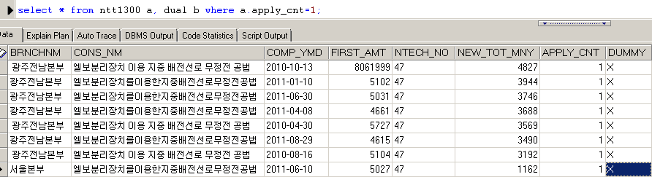

이렇게 걸려버리기 때문에 하나의값이 나온다. 즉 네츄럴조인이 안걸린다.

하지만 using을 자기자신으로넣고 걸게되면..

select count(*) from ntt1300 a, ntt1300 b where

a.BRNCHNM = '¼­¿ïº»ºÎ'

and a.CONS_NM = '°ü·Î±¼»è±â¹×È®Àå±â¸¦ÀÌ¿ëÇÑÁöÁßÄÉÀÌºí°ü·Îºñ±¼ÂøµµÅë°ø¹ý'

and a.COMP_YMD = '2011-03-14'

and a.FIRST_AMT = '11759'

and a.NTECH_NO = '14'

and a.NEW_TOT_MNY = '1025'

and a.APPLY_CNT = '431' 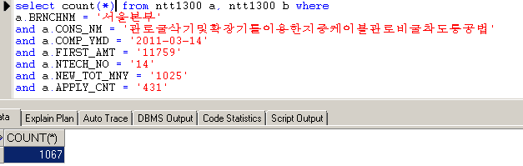

이런식으로 하면 무조건.. 매칭쪽으로 빠진다. 네츄럴조인이 걸린다.

strbuff.**append**("\n MERGE INTO ntt1300 t1 ");

strbuff.**append**("\n using ntt1300 t2 ");

strbuff.**append**("\n ON (t2.cons_no = ?) ");

strbuff.**append**("\n WHEN MATCHED THEN ");

strbuff.**append**("\n UPDATE SET ");

strbuff.**append**("\n OFFICECD = ? ");

strbuff.**append**("\n ,CID = ? ");

strbuff.**append**("\n WHEN NOT MATCHED THEN ");

strbuff.**append**("\n insert ");

strbuff.**append**("\n (CONS_NO ");

strbuff.**append**("\n ,TOT_MNY ");

strbuff.**append**("\n ,NEW_TOT_MNY ");

strbuff.**append**("\n ,EAI_STAT ");

strbuff.**append**("\n ,EAI_CDATE ");

….

즉 데이터 받아서 인설트할때는 dual를 써서 처리하는게 가장 현명하다

그럼 데이터를 입력받지않고 할때는..

strbuff.**append**("\n MERGE INTO ntt1300 t1 ");

strbuff.**append**("\n using ntt1300 t2 ");

strbuff.**append**("\n ON (t1.cons_no = t2.cons_no) ");

strbuff.**append**("\n WHEN MATCHED THEN ");

strbuff.**append**("\n UPDATE SET ");

strbuff.**append**("\n OFFICECD = ? ");

strbuff.**append**("\n ,CID = ? ");

strbuff.**append**("\n WHEN NOT MATCHED THEN ");

strbuff.**append**("\n insert ");

strbuff.**append**("\n (CONS_NO ");

strbuff.**append**("\n ,TOT_MNY ");

strbuff.**append**("\n ,NEW_TOT_MNY ");

strbuff.**append**("\n ,EAI_STAT ");

strbuff.**append**("\n ,EAI_CDATE ");

MERGE INTO NTO1101 a

USING dual b

ON (a.NTECH_ID = 'NT19' AND a.STATE = 'ST01')

WHEN MATCHED THEN

UPDATE SET

A.COMMENT_DATA='aaa'

WHEN NOT MATCHED THEN

INSERT (NTECH_ID,STATE,COMMENT_DATA,WRITE_DATE) VALUES('','','','');