Kenu 허광남 2016.06.25 판교 kosta

Elastic

https://www.elastic.co/  
<http://bit.ly/kosta-elk>

|  |  |
| --- | --- |
| <https://www.dropbox.com/s/v6emkuos0792fs3/ELK%EB%A5%BC%20%EC%9D%B4%EC%9A%A9%ED%95%9C%20%EC%8B%A4%EC%8B%9C%EA%B0%84%20%EB%8D%B0%EC%9D%B4%ED%84%B0%20%EC%88%98%EC%A7%91%2C%20%EB%B6%84%EC%84%9D%2C%20%EC%8B%9C%EA%B0%81%ED%99%94%20%EA%B5%90%EC%9E%AC_20160625_V1.pdf?dl=0a> | 교재 |
| **필요 소프트웨어** |  |
| jdk 1.8 | [java.sun.com](http://java.sun.com) |
| git bash | [git-scm.com](http://git-scm.com) |
| elasticsearch 2.3.x | [elastic.co](http://elastic.co) |
| kibana 4.x | [elastic.co](http://elastic.co) |
| logstash 2.3.x | [elastic.co](http://elastic.co) |
| filebeat | [elastic.co](http://elastic.co) |
| <http://52.79.194.183:5601/> | okky.kr elk |

엘라스틱 자바로 만들어져있음

자바 EE 가디언즈. 출범 (오라클 이새끼들..)

책

 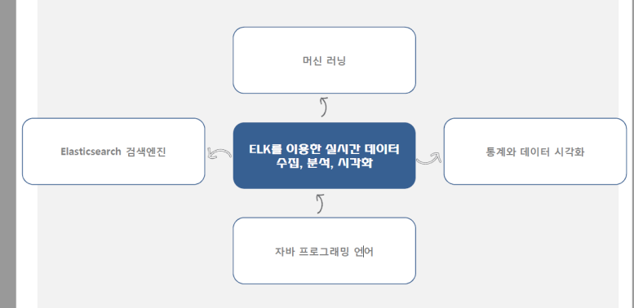

**ELK를 사용하면 기획자에게 대들수있다**

**데이터로써 증명 할수 있다.ㅋㅋ**

**개요**

|  |  |  |
| --- | --- | --- |
| 엘라스틱 스택 | ELK 검색엔진 | Elastic에서 개발한 ElasticSearch(검색엔진)  Elasticsearch는 Apache Lucene 기반의 실시간 분산 검색 엔진 |
| 로그 수집기 | Logstash는 각종 로그를 가져와 JSON형태로 만들어 Elasticsearch로 전송  점점 비츠(Beats)쪽으로 기능이 넘어가고 있다. – 김종민  JRuby 스크립트안쪽 필드..프로그래밍 |
| 시각화도구 | Kibana는 Elasticsearch에 저장된 Data를 사용자에게 Dashboard 형태로 보여주는 솔루션(node.js 들어가있다) |
| 구성된 수집, 검색, 시각화를 실시간으로 처리할 수 있는  오픈소스 패키지이다.  Elasticsearch(검색엔진) + Logstash(로그수집기) + Kibana(시각화도구)  Beats를 추가해 Elastic Stack이라 부름  로그에 적제할수 있는것들은 ELK쪽에서 모든 것을 로깅할수 있다. | |
| 특징 |  | |

|  |  |
| --- | --- |
| GA | Google Analytics  (직접 소스단에 스크립트가 박혀야된다, 시간대 별, ip별로는 볼수 없어서 좀 ..)  사용자의 front 화면의 정보를 가져올수도 있다. |
| DataViz | 넷플릭스에서 유행하는 단어 Data Visualization |

ELK

Elastic Stack

L

o

g

S

t

a

s

h

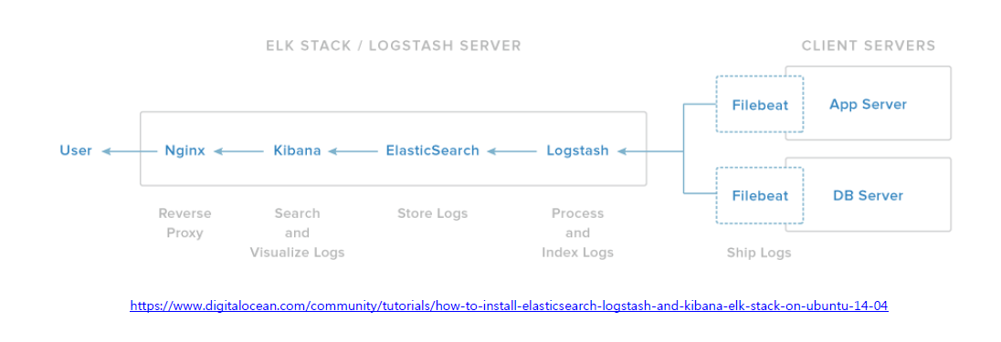

<https://www.digitalocean.com/community/tutorials/how-to-install-elasticsearch-logstash-and-kibana-elk-stack-on-ubuntu-14-04>

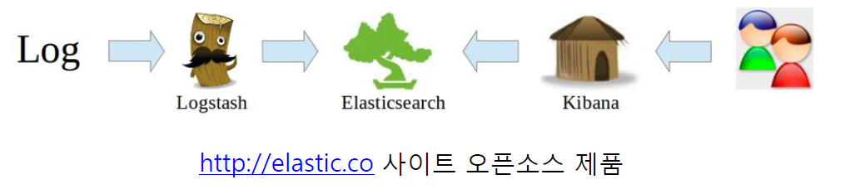

**엑세스로그 처리**

|  |  |
| --- | --- |
| Logstash | |
| • COMMONAPACHELOG | %{IPORHOST:clientip} %{HTTPDUSER:ident} %{USER:auth}  \[%{HTTPDATE:timestamp}\] "(?:%{WORD:verb} %{NOTSPACE:request}(?:  HTTP/%{NUMBER:httpversion})?|%{DATA:rawrequest})" %{NUMBER:response}  (?:%{NUMBER:bytes}|-) |
|  |
| • COMBINEDAPACHELOG | %{COMMONAPACHELOG} %{QS:referrer} %{QS:agent} |
|  |

https://github.com/logstash-plugins/logstash-patterns-core/blob/master/patterns/grok-patterns

**AWS 서비스 가입**

* http://aws.amazon.com EC2 가입

**실시간 데이터 수집, 검색, 분석, 시각화 절차의 이해**

1. **데이터 선정**
2. **채널 (open api등등 시스템 로그등)**
3. **파싱 패턴 매칭**
4. **시각화 도구 선정**
5. **차트 시각화**

**팁**

* 통계, R언어 쪽을 다시한번 찾아봐라
* 머신러닝 쪽으로도 갈수도 있으므로 (파이썬 이용하는것들이 많다)
* Semantic Versioning 소개
  + https://spoqa.github.io/2012/12/18/semantic-versioning.html

**주의**

* 버전 영향력이 있으므로 버전 조합잘해야된다.

**실습**

aws EC2

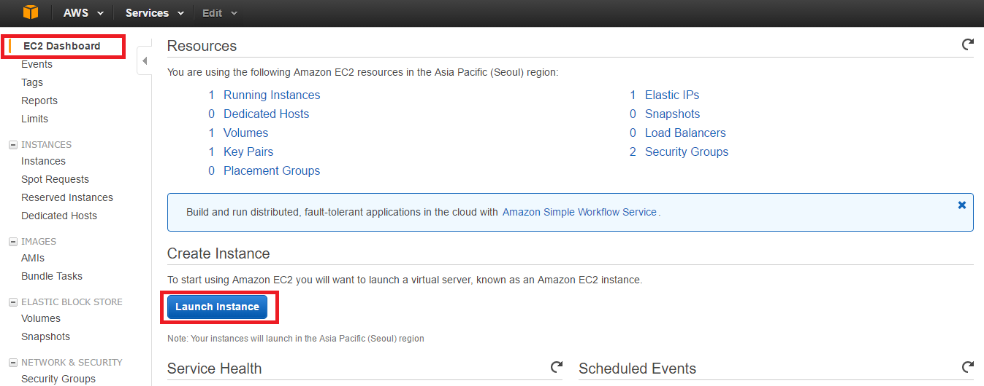



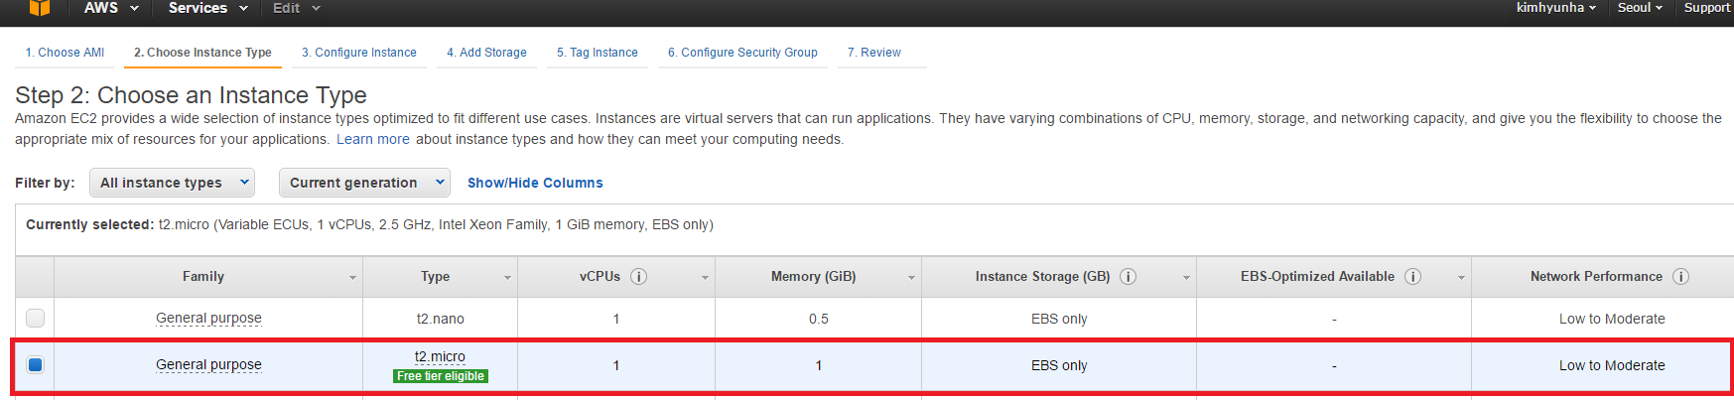이건 무료 1년

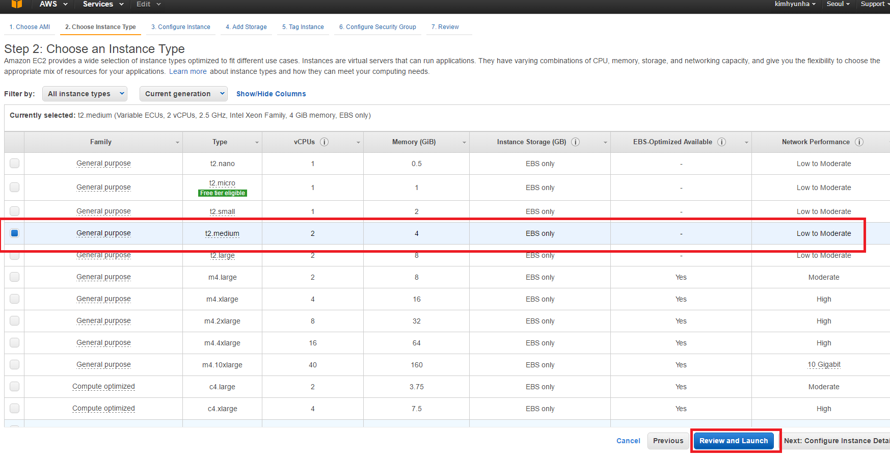

엘라스틱 하려면 위에꺼 사양좋은걸로..ㅠ_ㅠ

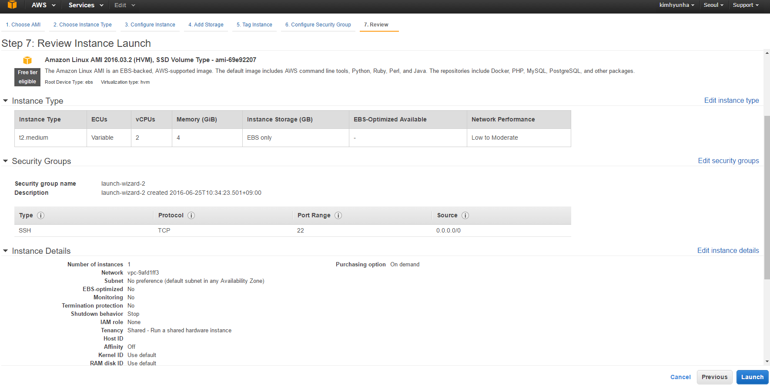

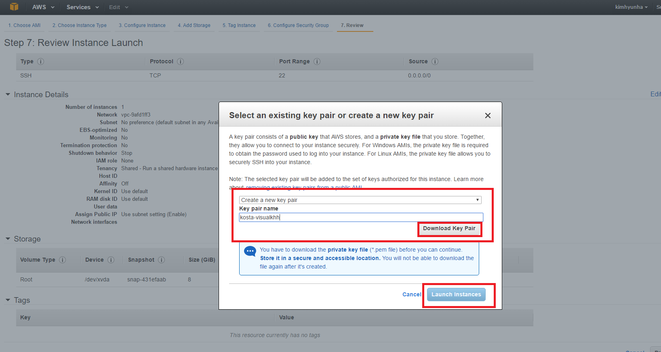위 런치를 누르면 과금 시작 다운로드(키 받아라) 어디에 흘리고 다니지말어라

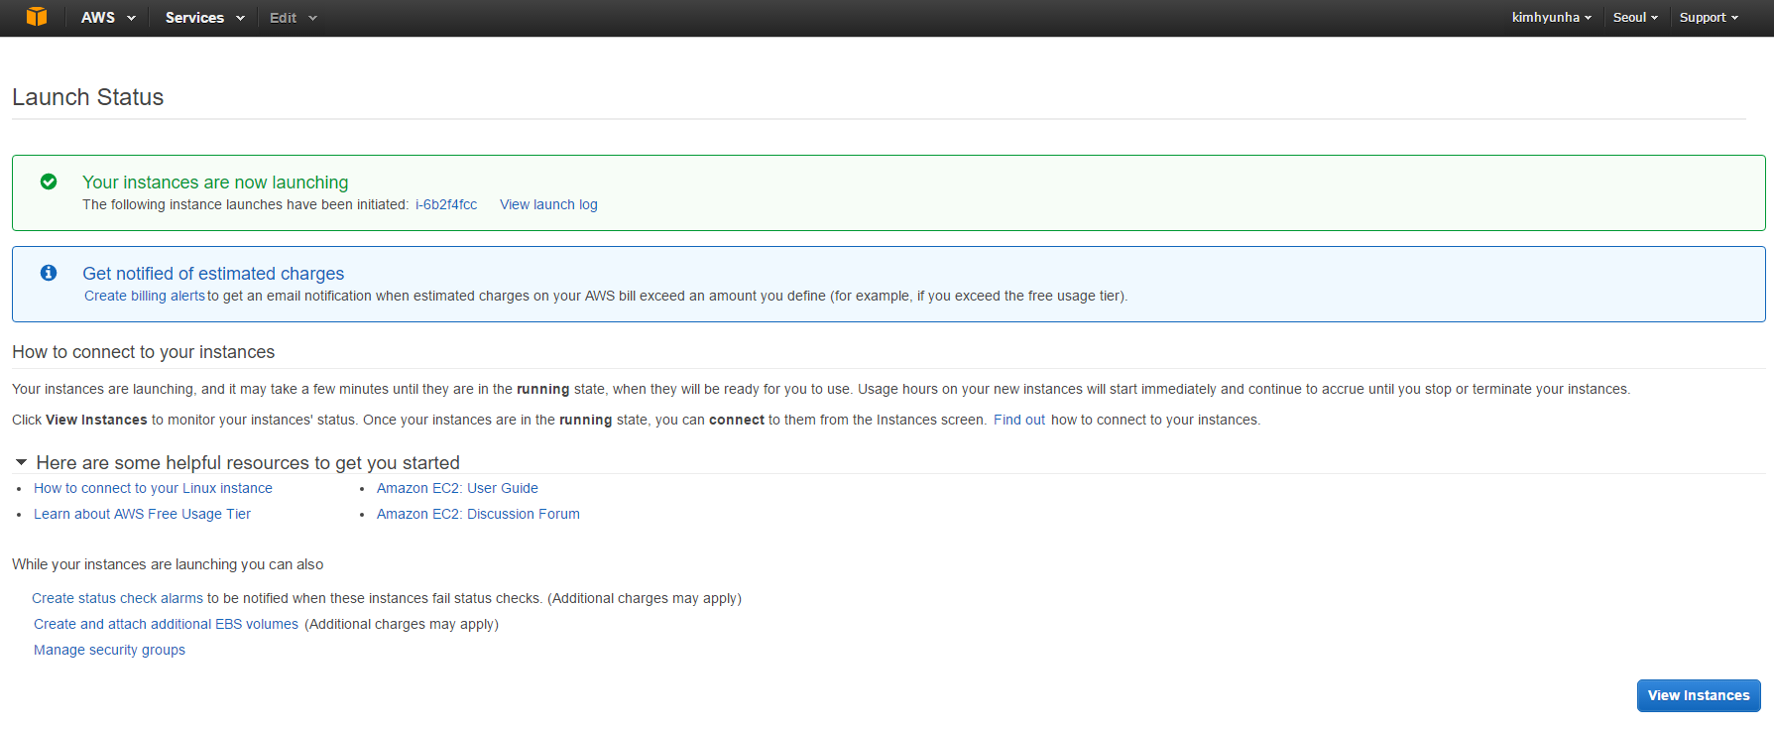

git bash 에서 받은 kosta-visualkhh.pem으로 ssh를 붙어보자

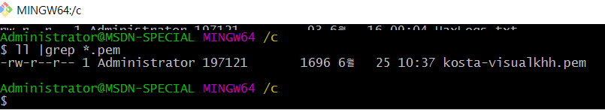

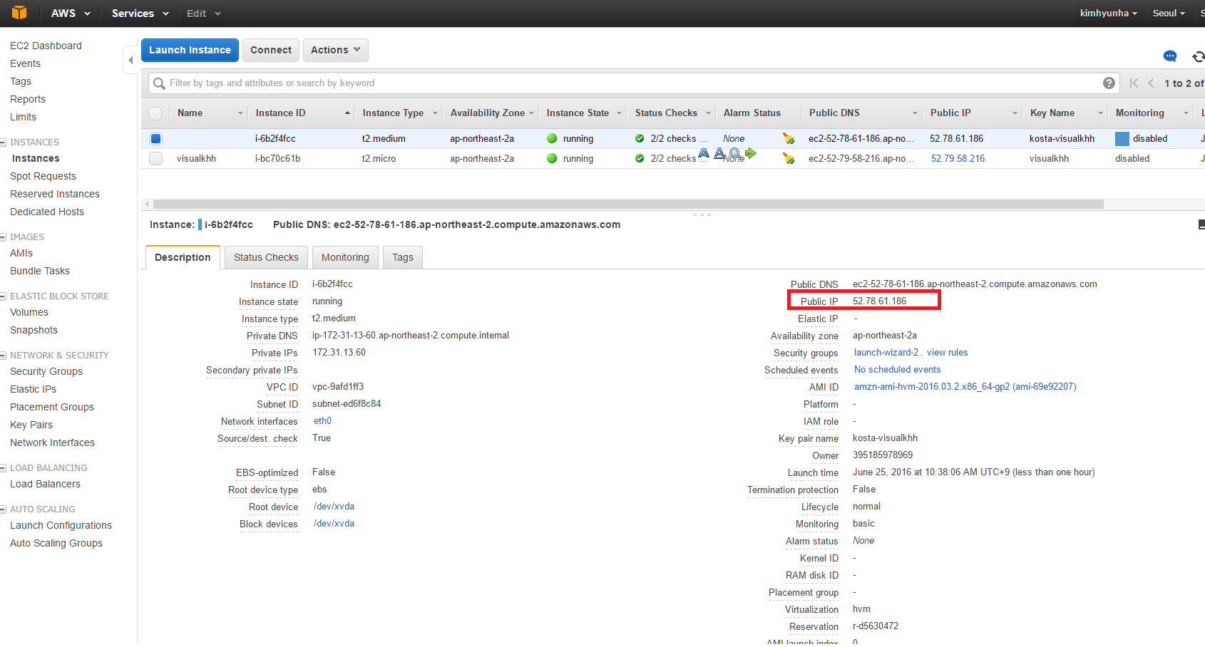

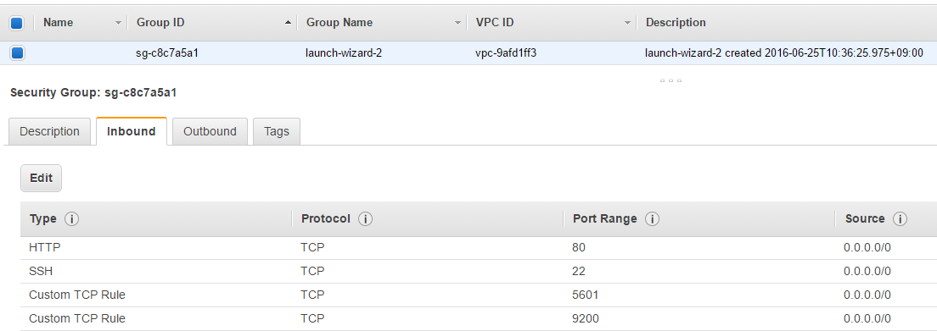

* EC2 Security Groups
* 외부 접근 포트 추가(inbound)
  + http(80)
  + elasticsearch(9200)
  + kibana(5601)

|  |
| --- |
| Administrator@MSDN-SPECIAL MINGW64 ~/elkdev  $ ll  total 8  -r--r--r-- 1 Administrator 197121 1696 6월 25 10:37 **kosta-visualkhh.pem**  Administrator@MSDN-SPECIAL MINGW64 ~/elkdev  $ **ssh -i ~/elkdev/kosta-visualkhh.pem ec2-user@52.78.61.186**  [ec2-user@ip-172-31-13-60 ~]$ **sudo yum update -y**  서버 업데이트… |

in aws

설치 4가지 (okdevtv.com/mib/elk/elk)

* nginx (아파치 보다 경량화되어 나온 웹서버, 이벤트방식이라 빠르다)
  + <http://okdevtv.com/mib/nginx/nginx>

|  |
| --- |
| sudo yum install nginx -y  sudo service nginx start  curl -i http://localhost  sudo chown -R ec2-user:ec2-user /var/log/nginx /usr/share/nginx/html  echo "<h1>Hello World</h1>" > /usr/share/nginx/html/hello.html |

|  |
| --- |
| [ec2-user@ip-172-31-13-60 ~]$ mkdir ~/local  [ec2-user@ip-172-31-13-60 ~]$ cd ~/local/  sudo yum install nginx -y  sudo service nginx start  curl -i http://localhost  sudo chown -R ec2-user:ec2-user /var/log/nginx /usr/share/nginx/html  echo "<h1>Hello World</h1>" > /usr/share/nginx/html/hello.html |
| curl -i http://localhost/hello.html  HTTP/1.1 200 OK  Server: nginx/1.8.1  Date: Sat, 25 Jun 2016 02:27:46 GMT  Content-Type: text/html  Content-Length: 21  Last-Modified: Sat, 25 Jun 2016 02:22:16 GMT  Connection: keep-alive  ETag: "576dead8-15"  Accept-Ranges: bytes  <h1>Hello World</h1> |
| 제대로 파일 호출되는지 웹에서 확인 |
|  |
| 설치 |
| cd ~/local  wget https://download.elastic.co/elasticsearch/release/org/elasticsearch/distribution/tar/elasticsearch/2.3.3/elasticsearch-2.3.3.tar.gz  tar xvfz elasticsearch-2.3.3.tar.gz  ln -s elasticsearch-2.3.3 elasticsearch  cd elasticsearch  ………  [ec2-user@ip-172-31-13-60 elasticsearch]$ ll  total 44  drwxrwxr-x 2 ec2-user ec2-user 4096 Jun 25 02:33 bin  drwxrwxr-x 2 ec2-user ec2-user 4096 Jun 25 02:33 config  drwxrwxr-x 2 ec2-user ec2-user 4096 Jun 25 02:33 lib  -rw-rw-r-- 1 ec2-user ec2-user 11358 Jan 27 12:53 LICENSE.txt  drwxrwxr-x 5 ec2-user ec2-user 4096 May 17 15:48 modules  -rw-rw-r-- 1 ec2-user ec2-user 150 May 12 13:24 NOTICE.txt  -rw-rw-r-- 1 ec2-user ec2-user 8700 May 12 13:24 README.textile  [ec2-user@ip-172-31-13-60 elasticsearch]$ |
|  |
| 엘라스틱서치 시작 |
| cd ~/local/elasticsearch  bin/elasticsearch –d  [ec2-user@ip-172-31-13-60 elasticsearch]$ cd ~/local/elasticsearch  [ec2-user@ip-172-31-13-60 elasticsearch]$ bin/elasticsearch -d  [ec2-user@ip-172-31-13-60 elasticsearch]$  [ec2-user@ip-172-31-13-60 elasticsearch]$ ps -ef |grep elasticsearch  ec2-user 7188 1 39 02:35 pts/0 00:00:04 /usr/lib/jvm/jre/bin/java -Xms256m -Xmx1g -Djava.awt.headless=true -XX:+UseParNewGC -XX:+UseConcMarkSweepGC -XX:CMSInitiatingOccupancyFraction=75 -XX:+UseCMSInitiatingOccupancyOnly -XX:+HeapDumpOnOutOfMemoryError -XX:+DisableExplicitGC -Dfile.encoding=UTF-8 -Djna.nosys=true -Des.path.home=/home/ec2-user/local/elasticsearch -cp /home/ec2-user/local/elasticsearch/lib/elasticsearch-2.3.3.jar:/home/ec2-user/local/elasticsearch/lib/* org.elasticsearch.bootstrap.Elasticsearch start -d  ec2-user 7240 2639 0 02:35 pts/0 00:00:00 grep --color=auto elasticsearch |
|  |
| 설정하기 설정변경하기 |
| vi config/elasticsearch.yml  network.host:0.0.0.0  kill -9 7188  [ec2-user@ip-172-31-13-60 elasticsearch]$ kill -9 7188  [ec2-user@ip-172-31-13-60 elasticsearch]$ ps -ef |grep elasticsearch  ec2-user 7247 2639 0 02:42 pts/0 00:00:00 grep --color=auto elasticsearch |
|  |
| 재실행 확인 |
| [ec2-user@ip-172-31-13-60 elasticsearch]$ kill -9 7188  [ec2-user@ip-172-31-13-60 elasticsearch]$ ps -ef |grep elasticsearch  ec2-user 7247 2639 0 02:42 pts/0 00:00:00 grep --color=auto elasticsearch  [ec2-user@ip-172-31-13-60 elasticsearch]$ bin/elasticsearch -d  [ec2-user@ip-172-31-13-60 elasticsearch]$ curl -i http://localhost:9200/  HTTP/1.1 200 OK  Content-Type: application/json; charset=UTF-8  Content-Length: 321  {  "name" : "Chan Luichow",  "cluster_name" : "elasticsearch",  "version" : {  "number" : "2.3.3",  "build_hash" : "218bdf10790eef486ff2c41a3df5cfa32dadcfde",  "build_timestamp" : "2016-05-17T15:40:04Z",  "build_snapshot" : false,  "lucene_version" : "5.5.0"  },  "tagline" : "You Know, for Search"  }  [ec2-user@ip-172-31-13-60 elasticsearch]$ |
|  |
| Kibana 설치 |
| cd ~/local  wget https://download.elastic.co/kibana/kibana/kibana-4.5.1-linux-x64.tar.gz  tar xvfz kibana-4.5.1-linux-x64.tar.gz  ln -s kibana-4.5.1-linux-x64 kibana  cd kibana |
|  |
| Kibana 실행 백그라운드 실행 (elasticsearch 가 실행되있어야된다) |
| cd ~/local/kibana  bin/kibana  nohup bin/kibana & |
|  |
| Logstash 설치 (설정 파일이 필요하다 로그관련) |
| cd ~/local  wget https://download.elastic.co/logstash/logstash/logstash-2.3.2.tar.gz  tar xvfz logstash-2.3.2.tar.gz  ln -s logstash-2.3.2 logstash  cd logstash |
|  |
| Logstash conf 파일 생성 |
| cd ~/local/logstash  mkdir logconf  vi logconf/nginx.conf |
| input {  file {  path => "/var/log/nginx/access.log"  start_position => beginning  }  }  filter {  grok {  match => { "message" => "%{COMBINEDAPACHELOG}"}  }  geoip {  source => "clientip"  }  }  output {  elasticsearch {}  stdout {}  }  위의 화살표 => 는 다른 언어와 다르게 msg => info 라면 msg는 info 값을 가진다(바라본다) 처럼 이해해야된다 |
|  |
| logstash 실행 |
| cd ~/local/logstash  # debug  bin/logstash -f logconf/nginx.conf --debug  # run  bin/logstash -f logconf/nginx.conf  # background run  nohup bin/logstash -f logconf/nginx.conf & |
|  |
|  |
| 확인… http://52.78.61.186:5601/ |
|  |

옥희 로그를 보고 분석해보장

|  |
| --- |
|  |
| cd ~/local/  mkdir okky  curl -O <http://okky.kr/examples/access.log-20160624.gz>  [ec2-user@ip-172-31-13-60 okky]$ cp access.log-20160624.gz access-okky.log.gz  [ec2-user@ip-172-31-13-60 okky]$ ll  total 16360  -rw-rw-r-- 1 ec2-user ec2-user 8372739 Jun 25 04:56 access.log-20160624.gz  -rw-rw-r-- 1 ec2-user ec2-user 8372739 Jun 25 04:58 access-okky.log.gz  [ec2-user@ip-172-31-13-60 okky]$ gunzip access-okky.log.gz  [ec2-user@ip-172-31-13-60 okky]$ ll  total 113864  -rw-rw-r-- 1 ec2-user ec2-user 8372739 Jun 25 04:56 access.log-20160624.gz  -rw-rw-r-- 1 ec2-user ec2-user 108217793 Jun 25 04:58 access-okky.log  [ec2-user@ip-172-31-13-60 okky]$ cp access-okky.log /var/log/nginx |
| 필요 유틸 추가 dstat 설치 |
| sudo yum install dstat –y  dstat 60 |
|  |
| 데이터 강제 적제, 확인 |
| cd ~/local/elasticsearch/data/elasticsearch/nodes/0/indices/  cd ~/local/logstash/logconf  vi nginx.conf  #logstash 패턴변경    재시작  ps -ef| grep logstash  ec2-user 7347 2639 0 02:54 pts/0 00:00:51 /usr/lib/jvm/jre/bin/java -XX:+UseParNewGC -XX:+UseConcMarkSweepGC -Djava.awt.headless=true -XX:CMSInitiatingOccupancyFraction=75 -XX:+UseCMSInitiatingOccupancyOnly -XX:+HeapDumpOnOutOfMemoryError -Xmx1g -Xss2048k -Djffi.boot.library.path=/home/ec2-user/local/logstash-2.3.2/vendor/jruby/lib/jni -XX:+UseParNewGC -XX:+UseConcMarkSweepGC -Djava.awt.headless=true -XX:CMSInitiatingOccupancyFraction=75 -XX:+UseCMSInitiatingOccupancyOnly -XX:+HeapDumpOnOutOfMemoryError -XX:HeapDumpPath=/home/ec2-user/local/logstash/heapdump.hprof -Xbootclasspath/a:/home/ec2-user/local/logstash-2.3.2/vendor/jruby/lib/jruby.jar -classpath : -Djruby.home=/home/ec2-user/local/logstash-2.3.2/vendor/jruby -Djruby.lib=/home/ec2-user/local/logstash-2.3.2/vendor/jruby/lib -Djruby.script=jruby -Djruby.shell=/bin/sh org.jruby.Main --1.9 /home/ec2-user/local/logstash/lib/bootstrap/environment.rb logstash/runner.rb agent -f logconf/nginx.conf --debug  ec2-user 29724 7841 0 05:07 pts/1 00:00:00 grep --color=auto logstash  kill -9 7347  cd ~/local/  [ec2-user@ip-172-31-13-60 local]$ cd logstash  [ec2-user@ip-172-31-13-60 logstash]$ nohup bin/logstash -f logconf/nginx.conf &  dstat 60  [ec2-user@ip-172-31-13-60 logstash]$ dstat 60  ----total-cpu-usage---- -dsk/total- -net/total- ---paging-- ---system--  usr sys idl wai hiq siq| read writ| recv send| in out | int csw  1 0 99 0 0 0| 26k 195k| 0 0 | 0 0 | 187 255  72 2 10 15 0 0| 0 **9093k**|1461B 4108B| 0 0 |2126 4453  쓰고있음 |
| Kibana확인 |
|  |

IP 검색

검색어는 따옴표("")로 감싼다.

"123.123.123.123"

clientip : "123.123.123.123"

URL 검색

"/order/form.html"

request : "/order/form.html"

device 검색 크롤러 제외

데이터 수집시 useragent 플러그인이 된 경우 가능

-device: "Spider"

여러 URL 검색

"/order/form.html" OR "/order/end.html"

OR 또는 AND는 대문자 dstat 설치

<https://dl.dropboxusercontent.com/u/2385737/Kibana-basic.pdf>

<https://okdevtv.com/mib/elk/kibana>

Kibana

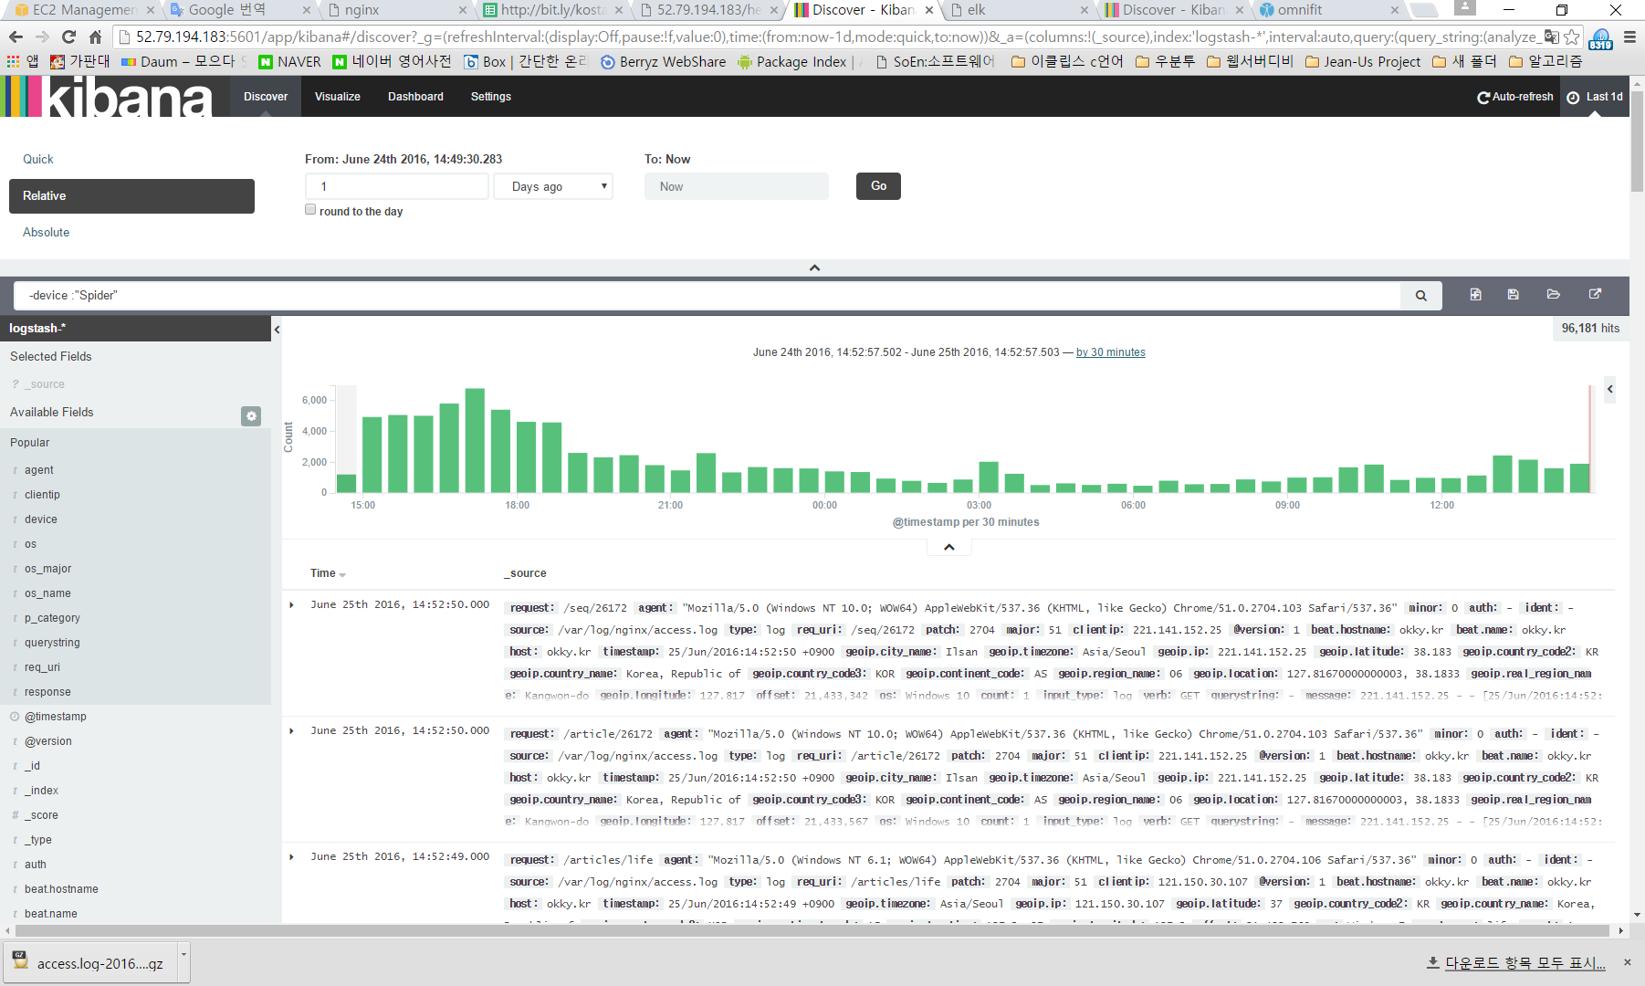device : “Spider”

하면은 검색봇에 대한 응답값들..

-device : “Spider”

앞부분에 –를 붙이면 제외다.

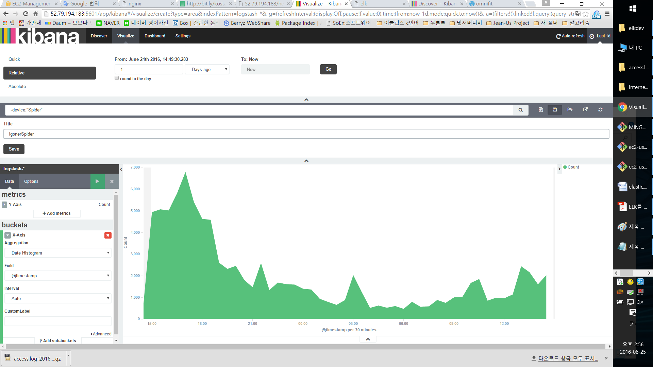그래프 생성 및 저장

서울 지하철 승하차 데이터 elk처리하기

<https://www.youtube.com/watch?v=ec-XzM6_CgU&feature=youtu.be>

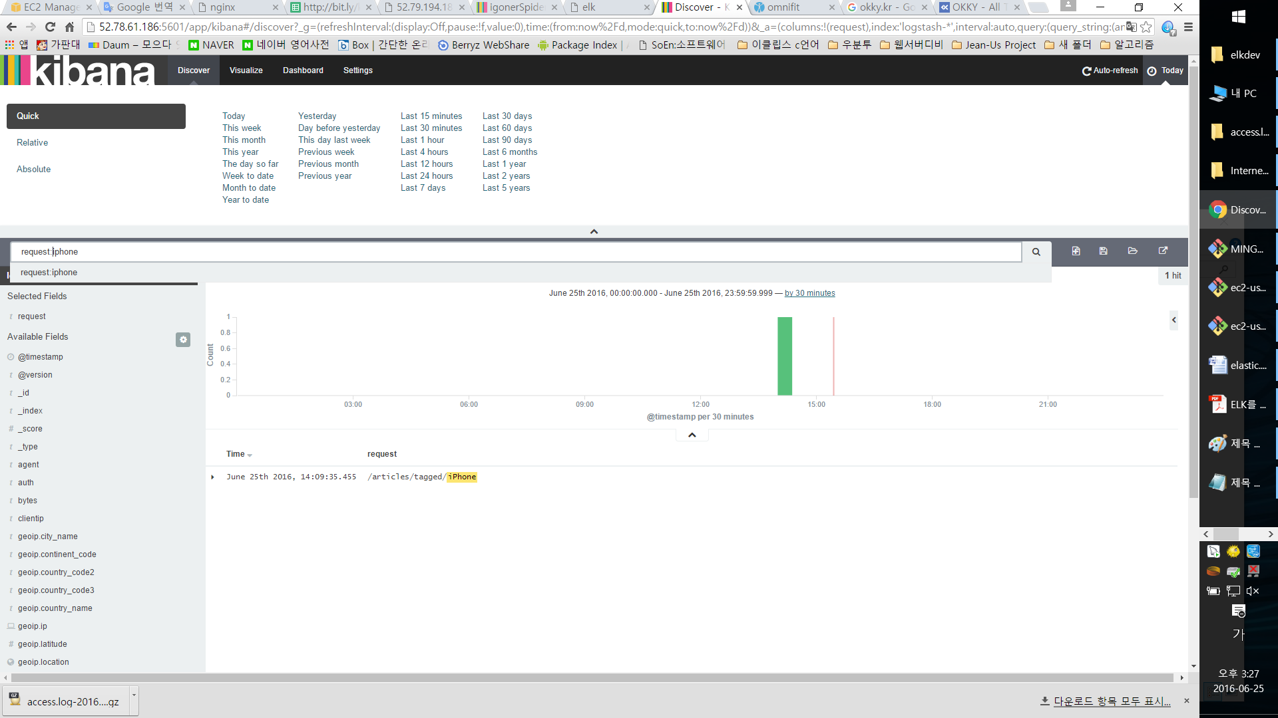

request:article

차트 만들기

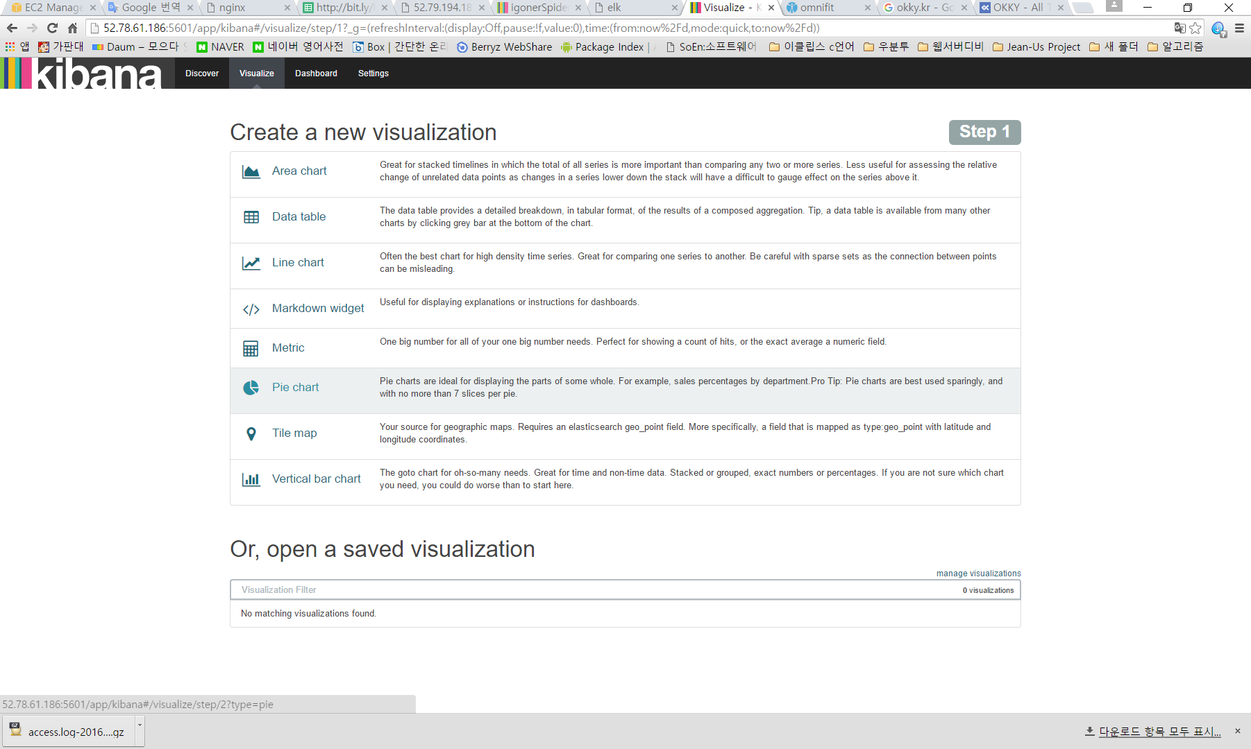

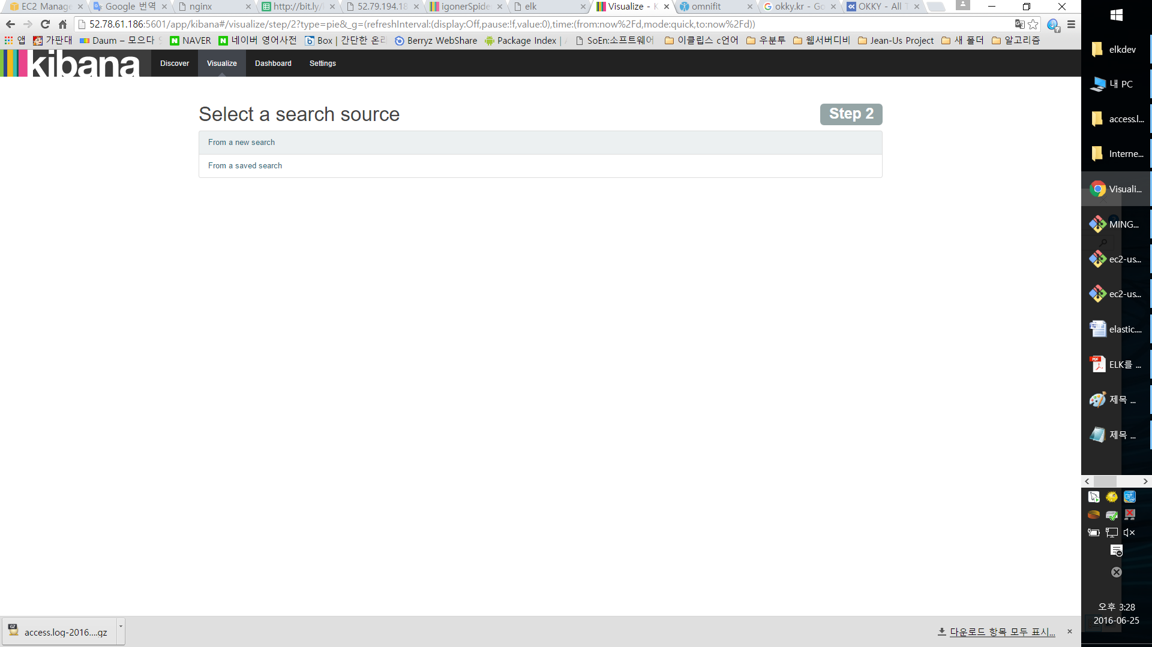

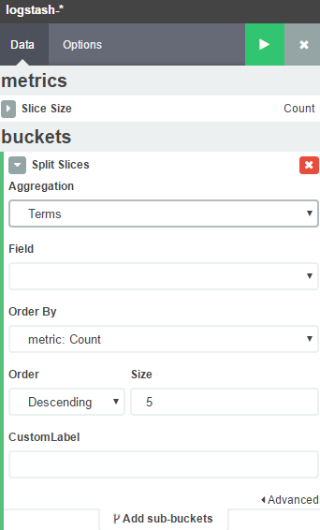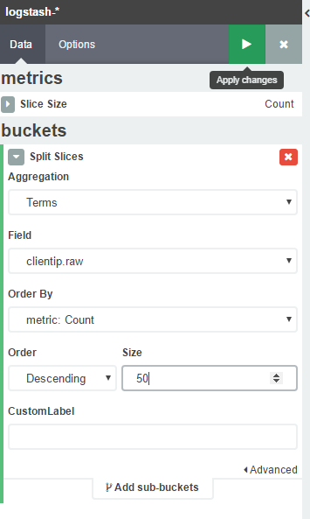

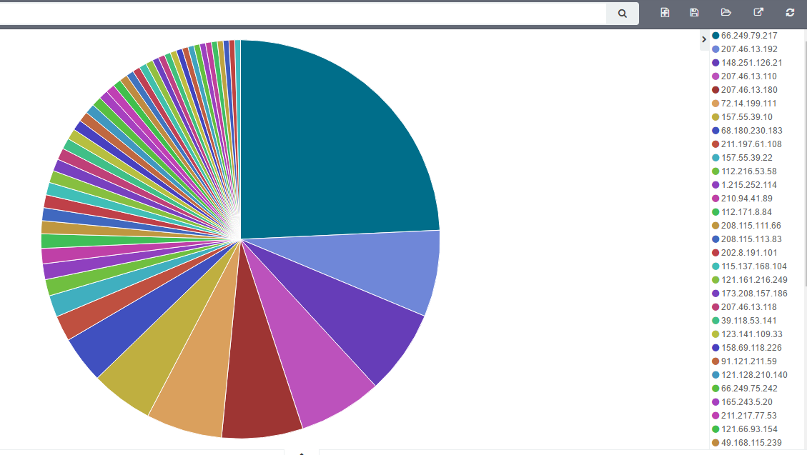

상태코드 까지 추가해볼까요~

add sub-buckets

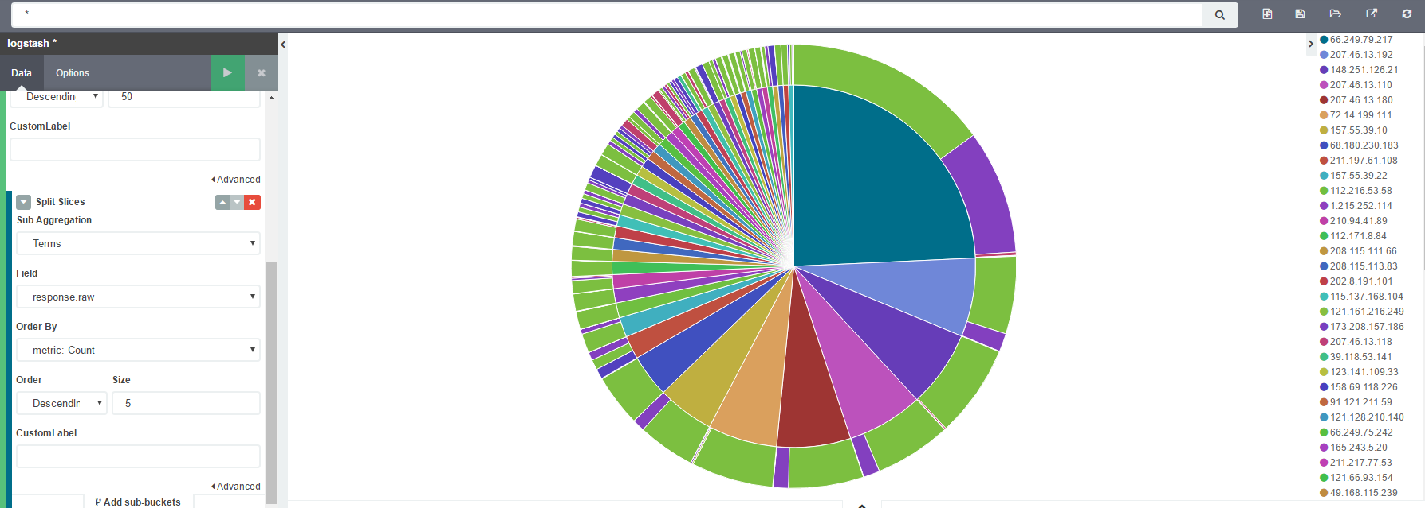

위쪽에 질의를 넣을수도 있다.

특정 필드를 시간타임 필드로 지정

* 이미지 제거
* filter {
* if [message] =~ "^#|\.(css|js|ico|png|xml|jpg|JPG|gif|jpeg|eot\?) " {
* drop {}
* }
* }
* useragent 파싱
* useragent {
* source => "agent"
* }
* timestamp 조정(apache log)
* date {
* match => [ "timestamp", "dd/MMM/yyyy:HH:mm:ss Z" ]
* }
* <https://www.elastic.co/guide/en/logstash/current/plugins-filters-date.html>
* urldecode
* urldecode {
* field => "params"
* }

LogStash 필터 변경

|  |
| --- |
| cd ~/local/logstash/logconf/  vi nginx.conf |
| input {  file {  path => "/var/log/nginx/access*.log"  start_position => beginning  }  }  filter {  grok {  match => { "message" => "%{COMBINEDAPACHELOG}"}  }  geoip {  source => "clientip"  }  date {  match => [ "timestamp", "dd/MMM/yyyy:HH:mm:ss Z" ]  }  }  output {  elasticsearch {}  stdout {}  } |
| Logstash 죽이기  ps -ef| grep logstash  ec2-user 7347 2639 0 02:54 pts/0 00:00:51 /usr/lib/jvm/jre/bin/java -XX:+UseParNewGC -XX:+UseConcMarkSweepGC -Djava.awt.headless=true -XX:CMSInitiatingOccupancyFraction=75 -XX:+UseCMSInitiatingOccupancyOnly -XX:+HeapDumpOnOutOfMemoryError -Xmx1g -Xss2048k -Djffi.boot.library.path=/home/ec2-user/local/logstash-2.3.2/vendor/jruby/lib/jni -XX:+UseParNewGC -XX:+UseConcMarkSweepGC -Djava.awt.headless=true -XX:CMSInitiatingOccupancyFraction=75 -XX:+UseCMSInitiatingOccupancyOnly -XX:+HeapDumpOnOutOfMemoryError -XX:HeapDumpPath=/home/ec2-user/local/logstash/heapdump.hprof -Xbootclasspath/a:/home/ec2-user/local/logstash-2.3.2/vendor/jruby/lib/jruby.jar -classpath : -Djruby.home=/home/ec2-user/local/logstash-2.3.2/vendor/jruby -Djruby.lib=/home/ec2-user/local/logstash-2.3.2/vendor/jruby/lib -Djruby.script=jruby -Djruby.shell=/bin/sh org.jruby.Main --1.9 /home/ec2-user/local/logstash/lib/bootstrap/environment.rb logstash/runner.rb agent -f logconf/nginx.conf --debug  ec2-user 29724 7841 0 05:07 pts/1 00:00:00 grep --color=auto logstash  kill -9 7347 |
|  |
| elastic search index 삭제 다시 데이터를 지우고 다시 입력한다. |
| cd ~/local/elasticsearch/data/elasticsearch/nodes/0/indices  curl -XDELETE "localhost:9200/logstash*" |
|  |
| logstash 재시작 |
| cd ~/local/  cd logstash  nohup bin/logstash -f logconf/nginx.conf &  확인  dstat 60  안쌓인다 띠발 |
| cd /var/log/nginx  cp ./access-okky.log ./access-okky2.log  파일 이벤트 발생시켜주면…  cd ~/local/elasticsearch/data/elasticsearch/nodes/0/indices  에가서 보면  [ec2-user@ip-172-31-13-60 indices]$ ls -al  total 20  drwxrwxr-x 5 ec2-user ec2-user 4096 Jun 25 06:59 .  drwxrwxr-x 4 ec2-user ec2-user 4096 Jun 25 03:07 ..  drwxrwxr-x 4 ec2-user ec2-user 4096 Jun 25 02:46 .kibana  drwxrwxr-x 8 ec2-user ec2-user 4096 Jun 25 06:58 logstash-2016.06.22  drwxrwxr-x 8 ec2-user ec2-user 4096 Jun 25 06:59 logstash-2016.06.23  [ec2-user@ip-172-31-13-60 indices]$  점점 쌓인다.  파일 수정날짜로 체크를 하나보다 띠발. |

플러그인 관리 사용하기

|  |
| --- |
| • 기본 플러그인  • input {}  • filter {}  • output {}  • 설정 파일을 만들어서 관리  • https://www.elastic.co/guide/en/logstash/current/first-event.html  cd logstash-2.3.0  bin/logstash -e 'input { stdin { } } output { stdout {} }' |
| 입력 소스 설정  • **beats**, couchdb_changes, drupal_dblog, elasticsearch, exec, eventlog, **file**, ganglia, gelf,  generator, graphite, github, heartbeat, heroku, http, http_poller, irc, imap, jdbc, jmx, kafka,  log4j, lumberjack, meetup, pipe, puppet_facter, relp, rss, rackspace, rabbitmq, redis,  salesforce, snmptrap, **stdin**, sqlite, s3, sqs, stomp, syslog, tcp, twitter, unix, udp,  varnishlog, wmi, websocket, xmpp, zenoss, zeromq  • <https://www.elastic.co/guide/en/logstash/current/input-plugins.html> |
| 출력 형태 설정  • <https://www.elastic.co/guide/en/logstash/current/output-plugins.html> |
| 필터 설정  • <https://www.elastic.co/guide/en/logstash/current/filter-plugins.html> |
| 이벤트 표시 설정  • avro, cef, cloudtrail, cloudfront, collectd, compress_spooler, dots, edn, edn_lines, es_bulk,  fluent, graphite, gzip_lines, json, json_lines, line, msgpack, multiline, netflow, nmap,  oldlogstashjson, plain, **rubydebug**, s3_plain, spool  • <https://www.elastic.co/guide/en/logstash/current/codec-plugins.html> |
| • filebeat 플러그인  cd ~/local/logstash  ./bin/logstash-plugin install logstash-input-beats  **• logstash 설정**  **input {**  **beats {**  **port => 5044**  **}**  **}** |

logstash구조

|  |  |  |
| --- | --- | --- |
| input(입력) | filter(데이터 수정 및 필터) | output(출력) |

파일 비츠 filebeat 설정 및 실행

|  |
| --- |
| • filebeat 설정  cd ~/local  wget https://download.elastic.co/beats/filebeat/filebeat-1.2.3-  x86_64.tar.gz  tar xvfz filebeat-1.2.3-x86_64.tar.gz  ln -s filebeat-1.2.3-x86_64 filebeat  cd filebeat  # elasticsearch 부분 #으로 주석 처리  # elasticsearch:  #hosts: ["localhost:9200"]  # logstash 부분 # 주석 해제  logstash:  hosts: ["localhost:5044"]  # filebeat.yml 내용 중 로그 위치 변경 `/var/log/nginx/*.log`  •실행  ./filebeat -e -c filebeat.yml  또는  nohub ….. & |

**로컬에 logstash 설치하여**

**서버측 elasticsearch 쪽에 데이터 전송하기**

1. 로컬에 자바 1.8설치하기
   1. wget url또는 curl -O url…
   2. curl -O https://download.elastic.co/logstash/logstash/logstash-2.3.3.zip
2. <https://www.elastic.co/downloads/logstash>
   1. 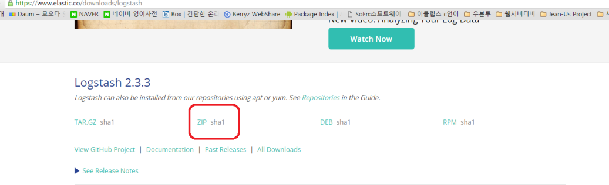
3. unzip logstash-2.3.3.zip
4. ~/logstash-2.3.3/bin/logstash -e 'input { stdin { } } output { stdout { } }'
   1. for window 🡪 bin/logstash -e 'input { stdio { } } output { stdout { } }'
5. bin\logstash -e 'input { stdin { } } output { stdout { codec => rubydebug } }'
   1. 오류 ㅠ_ㅠ 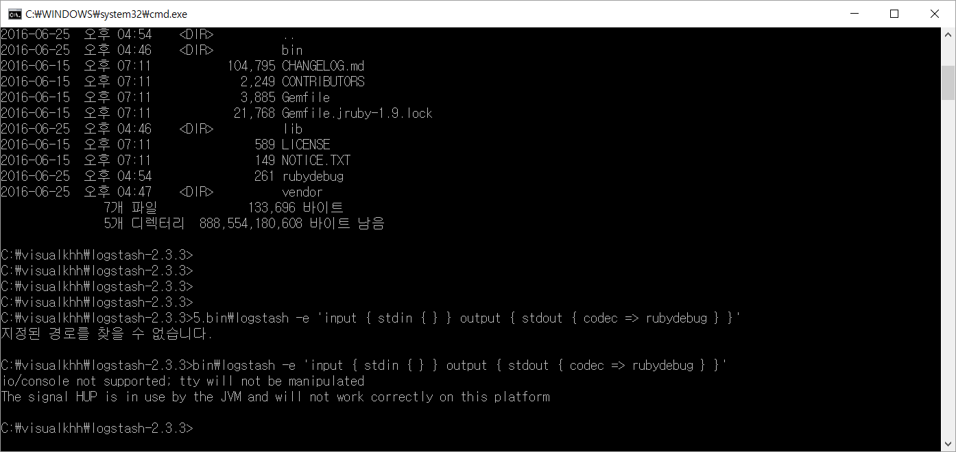
6. 위처럼 오류나서 파일로 직접 저정후 호출하여 해결 (window -> cmd) 에서실행

|  |
| --- |
| test.conf 파일 내용 |
| input{  stdin{}  }  output{  stdout{  codec => "rubydebug"  }  } |
| C:\visualkhh\logstash-2.3.3>bin\logstash -f test.conf  io/console not supported; tty will not be manipulated  Settings: Default pipeline workers: 4  Pipeline main started  {  "message" => "\r",  "@version" => "1",  "@timestamp" => "2016-06-25T08:02:12.037Z",  "host" => "MSDN-SPECIAL"  }  {  "message" => "\r",  "@version" => "1",  "@timestamp" => "2016-06-25T08:02:12.196Z",  "host" => "MSDN-SPECIAL"  } |

설정하자

|  |
| --- |
| mkdir logconf  notepad nginx.conf  input {  stdin{}  }  filter {  grok {  match => { "message" => "%{COMBINEDAPACHELOG}"}  }  geoip {  source => "clientip"  }  }  output {  stdout {  codec => "rubydebug"  }  } |
|  |
| 66.249.79.217 - - [25/Jun/2016:17:33:44 +0900] "GET /articles/community?query=250&sort=id&order=desc HTTP/1.1" 200 7341 "-" "Mozilla/5.0 (compatible; Googlebot/2.1; +http://www.google.com/bot.html)" "-"  붙쳐넣으면 기존거를 가지고 파싱을 한다 하지만 타임스템프가…틀리기 때문에 @ 가 안붙어서. 안되기떄문에  필터쪽에 걸어서 다시 해보자 |
| input {  stdin {}  }  filter {  grok {  match => { "message" => "%{COMBINEDAPACHELOG}"}  }  geoip {  source => "clientip"  }  date {  match => [ "timestamp", "dd/MMM/yyyy:HH:mm:ss Z" ]  }  }  output {  stdout {  codec => "rubydebug"  }  } |
| 66.249.79.217 - - [25/Jun/2016:17:33:44 +0900] "GET /articles/community?query=250&sort=id&order=desc HTTP/1.1" 200 7341 "-" "Mozilla/5.0 (compatible; Googlebot/2.1; +http://www.google.com/bot.html)" "-"  {  "message" => "66.249.79.217 - - [25/Jun/2016:17:33:44 +0900] \"GET /articles/community?query=250&sort=id&order=desc HTTP/1.1\" 200 7341 \"-\" \"Mozilla/5.0 (compatible; Googlebot/2.1; +http://www.google.com/bot.html)\" \"-\"\r",  "@version" => "1",  "@timestamp" => "2016-06-25T08:33:44.000Z",  "host" => "MSDN-SPECIAL",  "clientip" => "66.249.79.217",  "ident" => "-",  "auth" => "-",  "timestamp" => "25/Jun/2016:17:33:44 +0900",  "verb" => "GET",  "request" => "/articles/community?query=250&sort=id&order=desc",  "httpversion" => "1.1",  "response" => "200",  "bytes" => "7341",  "referrer" => "\"-\"",  "agent" => "\"Mozilla/5.0 (compatible; Googlebot/2.1; +http://www.google.com/bot.html)\"",  "geoip" => {  "ip" => "66.249.79.217",  "country_code2" => "US",  "country_code3" => "USA",  "country_name" => "United States",  "continent_code" => "NA",  "region_name" => "CA",  "city_name" => "Mountain View",  "postal_code" => "94043",  "latitude" => 37.41919999999999,  "longitude" => -122.0574,  "dma_code" => 807,  "area_code" => 650,  "timezone" => "America/Los_Angeles",  "real_region_name" => "California",  "location" => [  [0] -122.0574,  [1] 37.41919999999999  ]  }  } |
|  |
| request의 쿼리를 분리하고 싶다. |
| input {  stdin {}  }  filter {  grok {  match => { "message" => "%{COMBINEDAPACHELOG}"}  }  geoip {  source => "clientip"  }  date {  match => [ "timestamp", "dd/MMM/yyyy:HH:mm:ss Z" ]  }  **mutate {**  **add_field => {**  **"tmp" => "%{request}"**  **}**  **}**  **if [tmp] =~ "\?" {**  **mutate {**  **split => [**  **"tmp", "?"**  **]**  **add_field => {**  **"params" => "%{[tmp][1]}"**  **}**  **}**  **kv {**  **field_split => "&"**  **source => "params"**  **include_keys => [ "category", "utm_source" ]**  **prefix => "param_"**  **}**  **}**  **}**  output {  stdout {  codec => "rubydebug"  }  } |
| 테스트 데이터  66.249.79.217 - - [25/Jun/2016:17:33:44 +0900] "GET /articles/community?query=250&sort=id&order=desc HTTP/1.1" 200 7341 "-" "Mozilla/5.0 (compatible; Googlebot/2.1; +http://www.google.com/bot.html)" "-"  66.249.79.217 - - [25/Jun/2016:17:33:44 +0900] "GET /articles/community?category=hello&query=250&sort=id&order=desc HTTP/1.1" 200 7341 "-" "Mozilla/5.0 (compatible; Googlebot/2.1; +http://www.google.com/bot.html)" "-" |
| 위결과 : 둘다 쿼리부분 따로 빠지고  첫번째는 param_category안나옴 , 두번째꺼는 나옴 |
| 이미지 제거 처리 |
| input {  stdin {}  }  filter {  if [message] =~ "^#|\.(css|js|ico|png|xml|jpg|JPG|gif|jpeg|eot\?) " {  drop {}  }  grok {  match => { "message" => "%{COMBINEDAPACHELOG}"}  }  …  output {  stdout {  codec => "rubydebug"  }  } |
| 테스트 데이터  66.249.79.217 - - [25/Jun/2016:17:33:44 +0900] "GET /images/hello.gif HTTP/1.1" 200 7341 "-" "Mozilla/5.0 (compatible; Googlebot/2.1; +http://www.google.com/bot.html)" "-" |
| 결과  안나온다 ㅋㅋ |
|  |
| useragent 필터 처리 |
| input {  stdin {}  }  filter {  …  useragent {  source => "agent"  }  ….  output {  stdout {  codec => "rubydebug"  }  } |
| 테스트 데이터  116.39.189.14 - - [25/Jun/2016:17:53:50 +0900] "GET /article/333290 HTTP/1.1" 200 14015 "http://okky.kr/" "Mozilla/5.0 (Linux; Android 4.4.2; ko-kr; IM-A870K/2.13 Build/KOT49H) AppleWebKit/537.36 (KHTML, like Gecko) Version/4.0 Chrome/30.0.0.0 Mobile Safari/537.36" "-" |

aws instance삭제

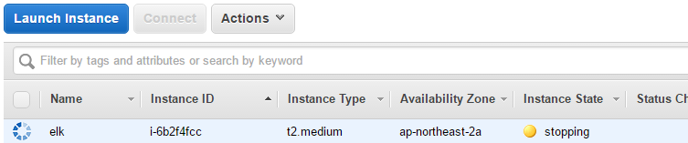

terminated

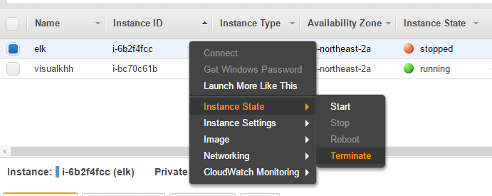

## Kibana 통계

### 시각화(Visualize)

* Terms(request.raw, clientip.raw, ...) 또는 Filters(request: "/hello.html", ...) 이용해서 차트 생성
* 테이블, 라인차트, 파이차트, 지도 등 가능
* 만들어진 차트는 저장 가능

### 대시보드 만들기

* 저장된 차트를 한 화면에서 볼 수 있도록 추가, 레이아웃 가능

## part 2

### Logstash

* 필드 추가
* field{
* mutate {
* add_field => {
* "reqs" => "%{request}"
* }
* }
* }
* 분리
* field{
* mutate {
* split => ["reqs", "?"]
* add_field => { "uri" => "%{reqs[0]}" }
* add_field => { "req_uri" => "%{reqs[0]}" }
* # add_field => { "querystring" => "%{reqs[1]}" }
* }
* }
* 필드 제거
* mutate {
* remove_field => [
* "reqs",
* "uri"
* ]
* }
* 파라미터 필드 만들기
* filter {
* mutate {
* add_field => {
* "tmp" => "%{request}"
* }
* }
* if [tmp] =~ "\?" {
* mutate {
* split => [
* "tmp", "?"
* ]
* add_field => {
* "params" => "%{[tmp][1]}"
* }
* }
* kv {
* field_split => "&"
* source => "params"
* include_keys => [ "category", "utm_source" ]
* prefix => "param_"
* }
* }
* }
* 또는

# params

if [request] =~ "\?" {

kv {

field_split => "&"

source => "querystring"

include_keys => [ "query", "redirectUrl" ]

prefix => "param_"

}

}

* 이미지 제거
* filter {
* if [message] =~ "^#|\.(css|js|ico|png|xml|jpg|JPG|gif|jpeg|eot\?) " {
* drop {}
* }
* }
* useragent 파싱
* useragent {
* source => "agent"
* }
* timestamp 조정(apache log)
* date {
* match => [ "timestamp", "dd/MMM/yyyy:HH:mm:ss Z" ]
* }
* <https://www.elastic.co/guide/en/logstash/current/plugins-filters-date.html>
* urldecode
* urldecode {
* field => "params"
* }

### Kibana

* 질의어 문법(query syntax)
  + Lucene 검색 엔진의 문법 그대로 사용(<https://lucene.apache.org/core/2_9_4/queryparsersyntax.html>)
* request: "uri"
* 제외 -device : "Spider"

### elasticsearch

* 데이터 지우기
  + curl -XDELETE http://localhost:9200/logstash*

## Filebeat with logstash

* (Optional)
* logstash forwarder(deprecated) 의 경량(lightweight) 버전
* logstash plugin 설치
* cd ~/local/logstash
* ./bin/logstash-plugin install logstash-input-beats
* filebeat 설치

cd ~/local

wget https://download.elastic.co/beats/filebeat/filebeat-1.2.3-x86_64.tar.gz

tar xvfz filebeat-1.2.3-x86_64.tar.gz

ln -s filebeat-1.2.3-x86_64 filebeat

cd filebeat

# elasticsearch 부분 #으로 주석 처리

# elasticsearch:

#hosts: ["localhost:9200"]

# logstash 부분 # 주석 해제

logstash:

hosts: ["localhost:5044"]

# filebeat.yml 내용 중 로그 위치 변경 `/var/log/nginx/*.log`

* logconf/nginx.conf 파일 변경

input {

beats {

port => 5044

}

}

filter {

grok {

match => [

"message", "%{COMBINEDAPACHELOG}",

"message", "%{COMMONAPACHELOG}"

]

}

geoip {

source => "clientip"

}

}

output {

elasticsearch {

hosts => "localhost:9200"

manage_template => false

index => "%{[@metadata][beat]}-%{+YYYY.MM.dd}"

document_type => "%{[@metadata][type]}"

}

}

./filebeat -e -c filebeat.yml

* start shell

echo "nohup ./filebeat -e -c filebeat.yml &" > start.sh

chmod +x start.sh

./start.sh

## ELK with PM2

* 2G짜리 메모리의 인스턴스에서 ELK를 돌리면 OutOfMemory 때문에 종종 Elasticsearch 또는 Kibana가 죽습니다.
* 고육지책으로 Kibana는 node 기반이기 때문에 pm2로 Kibana가 죽으면 자동으로 살리는 방법입니다.
* download from [http://nodejs.org](http://nodejs.org/) and install node.js
* npm install -g pm2
* cd ~/local/kibana
* pm2 start bin/cli
* check kibana status with pm2 list
* pm2 logs path is placed in ~/.pm2/logs

## kibana 인증 with nginx

sudo vi /etc/nginx/nginx.conf

* server_name: 아래 kibana 프록시 설정
* auth_basic "Restricted Access";
* auth_basic_user_file /etc/nginx/htpasswd.users;
* location / {
* proxy_pass http://localhost:5601;
* proxy_http_version 1.1;
* proxy_set_header Upgrade $http_upgrade;
* proxy_set_header Connection 'upgrade';
* proxy_set_header Host $host;
* proxy_cache_bypass $http_upgrade;
* }
* nginx 재시작
  + sudo service nginx restart
* 5601 포트는 막고 80으로만 접속

## 참고

* Logstash grok patterns
  + <https://github.com/logstash-plugins/logstash-patterns-core/blob/master/patterns/grok-patterns>
* ELKR (ElasticSearch + Logstash + Kibana + Redis) 를 이용한 로그분석 환경 구축하기
  + <http://brantiffy.axisj.com/archives/418>
* 2016 ELK 스택으로 서울시 지하철 대시보드 만들기 추천
  + <https://youtu.be/xPjNtd8xUZo>
* EMOCON 2015 F/W ELK 스택을 사용한 서울시 지하철 대시보드 만들기
  + <https://youtu.be/ec-XzM6_CgU>
* ELK 구축하기 1 – LOGSTASH
  + [http://linux.systemv.pe.kr/elk-구축하기-1-logstash/](http://linux.systemv.pe.kr/elk-%EA%B5%AC%EC%B6%95%ED%95%98%EA%B8%B0-1-logstash/)
* [Ubuntu] ELK 설치 및 테스트 하기
  + <http://digndig.kr/ubuntu/449/>
* Splunk 대체 Solution으로서의 ELK Stack
  + <http://blog.embian.com/18>
* How To Install Elasticsearch, Logstash, and Kibana 4 on Ubuntu 14.04
  + <https://www.digitalocean.com/community/tutorials/how-to-install-elasticsearch-logstash-and-kibana-4-on-ubuntu-14-04>
* ELK 프로그래밍 방송 영상
  + <http://bit.ly/okdevtv-elk>
* Logstash Configuration
  + <https://www.elastic.co/guide/en/logstash/current/event-dependent-configuration.html>
* Elasticsearch(Lucene) Query Syntax
  + <https://lucene.apache.org/core/2_9_4/queryparsersyntax.html>
* ELK Kibana 사용법
  + <https://dl.dropboxusercontent.com/u/2385737/Kibana-basic.pdf>

---------------------

|  |  |  |  |  |  |
| --- | --- | --- | --- | --- | --- |
|  |  |  |  |  |  |
| <https://www.dropbox.com/s/v6emkuos0792fs3/ELK%EB%A5%BC%20%EC%9D%B4%EC%9A%A9%ED%95%9C%20%EC%8B%A4%EC%8B%9C%EA%B0%84%20%EB%8D%B0%EC%9D%B4%ED%84%B0%20%EC%88%98%EC%A7%91%2C%20%EB%B6%84%EC%84%9D%2C%20%EC%8B%9C%EA%B0%81%ED%99%94%20%EA%B5%90%EC%9E%AC_20160625_V1.pdf?dl=0a> | 교재 |  |  |  |  |
| **필요 소프트웨어** |  |  |  |  |  |
| jdk 1.8 | [java.sun.com](http://java.sun.com) | java -version |  |  |  |
| git bash | [git-scm.com](http://git-scm.com) |  |  |  |  |
| elasticsearch 2.3.x | [elastic.co](http://elastic.co) |  |  |  |  |
| kibana 4.x | [elastic.co](http://elastic.co) |  |  |  |  |
| logstash 2.3.x | [elastic.co](http://elastic.co) |  |  |  |  |
| filebeat | [elastic.co](http://elastic.co) |  |  |  |  |
|  |  |  |  |  |  |
| aws console | [aws.amazon.com](http://aws.amazon.com) |  |  |  |  |
|  |  |  |  |  |  |
| <http://52.79.194.183:5601/> | okky.kr elk |  |  |  |  |
|  |  |  |  |  |  |
| [aws.amazon.com](http://aws.amazon.com) | hbenicloud@gmail.com | hbpass12 |  |  |  |
|  |  |  |  |  |  |
| [okdevtv.com/mib/elk/elk](http://okdevtv.com/mib/elk/elk) |  |  |  |  |  |
| mkdir ~/elkdev |  |  |  |  |  |
| cd ~/elkdev |  |  |  |  |  |
| pwd |  |  |  |  |  |
| explorer . |  |  |  |  |  |
| ssh -i ~/elkdev/kosta-kenu.pem ec2-user@ip |  |  |  |  |  |
| chmod 400 kosta-kenu.pem |  |  |  |  |  |
|  |  |  |  |  |  |
| aws |  |  |  |  |  |
| mkdir ~/local |  |  |  |  |  |
| cd ~/local |  |  |  |  |  |
|  |  |  |  |  |  |
| sudo yum update -y |  |  |  |  |  |
|  |  |  |  |  |  |
| [trends.google.com](http://trends.google.com) |  |  |  |  |  |
|  |  |  |  |  |  |
|  |  |  |  |  |  |
| <https://okdevtv.com/mib/nginx/nginx> |  |  |  |  |  |
|  |  |  |  |  |  |
| cd ~/local/elasticsearch |  |  |  |  |  |
| bin/elasticsearch -d |  |  |  |  |  |
| curl localhost:9200 |  |  |  |  |  |
|  |  |  |  |  |  |
|  |  |  |  |  |  |
| vi config/elasticsearch.yml |  |  |  |  |  |
| /192. |  |  |  |  |  |
| yy |  |  |  |  |  |
| p |  |  |  |  |  |
| x | # 지우고 |  |  |  |  |
| network.host: 0.0.0.0 |  |  |  |  |  |
| :wq |  |  |  |  |  |
|  |  |  |  |  |  |
| ps -ef | grep elastic |  |  |  |  |  |
| kill -9 7151 |  |  |  |  |  |
|  |  |  |  |  |  |
| curl -O http://okky.kr/examples/access.log-20160624.gz |  |  |  |  |  |
|  |  |  |  |  |  |
|  |  |  |  |  |  |
|  |  |  |  |  |  |
| aws 접속 |  |  |  |  |  |
| cd ~/local |  |  |  |  |  |
| mkdir okky |  |  |  |  |  |
| cd okky |  |  |  |  |  |
| curl - Ohttp://okky.kr/examples/access.log-20160624.gz |  |  |  |  |  |
| cp access.log-20160624.gz access-okky.log.gz |  |  |  |  |  |
| gunzip access-okky.log.gz |  |  |  |  |  |
| cp access-okky.log /var/log/nginx/ |  |  |  |  |  |
| sudo yum install dstat -y | dstat 설치 |  |  |  |  |
| 데이터 적재 확인 |  |  |  |  |  |
| cd ~/local/elasticsearch |  |  |  |  |  |
| cd data/elasticsearch/nodes/0/indices/ |  |  |  |  |  |
|  |  |  |  |  |  |
| cd ~/local/logstash |  |  |  |  |  |
| vi logconf/nginx.conf |  |  |  |  |  |
| access.log | access*.log |  |  |  |  |
| logstash 재시작 |  |  |  |  |  |
|  |  |  |  |  |  |
|  |  |  |  |  |  |
| <https://youtu.be/ec-XzM6_CgU> | 강추 |  |  |  |  |
| <http://bit.ly/okdevtv-elk> | 초간단 설치 동영상 |  |  |  |  |
|  |  |  |  |  |  |
| :13 |  |  |  |  |  |
| date {  match => [ "timestamp", "dd/MMM/yyyy:HH:mm:ss Z" ]  } |  |  |  |  |  |
| logstash 재시작 |  |  |  |  |  |
| elasticsearch index삭제 |  |  |  |  |  |
| cd ~/local/elasticsearch/data/elasticsearch/nodes/0/indices/ |  |  |  |  |  |
| du -h |  |  |  |  |  |
|  |  |  |  |  |  |
| curl -XDELETE "localhost:9200/logstash*" |  |  |  |  |  |
|  |  |  |  |  |  |
| cd ~/local/logstash |  |  |  |  |  |
| history | grep nohup |  |  |  |  |  |
| cd /var/log/nginx |  |  |  |  |  |
|  |  |  |  |  |  |
|  |  |  |  |  |  |
| <https://www.elastic.co/downloads/logstash> |  |  |  |  |  |
| curl -O https://download.elastic.co/logstash/logstash/logstash-2.3.3.zip |  |  |  |  |  |
| unzip logstash-2.3.3.zip |  |  |  |  |  |
|  |  |  |  |  |  |
| cd ~/elkdev/logstash-2.3.3 |  |  |  |  |  |
| bin/logstash -e 'input { stdin { } } output { stdout { } }' |  |  |  |  |  |
| bin\logstash -e 'input { stdio { } } output { stdout { } }' | for windows |  |  |  |  |
| bin\logstash -e 'input { stdin { } } output { stdout { } }' |  |  |  |  |  |
|  |  |  |  |  |  |
| bin\logstash -e 'input { stdin { } } output { stdout { codec => rubydebug } }' |  |  |  |  |  |
|  |  |  |  |  |  |
| The signal HUP is in use by the JVM and will not work correctly on this platform |  |  |  |  |  |
|  |  |  |  |  |  |
| notepad test.conf |  |  |  |  |  |
|  |  |  |  |  |  |
| input { stdin {}  }  output {  stdout { codec => "rubydebug" }  } |  |  |  |  |  |
| cmd 창 띄우기 |  |  |  |  |  |
| logstash-2.3.3 로 경로 이동 |  |  |  |  |  |
| mkdir logconf |  |  |  |  |  |
| cd logconf |  |  |  |  |  |
| notepad nginx.conf |  |  |  |  |  |
|  |  |  |  |  |  |
| <https://notepad-plus-plus.org/> |  |  |  |  |  |
| [brackets.io](http://brackets.io) |  |  |  |  |  |
| <https://atom.io/> |  |  |  |  |  |
| <https://code.visualstudio.com/> |  |  |  |  |  |
|  |  |  |  |  |  |
| input { stdin {} } filter { grok { match => { "message" => "%{COMBINEDAPACHELOG}"} } geoip { source => "clientip" } } output { stdout { codec <= "rubydebug" } } | input { stdin {} } filter { grok { match => { "message" => "%{COMBINEDAPACHELOG}"} } geoip { source => "clientip" } } output { stdout { codec => "rubydebug" } } |  |  |  |  |
|  |  |  |  |  |  |
| cd .. |  |  |  |  |  |
| bin\logstash -f logconf\nginx2.conf |  |  |  |  |  |
|  |  |  |  |  |  |
| 66.249.79.217 - - [25/Jun/2016:17:33:44 +0900] "GET /articles/community?query=250&sort=id&order=desc HTTP/1.1" 200 7341 "-" "Mozilla/5.0 (compatible; Googlebot/2.1; +http://www.google.com/bot.html)" "-" |  |  |  |  |  |
| 66.249.79.217 - - [25/Jun/2016:17:33:44 +0900] "GET /articles/community?category=hello&query=250&sort=id&order=desc HTTP/1.1" 200 7341 "-" "Mozilla/5.0 (compatible; Googlebot/2.1; +http://www.google.com/bot.html)" "-" | params test |  |  |  |  |
| 66.249.79.217 - - [25/Jun/2016:17:33:44 +0900] "GET /images/hello.gif HTTP/1.1" 200 7341 "-" "Mozilla/5.0 (compatible; Googlebot/2.1; +http://www.google.com/bot.html)" "-" | image test |  |  |  |  |
| 116.39.189.14 - - [25/Jun/2016:17:53:50 +0900] "GET /article/333290 HTTP/1.1" 200 14015 "http://okky.kr/" "Mozilla/5.0 (Linux; Android 4.4.2; ko-kr; IM-A870K/2.13 Build/KOT49H) AppleWebKit/537.36 (KHTML, like Gecko) Version/4.0 Chrome/30.0.0.0 Mobile Safari/537.36" "-" |  |  |  |  |  |
|  |  |  |  |  |  |
|  |  |  |  |  |  |
|  |  |  |  |  |  |
|  |  |  |  |  |  |
| input { stdin {} } filter { grok { match => { "message" => "%{COMBINEDAPACHELOG}"} } geoip { source => "clientip" } date { match => [ "timestamp", "dd/MMM/yyyy:HH:mm:ss Z" ] } } output { stdout { codec => "rubydebug" } } |  |  |  |  |  |