Status Report #2: Procure-to-Ship Close-Out
Hearth & Desk Supply Co. | Odoo 20 | Final report
Report date | Period | Prepared by | Overall status
Thu 10/22/2026 | 10/8 to 10/22 | Sawandi Kirby, project lead | Green, closed

Summary
All ten milestones are done. Every one of the nine sales orders shipped complete and on or before its 10/19 promise date, all five purchase orders are received and billed, and the data is exported and published. Two milestones finished late: M6 by two days when Greenline Bamboo Supply missed its delivery, and M10 by one day when the 10/21 close-out work moved to the 10/22 buffer day. Neither slip reached a customer.
The close-out review found one real gap: Greenline's PO was received in full but never billed (I3). The bill was entered and posted on 10/22, so all five vendor bills are now on the books before the database is deleted.
Milestones: Baseline vs Actual
ID | Milestone | Baseline | Actual | Variance
M1 | Wave 1 SOs entered, POs confirmed | 10/9 | 10/9 | 0
M2 | Fastline + Packwell received, bills posted | 10/10 | 10/10 | 0
M3 | Ironcrest received, Cable Tray MO produced | 10/12 | 10/12 | 0
M4 | Wave 2 SOs confirmed | 10/12 | 10/12 | 0
M5 | Brightform received, Laptop Riser MO produced | 10/13 | 10/13 | 0
M6 | Greenline received in full | 10/14 | 10/16 | +2
M7 | Remaining MOs complete | 10/15 | 10/15 | 0
M8 | All SOs shipped, carriers assigned | 10/19 | 10/19 | 0
M9 | Bills paid, exports, KPI dashboard | 10/20 | 10/20 | 0
M10 | Repo pushed, Odoo database deleted | 10/21 | 10/22 | +1

Final KPIs
KPI | Value | How it's measured
Customer OTIF | 100% | SOs shipped complete and on or before the promised date / SOs shipped. 9 of 9.
Order cycle time | 7.7 days | Ship date minus confirm date, averaged over the 9 shipped SOs.
Vendor on-time rate | 80% | First receipt on or before the confirmed date. 4 of 5; Greenline was the miss.
Vendor fill rate | 98.2% | Qty on first receipt / qty ordered across all 5 POs.
Schedule variance | 0.3 days | Average milestone variance, positive = late. M6 +2, M10 +1.
Avg PO cycle time | 3.2 days | PO confirmation to full receipt.
MO schedule adherence | 100% | Done MOs finished by their milestone baseline.
Avg shipping cost per order | $22.70 | Odoo carrier cost across all 9 deliveries.

Every value above is a formula in P2S_Project_Control.xlsx, calculated from the Odoo exports.
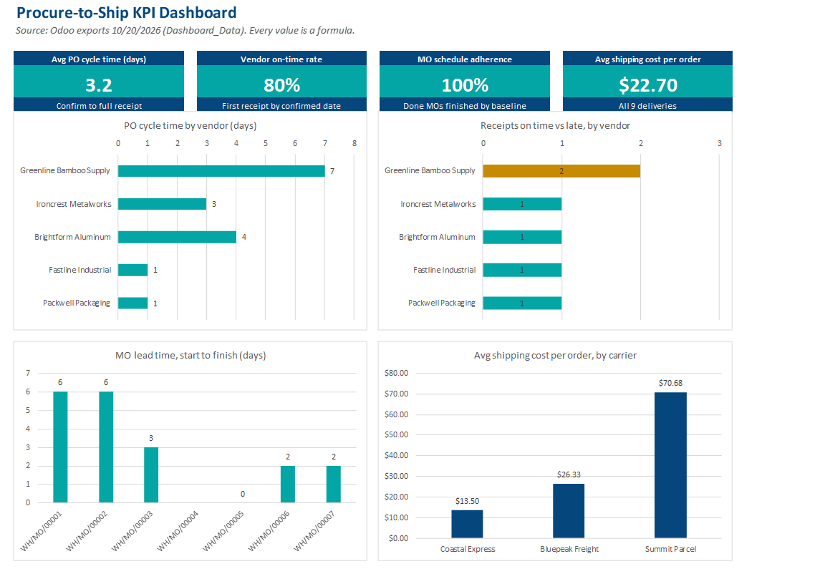
Shipping and the Carrier Mix (D7)
Coastal Express covers FL, GA, NC and SC only, at a flat $13.50 for anything over 3 lb. Six of the nine orders shipped on it. For the three out-of-region orders, the carrier rules decided the price: Bluepeak Freight charges $4.00 + $1.10/lb and Summit Parcel $6.00 + $1.40/lb (flat $8.50 at 5 lb or less), so Bluepeak is cheaper for anything above about 4 lb.
SO | State | Weight | Carrier used | Cost | Alternative
S00005 | KS | 13.8 lb | Bluepeak Freight | $19.18 | Summit Parcel $25.32
S00006 | TN | 26.8 lb | Bluepeak Freight | $33.48 | Summit Parcel $43.52
S00007 | MI | 46.2 lb | Summit Parcel | $70.68 | Bluepeak Freight $54.82

S00007 went on Summit Parcel on purpose, to keep a second out-of-region carrier active rather than routing all non-Coastal volume through one vendor. That choice cost more on this order. On a real lane, the trade is single-carrier risk against the per-order premium, and this project's three out-of-region orders are too few to justify a contract either way.
The Coastal rule also produced the out-of-region event logged under A2: on 10/18, S00005 (Kansas) was booked on Coastal first. Odoo never raised an error. The carrier just didn't appear as an option for a Kansas address, and the order was rebooked on Bluepeak.
Issues and Corrections
ID | What happened | Fix | Lesson
I1 10/13 | WH/MO/00004 consumed its components but recorded 0 Laptop Risers, and Odoo cancelled the MO. | Inventory adjustment returned the components; replacement WH/MO/00005 produced 22 the same morning. | Check the finished qty before marking an MO done.
I2 10/14 | Greenline missed its 10/14 date and sent a partial on 10/15. | Backorder WH/IN/00006 received in full 10/16. The partial covered every open MO. | A single-source vendor with the longest lead time needs a partial-shipment plan.
I3 10/20 | P00001 (Greenline) was received in full but never billed. Found during the M9 export review. | BILL/2026/10/0005 posted 10/22 for $1,039.86, 100% matched to P00001 and both receipts, Net 30. | Check every PO's billing status before close-out, not only the ones scheduled for payment.

Accounts Payable at Close
Bill | Vendor | Total | Due | Status
BILL/2026/10/0001 | Fastline Industrial | $139.75 | 11/9 | Paid 10/20
BILL/2026/10/0002 | Packwell Packaging | $250.69 | 11/9 | Paid 10/20
BILL/2026/10/0003 | Ironcrest Metalworks | $1,154.55 | 11/11 | Open
BILL/2026/10/0004 | Brightform Aluminum | $977.11 | 11/12 | Open
BILL/2026/10/0005 | Greenline Bamboo Supply | $1,039.86 | 11/21 | Open

What I'd Do Differently
- Build a billing check into the receipt step. I3 sat for six days because nothing tied a completed receipt to an open bill; a daily "received, not billed" filter on the PO list would have caught it on 10/16.
- Pull original dates before changing them. Odoo keeps the vendor's first promised date in date_promised, which the 10/9 notes missed. It's the field to report vendor reliability from.
- Expect carrier rules to filter quietly. An out-of-region carrier disappears from the picker with no warning, so the shipping checklist needs a state check, not a reliance on an error.
Note: Hearth & Desk Supply Co. is a fictional company run inside a real Odoo 20 trial. The vendor disruptions were designed scenarios, and vendor lead times were compressed so every receipt landed inside the trial (A1). The transactions, errors and corrections above all happened in the system.

