

Department of Computer Science

Visual Programming

Project Report

Class:
BSCS-B-F-24
Course Title:
Visual Programming
Project Title:
Real Estate Management System
Project Member:
Ayesha Akhlaq, Rasba Mazhar, Eisha Asim, Muhammad Furqan Arshad
Roll no:
243553, 243571, 243575, 243583
Submitted to:
Sir Faisal Idrees

INTRODUCTION & PROBLEM STATEMENT

Introduction:
The Real Estate Management System is a comprehensive desktop application developed using Windows Presentation Foundation (WPF) and C# for the frontend, with Microsoft SQL Server as the backend database. This system is designed to streamline and automate real estate operations for developers, agencies, societies, and investors, enabling efficient management of multiple projects, plots, buyers, and financial workflows.
The system provides a centralized platform to track transactions, manage commissions, oversee installment plans, and generate detailed operational and financial reports. It ensures accurate, real-time insights into all aspects of real estate operations while reducing manual work and errors.

Problem Statement:
Traditional real estate management relies heavily on manual processes, spreadsheets, and paper-based documentation, leading to several critical issues:
  - Data Fragmentation:
Information is scattered across multiple files, making it difficult to maintain consistency and retrieve accurate data quickly.
  - Manual Calculations:
Financial calculations for commissions, installments, and profit distributions are prone to human error, leading to discrepancies and disputes.
  - Lack of Real-time Tracking:
There is no centralized system to track plot availability, payment status, and receivables in real-time.
  - Inefficient Reporting:
Generating reports requires manual compilation of data from various sources, which is time-consuming and error-prone.
  - Poor Customer Management:
Customer information, payment history, and ledger entries are not systematically organized, making it difficult to track outstanding balances and aging receivables.
  - No Automation:
Critical business processes like commission calculation, installment reminders, and profit distribution require manual intervention.
  - Limited Visibility:
Management lacks visibility into project-wise performance, plot status, and financial health of the business.

Solution Overview:
The Real Estate Management System addresses these challenges by providing:
  - Centralized Database:
All data is stored in a single, normalized SQL Server database ensuring data integrity and consistency.
  - Automated Calculations:
System automatically calculates commissions, installments, and profit distributions based on predefined rules.
  - Real-time Updates:
All changes are immediately reflected across the system, providing up-to-date information.
  - Comprehensive Reporting:
Built-in reports for sales register, receivables aging, plot status, and customer statements.
  - Efficient Data Management:
User-friendly interfaces for managing projects, plots, customers, and transactions.
  - Audit Trail:
Complete transaction history and change tracking for accountability.

Objectives of the System

Primary Objectives
  - Automate Operations:
Fully automate all operations from project and plot management to sales, payments, and reporting.
  - Centralized Data Management:
Track buyers, sellers, agents, and plots in a centralized database with proper relationships and constraints.
  - Financial Accuracy:
Ensure accurate project-wise financial tracking and automatically calculate profit distribution for partners based on their investment shares.
  - Payment Management:
Manage flexible installment plans and receivables with automated tracking and reminders.
  - Error Reduction:
Minimize human errors by automating calculations for commissions, payments, and ledgers.
  - Real-time Insights:
Provide real-time insights into all aspects of real estate operations through interactive dashboards and reports.

Secondary Objectives
  - User-Friendly Interface:
Provide an intuitive, modern WPF interface that requires minimal training.
  - Data Security:
Implement proper authentication and authorization mechanisms to protect sensitive financial data.

  - Scalability:
Design the system to handle growing data volumes and multiple concurrent users.
  - Maintainability:
Create a well-structured codebase with clear separation of concerns for easy maintenance and future enhancements.
  - Reporting Capabilities:
Generate comprehensive reports for management decision-making.

Scope of the Project

Implemented Modules
  - Module 4.1: Project-Wise Plot Management (Marla-Based)
Features:
- Project creation and management with location and status tracking
- Plot management with Marla-based size measurements
- Plot specifications including Plot Number, Block, Phase, Facing
- Plot pricing and availability status management
- Ownership mapping linking plots to buyers and sellers
- Visual dashboard for plot status visualization
- Status tracking: Available, Sold, Blocked, Disputed, In Transfer
Functionality:
- Create, Read, Update, Delete (CRUD) operations for Projects
- Create, Read, Update, Delete (CRUD) operations for Plots
- Link plots to owners (buyers/sellers)
- Filter and search plots by project, status, or owner
- Visual representation of plot status with color coding
  - Module 4.2: Customer Ledger & Receivables Management
Features:
- Customer (Party) management for Buyers, Sellers, and Agents
- Complete customer information including Name, CNIC/NTN, Contact, Address
- Customer type classification (Buyer/Seller/Agent)
- Status management (Active/Inactive)
- Ledger view with running balance
- Full debit/credit transaction history
- Outstanding amount calculation
- Receivables aging breakdown
Functionality:
- Create, Read, Update, Delete (CRUD) operations for Customers
- Search and filter customers by type, status, or name
- View complete transaction ledger for each customer
- Calculate outstanding receivables
- Generate aging reports (0-30 days, 31-60 days, 61-90 days, 90+ days)
- Export customer data to PDF/Excel
  - Module 4.3: Installments & Payment Plans
Features:
- Payment plan creation with multiple plan types:
  - Monthly
  - Quarterly
  - Bi-annual
  - Custom
- Payment plan fields:
  - Buyer selection
  - Plot selection
  - Total Amount
  - Down Payment
  - Number of Installments
  - Installment Amount (auto-calculated)
  - Start Date
  - Status tracking
- Automatic installment generation based on plan type
- Auto reminders for:
  - Overdue installments
  - Upcoming installments
Functionality:
- Create, Read, Update, Delete (CRUD) operations for Payment Plans
- Automatic calculation of installment amounts
- Installment schedule generation
- Payment tracking and status updates
- Search and filter payment plans
- Export payment plan reports

Supporting Features
  - User Authentication:
Login and account creation functionality
  - Transaction Management:
Quick entry for recording payments and transactions
  - Ledger Views:
Comprehensive ledger views for buyers and sellers
  - Reports:
- Receivables Aging Report
- Customer Statements
- Plot Status Summary
  - Ownership Mapping:
Link sales to plots and buyers

Out of Scope (Future Work)
The following modules are planned but not implemented in this phase:
- Bank Accounts & CSV Upload (Module 4.4)
- Commission Management (Module 4.5)
- Seller Payment Tracking (Module 4.6)
- Partner & Investment Management (Module 4.7)
- Payroll Module (Module 4.8)
- Operational Reports (Module 4.9)
- Financial Reports (Module 4.10)
- Visualization Dashboard
- Email/SMS notifications

Tools & Technologies Used

Frontend Technologies
Technology | Version | Purpose
WPF | .NET 8.0 | Desktop Application Framework for UI
C# | 10.0 | Programming Language for Business Logic
XAML | - | Markup Language for UI Design
MVVM Pattern | - | Architectural pattern for separation of concern

Backend Technologies
Technology | Version | Purpose
Microsoft SQL Server | 2022 Express | Relational Database Management System
SSMS | Latest | Database Administration and Query tool
ADO.NET | - | Data Access Technology for Database Connectivity
Microsoft.Data.SqlClient | Latest | SQL Server Data Provider

Development Tools
Tool | Purpose
Visual Studio 2026 | Integrated Development Environment (IDE)
Git | Version Control System
SQL Server Management Studio | Database Design and Management
Windows Forms Designer | UI Layout and Design

Libraries & Frameworks
- System.Data.SqlClient: Database connectivity
- System.Windows: WPF UI framework
- System.Collections.Generic: Data structures
- System.Linq: Query operations

Design Patterns
- Data Access Layer (DAL): Separate classes for database operations
- Repository Pattern: Encapsulation of data access logic
- Singleton Pattern: Database connection management
- CRUD Operations: Standard Create, Read, Update, Delete patterns

Database Design

Entity Relational Diagram (ERD)
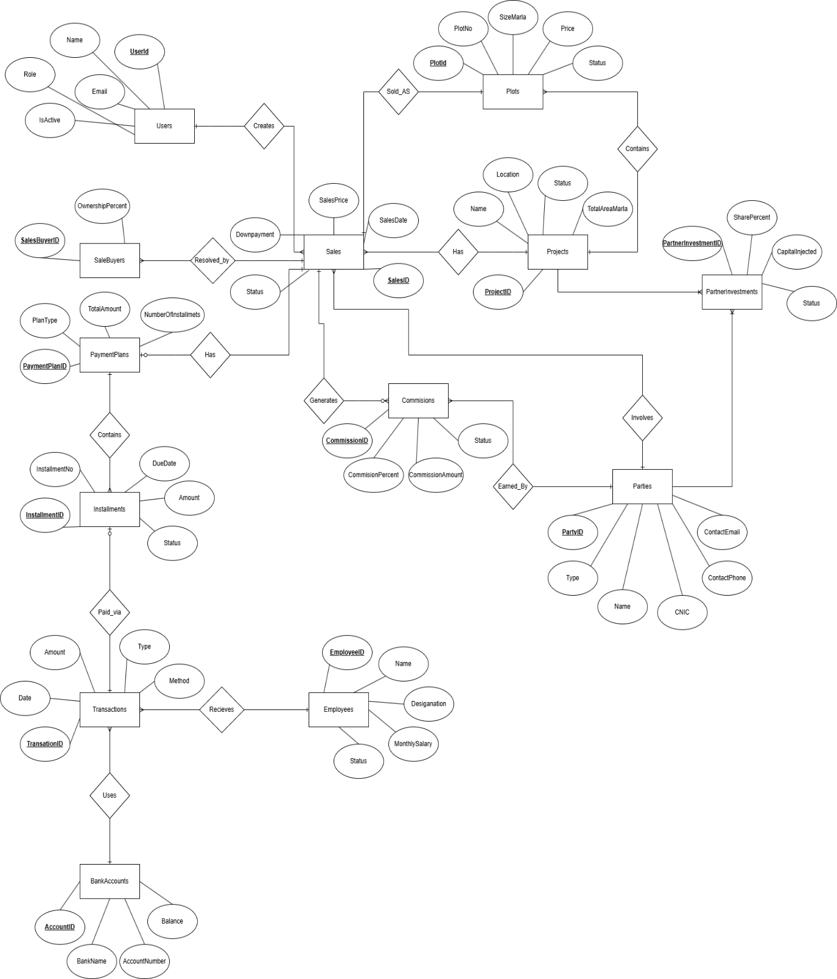

Relational Diagram
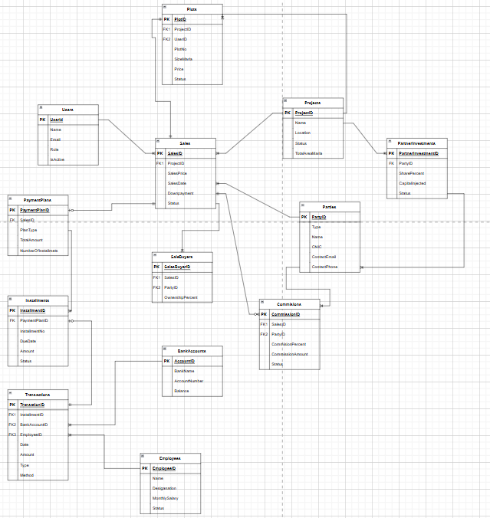

Foreign Key Relationships
  - Plots → Projects: One project can have many plots
  - Plots → Parties: Plots can have buyers and owners
  - Sales → Projects: Sales belong to projects
  - Sales → Plots: Sales are for specific plots
  - Sales → Parties: Sales involve buyers and sellers
  - PaymentPlans → Sales: One sale has one payment plan
  - Installments → PaymentPlans: One payment plan has many installments
  - Transactions → Installments: Transactions can be linked to installments
  - Transactions → Sales: Transactions can be linked to sales
  - Transactions → Parties: Transactions involve parties

Database Constraints
- Primary Keys: All tables have identity-based primary keys
- Foreign Keys: Referential integrity maintained through foreign key constraints
- Unique Constraints: Email in Users table, SaleId in PaymentPlans table
- Default Values: Status fields, timestamps, and numeric defaults
- Cascade Deletes: Configured for maintaining referential integrity

System Design

Architectural Overview
The system follows a three-tier architecture:
Presentation Layer (WPF)
- XAML Pages
- Code-Behind (C#)
- Event Handlers
Database Layer (SQL Server)
- Tables
- Views
- Stored Procedures
Data Access Layer
- DatabaseHelper
- SQL Queries
- Connection Management
Business Logic Layer
- Data Access Classes
- Business Rules
- Validation Logic

Form Design
  - Main Window
Purpose: Main application container with navigation frame
Features:
- Custom title bar with minimize, maximize, and close buttons
- Navigation frame for page switching
- Modern dark theme design
- Responsive layout
Components:
- Title bar (32px height)
- Main content frame
- Window controls (minimize, maximize, close)
  - Welcome Page
Purpose: Landing page after login with navigation menu
Features:
- Module navigation buttons
- Quick access to main features
- User information display
  - Login Page
Purpose: User authentication
Components:
- Email/Username input field
- Password input field
- Login button
- Create Account link
- Error message display
Functionality:
- Validates user credentials
- Redirects to Welcome page on success
- Shows error messages for invalid credentials
  - Create Account Page
Purpose: New user registration
Components:
- Name input field
- Email input field
- Password input field
- Confirm Password input field
- Role selection (Admin, Accountant, Sales Officer, etc.)
- Create Account button
- Back to Login link
Functionality:
- Validates input fields
- Checks email uniqueness
- Creates new user account
- Hashes password before storage
  - Project Management Page
Purpose: Manage real estate projects
Components:
- Input Form Section:
  - Project Name field
  - Location field
  - Status dropdown (Planning, Ongoing, Completed, On Hold)
  - Save, Clear, Delete buttons
- Project List Section:
  - DataGrid displaying all projects
  - Columns: Project Name, Location, Status
  - Row selection for editing
Functionality:
- Create new projects
- Edit existing projects
- Delete projects (with cascade checks)
- View all projects in grid
- Search and filter capabilities
  - Plot Management Page (Module 4.1)
Purpose: Manage plots within projects
Components:
- Input Form Section:
  - Plot Number field
  - Project dropdown (linked to Projects table)
  - Size (Marla) field
  - Price field
  - Status dropdown (Available, Sold, Blocked, Disputed, In Transfer)
  - Current Owner dropdown (linked to Parties table)
  - "+ New" button for adding owners
  - Save, Clear, Delete buttons
- Plots List Section:
  - DataGrid displaying all plots
  - Columns: Plot No, Project, Size (marla), Price, Status, Owner
  - Row selection for editing
Functionality:
- Create new plots
- Edit existing plots
- Delete plots (with cascade checks)
- Link plots to projects
- Assign owners to plots
- Filter plots by project or status
- Search plots by plot number
  - Customer Ledger & Receivables Management Page (Module 4.2)
Purpose: Manage customers (buyers, sellers, agents) and view ledgers
Components:
- Customer Information Form:
  - Name field
  - CNIC/NTN field
  - Contact field
  - Type dropdown (Buyer, Seller, Agent)
  - Address field (multiline)
  - Status dropdown (Active, Inactive)
  - Save, Clear, Delete buttons
- Search & Filter Section:
  - Search textbox
  - Filter by Type dropdown
  - Filter by Status dropdown
  - Export PDF button
  - Export Excel button
- Customer List Section:
  - DataGrid displaying all customers
  - Columns: Name, CNIC/NTN, Contact, Type, Status
  - Row selection for editing
Functionality:
- Create new customers
- Edit existing customers
- Delete customers
- Search customers by name or CNIC
- Filter customers by type or status
- Export customer data to PDF/Excel
- View customer transaction history (via Ledger View page)
  - Installments & Payment Plans Page (Module 4.3)
Purpose: Create and manage payment plans and installments

Components:
- Payment Plan Creation Form:
  - Buyer dropdown (linked to Parties where Type='Buyer')
  - Plot dropdown (linked to Plots table)
  - Plan Type dropdown (Monthly, Quarterly, Bi-annual, Custom)
  - Total Amount field
  - Down Payment field
  - Number of Installments field
  - Installment Amount field (auto-calculated, read-only)
  - Start Date picker
  - Status dropdown (Active, Completed, Cancelled, On Hold)
  - Auto Reminders section:
    - Overdue Reminder checkbox
    - Upcoming Installment Reminder checkbox
  - Save Plan, Clear, Delete buttons
- Search & Filter Section:
  - Search textbox
  - Filter by Status dropdown
  - Export PDF Button
  - Export Excel Button
- Payment Plans List Section:
  - DataGrid displaying all payment plans
  - Columns: Plan ID, Buyer, Plot, Plan Type, Total Amount, Down Payment, Installments, Installment Amount, Start Date, Status
  - Row selection for editing
Functionality:
- Create new payment plans
- Edit existing payment plans
- Delete payment plans (cascades to installments)
- Automatic calculation of installment amount
- Automatic generation of installment schedule based on plan type
- Search payment plans
- Filter by status
- Export payment plan reports
  - Ownership Mapping Page
Purpose: Link sales to plots and buyers
Components:
- Sale Information Form:
  - Project dropdown
  - Plot dropdown
  - Buyer dropdown
  - Seller dropdown
  - Sale Price field
  - Sale Date picker
  - Down Payment field
  - Status dropdown
  - Save, Clear, Delete buttons
- Sales List Section:
  - DataGrid displaying all sales
  - Columns: Sale ID, Project, Plot, Buyer, Seller, Sale Price, Sale Date, Status
  - Row Selection for editing
Functionality:
- Create new sales
- Edit existing sales
- Delete sales
- Link sales to plots and parties
- Tack sale status
  - Quick Entry Page
Purpose: Quick transaction entry
Components:
- Transaction Date picker
- Amount field
- Type dropdown
- Description field
- Party dropdown
- Save button
Functionality:
- Create transaction quickly
- Link transactions to sales or installments
- Record payments and other transaction types
  - Ledger View Page
Purpose: View customer transaction ledgers
Components:
- Customer dropdown
- DataGrid displaying transactions
- Columns: Date, Description, Debit, Credit, Balance, Type
Functionality:
- View complete transaction history for a customer
- Calculate Running Balance, Outstanding Amount, and Total Credit
  - Receivables Aging Report Age
Purpose: Generate receivables aging reports
Components:
- Customer filter
- Date range filters
- Aging bucket display:
  - 0-30 days
  - 31-60 days
  - 61-90 days
  - 90+ days
- DataGrid with aging details
- Export buttons
Functionality:
- Calculate outstanding receivables
- Categorize by aging buckets
- Generate aging reports
- Export to PDF/Excel
  - Customer Statements Page
Purpose: Generate customer statements
Components:
- Customer dropdown
- Statement period selection
- Statement preview
- Print button
- Export PDF button
Functionality:
- Generate customer statements
- Include transaction history
- Calculate outstanding balance
- Export to PDF
  - Plot Visual Dashboard Page
Purpose: Visual representation of plot status
Components:
- Project selector
- Visual grid/map of plots
- Color-coded plot status
- Plot details on click
- Status legend

Functionality:
- Visual representation of plots
- Color coding by status
- Interactive plot selection
- Quick status overview

User Interface Design Principles
  - Consistency: Uniform design language across all pages
  - Usability: Intuitive navigation and clear labels
  - Accessibility: Proper contrast ratios and readable fonts
  - Responsiveness: Layout adapts to window resizing
  - Feedback: Clear error messages and success confirmations
  - Modern Design: Dark theme with card-based layouts

Navigation Flow

Login Page
Customer Statements

Receivables Aging Report

Ledger View

Quick Entry

Ownership Mapping

Payment Plans (Module 4.3)

Customer Management (Module 4.2)

Plot Management (Module 4.1)

Project Management

Welcome Page

Reports (To be Implemented)

Sales Register Report
Purpose: Overview of all sales transactions
Contents:
- Plot information (Plot No, Project, Size)
- Buyer details (Name, CNIC, Contact)
- Total amount
- Payment plan details
- Payments received
- Balance receivable
- Sale status
Export Options:
- PDF
- Excel

Receivables Aging Report
Purpose: Track outstanding receivables by aging buckets
Contents:
- Customer information
- Outstanding amount breakdown:
- 0-30 days overdue
- 31-60 days overdue
- 61-90 days overdue
- 90+ days overdue
- Total outstanding
- Due dates
- Installment details
Export Options:
- PDF
- Excel

Plot Status Summary Report
Purpose: Overview of plot availability and status
Contents:
- Project-wise breakdown
- Total plots
- Available plots count
- Sold plots count
- Blocked plots count
- Disputed plots count
- In transfer plots count
- Total value by status
Export Options:
- PDF
- Excel

Customer Ledger Report
Purpose: Complete transaction history for a customer
Contents:
- Customer information
- Transaction list with:
- Date
- Description
- Debit amount
- Credit amount
- Running balance
- Outstanding amount
- Transaction count
Export Options:
- PDF
- Excel

Payment Plan Report
Purpose: Details of payment plans and installments
Contents:
- Payment plan details
- Buyer information
- Plot information
- Installment schedule
- Payment status
- Remaining balance
- Next due date
Export Options:
- PDF
- Excel

Customer Statement
Purpose: Periodic statement for customers
Contents:
- Statement period
- Opening balance
- Transaction list
- Closing balance
- Outstanding amount
- Payment due dates
Export Options:
- PDF (formatted statement)
- Print

Implementation Details

Data Access Layer
  - DatabaseHelper.cs
Purpose: Centralized database connection management
Key Methods:
public static SqlConnection GetConnection()
public static bool TestConnection()
Features:
    - Singleton connection string management
    - Connection testing functionality
    - Integrated Security authentication
  - Data Access Classes
    - ProjectDataAccess.cs
- GetAllProjects(): Retrieve all projects
- CreateProject(): Insert new project
- UpdateProject(): Update existing project
- DeleteProject(): Delete project with validation
    - PlotDataAccess.cs / PlotManagementDataAccess.cs
- GetAllPlots()`: Retrieve all plots with project names
- GetPlotsByProject()`: Filter plots by project
- CreatePlot()`: Insert new plot
- UpdatePlot()`: Update existing plot
- DeletePlot()`: Delete plot with validation
    - PartyDataAccess.cs / PartyManagementDataAccess.cs
- GetAllParties(): Retrieve all parties
- GetPartiesByType(): Filter by type (Buyer/Seller/Agent)
- CreateParty(): Insert new party
- UpdateParty(): Update existing party
- DeleteParty(): Delete party with validation
    - PaymentPlanDataAccess.cs
- GetAllPaymentPlans(): Retrieve all payment plans with details
- CreatePaymentPlan(): Insert payment plan and generate installments
- UpdatePaymentPlan(): Update payment plan
- DeletePaymentPlan(): Delete payment plan (cascades to installments)
- CalculateInstallmentAmount(): Auto-calculate installment amount
    - TransactionDataAccess.cs
- CreateTransaction(): Insert new transaction
- GetTransactionsByParty(): Retrieve party transactions
- GetTransactionsByDateRange(): Filter by date range
    - LedgerDataAccess.cs
- GetBuyerLedger(): Retrieve buyer ledger view
- GetSellerLedger(): Retrieve seller ledger view
- GetReceivablesAging(): Calculate aging buckets
- GetCustomerStatement(): Generate customer statement
    - SalesDataAccess.cs
- CreateSale(): Insert new sale
- GetAllSales(): Retrieve all sales
- UpdateSale(): Update sale
- DeleteSale(): Delete sale
    - UserDataAccess.cs
- AuthenticateUser(): Validate login credentials
- CreateUser(): Insert new user with password hashing
- GetUserByEmail(): Retrieve user by email

Business Logic Implementation
  - Payment Plan Calculation
- Installment Amount Calculation:
  - Installment Amount = (Total Amount - Down Payment) / Number of Installments
- Installment Schedule Generation:
  - Monthly: Add 1 month per installment
  - Quarterly: Add 3 months per installment
  - Bi-annual: Add 6 months per installment
  - Custom: User-defined intervals
  - Receivables Aging Calculation
- Aging Bucket Logic:
DaysOverdue = CurrentDate - DueDate
if (DaysOverdue <= 0) → "Not Due"
else if (DaysOverdue <= 30) → "0-30 Days"
else if (DaysOverdue <= 60) → "31-60 Days"
else if (DaysOverdue <= 90) → "61-90 Days"
else → "90+ Days"
  - Ledger Balance Calculation
Running Balance:
- Starting balance: 0
- For each transaction:
  - If Type = "Payment" → Debit (increase balance)
  - If Type = "Refund" → Credit (decrease balance)
- Running balance = Previous balance + Debit - Credit

User Interface Implementation
  - XAML Structure
Page Structure:
<Page>
<ScrollViewer>
<Grid>
<!-- Header Section -->
<!-- Input Form Section -->
<!-- Data Grid Section -->
</Grid>
</ScrollViewer>
</Page>
Styling:
- Static resources for consistent styling
- Modern card-based layouts
- Dark theme with proper contrast
- Responsive grid layouts
  - Code-Behind Implementation
Event Handlers:
- Page_Loaded: Initialize page data
- BtnSave_Click: Save/create operations
- BtnClear_Click: Clear form fields
- BtnDelete_Click: Delete operations
- DgSelectionChanged: Load selected record for editing
- TxtSearch_TextChanged: Real-time search filtering
Data Binding:
- DataGrid ItemsSource binding
- ComboBox SelectedItem binding
- TextBox Text binding
- Two-way binding for form fields

Error Handling
  - Database Errors
Handling:
- Try-catch blocks around database operations
- SQL exception handling
- Connection error handling
- User-friendly error messages
Example:
try {
// Database operation
}
catch (SqlException ex) {
MessageBox.Show($"Database error: {ex.Message}", "Error",
MessageBoxButton.OK, MessageBoxImage.Error);
}
catch (Exception ex) {
MessageBox.Show($"An error occurred: {ex.Message}", "Error",
MessageBoxButton.OK, MessageBoxImage.Error);
}
  - Validation
Input Validation:
- Required field validation
- Data type validation
- Range validation
- Format validation (email, phone, etc.)
Business Rule Validation:
- Foreign key existence checks
- Cascade delete warnings
- Duplicate prevention
- Status transition validation

Security Implementation
  - Authentication
- Password hashing (stored as hash, not plain text)
- Email uniqueness validation
- Session management
- Role-based access (prepared for future implementation)
  - Data Security
- Parameterized SQL queries (prevents SQL injection)
- Integrated Security for database connection
- Input sanitization
- Error message sanitization (no sensitive data exposure)

Performance Optimization
  - Database Optimization
- Indexed primary keys
- Foreign key indexes
- Efficient query design
  - Application Optimization
- Lazy loading of data
- Pagination for large datasets (future enhancement)
- Efficient data binding
- Minimal database round trips
- Connection pooling

Testing

Landing Page
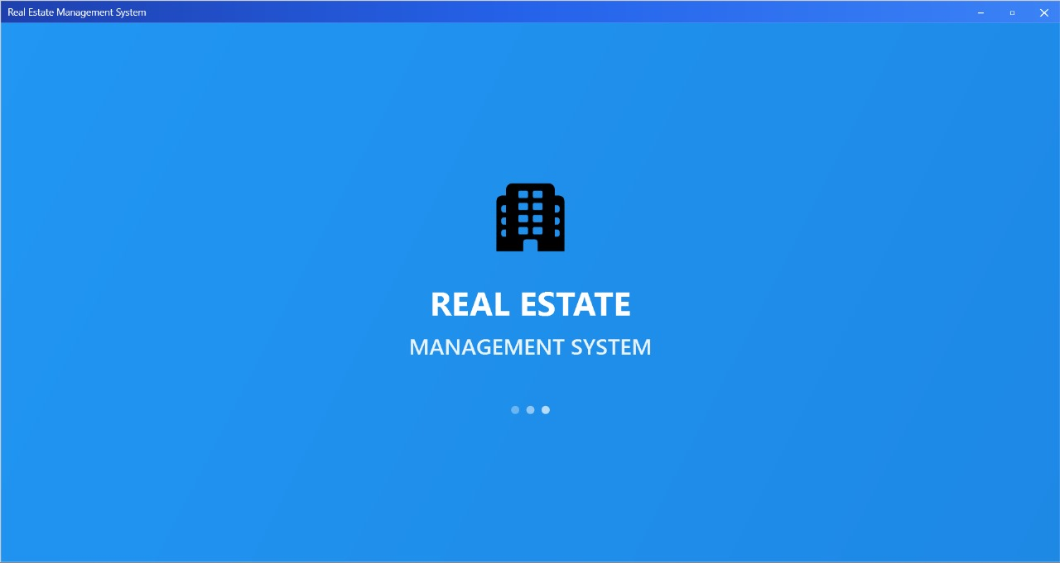

Login Page
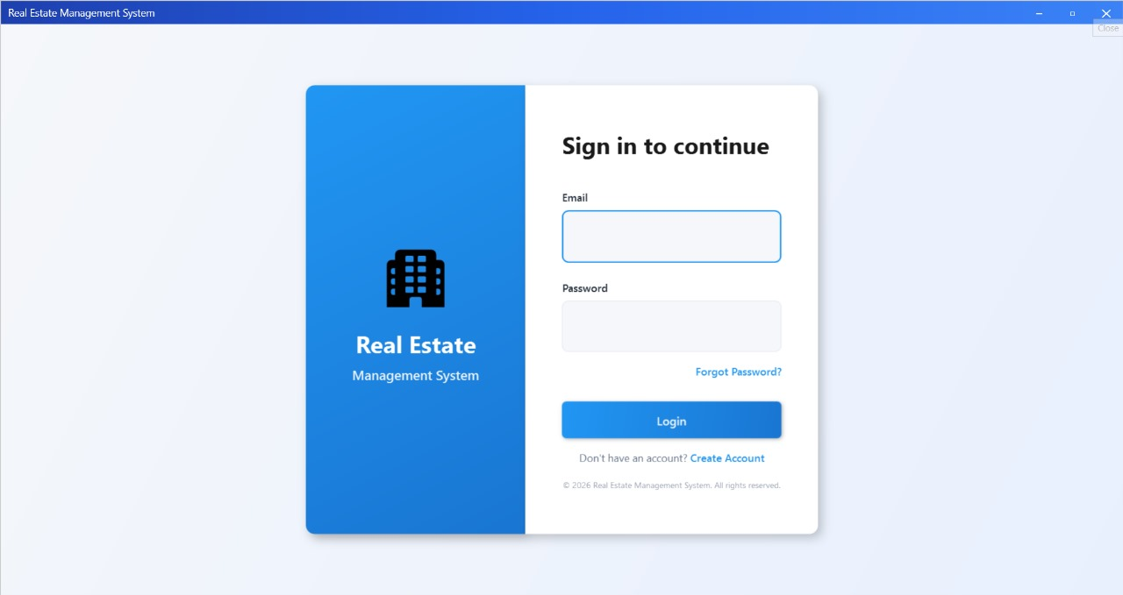

Sign Up Page
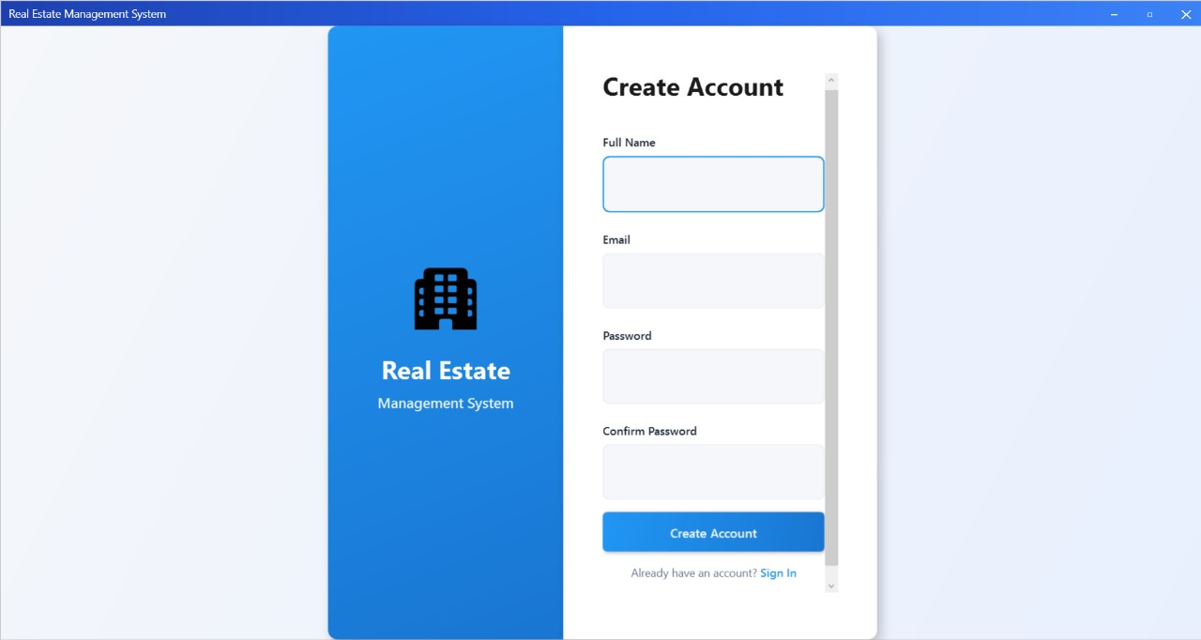

Welcome Page/Project Management Page
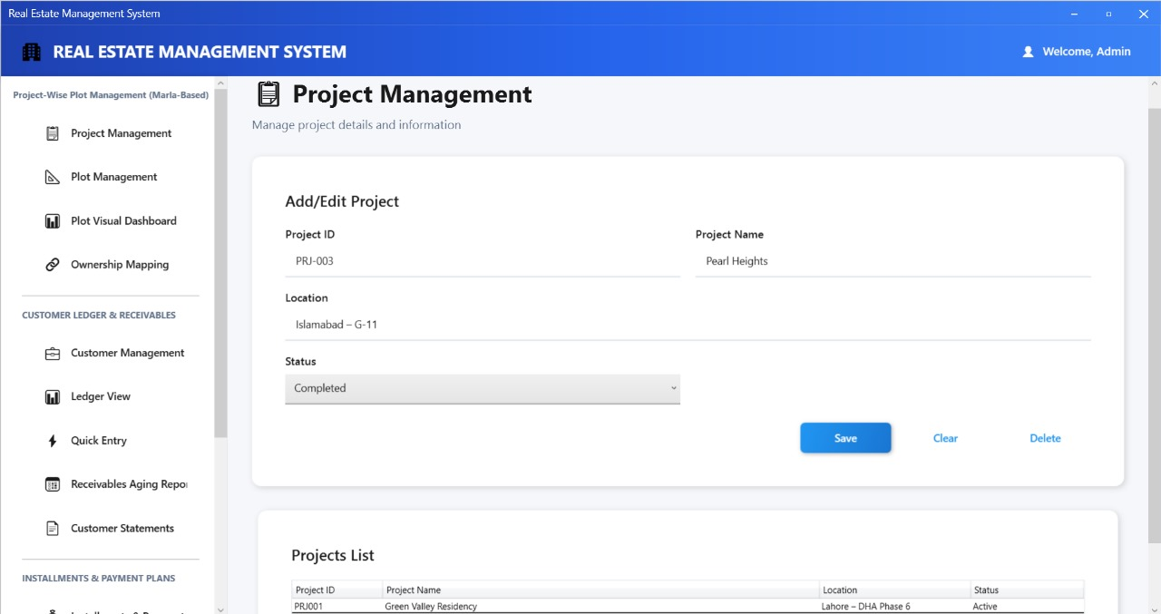

Project-Wise Plot Management (Marla-Based) Page
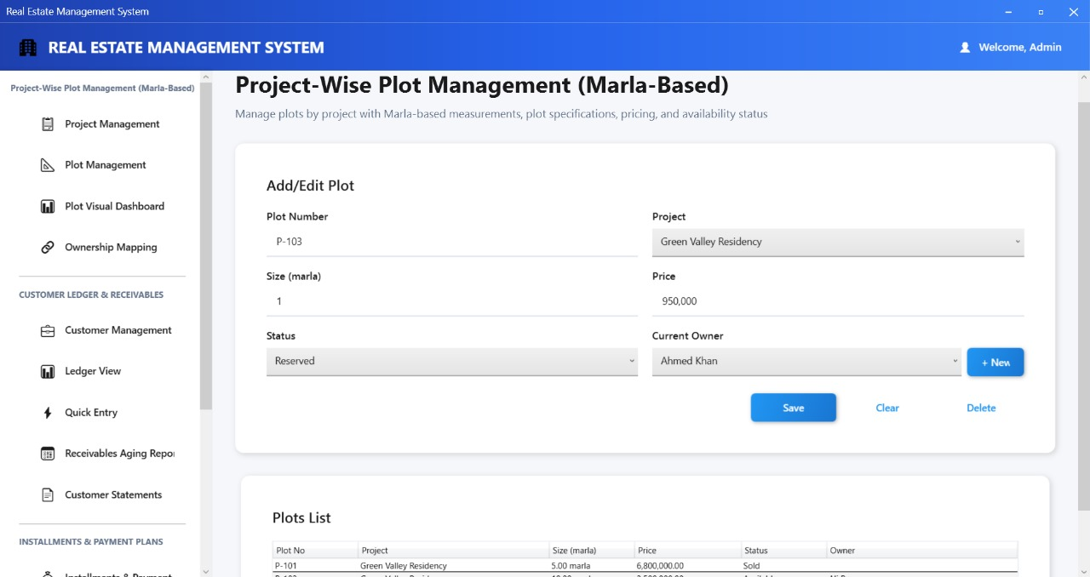

Plot Visual Dashboard Page
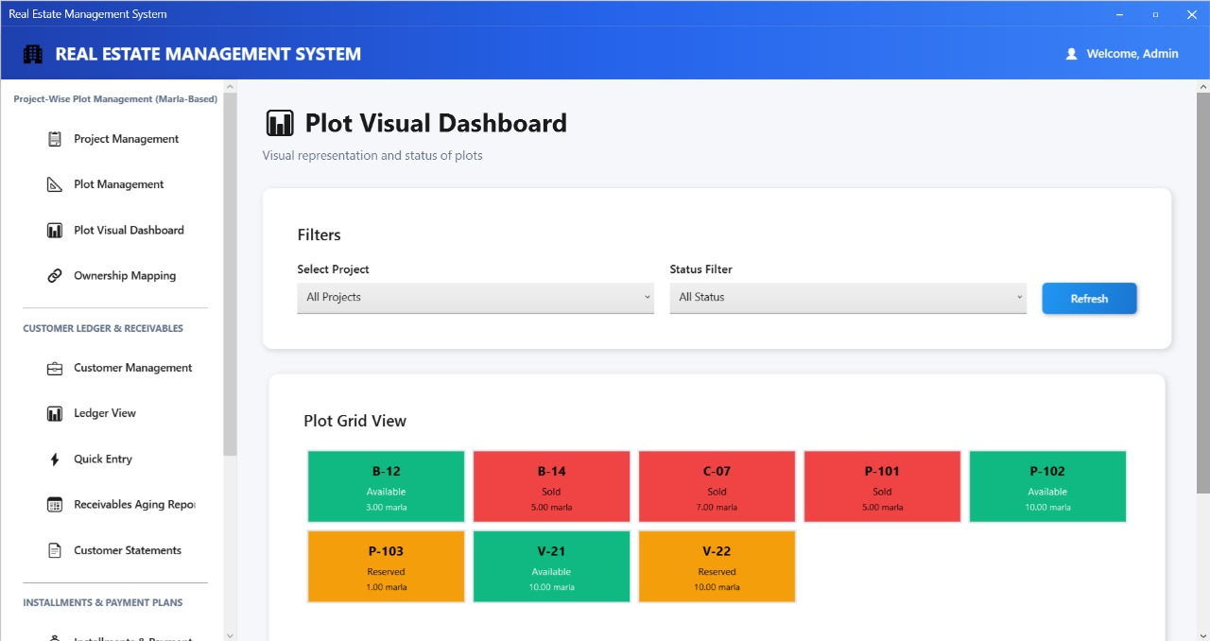

Ownership Mapping Page
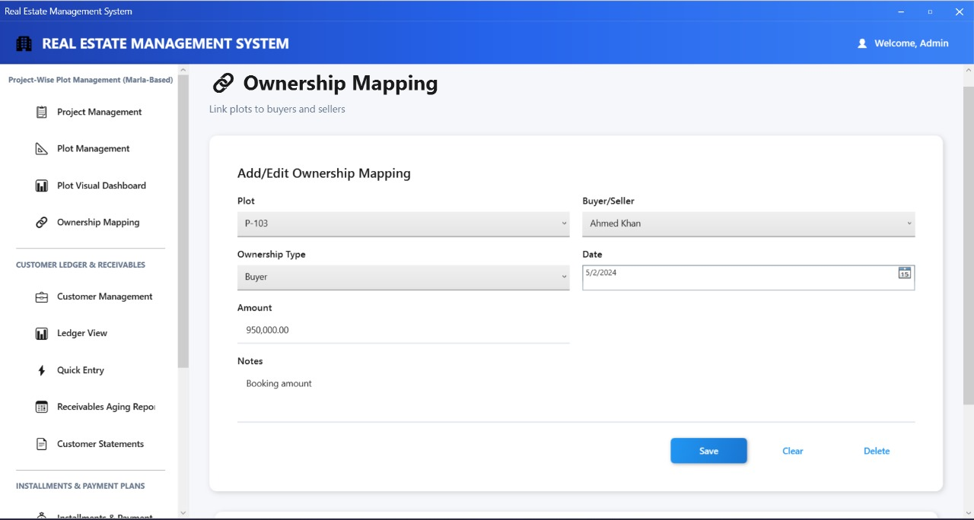

Manage Customers Page
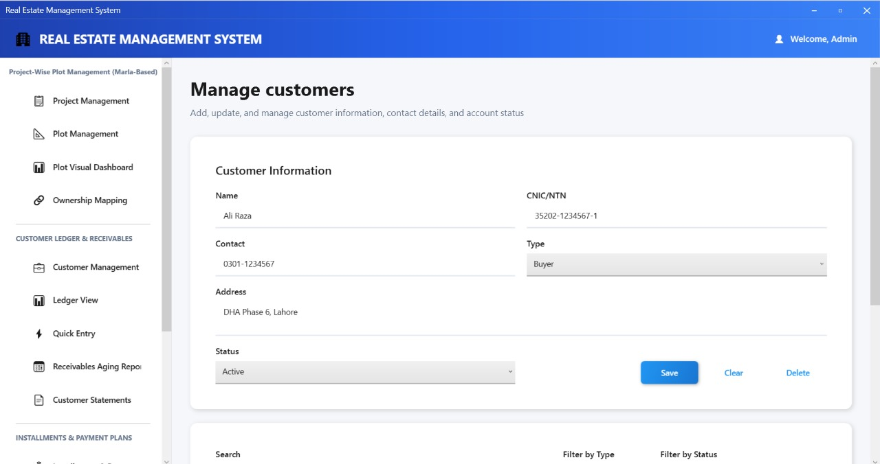

Ledger View Page
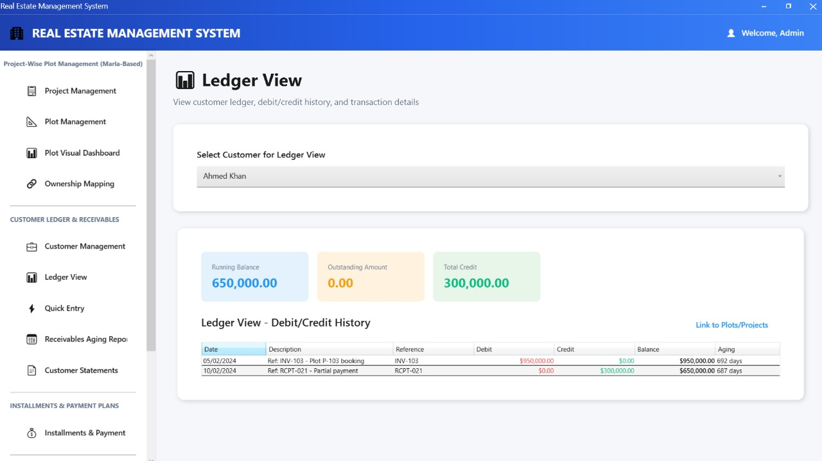

Customer’s Statement Page
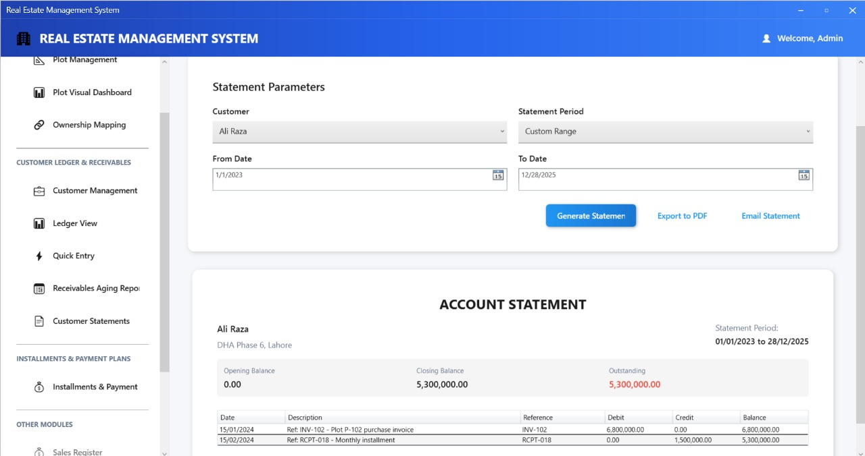

Installments & Payment Plans Page
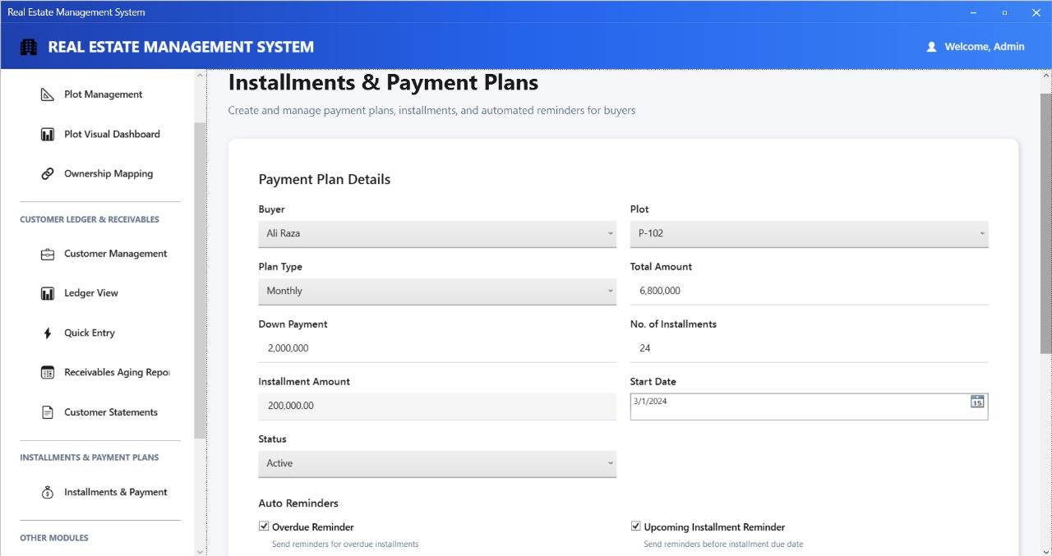

Conclusion & Future Enhancements

Conclusion
The Real Estate Management System successfully addresses the core challenges faced by real estate businesses in managing their operations. The three implemented modules (Project-Wise Plot Management, Customer Ledger & Receivables Management, and Installments & Payment Plans) provide a solid foundation for comprehensive real estate management.

Key Achievements:
- Centralized Data Management: All data is now stored in a single, normalized database, eliminating data fragmentation and ensuring consistency.
- Automated Processes: Payment plan calculations and installment generation are fully automated, reducing manual errors.
- Real-time Tracking: The system provides real-time visibility into plot status, customer information, and payment plans.
- User-Friendly Interface: The modern WPF interface is intuitive and requires minimal training.
- Comprehensive Reporting: Built-in reports provide valuable insights for management decision-making.
- Scalable Architecture: The three-tier architecture allows for easy expansion and maintenance.
- Data Integrity: Foreign key constraints and validation rules ensure data accuracy and consistency.

Technical Highlights:
- Clean separation of concerns with Data Access Layer
- Efficient database design with proper normalization
- Comprehensive error handling and validation
- Modern UI/UX design
- Security best practices implementation
The system demonstrates proficiency in:
  - WPF and XAML development
  - SQL Server database design and management
  - C# programming and object-oriented design
  - Software engineering principles and best practices

Limitations:
- Limited Modules: Only 3 out of 11 planned modules are implemented
- No Email/SMS Integration: Reminders are configured but not sent
- Basic Reporting: Reports are functional but could be more visually appealing
- No Multi-user Support: Single-user application (no concurrent user management)
- No Audit Trail: Change history tracking is limited
- No Backup/Restore: Manual database backup required
- Limited Export Formats: Only PDF and Excel exports available

Future Enhancements
- Short-term Enhancements (Next Phase)
  - Module 4.4: Bank Accounts & CSV Upload
- Multiple bank account management
- CSV/Excel import for bank statements
- Auto-matching of transactions
- Reconciliation features
  - Module 4.5: Commission Management
- Automatic commission calculation
- Commission release tracking
- Agent commission reports
- Commission payment vouchers
  - Module 4.6: Seller Payment Tracking
- Seller payment schedules
- Payment voucher generation
- Seller ledger management
- Pending payment reports
  - Enhanced Reporting
- Visual charts and graphs
- Dashboard with key metrics
- Custom report builder
- Scheduled report generation
  - Email/SMS Integration
- Automated reminder emails
- Payment receipt emails
- Statement distribution
- SMS notifications for overdue payments
- Medium-term Enhancements
  - Module 4.7: Partner & Investment Management
- Partner profile management
- Capital injection tracking
- Profit distribution automation
- Partner-wise reports
  - Module 4.8: Payroll Module
- Employee management
- Salary calculation
- Allowances and deductions
- Payroll reports
  - Module 4.9: Operational Reports
- Sales register
- Receivables aging (enhanced)
- Plot status summary
- Commission summary
- Monthly progress report (MPR)
  - Module 4.10: Financial Reports
- Profit & Loss statement
- Balance sheet
- Cash flow statement
- Project-wise financial reports
  - Advanced Features
- Tax calculation and reporting
- Document management
- Photo gallery for plots
- Map integration for project locations

Final Remarks
The Real Estate Management System project demonstrates a comprehensive understanding of software development principles, database design, and user interface design. The implemented modules provide a solid foundation that can be extended to create a complete enterprise-level real estate management solution.
The project successfully combines:
- Modern desktop application development (WPF)
- Robust database design (SQL Server)
- Clean code architecture
- User-centric design
- Practical business solutions
This system has the potential to significantly improve operational efficiency for real estate businesses and can serve as a foundation for a commercial product with the planned enhancements.

