|  |
| --- |
| *Capgemini* |
| Knowledge Repository  V1.0    ***Prepared by:***  **Capgemini Technology Services India Ltd.**  **Prestige Shantinikethan Rd (PSN Road),**  **Thigalarapalya, Krishnarajapura, Bengaluru, Karnataka 560067**.  [www.capgemini.com](http://www.capgemini.com)  Feb 25, 2018 | |
| Team Contact Information Tabulated below are the contact details for the testing team:  QA team   |  |  |  |  |  | | --- | --- | --- | --- | --- | | **#** | **Name** | **Role** | **Phone** | **eMail ID** | | **1** |  |  |  |  | | **2** |  |  |  |  | | **3** |  |  |  |  | | **4** |  |  |  |  | | **5** |  |  |  |  |   Dev Team   |  |  |  |  |  | | --- | --- | --- | --- | --- | | **#** | **Name** | **Role** | **Phone** | **eMail ID** | | **1** |  |  |  |  | | **2** |  |  |  |  | | **3** |  |  |  |  | | **4** |  |  |  |  | | **5** |  |  |  |  |   POC for Project level   |  |  |  |  |  |  | | --- | --- | --- | --- | --- | --- | | **#** | **SPOC** | **Name** | **Role** | **Phone** | **eMail ID** | | **1** |  |  |  |  |  | | **2** |  |  |  |  |  | | **3** |  |  |  |  |  | | **4** |  |  |  |  |  | | **5** |  |  |  |  |  | | |

# COX Pinpoint Knowledge Repository Key points

* **PinPoint :** Pinpoint is an APM (Application Performance Management) tool for large scale distributed systems written in Java. Pinpoint provides a solution to analyze overall structure of the system and how the components within them are interconnected by tracing transactions across distributed systems.

**PinPoint dsm integrations:-**

PinPoint DSM currently integrates with the following other applications:

* 1. EDW – (ICOMS and EBI) – Customer profile, subscriptions, usage, evaluations
  2. ICE – To present offers to NEW customers
  3. Cox.com – To present offers to Existing customers who log in to the Cox.com website
  4. CxConnect – To provide available and applicable equipments for installation (Work in progress)
* **Pega** : Pega is a Business Process Management tool. It is developed on Java and uses OOP and java concepts. And the big advantage is we don't have to have to build the system from the scratch like any conventional programming. It is becoming popular because of that, though most conventional programmers would disagree. And also because of it is agile way, Flexibility,and being extensible. We design the Business Process Flow (E.g. Order management System, Call Center Management, Finance, Healthcare anything which has a Business flow) and decide. **OR** PEGA is a platform which provided a systematic approach to build and deploy process-oriented and rule based solution and applications. Business process Management, Customer Relationship management , Decision Management and case management solutions are some of the examples . Where process and rules are integral part of application development. Just like Integrated Development environment [IDE)
* **DSM: [**DSM [ Decision strategy Management ] – Pega framework ] - use for offer management and analysis .

[Pre-built industry frameworks ensure decisions are responsive to specific business challenges such as marketing, customer service, cross-selling, up-selling and retention. Make Better Business Decisions in Every Channel. Unified channel capabilities deliver the Next-Best-Action.It is the core decision management component, DSM allows business users to design customer interaction strategies and propositions based on decisions and rules that reflect customer behaviour, preferences, legislation, corporate policies and desired business outcomes.

**Current DSM implementation Approach for Offer Recommendation:**

* **GetPropositions** requires is received, based on the Customer or House details. The Customer data is used in the forecast for the Model (perfect) and Model returns pyPropensity which is used in the calculations for Prioritization
* Final Prioritization calculation🡪The weights are defined in Site Control propositions (Decision Data rule) which are fetched based on the Site ID, Channel and Offer Type in the request.
* The final list and sequence of offers -- > Based on the values selected for each TreatmentStrategy and the appropriate Business Rules (Eligibility/Relevancy When rules).
* Offers prioritized are held in decisioning server “cache” for 2 hours
* **SetDispostions** service is used to update the user response on the presented offers

**PinPoint DSM( Decision strategy Management ) :**

1. Provides the offers to the customer - with the list of offers customers are eligible for.
2. PinPoint DSM also provides the details of the customers, their interaction history.
3. Its serves other applications through various REST Web Services.
4. Types of offers currently available are – eCommerce, Marketing, AddOn, Equipment, and Installation.
5. Create new offers or edit existing offers

* **Adaptive Model** : An adaptive model is a way to display data that can evolve with changing contexts provided during the modeling process. These models are used to predict outcomes in real-world situations where factors determining production and consumption change, affecting the marketability of products and services. They are created and used by data analysts in a number of business environments for this purpose.
* **Inbound/Outbound :** An inbound call center deals with a majority of incoming calls. Here customers calls the agents or Customer Service Representatives.

Outbound calls are nothing but Customer Service Representative(Agents) making calls to customers.

* **Pinpoint DSM provides 7 REST Web Services**

**1 . GetPropositions** – This service provides the list of offers to the customers

2. **SetDisposition** – This services provides the facility to submit customer responses back to the Pinpoint DSM system which helps in maintaining Interaction History

3. **GetSubscriber360** – This service provides with the details of the customer and some alerts and indicators which can be used to identify the kind of customer he/she is .

4. **GetInteractions** – This services provides with the list of past interactions that customer had with the Pinpoint DSM system

**5.GetAssessment** – This service provides with the list of questions and the applicable answers that would help the agent evaluate the customer.

**6.GetIntents** – This service provides with the list of Intents that the PinPoint DSM application currently recognizes.

**7. ProcessExternalRequest** – This service helps the PinPoint DSM application synchronize the offers with the OMC .

* **Customer call to customer service representative[CSR] through ICE application**

*Customer call to customer service representative[CSR] through ICE application –*

* *CSR Collect the information[ Like: Purpose to call( Regarding Existing offer, new offer, revoke offer, update with existing offer ] –*
* *CSR records the intent and sub Intent, Channel and provide the Customer ID or House number to DSM(Pinpoint) app.*
* *CSR provides above input to Pinpoint and runs* ***GetPropostion*** *service*
* *Pinpoint proposes offers based on the input (First offers are filtered based on ER rules🡪Filtered based on RR rules🡪Remaining filtered offers are prioritized based on score card)*
* Through SetDisposition service [ provides the facility to submit customer responses(what are the offers accepted or rejected) back to the PinPoint DSM system which helps in maintaining Interaction History ]
* *DSM(Pinpoint)* **integrated to** EDW[Customer profile] ,ICE [present offers to NEW customers],Cox.com[present offers to Existing customers] and CxConnect[provide available and applicable equipment for installation]
* *Offered features : By PinPoint DSM application:* 
  + Propose offers based on the behavior of similar customers profiles.
  + Storing the interaction history for identified the behavior of the customer.
  + Providing customer details from different systems and Update the offer details from external systems
  + Apply Eligibility and Relevancy rules [ ER for Customer and RR for Offer] to each offer.

Key Point

|  |  |
| --- | --- |
| **Key Point** | **Descriptions** |
| EDW | Customer profile DB |
| Customer Spine | we store all the cust details. Historical data. |
| NCSI | DB existing cust details. Contains most recent data. |
| AEM | Adobe Experience Manager – Content management and presentation system for cox.com |
| API | Application Programming Interface – Cn interface exposed by application |
| BAU | Business As Usual – Indicating that no change from current is required |
| CCM | Cox.com Middleware – Middleware for Cox.com |
| CSWS | Channel Sales Web Services - Middleware for eCommerce/Channel Sales |
| EDW | Enterprise Data Warehouse - System for data storage, analysis and reporting |
| ESC | Enterprise Service Classification – Cox methodology for classifying systems |
| ETL | Extract, Transform, Load – Process used to extract the data, transform the data, and load to another system |
| ODS | Operational Data Store – Data store primarily used for reporting |
| ICOMS , ECOM, OMC | all are product catlog repository which would be loaded into Pinpoint in the form of propositions/offfers. |
| RTC | Real Time Controls |
| ADM | Adaptive Design Manager |
| API Call | All the REST web service calls are API calls. |
| ICOMS , ECOM, OMC | Repository for different product catelogs with which pinpoint connects |
| Pega DB | Pinpoint system has a Pega DB to store the customer data. |
| External applications from Pega - Cox.com/ICE/iNave/Solution Center | nq |
| Customer Spine Data Flow ? | It’s a DB logs all the data for future interactions. |
| Deference between Prioritization Strategies , ADM Models and Container Strategies, | These are different strategies used in Pinpoint system. |
| What is 1P_Strategy | One of the strategy with set of rules. Need to know the rules. |
| Messages and Images | This set valid images and messages to corresponding offers |
| What is RTC’s | Pinpoint has images and urls to configure. |

### KT on 26/02/2018:

Pinpoint has total 12 services and the services are utilized with other downstream & upstream systems

**Downstream systems:**

ICE – thru call

INAV – thru call

Cox.com – Web (in cloud)

CxConnect – for Technicians

**Upstream systems:**

OMC – Offer Management Console

ICOMS – DB, having phstage and pstage schema (everything that has related to customer order)

EDW – Data related to every application in cox.

**Data Flow:**

ICOMS data flows into EDW which in turns flows into table Customer spine.

Customer Spine – is a table which has all the data of customer. (it has view)

Customer_house_view – subset of customer view.

Both above has one table.

On Daily basis – ETL job runs and EDW sends upto previous day’s data stores into Customer Spine.

To get the latest details – Pinpoint directly hits phstage(ICOMS) to get the details.

OMC – contains offers and gets data from QuickBase.

**Offer Types:**

Base – eCommerce, Marketing

Add-on – Installation/Add-on/Equipment

Each offer has around 100 properties and most of them comes from Quickbase and omc.

Only few are getting updated in Pinpoint.

The offer changes are updated to pinpoint forth night basis.

**How the offers created:**

All the offers showing to the customer are not created in pinpoint. We have other systems for creating offers.

Quick base – where offers are created, whereas quickbase sends these offers to OMC and in turn omc sends to Pinpoint.

There is an application being developed to fix the discrepancies occurring in creating and updating offers which is PLM (Product lifecycle Management).

**Existing Services: Total 9**

GetIntents

GetSubscription360

GetAssessments

Getinteractions

SetDispositions

Getpropositions

VerifyEquipments

GetCPERecommandations

**New Services: Total 3**

GetRules

ProcessExternalRequest

Get NextBestAction

**Get Intents:**

GetIntents  ( why customer is reaching out to us ) and every intent will have an  subIntent ( example retention)

There are 9 Agents. All agents will have their agent ids and based on the Agent id  GetIntents will respond back  to what Intent and subIntent  a agent can attend the call  for if not appropriate agent will attend.

Everything is inbound in pinpoint. Customer reach to us. not cox.

**Getsubscriber360:**

Called KYC/alerts. This service display alerts to help agents – to understand the customer behavior or about his usage. In the ICE dashboard, agent will see the information of customer information based on his behavior and usage with cox.

Agents to handle the customer based on the information from the service response. **Response from GetSub360 goes to GetPropositions.**

This service is also known as KYC (Know your customer) or alerts .In Ice dashboard agent will view different sections like

Customer information section – customer related data will be displayed (like Name, age ...)

Alert section – Displays all the alerts that the customer has (example: if the customer reaching closer to his internet data limit then alert will be displayed as “High data Usage customer”) and these alerts are notifications to the agent and will guide the agent to as how to interact with customer.

Offer details section – will display all the offers that agent will be presenting to customer

**Cart Sesction -**

**GetAssessments:**

to get the customer details and the offer already subscribed.

assessments response comes to inter

Getassessment will basically helping the agents as what kind of questions to be asked to the customer and what kind of answers we are expecting . Based on the responses of the customer we customize the offers. This will make the system understand the behavior of customer.

**GetInteractions:**

what is the interactions Customer already had to know customer behavior.

History of interaction with customer in terms of offers.

Response of customer for the offers proposed.

GetInteractions will give you what kind of past interactions that the agent had with the customer and this will also lets know the agent what kind of offers we offered to him based on the previous interactions.

**GetPropositions:**

Base (ecommerce/marketing) will have a product (psu) and product will have a tier value.

base offers does not show in cart. but add-on offer has something in the cart.

**Types:**

base/addon/equipment/installation

Every GetPropositions request is a base request and will not have anything in the cart and addon offer will have something in the cart.

**Set Dispositions:**

Pinpoint - To understand customer behavior.

To identify - Recommendation of offers.

**VerifyEquipments:**

Verify if the customer already has the Equipment. If not, request for purchase new.

Tiers – level of service.

**GetCPErecommandations:**

Technicians uses CxConnect to get the exact equipment details. CxConnect hits getcperecommendations and in turn it gives information from the inventory by looking at orders.

**ProcessExternalRequest:**

OMC and Quickbase send data to Pinpoint. To snyc with pinpoint, once ETL job done, this service executes and pinpoints refreshes to sync the offer catalog for pinpoint.

No response to this service.

**Note:**

Whenever customer care agent takes a call, calls for services Get Intents and GetSubscription360 happens automatically. Agent does not manually hit anything to access this webservices.

### KT on 27/02/2018 Session 1:

Pinpoint is an APM (Application Performance Management) application which using Pega - Business Process Management tool as DSM- (Decision strategy Management) -Framework.

Pega[ Decision management portal]

DSM : To provide  Customize offer.

For existing Customer –

[  1. Web Flow ] or OMNI channel   AND  New / existing customer can use

2. Call centre  : New customer [ ICE/INAV ]customer  through IVR.

Existing Customer – existing customer will login to Cox.com and he will be able to view current and eligible offers related to particular products like TV , Video, Data, ..etc

Customer Request ..> From ICE à Pega DSM

CallCenter  Channel – New customer who does not any account with cox can  call to ICE Callcenter or Ice Application and Ice Agent after getting few detail of customer and will submit the request to pega , then pinpoint after decisioning will provide the offers to agent(on Ice UI) and now agent can communicate the same offers to customer. This is called call center flow.

Note : Every  request when submitted through ICE the request is formed In json format and then sent to pega application. Even the response what ever received from pega will also be in Json format.

Using SOAP UI- [ JSON request ] .

If New customer – in this case system taking his/her house no as reference . COX having 21 Region

Offer display based on the 5 filter

1 .context – [ Chenal, Region, Intent]

2. Eligibility [ matching with customer details]

3. Relevancy [Region --]250 rules

4. Container relevancy- offer between the range

         Base match [ between the range]

Prioritisation

**Offers are available for below channels:**

Web, Call Center, Retail

While adding web offer – no need to create omc id (it will not be available)

**Theme list:**

For Existing customer, it’s for bundle offers (all in a package).

**Types of customers:**

New Customer – Call center

New Customer - Web

Repackaging customer – Existing customer who calls call Centre.

**Tier Control:**

PSU count will be shown based on the product selection in tier.

If no tier selected, then PSU will be 0.0.

**Campaign Attributes:** To select the best Priority values for the offers this attributes will help.

If the configuration changes/any issues during configuration – customer will not be able to see the offers.

PSU level will be used for Prioritization calculation. Conversion is also used for the same.

**Eligiblity and Relavancy rules:**

Only Eligibility when and relevancy when will be used. Other fields are not used.

**Prism restricted:**

Only for web customer – existing customer, not for new customer.

Prism code – only for specific region/area, will be decided with prism code.

**Theme List:** for bundle offers in a package.

In Pega based on the user logins( Dev /QA/Business)  it will take you to different screens

Decision Manger portal : If you login through business user in pega then it will directly take you to decision manager portal. All the business have all rights to configure an offer.

Designer Studio : if you login as non business user in pega  then it directly take you to designer studio screen.  Here all the actual coding happens and  we can see what is logic or development done for an functionality.

QuickBase – Offers created in quick base will be sent to OMC through an ETL job and here few data tables will updated appropriately and then through another ETL job it will sent to Pinpoint application.

Quickbase->OMC-getting offer --> Pinpoint à

Supercharge: for these users only one offer will be displayed for each one of the product ( TV, Video, Data)

### KT on 27/02/2018 Session 2:

Pinpoint Data Flow:

Data acquired from EDW and pStage.

Transformations happen at Customer spine view.

Pstage - real time data

Phstage - application data from Pega

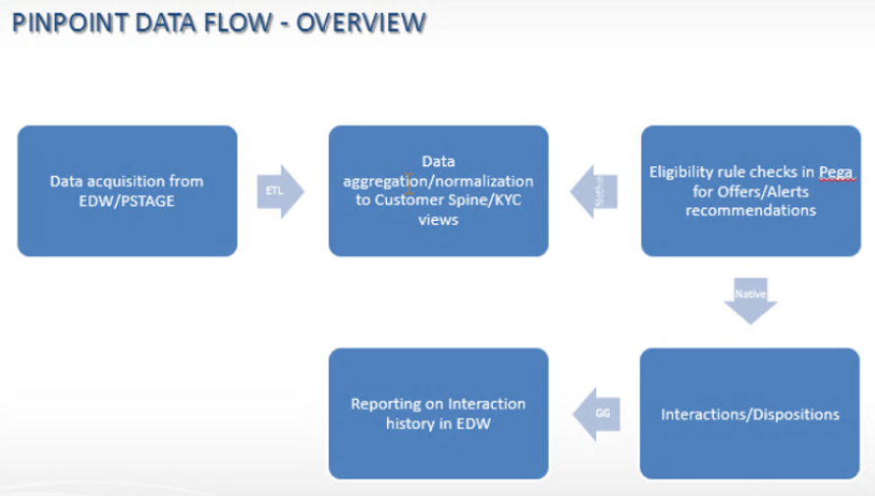

Below is the list of tables:

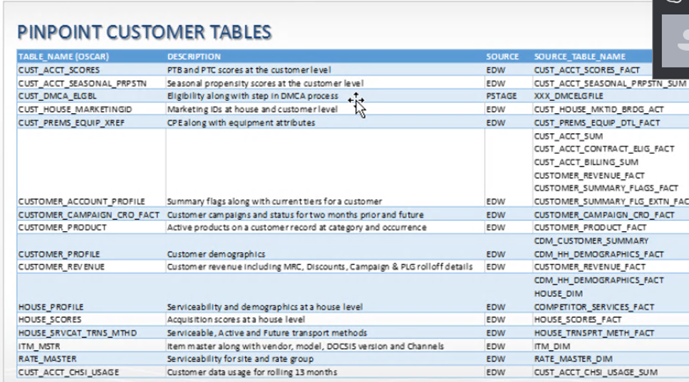

We have two Schemas: Cust DB and Pega DB in Pinpoint system.

Important Views:

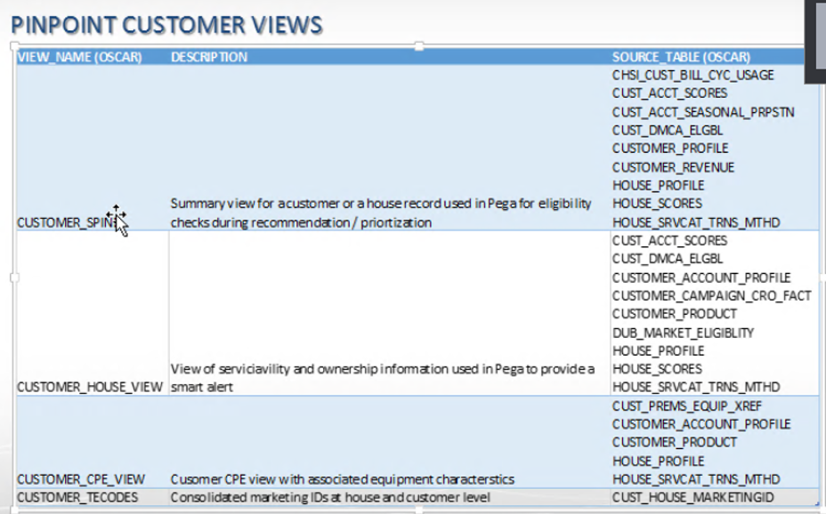

OMC – Offer management console:

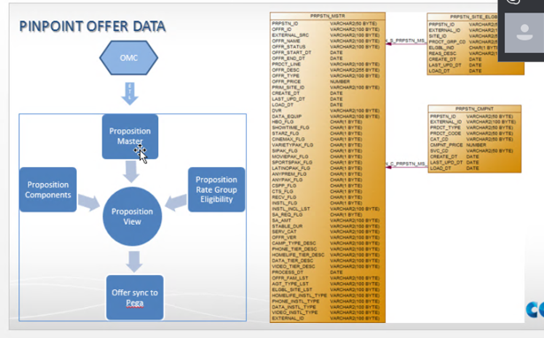

Customer talking to COX communication → call or web looks for cox communication offers or technical

Sales, retails and service.

We have to give customized propositions(pega term) to any one of the channel.

Cox.com – currently pinpoint apply offers on 3 stages. It shows offers only for existing customers. They have build 3 components. We show offers on myaccount page, Bundle packages, super chats page also we show offers.

Basically cox.com has two layers. The first layer is web layer also called as UI layer which is shown to the user (customer) and underlying which we have another layer called web API layer this web API layer talks to PinPoint using GetPropositon Service to display the current offers on MyAccount page. And inturn there is an another call which talks to channel sales application to get other details for the displayed offers like

* Price of the offers
* Terms and conditions of the offer
* Contracts or service agreements

Once the customer clicks on the offer, GetDisposition service will be called to store back these interactions (accept or reject) to Pega DB.

**ICE:** ICE is an agent facing application which will be used to service new subscriber or new customers. And all new customer request will be sent to PinPoint.

For Existing customer request goes to Cordian system instead of PinPoint. So going forward there will be only one application called ICE which will service for both new customer as well as existing customer.

To serve the channels (call center and retails) we have ICE application. For this application we are supporting only New customers. For new customer we will not be having any account ID. So we will ask for House Number.

House Serviceability information will be available in the Cox database. Based on House serviceability information, offers will be filtered.

Houses may be serviced with Coaxiable or fiber cable. Customer can opt giga blast when his house is serviced with the fiber cable.

For ex: If the house have the fiber cable then we can provide offer with giga bites internet speed.

**Alerts:** Not all alerts are meant for existing customers. There are two types of alerts. Some offers will be serviceability alerts and informative alerts.

Alerts will be displayed in alerts section For example if the customer is using high data and reaching his data limit.

Currently sending alerts to INav and ICE. Later it will be updated to COX.com.

INav is meant for displaying alerts for existing customer.

**Interactions:** We collect interaction history for existing customer but not for a new customer and not for House number (means we don’t look interactions history for new subscriber)

**TE Codes:** Means treatment eligibility codes. These TE codes will be used to display offers only for selected high paying customers.

**Base Offer:** Once the base offer is selected for ex: Data and Video -> next Add On offers should be selected

**Add On:** for ex: HBO, PackOne. These selected base and Add On offers will be sent to cart.

**Equipment:** what equipment’s are required for the customers is based on the base and addon offer selected**.** Appropriate equipment selection will be done in equipment offers page.

**Installation:** Installation of selected equipments can be done in two ways.

* Self installation - customer himself will do the installation
* Pro installation – will be done by the cox and this will be charged to the customer.

These above said installations will be decided by the PinPoint and not by the customer.

ICOMS is the brain of the infracture. It will have all offer, billing, etc information. This will create a workorder. ICOM rule will also be coded in ICE. At the end output will be the Work Order.

### KT on 27/02/2018 Session 3: (From Vamsi)

**What stakeholders with pinpoint:**

1. pinpoint - We want to give customized propositions to the offers thru channels.

2. Cox.com - build 3 components to support pinpoint offers (Basically to show offers) - only for exisitng customers

1. My Account Page - show offers

2. Bundle offers page

3. Super Charge

3. **How do they display offers:**

Get Propositions - When cox.com, when the component can

Cox.com has a Front end Web API - and in turn call other apis.

Context and container info. to get offers.

4. **Set Dispositions:**

Collecting the interactions history. Status as Presented.

Store this interactions history table.

Get Propositions and Set dispositions are one flow.

5. Customer looks offer and order now or see more. Cox.com send one more request to pinpoint.

Customer can choose one offer at a time and when customers click order now does not mean he took that.

Above is endtoend flow.

Pinpoint sends below info to Cox.com:

Offer info

Image info

Message info

Pinpoint is a decisioning applications and bouncing back with offers.

Other offer details - Price,

Get from channels

cox.com - go to my account - pinpoint offers - call get propositions - respo set dispositions with offer into.

Cox.com Integration - takes offer ids - fire one more API to different system called Channel sale to get the details of the offer liek Price of the offer, terms, contract etc.

Once pinpoint sends offer, then other details of the offers will be fetched from channel sale.

Once all this done, offers will be displayed in the page.

**ChannelSale applications** - has eligiblity rules rather than what we have in Pinpoint.

Sometimes eligiblityrules will not match between ChannelSale and pinpoint.

At the time we do debugging to analyze the differenences.

**CallCenter Channel:** called as cox commmunications.

iNav - only for exisitng customers.

Sale does thru custoemr calls or walkin to store. For this we have ICE application.

For exisitng customers, ICE redirect to Cardiot system not pinpoint. But future, Cardiont will be replaced by pinpoint.

Agent opens ICE - supporting only new customers.

Cox Communications - can service 16M houses in US. They have house no stored in DB and also the servicability of that house.

and it will be keep updating the house details which is in the cox commmunications area.

**In ICE app:**

only for new cust, For new type in address and get the custoemr details.

Get Assessments - in discovery page we have,

product interest

budget minded

data usage

All above will be sent by get propositions to pinpoint.

Relavancy rules - eligiblity of the offer itself depend on region.

T Code - Distinguish set of customers from others (eg: based on area)

Alerts: - only to ice and inav.

We uses getSub360 display in apps.

it can be house alerts or customer history. We dont collect interactions history for old customer.

And interactions history we need only for customer. not for house.

Offers for ICE divide 4 types (Base/add-on/equipment/installation)

Choose base offer - when ICE agent selects next - allows to choose add-ons, then choose equipment (ice send offer details to get equipmentdetails thru CPE matrix. )

Then - installation, self or by professional (installation type will be decided by pinpoint).

add all in Cart, submit the order. Once order is submit, ICE will create new Account id. (again set dispositions will be sent with Submit status)

ICOMS - create work order - it can conflict with icoms rules. ICOMS will update order occordingly and create a work order id.

### KT on 27/02/2018 Session 3: (From Vamsi)

**What stakeholders with pinpoint:**

1. pinpoint - We want to give customized propositions to the offers thru channels.

2. Cox.com - build 3 components to support pinpoint offers (Basically to show offers) - only for exisitng customers

1. My Account Page - show offers

2. Bundle offers page

3. Super Charge

3. **How do they display offers:**

Get Propositions - When cox.com, when the component can

Cox.com has a Front end Web API - and in turn call other apis.

Context and container info. to get offers.

4. **Set Dispositions:**

Collecting the interactions history. Status as Presented.

Store this interactions history table.

Get Propositions and Set dispositions are one flow.

5. Customer looks offer and order now or see more. Cox.com send one more request to pinpoint.

Customer can choose one offer at a time and when customers click order now does not mean he took that.

Above is endtoend flow.

Pinpoint sends below info to Cox.com:

Offer info

Image info

Message info

Pinpoint is a decisioning applications and bouncing back with offers.

Other offer details - Price,

Get from channels

cox.com - go to my account - pinpoint offers - call get propositions - respo set dispositions with offer into.

Cox.com Integration - takes offer ids - fire one more API to different system called Channel sale to get the details of the offer liek Price of the offer, terms, contract etc.

Once pinpoint sends offer, then other details of the offers will be fetched from channel sale.

Once all this done, offers will be displayed in the page.

**ChannelSale applications** - has eligiblity rules rather than what we have in Pinpoint.

Sometimes eligiblityrules will not match between ChannelSale and pinpoint.

At the time we do debugging to analyze the differenences.

**CallCenter Channel:** called as cox commmunications.

iNav - only for exisitng customers.

Sale does thru custoemr calls or walkin to store. For this we have ICE application.

For exisitng customers, ICE redirect to Cardiot system not pinpoint. But future, Cardiont will be replaced by pinpoint.

Agent opens ICE - supporting only new customers.

Cox Communications - can service 16M houses in US. They have house no stored in DB and also the servicability of that house.

and it will be keep updating the house details which is in the cox commmunications area.

**In ICE app:**

only for new cust, For new type in address and get the custoemr details.

Get Assessments - in discovery page we have,

product interest

budget minded

data usage

All above will be sent by get propositions to pinpoint.

Relavancy rules - eligiblity of the offer itself depend on region.

T Code - Distinguish set of customers from others (eg: based on area)

Alerts: - only to ice and inav.

We uses getSub360 display in apps.

it can be house alerts or customer history. We dont collect interactions history for old customer.

And interactions history we need only for customer. not for house.

Offers for ICE divide 4 types (Base/add-on/equipment/installation)

Choose base offer - when ICE agent selects next - allows to choose add-ons, then choose equipment (ice send offer details to get equipmentdetails thru CPE matrix. )

Then - installation, self or by professional (installation type will be decided by pinpoint).

add all in Cart, submit the order. Once order is submit, ICE will create new Account id. (again set dispositions will be sent with Submit status)

ICOMS - create work order - it can conflict with icoms rules. ICOMS will update order occordingly and create a work order id.

**KT on 28/02/2018 Session 1: (From Bhavana)**

* + 1. How to create /update /Import and Export

Before check out , need to refresh the page [ If check out, no one can use this ]. export - when you want to bulk change [ after and before checkout ] and all offer will be downloaded in

CSV file. And after changes import the offers updated.

[ Checkout 🡪 Actions 🡪Refresh

When u checkout - Edit changes and save. Once you checkin your changes will be saved.

Click NEw - to create update offer/proposition

Action - Edit and Duplicate

when Duplicate - only offer id fields will be blank. We cant create two orders with same

Delete - Select check any offer - click delete button.

We can delete all the offers in pinpoint which may come from omc/quickbase.

Ecomerce - CM_ XXX

Discard - to remove the changes u have done.

Application flow for create /update /Import and Export

Design -> Type - Preposition

**Note :** For New customer - No Marketing offer and Web user no Addon [ cox.com]

Marketing - only for web customers comes with MK_

Inactive offers will not be considered in decisioning. Installation - IN_

AD-XXXXXX: Add-on - once the customers get base offer, agent offer for add-on package. Only for who is calling thru call center.

Equipment - Starts with EQ.

Whenever customers goes for add-on offer, depends *******

Add-on types: not sure what is meant for.

Add on ancillary

Add on booster

Add on closure

Equipment offer:

Installation offer:

Installation - IN_

3 type - OTC [ One time charge while installing ] , Pro[ Professional will install ] and Self [ self install ]

Eligibility [338 rules] ER _C [ Customer -SPIN view - all eligibility rule execute ]

Eligibility rules:

Starts with ER ends with C

Pega data - contains report

csde - customer spine data extension

mapcustomer spine data - for data transform

to chewck property mapped to which column

run get pro

check respo - take offer - go that perticular offer in pega tool

search for that offer in eComm - see that offer has rule or nt.

Spin will get th data from two way [CUST data: all cust data info and Pega DATA : Reports login info and etc ]

three Physical table

1. Customer spin data extension, Customer Spin data and spin 2

data transfer - map customer spin data

**KT on 28/02/2018 Session 3: (From Andrew)**

Example of verifying Eligibility Rules please refer the recording.

**KT on 01/03/2018 Session 3: (From Sooraj)**

When req comes from any application, after filtering, we will have less offers.

We will decide what offer to go to differ containers

Treatments and containers

Web Treatments- in proposition section Open primary:

Edit proposition

4 sec for containers

1 - Primary

2 - Comparison of offers

3 - Featured

4 - Split promo

Treatments nothing but containers

Each offer is associated with one or more containers which we can see in the static Treatments list.

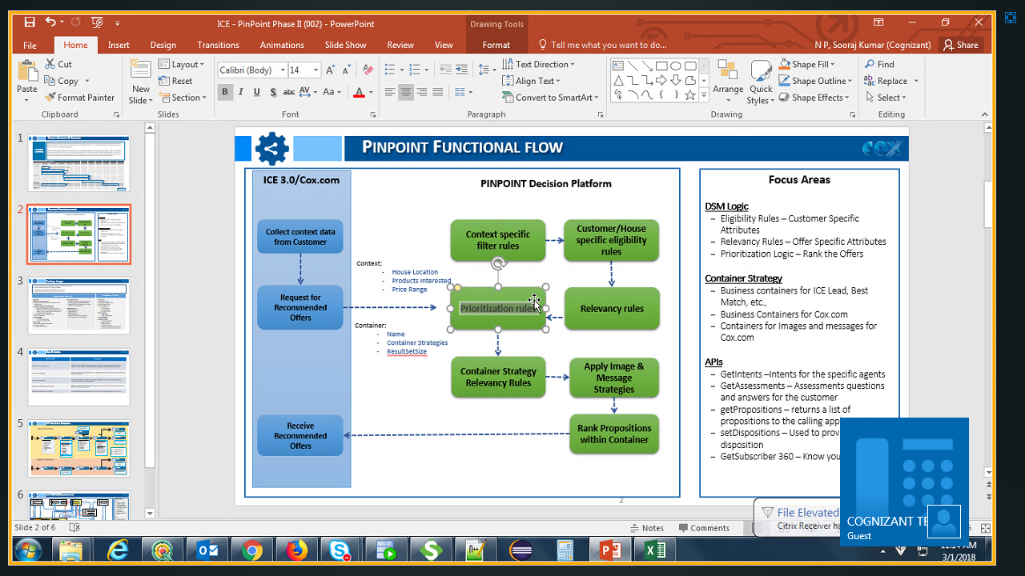

How this RR_Treatment matched rules.

We have edit the rules in propositions and test the request in soap ui.

If treatment str - null, it is applicable to all the containers

Retail/Call center:

Search Strategy- no conditions, whichever is applicable all will come

1P - 3P strategy will not come in 1P str

2P

3P

4P

Best Match - based on customer what he can afford (money) Attribute list 150 in soap get pro requ -

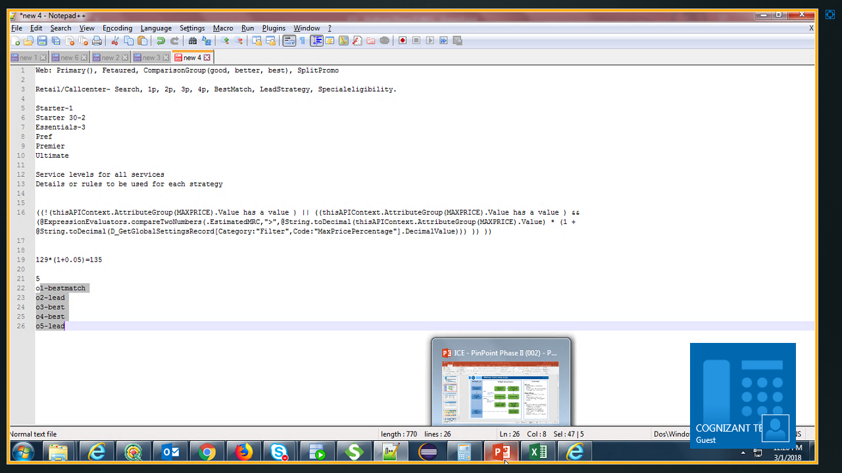>7 PSU - high service level -

<7 PSU - low service level.

max prize will be compared with mrp of the offer

how to verify we got the currect offers - do export and check.

get the rules for all the strategies -- Sooraj has to give the document

Lead Strategy:

Giving more than what customer is looking for.

PSU more

Estimate More

Special Eligibility:

There is a check box in offer for special eligibility - only those offers will come.

Rank, Global Rank.

Do prioritization and then get global rank

Note: Please refer the recording for the practical session to verify the container strategies.

**KT on 01/03/2018 Session 2: (From Andrew)**

* 4p – products: Television, phone, Internet, Video (These offers recommended to customer).

EX: ER_Housemodem

* which rule is applicable which offer – It’s based on the products ,Business users will create offers in production based on requirement.
* Campaign code include list (this offer would be recommended for that particular customer who has this code).

* RR rules on particular product:

EX: FreeHBOforVediocust

If look at the base offers with one of the Campaign code than this offer is recommended .

* Ecommerce is a offer type for an customers .Base offer has campaign code (AC1286CBS134).
* Can export all the information in CSV file and we can see this ER and RR rules for each offer.