**Screen Sketches**

VC_06

Jiwoo Kim, GeonHee Cho, Paige Ahlrichs, Viswadatta Chinta

Game Makers

Non-Functional Requirements

1. Performance
   1. Game updates in real-time
2. Reliability
   1. Game doesn’t crash or freeze while in play mode
3. Maintainability
   1. Game is easy to maintain, update, and add new features to

Tables and Fields

**Players**

|  |  |  |  |  |
| --- | --- | --- | --- | --- |
| Unique ID | Username | Password | Users Options (Audio, Video, Controls) | User Character Statistics |
| 00001 | viswa | ******** | Sound, resolution screen settings | Keep track of the character selections |
|  |  |  |  |  |
|  |  |  |  |  |
|  |  |  |  |  |
|  |  |  |  |  |
|  |  |  |  |  |

Screen Flow

Click “New Game”

Start Application

Click “Play Again”

Game Over

Click “Enter”

Back

Click “Options”

Click “New Player”

Click “Login”

End of Game

Game

Character Selection

Tutorial

Mode Selection

Options

Login Screen

Title Screen

New Player

Click “Back”

Click “Back”

Select Game Mode

Click “Back”

Click “Play”

Click “Quit”

Quit

Click “Quit”

Title Screen

1. Game Title

Paige Ahlrichs

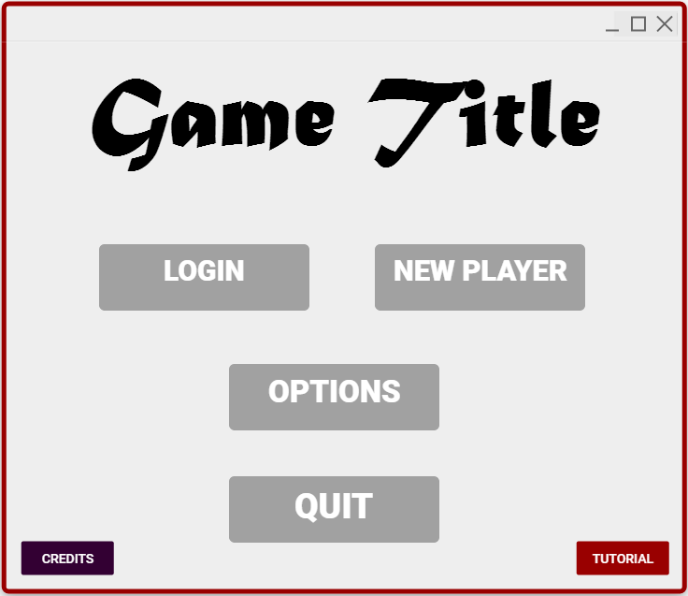alrichs

1. How to Play
2. Go to Game Settings
3. Exit the Game
4. Create a New Account
5. View Game Credits
6. Login to Existing Account

The title screen introduces the game to the user. The user gets an idea of the game genre by the images and title**(1)** on this screen. There are several intuitive options a user expects to see when they start playing a game, and this screen provides those options. Every time a user starts the game application, they are greeted by this screen.

The title screen provides to options for users to enter the game. An existing user may click the ‘LOGIN’ button**(2)** to type their username and password. A new user can click the ‘NEW PLAYER’ button**(3)** to create an account. Before logging in, users may select the ‘OPTION’ button**(4)** to adjust settings such as audio and controls. Users may exit the game from the title screen by clicking ‘QUIT’**(5)**. This prompt a trivial screen asking if the user is ready to leave the game. The ‘TUTORIAL’ button**(7)** allows user to learn the basic game controls and how to play the game before entering the game. Users may select the ‘CREDITS’ button**(6)** to read about the game developers and game development information.

Game Mode Screen

Paige Ahlrichs

ahlrichs

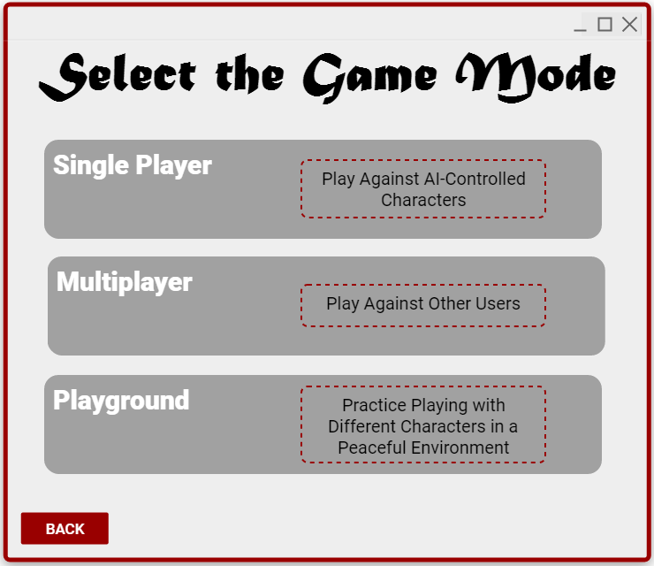

1. Return to Title Screen
2. Playground Mode
3. Multiplayer Mode
4. Single Player Mode

The game mode screen allows users to select which game mode they would like to play in. This screen is displayed after the user logs in to an existing account or creates a new account. A user can also navigate to this screen by clicking the back button on the character selection screen. In our game, the game mode is a unique configuration that allows users to experience multiple levels of difficulty when playing.

A user may choose one of three game modes to progress to the character selection screen. The single player mode**(1)** allows the user to battle against AI-controlled characters, which are programmed to be easier to defeat than other users. The multiplayer game mode**(2)** allows users to battle other users in an arena style game play. This mode is more complex than single player. Playground mode**(3)** allows users to demo characters before battling. When a user selects a game mode, they are directed to the character selection screen. Users may return to the title screen by selecting the ‘BACK’ button**(4)**.

Game Login Screen

GeonHee Cho

gunny91

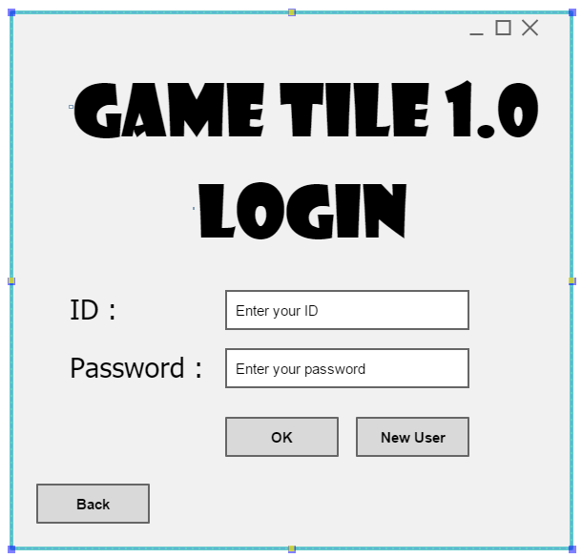

4. Selection “OK” button

5. Make a new account button

3. Return to the screen

1. User ID input

2. User password input

The game login screen allows users to access to the game to play in it. This screen helps the user not only logs in to the game but also creates a new account. Clicking the back button on the character selection screen, user can navigate to go back to the previous page.

A user may choose chose 4 of buttons to do his or her decision. The ID section, **(1)** allows the user to type in the his or her ID. The password section, **(2)** allows users to type in the password. The “back” button, **(3)** allows users to return to the previous screen. The “OK” button, **(4)** allows users to enter. The “New User” button, **(5)** allows the user to create the new account for this game.

Game Select the character

GeonHee Cho

Gunny91

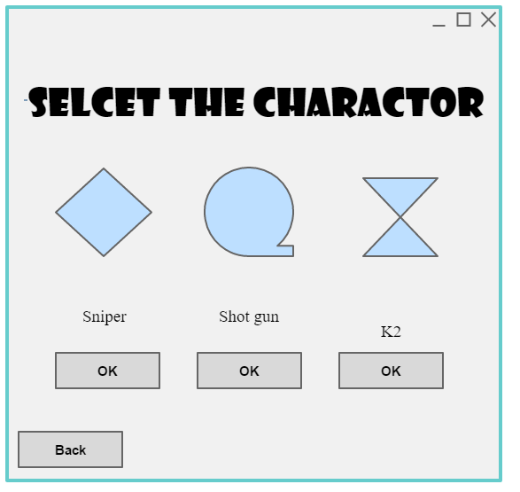

1. Return to the screen
2. Each of charactors
3. The selection button

The game character selection mode screen allows users to select which character that they would like to play with. This screen is displayed after the user logs in to an existing account or creates a new account. A user can also navigate to this screen by clicking the back button on the character selection screen. In our game, we prepared three different characters which are using different shooting ability to fight.

A user may choose one of three characters to progress to game play screen. From the **(1)**, represent the each of 3 characters. A sniper character, it has long distance attach against the enemy. The shot gun character is good for the short distance user to fight. The K2 character is a good for the average user to fight against the sniper and shotgun user. The multiplayer button **(2)** allows users to select the character. The “back” button, **(3)** allows users to return to the previous screen.

Creating New Account

Jiwoo Kim

bibimbab

**5**

**3**

**4**

**2**

**1**

Button to go back

Ok button to proceed

Password confirm

Password Input

ID input

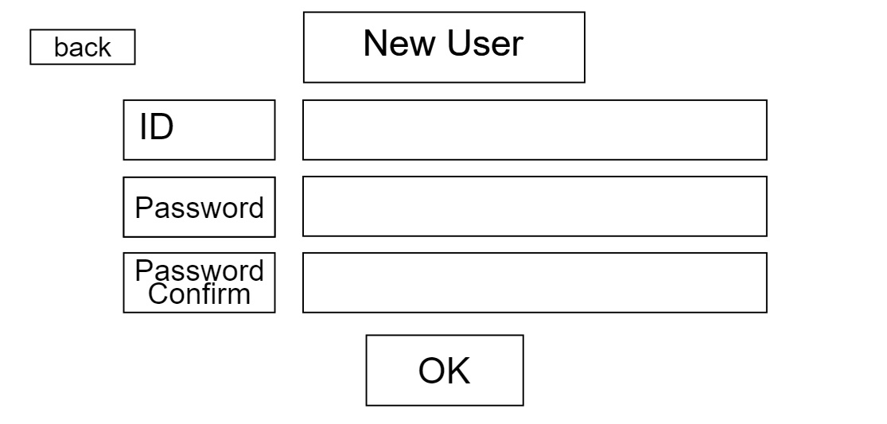

‘Creating New Account’, or ‘New User’ screen enables the new player who has no account in the database to create a new one. User is expected to provide an ID, a password, and the re-type of the password that he/she put in for the confirmation. User can press the either the ‘ok’ button to proceed to further step in the game, or ‘back’ button to go back to the title screen.

1. User can click this button to go back to the title screen.
2. User is expected to provide an input of the ID he/she wants to have in this box.
3. User is expected to provide an input of the Password he/she wants to have in this box.
4. User is expected to re-type the password that they provided in the box above.
5. Use can click this button to proceed to the further steps in the game.

Game

Jiwoo Kim

bibimbab

**3**

**2**

**1**

Bullet Indicator

Stamina Bar

Health Bar

**6**

Terrain

**5**

Enemy Health Bar

**4**

Player

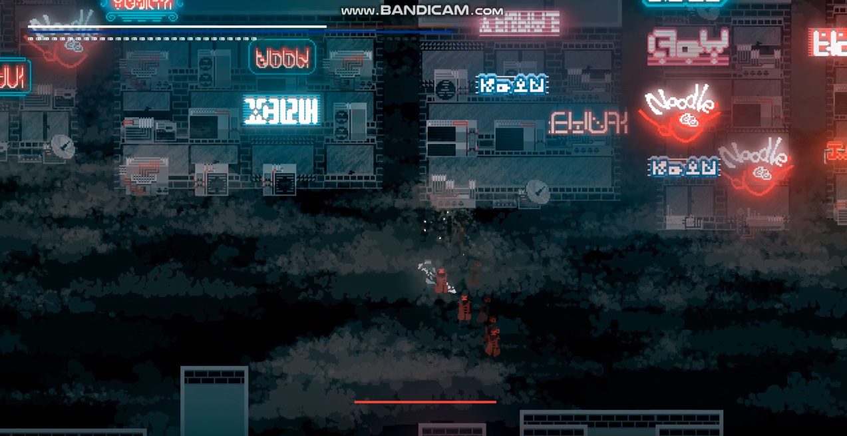

‘Game’ Screen is where actual game is running on. User is expected to engage with other players considering the information shown on the UIs, which display the Health, Stamina, Number of bullets left, Enemy health that the user is engaging with currently, players that are in sight, and the terrain graphics around the user.

1. Displays the current health of the user
2. Displays the current stamina of the user
3. Displays the bullets left of the user
4. Displays the players that are in visible sight of the user
5. Displays the current health of the enemy player that the user is currently engaging.
6. Displays the terrains around the user.

Tutorial screen

Viswadatta Chinta

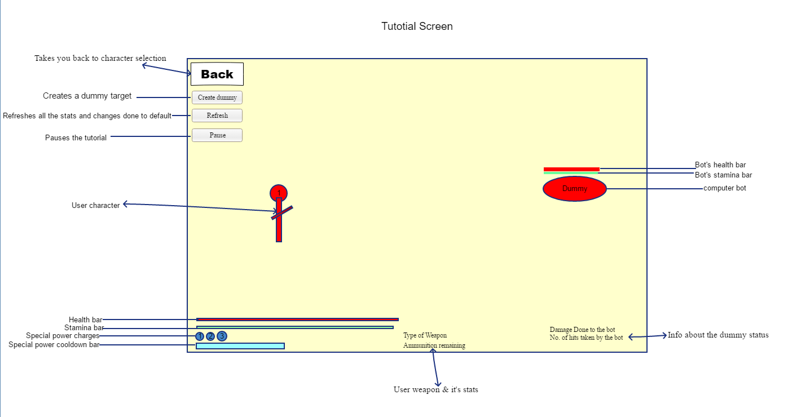

This is the tutorial screen can be accessed by new players to understand the game and is a lobby where the user can demo the characters available and explore their abilities. The BACK button on the top of the screen will take the user back to character selection screen to choose a different character to demo. The create dummy button creates a new dummy on the tutorial screen to demonstrate and know the character abilities.

The information on the dummy status will be shown and updated every time the user does some changes or uses any abilities on the dummy. The dummy is a passive bot which does not die.

The refresh button refreshes the screen status and damage done to the dummy.

The pause button will pause the tutorial.

Options Screen

Viswadatta Chinta

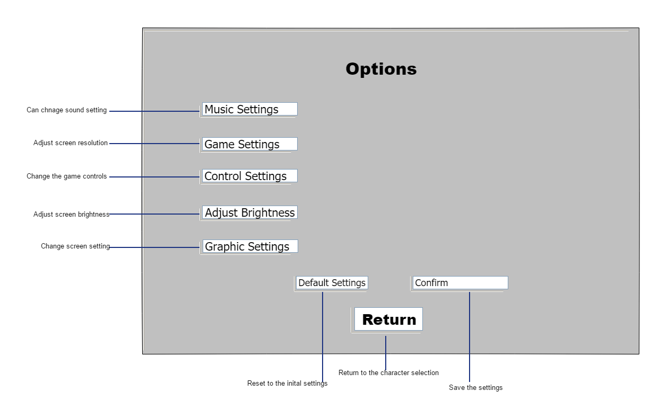

The music settings allow the user to change the volume as preferred by the user.

The game settings will give the options to change the screen resolution and full screen settings. The control settings will allow the user to change the settings and change it according to the user preference

The brightness of the screen can be adjusted by choosing the adjust brightness option.

Graphic settings will help user to change a few other extra graphics of the game.

The default setting option resets the settings to basic settings and using the confirm button saves the settings chosen unless the user changes again.

The RETURN button will help the user to go back to the title screen.