Java is the language, and the JDK helps you write Java programs.

We run our Java programs with a Java Virtual Machine (JVM) with Java runtime edition (JRE).

Oracle has moved to an LTS model for Java, LTS stands for Long Term Support.

java.sun.com to go to the latest versions of java (<https://www.oracle.com/java/technologies/> )



Windows symbol +R to open the “Run” Window and then type “cmd” to open the command prompt.

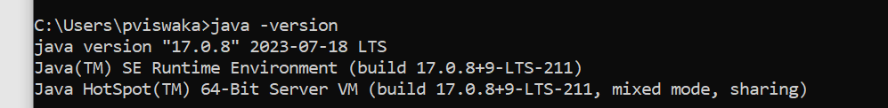

Introduction to JShell

<https://docs.oracle.com/en/java/javase/17/jshell/introduction-jshell.html>

JShell became a standard component of the Java Developers Kit in Java 9.

It is what is known as a Read-Eval-Print-Loop interactive program (or REPL for short) which means it does pretty much just that:

* it **reads** the command or code segment we type in.
* it **evaluates** and executes the code, and often allows short cuts to be used.
* it **prints** out the results of the evaluation or execution, without making the developer write code to output the results.
* Lastly, it loops right back for more input (more code segments or commands).

JShell runs in a terminal (or on the command line for Windows) and is useful for quickly trying out new ideas.

jshell on cmd will open jshell

Typing forward slash and the word '**exit**', or forward slash with the shortcut text **ex**, will end your JShell session, if you get stuck.

An example would be **/exit** or **/ex**.

/list -all

/help intro

/help

/vars

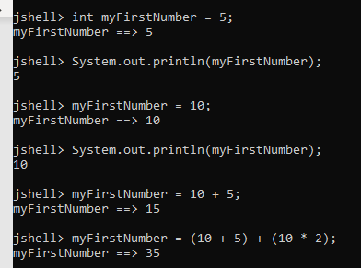

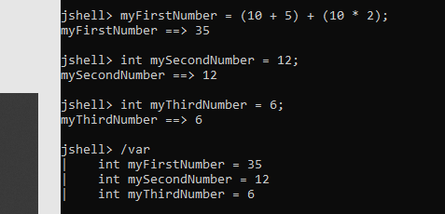

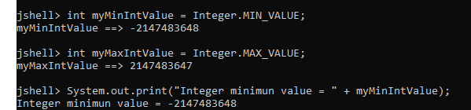



what is a class?

A class is a building block for object-oriented programming, and allows us to build custom data types.

Wrapper Classes

Java uses the concept of a wrapper class, for all of its eight primitive data types.

A wrapper class provides simple operations, as well as some basic information about the primitive data type, which cannot be stored on the primitive itself.

We saw that MIN_VALUE, and MAX_VALUE, are elements of this basic information, for the int data type.

What does an underscore mean in a numeric literal?

In Java, you cannot put commas in a numeric literal.

For example, the following is not valid syntax.



So Java provided an alternative way to improve readability, the underscore.



You can put the underscore anywhere you might want a comma, but you can't use an underscore at the start or end of the numeric literal.

A numeric literal that exceeds Integer.MAX_VALUE must use the 'L' suffix.

We cannot create a numeric literal in Java, that exceeds Integer.MAX_VALUE, without using the 'L' suffix, we'll always get the error 'integer number too large'.

Floating Point Number Precision Tips :

In general, float and double are great for general floating point operations.

But neither should be used when precise calculations are required – this is due to a limitation with how floating point numbers are stored, and not a Java problem as such.

Java has a class called BigDecimal that overcomes this.

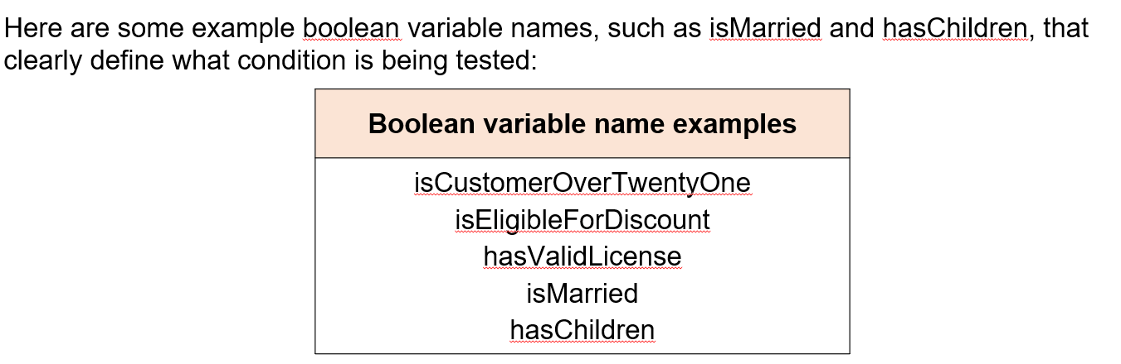

String using Unicode character along with others



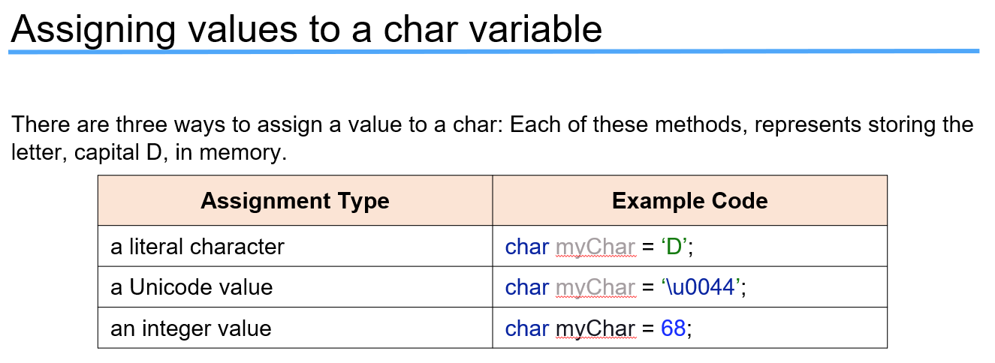

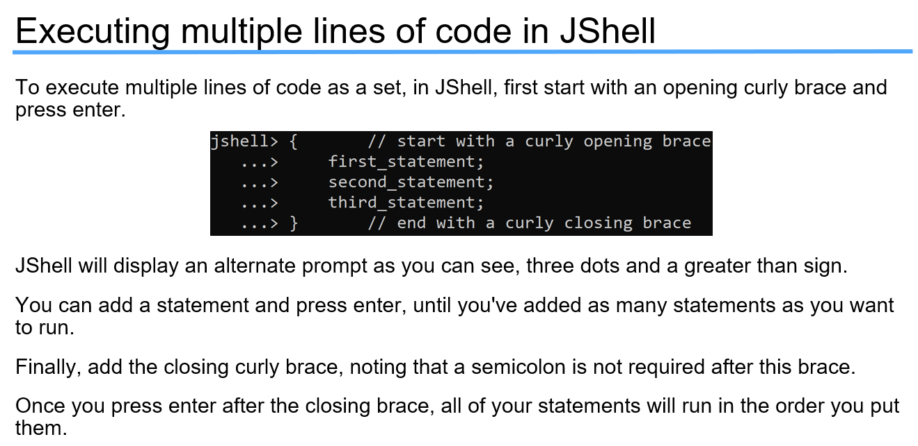

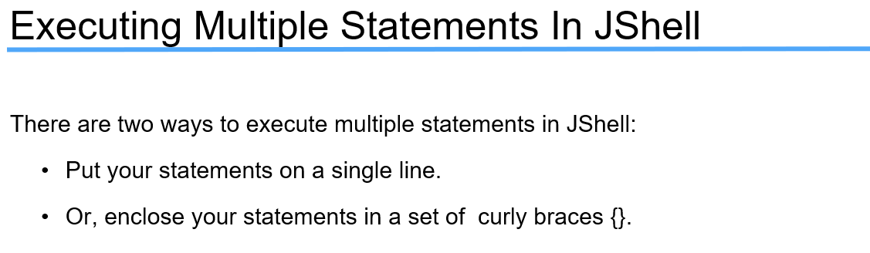

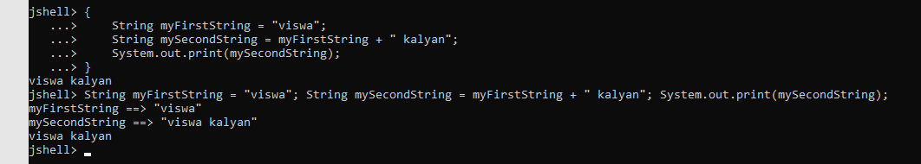

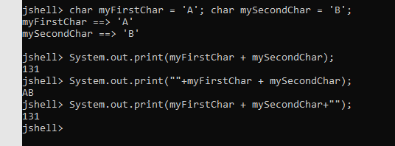

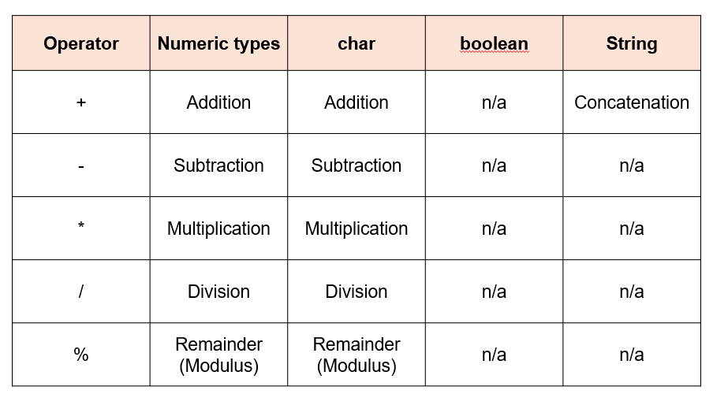

Because the char is stored as a whole number literal, all the operations are applicable to a char.

Sum++;

Sum += 7 ;

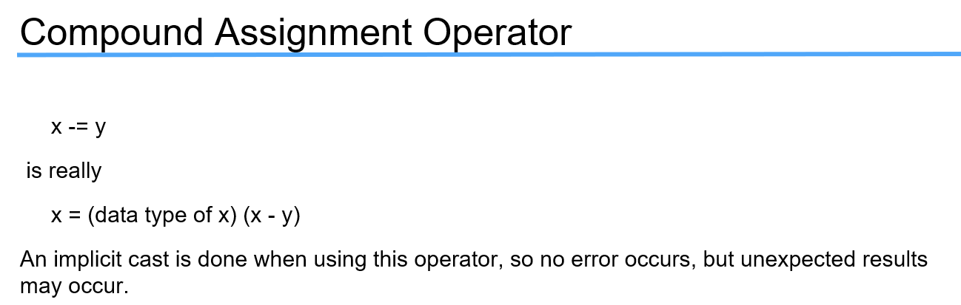

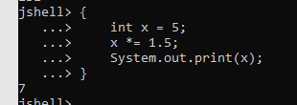

To download IntelliJ IDEA

<https://www.jetbrains.com/idea/>

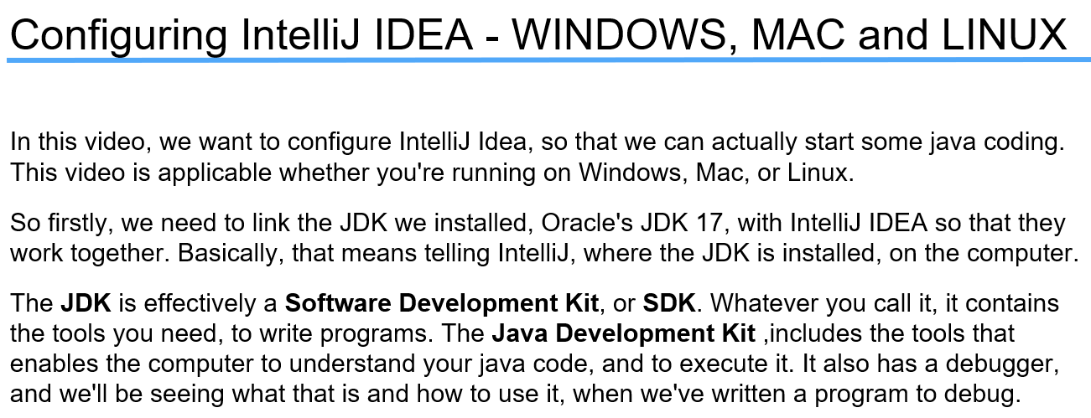

Note:

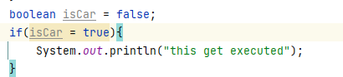

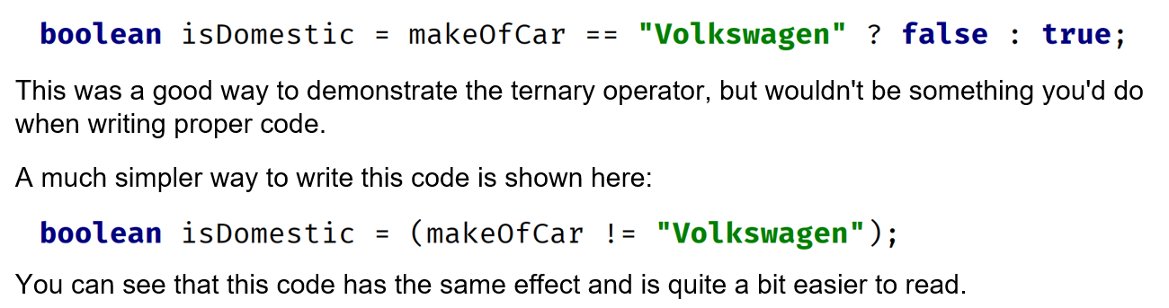

# Summary of Operators

<https://docs.oracle.com/javase/tutorial/java/nutsandbolts/opsummary.html>

## Java Operator Precedence Table

<https://www.cs.bilkent.edu.tr/~guvenir/courses/CS101/op_precedence.html>

## Keywords

<https://docs.oracle.com/javase/specs/jls/se17/html/jls-3.html>

# The Java® Language Specification

<https://docs.oracle.com/javase/specs/jls/se17/html/index.html>

reserved keywords are highlighted in blue in IntelliJ

whitespaces:

<https://google.github.io/styleguide/javaguide.html#s4.6-whitespace>

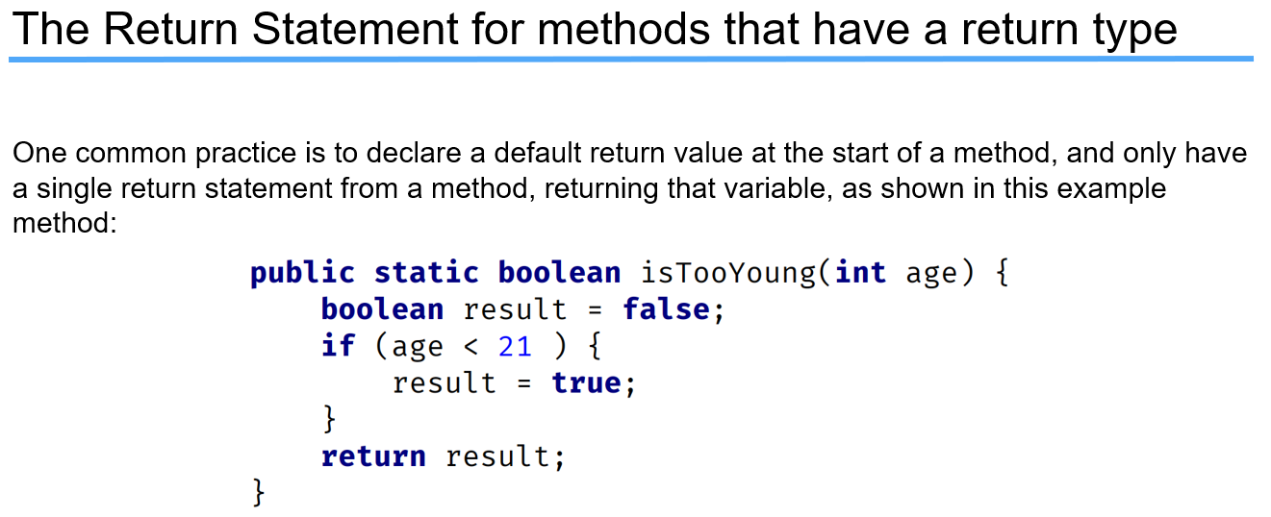

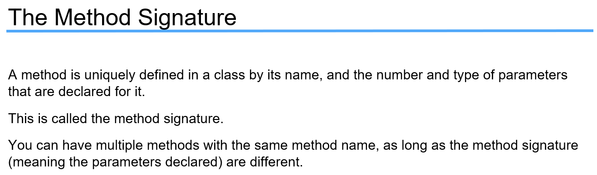

Method Signature:

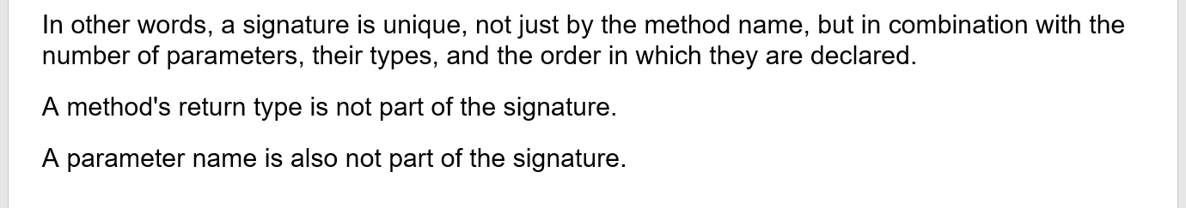

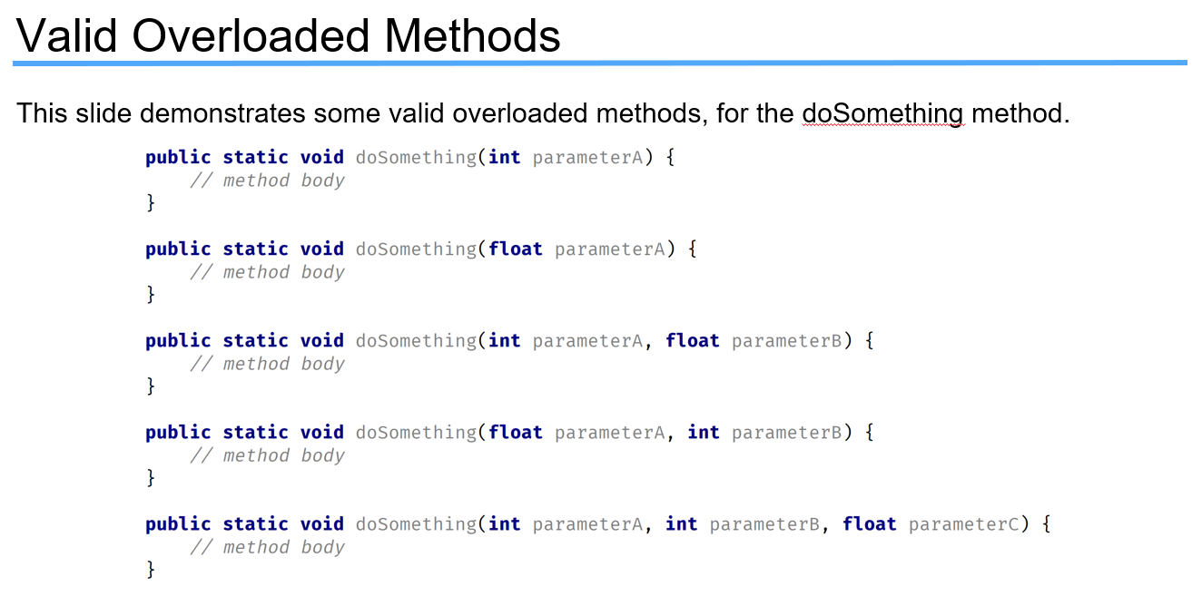

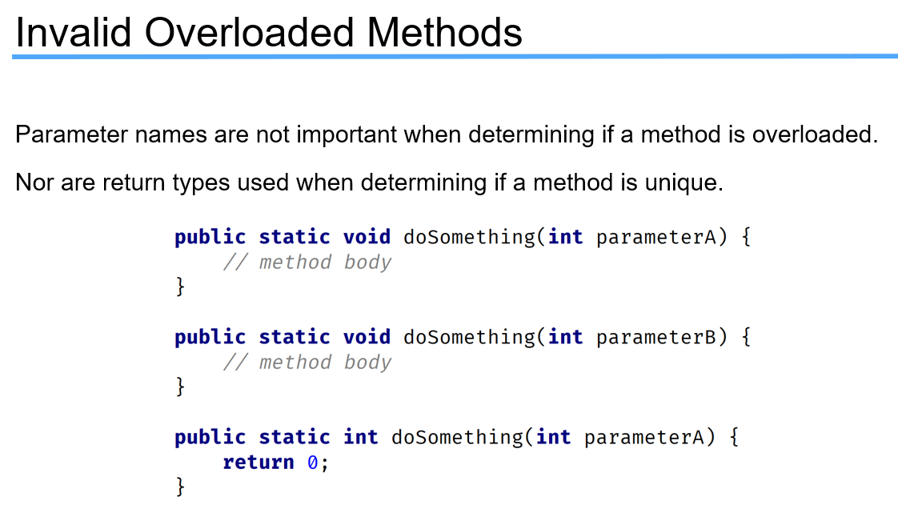

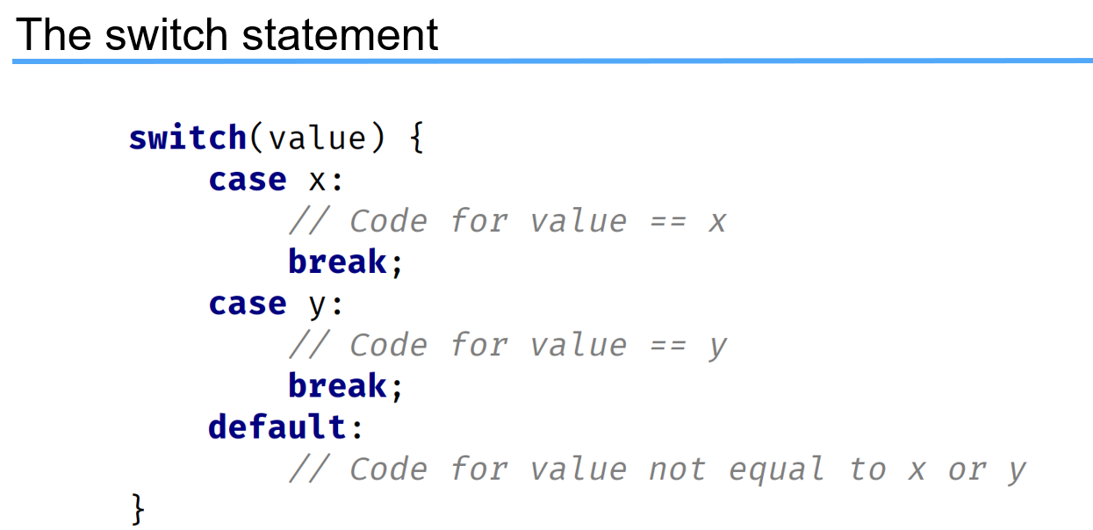

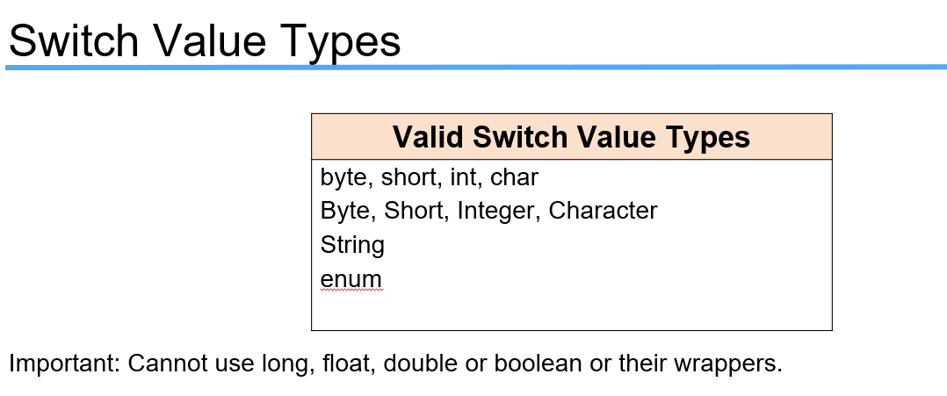

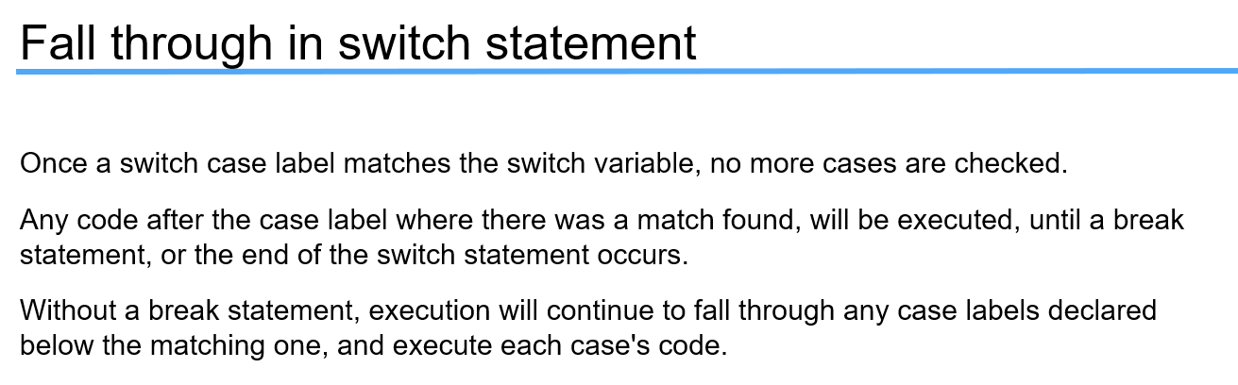

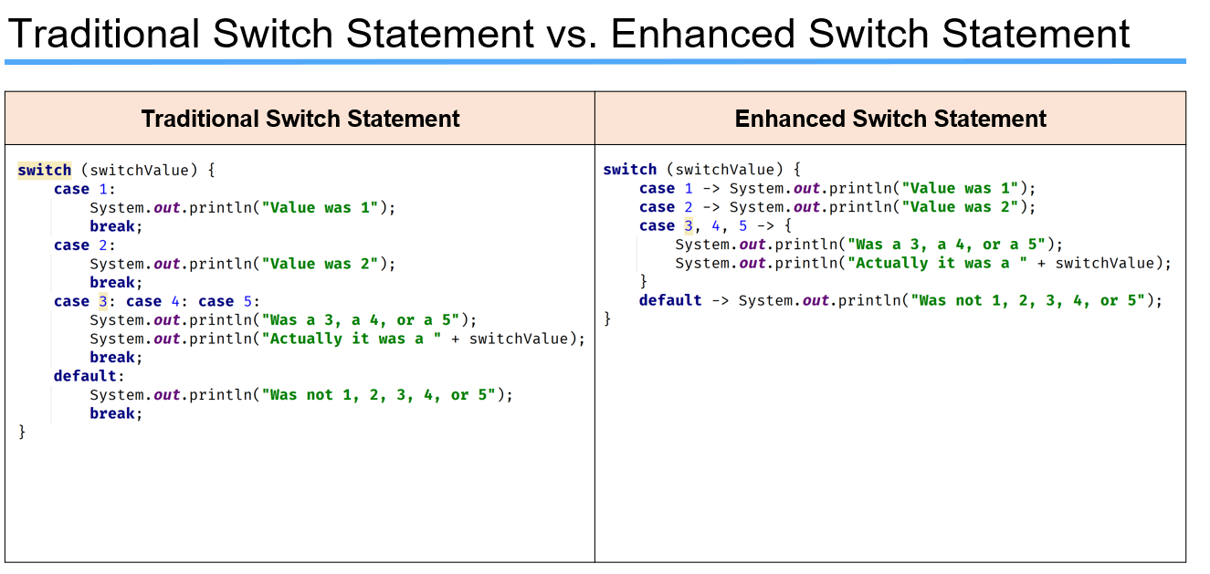

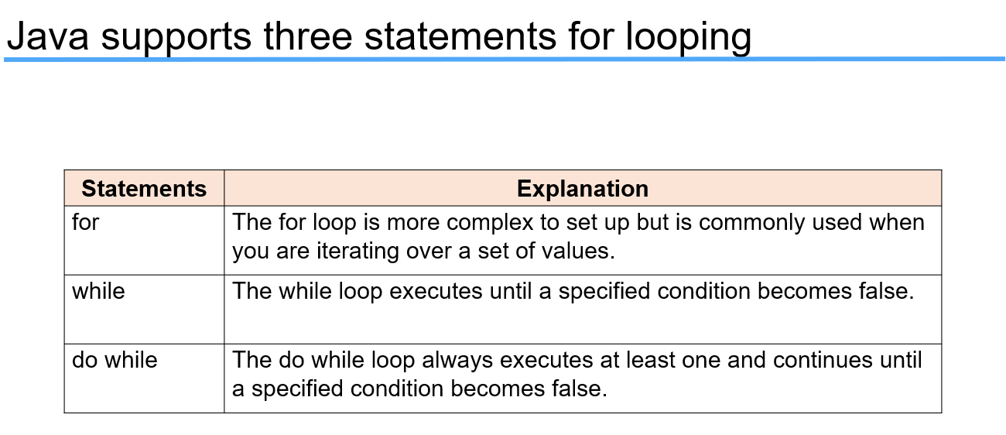

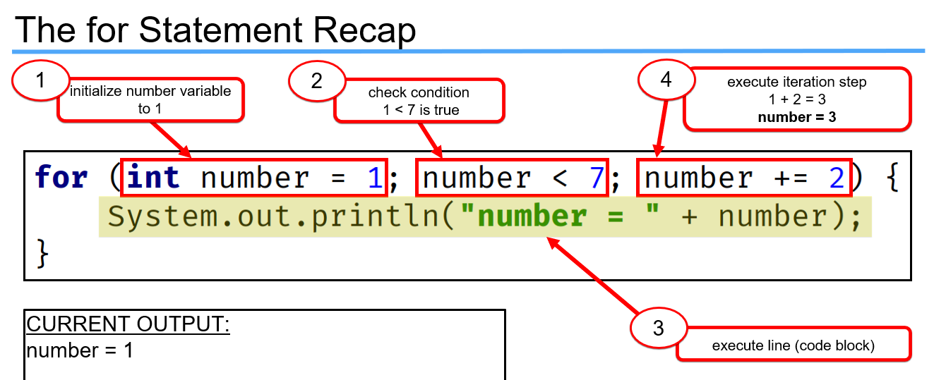

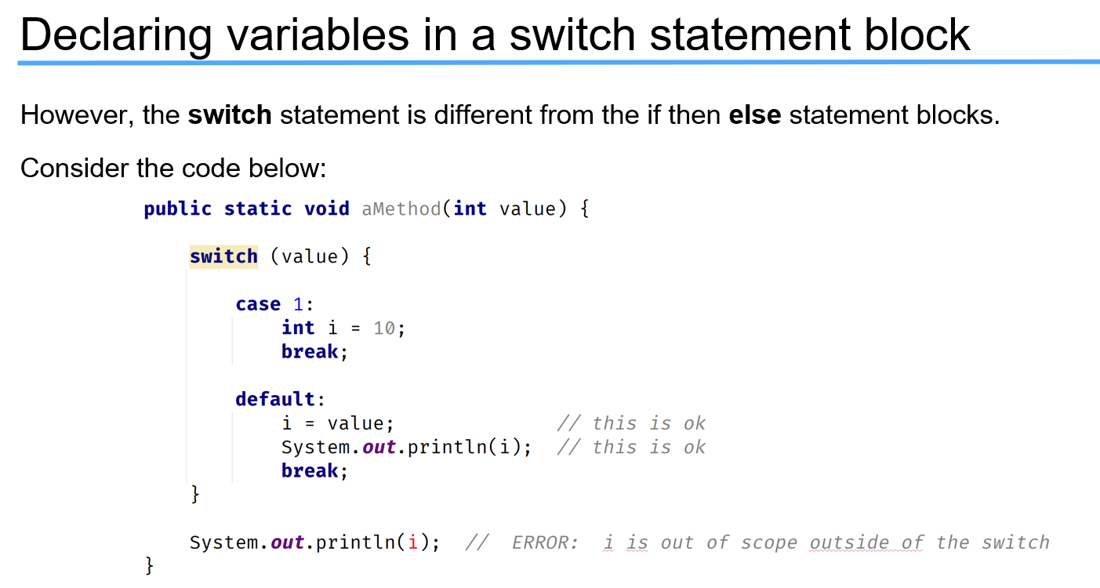

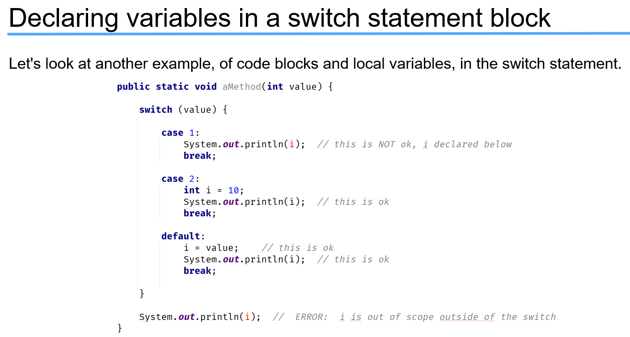

**What is a Palindrome number?**  A palindrome number is a number which when **reversed** is equal to the original **number**.