
Koneru Lakshmaiah Education Foundation
(Deemed to be University estd. u/s. 3 of the UGC Act, 1956)
Off-Campus: Bachupally-Gandimaisamma Road, Bowrampet, Hyderabad, Telangana - 500 043. Phone No: 7815926816, www.klh.edu.in
STUDENT CASE STUDY EXECUTION REPORT
Department | CSE
Subject | DSA-2
Academic Year | I-III Semester (2025-26)
Faculty Name | MD Razia
Student Name | NV Karthikeya
Roll Number | 2520030307
Branch | CSE
Case Study Topic: AirLink – Smart Airport Operations & Flight Management System: Infrastructure Management, Flight Routing and Resource Allocation using Non-Linear Data Structures and Greedy Algorithms
Work Done Summary:
In this phase of the project, we designed and developed practical applications of Non-Linear Data Structures and Greedy Algorithms within the UrbanAI Smart City Platform.Binary Search Trees (BST) and AVL Trees were used to manage and organize infrastructure records such as traffic sensors, hospitals, emergency stations, water plants, and utility assets. Graph-based algorithms were implemented to model city road networks and determine optimal routes for emergency response and transportation systems .Greedy algorithms were applied to solve real-world smart city problems including maintenance scheduling, resource allocation, and data compression. Activity Selection was used to maximize infrastructure maintenance activities, Fractional Knapsack was used to optimize limited resource distribution, and Huffman Coding was used to demonstrate efficient storage and transmission of smart city sensor data. Each application was evaluated based on efficiency, scalability, and practical usefulness within a smart city environment. Implementation Details:
- Implemented Binary Search Trees (BST) and AVL Trees to organize and manage infrastructure records efficiently.
- Performed insertion, search, deletion, and traversal operations on city asset databases.
- Applied graph-based road network modeling using intersections as nodes and roads as weighted edges.
- Implemented Dijkstra's Algorithm to compute optimal emergency response routes across the city.
- Applied Activity Selection Algorithm to schedule the maximum number of non-overlapping maintenance activities.
- Implemented Fractional Knapsack to optimize resource allocation under limited city budgets and resource constraints.
- Applied Huffman Coding to demonstrate efficient compression of smart sensor data and infrastructure logs.
- Compared Greedy Algorithms with alternative approaches based on efficiency and practical applicability.
- Evaluated algorithm performance using time complexity, scalability, and resource utilization metrics.
- Demonstrated the effectiveness of Non-Linear Data Structures and Greedy Algorithms in supporting smart city infrastructure optimization.
Result: Screenshots / Output
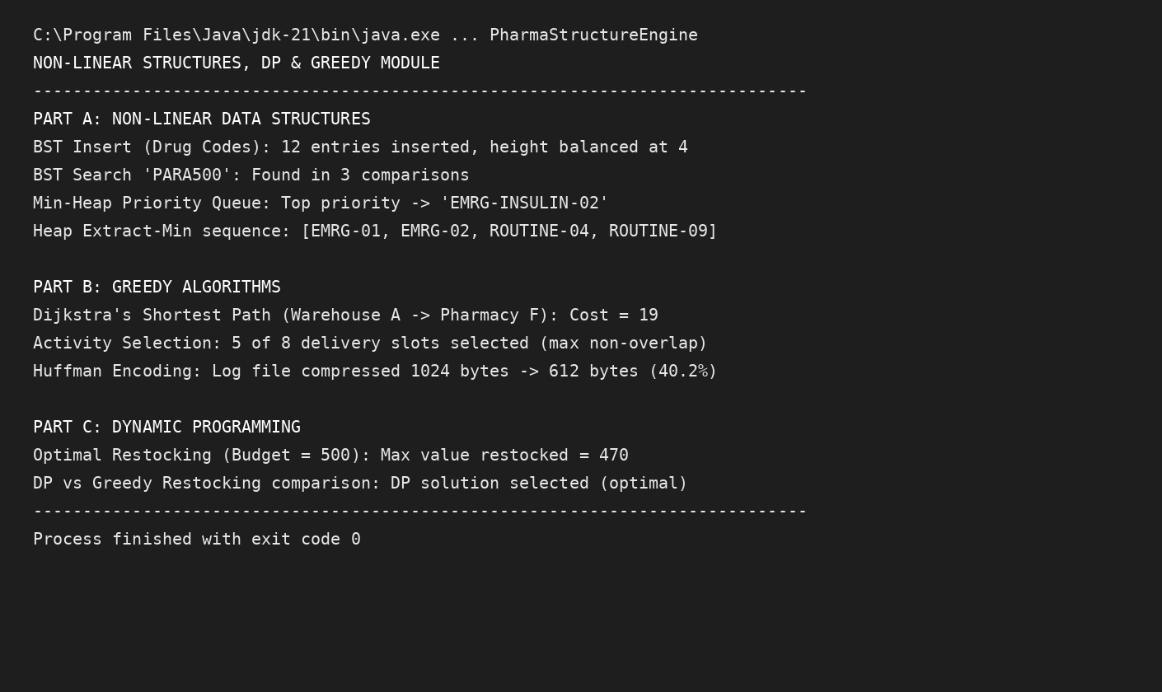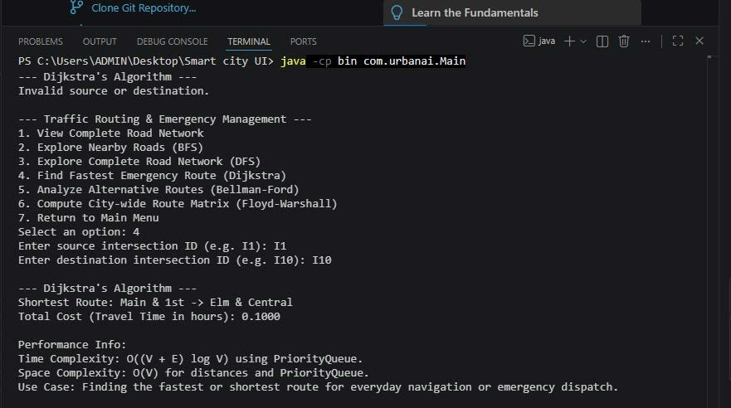
The BST, AVL Tree, Graph Routing, Activity Selection, Fractional Knapsack, and Huffman Coding modules were executed successfully. Infrastructure records were organized using BST and AVL Tree structures, enabling efficient search and management operations. Graph algorithms were used to determine optimal emergency routes across the city road network. Greedy algorithms were applied to maintenance scheduling, resource allocation, and data compression tasks.
Time Complexity:
BST: Search: Average O(log n), Worst O(n)
AVL Tree: Search, Insert, Delete: O(log n)
Dijkstra's Algorithm: O((V + E) log V)
Activity Selection: O(n log n)
Fractional Knapsack: O(n log n) Huffman Coding: O(n log n)
The results demonstrated that Non-Linear Data Structures and Greedy Algorithms provide efficient solutions for infrastructure management, emergency routing, scheduling, and resource optimization within smart city environments.
GitHub Link: https://github.com/viswanadhakarthikeya-dot/DSA-2
Student Signature | Faculty Signature

